
ARYAN PATIL 25070122051 CSEA2
Subject: Programming with Java
ASSIGNMENT No : 5
TITLE :Develop a Java application demonstrating the use of ArrayList, Vector, and StringBuffer for dynamic data storage, management, and string manipulation.
Problem Statement
Develop a Java application demonstrating the use of ArrayList, Vector, and StringBuffer for dynamic data storage, management, and string manipulation.
Learning Objectives
To implement dynamic data storage and string manipulation using ArrayList, Vector, and StringBuffer.
Theory
ArrayList and Vector are dynamic array implementations provided by the Java Collections Framework. ArrayList offers faster performance in single-threaded applications, whereas Vector provides synchronized operations for thread safety. StringBuffer is a mutable sequence of characters that allows efficient string modification without creating new objects. These classes are commonly used in applications requiring dynamic memory allocation and efficient string processing.
Outcome Conclusion Exercise
1.Create a To-Do List application using ArrayList to store tasks and StringBuffer to display tasks.

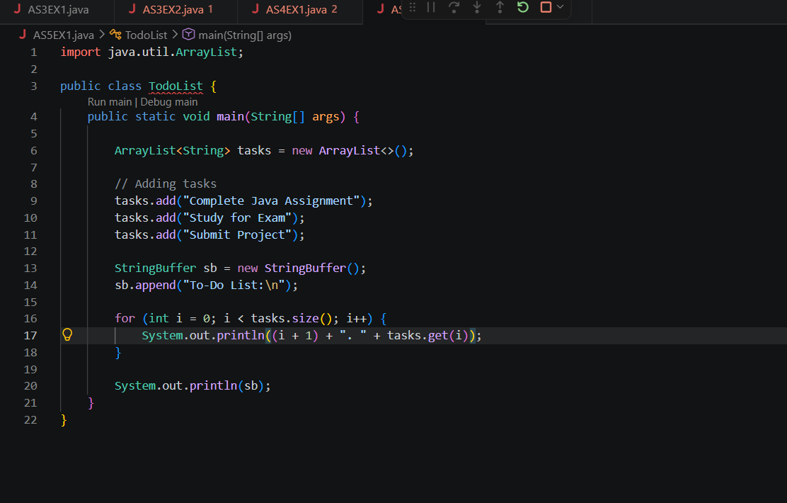
OUTCOME-
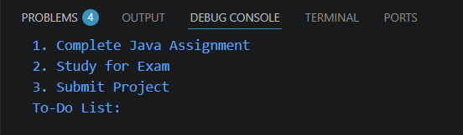

2. Create a Student Course Registration System using ArrayList to store the list of courses registered by a student and StringBuffer to generate and display the registered course list. The application should allow users to add, remove, and view registered courses.
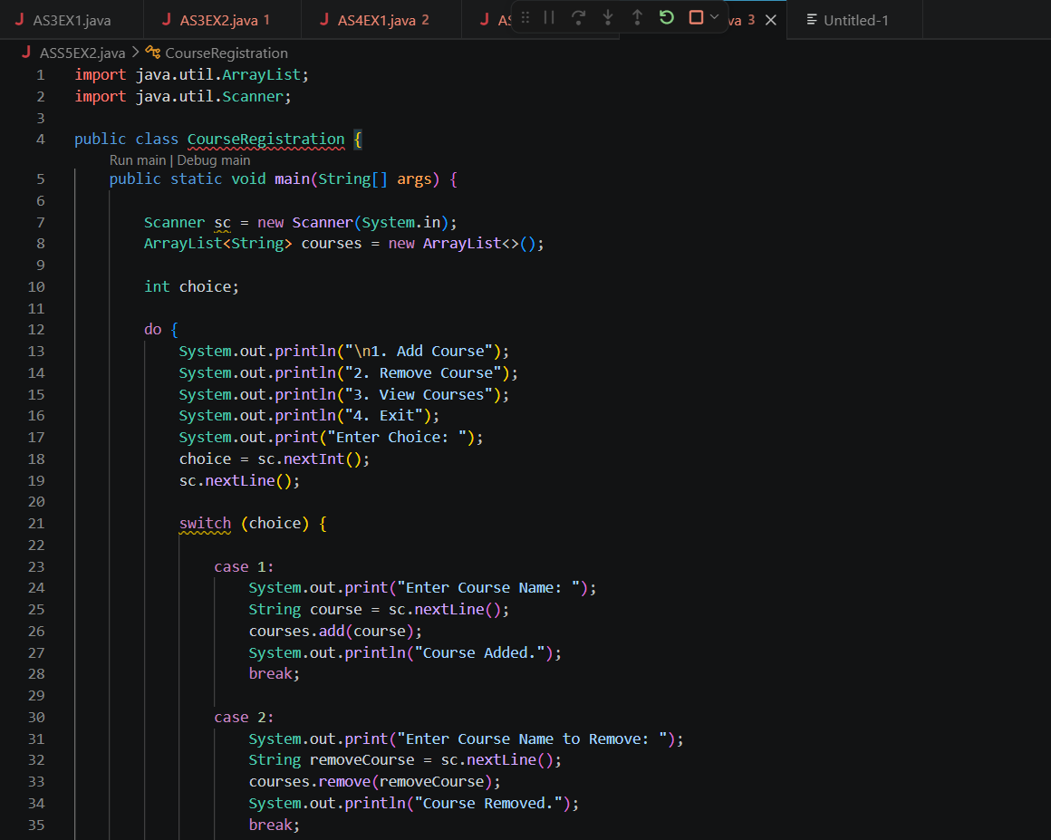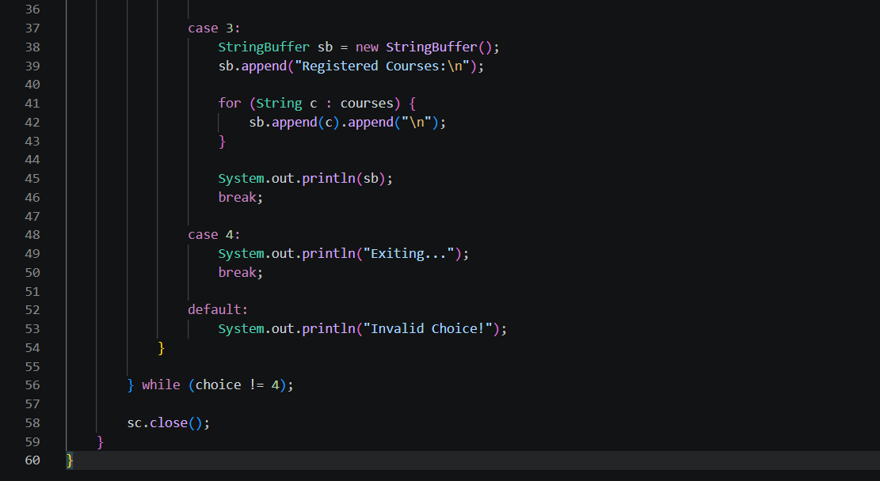

OUTCOME-
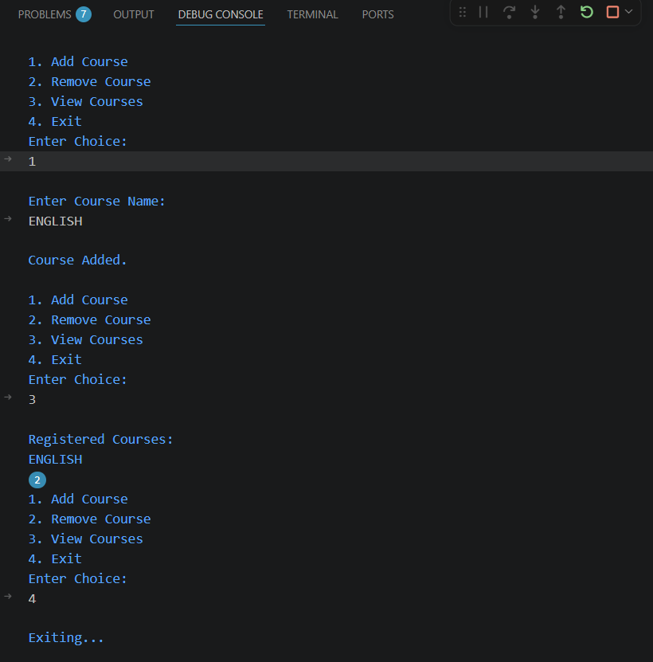

CONCLUSION-
Conclusion
The To-Do List application was successfully developed using ArrayList and StringBuffer. The ArrayList was used to store and manage tasks dynamically, allowing easy addition and retrieval of tasks. The StringBuffer was used to efficiently create and display the task list by modifying strings without creating multiple string objects. This practical demonstrated the effective use of Java Collection classes and mutable strings for dynamic data storage, management, and efficient string manipulation.

