
ARYAN PATIL 25070122051 CSEA2
Subject: Programming with Java
ASSIGNMENT No : 6
TITLE :Write a Java program to demonstrate the use of an inner class, an anonymous class.
Problem Statement
Write a Java program to demonstrate the use of an inner class, an anonymous class.
Learning Objectives
To implement inner classes and anonymous classes for improving encapsulation and event handling in Java.
Theory
An inner class is a class defined inside another class and has access to all members of the enclosing class, including private members. Inner classes help improve code organization and logical grouping of related classes. Anonymous classes are unnamed inner classes that are instantiated only once and are mainly used for implementing interfaces or abstract classes. They simplify code by eliminating the need for separate class definitions. These concepts are widely used in Java GUI programming and event handling
Outcome Conclusion Exercise
- Create a Vehicle program where an inner class displays vehicle details and anonymous class performs an action.
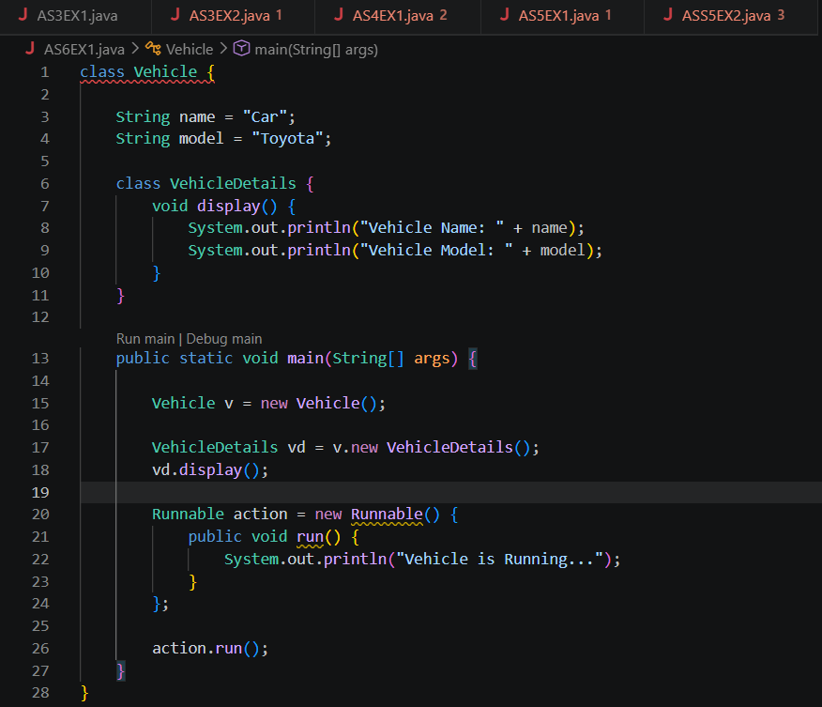

OUTCOME-
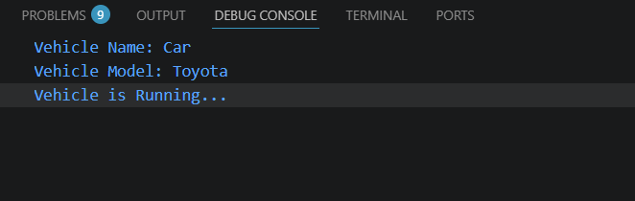
- Develop a Food Delivery Application where an inner class handles order details and anonymous classes handle delivery status updates.
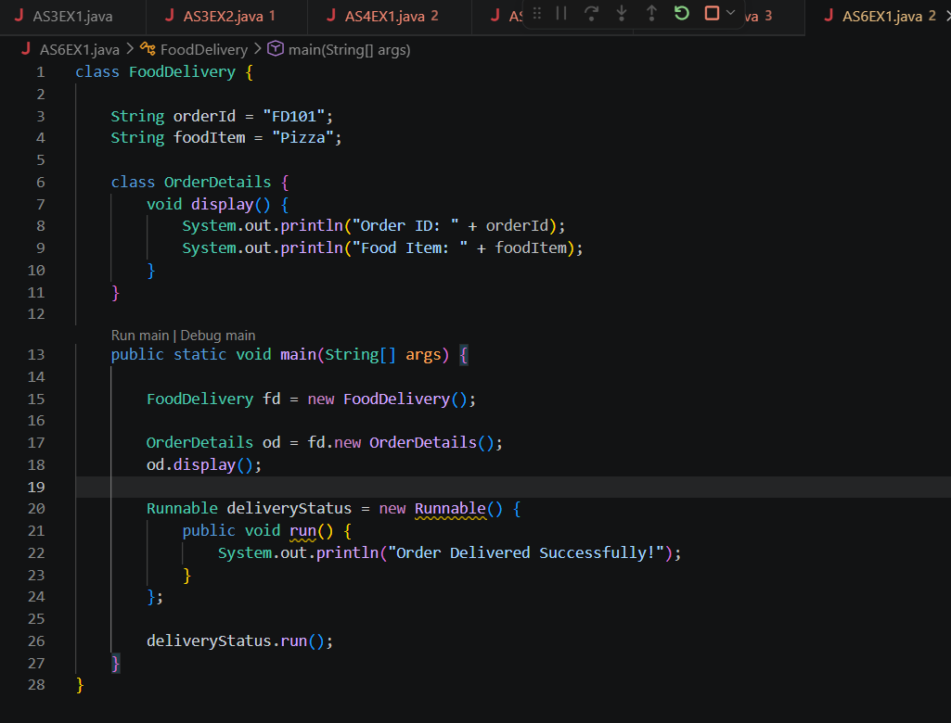

OUTCOME-

Conclusion
The Java program successfully demonstrated the use of inner classes and anonymous classes. The inner class showed how related classes can be logically grouped and how they can access the members of the outer class, improving encapsulation and code organization. The anonymous class demonstrated how a class can be created and used without a separate class definition, making the code shorter and more efficient. This practical helped in understanding the importance of inner and anonymous classes in Java, especially for event handling and object-oriented programming.

