
ARYAN PATIL 25070122051 CSEA2
Subject: Programming with Java
ASSIGNMENT No : 7
TITLE :Implement a Java program to demonstrate inheritance and interfaces using suitable real-world examples.
Problem Statement
Implement a Java program to demonstrate inheritance and interfaces using suitable real-world examples.
Learning Objectives
To implement inheritance and interfaces for achieving code reusability and abstraction.
Theory
Inheritance allows one class to acquire the properties and methods of another class, promoting code reuse and reducing redundancy. Java supports single inheritance through the extends keyword. Interfaces define a contract that implementing classes must follow, enabling abstraction and multiple inheritance of type. Together, inheritance and interfaces support polymorphism and modular software development. They are fundamental concepts of object-oriented programming.
Outcome
Exercise
- Create a Shape application where Circle and Rectangle inherit from Shape and calculate area.
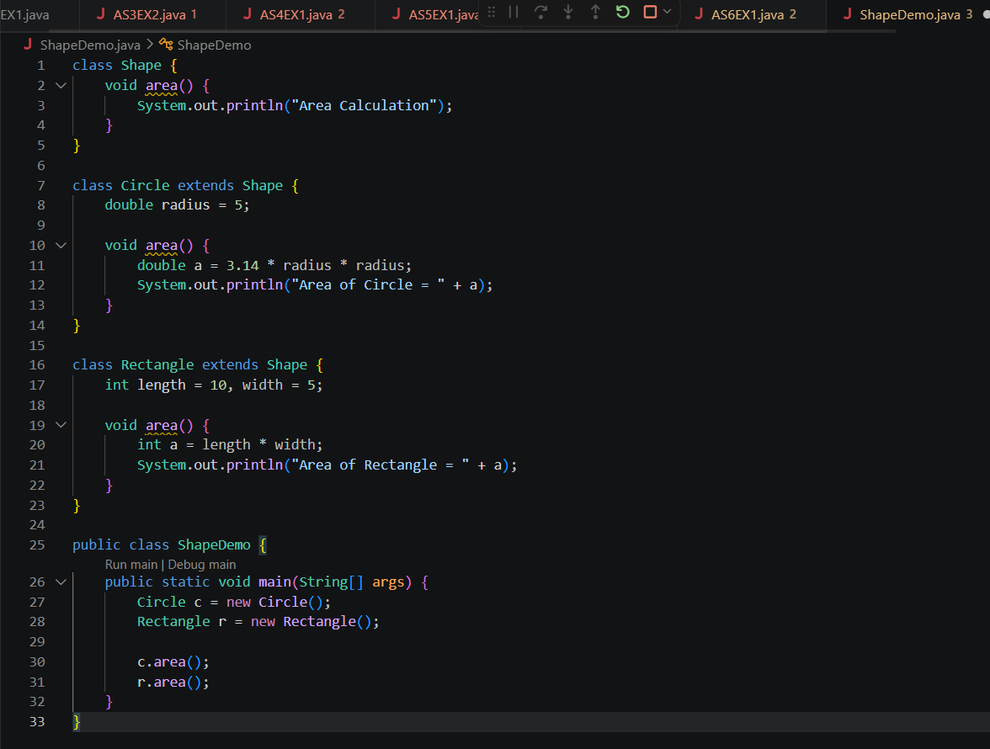

OUTCOME-
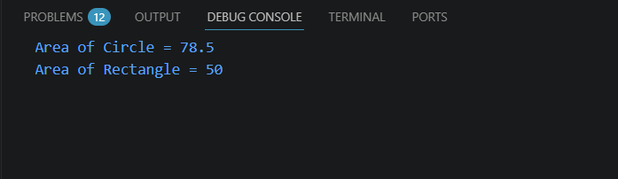
- Develop a E-Commerce Product System where electronic, clothing, and grocery products inherit common properties and implement product interfaces.
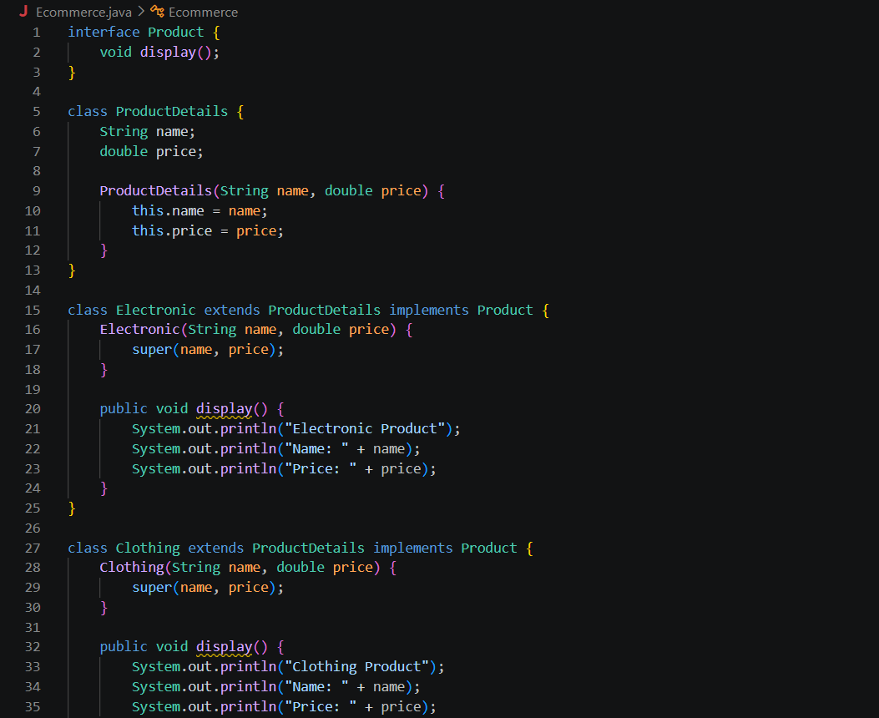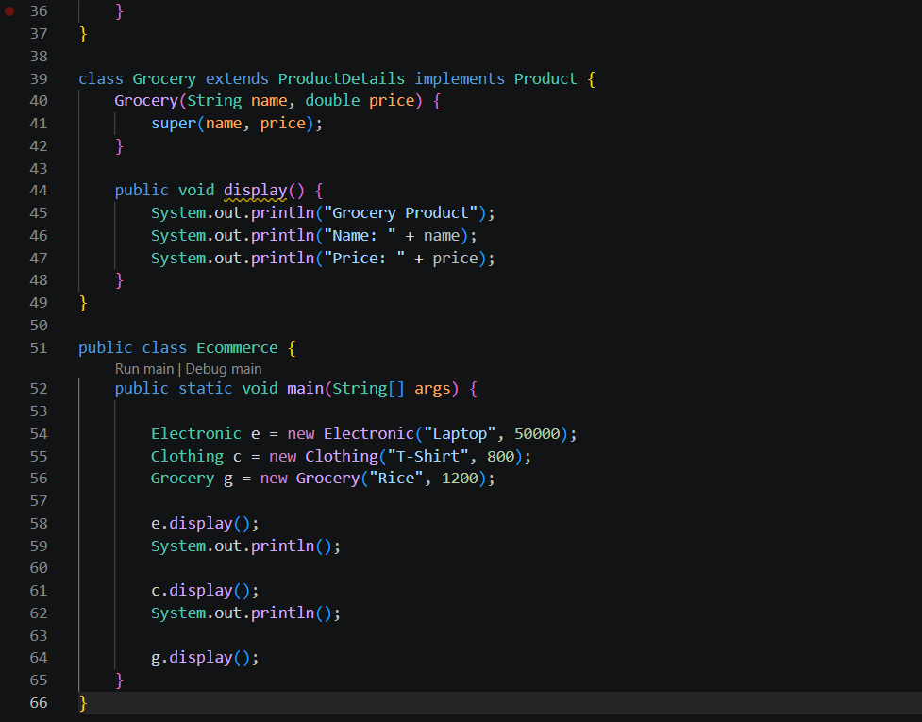
OUTCOME-

Conclusion
The program was successfully implemented to demonstrate the use of inheritance and interfaces in Java. It showed how inheritance promotes code reusability by allowing one class to inherit the properties and methods of another, while interfaces provide abstraction and define a common set of behaviors for implementing classes. This practical enhanced the understanding of object-oriented programming concepts and their role in developing modular, reusable, and maintainable applications.

