
ARYAN PATIL 25070122051 CSEA2
Subject: Programming with Java
ASSIGNMENT No : 8
TITLE :Write a Java program to demonstrate the use of the super keyword in inheritance.
Problem Statement
Write a Java program to demonstrate the use of the super keyword in inheritance.
Learning Objectives
To demonstrate the use of the super keyword for accessing parent class members.
Theory
The super keyword is used to refer to the immediate parent class in Java. It can invoke parent class constructors, access parent class variables, and call overridden methods. Super helps distinguish between parent and child class members with the same name. It ensures proper constructor chaining during object creation. It is an important concept in inheritance and method overriding.
Outcome
Exercise
- Create an Employee and Manager program where Manager accesses Employee details using super keyword.
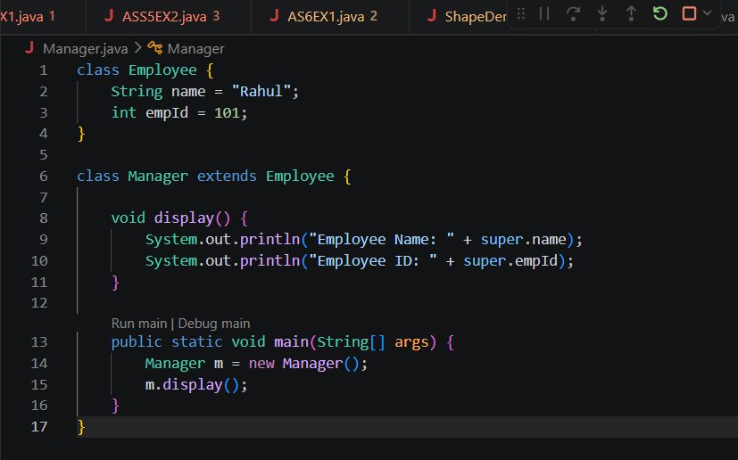

OUTCOME-

- Develop a Vehicle Insurance System where child insurance classes access parent vehicle information using the super keyword.
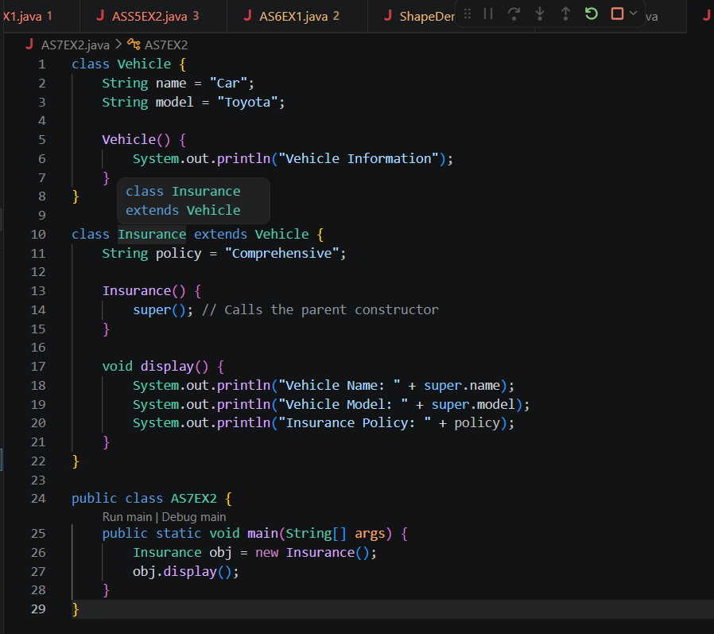
OUTPUT-
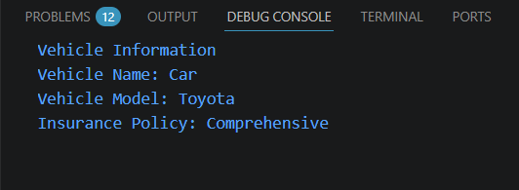
Conclusion
The program was successfully implemented to demonstrate the use of the super keyword in Java inheritance. It showed how super can be used to access parent class variables, invoke parent class constructors, and call parent class methods. This practical helped in understanding constructor chaining, method overriding, and the relationship between parent and child classes, thereby strengthening the concepts of inheritance in Java.

