
ARYAN PATIL 25070122051 CSEA2
Subject: Programming with Java
ASSIGNMENT No : 9
TITLE :Write a Java program to demonstrate the use of the final keyword with variables, methods, and classes.
Problem Statement
Write a Java program to demonstrate the use of the final keyword with variables, methods, and classes.
Learning Objectives
To implement the final keyword with variables, methods, and classes.
Theory
The final keyword restricts modification in Java programs. A final variable cannot be reassigned after initialization. A final method cannot be overridden by subclasses, while a final class cannot be inherited. This improves security, prevents accidental modifications, and increases program reliability. Final is commonly used for constants and immutable classes.
Outcome
Exercise
- Create a Bank Account program where account number is final and cannot be changed.
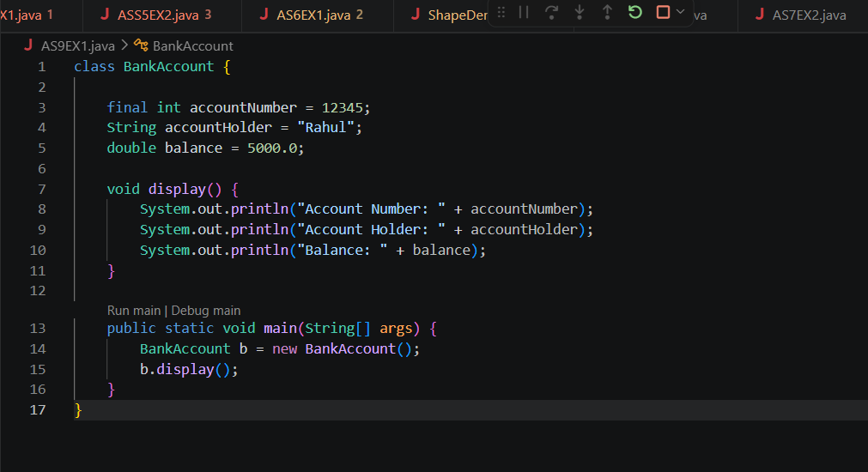
OUTPUT-
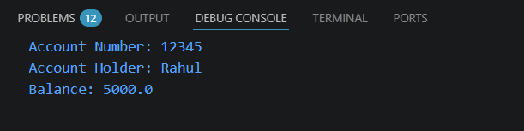
- Create a Library Book Management program where the book ISBN is declared as final and cannot be changed once assigned. Display the book's ISBN, title, author, and price.
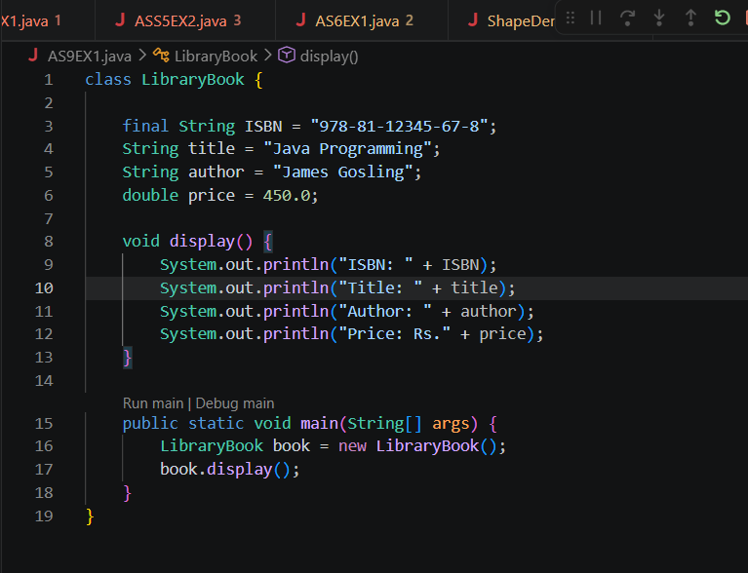
OUTCOME-
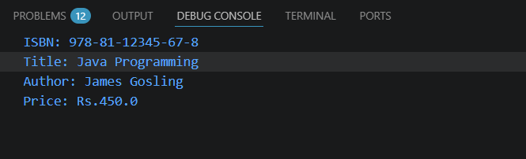
Conclusion
The program was successfully implemented to demonstrate the use of the final keyword with variables, methods, and classes in Java. It showed how the final keyword prevents reassignment of variables, overriding of methods, and inheritance of classes, thereby improving program security and reliability. This practical enhanced the understanding of data protection and code stability using the final keyword in object-oriented programming.

