# DATA STRUCTURES

**CSE228**

# INITIAL PROJECT REPORT



**Topic:** Student Gradebook, a program to calculate and manage student grades, storing data in files.

# Submitted By: Submitted To:

Aryan Pandey Waseem Ud Din Wani

K22UP UID: 63869

R.No: 23

**DECLARATION**

I hereby declare that the project work entitled **STUDENT GRADEBOOK** is an authentic record of our own work carried out as requirements of Capstone Project for the award of B.Tech degree in Computer Science and Engineering (AI & ML) from Lovely Professional University, Phagwara, under the guidance of Waseem Ud Din Wani, during January to May 2023. All the information furnished in this capstone project report is based on our own intensive work and is genuine.

Project Group Number: 22

Name of Student : ARYAN PANDEY

Registration Number: 12203693

Signature of Student: ARYAN

Date: 10.23.2023

**CERTIFICATE**

This is to certify that the declaration statement made by this student is correct to the best of my knowledge and belief. He has completed this Capstone Project under my guidance and supervision. The present work is the result of their original investigation, effort and study. No part of the work has ever been submitted for any other degree at any University. The Capstone Project is fit for the submission and partial fulfillment of the conditions for the award of B.Tech degree in Computer Science and Engineering (AI & ML) from Lovely Professional University, Phagwara.

**Signature and Name of the Mentor:**

**Designation:**

**School of Computer Science and Engineering,**

Lovely Professional University,

Phagwara, Punjab.

**ACKNOWLEDGEMENT**

I would like to extend my sincere thanks to the Lovely School of Computer Science and Engineering for providing me with the opportunity to fulfill my wish and achieve my goal. I am grateful to Waseen ud din Wani sir for providing me with the opportunity to undertake this project and for providing me with all the necessary facilities. I am highly thankful to sir for his active support, valuable time and advice, whole-hearted guidance, sincere cooperation, and pain-taking involvement during the study and in completing the assignment of preparing the said project within the time stipulated. Lastly, I am thankful to all those, particularly the various friends, who have been instrumental in creating a proper, healthy, and conducive environment and including new and fresh innovative ideas for me during the project. Without their help, it would have been extremely difficult for me to prepare the project in a timebound framework.

**Introduction**

A student gradebook is a system that is used to store and manage student grades. It can be used to add, remove, and view student grades. The gradebook can also be used to calculate the total grade and average grade for a student.

There are many different types of gradebooks available, including paper-based gradebooks, electronic gradebooks, and online gradebooks. Paper-based gradebooks are the most traditional type of gradebook. They are typically notebooks or binders that are used to record student grades by hand. Electronic gradebooks are software applications that are used to record and manage student grades electronically. Online gradebooks are web-based applications that allow students and teachers to access student grades from anywhere in the world.

**Problem Statement**

Student gradebooks are an essential tool for teachers to track student progress and assess learning. However, traditional paper-based gradebooks can be time-consuming to maintain and prone to errors. Electronic gradebooks offer a number of advantages, but they can be complex and expensive to implement.

This project aims to develop a StudentGradebook class in Java that is easy to use, efficient, and flexible. The class should be able to store and manage student grades, calculate total and average grades, and generate reports.

The StudentGradebook class should be able to be used to develop a variety of gradebook applications, such as a simple gradebook application for a single class or a more complex gradebook application for a school or district.

Data Structure Used**: Hash map and Array list**

**HASMAP**

A HashMap is a data structure that stores key-value pairs. The keys in a HashMap are typically strings, and the values in a HashMap can be any object. Hash Maps are implemented using a hash table, which is a data structure that is optimized for fast lookup of key-value pairs.

Hash Maps are very efficient for storing and retrieving data. They are also very versatile, and can be used for a variety of tasks, such as:

* Caching data
* Storing user preferences
* Implementing a database
* Implementing a graph

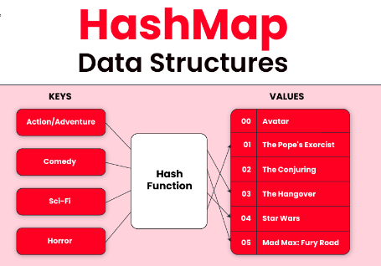

**ARRAYLIST**

An ArrayList is a dynamic array in Java. It is similar to a regular array, but it can grow and shrink as needed. This makes ArrayLists very efficient for storing and retrieving data.

ArrayLists are implemented using a linked list. This means that the elements in an ArrayList are stored in a chain of nodes. Each node contains a reference to the

next node in the chain, and the last node in the chain contains a reference to the first node in the chain.

To add an element to an ArrayList, you use the add() method. To remove an element from an ArrayList, you use the remove() method. To retrieve an element from an ArrayList, you use the get() method.

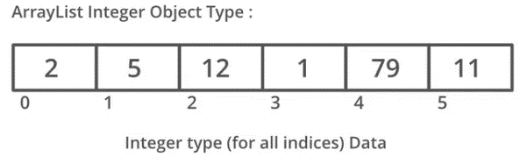

**Objective of the project**

The objective of this project was to develop a Student Gradebook class in Java. The class is used to store and manage student grades. It can be used to add, remove, and view student grades. The class also provides methods to calculate the total grade and average grade for a student.

**Description of the project**

The Student Gradebook class is implemented using a Hash Map. The Hash Map is used to store the student names and their grades. The class provides methods to add, remove, and view student grades. It also provides methods to calculate the total grade and average grade for a student.

The class is implemented in a way that is easy to use and extend. It can be used to develop a variety of gradebook applications, such as a simple gradebook application for a single class or a more complex gradebook application for a school or district.

**Implementation details**

*The Student Gradebook class is implemented using the following Java classes:*

* Hash Map: A Hash Map is a data structure that is used to store key-value pairs. The keys in a HashMap are typically strings, and the values in a HashMap can be any object.
* ArrayList: An ArrayList is a data structure that is used to store a collection of objects. ArrayLists are dynamic, meaning that they can grow and shrink as needed.
* File: A File object represents a file on the filesystem.
* Scanner: A Scanner object is used to read input from a file or from the console.
* PrintWriter: A PrintWriter object is used to write output to a file or to the console.

*The StudentGradebook class provides the following methods:*

* addStudentGrade(): This method adds a student to the gradebook. The method takes the student's name and a list of grades as input.
* removeStudent(): This method removes a student from the gradebook. The method takes the student's name as input.
* printGradebook(): This method prints the gradebook to the console.
* calculateTotalGrade(): This method calculates the total grade for a student. The method takes the student's name as input.
* calculateAverageGrade(): This method calculates the average grade for a student. The method takes the student's name as input.

**Source code:** [**student Gradebook repository Github**](https://github.com/aryanpnd/student-gradebook)

**Usage example**

*The following code shows how to use the StudentGradebook class:*

**

**Benefits of using the StudentGradebook class**

*The StudentGradebook class provides a number of benefits, including:*

* It is easy to use and extend.
* It can be used to develop a variety of gradebook applications.
* It is efficient and uses appropriate data structures and algorithms.

**OUTPUT**

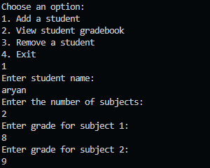

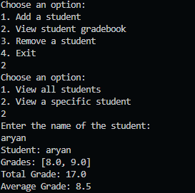

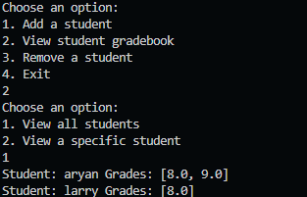

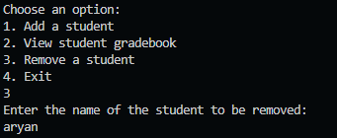

**Conclusion**

The StudentGradebook class is a powerful and flexible tool for managing student grades. It is easy to use and extend, and it can be used to develop a variety of gradebook applications.