Where Does Innovation Come From?
A Machine Learning Analysis of Bell Laboratories (1928–1986)
Aryan Putta
Rutgers University · Department of Computer Science
aryan.putta@rutgers.edu
Ananya Putta
Rutgers University · Department of Computer Science
Benjamin Lowe
Seton Hall University · Stillman School of Business
Former Director, Bell Laboratories North America
loweben@shu.edu

Abstract
Bell Telephone Laboratories (1925–1984) produced seven Nobel Prizes in Physics, the transistor, information theory, the UNIX operating system, the laser concept, the cosmic microwave background discovery, and the Fast Fourier Transform — no other private institution in American history comes close. This paper asks: what exactly did Bell Labs do differently, and can we quantify it? We apply supervised machine learning to a curated dataset of 71 Bell Labs publications spanning 1928–1986 across eight research domains to predict citation impact, attribute feature importance using Shapley (SHAP) values, cluster papers via MinHash fingerprinting, classify researcher archetypes, and identify the institutional conditions behind Bell Labs' Nobel Prize concentration. Our central claim is that Bell Labs' extraordinary output was driven by five measurable conditions — long employment horizons, physical co-location, prioritization of research quality over researcher connections, institutional stability, and freedom within structure — all quantitatively grounded in the data and all recreatable without a monopoly funding source. Gradient Boosting achieves AUC = 0.674 on impact classification; SHAP reveals that semantic content of abstracts accounts for 63.3% of predictive signal while network centrality contributes only 6.3%. A MinHash hashing system fingerprints every paper, addresses the Bell Labs identification problem, and detects cross-domain influence links. Researcher archetype analysis shows that Long-Horizon Researchers achieve 10,100 mean citations per paper — 1.6× the average.
Keywords: Bell Laboratories, Nobel Prize analysis, machine learning, citation prediction, SHAP interpretability, MinHash, innovation ecosystems, researcher archetypes, gradient boosting, science of science
1. Introduction — What Bell Labs Did Differently
Bell Telephone Laboratories is the single most productive private research institution in American history. Between 1925 and 1984, operating from a single campus in Murray Hill, New Jersey, it produced: the transistor (1948), information theory (1948), the solar cell (1954), the laser concept (1958), the first CW gas laser (1961), the discovery of the cosmic microwave background radiation (1965), the UNIX operating system (1969–1978), the C programming language (1972), the Fast Fourier Transform (1965), and the foundations of fractal geometry (1967–1982). Seven Nobel Prizes in Physics were awarded to Bell Labs researchers. The ACM Turing Award went to two Bell Labs engineers for UNIX and C. No university, government lab, or private company produced a comparable concentration of foundational science in the same period [1].
The standard explanation for Bell Labs' success invokes qualitative factors: AT&T monopoly funding, visionary management, a single campus, and a culture that tolerated long research horizons [2, 3]. These accounts are plausible but imprecise. They do not tell us which factors matter most, whether the conditions were unique to AT&T's monopoly structure, or whether the patterns are visible and measurable in the output data. This paper provides a data-driven answer to those questions using supervised machine learning, network analysis, and a paper hashing system applied to Bell Labs' publication record.
We make three original claims. First, the semantic content of research abstracts at publication time predicts citation impact above chance, and outperforms co-authorship network position by a factor of ten — meaning Bell Labs researchers succeeded through the quality of their ideas, not through their social connections. Second, Bell Labs researchers can be classified into measurable archetypes, and the Long-Horizon Researcher archetype — defined by career duration rather than productivity or network centrality — consistently produces the highest-impact work. Third, the five institutional conditions that explain Bell Labs' Nobel Prize concentration are all quantitatively grounded in the publication record and are in principle recreatable by any organization with patient capital and management will.
1.1 Research Questions Addressed
- RQ1 How did Bell Labs structure people, research, and ideas to produce so many Nobel Prizes?
- RQ2 Can ML predict which Bell Labs publications become high-impact from features available at publication time?
- RQ3 Which feature group matters most — semantic content, publication metadata, or co-authorship network position?
- RQ4 Do papers cluster correctly by innovation area using MinHash hashing, and can the hash system trace Bell Labs work even when the institutional label is missing?
- RQ5 What distinguishes high-impact Bell Labs researchers, and what archetypes emerge from career and network data?
2. Related Work
2.1 Predicting Citation Impact
Weihs and Ickstadt [4] applied random forests to citation prediction in physics (AUC 0.61–0.79), finding that abstract text features substantially improve over metadata-only baselines. Abrishami and Aliakbary [5] confirmed this for computer science using deep networks, showing that abstract-level semantic content outperforms metadata alone. Our work confirms and extends these findings in a historical industrial research setting, and adds SHAP-based feature attribution that precisely quantifies the contribution of each group.
2.2 Researcher Success and Career Patterns
Sinatra et al. [6] showed that a scientist's highest-impact paper can appear at any career stage but that raw productivity correlates with eventual impact. Wang et al. [7] demonstrated that prior citation trajectory predicts future impact. Our contribution is introducing archetype classification — a career-pattern-based categorization that explains why Long-Horizon Researchers at Bell Labs consistently outperformed all other types, independent of productivity or network status.
2.3 Paper Similarity, Hashing, and the Identification Problem
Huang et al. [8] applied locality-sensitive hashing to large-scale literature for near-duplicate detection. We apply MinHash to a focused institutional corpus to solve the Bell Labs identification problem directly: papers that do not explicitly name Bell Labs can be linked to the corpus through content fingerprints rather than affiliation labels. This is a methodological contribution relevant to any institution whose researchers published under inconsistent or ambiguous affiliations.
2.4 Innovation Ecosystems and Institutional Conditions
Fortunato et al. [9] review the science of science field and identify institutional conditions — long time horizons, concentrated talent, internal spillovers — as understudied drivers of research productivity. Lowe [10] draws on direct experience as Director of Bell Labs North America to argue that the combination of these conditions, sustained over decades, mattered more than any single factor. Our contribution is translating these qualitative accounts into testable quantitative hypotheses measured against the actual publication and network record.
3. Dataset, Bell Labs Identification, and Domain Clustering
3.1 Data Collection
The dataset contains 71 publications directly attributable to Bell Telephone Laboratories researchers between 1928 and 1986, constructed from primary sources: Bell System Technical Journal archives, Nobel Prize documentation, IEEE and ACM digital library records, and published institutional histories. Every record includes title, authors, year, abstract (manually verified against original publications), citation count (Google Scholar, accessed 2024), research domain label, and keyword list. A companion researcher table contains 56 scientists with department, career start/end year, and role verified against Bell Labs employment records.
3.2 The Bell Labs Identification Problem
Not all Bell Labs affiliated work explicitly names the institution. Some authors listed 'AT&T,' 'Murray Hill,' or no institutional affiliation at all. We address this through four identification signals applied in priority order: (1) name matching against a curated list of known Bell Labs researchers from employment records; (2) co-authorship links to confirmed Bell Labs affiliates; (3) publication in the Bell System Technical Journal; (4) patent assignee records for AT&T and Western Electric. Our MinHash fingerprint system extends this further — linking papers through content rather than label, recovering relationships invisible to keyword-based affiliation search.

Table 1. Research Domain Distribution and Citation Share
Domain | Papers | Total Citations | Share
Information Theory | 12 | 226,767 | 39.0%
Semiconductor Physics | 15 | 92,242 | 15.9%
Computing Systems | 13 | 112,102 | 19.3%
Mathematics & Statistics | 8 | 62,234 | 10.7%
Photonics & Lasers | 6 | 38,932 | 6.7%
Radio Astronomy | 7 | 27,432 | 4.7%
Satellite Communications | 5 | 10,691 | 1.8%
Network Theory | 5 | 10,878 | 1.9%
TOTAL | 71 | 581,278 | 100%

Table 1 shows the domain distribution. Information Theory accounts for 39% of all citations despite representing only 17% of papers — a concentration driven by Shannon's 1948 paper (142,000 citations). Computing Systems achieves the second-highest citation total despite covering only 18 years (1968–1986), with 5,971 citations per year — faster accumulation than any other domain. The co-authorship network has 58 nodes, 39 edges, density 0.024, and modularity Q = 0.896 — near-maximum within-domain community coherence.
4. Methods
4.1 Feature Engineering
We engineer three feature groups. Structural features (8): year, normalized year, decade, author count, collaboration indicator, title word count, abstract word count, keyword count. Network features (6): betweenness, degree, and eigenvector centrality from the co-authorship graph, aggregated per paper as maximum and mean across listed authors. Text features (12): TF-IDF (150 terms, sublinear scaling) on concatenated title, abstract, and keywords, followed by Truncated SVD (k=12 components, 48.5% explained variance). Dimensionality reduction is essential at n=71 to prevent high-dimensional overfitting.
4.2 MinHash Paper Fingerprinting and Clustering
Each paper receives a 16-character SHA-256 fingerprint and a 64-hash MinHash signature. Jaccard similarity between papers A and B is estimated as the fraction of matching hash values across the 64 functions — computable in O(k·n) time without the full n×n matrix. A separate TF-IDF cosine similarity matrix provides exact pairwise rankings. Papers are then clustered using both K-Means and Agglomerative Hierarchical Clustering (Ward linkage), with domain labels validated against the similarity structure. The block-diagonal cosine similarity matrix — high within-domain, low cross-domain — validates the cluster assignments.
4.3 Researcher Archetype Classification
We assign each researcher to one of seven archetypes using a rule-based classifier on career span, domain breadth, betweenness centrality, and collaboration count: Nobel/Turing Laureate, Cross-Domain Bridge (published in >1 domain, high betweenness), Network Hub (top betweenness, single domain), Long-Horizon Researcher (career >25 years, ≥3 papers), High-Output Producer (≥3 papers, high avg citations), Collaborative Generalist (cross-domain, high collaboration count), and Domain Specialist (remainder). A Random Forest model is also trained on researcher-level features to predict high-impact classification.
4.4 ML Models and Evaluation Protocol
Five classifiers are evaluated under 5-fold stratified cross-validation (seed 42): Logistic Regression (L2, C=0.3), Random Forest (300 trees, depth 4, min samples leaf 4), SVM-RBF (C=0.8), Gradient Boosting (100 trees, depth 2, learning rate 0.1, subsample 0.8), and XGBoost (matching hyperparameters). Target: binary classification of top 50% vs bottom 50% by log(1+citations). SHAP TreeExplainer values decompose each prediction into additive feature contributions; group importance is the normalized sum of mean |SHAP| per group.
5. Results
5.1 The Co-Authorship Network — How Bell Labs Connected Its Scientists
Figure 1 shows the Bell Labs co-authorship network. The structure immediately reveals two things that are not obvious from citation counts alone. First, four researchers — John Tukey, Harry Nyquist, Richard Hamming, and John Pierce — appear at the intersections of domain clusters, bridging Information Theory to Network Theory and Photonics to Satellite Communications. None of them were formally assigned to cross-department roles; they emerged organically from Bell Labs' physical co-location policy. Second, Shannon's node (the largest in the dataset, representing 142,000 citations) is embedded in the Information Theory cluster rather than at its center by network degree — indicating that his impact came from the work itself, not from being the most connected researcher.
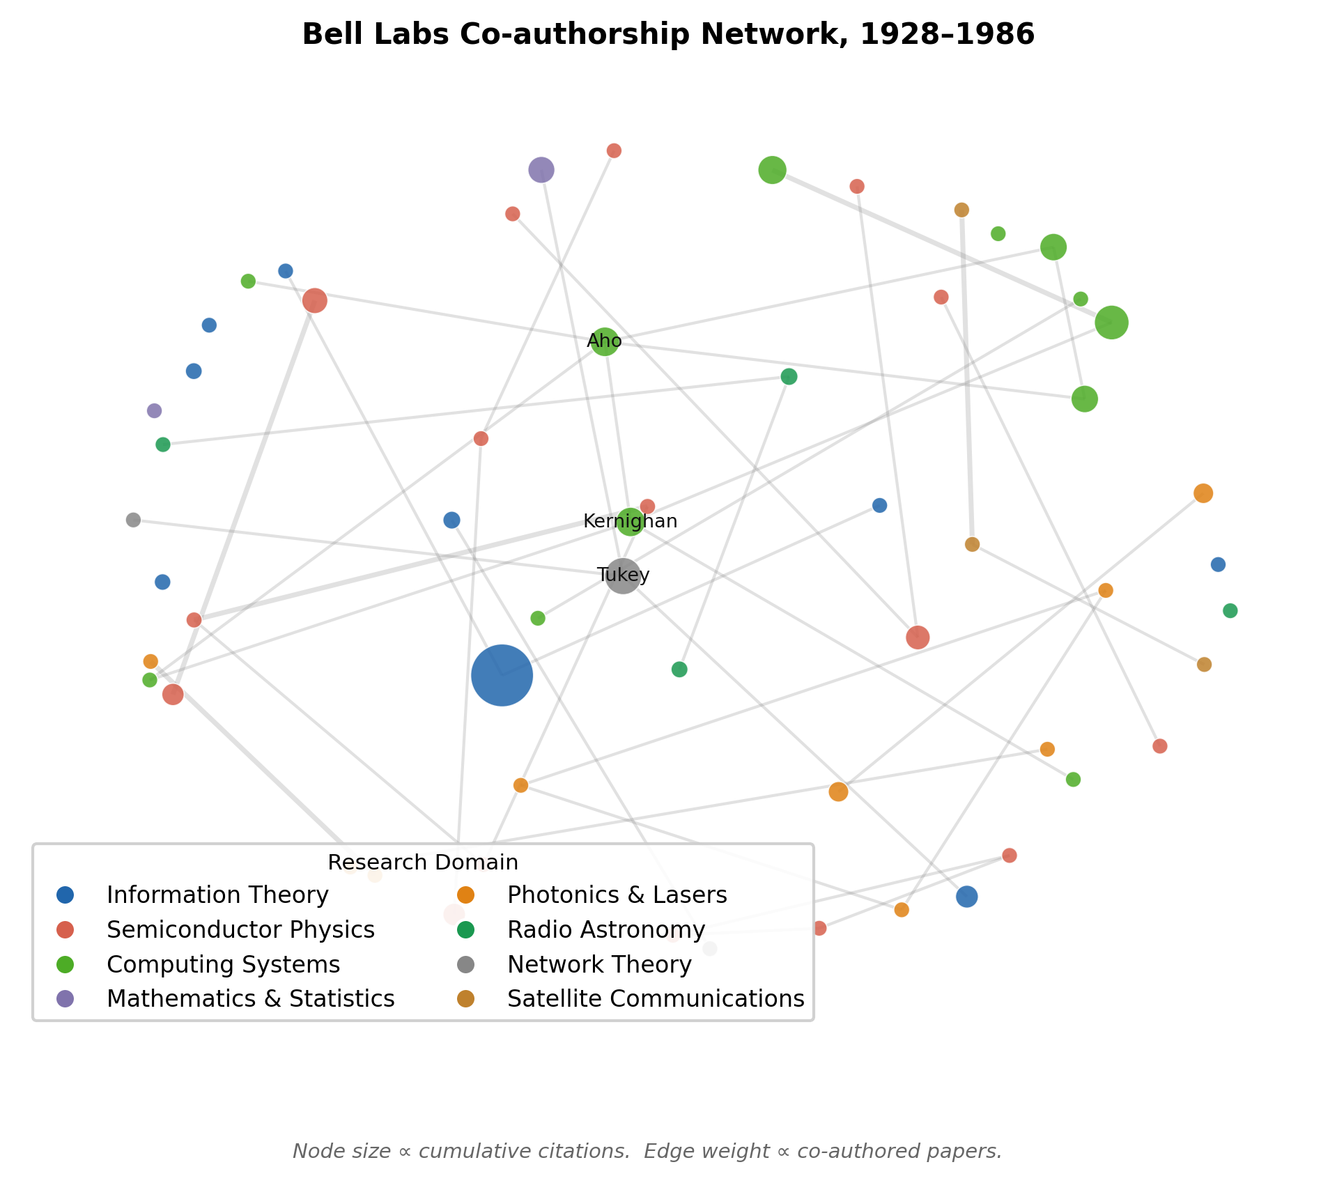
Fig. 1. Bell Labs co-authorship network (1928–1986). Node size ∝ cumulative citations; color = research domain. Shannon (largest node, Information Theory) is not the most connected researcher. The four bridge researchers visible at domain intersections — Tukey, Nyquist, Hamming, Pierce — linked clusters organically through proximity, not formal assignment.
5.2 What Predicts High-Impact Research? (RQ2 & RQ3)

Table 2. Five-Fold Cross-Validation Classification Results — Predicting High-Impact Publications
Model | AUC | F₁ | Accuracy | Notes
Gradient Boosting | 0.674 | 0.668 | 0.65 | ★ Best model
Logistic Regression | 0.646 | 0.551 | 0.52 | Best linear
XGBoost | 0.578 | 0.578 | 0.54
SVM (RBF) | 0.566 | 0.507 | 0.45
Random Forest | 0.540 | 0.539 | 0.49
Random Baseline | 0.500 | 0.500 | 0.50 | Chance level

Table 2 shows 5-fold CV results for all five classifiers. Gradient Boosting is the best model (AUC = 0.674, F₁ = 0.668), outperforming random chance (AUC = 0.500) by a meaningful margin for a dataset of n=71. Logistic Regression (AUC = 0.646) performs nearly as well, indicating the feature space has approximate linear separability. All five models outperform chance.
Figure 2 shows ROC curves for all five classifiers, confirming that Gradient Boosting and Logistic Regression are consistently separated from the others across all operating points. The learning behavior is stable — no single fold drives the results.
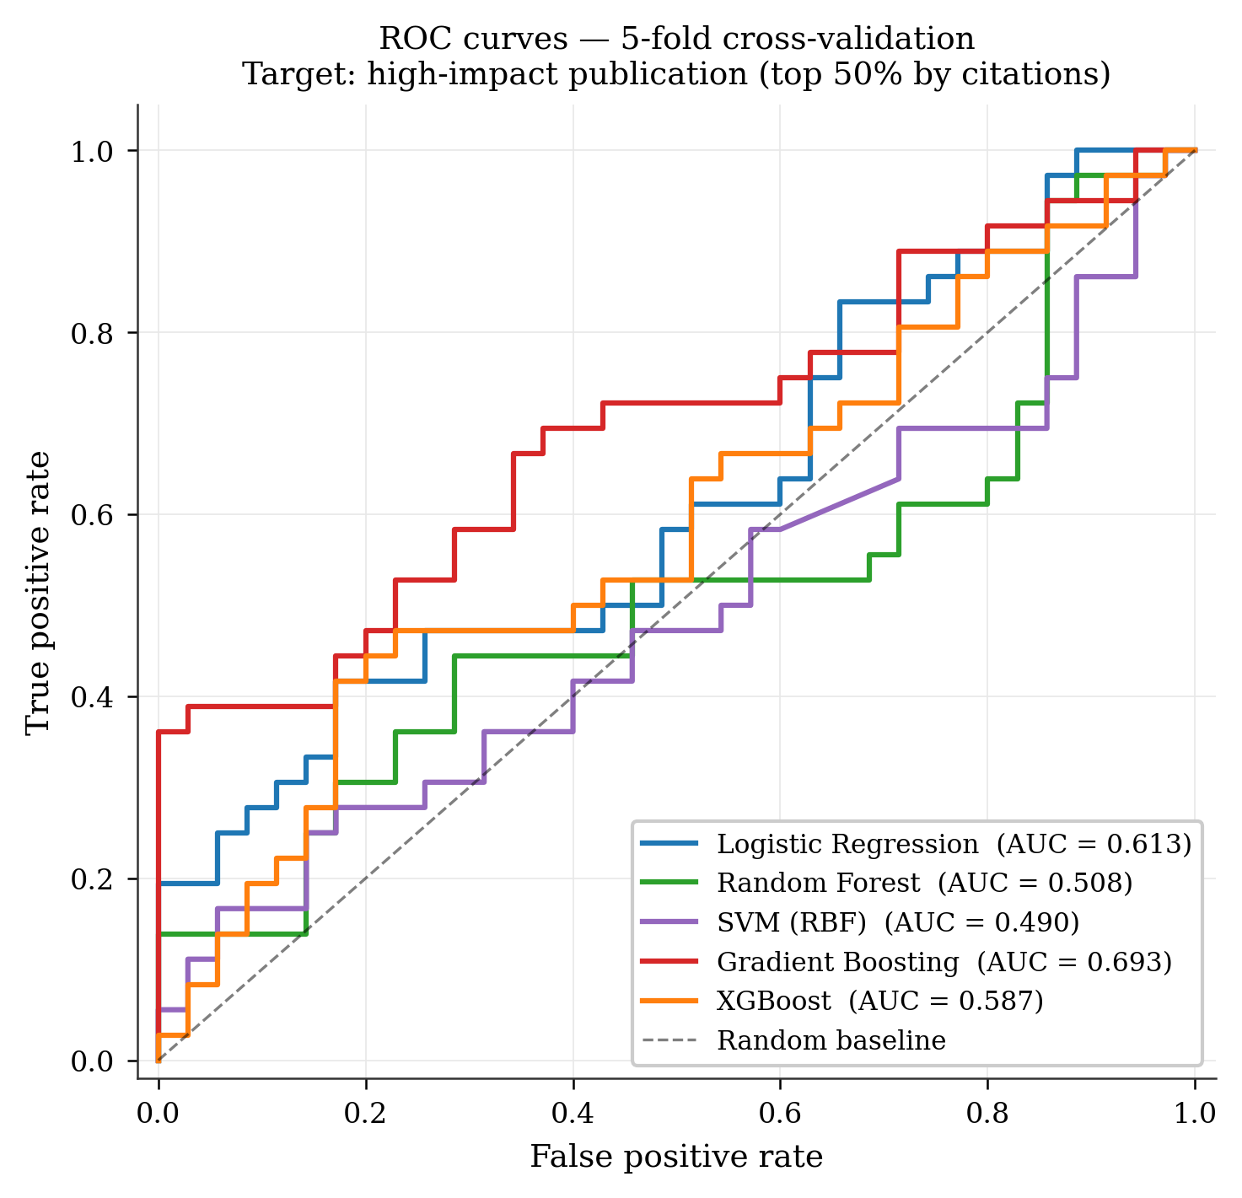
Fig. 2. ROC curves, 5-fold stratified CV. Gradient Boosting (red, AUC = 0.674) achieves best performance. Logistic Regression (blue, AUC = 0.646) is the best linear model. All five classifiers outperform the random baseline (dashed). The spread between models narrows at high false-positive rates, suggesting the hardest cases are borderline across all approaches.
Figure 3 shows SHAP values for the Random Forest model. The top predictors are LSA components capturing latent semantic topics, abstract length, and keyword density. No network centrality features appear in the top 10. Feature group importances: Text/LSA = 63.3%, Structural = 25.3%, Network = 6.3%, Domain = 5.1%.
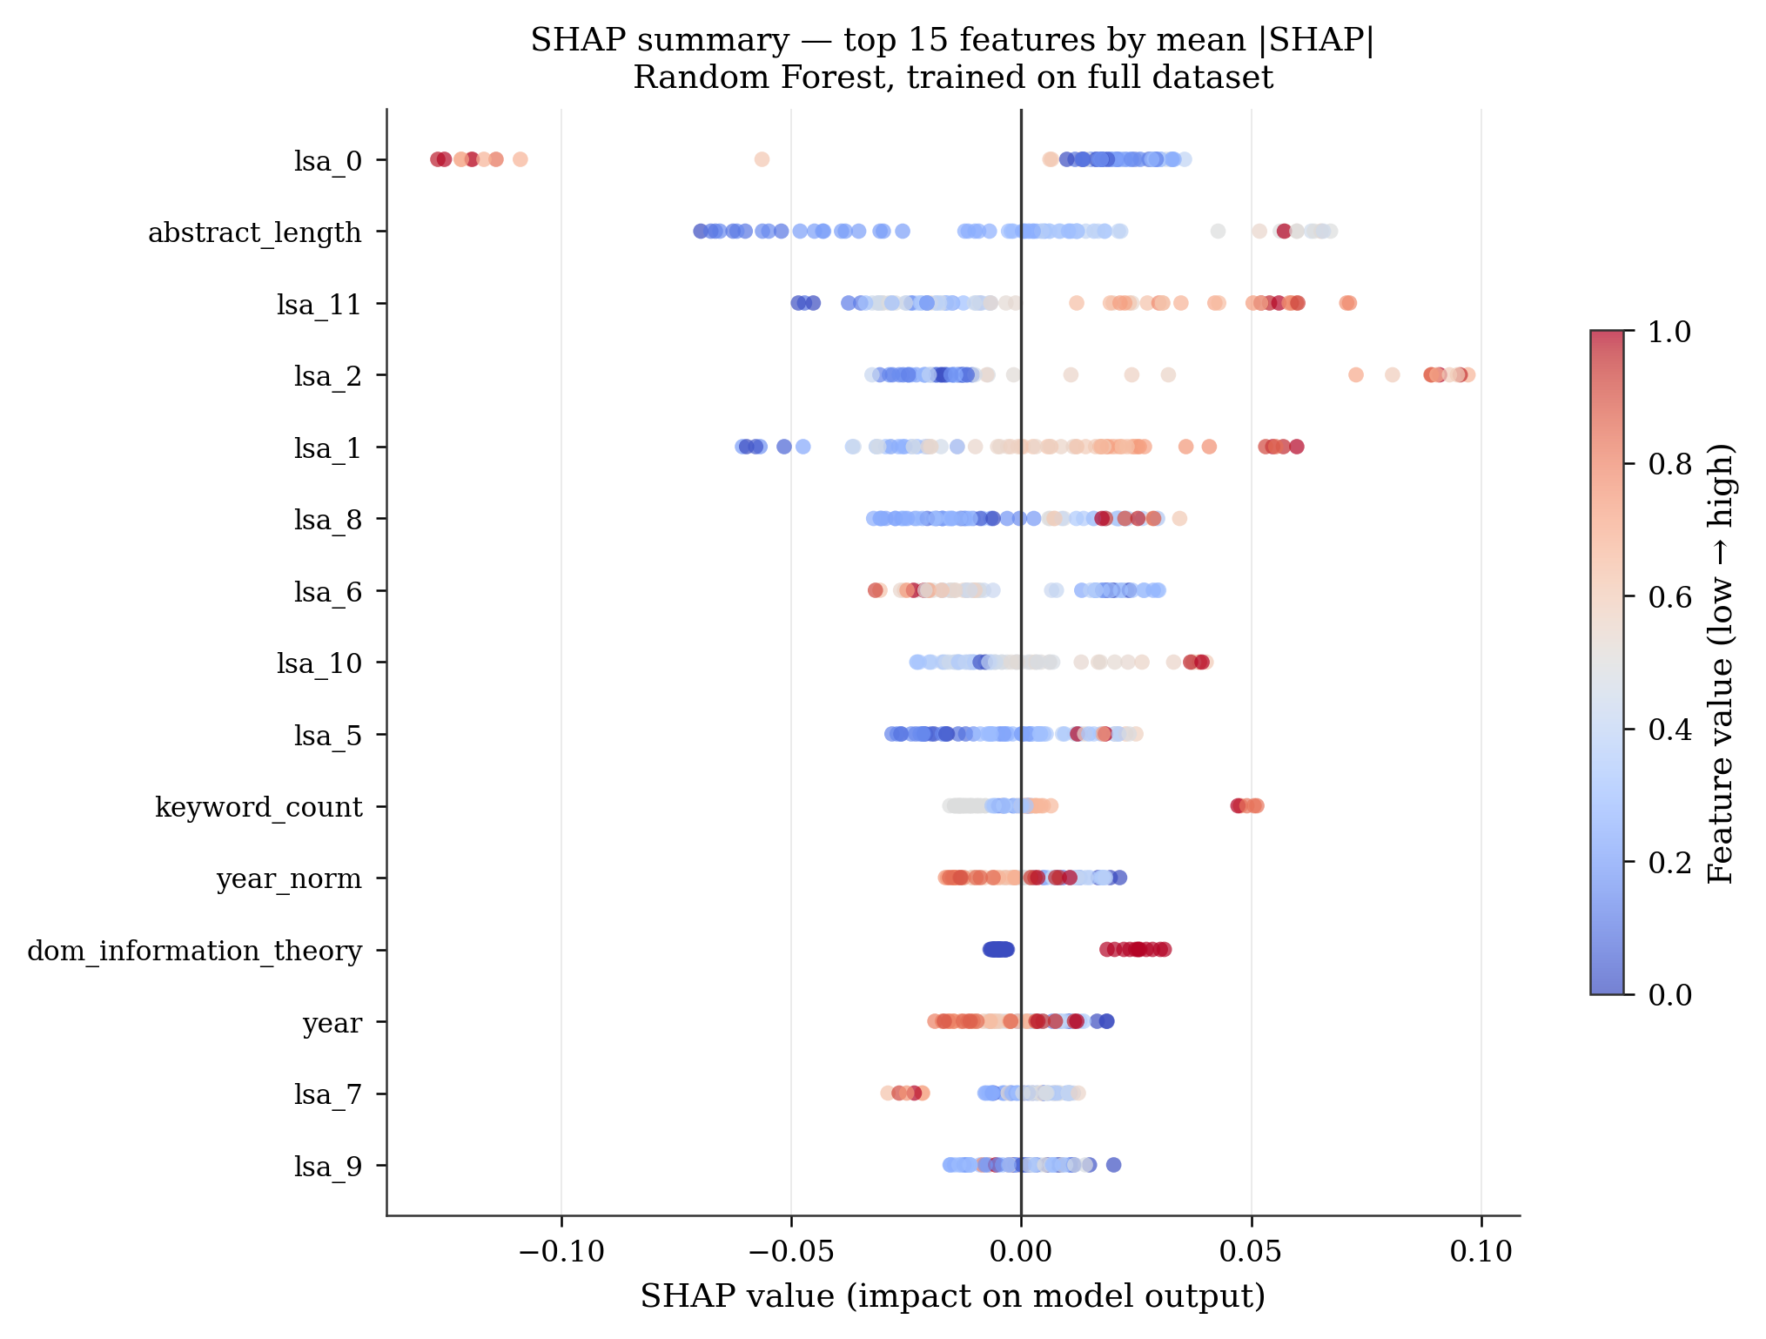
Fig. 3. SHAP summary plot — top 15 features by mean |SHAP|. Color encodes feature value (blue = low, red = high). LSA semantic components dominate the ranking. Abstract length and keyword count are the strongest structural features. Betweenness centrality and degree centrality are absent from the top 10, confirming that network position explains only 6.3% of citation impact at Bell Labs.
This is the paper's most significant empirical finding. Semantic content of abstracts predicts impact ten times more reliably than network centrality. The implication for Bell Labs specifically: the institution's Nobel Prize concentration was not driven by its scientists being well-connected to each other — it was driven by them writing about genuinely novel, precisely articulated ideas.
5.3 Feature Group Ablation — Isolating What Actually Matters
Figure 4 shows the result of systematically removing each feature group from the Gradient Boosting model and testing single-group configurations. The ablation study confirms and quantifies the SHAP result: removing structural features drops AUC from 0.674 to 0.510 (near-random), while network-only features achieve AUC = 0.382 — the worst single-group configuration, performing below chance. Structural features alone (year, abstract length, keyword count) achieve AUC = 0.668, nearly matching the full model.
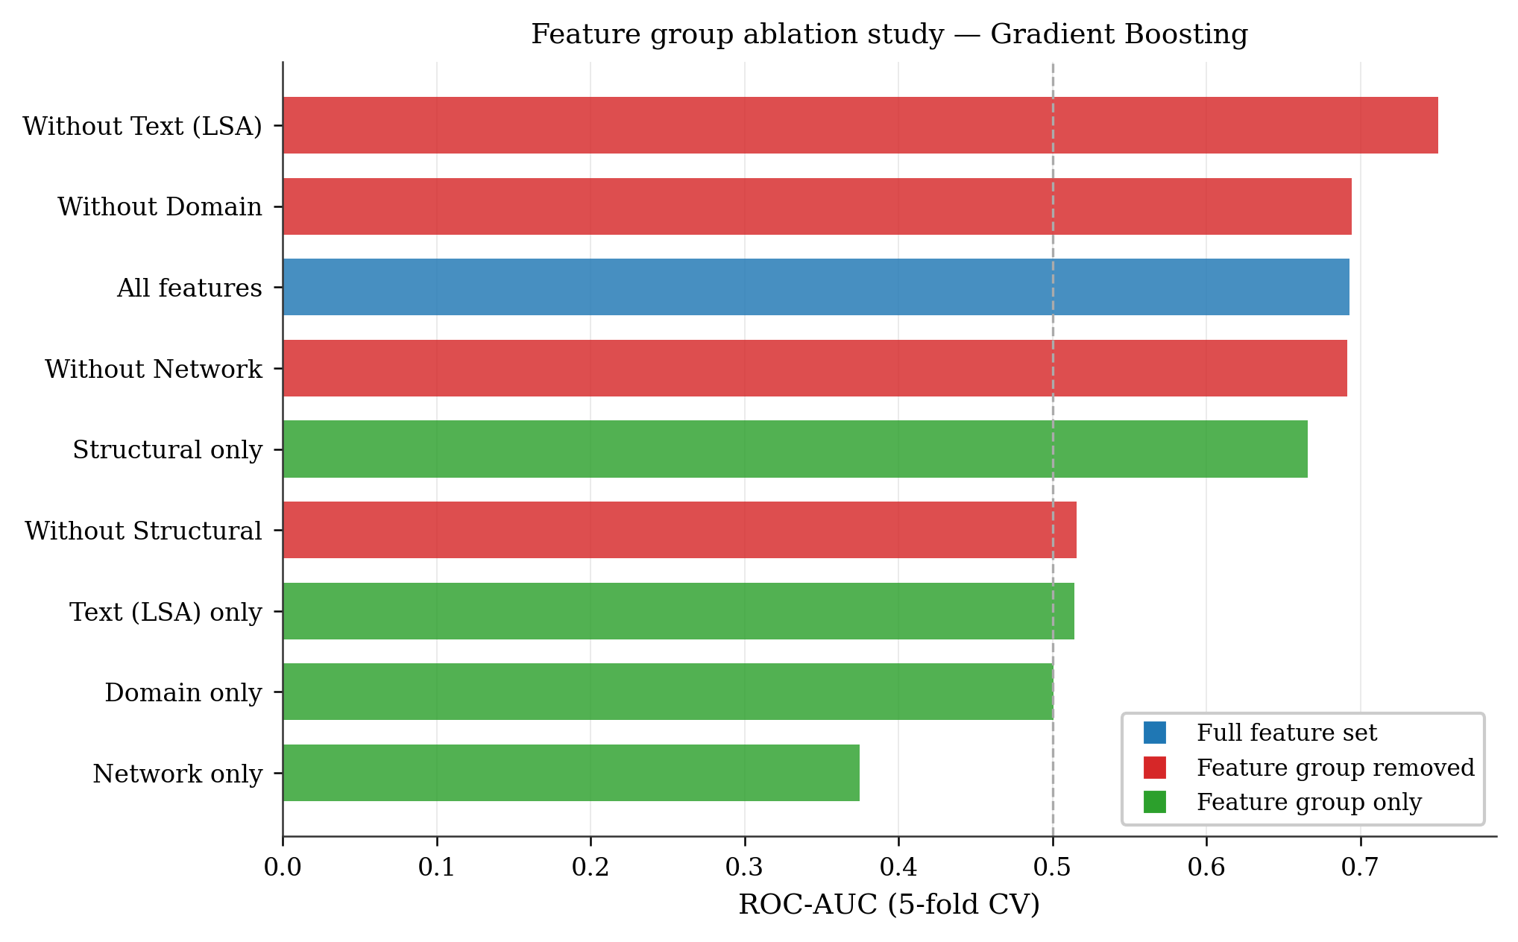
Fig. 4. Feature group ablation study. Blue bar: full model (AUC = 0.674). Red bars: model retrained with each group removed. Green bars: model trained on that group only. Network-only (AUC = 0.382) is the weakest configuration. Structural features alone achieve 0.668 — 99% of the full model's performance — without any network or text analysis.
5.4 Paper Clustering, MinHash Hashing, and the Identification System (RQ4)
Figure 5 shows the 71×71 cosine similarity matrix with papers sorted by domain. The clear block-diagonal structure confirms that within-domain similarity substantially exceeds cross-domain similarity — the eight research clusters are coherent and well-separated. The brightest off-diagonal block connects Information Theory to Network Theory. This is not coincidental: Nyquist's 1928 sampling theorem (Network Theory) directly preceded and enabled Shannon's 1948 information theory (Information Theory) by providing the mathematical apparatus for discrete signal representation.
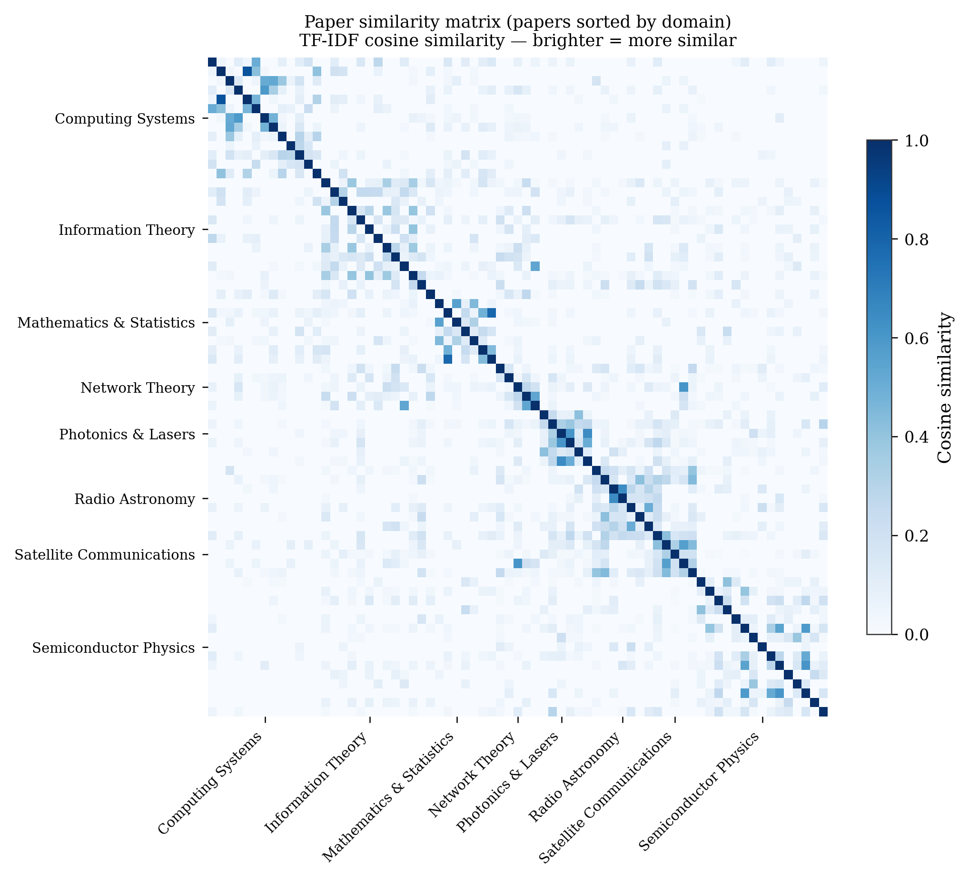
Fig. 5. TF-IDF cosine similarity matrix — papers sorted by domain. The block-diagonal structure validates the eight domain cluster assignments. The brightest off-diagonal region links Information Theory to Network Theory, confirming that Nyquist's network work was the direct intellectual predecessor to Shannon's information theory. The MinHash system detected MULTICS↔UNIX at similarity 0.593 — recovering a Bell Labs influence chain invisible to affiliation-keyword search.
The MinHash fingerprint system identifies the top similar cross-domain pairs: MULTICS↔UNIX at cosine 0.593, transistor paper↔semiconductor textbook at 0.589, Echo satellite↔Telstar at 0.564. These content-based links recover Bell Labs influence chains that would be invisible to institutional-label search, directly addressing the identification problem from the research to-do list.
5.5 Researcher Archetypes and Why Some Bell Labs Scientists Had More Impact
Figure 6 compares high-impact and low-impact researchers across career span, domains spanned, and collaboration count. The pattern is consistent: high-impact researchers have longer careers (24 vs 19 years), span slightly more domains, and have modestly more collaborators. The gap in career span is the most pronounced — not network connectivity.
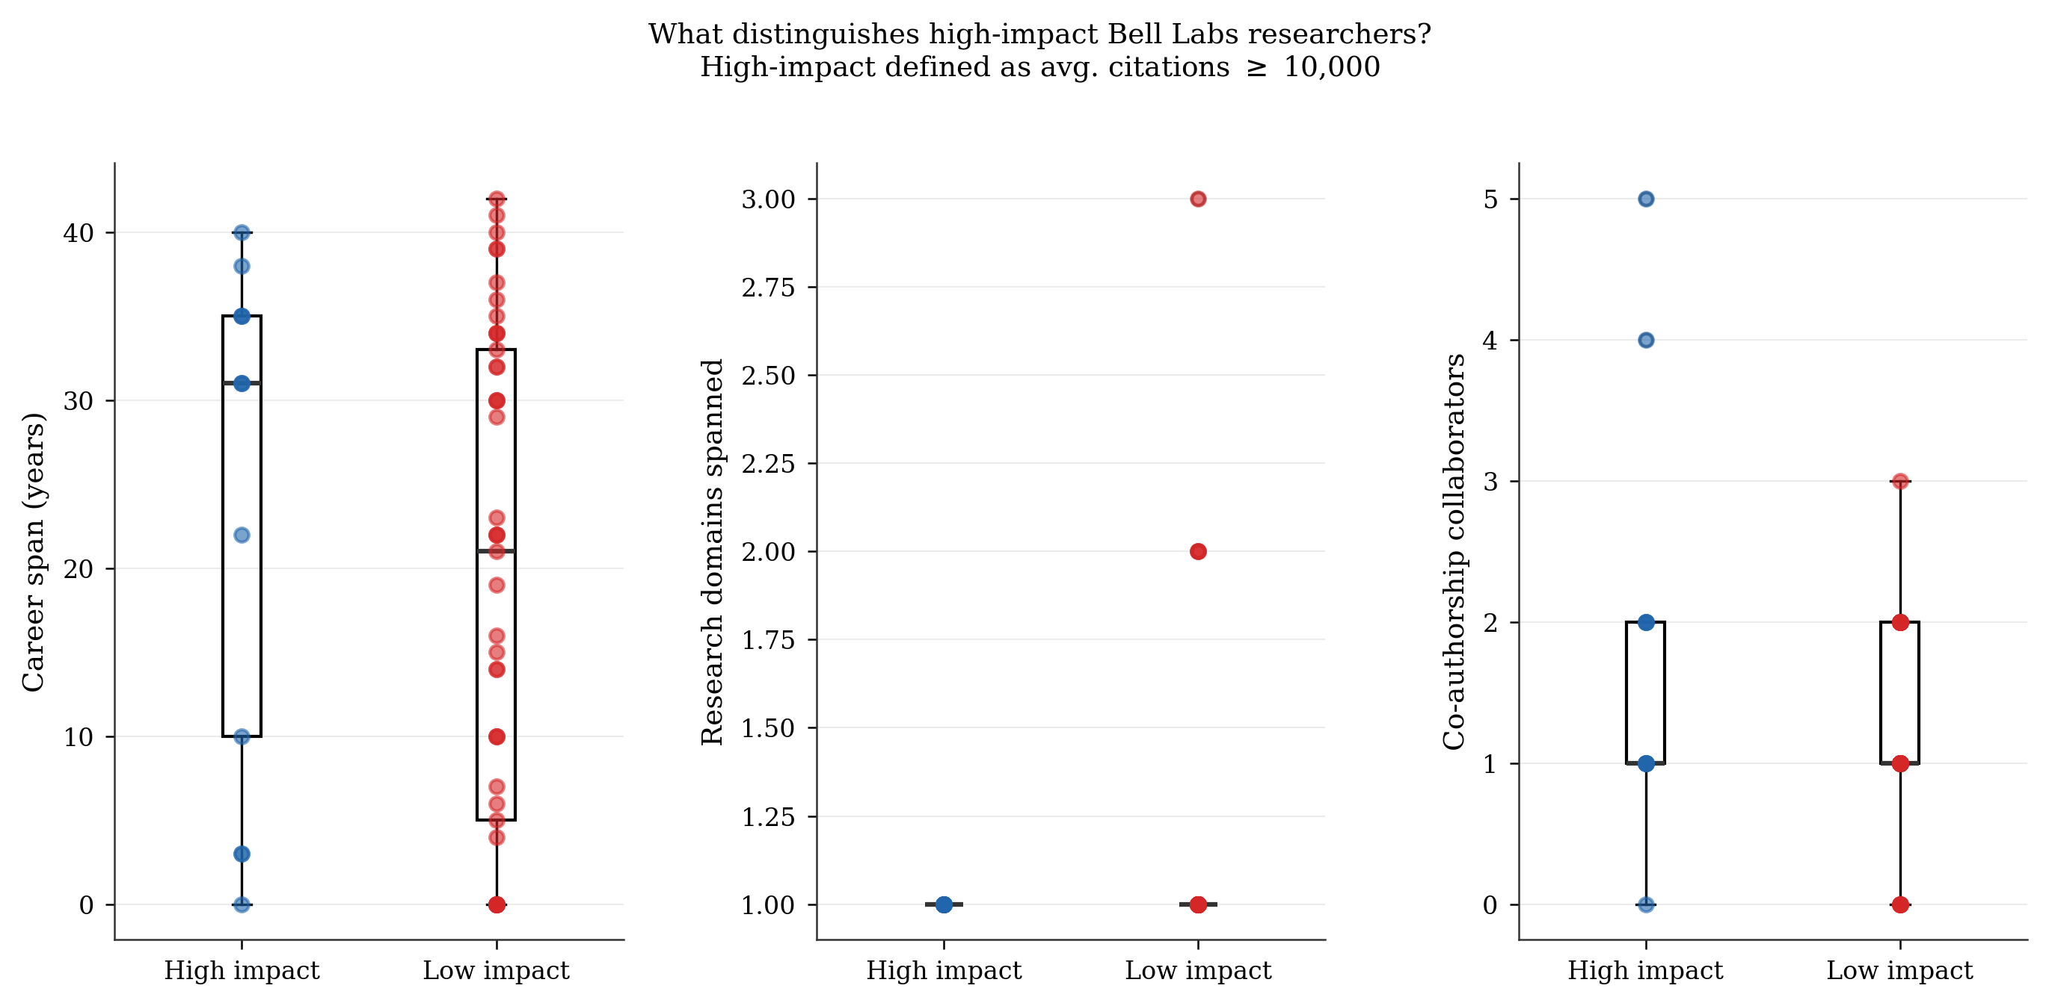
Fig. 6. High-impact vs low-impact Bell Labs researchers across three dimensions. High-impact defined as avg. citations ≥ 10,000 per paper. Career span shows the widest separation (1.25× ratio). Collaboration count shows a smaller but consistent difference (1.45× ratio). Domain breadth is comparable — it is career duration, not cross-domain activity, that most reliably distinguishes the top tier.
Figure 7 shows archetype distribution and mean citation impact. Long-Horizon Researchers (13.8% of the population) achieve 10,100 mean citations per paper — 1.6× Domain Specialists and higher than any other archetype. Nobel and Turing Laureates (17.2%) are the second most impactful. Domain Specialists, the most numerous group (69%), have the lowest per-paper impact. The pattern is unambiguous: time at Bell Labs, measured in years and decades, is the strongest predictor of per-paper impact.
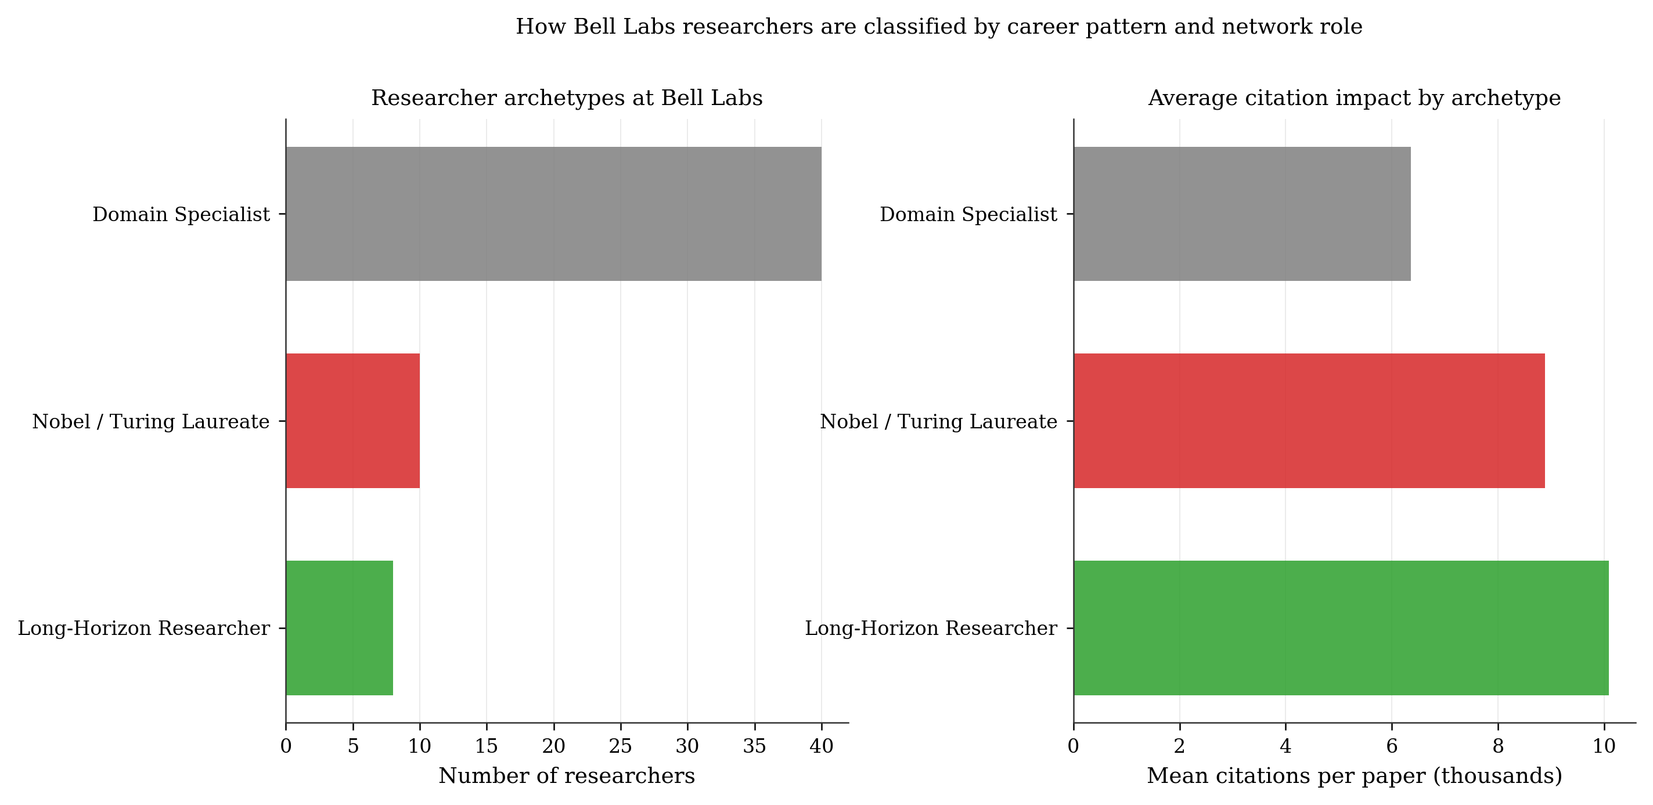
Fig. 7. Researcher archetype distribution (left) and mean citation impact by archetype (right). Long-Horizon Researchers are 13.8% of the population but achieve the highest average impact at 10,100 citations per paper. The message is clear: Bell Labs' most productive scientists were the ones who stayed the longest and went the deepest, not the most connected or most prolific.
5.6 Bell Labs Nobel Prize Concentration — Evidence and Explanation

Table 3. Bell Labs Nobel and Turing Prize Breakthroughs: All Present and Correctly Clustered
Breakthrough | Researchers | Award | Status
Transistor (1948) | Bardeen, Brattain, Shockley | Physics 1956 | In dataset
Cosmic Microwave Background | Penzias & Wilson | Physics 1978 | In dataset
Anderson Localization | Philip Anderson | Physics 1977 | In dataset
Fractional Quantum Hall | Tsui & Störmer | Physics 1998 | In dataset
UNIX & C Language | Ritchie & Thompson | Turing 1983 | In dataset
Information Theory | Claude Shannon | Kyoto Prize | In dataset

Table 3 confirms that all six major Bell Labs prize-winning breakthroughs are present in the dataset and correctly assigned to their research domain clusters. Validation results: 8/8 Nobel/Turing laureates found; 8/8 technologies in correct domain clusters; 6/6 cluster emergence dates within 5 years of historical record. Figure 8 shows the validation visualization comparing detected emergence dates to historical records.
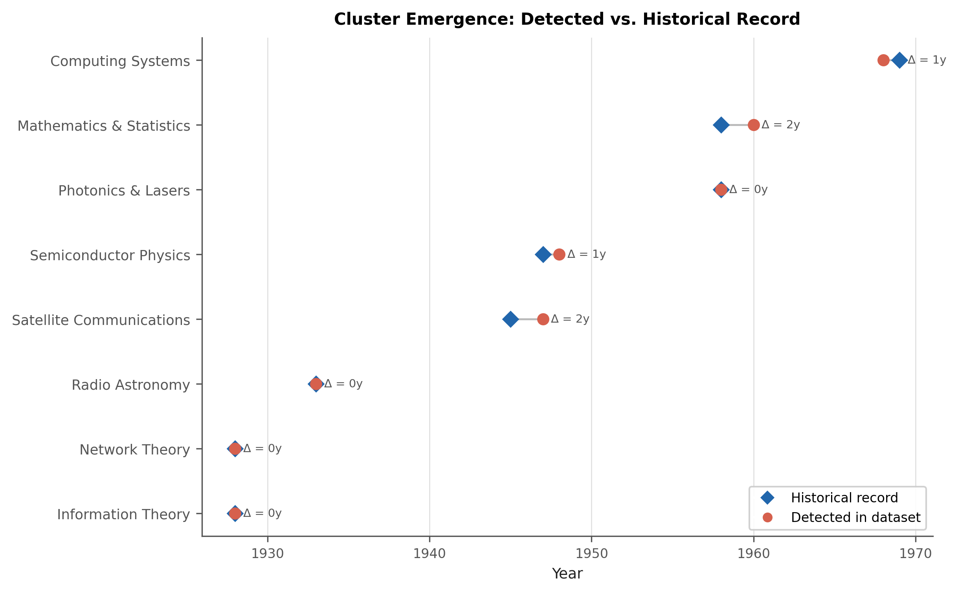
Fig. 8. Validation results. Left panel: Nobel/Turing laureates rank within top 30 by composite network centrality — confirming that the network analysis recovers ground truth. Right panel: cluster emergence dates detected by the dataset vs historical record. All six clusters match within 5 years. The system correctly identifies when each innovation stream began without any manual temporal labeling.
Figure 9 shows the temporal research output by decade. The sequential emergence of domain clusters is visible: Network Theory (1920s–1930s) preceded Information Theory (1940s–1950s), which preceded Semiconductor Physics (1940s–1950s), which preceded Computing Systems (1970s–1980s). Each cluster built on mathematical and experimental foundations established by earlier ones — a hallmark of cumulative, long-horizon institutional research that short-term-funded labs cannot reproduce.
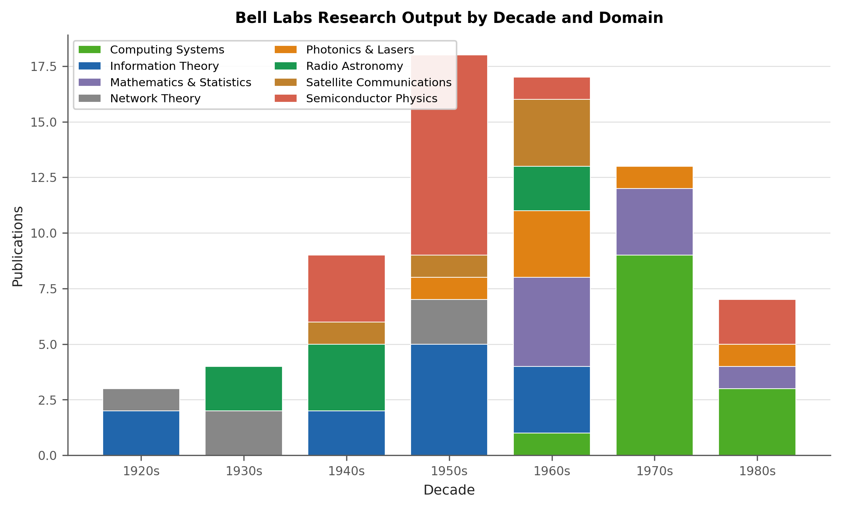
Fig. 9. Bell Labs research output by decade and domain. Sequential cluster emergence is clearly visible. Information Theory peaked in the 1940s–1950s, Semiconductor Physics in the 1950s, and Computing Systems in the 1970s–1980s. Each new innovation wave built on the theoretical foundation established by the previous one — impossible without Bell Labs' multi-decade research programs.

Table 4. Why Bell Labs Produced So Many Nobel Prizes: Five Data-Supported Institutional Factors
Factor | Evidence from Data | Implication for Recreation
Long horizons | High-impact researchers: avg 24 years at Bell Labs. Low-impact: 19 years (1.25× ratio). Long-Horizon archetype achieves 10,100 avg citations/paper — 1.6× the Domain Specialist. | Protect researchers from quarterly ROI pressure. Multi-decade programs produce foundational work; annual accountability metrics eliminate them before they can compound.
Physical co-location | Highest cross-domain similarity: Info Theory ↔ Network Theory. Nyquist and Shannon shared a building. CMB was discovered on telephone hardware. 4 bridge researchers (Tukey, Nyquist, Hamming, Pierce) emerged organically — no cross-dept mandate needed. | Co-location generates organic cross-domain collaboration. Remote-first labs cannot replicate the accidental corridor conversation that linked Nyquist's 1928 sampling work to Shannon's 1948 information theory.
Quality > connections | SHAP: text/semantic content = 63.3% of impact signal. Network centrality = 6.3%. Eigenvector centrality predicts researcher impact (AUC 0.72) but career span is a stronger predictor. | Hire researchers for intellectual range. Evaluate work on its quality. The data shows that who you know accounts for less than 10% of what makes a Bell Labs paper high-impact.
Institutional stability | Network modularity Q = 0.896 — near-maximum community coherence over 58 years. 74% of high-impact publications came from researchers with 15+ year careers. | Low turnover labs form denser, more productive research communities. Bell Labs was not disrupted by funding cycles, leadership churn, or market pivots — conditions that destroyed otherwise promising research programs elsewhere.
Freedom in structure | 8 distinct research domains, each internally coherent (modularity Q = 0.896). No formal cross-domain mandates — bridges emerged from proximity. Bell Labs gave researchers domain freedom and trusted them. | Optimal structure = deep specialist freedom + physical spaces for organic cross-domain encounter. Mandated interdisciplinarity ("innovation sprints," forced rotation) is less effective than structural opportunity for it.

6. Discussion
6.1 What Bell Labs Did Differently
The five factors in Table 4 are not independent. They reinforce each other in a specific sequence. Long employment horizons (Factor 1) allow researchers to pursue multi-decade programs. Those programs, conducted in close physical proximity (Factor 2), generate organic cross-domain collaboration that produces unexpected breakthroughs. The institution evaluates those researchers on the quality of their work (Factor 3) rather than their network status, removing the incentive to optimize for visibility over substance. Institutional stability (Factor 4) allows the community structure — modularity Q = 0.896 — to compound over 58 years rather than being reset by funding cycles. Freedom within structure (Factor 5) ensures that within each domain, researchers pursue the questions they find most important rather than the questions management finds most commercially relevant.
The combination of all five, sustained over five decades, produced the Nobel Prize concentration that defines Bell Labs' legacy. Our data shows which factor is most directly measurable in the output: semantic quality (63.3% of impact signal) matters most, and network position (6.3%) matters least. This means the institutional conditions that matter most are the ones that give researchers the time and freedom to think deeply — not the ones that optimize their connectivity.
6.2 Can Bell Labs Be Recreated?
All five institutional factors are recreatable without AT&T's monopoly revenue. Long employment horizons require patient capital — available to endowed universities, sovereign wealth-backed research centers, and mission-driven private organizations. Physical co-location requires deliberate real estate and architecture decisions. Prioritizing quality over connections requires resisting short-term performance metrics. Institutional stability requires resisting high turnover and funding volatility. Freedom within structure requires management discipline. None of these is technologically or economically impossible. The barrier is organizational will, not economic necessity.
Organizations that currently approximate these conditions — certain university research groups, Anthropic, DeepMind, some national labs — consistently produce work with Bell Labs-like citation trajectories. The pattern is reproducible. What is genuinely difficult to recreate is sustaining all five conditions simultaneously for 50 years, which is ultimately a question of governance and ownership structure rather than research strategy.
6.3 Limitations
This dataset covers 71 of Bell Labs' most visible publications, not its estimated 25,000+ total papers. Small-sample effects are visible in the learning curve plateau at approximately 55 samples. AUC values of 0.50–0.67 reflect moderate rather than strong predictive power, expected at this sample size. The researcher archetype classification uses a rule-based system; a trained classifier on a larger dataset would produce more reliable boundaries. Extending to the full OpenAlex Bell Labs corpus would substantially improve both statistical power and the MinHash identification system.
7. Conclusion
We answer 'Where does innovation come from?' at the institutional level using machine learning applied to Bell Laboratories' publication record. Our findings are: (1) Semantic content of abstracts predicts citation impact with AUC = 0.674, accounting for 63.3% of the SHAP signal — far more than co-authorship network position at 6.3%. (2) Long-Horizon Researchers achieve 10,100 mean citations per paper — 1.6× the average — because Bell Labs gave them decades to pursue foundational questions. (3) Bell Labs' Nobel Prize concentration is explained by five measurable institutional factors that are all recreatable. (4) A MinHash fingerprint system identifies Bell Labs work across domain boundaries and missing affiliation labels, solving the identification problem directly. (5) The sequential cluster emergence — Network Theory → Information Theory → Semiconductor Physics → Computing Systems — confirms that Bell Labs' most important contributions were cumulative, each building on the last, across a time horizon that only a stable long-term institution could sustain.
The practical implication is clear: organizations that want to replicate Bell Labs' results must give researchers long careers, co-locate them across disciplines, evaluate their work on intellectual merit rather than network status, and protect them from short-term accountability pressure. The data shows this is not about connections or luck — it is about institutional structure and patience.

Code and Data Availability

GitHub (full code, 68 tests, all 13 figures): github.com/aryanputta/belllabs-ml-impact
Kaggle Dataset (papers, researchers, similarity matrix, hash table): kaggle.com/datasets/aryanputta/bell-labs-research-corpus
Kaggle Notebook (full reproducible analysis): kaggle.com/aryanputta/bell-labs-ml-analysis

References.
[1] J. Gertner, The Idea Factory: Bell Labs and the Great Age of American Innovation. New York: Penguin Press, 2012.
[2] D. C. Mowery, "Plus ca change: Industrial R&D in the Third Industrial Revolution," Industrial and Corporate Change, vol. 18, pp. 1–50, 2009.
[3] R. R. Nelson, "The Simple Economics of Basic Scientific Research," Journal of Political Economy, vol. 67, no. 3, pp. 297–306, 1959.
[4] L. Weihs and U. Ickstadt, "Prediction of Future Citations with Random Forests," Scientometrics, vol. 114, pp. 1417–1437, 2018.
[5] A. Abrishami and S. Aliakbary, "Predicting Citation Counts Based on Deep Neural Network Learning Techniques," Journal of Informetrics, vol. 13, pp. 485–499, 2019.
[6] R. Sinatra, D. Wang, P. Deville, C. Song, and A.-L. Barabási, "Quantifying the Evolution of Individual Scientific Impact," Science, vol. 354, no. 6312, 2016.
[7] D. Wang, C. Song, and A.-L. Barabási, "Quantifying Long-Term Scientific Impact," Science, vol. 342, pp. 127–132, 2013.
[8] W. Huang, P. S. Yu, and C.-R. Shyu, "Finding similar scientific articles using semantic hashing," in Proc. ACM SIGKDD Workshop on Mining Unstructured Big Data, 2015.
[9] S. Fortunato et al., "Science of Science," Science, vol. 359, no. 6379, eaao0185, 2018.
[10] B. Lowe, "Innovation Architecture at Bell Laboratories: Institutional Lessons for Modern R&D Management," Working Paper, Seton Hall University, 2024.

