ARYAN RAJ 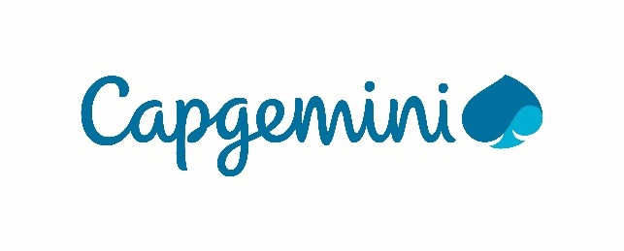
Professional Summary

Skills Profile
Technical
Operating System | Window, Linux, Unix
Environment | Informatica PowerCenter, Snowflake, Unix, IICS, SQL Developer.
Database | MYSQL
Internet Tools | Snowflake Data Warehouse
Languages | C++, Python
Other | Data Warehousing Concepts, ETL Concepts, Basic Unix, Concepts of Software Engineering.

Functional
Management and Leadership Skills | - Ensured clear communication, took initiative, and provided regular updates to maintain team coordination and transparency.  - Strategically organized and delegated tasks to ensure an even distribution of workload among team members.  - Led time-sensitive projects efficiently, ensuring all deliverables were completed punctually and upheld high standards of quality.
Training & Development | - Demonstrated a solid grasp of data warehousing principles and successfully applied transformation steps in real-time ETL processes.  - Collaborated effectively with team members to deliver project tasks using tools such as Informatica, Snowflake, Oracle Sql.  - Contributed to team development by sharing insights and best practices gained from training sessions.  - Partnered with colleagues to diagnose and resolve technical challenges encountered during project execution.

Professional Experience
RESTAURANT ANALYSIS  Role : Informatica Developer | July 2025
A data integration project focused on analyzing historical sales data from multiple restaurant outlets. The goal was to perform data cleaning and transformation on source data, build ETL workflows, and generate visual insights to support strategic business decisions.

- Informatica Cloud / PowerCenter – Conducted data cleaning and transformation, including handling missing values and resolving datatype inconsistencies (e.g., replacing string "null" in numeric fields with default values).
- ETL Workflow – Designed and implemented a star schema with dimension tables (Dim_Hotel, Dim_City, Dim_Speciality) and a central fact table (Fact_Hotel) to store transformed and structured data.
- Environment – Informatica Cloud/PowerCenter, Oracle Database, csv source file.

Summary of Projects

Sales Data Integration & Analysis Project – Restaurant Analysis (Informatica, Oracle SQL)
Led a data integration initiative to analyse historical sales data from various restaurants.
- Accessed and processed source data, performing data cleaning tasks such as handling missing values and resolving datatype mismatches to ensure data consistency.
- Designed and implemented a star schema with dimension tables (Dim_Hotel, Dim_City, Dim_Speciality) and a central fact table (Fact_Hotel) to support efficient reporting and analysis.
- Built ETL pipelines in Informatica to transform and load cleaned data into Oracle database, optimizing performance and data accuracy.
- Developed workflows to address specific business questions, such as identifying top voted restaurant in each city, number of hotel which has table booking, and analysing number of restaurant in each city.
- Tools- Informatica Cloud/PowerCenter, Snowflake, Oracle Sql.

Training and Seminars
Capgemini Training – A4 Analyst / Software Engineer
- Completed Analyst/A4 training covering Data Warehousing, ETL processes, Software Engineering, Basics Unix, Shell scripting and Oracle database.

- Worked on a team project during training, gained hands-on experience in Data Cleansing and building real-time data pipelines.

Education
Lakshmi Narain College of Technology Bhopal, Madhya Pradesh
Bachelor Of Technology(CSE), CGPA: 8.52 2021 – 2025

HIMALAYAN PUBLIC SCHOOL Patna, Bihar

HSC, 80.6% 2020

DAV PUBLIC SCHOOL Patna, Bihar

SSC, 84.2% 2018

