**Lab Assignment 5: Data Analysis**

Your task is to write a Python program that reads this CSV file, calculates the average score for each student, and then creates a new CSV file named "student_average_grades.csv”

* Steps to Solve
  1. Read the data from "student_grades.csv" using CSV file handling in Python.
  2. For each student, calculate their average score across all subjects (Maths, Science, and English).
  3. Create average functions to calculate the average for each student.
  4. Store the student's name and their corresponding average score in a new dictionary.
  5. Write the data from the dictionary into a new CSV file named

"student_average_grades.csv" with two columns: "Name" and "Average”.

Data Set –

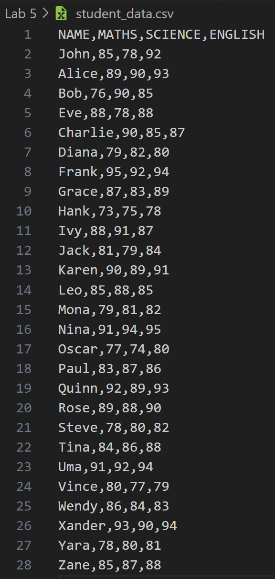

Code –

import csv

def read_student_data(input_file):

    """Reads student data from a CSV file and calculates average scores."""

    student_grade = {}

    with open(input_file, "r") as f:

        reader = csv.DictReader(f)

        for row in reader:

            name = row['NAME']

            math_score = int(row['MATHS'])

            science_score = int(row['SCIENCE'])

            english_score = int(row['ENGLISH'])

            avg_score = calculate_average(math_score, science_score, english_score)

            student_grade[name] = avg_score

    return student_grade

def calculate_average(math_score, science_score, english_score):

    """Calculates the average score of three subjects."""

    return round(((math_score + science_score + english_score) / 3), 2)

def write_student_averages(output_file, student_grade):

    """Writes the student names and their average scores to an output file."""

    with open(output_file, "w") as of:

        fieldnames = ['NAME', 'AVERAGE SCORE']

        writer = csv.DictWriter(of, fieldnames=fieldnames)

        writer.writeheader()

        for name, avg_score in student_grade.items():

            writer.writerow({"NAME": name, "AVERAGE SCORE": avg_score})

    print("Average score calculated for all students and stored in file.")

def main():

    input_file = "D:/5th Lab/Python/Lab 5/student_data.csv"

    output_file = "student_data_average.txt"

    # Read student data and calculate average scores

    student_grade = read_student_data(input_file)

    # Write the calculated averages to an output file

    write_student_averages(output_file, student_grade)

if __name__ == "__main__":

    main()

Output –



