**Lab Assignment 7: JSON Handling**

You are working as a data scientist for a healthcare organization, and your team has been tasked with analysing COVID-19 data from multiple countries. The data is stored in JSON files, with each file representing the daily COVID-19 statistics for a specific country. Each JSON file has the following structure:

{ "country": "Country Name",

"date": "YYYY-MM-DD",

"confirmed_cases": { "total": 1000, "new": 50 },

"deaths": { "total": 20, "new": 2 },

"recovered": { "total": 800, "new": 30 }

}

Your task is to write a Python program that performs the following operations:

1. Read COVID-19 data from all JSON files in a given directory and its subdirectories.
2. Calculate and display the following statistics for each country:
3. Total confirmed cases.
4. Total deaths.
5. Total recovered cases.
6. Total active cases (total confirmed cases minus total deaths and total recovered).
7. Determine the top 5 countries with the highest number of confirmed cases and the lowest number of confirmed cases.
8. Generate a summary report in JSON format that includes the statistics for all countries and save it to a file named "covid19_summary.json".

Data Set –

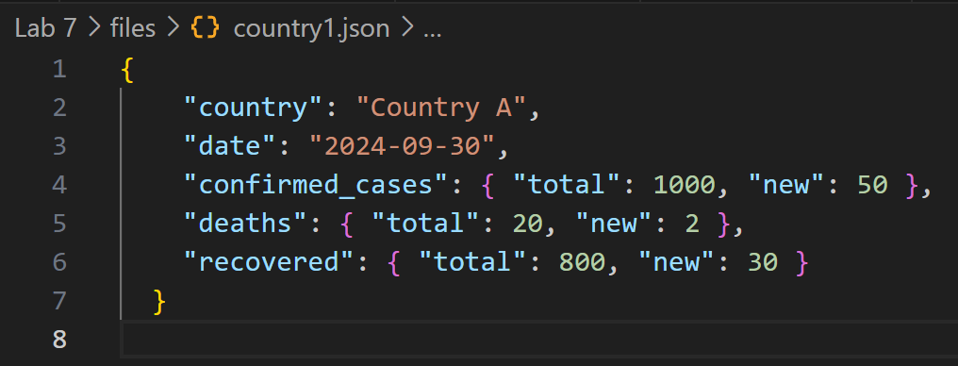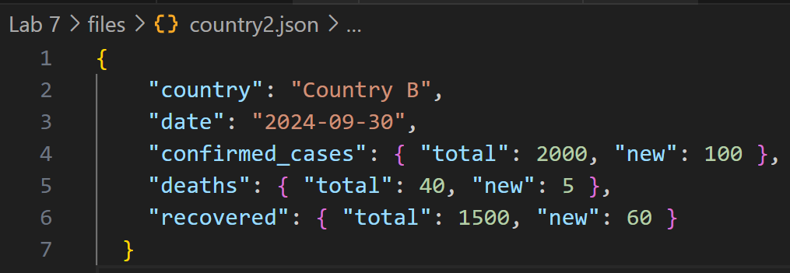

Code –

import os

import json

# Function to read all JSON files in a given directory and subdirectories

def read_json_files(directory):

    covid_data = []

    for root, _, files in os.walk(directory):

        for file in files:

            if file.endswith('.json'):

                file_path = os.path.join(root, file)

                with open(file_path, 'r') as f:

                    data = json.load(f)

                    covid_data.append(data)

    return covid_data

# Function to calculate statistics for each country

def calculate_statistics(covid_data):

    country_stats = {}

    for data in covid_data:

        country = data['country']

        if country not in country_stats:

            country_stats[country] = {

                'total_confirmed': 0,

                'total_deaths': 0,

                'total_recovered': 0,

                'total_active': 0

            }

        country_stats[country]['total_confirmed'] += data['confirmed_cases']['total']

        country_stats[country]['total_deaths'] += data['deaths']['total']

        country_stats[country]['total_recovered'] += data['recovered']['total']

        country_stats[country]['total_active'] = (

            country_stats[country]['total_confirmed'] -

            country_stats[country]['total_deaths'] -

            country_stats[country]['total_recovered']

        )

    return country_stats

# Function to determine top 5 countries with highest and lowest confirmed cases

def top_5_countries_by_confirmed_cases(country_stats):

    sorted_by_confirmed = sorted(country_stats.items(), key=lambda x: x[1]['total_confirmed'], reverse=True)

    highest_5 = sorted_by_confirmed[:5]

    lowest_5 = sorted_by_confirmed[-5:]

    return highest_5, lowest_5

# Function to generate summary report in JSON format

def generate_summary_report(country_stats, output_file):

    with open(output_file, 'w') as f:

        json.dump(country_stats, f, indent=4)

    print(f"Summary report saved to {output_file}")

def main():

    # Directory containing the JSON files

    directory = 'D:/5th Lab/Python/Lab 7/files'

    # Step 1: Read JSON files

    covid_data = read_json_files(directory)

    # Step 2: Calculate statistics for each country

    country_stats = calculate_statistics(covid_data)

    # Display statistics

    for country, stats in country_stats.items():

        print(f"{country}:")

        print(f"  Total Confirmed Cases: {stats['total_confirmed']}")

        print(f"  Total Deaths: {stats['total_deaths']}")

        print(f"  Total Recovered: {stats['total_recovered']}")

        print(f"  Total Active Cases: {stats['total_active']}")

        print()

    # Step 3: Determine top 5 countries with highest and lowest confirmed cases

    highest_5, lowest_5 = top_5_countries_by_confirmed_cases(country_stats)

    print("Top 5 countries with highest confirmed cases:")

    for country, stats in highest_5:

        print(f"{country}: {stats['total_confirmed']} confirmed cases")

    print("\nTop 5 countries with lowest confirmed cases:")

    for country, stats in lowest_5:

        print(f"{country}: {stats['total_confirmed']} confirmed cases")

    # Step 4: Generate summary report in JSON format

    generate_summary_report(country_stats, "covid19_summary.json")

if __name__ == "__main__":

    main()

Output –

