Student Name: Aryan Yadav UID: 24BCF10079
Branch: AIT-CSE (FSD) Section/Group: 24AIT_KRG-G2
Semester: 4
Subject Name: Database Management System Subject Code: 24CSH-298

Experiment 10 – Design of Trigger for Automatic Primary Key Generation (Enterprise Application)
Experiment
Designing and implementing a database trigger that automatically generates and enforces unique primary key values during record insertion. This experiment demonstrates automation, data integrity, and elimination of manual errors in enterprise database systems.

Aim
To create and implement a database trigger that automatically generates a unique primary key for each record inserted into a table.

Objective
- To understand the concept and working of database triggers
- To implement automatic primary key generation using triggers
- To eliminate manual intervention in key assignment
- To ensure uniqueness and data integrity
- To apply trigger-based automation in enterprise systems

Software Requirements
Database Management System:
- Oracle Database Express Edition (Oracle XE) / PostgreSQL
Database Administration Tool:
- Oracle SQL Developer / pgAdmin

Problem Statement
In enterprise-level applications, manually assigning primary keys can lead to duplication and errors. To maintain data integrity and ensure uniqueness, a trigger-based mechanism is required that automatically generates a primary key before inserting records into a table.

Practical / Experiment Steps
- Create a table requiring automatic primary key generation
- Create a sequence to generate unique values
- Design a trigger that activates before insert
- Assign the next sequence value to the primary key
- Insert multiple records to test the trigger
- Verify uniqueness of generated keys

Procedure
- Open Oracle SQL Developer and connect to the database
- Create the required table
- Create a sequence for primary key generation
- Create a trigger using BEFORE INSERT event
- Compile the trigger successfully
- Insert records without specifying the primary key
- Display the table contents

Input / Output Details
Input
Table: employee (emp_id, name, salary)

Step-1: Create EMPLOYEE Table
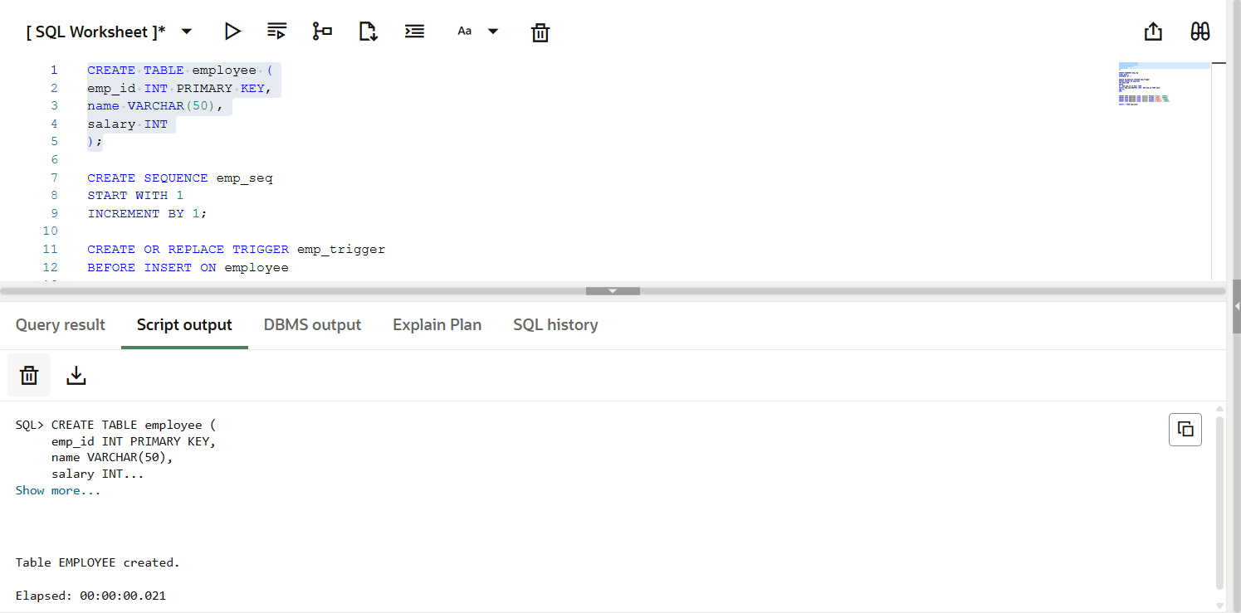
Step-2: Create Sequence emp_seq
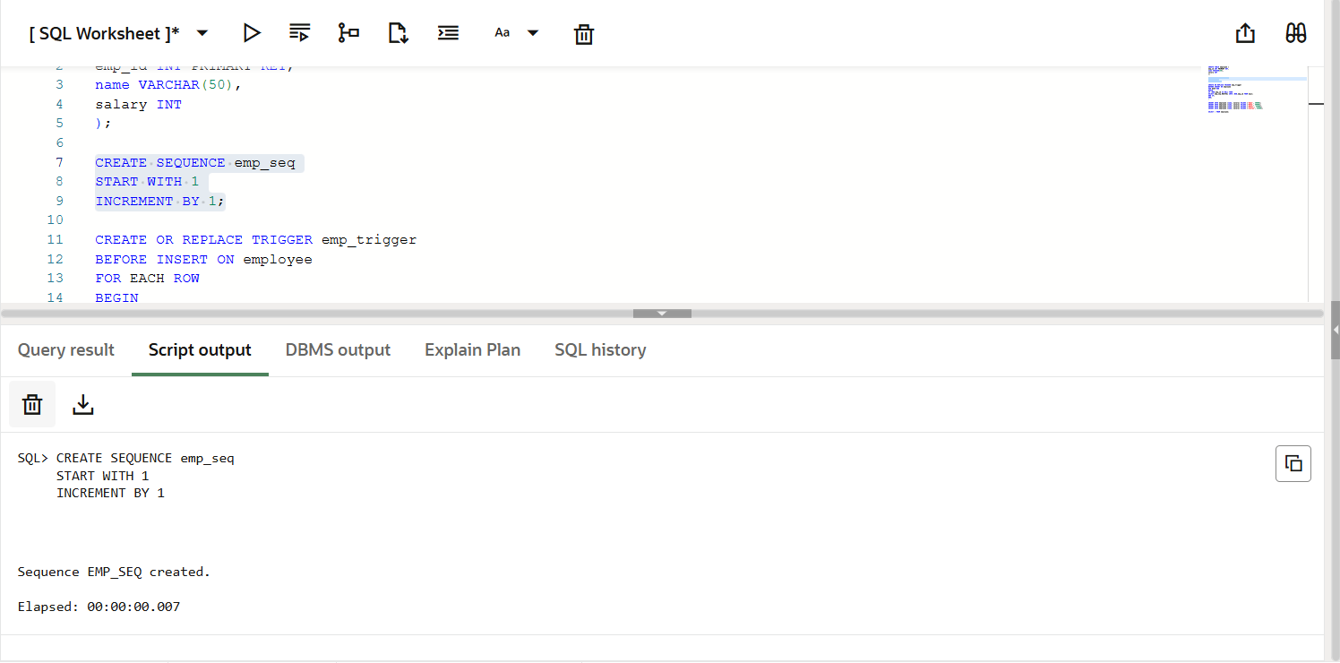
Step-3: Create Trigger emp_trigger
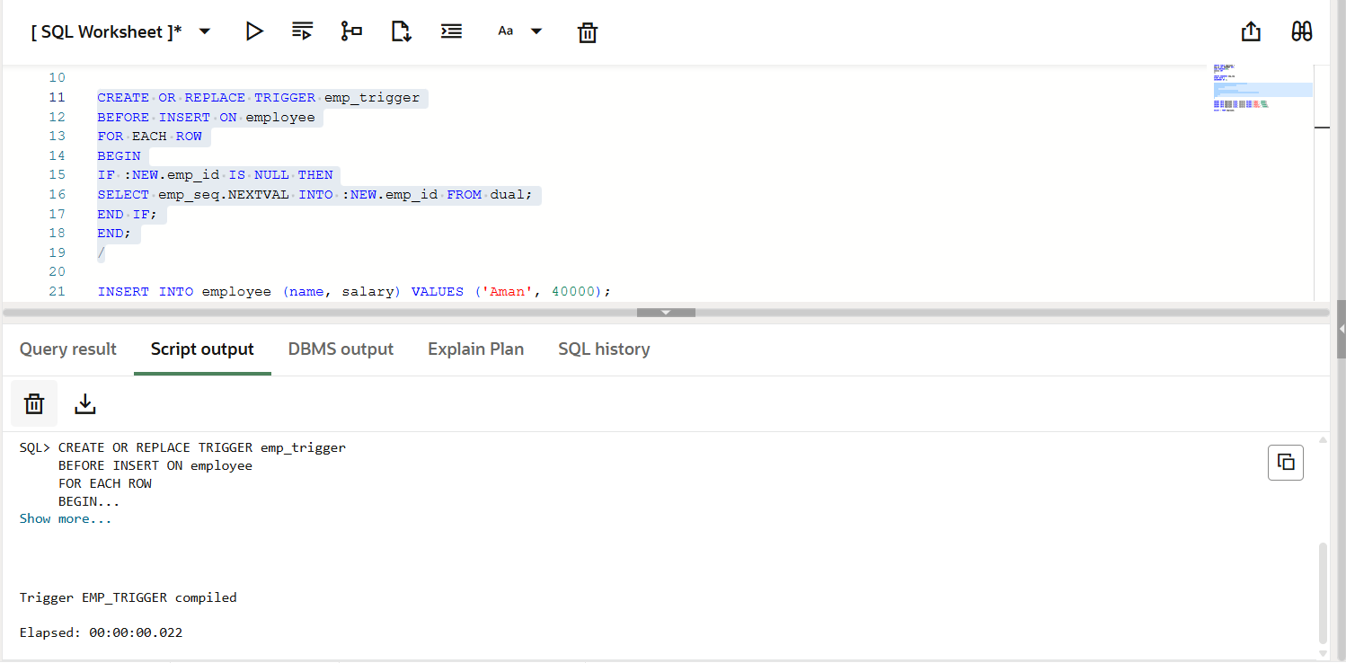
Step-4: Insert data into table
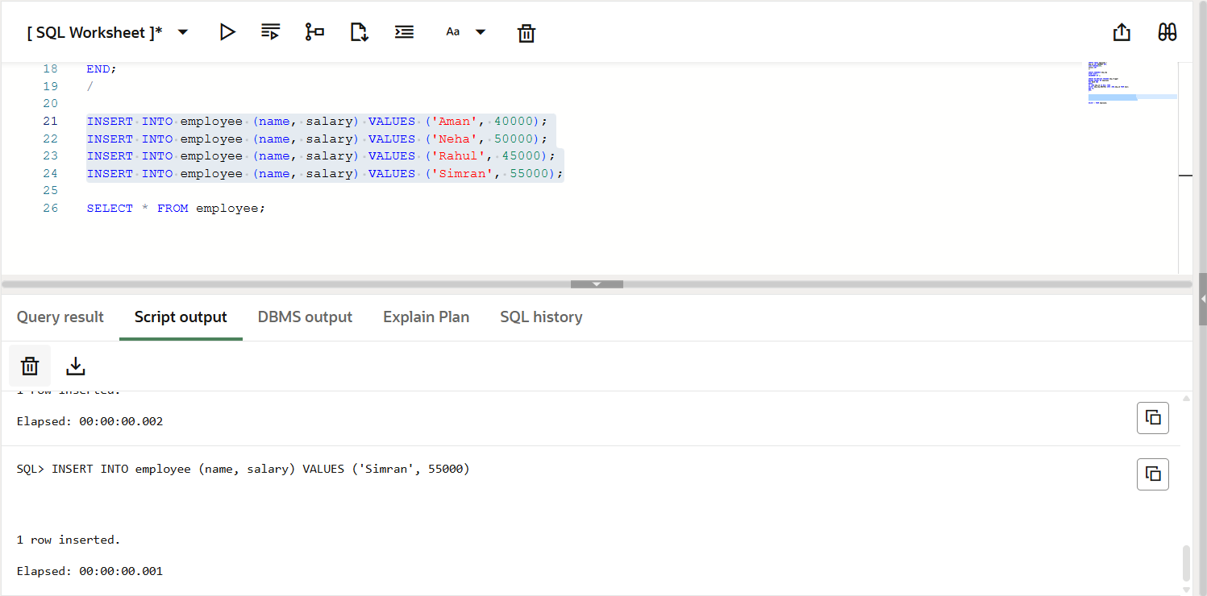

Step-5: Show table data
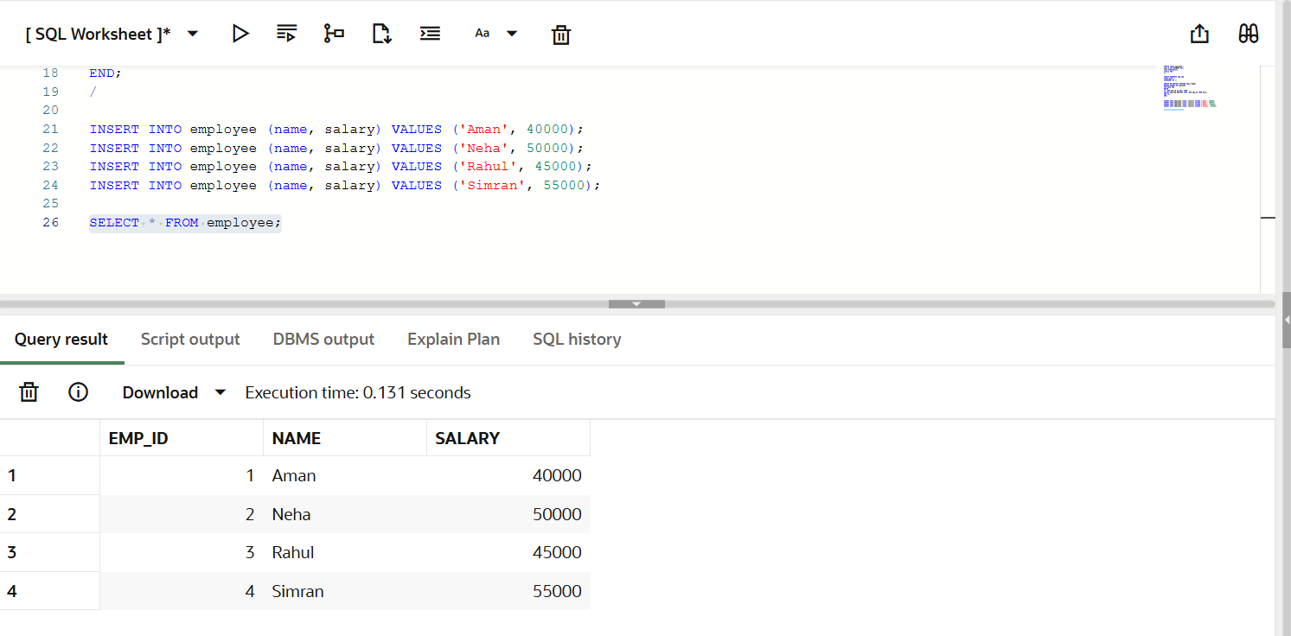

SQL Implementation Overview
- Table creation
- Sequence creation
- Trigger creation
- Data insertion
- Result verification

Output
After executing the program, each record is automatically assigned a unique primary key without manual input.
Example Output:
1 Aman 40000
2 Neha 50000
3 Rahul 45000
4 Simran 55000

Learning Outcome
After completing this experiment, the learner will be able to:
- Understand the working of database triggers
- Implement automatic primary key generation
- Ensure data integrity without manual intervention
- Apply trigger-based solutions in enterprise applications
- Develop efficient and reliable database systems

