Ques 1)Implement Static routing using 4 routers and 8 PC
Use IP From class A only 10.0.0.0
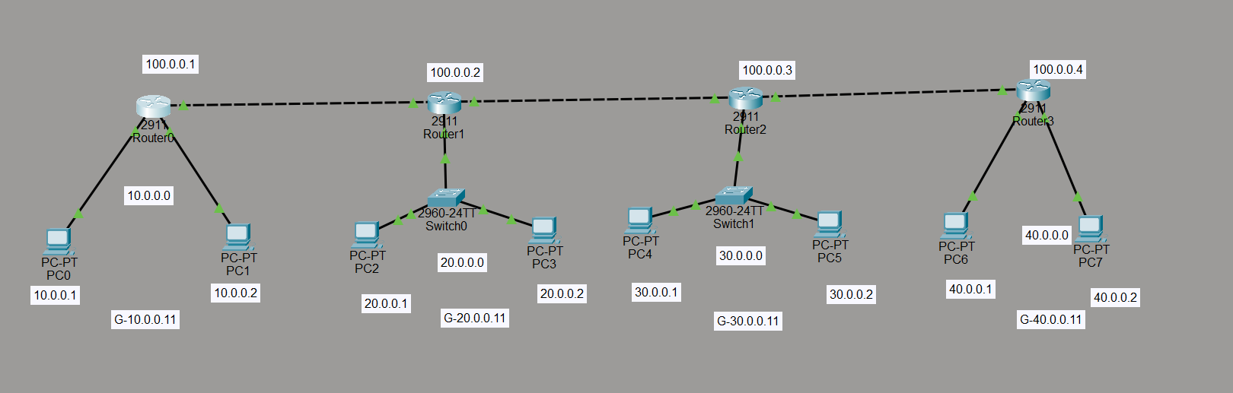
Steps: 1)Create a network with 8 pc’s, 4 routers and 2 switches
2) Connect each component of the network
3) Assign each pc its ip address and each router ip address in config tab
4) Assign gateway address to pc’s

Ques 2) Implement 3 vlans named HR, ADMIN, FINANCE AND VLAN Trunking using one switch and 6PC’S
Assign: Fa0/1 and 0/2 to HR, 0/3 and 0/4 to ADMIN, 0/5 and 0/6 to FINANCE