

**VIVEKANANDA INSTITUTE OF PROFESSIONAL STUDIES - TECHNICAL CAMPUS**

**Grade A++ Accredited Institution by NAAC**

NBA Accredited for MCA Programme; Recognized under Section 2(f) by UGC;

Affiliated to GGSIP University, Delhi; Recognized by Bar Council of India and AICTE

An ISO 9001:2015 Certified Institution

**SCHOOL OF ENGINEERING & TECHNOLOGY**

**BTECH Programme: AI&DS**

**Course Title: Mobile Application Development Lab**

**Course Code: OAE312P**

**Submitted To: Ms. Anjani**

**Submitted By:** Rohit Kumar Saxena

**Enrollment no.:** 03817711922

**VISION OF INSTITUTE**

To be an educational institute that empowers the field of engineering to build a sustainable future by providing quality education with innovative practices that supports people, planet and profit.

**MISSION OF INSTITUTE**

To groom the future engineers by providing value-based education and awakening students' curiosity, nurturing creativity and building  
capabilities to enable them to make significant contributions to the world.

**INDEX**

| **S.No** | **Experiment Name** | **Date** | **Marks** | | | **Remark** | **Updated Marks** | **Faculty Signature** |
| --- | --- | --- | --- | --- | --- | --- | --- | --- |
| **Laboratory Assessment (15 Marks)** | **Class Participation (5 Marks)** | **Viva (5 Marks)** |
|  |  |  |  |  |  |  |  |  |
|  |  |  |  |  |  |  |  |  |
|  |  |  |  |  |  |  |  |  |
|  |  |  |  |  |  |  |  |  |
|  |  |  |  |  |  |  |  |  |
|  |  |  |  |  |  |  |  |  |
|  |  |  |  |  |  |  |  |  |
|  |  |  |  |  |  |  |  |  |
|  |  |  |  |  |  |  |  |  |
|  |  |  |  |  |  |  |  |  |
|  |  |  |  |  |  |  |  |  |
|  |  |  |  |  |  |  |  |  |
|  |  |  |  |  |  |  |  |  |
|  |  |  |  |  |  |  |  |  |
|  |  |  |  |  |  |  |  |  |
|  |  |  |  |  |  |  |  |  |
|  |  |  |  |  |  |  |  |  |
|  |  |  |  |  |  |  |  |  |
|  |  |  |  |  |  |  |  |  |
|  |  |  |  |  |  |  |  |  |
|  |  |  |  |  |  |  |  |  |
|  |  |  |  |  |  |  |  |  |
|  |  |  |  |  |  |  |  |  |
|  |  |  |  |  |  |  |  |  |
|  |  |  |  |  |  |  |  |  |
|  |  |  |  |  |  |  |  |  |
|  |  |  |  |  |  |  |  |  |
|  |  |  |  |  |  |  |  |  |
|  |  |  |  |  |  |  |  |  |
|  |  |  |  |  |  |  |  |  |
|  |  |  |  |  |  |  |  |  |
|  |  |  |  |  |  |  |  |  |
|  |  |  |  |  |  |  |  |  |
|  |  |  |  |  |  |  |  |  |

# Experiment 1

## Aim: Study the frameworks of Mobile Application Development and design tools like sketch, adobe XD or flutter.

### Objectives:

* Gain the understanding of the frameworks of Mobile Application Development.
* Explore the tools used for designing, building, compiling and testing mobile applications.

### Theory:

#### Frameworks of Mobile Application Development

Mobile application development involves creating software applications that run on mobile devices, such as smartphones and tablets. Developers use various frameworks to streamline and simplify the development process by providing pre-built components, libraries, and tools. Frameworks play a critical role in ensuring efficient development, high performance, and seamless user experiences across different platforms.

##### Native Frameworks

Native frameworks are platform-specific and allow developers to create applications optimized for a particular operating system. Examples include **Swift** and **Objective-C** for iOS development, and **Kotlin** and **Java** for Android development. These frameworks provide complete access to platform-specific features and APIs, ensuring high performance and better integration with the device’s hardware and software. However, native development often requires maintaining separate codebases for different platforms, increasing development time and effort.

##### Cross-Platform Frameworks

Cross-platform frameworks enable developers to write a single codebase that can be deployed across multiple platforms, including iOS and Android. Popular cross-platform frameworks include **Flutter**, **React Native**, and **Xamarin**. These frameworks reduce development time and cost by eliminating the need for separate codebases. For example, Flutter, powered by Google, uses the Dart programming language and offers a rich set of pre-designed widgets for building visually appealing applications. React Native, backed by Facebook, allows developers to use JavaScript and reuse components between platforms, enhancing efficiency.

##### Hybrid Frameworks

Hybrid frameworks, such as **Ionic** and **Cordova**, combine the advantages of web and native technologies. Applications developed using hybrid frameworks are essentially web apps wrapped in a native container. They rely on web technologies like HTML, CSS, and JavaScript but can access device-specific features through plugins. While hybrid frameworks enable faster development, they may face performance limitations compared to native applications.

#### Design Tools for Mobile Application Development

Design tools are an integral part of mobile application development, enabling designers to conceptualize, prototype, and refine user interfaces and experiences. Tools like **Sketch**, **Adobe XD**, and **Flutter’s UI toolkit** have revolutionized the design process, making it more efficient and collaborative.

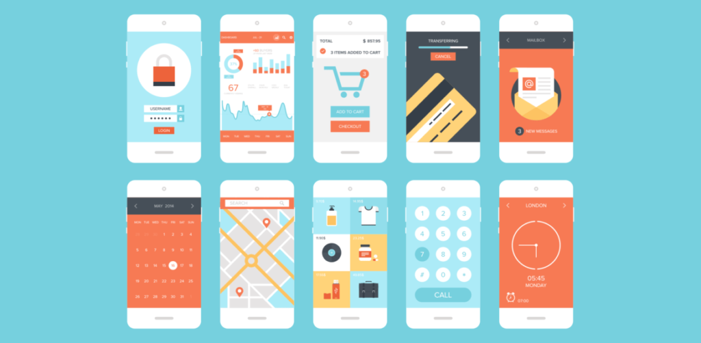

##### Sketch

Sketch is a vector-based design tool specifically tailored for UI and UX design. It allows designers to create wireframes, mockups, and high-fidelity prototypes. Sketch’s simplicity, combined with its robust plugin ecosystem, makes it a favorite among designers. Features like reusable symbols, shared libraries, and support for collaborative workflows enhance productivity. Additionally, Sketch integrates seamlessly with third-party tools, making it easier to transition from design to development.

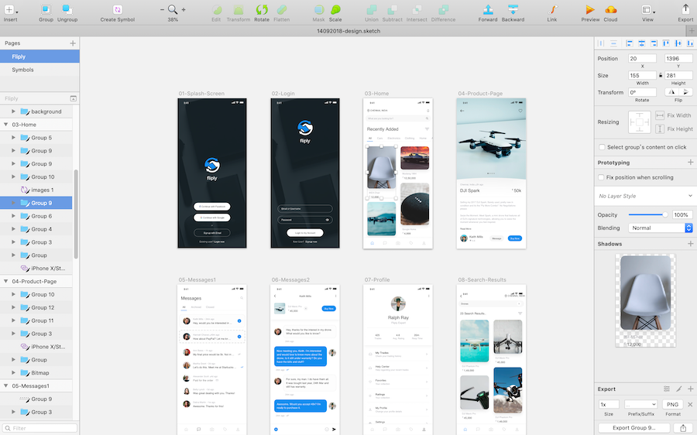

##### Adobe XD

Adobe XD is a powerful tool for designing and prototyping user experiences. It offers a wide range of features, including vector editing, responsive design capabilities, and interactive prototyping. Designers can create clickable prototypes to simulate user interactions and share them with stakeholders for feedback. Adobe XD’s integration with other Adobe Creative Cloud apps, such as Photoshop and Illustrator, allows for a cohesive design workflow. Its collaborative features enable multiple team members to work on a project simultaneously, streamlining the design process.

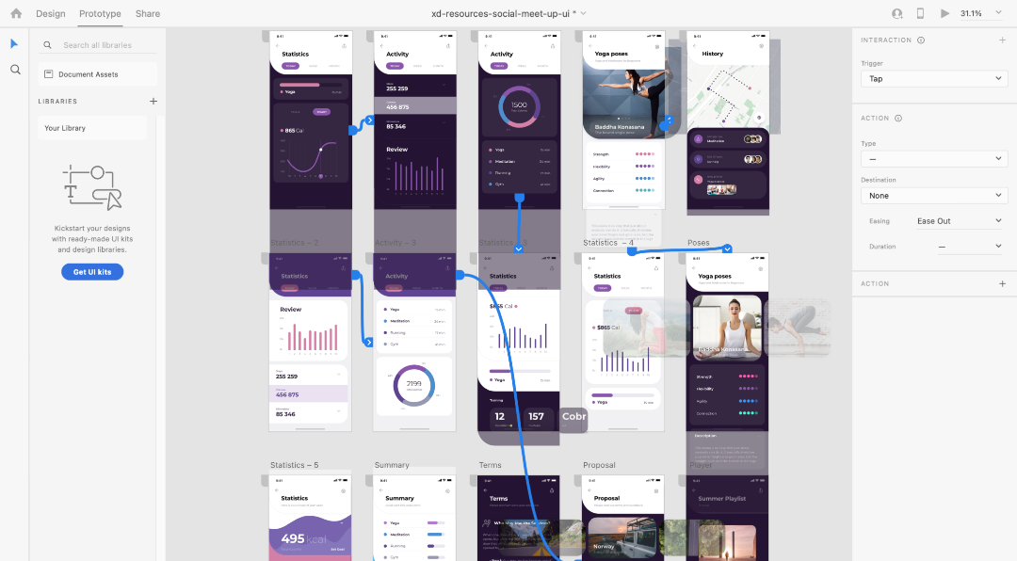

##### Flutter’s UI Toolkit

Flutter’s UI toolkit stands out as both a design and development tool. It allows developers to create visually rich and natively compiled applications from a single codebase. With Flutter, designers can use customizable widgets to build user interfaces that look and feel native. The toolkit’s "hot reload" feature enables real-time preview and testing of changes, reducing development cycles. Flutter’s emphasis on design consistency and pixel-perfect rendering ensures that the final product aligns with the designer’s vision.

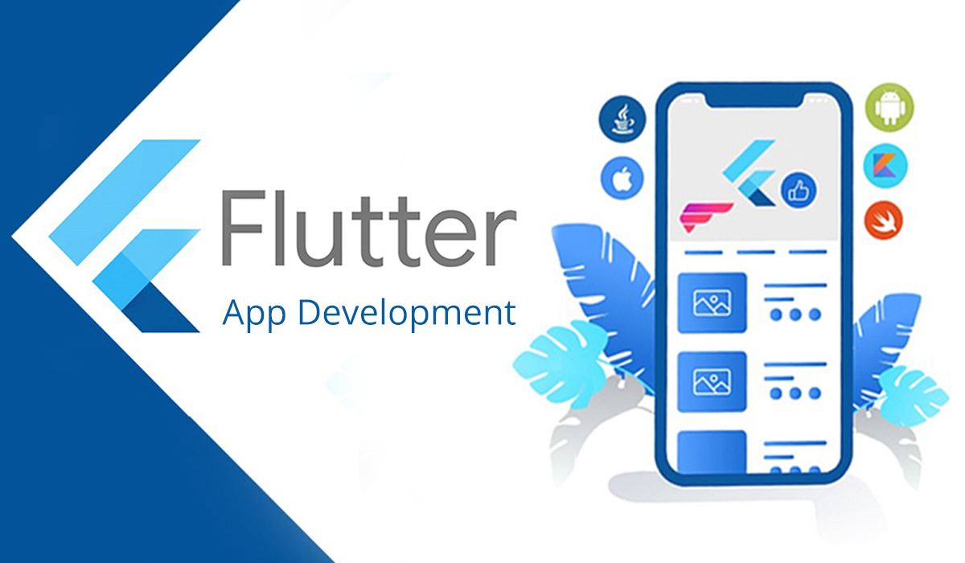

#### Conclusion

Frameworks and design tools are the backbone of modern mobile application development. Native, cross-platform, and hybrid frameworks provide developers with the flexibility to choose the best approach based on their project’s requirements. Meanwhile, design tools like Sketch, Adobe XD, and Flutter’s UI toolkit empower designers to create intuitive and engaging user experiences. By leveraging these tools and frameworks, developers and designers can collaborate effectively to deliver high-quality mobile applications that meet user needs and industry standards.

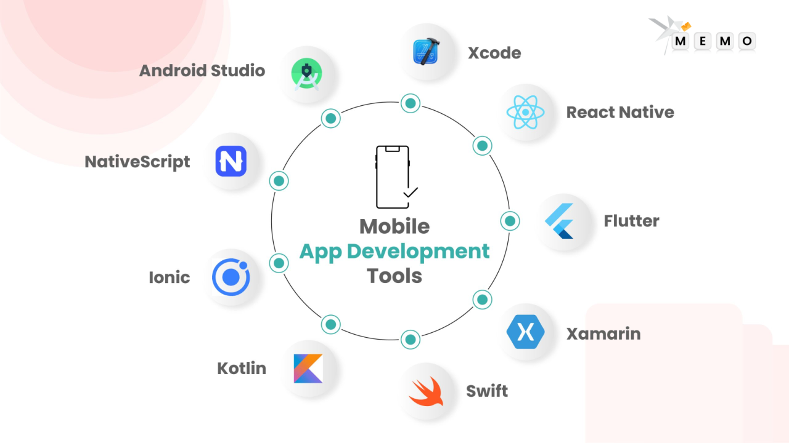

### Learning Outcomes:

|  |
| --- |
|  |
|  |
|  |
|  |
|  |

# Experiment 2

## Aim: Design a simple user interface for a mobile application using a design tool or framework like Sketch, Adobe XD, or Flutter.

### Objectives:

* Gain the understanding about User Interface and its significance.
* Gain knowledge of how to implement simple UI using any one framework.

### Theory:

#### **Introduction to UI Design**

User Interface (UI) design is a crucial aspect of mobile application development, focusing on creating visually appealing and user-friendly interfaces. A well-structured UI enhances user experience (UX) by ensuring intuitive navigation, responsiveness, and accessibility.

#### **Importance of UI in Mobile Applications**

A good UI design improves usability, making the application easy to interact with. It enhances user engagement, reduces learning curves, and contributes to the overall success of an application. Key factors such as color schemes, typography, and element placement play a significant role in shaping user perception.

#### **Principles of Effective UI Design**

Modern UI design follows several essential principles:

* **Consistency:** Maintaining uniform design elements across the application.
* **Simplicity:** Avoiding clutter and keeping interactions straightforward.
* **Responsiveness:** Ensuring compatibility across different screen sizes and devices.
* **Accessibility:** Designing for users with diverse needs, including those with disabilities.

#### **Role of UI Design Tools and Frameworks**

Various design tools and frameworks simplify the UI development process. Tools like **Adobe XD, Sketch, and Figma** help create wireframes and prototypes, while frameworks like **Flutter** provide ready-to-use UI components. **FlutLab.io**, a cloud-based Flutter IDE, allows developers to design, code, and preview mobile UIs in real time.

#### **Evaluating UI Effectiveness**

A UI is considered effective if it is **usable, visually appealing, and functionally efficient**. User feedback, usability testing, and performance analysis help refine the UI to meet user expectations.

#### **Conclusion**

A well-designed UI is fundamental to a successful mobile application. By following UI design principles and leveraging modern tools like **FlutLab.io**, developers can create applications that are both aesthetically pleasing and highly functional.

### Steps to Design a simple UI using FlutLab:

1. **Go to flutlab.io**

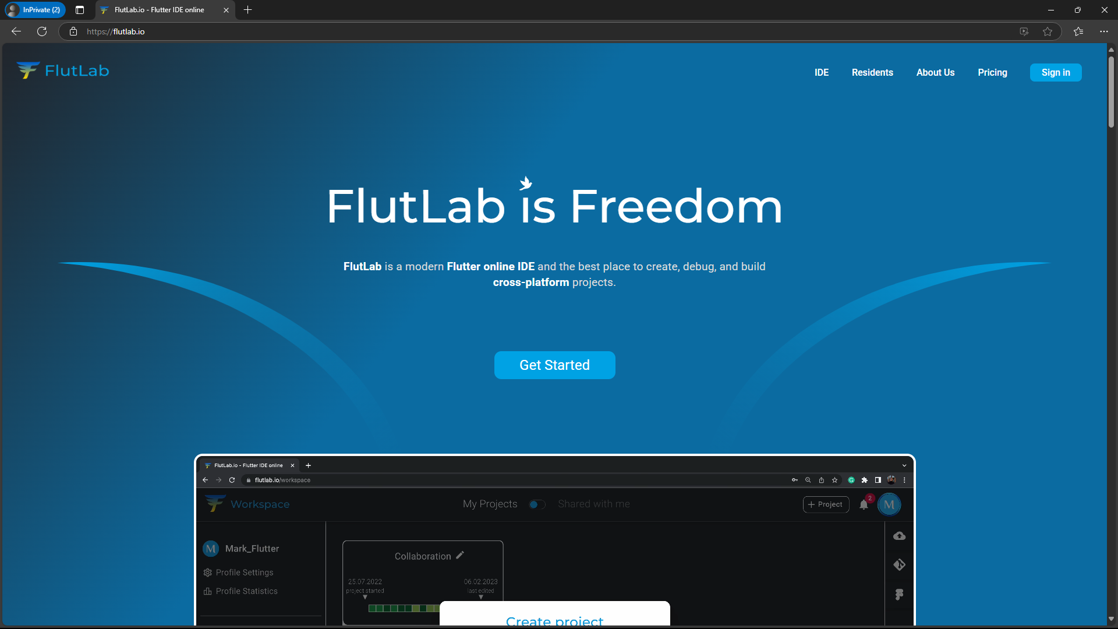

1. **Sign-In using your credentials or Create a new account.**

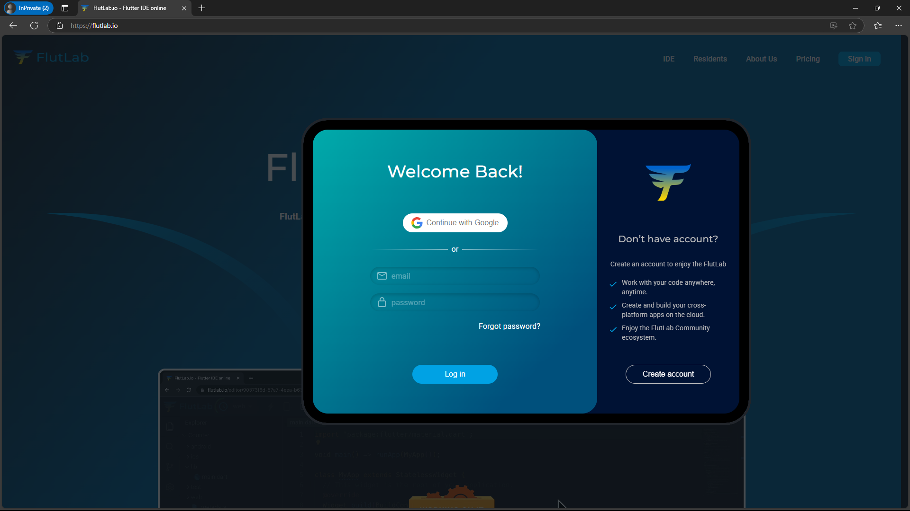

1. **Click on Create Project**

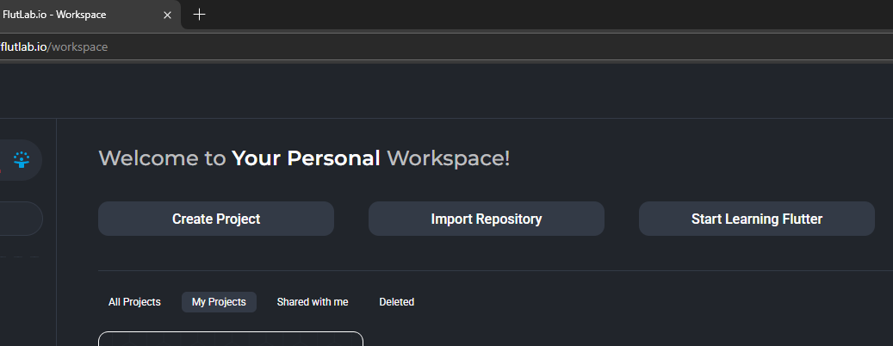

1. **Select ‘Hello World’**

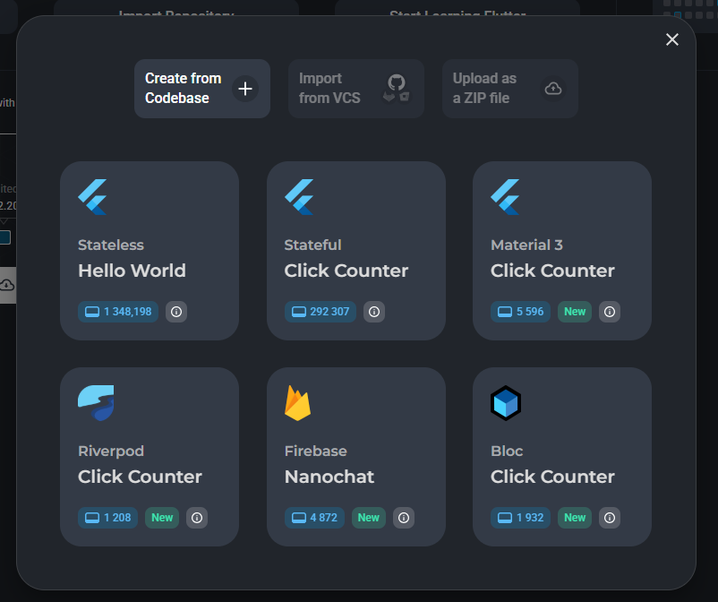

1. **Give a project Name**

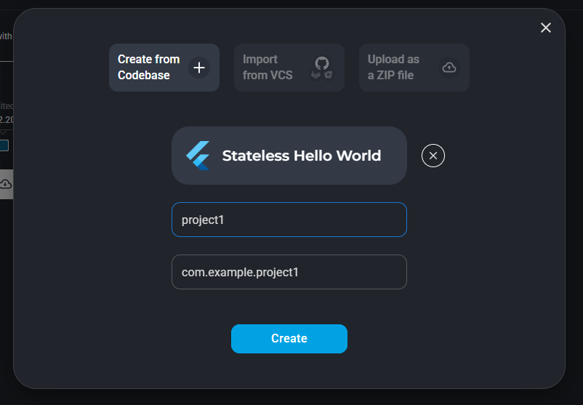

1. **Go to the project**

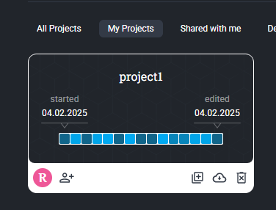

1. **Editor Window is Opened.**

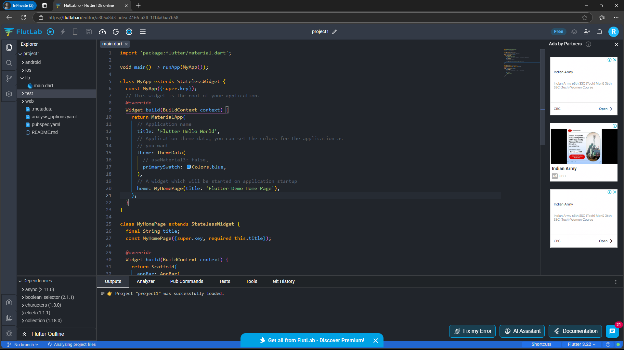

1. **Click on Build Project to Run the Provided Code**

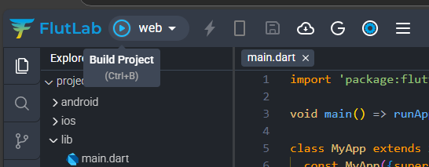

1. **Wait for the build to get complete.**

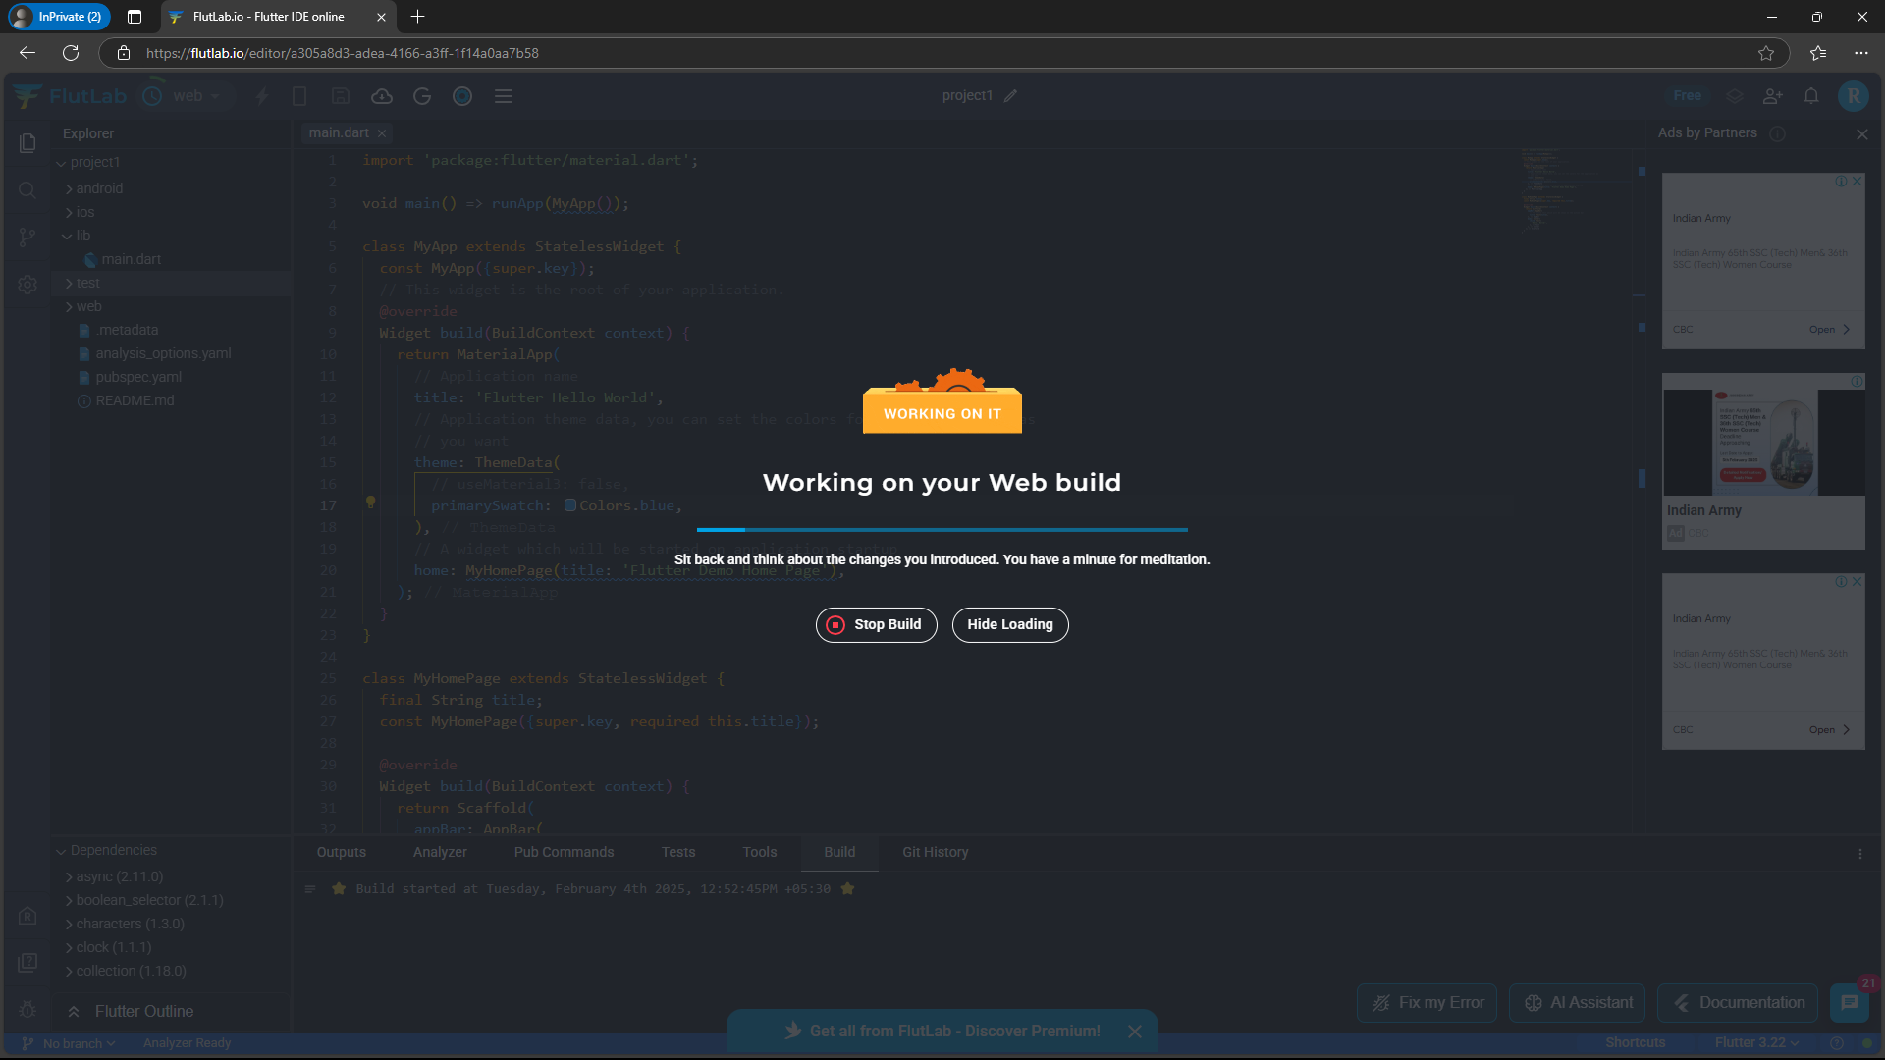

1. **Output Screen is Shown.**

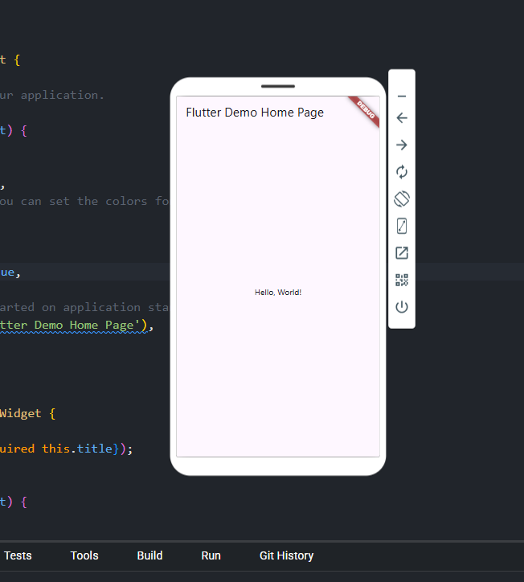

### Learning Outcomes:

|  |
| --- |
|  |
|  |
|  |
|  |
|  |

# Experiment 3

## Aim: Hello World Application: Create a basic "Hello World" application for a mobile platform of your choice (Android or iOS) using the respective development environment.

### Objectives:

* To Understand the basic development of Mobile Applications.
* To gain knowledge and practice of printing basic texts on a screen of mobile app.

### Theory:

#### Introduction to Mobile Application Development

Mobile application development is the process of creating software applications that run on mobile devices such as smartphones and tablets. These applications can be developed for different platforms, primarily Android and iOS, using platform-specific or cross-platform development environments. A "Hello World" application is a fundamental starting point in mobile app development, serving as an introductory exercise to understand the development workflow, tools, and programming languages involved.

#### Development Environments for Mobile Platforms

Different platforms require different development environments:

* **Android Development:** Uses Android Studio with the Kotlin or Java programming language.
* **iOS Development:** Uses Xcode with the Swift programming language.
* **Cross-Platform Development:** Tools like Flutter (Dart) or React Native (JavaScript/TypeScript) allow development for both Android and iOS using a single codebase.

#### Fundamental Concepts in a Mobile Application

A basic "Hello World" application introduces key concepts in mobile development:

* **User Interface (UI):** The app's visual representation, usually defined using XML (Android), SwiftUI (iOS), or Flutter widgets.
* **Activity/ViewController:** The main screen or component that controls UI interaction.
* **Rendering & Lifecycle:** Understanding how the app initializes and displays content on the screen.

Creating a "Hello World" application is the first step in mobile development, offering insight into essential tools, frameworks, and programming structures. Whether using Android Studio, Xcode, or cross-platform frameworks like Flutter, this experiment builds confidence in developing mobile applications and sets the foundation for advanced mobile programming concepts.

### Code:

import 'package:flutter/material.dart';

void main() => runApp(MyApp());

class MyApp extends StatelessWidget {

  const MyApp({super.key});

  // This widget is the root of your application.

  @override

  Widget build(BuildContext context) {

    return MaterialApp(

      // Application name

      title: 'Flutter Hello World',

      // Application theme data, you can set the colors for the application as

      // you want

      theme: ThemeData(

        // useMaterial3: false,

        primarySwatch: Colors.blue,

      ),

      // A widget which will be started on application startup

      home: MyHomePage(title: 'FlutLab'),

    );

  }

}

class MyHomePage extends StatelessWidget {

  final String title;

  const MyHomePage({super.key, required this.title});

  @override

  Widget build(BuildContext context) {

    return Scaffold(

      appBar: AppBar(

        // The title text which will be shown on the action bar

        title: Text(title),

      ),

      body: Center(

        child: Text(

          'Hello, World!',

        ),

      ),

    );

  }

}

### Output:

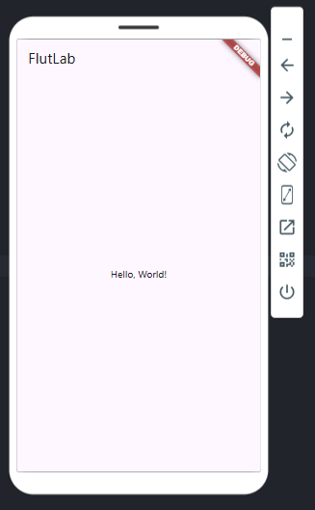

### Learning Outcomes:

|  |
| --- |
|  |
|  |
|  |
|  |
|  |

# Experiment 4

## Aim: Design a simple mobile user interface to add image on a mobile platform.

### Objectives:

* To understand the basic development of Mobile Applications.
* To gain knowledge and practice of displaying Images on a screen of mobile app.

### Theory:

**Introduction**

Flutter is an open-source UI software development framework by Google used for building natively compiled applications for mobile, web, and desktop from a single codebase. One of the fundamental tasks in Flutter application development is displaying images, which can be achieved using widgets like Image.asset() and Image.network().

**Objective**

The objective of this experiment is to understand the process of displaying an image in a Flutter application using both local assets and network sources. This experiment aims to familiarize developers with Flutter’s image handling mechanisms, asset management, and UI design considerations.

**Concept and Implementation**

Flutter provides the Image widget as a simple way to render images on the screen. There are two primary ways to load images:

1. **Loading from Assets**: Images stored in the project's asset directory are displayed using the Image.asset() constructor. The asset must be declared in the pubspec.yaml file before use.
2. **Loading from a Network**: External images can be fetched from the internet using Image.network() by providing a valid URL.

**Conclusion**

This experiment demonstrates the ease of displaying images in a Flutter application using the Image widget. Understanding how to manage assets and load images dynamically enhances the ability to create visually rich and interactive applications. Mastering these fundamental concepts is essential for building advanced Flutter applications with dynamic content.

### Code:

import 'package:flutter/material.dart';

void main() {

  runApp(MyApp());

}

class MyApp extends StatelessWidget {

  @override

  Widget build(BuildContext context) {

    return MaterialApp(

      home: Scaffold(

        body: Center(

          child: Column(

            children: [

              Image.asset('assets/image.jpg', height: 500, width: 500),

              SizedBox(height: 40, width: 100),

              Text(

                'Image 1',

                style: TextStyle(fontSize: 40),

              ),

            ],

          ),

        ),

      ),

    );

  }

}

### Output:

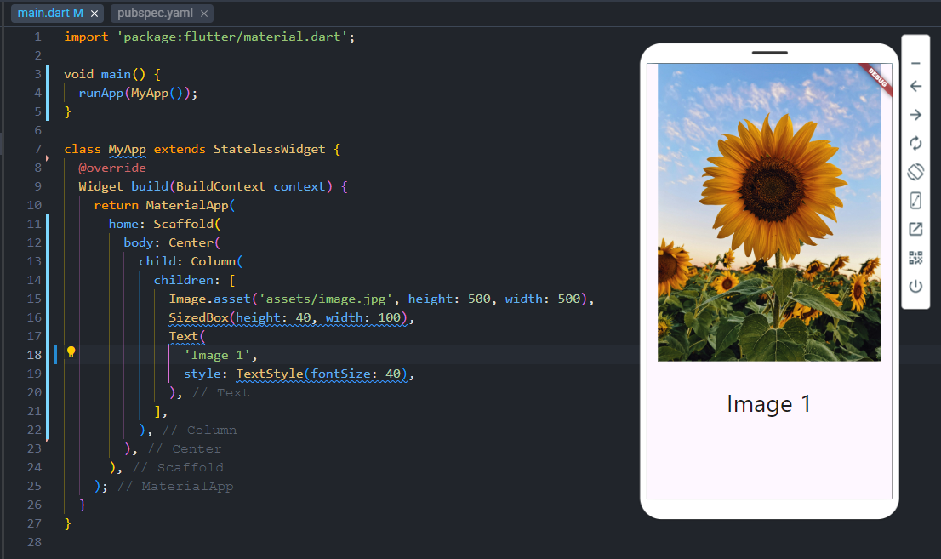

### Learning Outcomes:

|  |
| --- |
|  |
|  |
|  |
|  |
|  |

# Experiment 5

## Aim: Develop a mobile application that interacts with a button.

### Objectives:

* To understand the basic development of Mobile Applications.
* To gain knowledge and practice of displaying buttons on a screen of mobile app for interaction.

### Theory:

**Introduction**

Buttons are essential UI components in mobile applications that enable user interaction. In Flutter, buttons are widely used for triggering events, submitting forms, or navigating between screens. Buttons enhance the user experience by providing intuitive access to different functionalities. Flutter provides multiple types of buttons such as ElevatedButton, TextButton, OutlinedButton, and IconButton, each serving different UI requirements. Additionally, these buttons can be customized with different styles, colors, and animations to enhance usability and aesthetic appeal.

**Objective**

The objective of this experiment is to understand the implementation and functionality of buttons in a Flutter application. This involves creating various buttons, customizing their appearance, and handling user interactions through callback functions. Furthermore, this experiment explores how buttons contribute to UI/UX design by improving accessibility and user engagement.

**Types of Buttons in Flutter**

1. **ElevatedButton**: A button with a shadow effect, useful for emphasizing primary actions and adding depth to the UI.
2. **TextButton**: A simple button with no elevation, typically used for secondary actions or inline links.
3. **OutlinedButton**: A button with an outlined border, offering a balance between prominence and subtlety, often used when a softer emphasis is needed.
4. **IconButton**: A button displaying an icon instead of text, often used for toolbars, navigation, or quick actions.

**Conclusion**

Buttons play a crucial role in user interaction within a Flutter application. By understanding their types, properties, and usage, developers can create intuitive and user-friendly interfaces. Effective button placement and styling enhance the overall user experience, making applications more engaging and accessible. Mastering button implementation enables the development of dynamic and interactive applications, ensuring seamless interaction between the user and the app.

### Code:

import 'package:flutter/material.dart';

void main() {

  runApp(const MyApp());

}

class MyApp extends StatelessWidget {

  const MyApp({super.key});

  @override

  Widget build(BuildContext context) {

    return const MaterialApp(

      debugShowCheckedModeBanner: false,

      home: ButtonTextScreen(),

    );

  }

}

class ButtonTextScreen extends StatefulWidget {

  const ButtonTextScreen({super.key});

  @override

  _ButtonTextScreenState createState() => _ButtonTextScreenState();

}

class _ButtonTextScreenState extends State<ButtonTextScreen> {

  String displayedText = "Press a button";

  void updateText(String text) {

    setState(() {

      displayedText = text;

    });

  }

  @override

  Widget build(BuildContext context) {

    return Scaffold(

      appBar: AppBar(title: const Text('Button Press Example')),

      body: Center(

        child: Column(

          mainAxisAlignment: MainAxisAlignment.center,

          children: [

            Text(

              displayedText,

              style: const TextStyle(fontSize: 20),

            ),

            const SizedBox(height: 20),

            ElevatedButton(

              onPressed: () => updateText("Elevated Button Pressed!"),

              child: const Text('Elevated Button'),

            ),

            const SizedBox(height: 20),

            TextButton(

              onPressed: () => updateText("Text Button Pressed!"),

              child: const Text('Text Button'),

            ),

          ],

        ),

      ),

    );

  }

}

### Output:

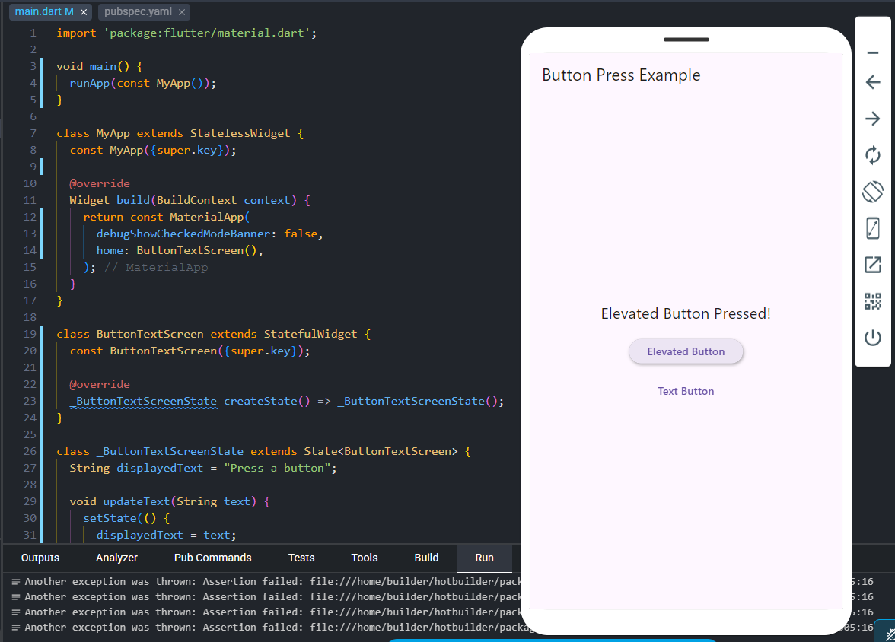

### Learning Outcomes:

|  |
| --- |
|  |
|  |
|  |
|  |
|  |

# Experiment 6

## Aim: Develop a mobile application of portfolio.

### Objectives:

* To implement various Flutter widgets for structured content presentation.
* To create a responsive and visually appealing digital resume accessible across multiple devices.

### Theory:

The Portfolio Flutter App is a mobile application developed using the Flutter framework to showcase a professional portfolio. It serves as a digital resume, allowing users to present their skills, education, projects, and other relevant professional information in an interactive and visually appealing manner.

**Technology Stack**

The app is built using Flutter, an open-source UI software development toolkit created by Google. Flutter uses the Dart programming language and provides a cross-platform development environment, enabling the application to run seamlessly on both Android and iOS devices.

**Features**

1. **Profile Section**: Displays the user's profile picture, name, and a brief introduction.
2. **Education Section**: Lists academic qualifications, including university details.
3. **Skills Section**: Highlights key technical and soft skills.
4. **Projects Section**: Provides an overview of completed and ongoing projects.
5. **Interactive UI**: A well-structured and visually appealing interface using Material Design principles.
6. **Responsiveness**: Ensures a smooth experience across various screen sizes.
7. **Scalability**: Can be expanded to include additional sections like work experience, certifications, and contact details.

**UI/UX Design Principles**

The app follows modern UI/UX design principles with a clean layout, readable typography, and intuitive navigation. The design ensures that users can easily browse through different sections with a seamless experience.

### Code:

**Home:**

import 'package:flutter/material.dart';

class HomeScreen extends StatelessWidget {

  @override

  Widget build(BuildContext context) {

    return Scaffold(

      appBar: AppBar(

        title: Text('Home'),

      ),

      body: Center(

        child: Column(

          mainAxisAlignment: MainAxisAlignment.center,

          children: <Widget>[

            Text(

              'Welcome to My Portfolio!',

              style: TextStyle(fontSize: 24.0),

            ),

            SizedBox(height: 20.0),

            ElevatedButton(

              onPressed: () {

                Navigator.pushNamed(context, '/portfolio_screen');

              },

              child: Text('View Portfolio'),

            ),

            SizedBox(height: 10.0),

            ElevatedButton(

              onPressed: () {

                Navigator.pushNamed(context, '/contact_screen');

              },

              child: Text('Contact Me'),

            ),

          ],

        ),

      ),

    );

  }

}

**Portfolio Screen**

import 'package:flutter/material.dart';

class PortfolioItemScreen extends StatelessWidget {

  @override

  Widget build(BuildContext context) {

    return Scaffold(

      appBar: AppBar(

        title: Text('Portfolio Item'),

        backgroundColor: Color(0xffbeb5ef), // Set AppBar color for consistency

      ),

      body: Padding(

        padding:

            const EdgeInsets.all(16.0), // Padding to make the UI more spacious

        child: SingleChildScrollView(

          // Make it scrollable if content overflows

          child: Column(

            crossAxisAlignment: CrossAxisAlignment.start,

            children: [

              // Profile Picture

              Center(

                child: CircleAvatar(

                  radius: 60,

                  backgroundImage: AssetImage(

                      'assets/avatar.jpg'), // Replace with your image path

                ),

              ),

              SizedBox(height: 16),

              // Title with improved styling

              Center(

                child: Text(

                  'Rohit Kumar Saxena',

                  style: TextStyle(

                    fontSize: 28,

                    fontWeight: FontWeight.bold,

                    color: Color(0xff3d3664),

                  ),

                ),

              ),

              SizedBox(height: 16),

              // Education section title

              Text(

                'Education',

                style: TextStyle(

                  fontSize: 24,

                  fontWeight: FontWeight.bold,

                  color: Color(0xff3d3664),

                ),

              ),

              SizedBox(height: 16),

              // Education details with Icon and text aligned

              Row(

                crossAxisAlignment: CrossAxisAlignment.start,

                children: [

                  Icon(Icons.school, color: Colors.teal, size: 24),

                  SizedBox(width: 10),

                  Expanded(

                    child: Text(

                      'University: Vivekananda Institute of Professional Studies.',

                      style: TextStyle(fontSize: 16),

                    ),

                  ),

                ],

              ),

              SizedBox(height: 20),

              // Skills section

              Text(

                'Skills',

                style: TextStyle(

                  fontSize: 24,

                  fontWeight: FontWeight.bold,

                  color: Color(0xff3d3664),

                ),

              ),

              SizedBox(height: 10),

              Text(

                '• Flutter Development\n• Dart Programming\n• UI/UX Design',

                style: TextStyle(fontSize: 16),

              ),

              SizedBox(height: 20),

              // Projects Section

              Text(

                'Projects',

                style: TextStyle(

                  fontSize: 24,

                  fontWeight: FontWeight.bold,

                  color: Color(0xff3d3664),

                ),

              ),

              SizedBox(height: 10),

              Text(

                '• Portfolio App\n• E-commerce App\n• Chat Application',

                style: TextStyle(fontSize: 16),

              ),

            ],

          ),

        ),

      ),

    );

  }

}

**Contact Screen**

import 'package:flutter/material.dart';

import 'package:url_launcher/url_launcher.dart';

class ContactScreen extends StatelessWidget {

  // Function to launch a URL

  Future<void> _launchURL(String url) async {

    if (await canLaunch(url)) {

      await launch(url);

    } else {

      throw 'Could not launch $url';

    }

  }

  @override

  Widget build(BuildContext context) {

    return Scaffold(

      appBar: AppBar(

        title: Text('Contact'),

      ),

      body: Column(

        crossAxisAlignment: CrossAxisAlignment.start,

        children: [

          Text(

            'Contact Information',

            style: TextStyle(

              fontSize: 24,

              fontWeight: FontWeight.bold,

              color: Colors.teal,

            ),

          ),

          SizedBox(height: 40),

          Row(

            children: [

              Icon(Icons.person, color: Colors.teal),

              SizedBox(width: 10),

              Text(

                'Rohit Kumar Saxena',

                style: TextStyle(fontSize: 16),

              ),

            ],

          ),

          SizedBox(height: 10),

          Row(

            children: [

              Icon(Icons.email, color: Colors.teal),

              SizedBox(width: 10),

              InkWell(

                onTap: () => _launchURL('mailto:03817711922_ds@vips.edu'),

                child: Text(

                  '03817711922_ds@vips.edu',

                  style: TextStyle(fontSize: 16, color: Colors.blue),

                ),

              ),

            ],

          ),

          SizedBox(height: 10),

          Row(

            children: [

              Icon(Icons.phone, color: Colors.teal),

              SizedBox(width: 10),

              InkWell(

                onTap: () => _launchURL('tel:+919876xxxxxx'),

                child: Text(

                  '+91 9876xxxxxxx',

                  style: TextStyle(fontSize: 16, color: Colors.blue),

                ),

              ),

            ],

          ),

          SizedBox(height: 10),

          Row(

            children: [

              Icon(Icons.link, color: Colors.teal),

              SizedBox(width: 10),

              InkWell(

                onTap: () => _launchURL('https://linkedin.com/in/rohi-s'),

                child: Text(

                  'linkedin.com/in/rohi-s',

                  style: TextStyle(fontSize: 16, color: Colors.blue),

                ),

              ),

            ],

          ),

        ],

      ),

    );

  }

}

**Main file**

import 'package:flutter/material.dart';

import 'home_screen.dart';

import 'portfolio_screen.dart';

import 'contact_screen.dart';

void main() {

  runApp(PortfolioApp());

}

class PortfolioApp extends StatelessWidget {

  @override

  Widget build(BuildContext context) {

    return MaterialApp(

      initialRoute: '/',

      routes: {

        '/': (context) => HomeScreen(),

        '/portfolio_screen': (context) => PortfolioItemScreen(),

        '/contact_screen': (context) => ContactScreen(),

      },

    );

  }

}

### Output :

**Home Portfolio**

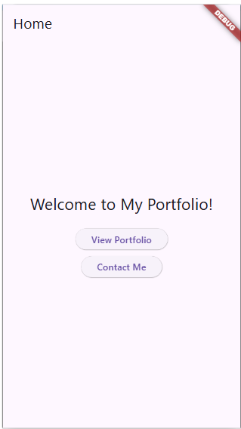 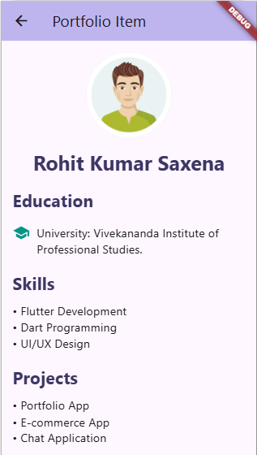

**Contact**

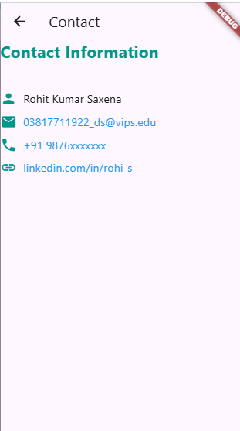

### Learning Outcomes:

|  |
| --- |
|  |
|  |
|  |
|  |
|  |

# Experiment 7

## Aim: Write Flutter Mobile Application for Data Store Shared Preferences.

### Objectives:

* To store, retrieve, and delete student data using enrollment numbers as unique keys in Flutter with SharedPreferences.
* To implement a user-friendly interface that allows efficient data management with proper input validation and UI spacing.

### Theory:

**SharedPreferences in Flutter** is a lightweight, efficient storage mechanism designed for saving simple data as key-value pairs directly on a user's device. It offers a persistent way to store data even after the application is closed and reopened, making it a preferred choice for storing user settings, login sessions, theme preferences, and other small data elements that do not require the complexity of a database.

In Flutter, SharedPreferences is implemented through a plugin that bridges native platform storage mechanisms (like NSUserDefaults on iOS and SharedPreferences on Android) to provide a unified API. It is especially useful for scenarios where developers need to store and retrieve non-sensitive information quickly and without the overhead of setting up a full database solution like SQLite or Hive.

In this project, SharedPreferences is used to manage student information efficiently. Each student's data is saved using their **enrollment number as a unique key**, which allows quick lookup and avoids data conflicts. The application ensures that users can **save, retrieve, and delete** student records through an intuitive interface. Text fields are provided for entering the student's details such as name, department, and contact information. These are complemented by action buttons to perform CRUD operations on the stored data.

To improve user experience, the UI is designed with proper alignment and spacing, ensuring clarity and accessibility. The integration of SharedPreferences not only facilitates fast local storage but also simplifies the logic required to manage state across app launches. This makes it an ideal choice for lightweight data persistence in mobile applications where performance and simplicity are critical.

### Code

**Main.dart**

import 'package:flutter/material.dart';

import 'package:shared_preferences/shared_preferences.dart';

void main() {

  runApp(MyApp());

}

class MyApp extends StatelessWidget {

  @override

  Widget build(BuildContext context) {

    return MaterialApp(

      debugShowCheckedModeBanner: false,

      theme: ThemeData(primarySwatch: Colors.blue),

      home: DataStorageScreen(),

    );

  }

}

class DataStorageScreen extends StatefulWidget {

  @override

  _DataStorageScreenState createState() => _DataStorageScreenState();

}

class _DataStorageScreenState extends State<DataStorageScreen> {

  TextEditingController enrollmentController = TextEditingController();

  TextEditingController nameController = TextEditingController();

  TextEditingController projectController = TextEditingController();

  TextEditingController retrieveController = TextEditingController();

  String studentDetails = '';

  Future<void> saveStudentData(

      String enrollment, String name, String project) async {

    try {

      SharedPreferences prefs = await SharedPreferences.getInstance();

      await prefs.setString(enrollment, '$name | $project');

      ScaffoldMessenger.of(context).showSnackBar(

        SnackBar(content: Text('Data saved successfully!')),

      );

    } catch (e) {

      ScaffoldMessenger.of(context).showSnackBar(

        SnackBar(content: Text('Error saving data: $e')),

      );

    }

  }

  Future<void> getStudentData(String enrollment) async {

    try {

      SharedPreferences prefs = await SharedPreferences.getInstance();

      String? data = prefs.getString(enrollment);

      setState(() {

        studentDetails = data ?? 'No data found for this enrollment number.';

      });

    } catch (e) {

      ScaffoldMessenger.of(context).showSnackBar(

        SnackBar(content: Text('Error retrieving data: $e')),

      );

    }

  }

  Future<void> deleteStudentData(String enrollment) async {

    try {

      SharedPreferences prefs = await SharedPreferences.getInstance();

      await prefs.remove(enrollment);

      setState(() {

        studentDetails = 'Data deleted successfully!';

      });

    } catch (e) {

      ScaffoldMessenger.of(context).showSnackBar(

        SnackBar(content: Text('Error deleting data: $e')),

      );

    }

  }

  @override

  Widget build(BuildContext context) {

    return Scaffold(

      appBar: AppBar(title: Text('Student Data Storage')),

      body: Padding(

        padding: const EdgeInsets.all(16.0),

        child: SingleChildScrollView(

          child: Column(

            children: <Widget>[

              buildTextField(enrollmentController, 'Enter Enrollment Number'),

              SizedBox(height: 15),

              buildTextField(nameController, 'Enter Student Name'),

              SizedBox(height: 15),

              buildTextField(projectController, 'Enter Project Title'),

              SizedBox(height: 20),

              buildButton('Save Data', () {

                if (enrollmentController.text.isNotEmpty &&

                    nameController.text.isNotEmpty &&

                    projectController.text.isNotEmpty) {

                  saveStudentData(enrollmentController.text,

                      nameController.text, projectController.text);

                }

              }),

              SizedBox(height: 30),

              Text(

                'Retrieve Data',

                style: TextStyle(fontSize: 18, fontWeight: FontWeight.bold),

              ),

              SizedBox(height: 10),

              buildTextField(retrieveController, 'Enter Enrollment Number'),

              SizedBox(height: 15),

              buildButton('Retrieve Data',

                  () => getStudentData(retrieveController.text)),

              SizedBox(height: 20),

              buildButton('Delete Data',

                  () => deleteStudentData(retrieveController.text)),

              SizedBox(height: 30),

              Text(

                'Student Details: $studentDetails',

                style: TextStyle(fontSize: 16, fontWeight: FontWeight.bold),

                textAlign: TextAlign.center,

              ),

            ],

          ),

        ),

      ),

    );

  }

  Widget buildTextField(TextEditingController controller, String hintText) {

    return TextField(

      controller: controller,

      decoration: InputDecoration(

        labelText: hintText,

        border: OutlineInputBorder(),

      ),

    );

  }

  Widget buildButton(String text, VoidCallback onPressed) {

    return ElevatedButton(

      style: ElevatedButton.styleFrom(minimumSize: Size(double.infinity, 50)),

      onPressed: onPressed,

      child: Text(text),

    );

  }

}

**Output**

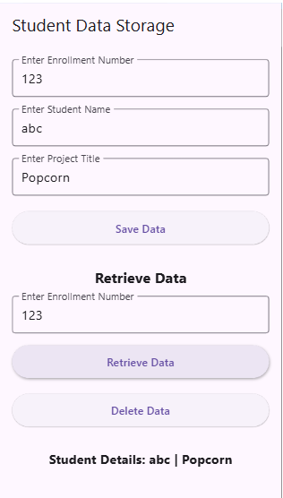

### Learning Outcomes:

|  |
| --- |
|  |
|  |
|  |
|  |
|  |

# Experiment 8

## Aim: Create a flutter app using Restful API.

### Objective:

To develop a cross-platform mobile application using Flutter that integrates with a RESTful API to fetch, display, and manipulate data dynamically, thereby enhancing real-time user interaction and demonstrating effective communication between the frontend and backend services.

### Theory:

Flutter is an open-source UI software development toolkit created by Google, used to build natively compiled applications for mobile, web, and desktop from a single codebase. It uses Dart as its programming language and provides a rich set of pre-designed widgets to create visually appealing and responsive interfaces.

A **RESTful API (Representational State Transfer)** is an architectural style for designing networked applications. It allows client applications (like mobile apps) to communicate with backend services over HTTP using standard methods such as GET, POST, PUT, and DELETE. These APIs return data typically in JSON format, which can be easily parsed and displayed in a Flutter app.

By integrating a RESTful API in a Flutter app:

* The app becomes dynamic and data-driven.
* Backend data can be retrieved and updated without rebuilding the app.
* Real-time interaction between users and servers can be achieved, improving user experience.

### Code

import 'dart:convert';

import 'package:flutter/material.dart';

import 'package:http/http.dart' as http;

void main() {

  runApp(MyApp());

}

class MyApp extends StatelessWidget {

  @override

  Widget build(BuildContext context) {

    return MaterialApp(

      title: 'Flutter REST API Demo',

      theme: ThemeData(

        primarySwatch: Colors.deepPurple,

        colorScheme: ColorScheme.fromSwatch(primarySwatch: Colors.deepPurple)

            .copyWith(secondary: Colors.orange),

        textTheme: TextTheme(

          titleMedium: TextStyle(

              fontSize: 20,

              fontWeight:

                  FontWeight.bold), // Replaced headline5 with titleMedium

          bodyLarge: TextStyle(

              fontSize: 16,

              color: Colors.black87), // Replaced bodyText1 with bodyLarge

        ),

        scaffoldBackgroundColor: Colors.grey[100],

      ),

      home: MyHomePage(),

    );

  }

}

class MyHomePage extends StatefulWidget {

  @override

  _MyHomePageState createState() => _MyHomePageState();

}

class _MyHomePageState extends State<MyHomePage> {

  List<dynamic> _data = [];

  bool _isLoading = true;

  String? _errorMessage;

  @override

  void initState() {

    super.initState();

    fetchData();

  }

  Future<void> fetchData() async {

    setState(() {

      _isLoading = true;

      _errorMessage = null;

    });

    try {

      final response = await http

          .get(Uri.parse('https://jsonplaceholder.typicode.com/posts'));

      if (response.statusCode == 200) {

        setState(() {

          _data = json.decode(response.body);

        });

      } else {

        setState(() {

          _errorMessage = 'Failed to load data. Please try again later.';

        });

      }

    } catch (e) {

      setState(() {

        _errorMessage = 'An error occurred. Please check your connection.';

      });

    } finally {

      setState(() {

        _isLoading = false;

      });

    }

  }

  @override

  Widget build(BuildContext context) {

    return Scaffold(

      appBar: AppBar(

        title: Text('Flutter REST API Demo'),

      ),

      body: _isLoading

          ? Center(child: CircularProgressIndicator())

          : _errorMessage != null

              ? Center(

                  child: Text(_errorMessage!,

                      style: TextStyle(color: Colors.red, fontSize: 18)))

              : ListView.builder(

                  itemCount: _data.length,

                  itemBuilder: (BuildContext context, int index) {

                    return Card(

                      margin: EdgeInsets.symmetric(vertical: 8, horizontal: 12),

                      elevation: 4,

                      shape: RoundedRectangleBorder(

                        borderRadius: BorderRadius.circular(10),

                      ),

                      child: ListTile(

                        contentPadding: EdgeInsets.all(16),

                        title: Text(

                          _data[index]['title'],

                          style: Theme.of(context)

                              .textTheme

                              .titleMedium, // Use titleMedium

                        ),

                        subtitle: Text(

                          _data[index]['body'],

                          style: Theme.of(context)

                              .textTheme

                              .bodyLarge, // Use bodyLarge

                          maxLines: 3,

                          overflow: TextOverflow.ellipsis,

                        ),

                      ),

                    );

                  },

                ),

    );

  }

}

### Output

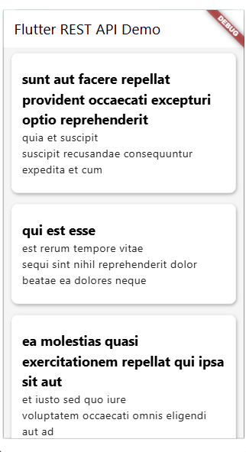

### Learning Outcomes:

|  |
| --- |
|  |
|  |
|  |
|  |
|  |

# Experiment 9

## Aim: To create a Flutter application that captures and displays real-time accelerometer sensor data using the sensors_plus package.

### Objective:

* To understand how to access and use hardware sensors in a mobile device through Flutter.
* To subscribe to and handle real-time accelerometer events.
* To display the current X, Y, and Z axis values of the device’s motion in a user-friendly UI.
* To practice proper subscription and disposal of sensor streams to manage memory efficiently.

### Theory

The **accelerometer** is a hardware sensor used in mobile devices to measure the acceleration force applied to the device along the X, Y, and Z axes. This force can be due to gravity or movement and is useful in a variety of applications such as motion detection, orientation changes, and step counting.

In Flutter, the sensors_plus package provides easy access to device sensors including the **accelerometer**, **gyroscope**, and **magnetometer**. The accelerometer data is accessed through a stream (accelerometerEvents) which emits AccelerometerEvent objects containing the X, Y, and Z values.

This Flutter app:

* Initializes a subscription to the accelerometer stream in initState().
* Updates the UI with the latest accelerometer readings using setState().
* Properly cancels the subscription in dispose() to prevent memory leaks.

**Code**

import 'dart:async';

import 'package:flutter/material.dart';

import 'package:sensors_plus/sensors_plus.dart';

void main() {

  runApp(MyApp());

}

class MyApp extends StatelessWidget {

  @override

  Widget build(BuildContext context) {

    return MaterialApp(

      theme: ThemeData(

        primarySwatch: Colors.green, // Set the app's primary theme color

      ),

      debugShowCheckedModeBanner: false,

      home: AccelerometerExample(),

    );

  }

}

class AccelerometerExample extends StatefulWidget {

  const AccelerometerExample({super.key});

  @override

  State<AccelerometerExample> createState() => _AccelerometerExampleState();

}

class _AccelerometerExampleState extends State<AccelerometerExample> {

// List to store accelerometer data

  List<AccelerometerEvent> _accelerometerValues = [];

// StreamSubscription for accelerometer events

  late StreamSubscription<AccelerometerEvent> _accelerometerSubscription;

  @override

  void initState() {

    super.initState();

// Subscribe to accelerometer events

    _accelerometerSubscription = accelerometerEvents.listen((event) {

      setState(() {

// Update the _accelerometerValues list with the latest event

        _accelerometerValues = [event];

      });

    });

  }

  @override

  void dispose() {

// Cancel the accelerometer event subscription to prevent memory leaks

    _accelerometerSubscription.cancel();

    super.dispose();

  }

  @override

  Widget build(BuildContext context) {

    return Scaffold(

      appBar: AppBar(

        title: Text('Accelerometer Example'),

      ),

      body: Center(

        child: Column(

          mainAxisAlignment: MainAxisAlignment.center,

          children: <Widget>[

            Text(

              'Accelerometer Data:',

              style: TextStyle(fontSize: 20),

            ),

            SizedBox(height: 10),

            if (_accelerometerValues.isNotEmpty)

              Text(

                'X: ${_accelerometerValues[0].x.toStringAsFixed(2)}, '

                'Y: ${_accelerometerValues[0].y.toStringAsFixed(2)}, '

                'Z: ${_accelerometerValues[0].z.toStringAsFixed(2)}',

                style: TextStyle(fontSize: 16),

              )

            else

              Text('No data available', style: TextStyle(fontSize: 16)),

          ],

        ),

      ),

    );

  }

}

### Output

### 

### Learning Outcomes:

|  |
| --- |
|  |
|  |
|  |
|  |
|  |

# Experiment 10

## Aim: Add multimedia functionality to your mobile application.

### Objective:

* To implement basic multimedia functionality in a Flutter mobile application.
* To display the progress bar of audio playback.
* To provide play pause functionalities for video and audio files.

### Theory

Multimedia functionality, particularly the inclusion of audio and video playback, is an essential part of modern mobile applications. Whether it’s for entertainment, education, or interactive media, integrating these features greatly enhances the user experience. In Flutter, a cross-platform framework by Google, multimedia features can be implemented efficiently using third-party packages like video_player and audioplayers.

For video playback, Flutter utilizes the video_player plugin, which allows developers to load video files from assets, the internet, or device storage. The VideoPlayerController is responsible for managing the video source, and it must be initialized before the video can be displayed. The video widget is typically wrapped in an AspectRatio to preserve the video's dimensions. A common approach is to display a CircularProgressIndicator while the video is loading to inform the user that content is being prepared.

**Code**

import 'package:flutter/material.dart';

import 'package:video_player/video_player.dart';

import 'package:audioplayers/audioplayers.dart';

void main() => runApp(const MyApp());

class MyApp extends StatelessWidget {

  const MyApp({super.key});

  @override

  Widget build(BuildContext context) {

    return const MaterialApp(

      debugShowCheckedModeBanner: false,

      home: MultimediaScreen(),

    );

  }

}

class MultimediaScreen extends StatefulWidget {

  const MultimediaScreen({super.key});

  @override

  State<MultimediaScreen> createState() => _MultimediaScreenState();

}

class _MultimediaScreenState extends State<MultimediaScreen> {

  late VideoPlayerController _videoController;

  final AudioPlayer _audioPlayer = AudioPlayer();

  Duration _audioDuration = Duration.zero;

  Duration _audioPosition = Duration.zero;

  @override

  void initState() {

    super.initState();

    // Initialize video

    _videoController = VideoPlayerController.asset('assets/sample.mp4')

      ..initialize().then((_) {

        setState(() {}); // Rebuild after video loads

      });

    // Initialize audio

    _audioPlayer.onDurationChanged.listen((duration) {

      setState(() {

        _audioDuration = duration;

      });

    });

    _audioPlayer.onPositionChanged.listen((position) {

      setState(() {

        _audioPosition = position;

      });

    });

  }

  @override

  void dispose() {

    _videoController.dispose();

    _audioPlayer.dispose();

    super.dispose();

  }

  void playAudio() {

    _audioPlayer.play(AssetSource('sample.mp3'));

  }

  void pauseAudio() {

    _audioPlayer.pause();

  }

  void seekAudio(Duration position) {

    _audioPlayer.seek(position);

  }

  @override

  Widget build(BuildContext context) {

    return Scaffold(

      appBar: AppBar(title: const Text("Multimedia Demo")),

      body: SingleChildScrollView(

        padding: const EdgeInsets.all(16),

        child: Column(

          children: [

            const Text("Video Playback", style: TextStyle(fontSize: 18)),

            const SizedBox(height: 10),

            _videoController.value.isInitialized

                ? AspectRatio(

                    aspectRatio: _videoController.value.aspectRatio,

                    child: VideoPlayer(_videoController),

                  )

                : const CircularProgressIndicator(),

            ElevatedButton(

              onPressed: () {

                setState(() {

                  _videoController.value.isPlaying

                      ? _videoController.pause()

                      : _videoController.play();

                });

              },

              child: Text(_videoController.value.isPlaying

                  ? 'Pause Video'

                  : 'Play Video'),

            ),

            const SizedBox(height: 30),

            const Divider(),

            const Text("Audio Playback", style: TextStyle(fontSize: 18)),

            const SizedBox(height: 10),

            Slider(

              min: 0,

              max: _audioDuration.inSeconds.toDouble(),

              value: _audioPosition.inSeconds

                  .toDouble()

                  .clamp(0, _audioDuration.inSeconds.toDouble()),

              onChanged: (value) {

                seekAudio(Duration(seconds: value.toInt()));

              },

            ),

            Text(

              "${_formatTime(_audioPosition)} / ${_formatTime(_audioDuration)}",

              style: const TextStyle(fontSize: 14),

            ),

            Row(

              mainAxisAlignment: MainAxisAlignment.center,

              children: [

                ElevatedButton(

                  onPressed: playAudio,

                  child: const Text("Play"),

                ),

                const SizedBox(width: 10),

                ElevatedButton(

                  onPressed: pauseAudio,

                  child: const Text("Pause"),

                ),

              ],

            ),

          ],

        ),

      ),

    );

  }

  String _formatTime(Duration duration) {

    String twoDigits(int n) => n.toString().padLeft(2, '0');

    return "${twoDigits(duration.inMinutes)}:${twoDigits(duration.inSeconds % 60)}";

  }

}

### Output

### 

### Learning Outcomes:

|  |
| --- |
|  |
|  |
|  |
|  |
|  |