CausalLOB
Temporal Causal Discovery and Dynamic Bayesian Inference for Limit Order Book Price Formation
Applied AI | Financial Market Microstructure | FI-2010 NoAuction Decimal Precision | Group G9

1. Problem statement, motivation and scope
Research question. Which lagged limit-order-book (LOB) states are stable probabilistic antecedents of short-horizon midpoint price formation, and can a Dynamic Bayesian Network (DBN) represent those dependencies for calibrated probabilistic inference?
Motivation. Modern LOB forecasters can be accurate but often provide limited interpretability, causal reasoning or calibrated uncertainty. CausalLOB treats price formation as a temporal PGM problem rather than only a three-class Up/Stationary/Down prediction task.
Scope and assumptions. The project fixes one domain and one principal dataset: FI-2010. Because the data are observational, the project seeks robust lagged temporal causal candidates under explicit assumptions, not the true causal graph or experimentally identified causal effects. FI-2010 horizons and lags are representation steps, not seconds; the OFI variable is a quote-change proxy rather than event-level OFI.

2. PGM mapping: Representation, Learning and Inference

2.1 Representation - random variables, nodes, edges and dependencies
At each representation step t, the market state X_t contains six primary random variables. Rolling 20-step volatility is retained as a regime/sensitivity variable rather than a primary causal primitive. A future outcome node Y_{t+h} takes values {Up, Stationary, Down} for h in {10,20,30,50,100}.
Node / random variable | Meaning | PGM role
log relative spread | top-of-book trading cost / liquidity | primary state node
log total depth L1-L5 | near-book available liquidity | primary state node
L1 imbalance | best bid-vs-ask queue pressure | primary state node
L2-L5 imbalance | deeper pressure excluding L1 | primary state node
quote-change OFI proxy | depth-normalized quote pressure | primary state node
one-step log midpoint return | immediate price response | primary state node
20-step volatility | recent volatility regime | sensitivity / optional regime evidence
Y(t+h) | Up / Stationary / Down | future outcome node

Edges. Primary structure learning considers directed lagged dependencies X_i(t-k) -> X_j(t), initially for k=1,...,5 representation steps. Candidate edges are learned from data; no M1 figure is a claimed causal graph. Domain constraints enforce temporal order and prohibit any lag from crossing day/security boundaries. Contemporaneous links may be examined only as a later sensitivity analysis if the data semantics support them.
Why this representation is appropriate. The verified lag-1 ACFs are 0.929 for depth, 0.844 for spread, 0.894 for L2-L5 imbalance and 0.762 for L1 imbalance, while return is -0.097 and the OFI proxy is near zero. The market state is therefore strongly temporal and heterogeneous in persistence, making an IID/static representation inappropriate.
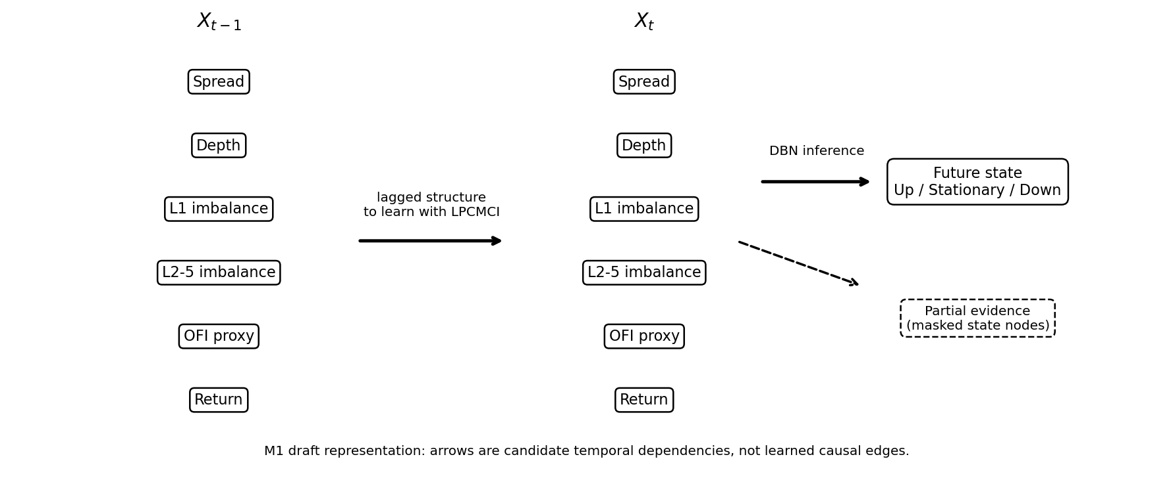
Figure 1. M1 draft two-slice PGM. Arrows denote candidate temporal dependencies to be learned, not established causal edges.

2.2 Learning - how the model is obtained from data
Structure learning. LPCMCI is the primary temporal causal-discovery algorithm because the variables are autocorrelated and latent common drivers are plausible. PCMCI+ is a controlled causal-sufficiency comparison. The primary evidence will come from chronological/day-block stability, sign stability, FDR-controlled support, lag sensitivity, nonlinear conditional-independence sensitivity for shortlisted edges, and semi-synthetic graph recovery.
Parameter learning. After structure is frozen, the DBN parameters will be learned from data using regularized Bayesian or parametric conditional distributions. Sparse high-dimensional tabular CPTs will be avoided where parametric CPDs are more stable; EM is reserved only for a justified latent-regime extension.

2.3 Inference - what the model will compute
The central query is the posterior predictive distribution P(Y(t+h) | evidence), producing probabilities for Up, Stationary and Down and a MAP state if required. With complete evidence, exact Variable Elimination (VE) will be used where tractable. To make inference a substantive PGM experiment, state variables will also be deliberately masked; the model must marginalize unobserved nodes and exact VE will be compared with an approximate method such as likelihood weighting or sampling. The principal inference benchmark is posterior error (or KL divergence) versus computation time.

3. Verified M1 data foundation
The rebuilt M1 pipeline uses only the raw 40 LOB columns plus the five future labels; the publisher-provided engineered features are excluded from the initial causal graph. The canonical reconstruction contains 394,337 representations over 10 days. Five anonymous securities are concatenated within each day, so four dominant midpoint discontinuities infer five blocks per day only to prevent temporal leakage.
Item | Verified M1 value | Item | Verified M1 value
Rows | 394,337 | Days | 10
Raw LOB variables | 40 | Future labels | 5
Boundary-separated sequences | 50 | Min / median boundary ratio | 21.10x / 51.39x
Current-state valid | 393,337 | Full t..t-5 valid | 393,087
Publisher engineered features | Excluded | Temporal boundary leakage | 0
Max |Spearman|, primary vars | 0.610 | L1 vs L2-L5 imbalance | 0.149

Important terminology: the 50 day-security blocks are boundary-separated temporal sequences, not 50 statistically independent replications. Later uncertainty calculations use trading day as the outer inferential block. The microprice identity error is approximately 5.9e-13, providing an algebraic consistency check of the reconstructed LOB features.
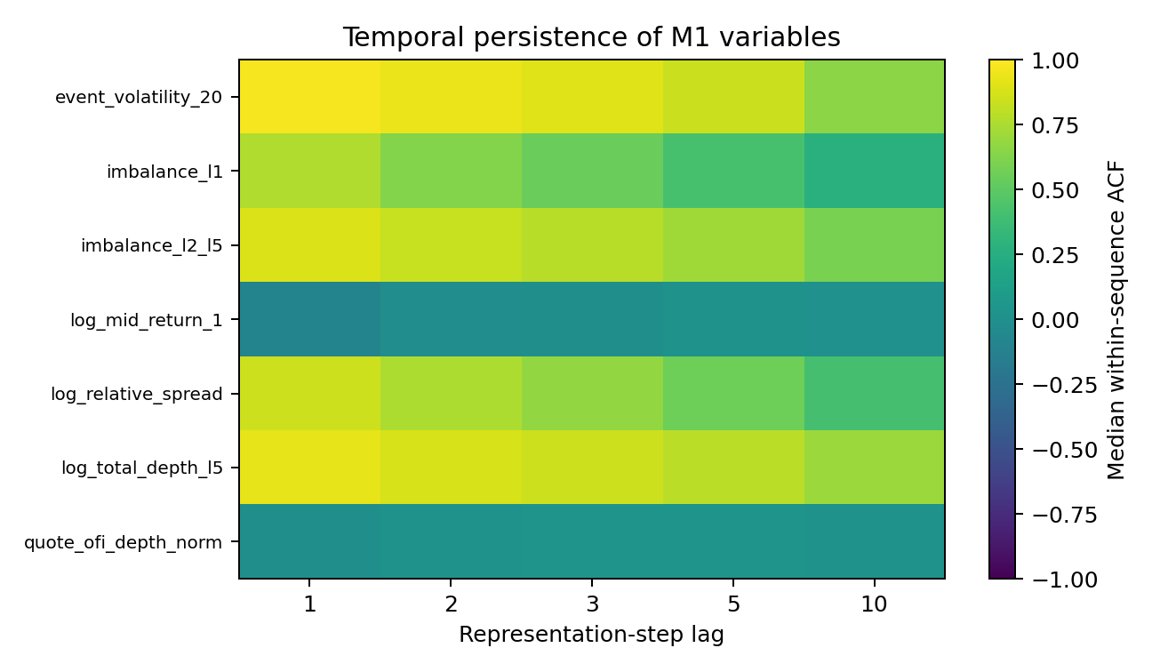
Figure 2. Median within-sequence autocorrelation. Strong state persistence empirically motivates time-series structure learning.

4. State-of-the-art (SOTA) position
Primary SOTA anchor. Andreas Gerhardus and Jakob Runge, “High-Recall Causal Discovery for Autocorrelated Time Series with Latent Confounders,” NeurIPS 2020, German Aerospace Center (DLR), Institute of Data Science. This is the base paper for the project’s structure-learning position.
Required SOTA element | Gerhardus & Runge (NeurIPS 2020) | Relationship to CausalLOB
Problem addressed | Causal discovery in strongly autocorrelated observational time series when latent confounders may exist. | LOB states are strongly autocorrelated and hidden market drivers are plausible.
Representation | Temporal causal graph with lagged/contemporaneous relations and ambiguity induced by latent confounding. | We use a domain-constrained temporal graph over interpretable LOB state variables, then induce a predictive DBN from supported directed structure.
Learning methodology | LPCMCI: iterative conditional-independence testing plus orientation rules designed to improve recall under autocorrelation and latent confounding. | LPCMCI is the primary structure learner; PCMCI+ is a causal-sufficiency sensitivity baseline.
Inference methodology | The paper is primarily a structure-learning method, not a posterior DBN inference model; graph orientation follows CI information and causal-discovery rules. | Our extension adds DBN posterior/MAP inference and a separate exact-vs-approximate inference benchmark under partial evidence.
Evaluation | Synthetic/time-series experiments compare causal-graph recovery as autocorrelation and confounding conditions vary. | We add chronological FI-2010 stability tests and semi-synthetic SCM recovery with known ground truth.
Main finding | LPCMCI substantially improves graph recall in autocorrelated settings while controlling false positives relative to prior approaches. | This motivates its use where spread/depth/imbalance show strong persistence.
Limitations relevant here | Observational identification remains assumption-dependent; CI tests and finite samples limit recoverability; it is not a trading or DBN forecasting paper. | We restrict causal language, add probabilistic DBN inference, calibration, domain constraints and explicit falsification.

Secondary positioning. Runge (UAI 2020) / PCMCI+ supplies a causal-sufficiency comparison for contemporaneous and lagged relations. DeepLOB (Zhang, Zohren & Roberts, IEEE TSP 2019) is a predictive LOB benchmark rather than a causal SOTA anchor. Gao et al. (NeurIPS 2023) motivates a regime/semi-stationary extension only if mechanism changes are empirically supported.

5. Baselines and predeclared KPIs
Accuracy alone is insufficient: at h=10 the verified label distribution is 18.1% Up, 64.1% Stationary and 17.8% Down, so an always-Stationary classifier already achieves 64.1% raw accuracy.
PGM vertical | Baseline / comparison | Initial KPIs
Representation | reduced state; own-history-only state | boundary leakage; redundancy; lag sensitivity; state sparsity
Structure learning | AR-only; PCMCI+; static BN/other feasible ablations | day-block selection/sign stability; FDR; Jaccard; synthetic SHD/edge precision-recall; incremental NLL beyond AR
Prediction / calibration | class prior; multinomial logistic; boosted trees; DeepLOB context | balanced accuracy; macro-F1; log loss/NLL; Brier; ECE; reliability curves
Inference | exact VE vs approximate inference under masked evidence | posterior error / KL; runtime; error-vs-time curve

6. Experimental plan, timeline and responsibilities
Milestone | Planned work | Frozen output
M1 | canonical data, PGM map, SOTA, baselines/KPIs | versioned preprocessing checkpoints and proposal
M2 | LPCMCI, nonlinear CI sensitivity, day-block stability, semi-synthetic SCM | frozen temporal edge tiers
M3 | DBN parameter learning, calibrated outcomes, partial-evidence exact/approximate inference | probability engine + inference benchmark
M4 | falsification, economic diagnostics, external replication if feasible | final claim registry and reproducible package

7. Risks, mitigations and M1 submission status
Risk | Mitigation
Only 10 days; anonymous securities | day is the outer inference block; external replication sought later
Engineered-variable overlap | L1 separated from L2-L5 imbalance; rolling volatility demoted to regime sensitivity
OFI not event-level | explicit quote-change OFI-proxy terminology
Representation time not physical time | report lags/horizons only as representation steps
Observational causal discovery | stability/falsification; no true-DAG or experimental do-effect claim
Trivial full-evidence inference | masked-evidence VE vs approximate-inference benchmark
Economic overfitting | economics remain secondary to PGM KPIs; no repeated target/policy mining

GitHub repository: https://github.com/aryans7-glitch/CausalLOB-CSE516-2026. The M1 folder contains README, PDF report, video link/file, Colab/source code, Data README and Results plots/tables. The rebuilt preprocessing is checkpointed and frozen; later model learning must use this representation rather than silently mixing older post-hoc FI-2010 experiments.

References
[1] A. Gerhardus and J. Runge, “High-Recall Causal Discovery for Autocorrelated Time Series with Latent Confounders,” NeurIPS 33, 2020.
[2] J. Runge, “Discovering Contemporaneous and Lagged Causal Relations in Autocorrelated Nonlinear Time Series Datasets,” UAI 2020, PMLR 124, pp. 1388-1397.
[3] A. Ntakaris, M. Magris, J. Kanniainen, M. Gabbouj, and A. Iosifidis, “Benchmark Dataset for Mid-Price Forecasting of Limit Order Book Data with Machine Learning Methods,” Journal of Forecasting 37(8), 852-866, 2018. DOI: 10.1002/for.2543.
[4] Z. Zhang, S. Zohren, and S. Roberts, “DeepLOB: Deep Convolutional Neural Networks for Limit Order Books,” IEEE Transactions on Signal Processing 67(11), 3001-3012, 2019. DOI: 10.1109/TSP.2019.2907260.
[5] S. Gao, R. Addanki, T. Yu, R. A. Rossi, and M. Kocaoglu, “Causal Discovery in Semi-Stationary Time Series,” NeurIPS 36, 2023.

