CSE 516: PROBABILISTIC GRAPHICAL MODELS |GROUP G9 |APPLIED AI
CausalLOB
Temporal Causal Discovery and Dynamic Bayesian Inference
for Limit-Order-Book Price Formation
Milestone 3 — Results & Analysis |
Abstract
We evaluate the frozen CausalLOB six-state dynamic Bayesian network (DBN) established in Milestones 1–2 on the FI-2010 NoAuction Decimal Precision benchmark. LPCMCI-discovered candidates were screened on Days 6–7; the resulting graph retains 30 own-history and nine cross-variable lag slots and is not reopened in M3. The sparse model has lower retrospective pooled state RMSE than an equal-history AR(5) baseline (0.586137 versus 0.588347), but a dense VAR(5) is slightly better (0.585171). On matched complete-evidence rows, a DeepLOB-style predictive comparator has lower log loss at all five outcome horizons, although the DBN has better balanced accuracy and Brier score at horizon 10. The training class-prior baseline beats the DBN on all 12 pooled consecutive-gap comparisons. We report descriptive three-day variability, calibrated-probability metrics, graph and missing-evidence ablations, and a clearly separated synthetic exact-versus-Monte-Carlo numerical check. The original dataset checkpoints were not supplied with the uploaded notebook: FI-2010 results in this report are recovered from earlier executed outputs, not freshly rerun or independently confirmed; Days 8–10 were previously inspected. The contribution is a transparent probabilistic evaluation, not identified market causality or predictive superiority.

Research question
Research question (unchanged since M1): Which lagged limit-order-book (LOB) states are stable probabilistic antecedents of short-horizon midpoint-price formation, and can a DBN express these dependencies for calibrated probabilistic inference? M1 fixed a single application domain (market microstructure), the FI-2010 dataset, six interpretable state nodes, a maximum of five representation-step lags, a structure-learning SOTA anchor, and the Representation–Learning–Inference plan . M2 reconstructed 394,337 observations, enforced 50 day–security leakage boundaries, froze the 39-slot temporal graph, fitted Gaussian conditional distributions and five ordered-probit heads, and demonstrated exact partial-observation inference .
M3 questions. H1: Do the selected lagged cross-variable edges improve reconstruction compared with own-history AR(5)? H2: Do source identities outperform target/lag-matched random alternatives? H3: Do calibrated outcomes and missing-evidence inference offer practical advantages, including under consecutive gaps? The answers below include falsifications. FI-2010 is observational; neither LPCMCI links nor post-hoc predictive gains establish intervention-level causal effects.

Representation, learning, and inference
State. At representation step , the six-vector contains log relative spread, log total depth over levels 1–5, L1 bid–ask imbalance, incremental L2–L5 imbalance, depth-normalized quote-change OFI proxy, and one-step log midpoint return. Volatility is a regime sensitivity, not a seventh primary node. Steps and publisher horizons are not elapsed seconds. The quote-change proxy is not event-level order-flow imbalance.
Graph. Thirty mandatory own-history lags (six nodes lags 1–5) plus nine cross-lag slots from five retained source–target families: L1 imbalance return (1); L2–L5 imbalance return (1,5); L2–L5 imbalance OFI proxy (1); depth spread (1); OFI proxy return (2–5). Arrows indicate conditional predictive ordering, not unconfounded causal effects. The model is

The primary gives the explicitly factorized Gaussian DBN

LPCMCI ran only on Days 1–5, with cross-family checks on Days 6–7; the graph was frozen before Ridge () fitted 39 slopes, six intercepts and six innovation variances using Days 1–7. Five ordered-probit outcome heads were also fitted on those days for raw publisher messages .
Posterior query. For missing current components , observed components , and the five-step observed lag history , Gaussian conditioning is exact:

Here . For diagonal , contemporaneous measured states do not update an unobserved state at that same step; improvements come mainly through history. A train-only shrinkage/correlated- alternative probes sensitivity but changes the contemporaneous independence assumptions. Integrating each ordered-probit head over the state posterior yields normalized for Down/Stationary/Up. Exact conditioning is preferred at six dimensions; sampling is a numerical comparator rather than a necessary approximation.

Experimental protocol, baselines, and KPIs
Frozen experimental controls, retained from M1–M2.
Dataset | FI-2010 NoAuction Decimal Precision; 394,337 representations / ten days / 50 boundary-separated day–anonymous-security sequences.
Discovery/validation | Days 1–5 LPCMCI; Days 6–7 family validation; frozen graph afterwards.
Fit/assessment | Days 1–7 estimation; 139,212 eligible transition rows on the retrospectively inspected Days 8–10.
Temporal leakage | No lag/window crosses a day–security boundary. The 50 sequences are not independent inferential replications.
Outcomes | Publisher three-class labels, horizons 10/20/30/50/100 raw messages; original label-generation recipe not independently established.
Inference unit | Trading day, not individual overlapping windows; only three retrospective evaluation-day blocks.
Comparators. Equal-history AR(5) Ridge isolates extra cross-variable structure. Dense VAR(5) estimates a broader temporal parent set on the same state, training rows and lags. Static (no history) separates persistence from network-edge value. One hundred matched alternative graphs preserve cross-parent counts by target and lag while changing source identities. A train-frequency class prior tests probabilistic forecasting without state information. A DeepLOB-style model uses 10040 raw LOB windows and different capacity and input history; it is useful predictive context but not a like-for-like graph-only ablation.
Preselected KPIs. Representation: six nodes, 39 slots, five retained cross-variable families, structural sparsity. Learning: standardized state/return RMSE and joint/return NLL. Inference: missing-state RMSE, joint NLL, marginal 90% coverage error, numerical exact-vs-sampling error/runtime. Forecasting: three-class log loss ; multiclass Brier ; balanced accuracy; confidence expected calibration error (ECE). Smaller values are better unless indicated. FI-2010 has no verified true causal graph, so empirical SHD/SID and a sample-size-vs-SHD curve would be fabricated; the separate known-DGP diagnostic is marked synthetic.

Results: matched baselines and falsifications

Temporal transition learning and structural ablation
Archived pooled standardized transitions (lower is better). The last row is the median of 100 matched alternative graphs, not a trained new baseline.
Model | State RMSE | Joint NLL | Return RMSE | Return NLL
Sparse-39 DBN | 0.586137 | 3.712316 | 0.824720 | 1.251983
AR(5) | 0.588347 | 3.725577 | 0.833930 | 1.265020
Dense VAR(5) | 0.585171 | 3.705322 | 0.822980 | 1.249820
100 matched graphs (med.) | 0.586529 | 3.714656 | 0.826415 | 1.254092
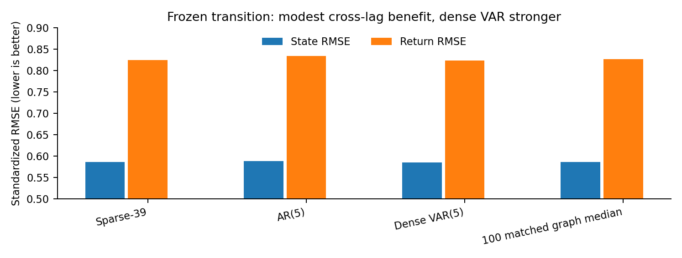
Archived, pooled FI-2010 transition reconstruction. Deep red/negative evidence is not omitted: dense VAR(5) has the lowest displayed error.
Sparse-39 reduces pooled state RMSE by against AR(5) at the rounded tabulated precision, and return RMSE by . The original higher-precision outputs report and , respectively; these are rounding, not contradictory experiments. Yet dense VAR(5) improves on both and has smaller joint NLL. In the matched random-graph challenge, Sparse-39 beats 85/100 source-identity alternatives for state RMSE, 90/100 for joint NLL, 93/100 for return RMSE, and 95/100 for return NLL. This is descriptive graph-specific evidence, not a selection-adjusted -value; the alternatives are fitted on the same observational system after graph discovery.
Interpretation. Adding a few cross-lags contributes small predictive information above the strong own-history persistence, but the selected sparse structure is not an error-minimizing substitute for all cross-lags. The graph’s value is inspectable conditional structure plus calibrated state-space queries, not the broadest possible fit. Figure 1 does not establish economic benefit or true causal direction.

Matched three-class forecasts
Identical retrospective forecast rows for each model at a given publisher horizon. LL is multiclass log loss; lower is better.
 | Matched | DeepLOB LL | DBN LL | Prior LL | DBN DeepLOB
10 | 137,952 | 0.4546 | 0.4984 | 0.8292 | +0.0438
20 | 137,802 | 0.6459 | 0.7142 | 0.9578 | +0.0683
30 | 137,652 | 0.6015 | 0.9368 | 1.0302 | +0.3353
50 | 137,352 | 0.5606 | 1.0711 | 1.1096 | +0.5105
100 | 136,602 | 0.5695 | 1.1477 | 1.1614 | +0.5782
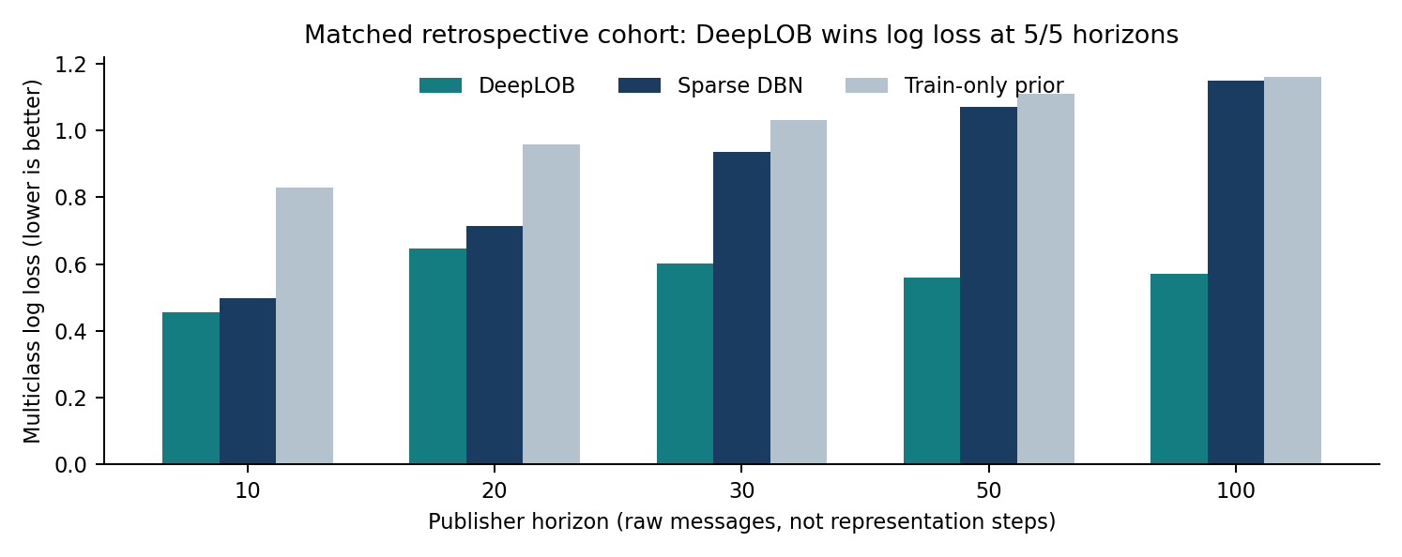
Matched retrospective log loss at the five publisher horizons; DeepLOB wins this particular probabilistic forecasting KPI at all five.
DeepLOB-style probabilities have smaller log loss at all horizons (Table 3), falsifying a generic DBN forecasting-superiority claim. At , however, DBN balanced accuracy is versus for DeepLOB, and Brier is versus despite DeepLOB’s better log loss ( versus ). This discrepancy is substantive: different proper scores respond differently to rare overconfident mistakes, while balanced accuracy reflects a decision rule. DeepLOB uses a richer input window and different model capacity, so the result cannot isolate the causal discovery algorithm or prove edge invalidity. The prior remains a strong reference as horizons increase.

Exact one-step missing-state inference
Archived masked-state inference ablation. A positive gain favors Sparse-39 over the equal-history AR(5); all values are small absolute gains, not percentages.
Missing current evidence | RMSE gain | Joint NLL gain | coverage gain
L1 imbalance | 0.000000 | 0.000000 | 0.000000
OFI proxy | +0.000332 | +0.000661
Both imbalances | 0.000000 | 0.000000 | 0.000000
Liquidity |  |  | +0.000672
Return + OFI | +0.004752 | +0.013698
History only | +0.002209 | +0.013261
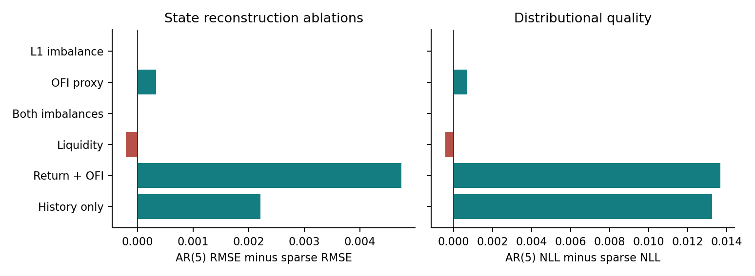
The partial-observation advantage is mask-specific. In the liquidity mask, the sparse graph does not win.
The focal Return+OFI mask gains 0.004752 state RMSE and 0.013698 joint NLL, but has worse absolute marginal 90% coverage error by 0.005984. Likewise, the liquidity mask modestly favors AR(5). The source Step 8 static/temporal decomposition records a 0.360443 history-over-static RMSE gain in the history-only setting, compared with just 0.002209 due to extra sparse cross-lags. Thus temporal persistence explains much more than the identity of the selected cross edges. The marginal interval metric cannot be claimed to measure simultaneous joint credible-set coverage. A correlated- sensitivity can affect these values, but replaces the primary diagonal- conditional-independence assumption; it is not silently substituted into the main results.

Consecutive observation gaps: adverse robustness result
The source Step 9 uses 697 spaced retrospective endpoints (Day 8: 277; Day 9: 260; Day 10: 160), synthetic gaps of 1, 5 or 20 representation steps, two evidence masks, and horizons 10/20. In all 12 pooled mask–gap–horizon cells, the train-frequency prior’s log loss is lower than the DBN’s. The zero-history and partially masked cases use exactly the specified endpoints. They are not naturally observed exchange-feed outages.
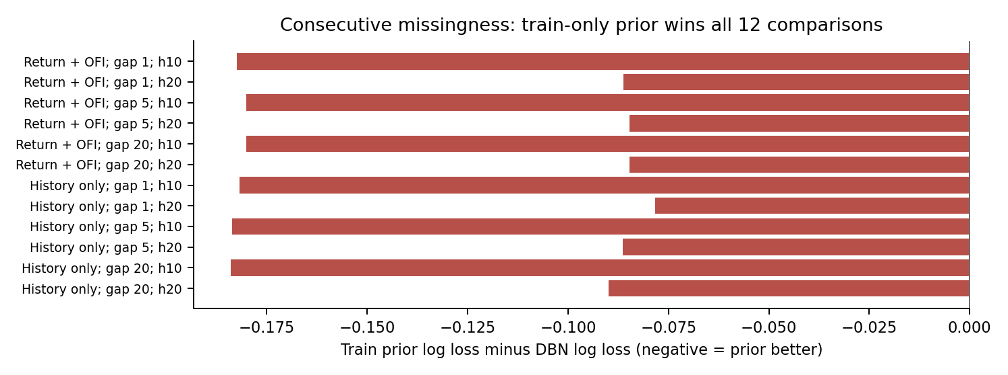
Negative prior-minus-DBN log-loss improvements indicate DBN failures across all 12 tested consecutive-gap conditions.
Interpretation. A slightly better sparse graph than AR(5) does not imply a useful calibrated outcome forecast when evidence stops arriving: recursive state uncertainty and misspecification matter. This falsifies the strongest robustness interpretation of H3. The safe deployment implication is to maintain a fallback prior and detect missing-feed regimes; this study does not justify a trading system.

Statistical variation, calibration, and broader robustness

Day-block variability and statistical credibility
DeepLOB log-loss advantage over DBN, by three historically inspected days. Mean sample SD is descriptive only; SD is reconstructed algebraically from rounded day minimum/maximum/mean in the executed source.
 | Days won | Daily mean SD | Min day | Max day
10 | 3/3 |  | 0.0146 | 0.0571
20 | 3/3 |  | 0.0362 | 0.0879
30 | 3/3 |  | 0.2938 | 0.3556
50 | 3/3 |  | 0.4602 | 0.5434
100 | 3/3 |  | 0.4557 | 0.6450
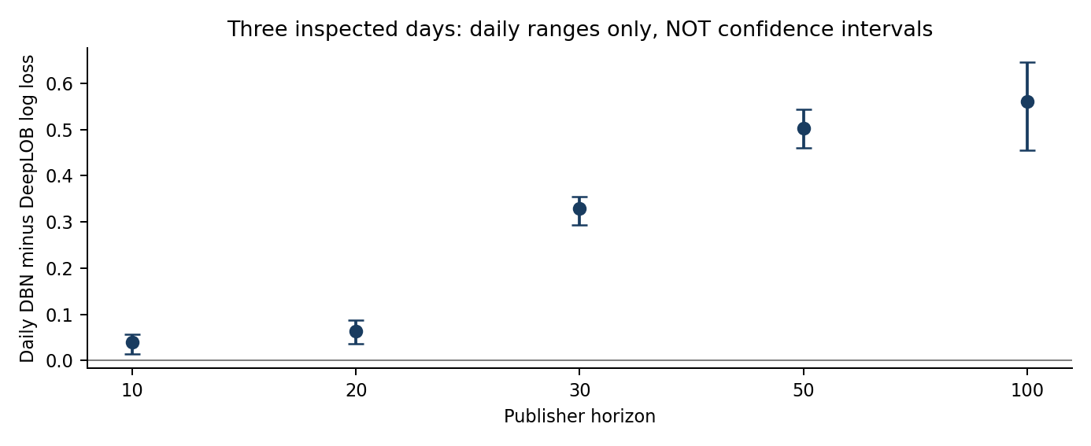
Observed three-day range of retrospective log-loss gains; vertical spreads are not confidence intervals.
For each horizon, the source Step 13/15 retains , , and the unweighted mean of precisely three day-level gaps. The third value is recoverable as and the displayed sample SD uses denominator ; precision is limited by the six-decimal input summaries. These three days are the only empirical outer blocks. We do not apply a window-level paired -test, Wilcoxon test, bootstrap CI, or ANOVA to 136k overlapping observations, nor call 100 alternative graphs 100 test splits. Even a nominal day-level 95% CI would be unreliable and non-confirmatory because , temporal dependence is plausible, and these days were exposed to previous research. Therefore no causal-edge -value or statistically significant forecast improvement is claimed. This is an explicit missing inferential requirement, not a suppressed negative result.

Probabilistic calibration and coverage error
Confidence ECE from the full-observation Step 6 cohort. Do not compare these values directly to the stricter DeepLOB-matched cohort in Table 3.
 | DBN ECE | Prior ECE | DBN LL | Prior LL
10 | 0.088780 | 0.101577 | 0.499358 | 0.830344
20 | 0.135478 | 0.126579 | 0.715190 | 0.958605
30 | 0.195836 | 0.143100 | 0.937313 | 1.030661
50 | 0.103171 | 0.068967 | 1.070878 | 1.109434
100 | 0.086855 | 0.063303 | 1.146834 | 1.160453
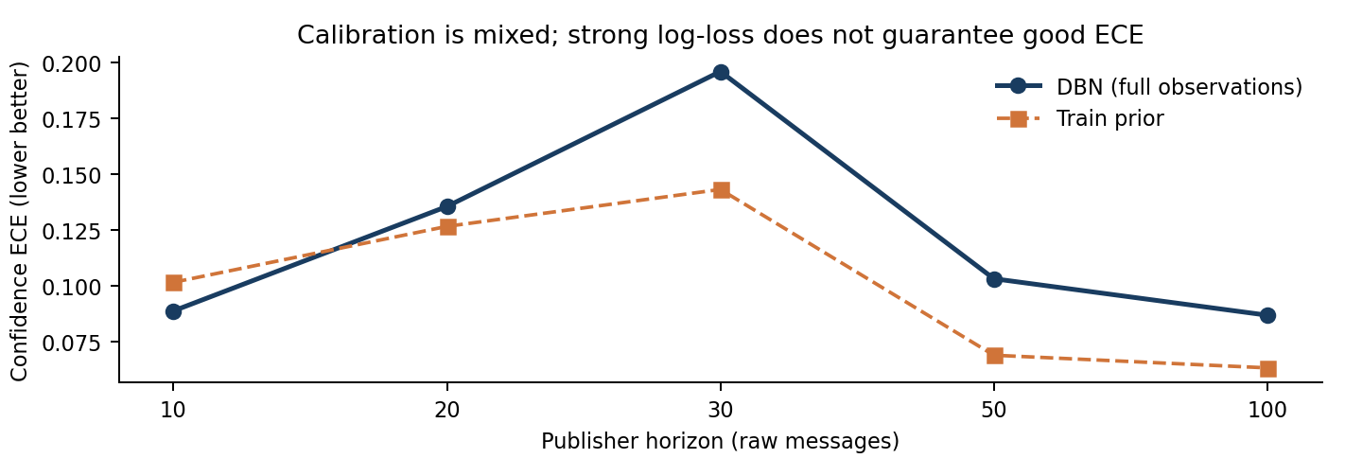
ECE by publisher horizon on the Step 6 cohort: DBN confidence calibration is not consistently better than the prior.
The DBN improves ECE versus the prior only at . For larger horizons, its ECE worsens even where its overall log loss remains lower; calibration and proper scoring rules capture different failures. Step 6 reports multiclass probabilities, not just hard classifications. Fully reconstructed reliability-bin diagrams would require the unavailable stored row-level probabilities and labels; no bin counts are invented. Likewise, posterior 90% marginal coverage errors must be read alongside RMSE and NLL, not replaced by a generic “well calibrated” claim.

Variation in structure, regime, data and numerical approximation
Random graph identity: The 100 target/lag-matched alternative graphs vary source identity, not graph density or empirical causal ground truth. The empirical comparison gives conditional rank fractions, not a valid structure-discovery hypothesis test. Constructed mechanisms: source Step 16 includes 40 replications of a known stable synthetic generator: a designated true-edge model beats AR(5) and a wrong-edge model 40/40 each, and dense 39/40; under a deliberately flipped coefficient, it beats neither AR(5) nor wrong-edge (0/40 each), but beats dense 29/40. This checks sensitivity to a change in data-generating mechanism and is not FI-2010 structure recovery. Sample size/noise/density: the supplied executed outputs do not contain a verified empirical sample-size-vs-SHD, injected-noise grid, or graph-density sweep. We do not fabricate them; a future preregistered synthetic protocol with true graphs would be needed.

Exact-versus-approximate inference: explicit numerical fixture
The M1 inference commitment and M2 handoff call for an inference-error-versus-time curve on the frozen real DBN. The uploaded notebook’s Drive-based fitted and transition checkpoints are not present here; a faithful new empirical timing benchmark cannot be asserted. The companion re-analysis notebook instead performed a six-dimensional diagonal-Gaussian synthetic numerical check with 50 deterministic sampling replications per Monte Carlo size, using exact conditional Gaussian mean as reference. As expected, posterior-mean error shrinks with larger Monte Carlo samples while analytic conditioning has no sampling error.
Synthetic-only Gaussian numerical test, 50 replications. The shown 95% intervals quantify conditional Monte Carlo variation for this fixture only, not FI-2010 uncertainty.
MC | Mean RMSE | Sample SD | 95% CI (fixture) | 50-run time (s)
32 | 0.14945 | 0.07302 | [0.12869, 0.17020] | 0.0100
128 | 0.09150 | 0.04786 | [0.07789, 0.10510] | 0.0048
512 | 0.04226 | 0.02179 | [0.03607, 0.04845] | 0.0063
2048 | 0.01994 | 0.01236 | [0.01643, 0.02346] | 0.0101
8192 | 0.00825 | 0.00561 | [0.00666, 0.00984] | 0.0249
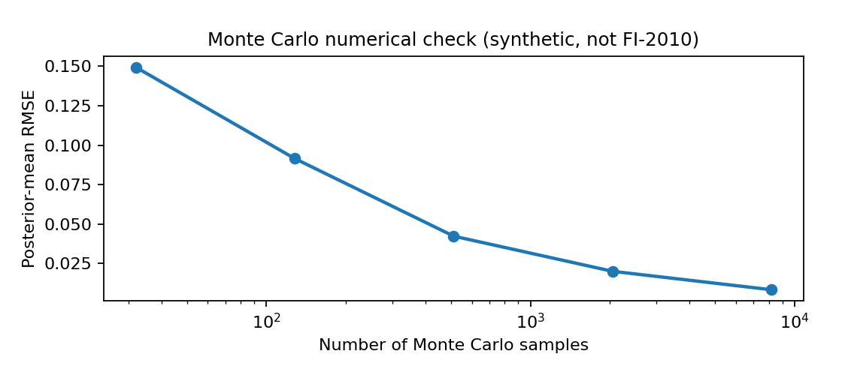
Exact Gaussian versus sampled mean, synthetic numerical fixture only; wall-clock time depends on this run’s implementation and hardware.
Times are totals for 50 samples-of-size- experiments, not times for each posterior query; small- runtimes are noisy/non-monotonic and should not be used for hardware-independent speed claims. The earlier M2 report contained a different numerical test (RMSE 0.228 at 32 to 0.0288 at 2,048). Neither is a real-data benchmark. The required real frozen-DBN inference timing therefore remains contingent on loading the original checkpoints, and is identified as an incomplete experiment rather than a market result.

Revised SOTA positioning
Structure-learning anchor: Gerhardus and Runge (NeurIPS 2020; DLR Institute of Data Science) propose LPCMCI for high-recall discovery under autocorrelation and latent confounders . Problem: autocorrelated observational time series. Representation: temporal causal graphs with orientation ambiguity. Learning: iterative CI testing/orientation rules. Inference/evaluation: structural discovery evaluated on controlled graphical models, not a learned six-state DBN posterior or LOB trading performance. Transfer to CausalLOB: use LPCMCI for candidate lagged relations, challenge source–target families beyond discovery days, then freeze an explicit Gaussian inference model. Limitations: observational assumptions and no FI-2010 ground-truth DAG prevent a causal recovery claim. Our random-identity ranking is not a reproduction of the NeurIPS SHD/recall benchmarks.
Applied forecasting comparator: Zhang, Zohren and Roberts’ DeepLOB (IEEE TSP, 2019) combines neural LOB window representation and supervised prediction . The uploaded notebook’s DeepLOB-style model offers a predictive reference. It has lower matched log loss across all five horizons (Table 3) but different features, receptive field and capacity, so this is not a causal-discovery comparison or claim to reproduce a published SOTA leaderboard. Repositioning after M3: CausalLOB is an interpretable, inspectable probabilistic baseline with limited incremental edge-specific transition gains and material gaps in prediction robustness and calibration. That narrower conclusion supersedes any optimistic M1 framing; it still delivers a substantive Representation–Learning–Inference evaluation.

Discussion and limitations
What worked: frozen graph fidelity, boundary-safe temporal modeling, probabilistic outcome outputs, exact masked-state queries, numerical validity checks, and certain positive graph-specific ablations. What did not: dense VAR has lower transition error, DeepLOB has lower matched forecast log loss, a class prior wins all consecutive-gap forecast cells, and probability calibration is inconsistent. These negatives are central to the scientific interpretation, not exceptions to hide.
Limitations: (i) only three historically inspected empirical evaluation days; (ii) anonymous securities and a single benchmark; (iii) missing original Drive files, preventing fresh full-data replay of fitted checkpoints; (iv) unknown exact publisher label-generation semantics; (v) observational edges and latent confounding; (vi) artificial missingness and conditional-diagonal assumptions; (vii) DeepLOB input and capacity mismatch; (viii) no verified deployment, transaction cost, fees, impact, real-time execution or net-P&L; (ix) no legitimate selection-adjusted causal significance claim.
M4 study design: acquire genuinely unseen compatible market data and verify label generation before evaluation; freeze new claims and conditions ex ante; use sufficiently many independent trading-day blocks for robust day-cluster intervals/paired inference; assess noise/missingness, graph size/density and real fitted- inference cost; archive failures and do not tune on previously examined Days 8–10. This is the evidential work still required for a stronger conclusion.

Conclusion
M3 follows the frozen M1/M2 research contract and provides matched probabilistic comparisons, meaningful ablations, descriptive uncertainty and negative-result robustness analysis. The sparse temporal DBN outperforms AR(5) on selected reconstruction metrics, but does not dominate richer predictors or a simple missingness fallback prior. Its credible contribution is an explicit uncertainty-aware representation and a transparent record of where that representation helps and fails. Results are retrospective and do not identify market causality, establish significance, or justify trading profitability.
[1] A. Ntakaris et al., “Benchmark Dataset for Mid-Price Forecasting of Limit Order Book Data with Machine Learning Methods,” Journal of Forecasting 37(8), 852–866, 2018. doi:10.1002/for.2543.
[2] A. Gerhardus and J. Runge, “High-Recall Causal Discovery for Autocorrelated Time Series with Latent Confounders,” Advances in Neural Information Processing Systems, 2020.
[3] J. Runge, “Discovering Contemporaneous and Lagged Causal Relations in Autocorrelated Nonlinear Time Series Datasets,” UAI, PMLR 124, 1388–1397, 2020.
[4] Z. Zhang, S. Zohren, and S. Roberts, “DeepLOB: Deep Convolutional Neural Networks for Limit Order Books,” IEEE Transactions on Signal Processing 67(11), 3001–3012, 2019. doi:10.1109/TSP.2019.2907260.
[5] Group G9, “CausalLOB: Milestone 1 Proposal & Scoping,” CSE 516, September 2026, M1_G9_Merged_Final.pdf.
[6] Group G9, “CausalLOB: Technical Foundation for a Dynamic Bayesian Network of Limit-Order-Book States,” CSE 516, Milestone 2, M2_G9_Report.pdf.
[7] CSE 516, “Major Project Guidelines,” provided course PDF and updated M3 deliverables notice.
[8] Group G9, PGM_Project (4).ipynb, previously executed CausalLOB Steps 6–9 and 13–16, archived outputs; source Drive checkpoints unavailable.

