**INTRODUCTION**

In today’s world, social media has become a very import part in everyone’s life, may that be teenagers or adults. In times like these where social media is on the boom, there exists a lot of platforms (websites and applications) which allow users to communicate and share media with each other in various different form, but none of these platforms give the user their privacy.

In the today’s changing world privacy has become the biggest concern for the general public. There exists no social media platform where a user can stay anonymous and interact with people over the internet.

INCAGE is a web based application designed in such a way that will once again revolutionize the world of social media. It is a platform dedicated toward the youth audience where people in the same locality can connect with each other and interact with one another in a way that was unheard before.  
Everyone on this platform is recognized via a general nickname. Which means users are anonymous on this platform. Once a user is successfully registered with the application they can connect to the people around them with a single click.

Once logged in, a user enters a chat room where the user can chat, send emoticons, and gossip about anything of the common interest, this chat room will have all the people in the person’s locality.

Chatting, is a method of using technology to bring people and ideas “together” despite of the geographical barriers. The technology has been available for years but the acceptance it was quit recent. Our project is an example of a chat server. It is made up of 2 applications the client application, which runs on the user’s Pc and server application, which runs on any PC on the network. To start chatting client should get connected to server where they can practice two kinds of chatting, public one (message is broadcasted to all connected users) and private one (between any 2 users only) and during the last one security measures were taken. Incage Supports public chatting as the only feature.

**OBJECTIVE**

Communication over a network is one field where this tool finds wide ranging application. Chat application establishes a connection between 2 or more systems connected over an intra- net or ad-hoc. This tool can be used for large scale communication campus of vast size, thus increasing the standard of co-operation. In addition, it converts the complex concept of sockets to a user friendly environment. This software can have further potentials, such as file transfer and voice chatting options that can be worked upon later.

The other objective of this application is to light up the fun element in a campus, it can be really interesting for the student of any campus to chat in just one room where everyone is anonymous and can share anything with each other which will be really fun.

It can also be helpful for those students who are introvert and cannot share their problems with anyone, so they can share their problems with everyone without letting anyone know their real identity.

**LOGO**



**LITRATURE REVIEW**

Many people want to use anonymous chat apps to meet people rather than converse with existing friends. Interacting with new people can let you make new friends, acquaintances, and perhaps even find a relationship partner.

There are of course inherent downsides to such communication or sharing of images, videos, information with complete strangers. However, steering clear of all of that, these apps can be a lot of fun and a great opportunity to form new bonds with people you would have otherwise never run into.

Before starting the designing of INCAGE we took into consideration some similar apps and the functions they had, after finding the vulnerabilities and limitaions of each we designed Incage.

We took the following applications into consideration before planning for INCAGE:

* **WHISPER**

Whisper is a very popular anonymous chat community that concentrates more on random user interactions to discuss everyday topics, steering away from adult-related chats.

Many Whisper users report positive experiences and fulfilling conversations with the people they have met.

You can privately confide in strangers who do not know your thoughts without worrying about being judged about them by someone you know.

Whisper does not support location based chat boxes which obviously INCAGE does

* Moco: Chat & Meet New People - Apps on Google Play**MOCO**

Moco is yet another way to converse anonymously with people about a variety of topics of mutual interest. This platform can be used to find any type of user based on gender, age, and sexual preference.

Those who hit it off can even play social games like FriendShop, MatchMe, and Street Wars. The information the user offers can be as extensive or as limited as a user wishes.

This supports private message but people cannot chat in groups, which is obviously a big feature of Incage and also people are not annonamous.

* **PSST!**

Psst is an interesting variation on chat apps as it uses the user’s Facebook account which is used to connect anonymously and secretly to Facebook friends.

The app even has block features to avoid having to have private conversations with anyone the user does not wish to interact with.

You can add friends to the conversation and in order to share photos with someone, the users must be friend-linked. This helps to avoid often unwanted random photos from strangers.

The company uses a person’s data from facebook and this cannot be trusted, INCAGE solves this problem very effectively.

Comparison table:

|  |  |  |  |  |
| --- | --- | --- | --- | --- |
|  | cdn-webcache.wimages.net/img/whisper-purple-log... | Moco: Chat & Meet New People - Apps on Google Play | Psst! Mobile App (@psstmobileapp) / Twitter |  |
| Public messaging | ✓ | ✓ | ✕ | ✓ |
| Location based chat rooms | ✕ | ✕ | ✕ | ✓ |
| Anonymous | ✓ | ✓ | ✓ | ✓ |
| Secure via email | ✓ | ✓ | ✕ | ✓ |
| Secure User data | ✕ | ✕ | ✕ | ✓ |
| Does not ask for users private information | ✓ | ✕ | ✕ | ✓ |
| Does not connect to a third party application | ✕ | ✓ | ✕ | ✓ |
| Notification via PING sound | ✕ | ✕ | ✕ | ✓ |

**METHODOLOGY**

Since the project was created as Project Based Learning and since waterfall methodology is used when:

* the requirements are constant and not changed regularly.
* A project is short
* The situation is calm
* Where the tools and technology used is consistent and is not changing
* When resources are well prepared and are available to use.

Waterfall model is a perfect fit for the Software Development Life Cycle of *Incage*

**WATERFALL MODEL:**

Winston Royce introduced the Waterfall Model in 1970.This model has five phases: Requirements analysis and specification, design, implementation, and unit testing, integration and system testing, and operation and maintenance. The steps always follow in this order and do not overlap. The developer must complete every phase before the next phase begins. This model is named "**Waterfall Model**", because its diagrammatic representation resembles a cascade of waterfalls.

The waterfall model depicts the software development process in a linear sequential flow; due to this, it is also referred to as a linear-sequential life cycle model, which indicates that any development process steps can start only after the previous one has finished. The stages are always done in this order and never overlap. Before moving on to the next step, the developer must finish the present one. The model is called a waterfall because it progresses from one phase to the next logically.

There is an emphasis on the natural succession of these phases. During the SDLC phase, each step is meant to execute specific tasks.

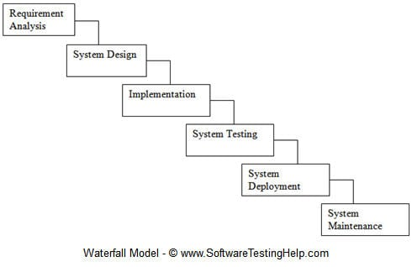

Fig.5.1

**Phases and work done in each phase:**

**1) Requirement & Analysis:**

All possible requirements of the system to be developed are captured in this phase and documented in a requirement specification document.

In this phase we:

* Conducted a brainstorming session,
* Decided upon an idea to proceed with,
* Discussed it with our mentor
* Finalized it,
* Completed literature survey
* Deviced a problem statement
* Classified the single problem in multiple levels
* Finalized the tool and technologies which will be used throughout the project life cycle,
* Gathered expertise in the required tool and technologies.

**2)System Design:**

The requirement specifications from first phase are studied in this phase and the system design is prepared. This system design helps in specifying hardware and system requirements and helps in defining the overall system architecture.

In this phase we:

* Created the outline map of the system,
* Studied detailed use cases,
* Decided the control flow of all web pages
* Created UML diagrams,

**3)Implementation:**

With inputs from the system design, the system is first developed in small programs called units, which are integrated in the next phase. Each unit is developed and tested for its functionality, which is referred to as Unit Testing.

In this phase we:

* Created a server by using the designs from the last phase,
* Wrote code for the server application,
* Wrote code and locally hosted a client

**4) System Testing**

All the units developed in the implementation phase are integrated into a system after testing of each unit. Post integration the entire system is tested for any faults and failures.

In this phase we:

* Hosted the webpages over different machines and different interpreters,
* Unified all implemented pieces of code together into a single entity INCAGE.
* Thoroughly tested the web pages of all planned test cases, and drew conclusions

**5) Deployment:**

Once the functional and non-functional testing is done; the product is deployed in the customer environment or released into the market.

This phase is currently in progress.

**6) Maintenance:**

To enhance the product some better versions are released. Maintenance is done to deliver these changes in the customer environment.

Post deployment we aim for the proper maintenance of the application.

**PROJECT DESIGN**

**BEHAVIORAL MODELING:**

Behavioral diagrams visualize, specify, construct, and document the dynamic aspects of a system. The behavioral diagrams are categorized as follows: use case diagrams, interaction diagrams, state–chart diagrams, and activity diagrams.

UML Behavioral Diagrams depict the elements of a system that are dependent on time and that convey the dynamic concepts of the system and how they relate to each other. The elements in these diagrams resemble the verbs in a natural language and the relationships that connect them typically convey the passage of time.

In the project we have used two behavioral models to depict the system they are:

* Activity Diagram:

Activity diagram is basically a flowchart to represent the flow from one activity to another activity. The activity can be described as an operation of the system.

Activity is a particular operation of the system. Activity diagrams are not only used for visualizing the dynamic nature of a system, but they are also used to construct the executable system by using forward and reverse engineering techniques. The only missing thing in the activity diagram is the message part.

* Use Case Diagram

A use case diagram can summarize the details of your system's users (also known as actors) and their interactions with the system. To build one, you'll use a set of specialized symbols and connectors. An effective use case diagram can help your team discuss and represent scenarios in which your system or application interacts with people, organizations, or external systems, Goals that your system or application helps those entities (known as actors) achieve, & the scope of your system.

**ACTIVITY DIAGRAM OF INCAGE:**

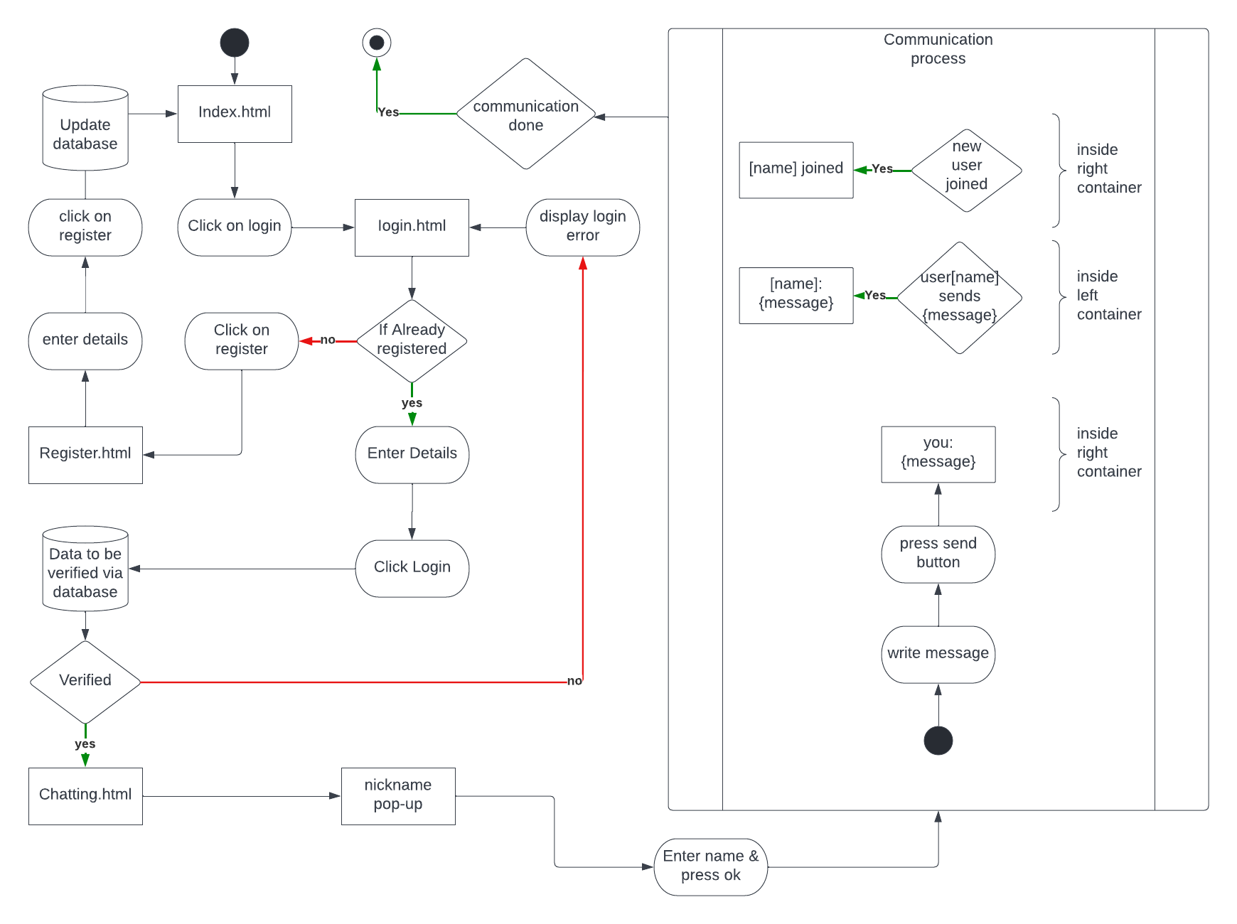

Fig.

Fig.6.1

**USE CASE DIAGRAM OF INCAGE:**

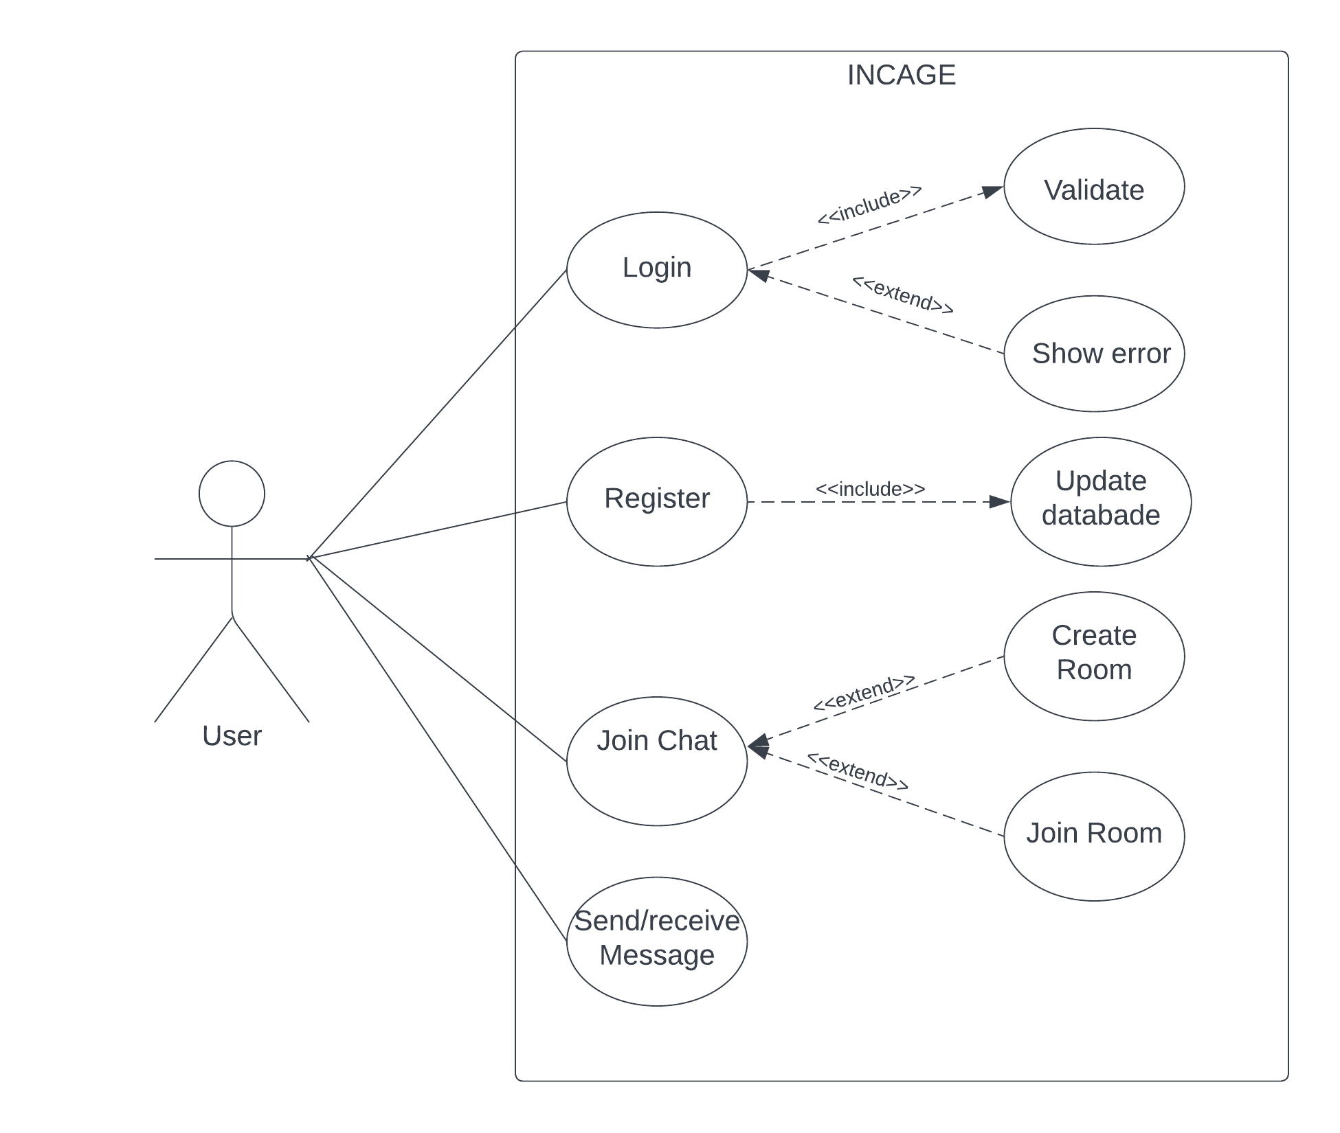

Fig. 6.2

**IMPLEMENTATION**

**Tools and Technology:**

To achieve the results, we used the following technologies:

|  |  |  |
| --- | --- | --- |
| S.No. | Name | Description |
| 1 | HTML | To create the skeleton of frontend part. |
| 2 | CSS | To Give the elements of the frontend a rich look and feel |
| 3 | Java Script | To handle events in the website and to connect to the socket servers |
| 4 | Node JS | To aid the implementation part |
| 5 | Socket.io | To provide live interaction between the server and instances of client |

* **HTML:**

The HyperText Markup Language or HTML is the standard [markup language](https://en.wikipedia.org/wiki/Markup_language) for documents designed to be displayed in a [web browser](https://en.wikipedia.org/wiki/Web_browser). It can be assisted by technologies such as [Cascading Style Sheets](https://en.wikipedia.org/wiki/Cascading_Style_Sheets) (CSS) and [scripting languages](https://en.wikipedia.org/wiki/Scripting_language) such as [JavaScript](https://en.wikipedia.org/wiki/JavaScript).

[Web browsers](https://en.wikipedia.org/wiki/Web_browser) receive HTML documents from a [web server](https://en.wikipedia.org/wiki/Web_server) or from local storage and [render](https://en.wikipedia.org/wiki/Browser_engine) the documents into multimedia web pages. HTML describes the structure of a [web page](https://en.wikipedia.org/wiki/Web_page) [semantically](https://en.wikipedia.org/wiki/Semantic_Web) and originally included cues for the appearance of the document.

[HTML elements](https://en.wikipedia.org/wiki/HTML_element) are the building blocks of HTML pages. With HTML constructs, [images](https://en.wikipedia.org/wiki/HTML_element#Images_and_objects) and other objects such as [interactive forms](https://en.wikipedia.org/wiki/Fieldset) may be embedded into the rendered page. HTML provides a means to create [structured documents](https://en.wikipedia.org/wiki/Structured_document) by denoting structural [semantics](https://en.wikipedia.org/wiki/Semantics) for text such as headings, paragraphs, lists, [links](https://en.wikipedia.org/wiki/Hyperlink), quotes and other items. HTML elements are delineated by tags, written using [angle brackets](https://en.wikipedia.org/wiki/Bracket#Angle_brackets). Tags such as <img /> and <input /> directly introduce content into the page. Other tags such as <p> surround and provide information about document text and may include other tags as sub-elements. Browsers do not display the HTML tags but use them to interpret the content of the page.

In 1980, [physicist](https://en.wikipedia.org/wiki/Physicist) [Tim Berners-Lee](https://en.wikipedia.org/wiki/Tim_Berners-Lee), a contractor at [CERN](https://en.wikipedia.org/wiki/CERN), proposed and prototyped [ENQUIRE](https://en.wikipedia.org/wiki/ENQUIRE), a system for CERN researchers to use and share documents. In 1989, Berners-Lee wrote a memo proposing an [Internet](https://en.wikipedia.org/wiki/Internet)-based [hypertext](https://en.wikipedia.org/wiki/Hypertext) system. Berners-Lee specified HTML and wrote the browser and server software in late 1990. That year, Berners-Lee and CERN [data systems](https://en.wikipedia.org/wiki/Data_system) engineer [Robert Cailliau](https://en.wikipedia.org/wiki/Robert_Cailliau) collaborated on a joint request for funding, but the project was not formally adopted by CERN. In his personal notesfrom 1990 he listed "some of the many areas in which hypertext is used" and put an [encyclopedia](https://en.wikipedia.org/wiki/Encyclopedia) first.

The first publicly available description of HTML was a document called ["HTML Tags"](http://info.cern.ch/hypertext/WWW/MarkUp/Tags.html), first mentioned on the Internet by Tim Berners-Lee in late 1991. It describes 18 elements comprising the initial, relatively simple design of HTML. Except for the hyperlink tag, these were strongly influenced by [SGMLguid](https://en.wikipedia.org/wiki/SGMLguid" \o "SGMLguid), an in-house [Standard Generalized Markup Language](https://en.wikipedia.org/wiki/Standard_Generalized_Markup_Language) (SGML)-based documentation format at CERN. Eleven of these elements still exist in HTML 4.

HTML is a [markup language](https://en.wikipedia.org/wiki/Markup_language) that [web browsers](https://en.wikipedia.org/wiki/Web_browser) use to interpret and [compose](https://en.wikipedia.org/wiki/Typesetting) text, images, and other material into visual or audible web pages. Default characteristics for every item of HTML markup are defined in the browser, and these characteristics can be altered or enhanced by the web page designer's additional use of [CSS](https://en.wikipedia.org/wiki/Cascading_Style_Sheets). Many of the text elements are found in the 1988 ISO technical report TR 9537 Techniques for using SGML, which in turn covers the features of early text formatting languages such as that used by the [RUNOFF command](https://en.wikipedia.org/wiki/TYPSET_and_RUNOFF) developed in the early 1960s for the [CTSS](https://en.wikipedia.org/wiki/Compatible_Time-Sharing_System) (Compatible Time-Sharing System) operating system: these formatting commands were derived from the commands used by typesetters to manually format documents. However, the SGML concept of generalized markup is based on elements (nested annotated ranges with attributes) rather than merely print effects, with also the separation of structure and markup; HTML has been progressively moved in this direction with CSS.

Berners-Lee considered HTML to be an application of SGML. It was formally defined as such by the [Internet Engineering Task Force](https://en.wikipedia.org/wiki/Internet_Engineering_Task_Force) (IETF) with the mid-1993 publication of the first proposal for an HTML specification, the "Hypertext Markup Language (HTML)" Internet Draft by Berners-Lee and [Dan Connolly](https://en.wikipedia.org/wiki/Dan_Connolly_(computer_scientist)), which included an SGML [Document type definition](https://en.wikipedia.org/wiki/Document_type_definition) to define the grammar.The draft expired after six months, but was notable for its acknowledgment of the [NCSA Mosaic](https://en.wikipedia.org/wiki/Mosaic_(web_browser)) browser's custom tag for embedding in-line images, reflecting the IETF's philosophy of basing standards on successful prototypes. Similarly, [Dave Raggett](https://en.wikipedia.org/wiki/Dave_Raggett)'s competing Internet-Draft, "HTML+ (Hypertext Markup Format)", from late 1993, suggested standardizing already-implemented features like tables and fill-out forms.

After the HTML and HTML+ drafts expired in early 1994, the IETF created an HTML Working Group, which in 1995 completed "HTML 2.0", the first HTML specification intended to be treated as a standard against which future implementations should be based.

Further development under the auspices of the IETF was stalled by competing interests. Since 1996, the HTML specifications have been maintained, with input from commercial software vendors, by the [World Wide Web Consortium](https://en.wikipedia.org/wiki/World_Wide_Web_Consortium) (W3C).However, in 2000, HTML also became an international standard ([ISO](https://en.wikipedia.org/wiki/International_Organization_for_Standardization)/[IEC](https://en.wikipedia.org/wiki/International_Electrotechnical_Commission) 15445:2000). HTML 4.01 was published in late 1999, with further errata published through 2001. In 2004, development began on HTML5 in the [Web Hypertext Application Technology Working Group](https://en.wikipedia.org/wiki/Web_Hypertext_Application_Technology_Working_Group) (WHATWG), which became a joint deliverable with the W3C in 2008, and completed and standardized on 28 October 2014.

* **CSS**

Cascading Style Sheets (CSS) is a [style sheet language](https://en.wikipedia.org/wiki/Style_sheet_language) used for describing the [presentation](https://en.wikipedia.org/wiki/Presentation_semantics) of a document written in a [markup language](https://en.wikipedia.org/wiki/Markup_language) such as [HTML](https://en.wikipedia.org/wiki/HTML) or XML (including XML dialects such as SVG, MathML or XHTML).[[1]](https://en.wikipedia.org/wiki/CSS#cite_note-1) CSS is a cornerstone technology of the [World Wide Web](https://en.wikipedia.org/wiki/World_Wide_Web), alongside HTML and [JavaScript](https://en.wikipedia.org/wiki/JavaScript).[[2]](https://en.wikipedia.org/wiki/CSS#cite_note-2)

CSS is designed to enable the separation of presentation and content, including [layout](https://en.wikipedia.org/wiki/Page_layout), [colors](https://en.wikipedia.org/wiki/Color), and [fonts](https://en.wikipedia.org/wiki/Typeface).[[3]](https://en.wikipedia.org/wiki/CSS#cite_note-3) This separation can improve content [accessibility](https://en.wikipedia.org/wiki/Accessibility); provide more flexibility and control in the specification of presentation characteristics; enable multiple [web pages](https://en.wikipedia.org/wiki/Web_page) to share formatting by specifying the relevant CSS in a separate .css file, which reduces complexity and repetition in the structural content; and enable the .css file to be [cached](https://en.wikipedia.org/wiki/Cache_(computing)) to improve the page load speed between the pages that share the file and its formatting.

Separation of formatting and content also makes it feasible to present the same markup page in different styles for different rendering methods, such as on-screen, in print, by voice (via speech-based browser or [screen reader](https://en.wikipedia.org/wiki/Screen_reader)), and on [Braille-based](https://en.wikipedia.org/wiki/Braille_display) tactile devices. CSS also has rules for alternate formatting if the content is accessed on a [mobile device](https://en.wikipedia.org/wiki/Mobile_device).[[4]](https://en.wikipedia.org/wiki/CSS#cite_note-4)

The CSS specifications are maintained by the [World Wide Web Consortium](https://en.wikipedia.org/wiki/World_Wide_Web_Consortium) (W3C). Internet media type ([MIME type](https://en.wikipedia.org/wiki/MIME_media_type)) text/css is registered for use with CSS by RFC 2318 (March 1998). The W3C operates a free [CSS validation service](https://en.wikipedia.org/wiki/W3C_Markup_Validation_Service#CSS_validation) for CSS documents.[[5]](https://en.wikipedia.org/wiki/CSS#cite_note-5)

In addition to HTML, other markup languages support the use of CSS including [XHTML](https://en.wikipedia.org/wiki/XHTML), [plain XML](https://en.wikipedia.org/wiki/Plain_Old_XML), [SVG](https://en.wikipedia.org/wiki/Scalable_Vector_Graphics), and [XUL](https://en.wikipedia.org/wiki/XUL).

* Java Script:

JavaScript,[[10]](https://en.wikipedia.org/wiki/JavaScript#cite_note-10) often abbreviated JS, is a [programming language](https://en.wikipedia.org/wiki/Programming_language) that is one of the core technologies of the [World Wide Web](https://en.wikipedia.org/wiki/World_Wide_Web), alongside [HTML](https://en.wikipedia.org/wiki/HTML) and [CSS](https://en.wikipedia.org/wiki/CSS).[[11]](https://en.wikipedia.org/wiki/JavaScript#cite_note-11) As of 2022, 98% of [websites](https://en.wikipedia.org/wiki/Website) use JavaScript on the [client](https://en.wikipedia.org/wiki/Client_(computing)) side for [web page](https://en.wikipedia.org/wiki/Web_page) behavior,[[12]](https://en.wikipedia.org/wiki/JavaScript#cite_note-deployedstats-12) often incorporating third-party [libraries](https://en.wikipedia.org/wiki/Library_(computing)).[[13]](https://en.wikipedia.org/wiki/JavaScript#cite_note-lib_usage-13) All major [web browsers](https://en.wikipedia.org/wiki/Web_browser) have a dedicated [JavaScript engine](https://en.wikipedia.org/wiki/JavaScript_engine) to execute the [code](https://en.wikipedia.org/wiki/Source_code) on [users](https://en.wikipedia.org/wiki/User_(computing))' devices.

JavaScript is a [high-level](https://en.wikipedia.org/wiki/High-level_programming_language), often [just-in-time compiled](https://en.wikipedia.org/wiki/Just-in-time_compilation) language that conforms to the [ECMAScript](https://en.wikipedia.org/wiki/ECMAScript) standard.[[14]](https://en.wikipedia.org/wiki/JavaScript#cite_note-tc39-14) It has [dynamic typing](https://en.wikipedia.org/wiki/Dynamic_typing), [prototype-based](https://en.wikipedia.org/wiki/Prototype-based_programming) [object-orientation](https://en.wikipedia.org/wiki/Object-oriented_programming), and [first-class functions](https://en.wikipedia.org/wiki/First-class_function). It is [multi-paradigm](https://en.wikipedia.org/wiki/Programming_paradigm), supporting [event-driven](https://en.wikipedia.org/wiki/Event-driven_programming), [functional](https://en.wikipedia.org/wiki/Functional_programming), and [imperative](https://en.wikipedia.org/wiki/Imperative_programming) [programming styles](https://en.wikipedia.org/wiki/Programming_paradigm). It has [application programming interfaces](https://en.wikipedia.org/wiki/Application_programming_interface) (APIs) for working with text, dates, [regular expressions](https://en.wikipedia.org/wiki/Regular_expression), standard [data structures](https://en.wikipedia.org/wiki/Data_structure), and the [Document Object Model](https://en.wikipedia.org/wiki/Document_Object_Model) (DOM).

The ECMAScript standard does not include any [input/output](https://en.wikipedia.org/wiki/Input/output) (I/O), such as [networking](https://en.wikipedia.org/wiki/Computer_network), [storage](https://en.wikipedia.org/wiki/Data_storage), or [graphics](https://en.wikipedia.org/wiki/Computer_graphics) facilities. In practice, the web browser or other [runtime system](https://en.wikipedia.org/wiki/Runtime_system) provides JavaScript APIs for I/O.

JavaScript engines were originally used only in web browsers, but are now core components of some [servers](https://en.wikipedia.org/wiki/Server_(computing)) and a variety of [applications](https://en.wikipedia.org/wiki/Application_software). The most popular runtime system for this usage is [Node.js](https://en.wikipedia.org/wiki/Node.js).

Although [Java](https://en.wikipedia.org/wiki/Java_(programming_language)) and JavaScript are similar in name, [syntax](https://en.wikipedia.org/wiki/Syntax_(programming_languages)), and respective [standard libraries](https://en.wikipedia.org/wiki/Standard_library), the two languages are distinct and differ greatly in design.

**WEBPAGES:**

|  |  |
| --- | --- |
| **1** | **Server Side** |
| 1.1 | Index.js |
| 1.2 | Package.json |
| **2** | **Client** |
| 2.1 | Index.html |
| 2.2 | Chatting.html |
| 2.3 | Login.html |
| 2.4 | Register.html |
| 2.5 | Style.css |

**SERVER SIDE:**

1. Index.html:

const io = require('socket.io')(8000)

const users = {};

io.on('connection', socket =>{

socket.on('new-user-joined', name=>{

console.log("New User", name);

users[socket.id] = name;

socket.broadcast.emit('user-joined', name);

});

socket.on('send', message =>{

socket.broadcast.emit('receive', {message: message, name: users[socket.id]})

});

socket.on('disconnect', message =>{

socket.broadcast.emit('left',users[ServiceWorkerContainer.id])

delete users[socket.id];

});

})

**CLIENT SIDE:**

1. Index.html:

<!DOCTYPE html>

<html>

<head>

<meta charset="UTF-8">

<meta name="INCAGE" content="Aryan Sahu & Aayush Khare">

<title>Incage</title>

<link rel="icon" type="image/x-icon" href="images/favicon.png">

</head>

<body>

<a href="index.html"><h1 align="center" style="color:darkslategray"><i>Incage</i></h1>

</a>

<p align="center">"To the Sageins, for the Sageins, by the Sageins"</p>

<hr>

<pre> <img src="images/favicon.png" alt="INCAGE LOGO" style="height:250px;" style="vertical-align:middle" title="Incage Official Logo"></pre>

<hr>

<h4 style= "font-family: 'Gill Sans', 'Gill Sans MT', Calibri, 'Trebuchet MS', sans-serif;"align="center">Vision</h4>

<p align="center">Our Aim is to create a fun and anonymous web application for the

youth of today, we aim to create a new chatting

experience, in which people can enter chat room

according to their location.<br><br>

The user can choose any chat room available in their

locality and can chat & gossip with people anonymously.</p>

<hr>

<pre> <a href="login.html"><img src="images/login.png" alt="CLICK HERE TO LOGIN" height="75px"></pre>

</body>

</html>

1. Chatting.html:

<!DOCTYPE html>

<html lang="en">

<head>

<meta charset="UTF-8">

<meta name="viewport" content="width=device-width, initial-scale=1.0">

<title>Incage Chatting page</title>

<script defer src="http://localhost:8000/socket.io/socket.io.js"></script>

<script defer src="js/client.js"></script>

<link rel="stylesheet" href="css\style.css">

</head>

<body>

<nav>

<img class="logo" src="images/favicon.png"

</nav>

<br>

<div class="container">

</div>

<br>

<div class="send">

<form action="#" id="send-container">

<input type="text" name="messageInp" id="messageInp">

<button class="btn" type="submit">Send</button>

</form>

</div>

</body>

</html>

1. Login.html:

<!DOCTYPE html>

<html>

<head>

<meta charset="UTF-8">

<meta name="INCAGE" content="Authors: Aryan Sahu & Aayush Khare">

<title>Incage Longin page</title>

<link rel="icon" type="image/x-icon" href="images/favicon.png">

</head>

<body>

<a href="index.html"><h1 align="center" style="color:darkslategray"><i>Incage</i></h1>

</a>

<p align="center">"To the Sageins, for the Sageins, by the Sageins"</p>

<hr>

<form>

<label for="username">Username:</label><br>

<input type="text" id="username" name="username"><br><br>

<label for="password">Password:</label><br>

<input type="password" id="password" name="password">

<br><br>

<input type="submit" value="login">

</form>

<p>not yet registerd?<br>press the register button and start gossiping today </p>

<a href="register.html"><img src="images/reg.png" alt="Register Now" height="35"></a>

</body>

</html>

1. Regiter.html:

<!DOCTYPE html>

<html lang="en">

<head>

<meta charset="UTF-8">

<meta name="INCAGE" content="Aryan Sahu & Aayush Khare">

<title>Incage</title>

<link rel="icon" type="image/x-icon" href="images/favicon.png">

</head>

<body>

<a href="index.html"><h1 align="center" style="color:darkslategray"><i>Incage</i></h1>

</a>

<p align="center">"To the Sageins, for the Sageins, by the Sageins"</p>

<hr>

<form>

<label>Name: </label><br>

<input type="text" id="name" name="name" required><br><br>

<label>Nickname:</label><br>

<input type="text" id="nickname" name="nickname" required>

<label style="color:red">Note: This nickname will appear as your name in chat box, and this name alone makes you anonymous</label><br><br>

<label>E-mail: </label><br>

<input type="number" id="number" name="number"><br><br>

<label>Date of Birth: </label>

<input type="date" id="date" name="date"><br><br>

<button type="submit" value="login.html" href="login.html">submit</button><br>

</form>

</body>

</html>

**USER INTERFACE**

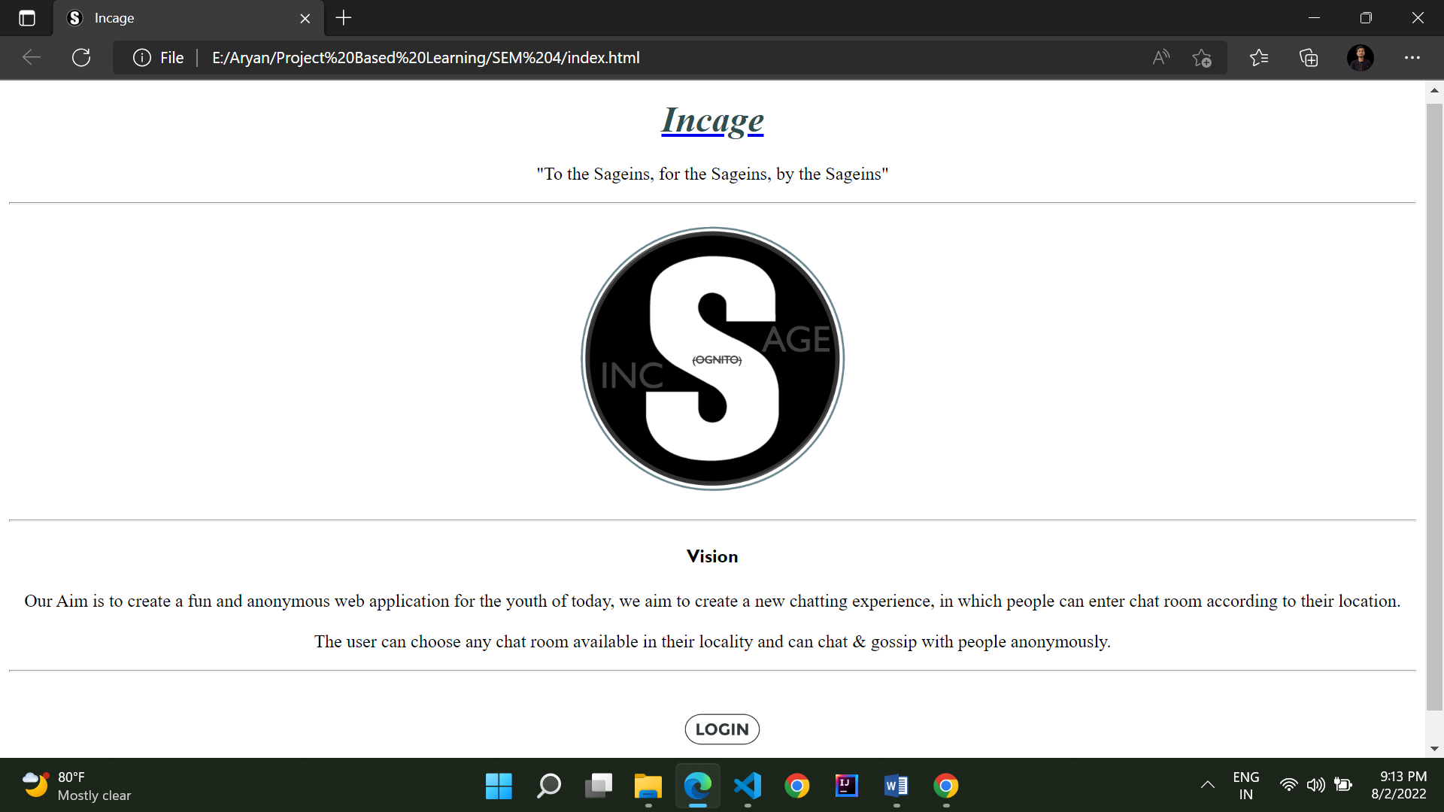

Fig.8.1

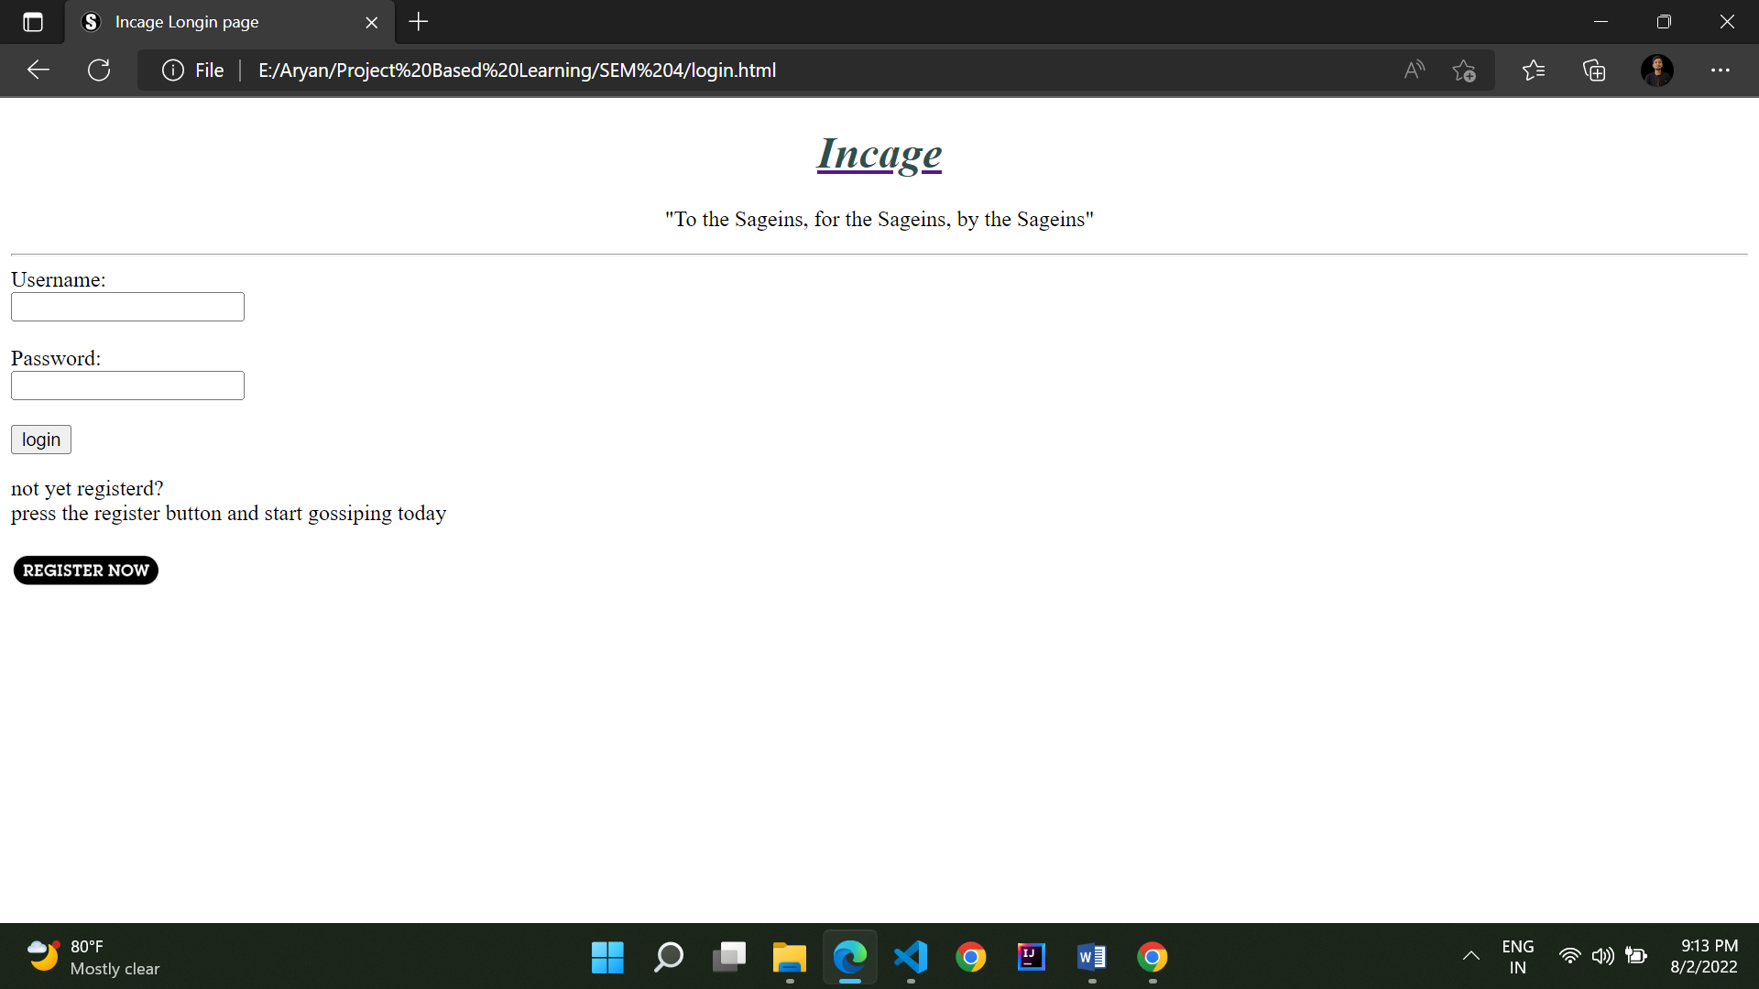

Fig.8.2

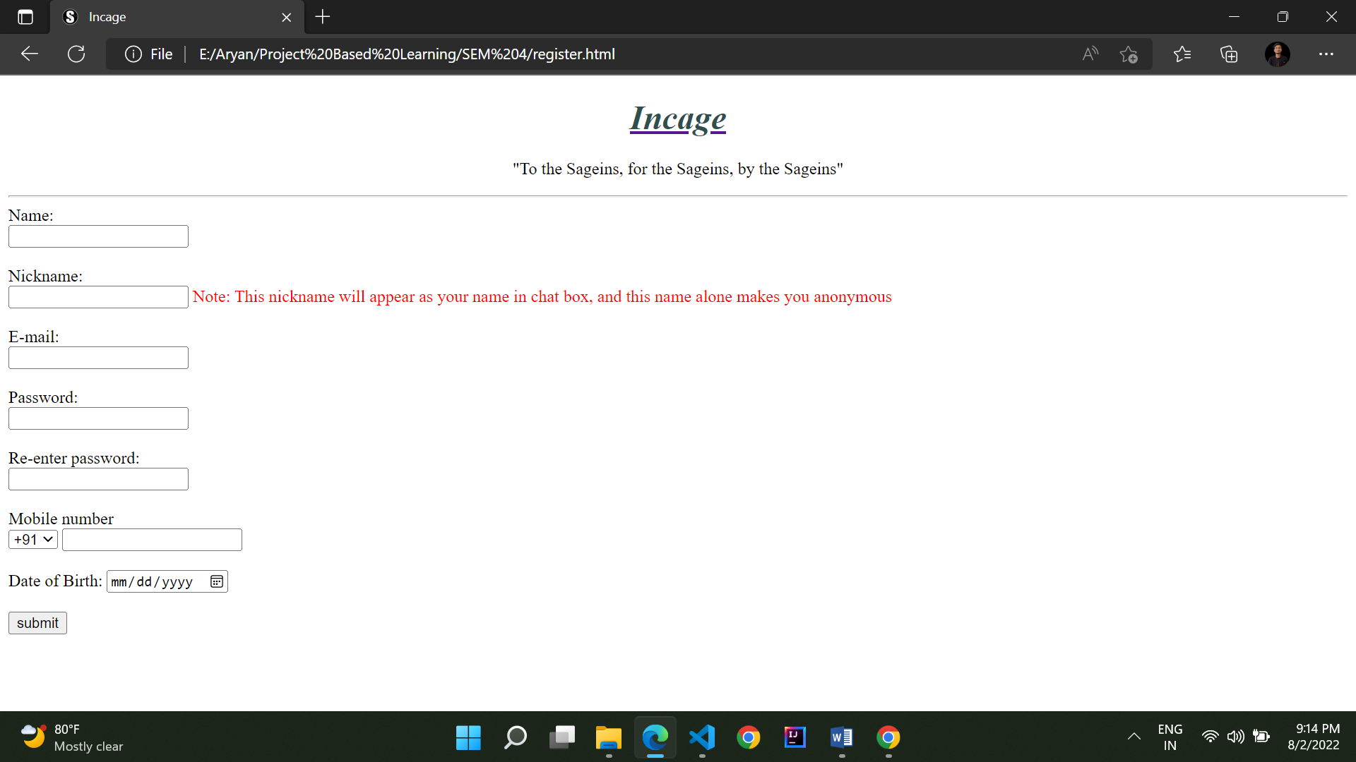

Fig.8.3

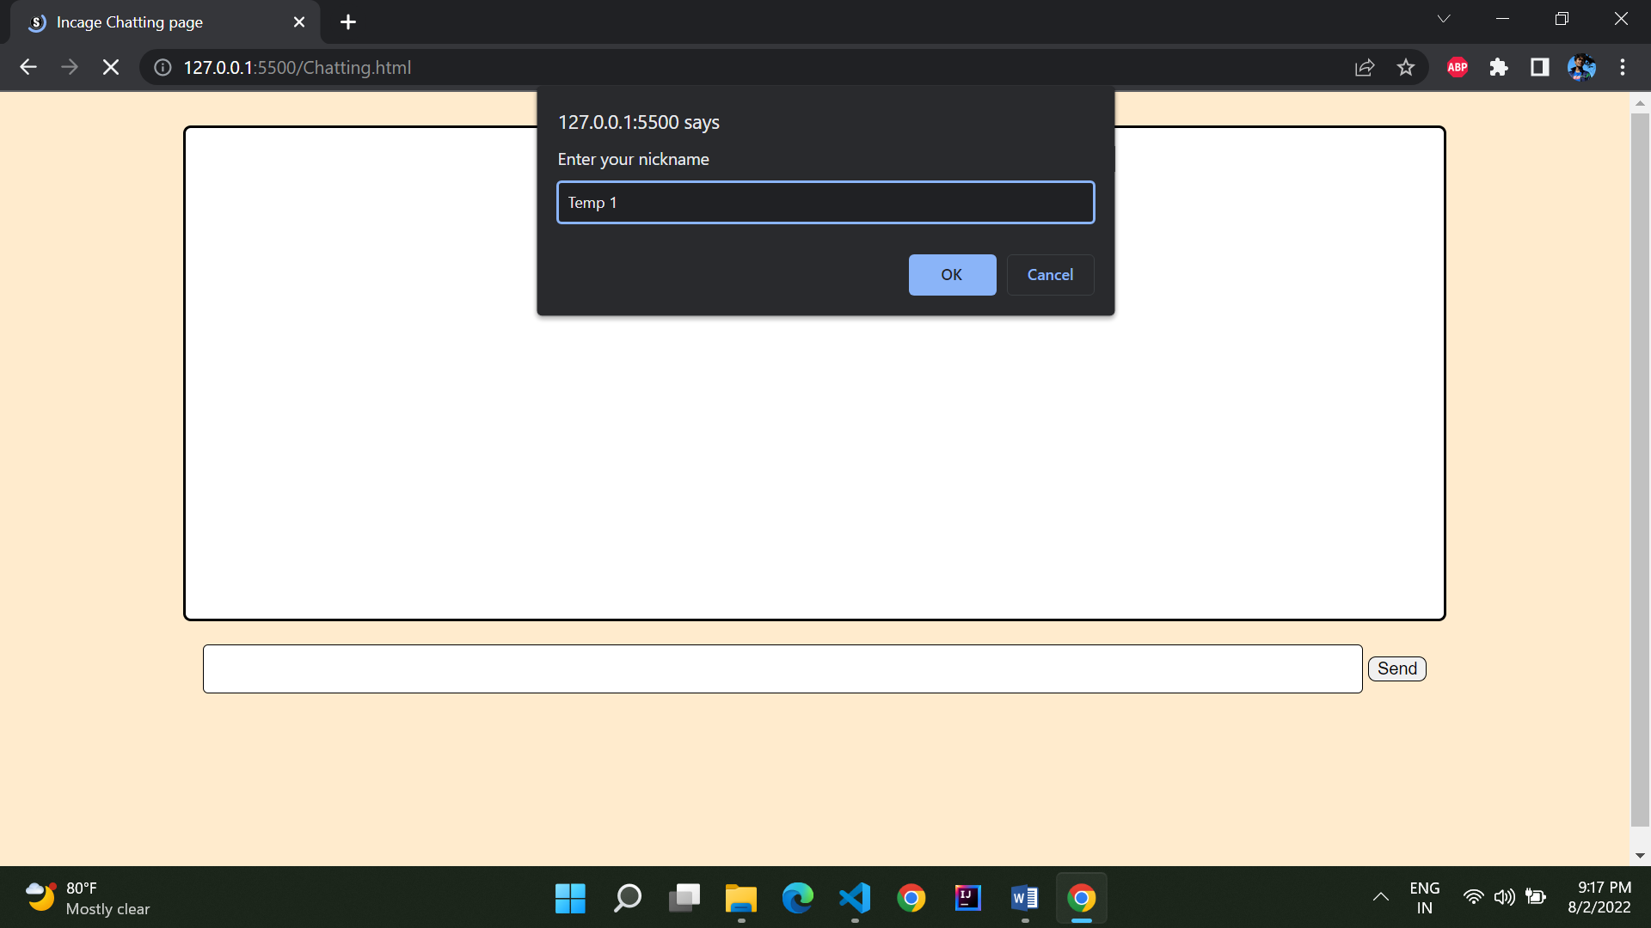

Fig.8.4

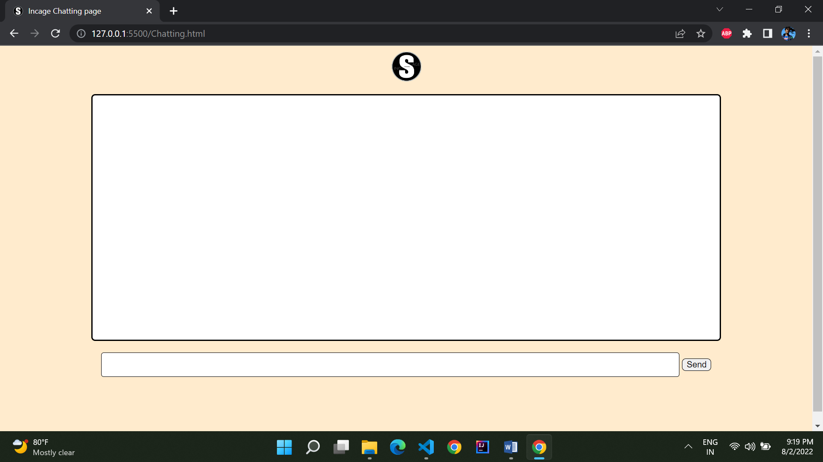

Fig.8.5

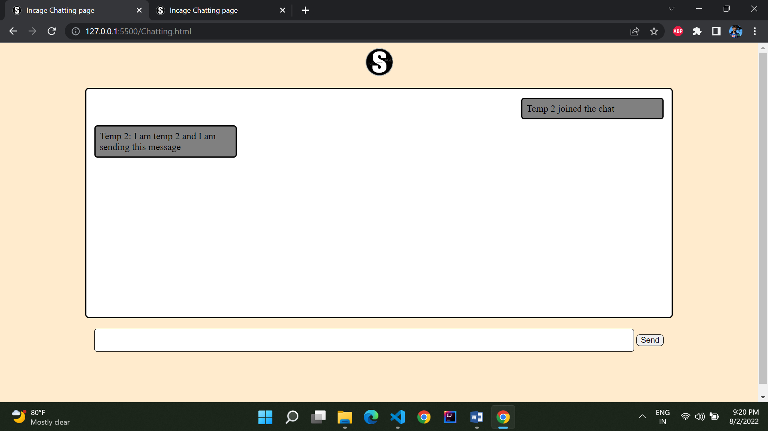

Fig.8.6

**Figure description:**

|  |  |  |
| --- | --- | --- |
| **S.No** | **Figure name** | **Description** |
| 1 | 8.1 | This is a snapshot of the home page of Incage, whenever any user or client will open our website this is the first page which will be loaded in their machines. |
| 2 | 8.2 | This is the login page, the registered users can login to their accounts via this page. Non registered users can register on the application by pressing the register button. |
| 3 | 8.3 | New user for registration are directed to this page, here they will fill their information and submit it. |
| 4 | 8.4 | Once a user is logged in successfully, this page loads in the memory, the user is asked for a nickname, the nickname which the user will enter will be his user name for the entire session. |
| 5 | 8.5 | If a user enter any chat room this is what the user see, a container which will hold messages, a container to type a message and a send button |
| 6 | 8.6 | This window shows the interaction between 2 users from the perspective of user 1 |

**CONCLUSION**

This project succeeded in creating web based application which named after our college and also on how the application works , i.e. working in **INCOGNITO** mode and also the college name **SAGE** and that’s how our application is named **INCAGE**. While creating the application we have came a long way in learning the new languages such as HTML , JSS , CSS .

Our aim was to made to a fun web based application and we have successfully completed it. New languages which we have learned though our journey of making this project possible has helped us a lot, the benefits of the languages were not immediate and also it was not easy but as it is said what is success without struggle. This will surely benefit us in the future too.

There were several unknown elements and errors in the start but however we have overcome them and completed our project with the help of the roadmap which we have decide. And with the help of this we have get know that planning is a really important part or we can say a key to ensure we go smoothly while working on a project so that we can complete the project in the particular time with discipline, and this will create a habit of working with a planned time table.

Teachers and classmates have motivated us to develop the application when we were thinking in the start and was not really sure about it , whenever our wheel got stuck our mentors were always there and we can say that it is also an outcome of out mentors and classmates and that’s why we have decided the tagline for our web based application i.e.

**“TO THE SAGIANS, FOR THE SAGIANS, BY THE SAGIANS”**

The technical difficulties encountered during the development of the project were reported, as were the logistic problems that were faced. Possible improvements to the system were identified, including more integration and linkage between different elements of the system and an improved courseware developer interface. There are many possible themes for future work based on this project.

**FUTURE WORK**

With a project such as this, there is always room for improvement and we will surely be going to work on this in the future and there are number of things which we have already thought of implementing in it, which are as follows

* In the future there are going to be number of rooms for the user and it will be their choice which room they want to get in and chat anonymously.
* The rooms will be geographically divided; each room will be divided in a x radius which will it cover.
* The security feature will be upgraded in an upcoming update of this application in which if any user in a room is not appropriate and disturbing the ambiance and the decorum according to the other users which are present, so all can vote for it and ban that user to enter in that room for a particular time.
* There will always be a little more room for improving the user interface of this application which will make it look more attractive and eye catchy. By designing it in the way by which it represents its name, attributes, properties such anonymous users which have no identity.
* We will try to publish it publicly so everyone can use it in their respective areas and can join them and also we will provide a feedback block in the application itself so every user can give their feedback and what all new things they would like to see in the upcoming updates and in this way we can always be up to date in the market .

Improving this application with time to time is the Biggest **FUTURE WORK** which will never stop because it is said that we should never stop learning (as Sage University Bhopal says it “Project based learning”).

**REFERENCES**

* [**https://www.gotechtor.com/best-anonymous-chat-apps/#psst**](https://www.gotechtor.com/best-anonymous-chat-apps/#psst)
* [**https://www.mocospace.com/html/landingpage/index.jsp**](https://www.mocospace.com/html/landingpage/index.jsp)
* [**https://whisper.sh/terms**](https://whisper.sh/terms)
* [**https://www.tutorialspoint.com/html/index.htm**](https://www.tutorialspoint.com/html/index.htm)
* [**https://www.w3schools.com/js/**](https://www.w3schools.com/js/)
* [**https://www.youtube.com/watch?v=1Rs2ND1ryYc**](https://www.youtube.com/watch?v=1Rs2ND1ryYc)
* [**https://www.youtube.com/watch?v=3QNBVG2yqKA**](https://www.youtube.com/watch?v=3QNBVG2yqKA)
* [**https://www.youtube.com/watch?v=Q33KBiDriJY**](https://www.youtube.com/watch?v=Q33KBiDriJY)
* [**https://nodemon.io/**](https://nodemon.io/)
* [**https://github.com/socketio/socket.io**](https://github.com/socketio/socket.io)
* [**https://www.youtube.com/watch?v=ZKEqqIO7n-k**](https://www.youtube.com/watch?v=ZKEqqIO7n-k)