“DIGINOTE”
A notes Uploading App



A
PBL Report
is submitted to the
SAGE University Bhopal, M.P.
in partial fulfillment of the requirements for award of the Degree of

“Bachelor of Technology”

With specialization in

(Computer Science & Engineering)

UNDER THE GUIDANCE OF Prepared By:
Prof. Mukesh Dixit Anushka Agrawal (20BTE3CSE10005)
Engineering & Technology Ekta Agarwal (20BTE3CSE11015)
Yogita Bhargava(20BTE3CSE10037)

 | SANJEEV AGRAWAL GLOBAL EDUCATIONAL (SAGE)UNIVERSITY, BHOPAL

Department of Engineering & Technology

CERTIFICATE
This is to certify that the work embodies in this dissertation entitled “DIGINOTE" is being submitted by Anushka Agrawal[20BTE3CSE10005], Ekta Agarwal[20BTE3CSE11015] and Yogita Bhargava[20BTE3CE10037] for the fulfilment of the requirement for the award of "BTECH[CSE]" discipline to SAGE University, Bhopal (M.P.) during the academic year 2020-24 is a record of a bonafide piece of work, undertaken by him under the supervision of the undersigned.
HoS

Supervisor
Prof. Mukesh Dixit
BTECH(CSE)

SANJEEV AGRAWAL GLOBAL EDUCATIONAL (SAGE) UNIVERSITY, BHOPAL

Department of Engineering & Technology

CERTIFICATE OF APPROVAL

The Dissertation Entitled "DIGINOTE" being submitted by Anushka Agrawal[20BTE3CSE10005], Ekta Agarwal[20BTE3CSE11015], and Yogita Bhargava[20BTE3CSE10037] has been examined by us and is hereby approved for the award of " BTECH[CSE]", for which it has been submitted. It is understood that by this approval the undersigned does not necessarily endorse or approve any statement made, opinion expressed or conclusion draw therein, but approves he dissertation only for the purpose for which it has been submitted.

(Internal Examiner) (External Examiner)
SANJEEV AGRAWAL GLOBAL EDUCATIONAL (SAGE)UNIVERSITY, BHOPAL
Department of Engineering & Technology

DECLARATION

We hereby declare that the work, which is being presented in this dissertation entitled "DIGINOTE" for the fulfillment of the requirements for the award the degree of "BTECH[CSE]" submitted in the Department of Engineering and Technology Bhopal, M.P Bhopal, M.P is an authentic record own work carried under the guidance of Prof. Mukesh Dixit. We have not submitted the matter embodied in this report for the award of any other degree.
We also declare that “A check for Plagiarism has been carried out on this dissertation and is found within the acceptable limit and report of which is enclosed herewith.”

UNDER THE GUIDANCE NAME OFSTUDENTS Prof. Mukesh Dixit Anushka Agrawal (20BTE3CSE10005) Engineering & Technology Ekta Agarwal(20BTE3CSE11015)
Yogita Bhargava (20BTE3CSE10037)

HOS/Dean Sign with seal
SUB, Bhopal

ACKNOWLEDGEMENT

We would like to express my heartfelt gratitude to my supervisors Prof .Mukesh Dixit (Guide) and Prof. Nikhil Chaurasia (Co Guide) Department of Engineering & Technology Bhopal who encouraged me all throughout the course of the project. Their careful support and motivation were the prime factors contributing to the timely and successful completion of this project.
We owe an enormous debt of gratitude to my thesis guide, Prof .Mukesh Dixit (HOD CE), for guiding and inspiring me from the beginning through the end advice thesis with his intellectual advices and insightful suggestions. We truly appreciate and value his consistent feedback on my progress, which was always constructive and encouraging, and ultimately drove me to the right direction.
We also owe a great deal of thanks to several people who have helped and motivated me throughout my thesis work as well as throughout my postgraduate course at SOET, Bhopal, in particular, (HOS, SUB, Bhopal), and all teaching and non teaching staff of Engineering Department for their valuable assistances they offered me generously during the past two years.
Anushka Agrawal
(20BTE3CSE10005)
Ekta Agarwal
(20BTE3CSE11015)
Yogita Bhargava
(20BTE3CSE10037)

TABLE OF CONTENT

S.NO | TITLE | PAGE NO
1. | FRONT PAGE | I
2. | CERTIFICATE | II
3 | APPROVAL CERTIFICATE | III
4 | DECLARATION | IV
5 | ACKNOWLEDGEMENT | VI
6 | TABLE OF CONTENT | VII
7 | LIST OF FIGURES | VIII
CHAPTER 1 INTRODUCTION
1.1 | Introduction | 1
1.2 | Objective | 2
1.3 | Features
CHAPTER 2LITERATURE REVIEW
2.1 | Literature Review | 3
CHAPTER 3 MATERIAL AND METHODS
3.1 | Tools and Technology Used | 30
3.2 | Software and hardware Requirement | 30
3.2.1 | Methodology | 30
CHAPTER 4 EXERIMENTAL WORK
4.1 | UI Design | 46
CHAPTER 5 CONCLUSION AND FUTURE SCOPE
5.1 | CONCLUSION | 56
5.2 | FUTURE SCOPE | 56
5.3 | ADAVANTAGES
 | REFRENCES | 57

LIST OF FIGURES
S.NO | TITLE | PAGE NO
FIGURES
FIGURE 1 | WaterFall Model | 36
FIGURE 2 | Flow Diagram | 37
FIGURE 3 | Use Case Diagram | 51

1. INTRODUCTION

Today we see students facing the problem of finding the handwritten notes. The notes which consist of all the important topics which are important for exam . Although faculties provides all the study material but still the last minute notes before exam is something that is difficult for students to find. Many students make their own notes for the preparation of exam. But some students depend on their classmates or seniors. A lot of content and study material is already there on the internet but student gets confused eh\what to read and what not to read before exam. They just search for the main topics that is important for their exam.
According to the official data present on the internet we find that almost 70 percent of the student face the problem of finding the handwritten notes for their exam. We see that according to keyword search “notes” keyword is searched for no. of times a day. This is the problem of every college student, whether from engineering or any other branch. In our department, only many of the juniors face the problem of finding proper material or content for their study and they interacted with the seniors for the notes.
So keeping all these problems in mind we are providing a platform where user is provided with all the necessary handwritten notes that is uploaded by others. Anyone can upload their notes with good quality content. That is accessible to all others. And user can download and save it to there device. So it is accessible in offline mode also.

1.1Objective:
The main objective of our app is to provide a platform where user is provided with all the necessary handwritten notes, and to create a user friendly website.
- To provide all the study material at one place.
- To provide the Important topics
- To provide all the Point-to-point notes
- Best handwritten notes

1.2Features
- User can upload and Download their notes.
- One can connect with any one living in any part of the world overall user can send the request and follow someone until he or she accept the request.
- Group chat functionality is provided for the users so that they can exchange there notes with wide range range of network.
- User can like, comment and share the notes that is uploaded.
- User can save the notes in offline mode as well.

2.LITERATURE REVIEW:
1.docmerit.com:

FOUNDED IN 2019

SELL STUDY NOTES ONLINE
Upload your first study notes on Docmerit and start earning today!
Docmerit offers an online platform to sell study notes, so you can make the most of your studies. Within seconds, you're able to create your personal study store. Making effective study notes will not only boost your grades but also give you some extra cash.
But the drawbacks are:
- First, when you visit them and buy, you cannot look for each and every topics right at the moment. Sometimes they show you different material and then when you purchase they put different notes, or the ones which contain less content.
- Once you are out of their shop, there is no guarantee.

2.studocu.com:
FOUNDED IN 2013
Founded by four students, to exchange study documents with each other and together strive for better grades.
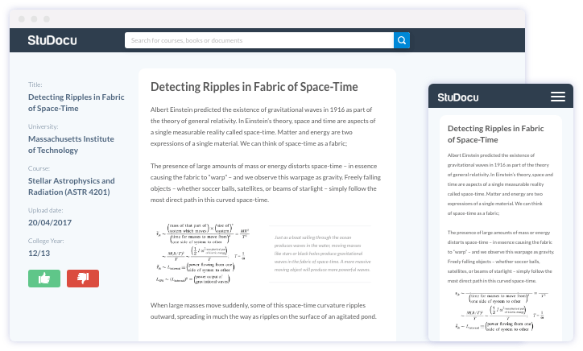
Figure 1
This types of notes cannot be downloaded , share and we cannot chat for the doubt questions.
You cannot comment about the quality and quantity of notes provided. The pixels are not clear as it is computerized while zooming and sometimes when we take screenshort the quality is not clear.
FREE PDF’S: The pdf’s available free in most of the websites as well as apps

- Let me tell, first of all nothing is free, if you are visiting any site which is provided free pdfs, they contain a lot of malwares on sites and as well as attached with the files. You can surely see it while visiting their sites.
- So nothing is free, it's just you are paying the price with your privacy and data.

3. TOOLS AND TECHNOLOGIES
3.1 SOFTWARE AND HARDWARE REQUIREMENTS
- Software requirements
This software package is developed using java as a frontend which is supported by android system.
• Operating system- Android System
• Database Firebase-Firebase is used as a database as it easy to maintain and retrieve records .
• Development tools and Programming language- Android Studio, Firebase and java.
3.1.1 Java
As the project is developing an Android Application, the default programming language is Java. All Android applications are built using Java in Android Studio or Eclipse or both. Java is a popular and widely used language throughout the world. Java is one of the powerful programming languages like C, C++. developed by Sun Microsystems which has many powerful features as described below. After the development of C, C++, Java has come into evolution by addressing their drawbacks . It is one of the open source projects that could be easily installed in our machine. The language is also easy to learn, understand and implement. Java is used in various kinds of applications like Web, Desktop, Mobile, and Big Data. Many powerful features are supported by Java including various libraries, application services, graphics library for 2D/3D applications. The language is flexible enough to maintain code complexity, test, implementation, integration and support. Apart from these, there are other key features which make Java more special. It is object oriented programming language, one of the important hierarchies in the programming languages which is used to implement real time applications, it provides for code reusability, it has a platform independence feature including any virtual machines(Write Once Read Everywhere), as in no need to write the 20 code for different OS as the Java Compliers convert the java source files to bytecode and this could be interpreted by any machine and the actual code is compiled irrespective of any machine, OS. It is more secured as the compilers are designed efficiently to figure out any kind of errors.
3.1.2 IDE’s Tools and Technologies:
3.1.2.1 Android Studio:
Android Studio is Android's official IDE. It is purpose-built for Android to accelerate your development and help you build the highest-quality apps for every Android device.

Figure 2
Android Studio is exclusively designed for developing Android applications. It consists of all Android SDK tools to design, develop, maintain, test, debug and publish our app. The IDE is designed very efficiently which makes the developer’s job easy. It also supports the IntelliJ IDE, the main idea behind this IDE is that it automatically senses the variables, methods, classes, built-in functions or it could be anything else when we press the first letter of it. Say, suppose we declared few variables or methods that starts with an ‘S’, it automatically senses everything that starts with an ‘S’ and makes suggestions. It also supports Git as a version control system to maintain the app changes and push them into github. All java files, layout files (for design) are integrated into a single project easily. After the completion of project, the whole application could be put as an .APK (Android Package) file, in which we can run that APK file in any device and use the application. Other main tools include Android SDK, ADB, and Gradle Build.
3.1.2.2 Android Software Development Kit (SDK): One of the main tools used in developing android applications, as it packages many core features into one SDK and it can be used in the application easily. This helps us to avoid writing lot of code, and building applications faster.
3.1.2.3 Gradle Build: Gradle Scripts are the recent feature that is added to Android Studio. It is basically an automated build system which is used to automate the various phases involved in designing an application that includes design, development, test, debug, and publish.
The gradle builds that we have used in Diginotes are:
implementation 'androidx.appcompat:appcompat:1.4.1'
implementation 'com.google.android.material:material:1.6.0'
implementation 'androidx.constraintlayout:constraintlayout:2.1.4'
implementation 'de.hdodenhof:circleimageview:3.1.0'
implementation 'com.google.firebase:firebase-auth:21.0.1'
implementation 'com.google.firebase:firebase-database:20.0.3'
implementation 'com.google.firebase:firebase-firestore:24.0.1'
implementation 'com.squareup.picasso:picasso:2.5.2'
api 'com.theartofdev.edmodo:android-image-cropper:2.8.+'
implementation 'com.google.firebase:firebase-storage:20.0.1'
testImplementation 'junit:junit:4.13.2'
androidTestImplementation 'androidx.test.ext:junit:1.1.3'
androidTestImplementation 'androidx.test.espresso:espresso-core:3.4.0'
3.1.2.4 SDK Manager: It is one of the main tools to maintain the updates of all the installed components required to run the project. It also notifies us when the project is not compatible with device or any other compatibility issues and to download any component that is required.

3.1.2.5.Package: Package objects contain version information about the implementation and specification of a Java package. This versioning information is retrieved and made available by the classloader instance that loaded the class(es). Typically, it is stored in the manifest that is distributed with the classes.
The set of classes that make up the package may implement a particular specification and if so the specification title, version number, and vendor strings identify that specification. An application can ask if the package is compatible with a particular version,
The package that we use in DIGINOTE is:
package com.example.diginote;
3.1.3 Firebase:
In this project, We have used Firebase as a database to store the data.
Firebase is an app development platform that helps you build and grow apps and games users love. Backed by Google and trusted by millions of businesses around the world.
Firebase is a Backend-as-a-Service, and it is a real-time database which is basically designed for mobile applications. This tutorial is designed in such a way that we can easily understand or can perform the service of Firebase in a very efficient way.
Firebase can be used for Android, iOS, Web, or Unity. A good understanding of basic JAVA and XML is required that allows us to understand the concept of Firebase better. Firebase provides integration to Google Advertising, Ad Mob, Data Studio, Big Query DoubleClick, Play Store, and Slack to develop our apps with efficient and accurate management and maintenance.

Figure 3
Firebase Authentication service provides easy to use UI libraries and SDKs to authenticate users to your app. It reduces the manpower and effort required to develop and maintain the user authentication service. It even handles tasks like merging accounts, which if done manually can be hectic.
The remote configuration service helps in publishing updates to the user immediately. The changes can range from changing components of the UI to changing the behavior of the applications. These are often used while publishing seasonal offers and contents to the application that has a limited life.
Firebase Cloud Messaging (FCM): The FCM service provides a connection between the server and the application end users, which can be used to receive and send messages and notifications. These connections are reliable and battery-efficient.
This feature provides your application analytics and features that can help you to interact with your user and make predictions that help you to grow your app.
Features of Firebase:
Mainly there are 3 categories in which firebase provides its services.
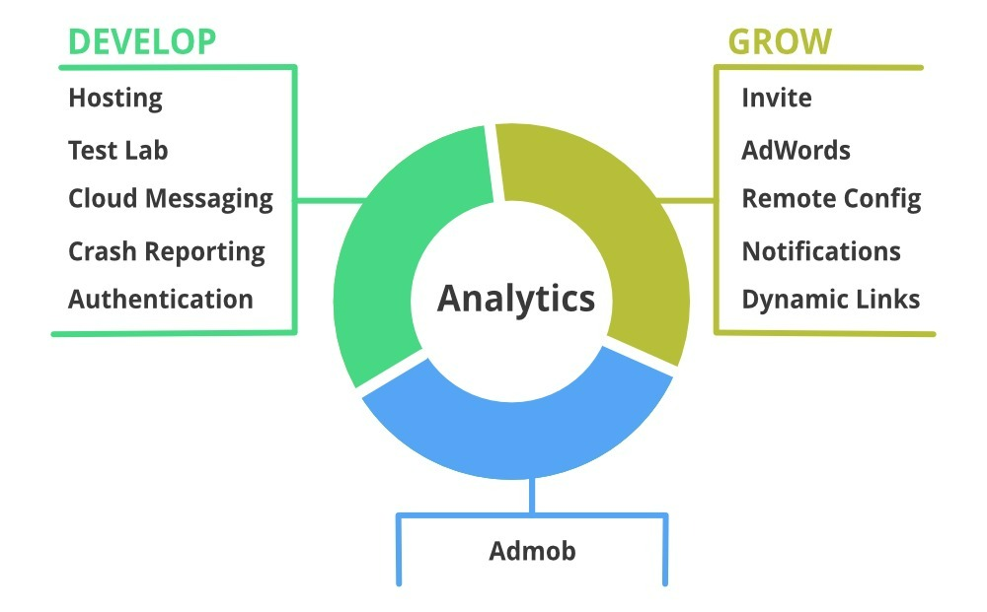
Figure 4

- HARDWARE REQUIREMENTS :

- 64-bit Microsoft® Windows® 8/10/11.
- x86_64 CPU architecture; 2nd generation Intel Core or newer, or AMD CPU with support for a Windows Hypervisor.
- 8 GB RAM or more.
- 8 GB of available disk space minimum (IDE + Android SDK + Android Emulator)
- 1280 x 800 minimum screen resolution.

3.2Methodology:
There is a lot of models available but we have chosen waterfall model as A schedule can be set with deadlines for each stage of development and a product can proceed through the development process model phases one by one. Waterfall model works well for smaller projects where requirements are clearly defined and very well understood
This model is simple and easy to understand and use.
It is easy to manage due to the rigidity of the model – each phase has specific deliverables and a review process.
3.2.1Water Fall model
The Waterfall Model was the first Process Model to be introduced. It is also referred to as a linear-sequential life cycle model. It is very simple to understand and use. In a waterfall model, each phase must be completed before the next phase can begin and there is no overlapping in the phases.
Stages of Waterfall Model
The Waterfall methodology follows a chronological process and works based on fixed dates, requirements, and outcomes. With this method, the individual execution teams aren’t required to be in constant communication and, unless specific integrations are required, are usually self-contained.

Requirements
The Waterfall methodology depends on the belief that all project requirements can be gathered and understood upfront. The project manager does their best to get a detailed understanding of the project sponsor’s requirements. Written requirements, usually contained in a single document, are used to describe each stage of the project, including the costs, assumptions, risks, dependencies, success metrics, and timelines for completion.

Design
Here, software developers design a technical solution to the problems set out by the product requirements, including scenarios, layouts, and data models. First, a higher-level or logical design is created that describes the purpose and scope of the project, the general traffic flow of each component, and the integration points. Once this is complete, it is transformed into a physical design using specific hardware and software technologies.

Implementation
Once the design is complete, technical implementation starts. This might be the shortest phase of the Waterfall process, because painstaking research and design have already been done. In this phase, programmers code applications based on project requirements and specifications, with some testing and implementation taking place as well. If significant changes are required during this stage, this may mean going back to the design phase.

Verification or testing
Before a product can be released to customers, testing needs to be done to ensure the product has no errors and all of the requirements have been completed, ensuring a good user experience with the software. The testing team will turn to the design documents, personas, and user case scenarios supplied by the product manager to create their test cases.

Deployment and maintenance
Once the software has been deployed in the market or released to customers, the maintenance phase begins. As defects are found and change requests come in from users, a team will be assigned to take care of updates and release new versions of the software.
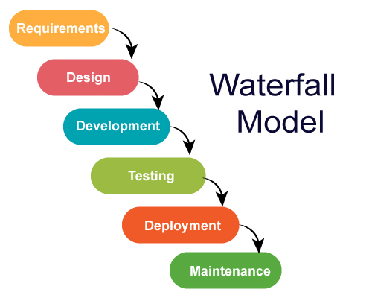
Figure 5

Flow Diagram :

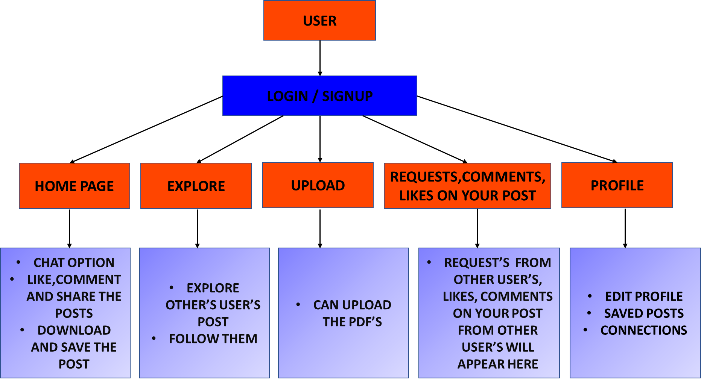
Figure 6

Use Case Diagram: 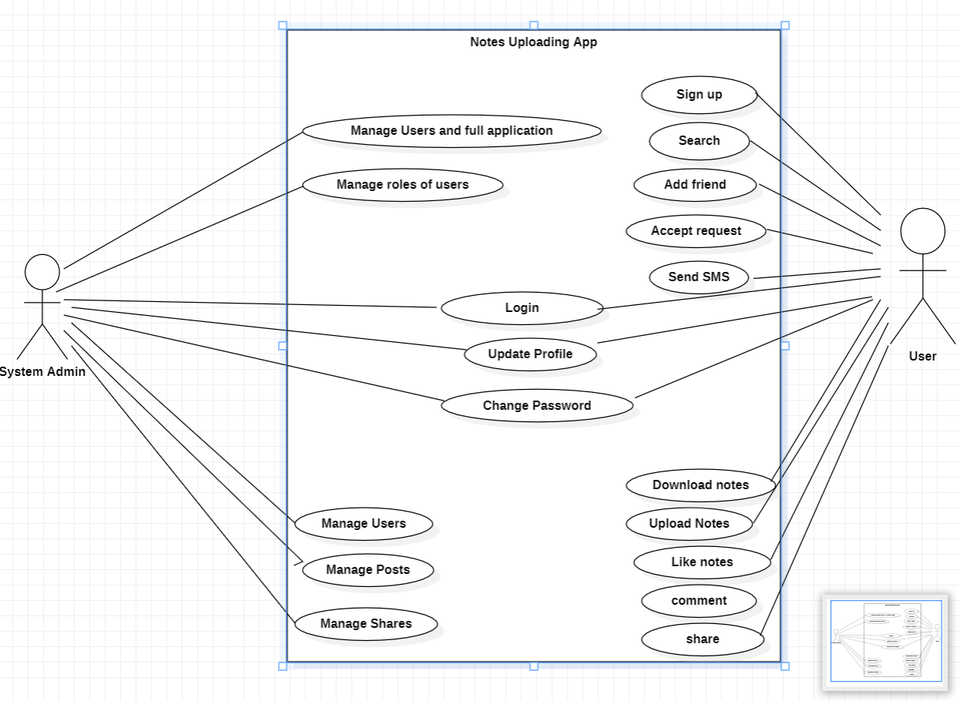
Figure 7

4.Experimental work
4.1 Description of Features and the Approach
1. User Login/Registration: If the user wants to use theDigiNote, we must download the application from the play store, install and register it by providing login information. As shown in the Figure below, the login information includes E-mail and password.
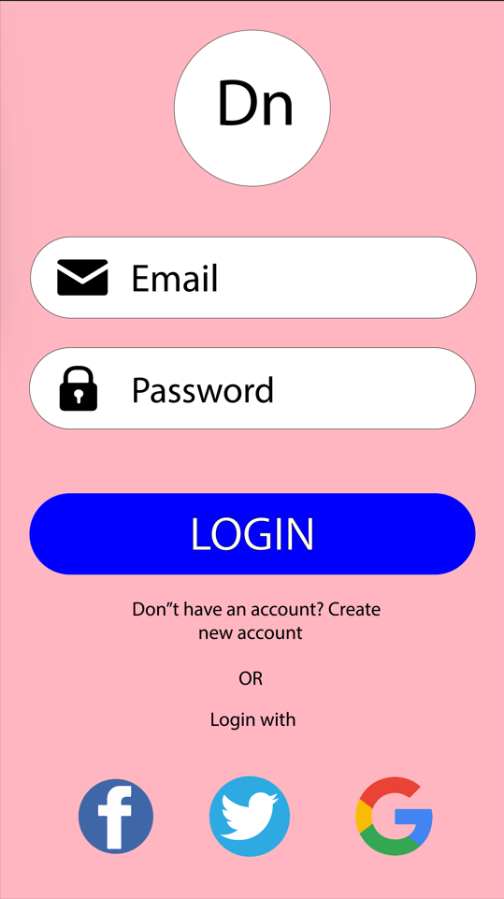
Figure 8
For the new user, the user must sign up by providing Full Name, Email Id and Password. Once, he registers, the registered information is stored in the server and can be validated, checking for the valid credentials for the next time he logins with the application. After using the application, he can logout.
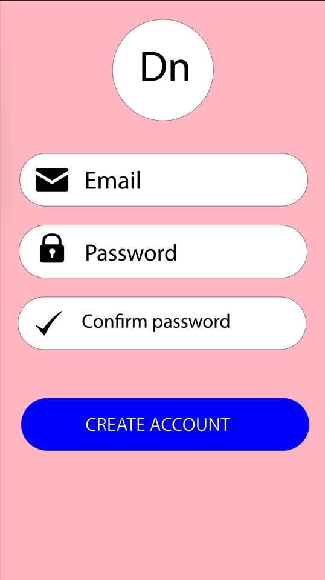
Figure 9
After filling all the details and Clicking on Create account . The account will be saved and user can proceed to use the app.
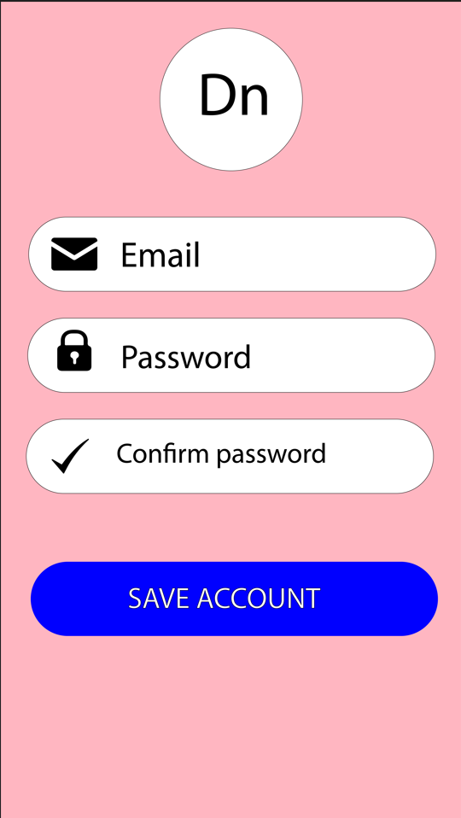
Figure 10
When user proceeds to the app user is directed to the home page where in the left side he/ she will be redirected to main page from where he or she can upload or download the notes as shown below. 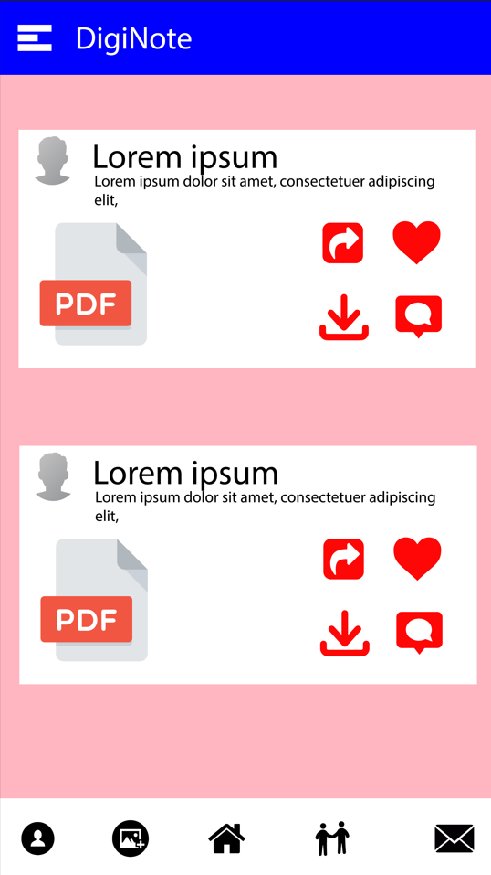
Figure 11

On the top left corner when user clicks on that he or she will b provided with the following features from where the user can add new post, update profile, find friends, see messages and also control settings.

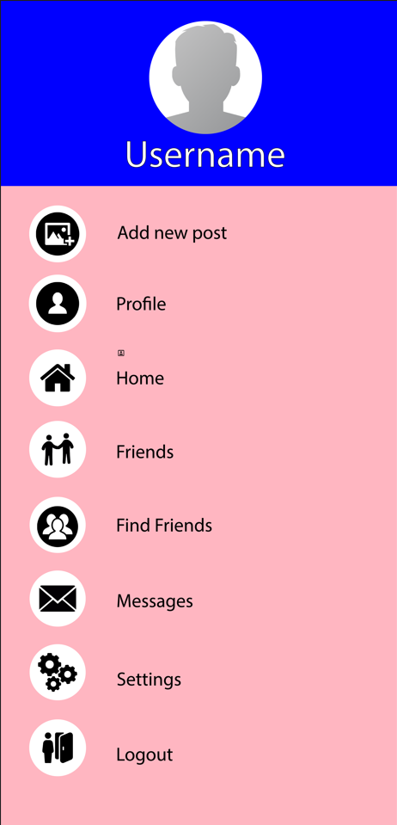
Figure 12
Profile page of user is shown below:
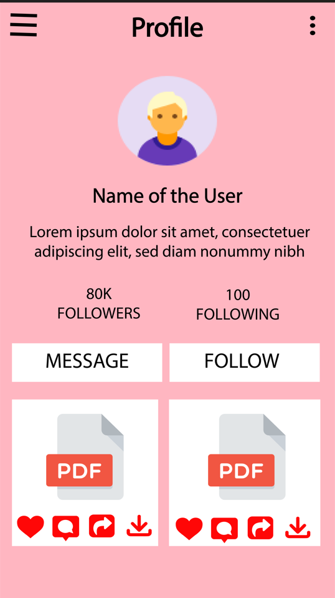
Figure 13

The profile of other user :
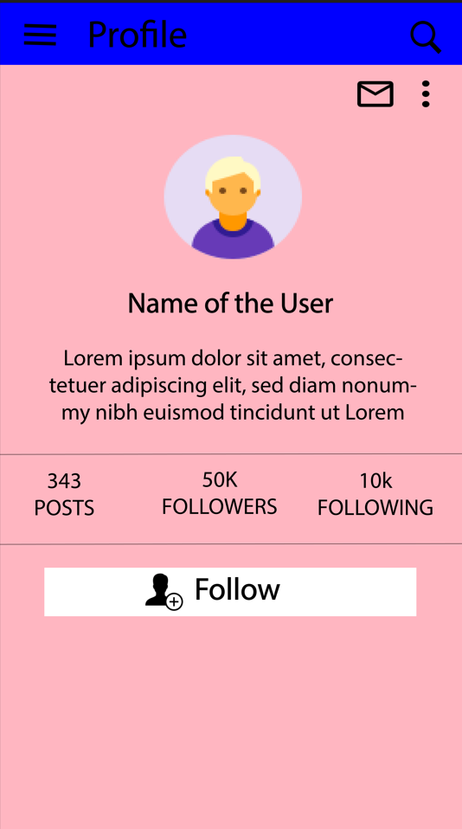

Figure 14

5.CONCLUSION & FUTURE SCOPE
5.1 CONCLUSION
We have learned a lot from this project on how to develop Android Application and publishing it in real time, use sdk tools, use of firebase. Diginote provides student the best platform to find the handwritten notes . Through this students can get their notes one day before exam
And the main issue is finding the notes so Diginotes provies all the roadmaps that the students needed . They can contact anyone from any part of the world for handwritten notes.
We have seen that almost in any school and colleges juniors asks for notes to their seniors. But not able to find the notes so what we have done is we are providing the platform where user having notes can upload there notes as well as download from our app.

5.2.FUTURE SCOPE
- The notes will be verified through AI/ML.
- Credit and swags will be provided to the user having highest points or score.
5.3 ADVANTAGES:
- User can download all handwritten notes.
- User will be provided with all the important topics to prepare for exam.
- There is a credit system for users so that is one uploaded they will be credited with some points.

