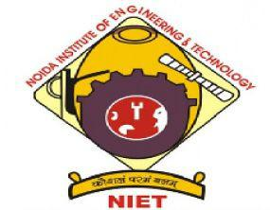 **ARYAN KUMAR SHAH** 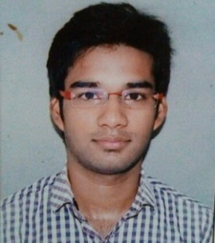

**B.Tech(Computer Science and Engineering)**

**Email:**[**aryanshah373@gmail.com**](mailto:aryanshah373@gmail.com)

**Mobile: +918512097276**

**Objective:** To work in an environment which is challenging as well exciting and to use my skills and knowledge to contribute to an organization, this caters to my professions and personal growth.

**Academic Details**



* **Current Status​**:Completed professional graduation(B.Tech) in Computer Science & Engineering from Noida Institute of Engineering and Technology in 2019 and secured 71.62 %.
* Secured 65% (approx.) marks in class 12th CBSE Board.
* Secured 74% in class 10th CBSE Board.

** Interpersonal Skills**

* Determined to learn with a Practical approach.
* Self-Motivated
* Quick Learner



**Technical Skills**

* Core Java
* Star Patterns
* OOPs Concept

(Class, Object, Inheritance, Polymorphism, Incapsulation)

* Declarative development for platform app builders (Salesforce)

**Certification and Training**



* **Organisation :** Qspider and Jspider.
* **Technology**  **:** core java.
* **Duration**  **:** 3 months

**Hobbies/Interests**



* Yoga
* Readings Books
* Listening motivational speakers
* Exploration of Human body & Mind

**Personal Profile**



* **Father’s Name :**  Radhey Krishan
* **Date of Birth :**  22/11/1995
* **Language known :**  Hindi, English.