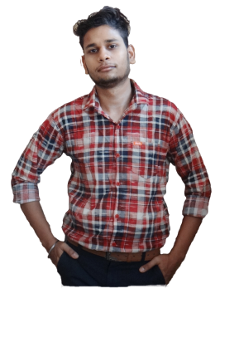

2019 - Present

**Aryan Sharma**

I am a Professional, User Friendly Web Designer and Web Developer. I have created my own Portfolio too using HTML, CSS, JavaScript, etc.

I am a Fresher, have no experience.

2017

2018

2020

Senior Secondary Education

Parishkar College of Global ExcellenceBachelor of Computer Application

Rajasthan University

Tilak Public School

A Shield for passing my 1st Part of Bachelor Degree

Top position Winning Trophy in Kabaddi in my School

Hobbies

Education

Awards Received

About

Hindi

English

Language

Wordpress

Flash

Illustrator

Dreamweaver

Photoshop

Skills

Website:  
<https://aryansharma11223.github.io/portfolio-cv/>

aryansharma11223@gmail.com

Email

116-A, Krishna Vihar, Gopalpura Bypass, Jaipur

Address

Contact

A Web Designer & Developer