Name: Aryan Sharma
Reg. No.: 23BCE1320
Subject: Cryptography & Network Security Lab
Assignment: Lab 6

Codes:
RSAUtils.java

public class RSAUtils {

public static int gcd(int a, int b) {
System.out.println("\nComputing GCD(" + a + ", " + b + ")");
while (b != 0) {
int temp = b;
b = a % b;
a = temp;
System.out.println("a = " + a + ", b = " + b);
}
System.out.println("Final GCD = " + a);
return a;
}

public static int[] extended_euclidean(int a, int b) {
if (b == 0)
return new int[]{a, 1, 0};

int[] vals = extended_euclidean(b, a % b);
int d = vals[0];
int x = vals[2];
int y = vals[1] - (a / b) * vals[2];

return new int[]{d, x, y};
}

public static int mod_inverse(int e, int phi) {
System.out.println("\nComputing Modular Inverse of " + e + " mod " + phi);
int[] vals = extended_euclidean(e, phi);
int gcd = vals[0];
int x = vals[1];

if (gcd != 1)
throw new ArithmeticException("Inverse does not exist.");

int result = (x % phi + phi) % phi;
System.out.println("Private exponent d = " + result);
return result;
}

public static long mod_exp(long base, long exponent, long modulus) {
System.out.println("\nPerforming Modular Exponentiation:");
System.out.println("Base = " + base + ", Exponent = " + exponent + ", Modulus = " + modulus);

long result = 1;
base = base % modulus;

while (exponent > 0) {
if ((exponent & 1) == 1) {
result = (result * base) % modulus;
System.out.println("Result updated to " + result);
}
base = (base * base) % modulus;
exponent >>= 1;
}
return result;
}

public static long encrypt(long message, long e, long n) {
System.out.println("\nEncrypting Message: " + message);
long cipher = mod_exp(message, e, n);
System.out.println("Ciphertext = " + cipher);
return cipher;
}

public static long decrypt(long cipher, long d, long n) {
System.out.println("\nDecrypting Cipher: " + cipher);
long message = mod_exp(cipher, d, n);
System.out.println("Decrypted Message = " + message);
return message;
}
}

RSAServer.java

import java.io.*;
import java.net.*;

public class RSAServer {

public static void main(String[] args) throws Exception {

int p = 11;
int q = 13;

int n = p * q;
int phi = (p - 1) * (q - 1);

int e = 7;

System.out.println("========== RSA KEY GENERATION ==========");
System.out.println("Chosen primes:");
System.out.println("p = " + p);
System.out.println("q = " + q);

System.out.println("\nn = p * q = " + n);
System.out.println("phi(n) = (p-1)(q-1) = " + phi);

RSAUtils.gcd(e, phi);
int d = RSAUtils.mod_inverse(e, phi);

System.out.println("\nPublic Key (e, n) = (" + e + ", " + n + ")");
System.out.println("Private Key (d, n) = (" + d + ", " + n + ")");

System.out.println("\n========== HOMOMORPHIC PROPERTY TEST ==========");

int m1 = 4;
int m2 = 5;

long c1 = RSAUtils.encrypt(m1, e, n);
long c2 = RSAUtils.encrypt(m2, e, n);

long c_mul = (c1 * c2) % n;
System.out.println("\nCipher Multiplication mod n = " + c_mul);

long decryptedMul = RSAUtils.decrypt(c_mul, d, n);

long expected = (m1 * m2) % n;

System.out.println("\n(m1 * m2) mod n = " + expected);

if (decryptedMul == expected)
System.out.println("Homomorphic Property VERIFIED");
else
System.out.println("Homomorphic Property NOT VERIFIED");

ServerSocket serverSocket = new ServerSocket(5000);
System.out.println("\nServer waiting on port 5000...");

Socket socket = serverSocket.accept();
System.out.println("Client connected.");

BufferedReader in = new BufferedReader(
new InputStreamReader(socket.getInputStream()));

long receivedCipher = Long.parseLong(in.readLine());

System.out.println("\nEncrypted message received from client: " + receivedCipher);

long decryptedMessage = RSAUtils.decrypt(receivedCipher, d, n);

System.out.println("\nFinal Decrypted Message at Server: " + decryptedMessage);

socket.close();
serverSocket.close();
}
}

RSAClient.java

import java.io.*;
import java.net.*;
import java.util.Scanner;

public class RSAClient {

public static void main(String[] args) throws Exception {

int e = 7;
int n = 143;

Scanner sc = new Scanner(System.in);

System.out.println("========== CLIENT SIDE ==========");
System.out.print("Enter message (M < 143): ");
long message = sc.nextLong();

long cipher = RSAUtils.encrypt(message, e, n);

Socket socket = new Socket("localhost", 5000);

PrintWriter out = new PrintWriter(socket.getOutputStream(), true);
out.println(cipher);

System.out.println("\nEncrypted message sent to server.");

socket.close();
}
}
Output:
ServerSide

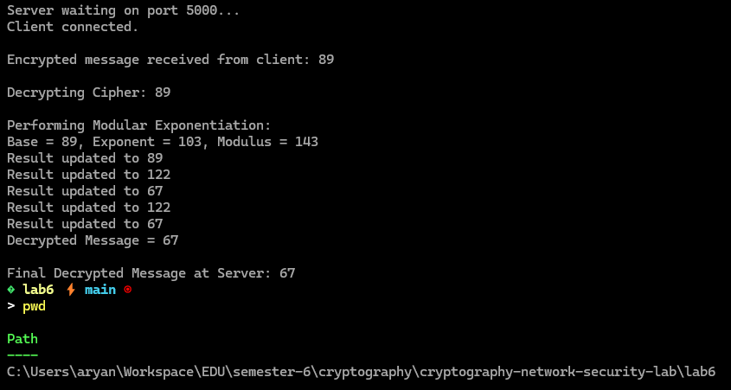

ClientSide

