BCSE309L - Cryptography and Network Security
LAB 7: SHA512 and DSS

Name: Aryan Sharma
Register Number: 23BCE1320
SHA512 SERVER CODE

import java.io.ObjectInputStream;
import java.net.ServerSocket;
import java.net.Socket;

public class SHA512Server {
public static void main(String[] args) {
int port = 65432;
try (ServerSocket serverSocket = new ServerSocket(port)) {
System.out.println("Server listening on port " + port + "...");

try (Socket socket = serverSocket.accept();
ObjectInputStream ois = new ObjectInputStream(socket.getInputStream())) {

System.out.println("Client connected!");
long[] words = (long[]) ois.readObject();

System.out.println("\n--- Received SHA-512 Message Schedule (W0 - W15) ---");
for (int i = 0; i < words.length; i++) {
System.out.printf("W%-2d: 0x%016x%n", i, words[i]);
}
}
} catch (Exception e) {
e.printStackTrace();
}
}
}
SHA512 CLIENT CODE
import java.io.ObjectOutputStream;
import java.net.Socket;
import java.nio.ByteBuffer;
import java.util.Scanner;

public class SHA512Client {

public static long[] preprocessSHA512(String message) {
byte[] msgBytes = message.getBytes();
long origLenBits = (long) msgBytes.length * 8;

ByteBuffer buffer = ByteBuffer.allocate(128);
buffer.put(msgBytes);
buffer.put((byte) 0x80);

while (buffer.position() < 112) {
buffer.put((byte) 0x00);
}

buffer.putLong(0L);
buffer.putLong(origLenBits);

buffer.flip();
long[] wWords = new long[16];
for (int i = 0; i < 16; i++) {
wWords[i] = buffer.getLong();
}

return wWords;
}

public static void main(String[] args) {
String host = "127.0.0.1";
int port = 65432;

try (Scanner scanner = new Scanner(System.in)) {
System.out.print("Enter a short message to process: ");
String message = scanner.nextLine();

long[] words = preprocessSHA512(message);

try (Socket socket = new Socket(host, port);
ObjectOutputStream oos = new ObjectOutputStream(socket.getOutputStream())) {

oos.writeObject(words);
System.out.println("Message schedule sent to the server successfully.");
}
} catch (Exception e) {
e.printStackTrace();
}
}
}

SHA 512 OUTPUT
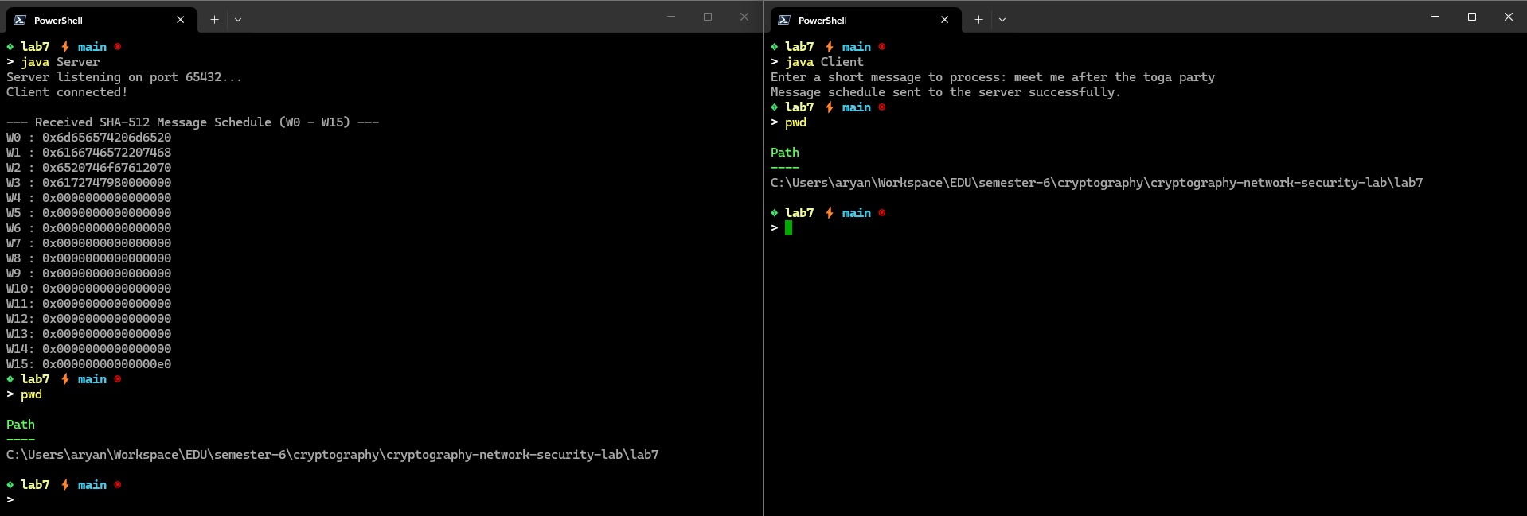
DSS SEVER CODE
import java.io.ObjectInputStream;
import java.math.BigInteger;
import java.net.ServerSocket;
import java.net.Socket;

public class BankServer {

public static BigInteger getHash(String message) {
byte[] data = message.getBytes();
int[] h = { 0x67452301, 0xEFCDAB89, 0x98BADCFE, 0x10325476, 0xC3D2E1F0 };
for (int i = 0; i < data.length; i++) {
h[i % 5] = Integer.rotateLeft(h[i % 5] ^ data[i], 5);
h[(i + 1) % 5] += h[i % 5] * 31;
}
byte[] out = new byte[20];
for (int i = 0; i < 5; i++) {
out[i * 4] = (byte) (h[i] >>> 24);
out[i * 4 + 1] = (byte) (h[i] >>> 16);
out[i * 4 + 2] = (byte) (h[i] >>> 8);
out[i * 4 + 3] = (byte) h[i];
}
return new BigInteger(1, out);
}

public static void main(String[] args) {
int port = 65433;
try (ServerSocket serverSocket = new ServerSocket(port)) {
System.out.println("Bank Secure Server listening on port " + port + "...");
try (Socket socket = serverSocket.accept();
ObjectInputStream ois = new ObjectInputStream(socket.getInputStream())) {

BigInteger p = (BigInteger) ois.readObject();
BigInteger q = (BigInteger) ois.readObject();
BigInteger g = (BigInteger) ois.readObject();
BigInteger y = (BigInteger) ois.readObject();

String message = (String) ois.readObject();
BigInteger r = (BigInteger) ois.readObject();
BigInteger s = (BigInteger) ois.readObject();

System.out.println("\nReceived Transaction Request: '" + message + "'");

BigInteger hm = getHash(message);

BigInteger w = s.modInverse(q);
BigInteger u1 = hm.multiply(w).mod(q);
BigInteger u2 = r.multiply(w).mod(q);

BigInteger v = g.modPow(u1, p).multiply(y.modPow(u2, p)).mod(p).mod(q);

if (v.equals(r)) {
System.out.println("[SUCCESS] Signature verified! The transaction is authentic and unaltered.");
} else {
System.out.println("[ERROR] Signature verification failed! Transaction rejected.");
}
}
} catch (Exception e) {
e.printStackTrace();
}
}
}

DSS CLIENT CODE
import java.io.ObjectOutputStream;
import java.math.BigInteger;
import java.net.Socket;
import java.util.Random;

public class BankClient {

public static BigInteger getHash(String message) {
byte[] data = message.getBytes();
int[] h = { 0x67452301, 0xEFCDAB89, 0x98BADCFE, 0x10325476, 0xC3D2E1F0 };
for (int i = 0; i < data.length; i++) {
h[i % 5] = Integer.rotateLeft(h[i % 5] ^ data[i], 5);
h[(i + 1) % 5] += h[i % 5] * 31;
}
byte[] out = new byte[20];
for (int i = 0; i < 5; i++) {
out[i * 4] = (byte) (h[i] >>> 24);
out[i * 4 + 1] = (byte) (h[i] >>> 16);
out[i * 4 + 2] = (byte) (h[i] >>> 8);
out[i * 4 + 3] = (byte) h[i];
}
return new BigInteger(1, out);
}

public static void main(String[] args) {
String host = "127.0.0.1";
int port = 65433;

try {
Random random = new Random();

BigInteger q = BigInteger.probablePrime(160, random);
BigInteger p;
BigInteger pMinus1;
do {
BigInteger k = new BigInteger(512 - 160, random);
pMinus1 = k.multiply(q);
p = pMinus1.add(BigInteger.ONE);
} while (!p.isProbablePrime(50));

BigInteger hNum = new BigInteger(512 - 2, random).add(BigInteger.TWO);
BigInteger g = hNum.modPow(pMinus1.divide(q), p);

BigInteger x;
do {
x = new BigInteger(160, random);
} while (x.compareTo(BigInteger.ZERO) <= 0 || x.compareTo(q) >= 0);

BigInteger y = g.modPow(x, p);

String transactionMsg = "TRANSFER $50,000 TO ACCOUNT #987654321";
System.out.println("Transaction prepared: '" + transactionMsg + "'");

BigInteger hm = getHash(transactionMsg);

BigInteger k;
do {
k = new BigInteger(160, random);
} while (k.compareTo(BigInteger.ZERO) <= 0 || k.compareTo(q) >= 0);

BigInteger r = g.modPow(k, p).mod(q);
BigInteger kInv = k.modInverse(q);
BigInteger s = kInv.multiply(hm.add(x.multiply(r))).mod(q);

try (Socket socket = new Socket(host, port);
ObjectOutputStream oos = new ObjectOutputStream(socket.getOutputStream())) {

oos.writeObject(p);
oos.writeObject(q);
oos.writeObject(g);
oos.writeObject(y);

oos.writeObject(transactionMsg);
oos.writeObject(r);
oos.writeObject(s);

System.out.println("Transaction and manual DSA signature sent to the bank server.");
}

} catch (Exception e) {
e.printStackTrace();
}
}
}
DSS OUTPUT
