ARYAN SHETTY
Jr. Software Engineer
+91 7483484518 | aryanshetty477@gmail.com | Chennai, India | LinkedIn
SUMMARY
Jr. Software Engineer with 2 years of hands-on experience building and supporting mission-critical backend systems, ETL pipelines, and full-stack web applications for royalty and financial processing platforms. Proficient in .NET, SQL, SSIS, and React JS, with daily ownership of production batch jobs and month-end financial reporting. Google Cloud Digital Leader certified, with a strong track record of improving data accuracy and streamlining manual processes.
CERTIFICATIONS
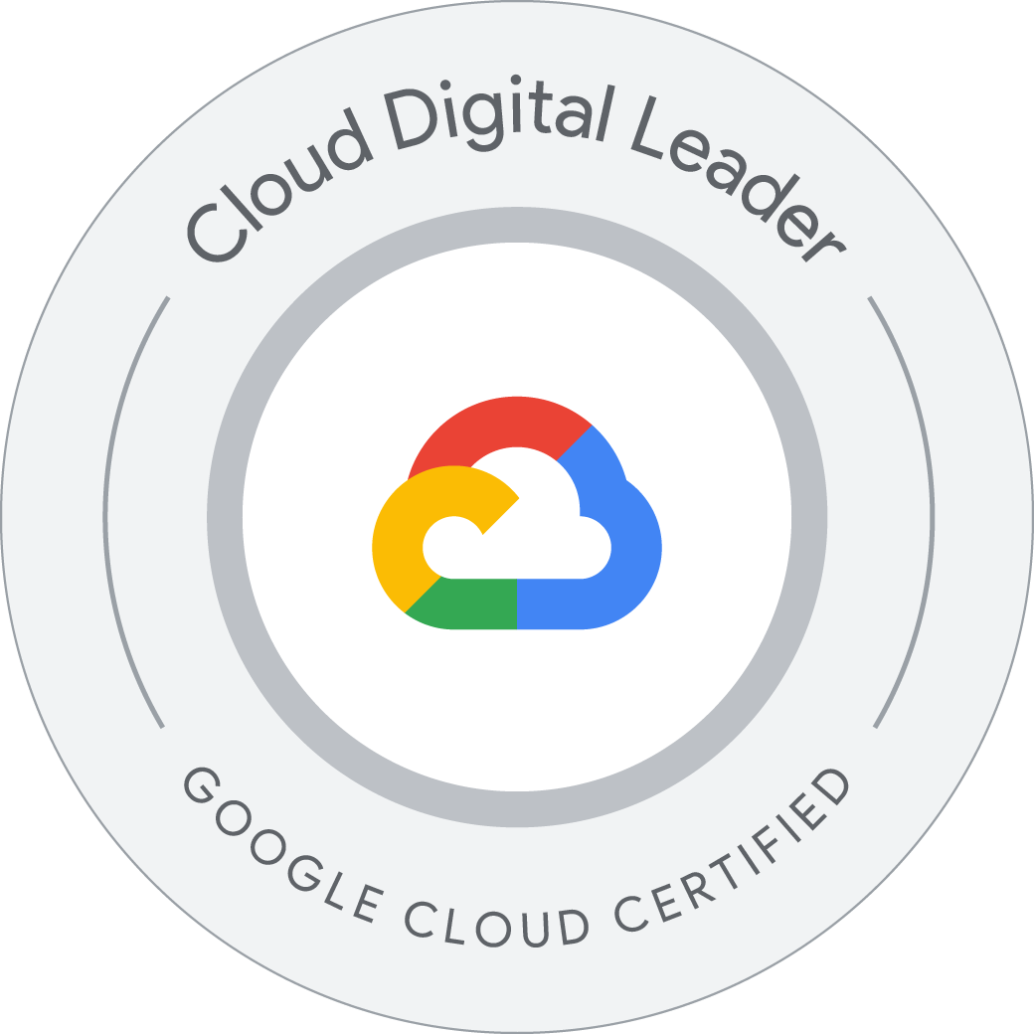 Google Cloud Digital Leader — Google Cloud | Verify on Credly
 Claude Certified Architect – Foundations — Anthropic | Verify on Credly
SKILLS
- Backend & Languages: .NET, Java, Python, JavaScript
- Frontend: React JS, HTML, CSS, Bootstrap
- Data & ETL: SQL, SSIS, Microsoft SQL Server, Batch Job Monitoring
- Cloud & Tools: GCP, Anthropic Claude, Git, GitHub, Linux, Visual Studio Code, NLP
EXPERIENCE
Jr. Software Engineer, Cognizant Technology Solutions 01/2024 – Present
Chennai, India
- Managed and maintained complex ETL processes utilizing SSIS to ensure accurate daily data flow and data integrity across systems.
- Contributed to front-end development using HTML, CSS, Bootstrap, JavaScript, and React JS to implement and improve user interface (UI) experiences.
- Monitored and supported 10–25 SQL jobs and batch processes daily, including weekends, ensuring timely execution and critical uptime for royalty calculation systems.
- Participated in debugging, testing, and deployment of updates across backend and frontend components, ensuring seamless system integration.
- Analyzed and supported backend processes using SQL Server and SSIS for ETL operations, streamlining data flow monitoring and reducing manual validation effort.
- Executed critical month-end processing, including data consistency validation and Financial Balancing Reports for reconciliation and reporting; collaborated with cross-functional teams to resolve production issues.
PROJECTS
Pet Store – E-Commerce Website (.NET, React JS)
- Designed and developed a full-stack e-commerce platform using .NET for the backend and React JS (FSE) for the front end, covering product catalog, cart, and checkout flows.
- Implemented RESTful APIs in .NET for product listings, authentication, and order processing (SQL Server), with responsive, reusable React components for the storefront UI.
MAMABOT – ML/NLP System Supporting Pregnant Women
- Built an intelligent chatbot-based system using Machine Learning and NLP to answer pregnancy-related queries and provide personalized guidance to expecting mothers.
- Trained NLP models to understand user intent and generate contextually relevant responses, integrating the model with a user-facing interface for real-time query handling.
EDUCATION
B.Tech, Dr. Ambedkar Institute of Technology 08/2019 – 06/2023
Bangalore, India
KEY ACHIEVEMENTS
- Best Project of the Year 2022–2023 — Awarded at a state-level seminar organized by the Karnataka State Council of Science and Technology (KSCST) at Alva's Institute of Engineering and Technology, Moodubidre.
LANGUAGES
English (Advanced) • Hindi (Advanced) • Kannada (Advanced) • Tulu (Native) • Marathi (Intermediate)

