LIGHT IN MOTION
WEBSITE MASTER SPECIFICATION
From-zero build • Home + Store • Existing App Download Page
Version 1.0 | 16 September 2026
Purpose: define the complete product, UX, frontend, backend, data, payments, shipping, authentication, security, operations, and integration requirements before development begins.

1. Executive Summary
This document is the single source of truth for the new Light in Motion ecommerce website. The site will be rebuilt from zero around the approved visual direction: a cinematic, premium, technology-focused product experience inspired structurally by the supplied Alienware product configurator reference, but using original Light in Motion branding, copy, assets, layouts, and interactions.
Public website scope is intentionally limited to two primary pages: Home and Store. The existing App Download page remains separate and should not be rebuilt. Functional states such as login, cart, checkout, product details, order confirmation, and account/order history may appear as drawers, modals, overlays, or controlled application states without becoming additional marketing pages.
Core principle
The UI must never be trusted for price, stock, payment state, shipping cost, permissions, or order status. The server/database is the source of truth.

1.1 Project goals
- Present Light in Motion as a credible technology/product brand rather than a generic RGB accessories store.
- Make product discovery and purchase possible with minimal friction.
- Provide a secure ecommerce backend that can handle real payments and shipping.
- Keep the visual system cinematic and restrained; lighting effects should come primarily from product imagery/video, not excessive CSS glow.
- Make the system manageable by the team without editing code for routine product, inventory, pricing, and order operations.
- Build an architecture that can later support more products, discounts, analytics, customer accounts, returns, and additional pages without a rewrite.

1.2 Public route scope
Route / surface | Status | Purpose
/ | BUILD | Home / brand experience / product discovery / primary conversion.
/store | BUILD | Product catalogue, filtering, product configuration, cart and purchase entry point.
Existing app download page | KEEP | Existing app download experience; do not rebuild unless integration requires a shared header/footer.
Login / signup | FUNCTIONAL STATE | Modal/drawer or controlled overlay from Store/Home.
Cart | FUNCTIONAL STATE | Cart drawer or full-screen overlay.
Checkout | FUNCTIONAL STATE | Secure checkout state; may later become a dedicated route without backend redesign.
Account / orders | FUNCTIONAL STATE | Authenticated customer area; can initially be a drawer/overlay.
Admin | PRIVATE SYSTEM | Not part of public navigation; required for operations.

2. Design & Experience Requirements

2.1 Primary visual reference
The supplied Alienware product-page screenshot is the primary structural and interaction reference. It should guide composition, hierarchy, navigation density, translucent interface treatment, product prominence, and configurator-like interaction. It is not a source for copying branding, logos, text, proprietary assets, or exact page code.
Reference asset: LIM_Design_Reference_Alienware.png (saved with the project reference materials).

2.2 Visual language
- Dark, cinematic, high-contrast base.
- Large, confident typography and short headlines.
- Product/environment photography as the main source of color and visual energy.
- Translucent panels used selectively for navigation, product information, and controls.
- Thin borders and disciplined spacing.
- Subtle motion and depth; no uncontrolled particle systems.
- RGB should feel physical and photographic, not like a CSS neon overlay.
- No generic AI-slop gradients, excessive purple/blue glow, floating-card clutter, or unnecessary rounded containers.
- Desktop and mobile must be designed intentionally rather than treating mobile as a scaled-down desktop.

2.3 UX principles
- Every interaction must have a clear purpose.
- Primary CTA should always be visually obvious.
- Product information must be scannable before the user commits to purchase.
- Checkout should be faster and visually calmer than the marketing experience.
- Errors must be explicit and recoverable.
- Loading states should preserve layout and avoid layout shift.
- No UI element should cover product details or make the product difficult to see.

3. Recommended Technical Architecture
Recommended baseline: Next.js App Router + TypeScript for the full-stack web application, PostgreSQL for relational data, Prisma ORM for database access, Auth.js for authentication/session management, Razorpay for online payments, Shiprocket for fulfilment/shipping, Cloudinary for product media, and a transactional email provider such as Resend. Next.js officially supports Route Handlers for server-side request handling and recommends server-side authorization/data-access patterns. citeturn1search0turn3search0
Layer | Technology / approach | Responsibility
Frontend | Next.js App Router + React + TypeScript | UI, routing, interactions, responsive rendering.
Styling | Tailwind CSS + custom CSS tokens | Design system, responsive layout, motion.
Backend | Next.js Route Handlers / Server Actions | Business logic and secure API boundary.
Database | PostgreSQL | Users, products, variants, inventory, carts, orders, payments, shipments, audit logs.
ORM | Prisma ORM | Typed database access, relations, transactions.
Authentication | Auth.js | Login/session management and provider integration; final provider set to be configured.
Payments | Razorpay Standard Checkout + Orders API + webhooks | Payment collection, verification, payment lifecycle.
Shipping | Shiprocket API + tracking webhooks | Serviceability, shipment creation, AWB, tracking and fulfilment.
Media | Cloudinary | Product images/videos, transformations, CDN delivery.
Email | Resend or equivalent transactional email API | Order confirmations, password reset, shipping updates.
Hosting | Vercel or equivalent | Production deployment, HTTPS, environment variables.
Monitoring | Vercel monitoring + structured server logs; optional Sentry | Errors, performance and operational visibility.
Prisma supports relational modelling and transactions, which are important for order creation, inventory changes, and other multi-write business operations. citeturn0search10turn0search12
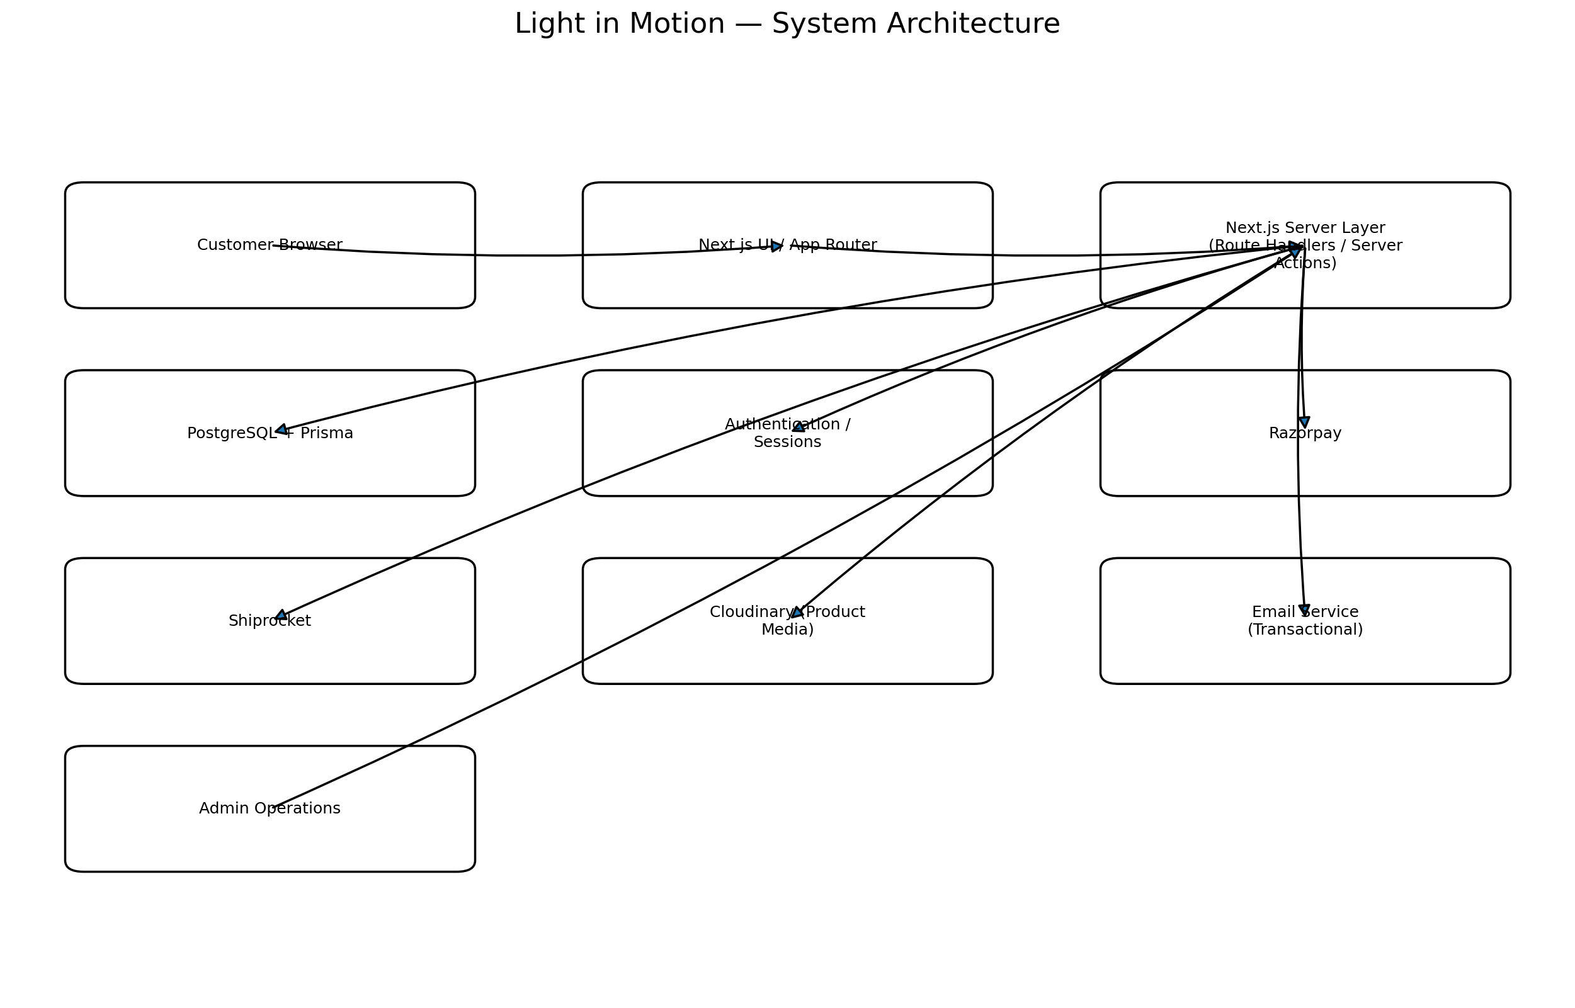

4. Page & Component Specification

4.1 Home page
Section | Required behavior
Global header | Logo, Store, Experience/technology anchors as needed, App link, account, cart. Header changes state based on scroll.
Hero | Full-screen cinematic product/setup visual, bold headline, primary Store CTA. Product must dominate.
Product showcase | Highlight the main product families with controlled motion and concise copy.
How it works | Explain sync/ambient-light experience visually in 3–4 steps.
Compatibility | Show supported TV/monitor/setup use cases.
Technology / differentiator | Explain the technical value without turning the page into a spec sheet.
Installation | Simple visual explanation of setup and plug-and-play nature.
Social proof | Reviews/testimonials/UGC when real data is available; never fabricate reviews.
CTA | Strong final route into Store.
Footer | Support/contact, policies, social links, app download, legal links.

4.2 Store page
Feature | Required behavior
Catalogue | Products loaded from backend/database, not hardcoded into the UI.
Categories | Filter by product family/use case.
Product card | Image/video preview, product name, starting price, availability, quick add/details.
Product detail | Modal/side panel/full-screen overlay with gallery, features, specs, variant selection, quantity and add-to-cart.
Configuration | Variant-dependent price and stock must be recalculated server-side.
Cart | Persistent cart for guests; merge with account cart after login.
Discount code | Optional but architecture should support coupon validation server-side.
Pincode | Validate serviceability and calculate shipping before payment where applicable.
Checkout | Collect customer/contact/address data, shipping option, payment method, order summary.
Payment | Razorpay checkout for online payment.
Order confirmation | Show internal order number and payment/order status; never assume success solely from browser callback.
Account | Login, signup, logout, password reset, saved address, order history.

5. Functional Requirements

5.1 Product catalogue
- Products must be database-driven.
- Each product can have multiple variants/SKUs.
- Each SKU stores its own price, compare-at price if used, stock quantity, SKU code, weight, dimensions, active/inactive state, and media references.
- Product media should support multiple images and optional video.
- Product attributes should be structured so they can be filtered/searchable.
- Out-of-stock states must be explicit.
- Never calculate final payable price only from client-provided data.

5.2 Cart
- Guest cart identified by a secure random cart/session identifier.
- Authenticated cart linked to user account.
- Merge guest cart into user cart on login.
- Validate product existence, active status, variant, current price and stock whenever cart is submitted for checkout.
- Prevent negative quantities and excessive quantities.
- Do not trust a client-side total.

5.3 Customer accounts
Feature | Requirement
Signup | Name, email, password; verify email if enabled.
Login | Email/password; optional Google sign-in.
Password reset | Single-use, time-limited reset token delivered by email.
Logout | Invalidate/expire session.
Profile | Name, email, phone.
Addresses | Multiple saved shipping addresses; one default.
Orders | List and detail view with payment and shipment status.
Security | Session expiry, secure cookies, rate limiting, failed-login protection.
Next.js recommends authentication libraries for increased security/simplicity and recommends HttpOnly, Secure and SameSite cookie settings for sessions. Auth.js is a Next.js-compatible authentication library. citeturn3search0turn3search2

6. Database Design
The database should be normalized around commerce entities. Exact Prisma schema should be generated during Stage 1 implementation, but the following logical model is mandatory.
Model | Key fields / purpose
User | id, name, email, phone, password/provider identity, role, status, timestamps.
Session / Account | Auth.js session/provider data.
Address | userId, recipient name, phone, address lines, city, state, pincode, country, label.
Product | id, slug, name, description, active, category, metadata.
ProductVariant / SKU | productId, sku, name, price, comparePrice, stock, weight, dimensions, active.
ProductMedia | productId/variantId, type, URL/publicId, alt text, sort order.
Cart | id, userId or guest token, status, timestamps.
CartItem | cartId, variantId, quantity, price snapshot if required.
Order | id, publicOrderNumber, userId/guest contact, status, totals, shipping address snapshot, timestamps.
OrderItem | orderId, variantId/SKU, name snapshot, price snapshot, quantity, tax/discount fields.
Payment | orderId, provider, providerOrderId, providerPaymentId, amount, currency, status, signature verification state.
Shipment | orderId, Shiprocket order/shipment IDs, AWB, courier, status, tracking URL, timestamps.
Coupon | code, discount type/value, limits, validity window, usage rules.
InventoryEvent | SKU, delta, reason, reference/order ID, actor, timestamp.
WebhookEvent | provider, external event ID, event type, payload hash/reference, processed state, timestamps.
AuditLog | actor, action, entity, entityId, metadata, timestamp.

6.1 Data integrity rules
- Use foreign keys and database constraints.
- Use unique constraints for email, SKU, public order number and provider event IDs where appropriate.
- Use transactions for operations that update multiple related records.
- Use immutable snapshots for order item name/price and shipping address so historical orders remain accurate even if the product changes.
- Use integer minor units for monetary values (for example paise) rather than floating-point currency arithmetic.
- Never delete historical orders/payments as a routine admin action; use status/soft-delete patterns where appropriate.
Prisma documents transactions as atomic units where writes either all commit or all roll back; this is directly relevant to order and inventory operations. citeturn0search0turn0search10

7. Backend API Specification
All sensitive operations are server-side. Public read endpoints may be cached; mutation endpoints require validation, authentication where appropriate, authorization, rate limiting and structured error handling.
Endpoint | Method | Purpose | Auth
/api/products | GET | List active products / filters. | Public
/api/products/[slug] | GET | Product detail + variants/media. | Public
/api/cart | GET/POST/PATCH/DELETE | Read/update cart. | Guest or user
/api/checkout/validate | POST | Validate cart, stock, price and address before order creation. | Guest/user
/api/shipping/serviceability | POST | Check pincode/serviceability and available shipping options. | Guest/user
/api/orders | POST | Create internal pending order after server validation. | Guest/user
/api/orders/[id] | GET | Retrieve order visible to owner/admin. | Owner/admin
/api/payments/razorpay/order | POST | Create Razorpay order from trusted server amount. | Guest/user
/api/payments/razorpay/verify | POST | Verify checkout signature server-side. | Guest/user + verification
/api/webhooks/razorpay | POST | Receive/verify Razorpay webhook events. | Provider
/api/shipments | POST | Create/submit shipment to Shiprocket after payment/fulfilment criteria. | Admin/server
/api/webhooks/shiprocket | POST | Receive tracking/status updates. | Provider
/api/account/profile | GET/PATCH | Read/update own profile. | User
/api/account/addresses | GET/POST/PATCH/DELETE | Manage saved addresses. | User
/api/account/orders | GET | List current user's orders. | User
/api/auth/* | Auth.js endpoints | Login/session/provider callbacks. | Public/auth
/api/admin/products | CRUD | Product management. | Admin
/api/admin/inventory | GET/PATCH | Stock operations. | Admin
/api/admin/orders | GET/PATCH | Order management. | Admin
/api/admin/shipments | GET/PATCH | Shipment/fulfilment controls. | Admin
/api/admin/coupons | CRUD | Coupon management. | Admin
/api/admin/audit-logs | GET | Operational audit history. | Admin

8. Payments — Razorpay
Razorpay Standard Checkout should be the online payment provider. The implementation must follow Razorpay's server-first flow: create the Razorpay order on the server, pass the returned order_id to Checkout, collect the payment, verify the returned signature on the server, and use webhooks for asynchronous payment events. Razorpay explicitly states that signature verification is mandatory and that the server must use the order_id retrieved from its trusted source rather than trusting a client-supplied order ID. citeturn4search0turn4search1turn1search4

8.1 Required payment sequence
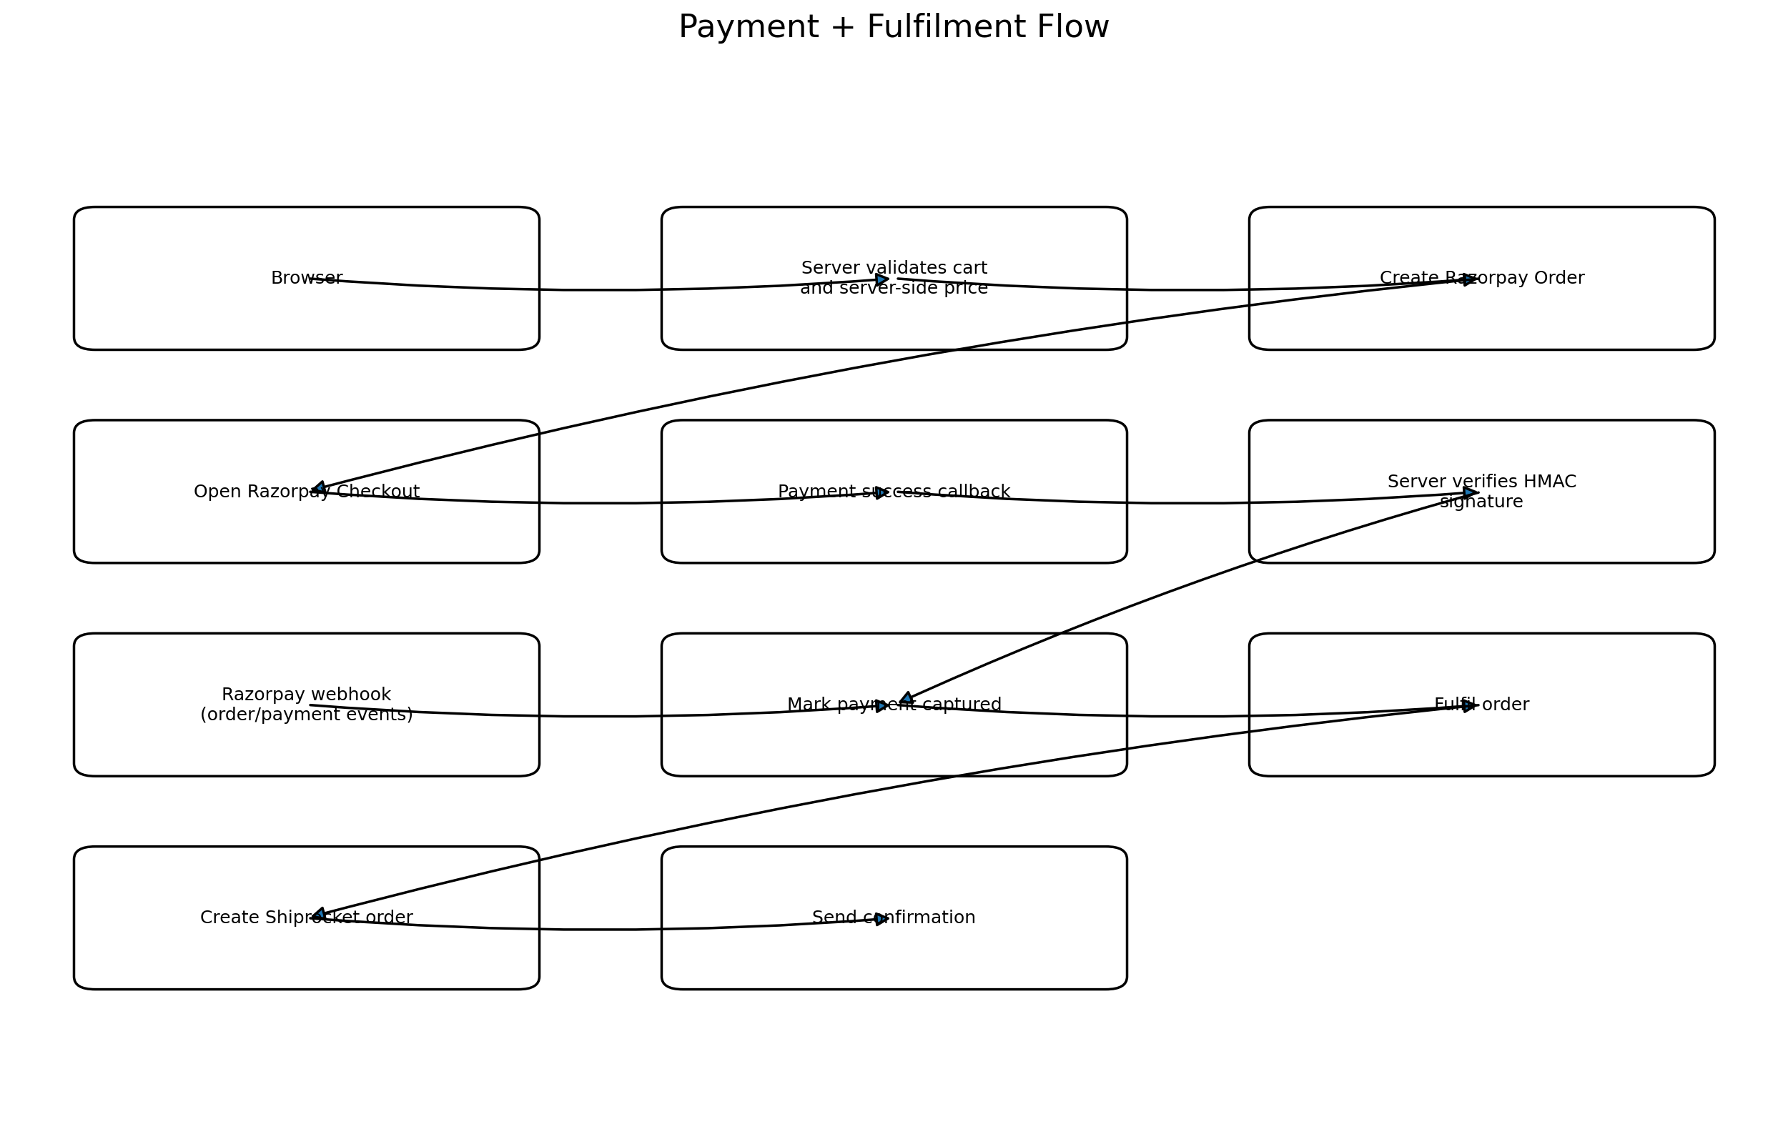
- Client asks server to initiate checkout.
- Server loads the cart/order from database.
- Server recalculates subtotal, discount, shipping and final amount.
- Server creates an internal pending order.
- Server creates a Razorpay Order using the trusted final amount.
- Client opens Razorpay Checkout using the returned Razorpay order ID and public key.
- After successful checkout, client sends payment identifiers back to server.
- Server verifies HMAC signature using the server-side Razorpay secret and the trusted internal/Razorpay order mapping.
- Server checks payment status/capture state as needed.
- Razorpay webhook is received and verified; webhook processing is idempotent.
- Only after trusted payment confirmation is the order moved to the appropriate paid/processing state and fulfilment initiated.

8.2 Payment security requirements
- Razorpay key secret must never be exposed to the browser.
- Amount is always calculated on the server.
- Order ID used for signature verification must come from trusted server/database state.
- Reject invalid signatures; do not fulfil the order.
- Persist provider IDs and payment state.
- Use webhook event IDs to prevent duplicate processing.
- Use idempotency/business-state checks so a repeated callback cannot create duplicate shipments or inventory deductions.
- Support payment failure, cancellation, timeout and refund states.
- Do not mark an order paid based only on a client-side 'success' screen.
Razorpay's current security checklist also calls for server-side handling of trusted amounts and HMAC validation for webhooks. citeturn1search5

9. Shipping & Fulfilment — Shiprocket
Shiprocket will be the shipping/fulfilment integration. Shiprocket provides APIs for authentication, serviceability/rate calculation, order creation, AWB/courier assignment, pickup generation and tracking. Its developer material also supports webhooks for tracking updates. citeturn1search6turn1search7turn1search8

9.1 Required Shiprocket capabilities
- Authenticate server-to-server with Shiprocket credentials.
- Cache the Shiprocket access token securely and refresh it according to its validity; do not request a new token unnecessarily on every user request.
- Pincode serviceability check.
- Shipping rate/courier selection where needed.
- Create shipment/order only after the business rules allow fulfilment.
- Store Shiprocket order ID and shipment ID.
- Assign/get AWB and courier information.
- Track shipment.
- Receive Shiprocket tracking webhooks.
- Persist shipment status history.
- Expose customer-friendly tracking status without exposing internal API credentials.

9.2 Fulfilment decision
Order state | Shiprocket action
Payment pending | Do not create fulfilment shipment.
Payment failed/cancelled | No shipment.
Payment confirmed | Eligible for fulfilment.
Processing | Create/prepare Shiprocket shipment.
Shipped | Store AWB/courier and show tracking.
Out for delivery | Update customer order status.
Delivered | Mark delivered.
Cancelled before dispatch | Cancel/void shipment if applicable and process refund according to policy.
Return/RTO | Track separately; do not overwrite original order history.
Shiprocket's API documentation states that API credentials are created from the Shiprocket panel and that the token is used as a Bearer token; its support documentation currently describes a 10-day token validity. Implementation should follow the live Shiprocket documentation at deployment time rather than hard-coding undocumented assumptions. citeturn1search6turn1search7

10. Product Media & Asset Management
Cloudinary is recommended for product images and optional product videos because its API supports authenticated uploads, transformations, CDN delivery, and media metadata. API secrets must remain server-side. citeturn2search0turn2search1
- Store Cloudinary public IDs/asset IDs in the database, not large binary blobs.
- Generate responsive image transformations.
- Provide meaningful alt text.
- Use separate hero, gallery, thumbnail and mobile crops where necessary.
- Do not ship original 5–20 MB images to mobile if a transformed version is sufficient.
- Use lazy loading below the fold and preload only critical hero assets.
- Video should be compressed and poster images supplied.
- Admin uploads must be authenticated and restricted by role.

11. Authentication, Authorization & Accounts

11.1 Authentication
- Email + password account creation.
- Login/logout.
- Password reset via time-limited single-use token.
- Optional Google OAuth can be enabled without changing the commerce data model.
- Email verification can be enabled for new accounts.
- Guest checkout remains available unless a business decision later requires mandatory accounts.

11.2 Session design
- Use Auth.js or an equivalent mature auth library.
- Use secure, HttpOnly, SameSite cookies.
- Use HTTPS in production.
- Never store raw passwords; use a strong password hashing mechanism through the chosen auth library.
- Session expiry and revocation must be supported.
- Sensitive account actions require server-side authorization checks.

11.3 Authorization roles
Role | Permissions
CUSTOMER | Own profile, addresses, cart, orders.
STAFF | Operational order/product tasks explicitly granted.
ADMIN | Full product, inventory, order, shipping and customer-support operations.
SUPER_ADMIN | Admin management and security/audit controls.
Next.js distinguishes authentication, session management and authorization and recommends secure checks close to the data source rather than relying only on client UI or route-level checks. citeturn3search0

12. Security Specification
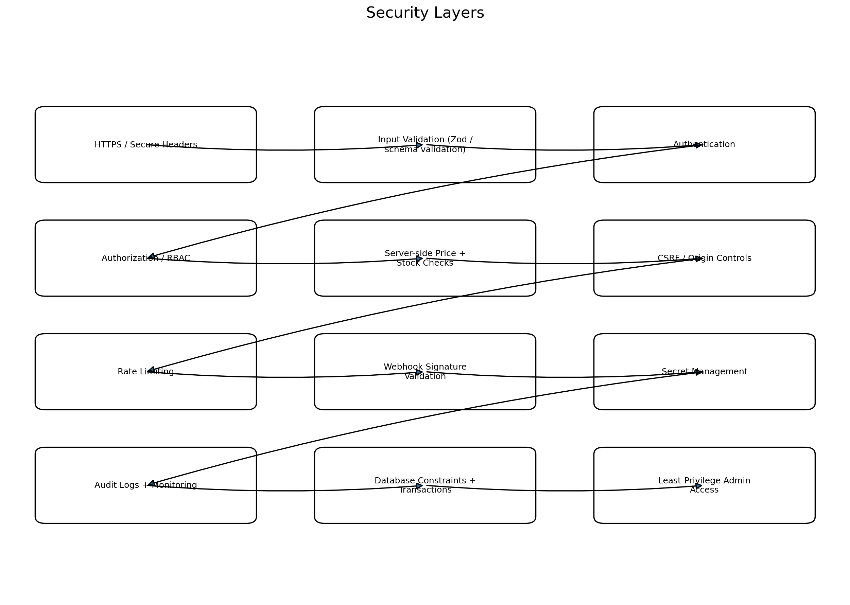
Area | Requirement
Transport | HTTPS only in production; secure cookies.
Secrets | All API keys/secrets in environment variables or secret manager; never commit .env.
Auth | Mature auth library, secure session cookies, login rate limits.
Authorization | RBAC enforced server-side for every admin mutation/read.
Validation | Validate every external input with schema validation on the server.
SQL injection | Use Prisma parameterized queries; never concatenate untrusted SQL.
XSS | Escape/render user content safely; sanitize any rich text.
CSRF | Use SameSite cookies plus framework/auth protections and origin checks for sensitive mutations.
Rate limiting | Apply to login, password reset, checkout, coupon, shipping and public mutation endpoints.
Payment | Verify Razorpay signatures/webhooks server-side.
Shipping | Keep Shiprocket credentials server-side; validate webhook security token/verification mechanism.
Uploads | Restrict file type/size, authenticated admin access, safe media processing.
Inventory | Use database transaction/locking strategy to prevent overselling.
Idempotency | Payment, webhooks, order creation and shipment creation must be safe to retry.
Logging | Structured logs without passwords, secrets, full card data or unnecessary PII.
Audit | Log admin changes to products, prices, inventory, orders and refunds.
Headers | CSP and other secure headers; review against current Next.js security guidance.
Dependencies | Lockfile, automated dependency/security updates, no unnecessary packages.
Backups | Managed PostgreSQL backups and tested restore procedure.
Privacy | Collect only required customer data and define retention/deletion rules.
Next.js production guidance specifically calls out secure environment-variable handling, authorization for Server Actions, data security and Content Security Policy. citeturn1search3turn3search5

13. Inventory & Concurrency
- Inventory is SKU-level, not product-level.
- Checkout validates current stock before payment/order finalization.
- The database, not browser state, determines available quantity.
- Inventory mutations use transactions.
- Inventory events are recorded for auditability.
- Define whether stock is reserved at order creation or only deducted after payment. Recommended initial model: create a short-lived reservation/pending state, then commit deduction after trusted payment confirmation; expired reservations release stock.
- Prevent two concurrent purchases from consuming the same last unit.
- Admin manual stock adjustments require a reason and are logged.

14. Order Lifecycle
State | Meaning
CART | Items selected but no order.
PENDING_PAYMENT | Internal order created; awaiting trusted payment.
PAID | Payment verified/captured.
PROCESSING | Fulfilment preparation underway.
SHIPMENT_CREATED | Shiprocket shipment created.
SHIPPED | AWB/courier assigned and dispatched.
OUT_FOR_DELIVERY | Courier has shipment out for delivery.
DELIVERED | Delivered.
CANCELLED | Order cancelled under policy.
REFUND_PENDING | Refund initiated/awaiting provider confirmation.
REFUNDED | Refund confirmed.
RTO | Returned to origin.
RETURN_REQUESTED | Customer return request created, if returns are enabled.
RETURNED | Return received/accepted.

15. Transactional Communication
Use a transactional email API such as Resend for system emails. Its current API supports sending templated or HTML/text messages and idempotency keys. citeturn2search2
Trigger | Email
Signup | Welcome / verify email.
Password reset | Reset link.
Order placed | Order confirmation.
Payment confirmed | Payment receipt/status.
Shipment created | Shipment/AWB information.
Shipped | Tracking link.
Out for delivery | Delivery update.
Delivered | Delivery confirmation + support/return information.
Refund | Refund status.

16. Private Admin / Operations System
Although the public website has only Home and Store, a private admin system is required to operate the store. It should not be linked from the public navigation.
Module | Required controls
Dashboard | Orders today, revenue, payment status, low-stock alerts, shipment exceptions.
Products | Create/edit/archive products, variants, pricing, media, specs.
Inventory | View stock, adjust stock, stock history.
Orders | Search, filter, view details, payment/shipping status, notes, support actions.
Payments | View provider IDs/status; never expose secrets.
Shipping | View Shiprocket IDs, AWB, courier, tracking and exceptions.
Coupons | Create/disable coupons and usage rules.
Customers | Search customers and view permitted support information.
Content | Home page promotional content should ideally be data-driven where practical.
Audit log | Who changed what and when.
Admin users | Role assignment, disable access, last login.

17. End-to-End Customer Flow
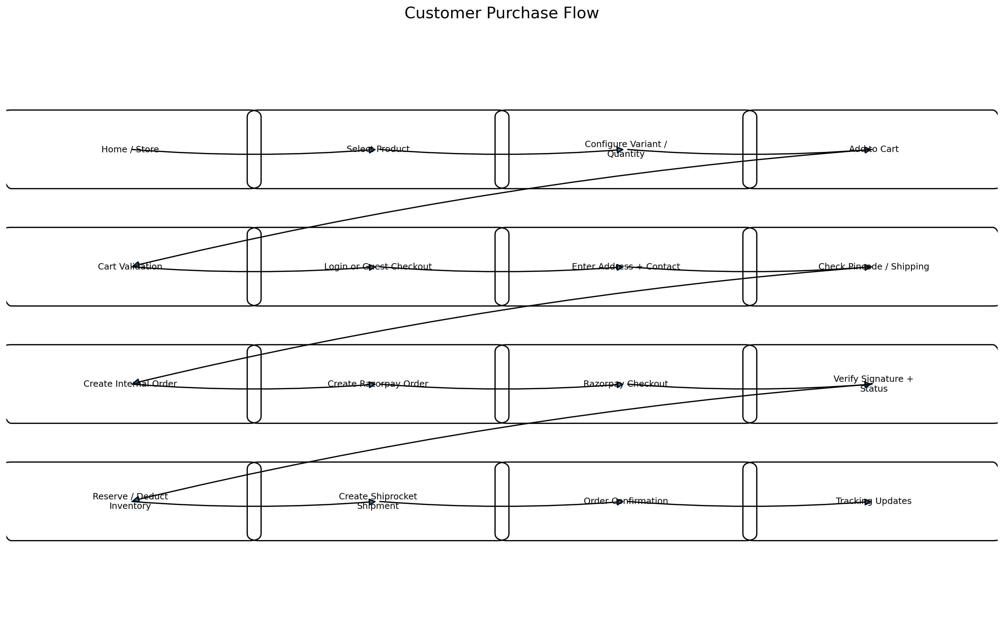

17.1 Critical failure paths
Failure | Expected behavior
Payment failed | Keep order pending/failed; do not create shipment; allow retry.
Browser closes after payment | Webhook/API verification must still finalize payment state.
Payment succeeds but webhook is delayed | Use server-side verification/fetch to confirm critical user-facing state; webhook later reconciles.
Duplicate webhook | Ignore if provider event already processed.
Shiprocket API timeout | Do not create duplicate shipment blindly; retry with idempotent/business-state protection.
Stock changed during checkout | Reject/reprice and ask customer to review cart.
Pincode not serviceable | Do not allow shipment selection to proceed.
Invalid coupon | Show error and recalculate totals.
User tries to access another user's order | Return unauthorized/not found; never leak order data.
Admin unauthorized | Block server-side even if UI route is manually opened.

18. SEO, Performance & Accessibility

18.1 SEO
- Unique title and meta description for Home and Store.
- Canonical URLs.
- Open Graph/Twitter metadata.
- Product structured data where applicable.
- Sitemap and robots.txt.
- Descriptive image alt text.
- Semantic headings; one clear H1 per page context.
- Readable text even when visual effects are disabled.

18.2 Performance
- Use Next.js Image optimization.
- Serve modern image formats and responsive sizes.
- Lazy-load below-the-fold media.
- Avoid loading large animation libraries when CSS/Framer Motion-level behavior is enough.
- Do not animate layout-heavy properties unnecessarily.
- Keep third-party scripts limited.
- Cache public product reads safely.
- Measure Core Web Vitals before launch.
Next.js production guidance recommends optimized images, hosted fonts where appropriate, careful third-party script loading and performance monitoring. citeturn1search3

18.3 Accessibility
- Keyboard navigation.
- Visible focus states.
- Proper labels and ARIA only where necessary.
- Sufficient text/background contrast.
- Reduced-motion support.
- Accessible dialogs/drawers with focus management.
- Accessible error messages.

19. Environment Variables & Secrets
Variable | Purpose | Client exposed?
DATABASE_URL | PostgreSQL connection. | NO
AUTH_SECRET | Auth.js/session encryption secret. | NO
RAZORPAY_KEY_ID | Razorpay public key identifier. | Limited: can be exposed where required
RAZORPAY_KEY_SECRET | Razorpay server secret. | NO
RAZORPAY_WEBHOOK_SECRET | Webhook verification secret. | NO
SHIPROCKET_EMAIL | Shiprocket API user. | NO
SHIPROCKET_PASSWORD | Shiprocket API user password. | NO
SHIPROCKET_WEBHOOK_TOKEN | Shiprocket webhook verification token if configured. | NO
CLOUDINARY_CLOUD_NAME | Cloudinary environment identifier. | Can be public depending on upload design
CLOUDINARY_API_KEY | Cloudinary API key. | Prefer server-side
CLOUDINARY_API_SECRET | Cloudinary secret. | NO
RESEND_API_KEY | Transactional email API key. | NO
NEXT_PUBLIC_* | Only genuinely public configuration. | YES
Next.js production guidance states that .env files should be excluded from source control and only variables prefixed NEXT_PUBLIC_ should be exposed to the browser. citeturn1search3

20. Testing & QA
Test area | Minimum acceptance criteria
Authentication | Signup/login/logout/reset work; unauthorized access blocked.
Cart | Guest/user cart works; merge on login; invalid quantities rejected.
Pricing | Client cannot manipulate final amount.
Inventory | Concurrent checkout cannot oversell.
Razorpay | Test success/failure/cancel; signature mismatch rejected; duplicate webhook safe.
Shiprocket | Serviceability, shipment creation, tracking webhook and API failures tested.
Orders | All state transitions logged and recoverable.
Admin | RBAC tested for every mutation.
Responsive | Desktop/tablet/mobile layouts tested on real devices where possible.
Accessibility | Keyboard, focus, dialogs, contrast and reduced motion tested.
Performance | Core Web Vitals and image payload measured.
Security | Dependency scan, basic OWASP checks, secret scan, rate-limit testing.
Recovery | Database backup restore and webhook retry behavior tested.

21. Deployment & Production
- Development, staging and production environments must be separated.
- Razorpay Test Mode used in development/staging; Live Mode only in production.
- Shiprocket sandbox/test environment used where available before production credentials.
- Production secrets stored in deployment platform secret/environment settings.
- Database migrations reviewed before production.
- Backups enabled and restore tested.
- Custom domain + HTTPS configured.
- Webhook URLs use production HTTPS endpoints.
- Error monitoring enabled before launch.
- A rollback strategy exists for failed deployments.
- No test products, fake orders or development API keys in production.

22. Development Phases
Phase | Deliverables | Exit condition
0. Specification | This document + approved design reference. | Scope frozen.
1. Foundation | Next.js project, TypeScript, design tokens, linting, folder architecture, env handling. | Clean local build.
2. UI system | Header, typography, buttons, panels, product cards, dialogs, motion primitives. | Reusable component system approved.
3. Home | Complete Home page with real product assets/content placeholders. | Desktop + mobile visual QA passed.
4. Store | Catalogue, filters, product detail state, cart. | Product selection flow works.
5. Database | PostgreSQL + Prisma schema/migrations + seed data. | CRUD and constraints verified.
6. Authentication | Auth.js, users, sessions, login/signup/reset, RBAC. | Auth security tests pass.
7. Checkout | Address, shipping calculation, internal order creation. | Server validates all totals.
8. Razorpay | Order creation, checkout, signature verification, webhooks. | Payment lifecycle passes test suite.
9. Shiprocket | Serviceability, shipment creation, tracking, webhook. | Shipment lifecycle passes.
10. Admin | Products, inventory, orders, shipping, audit. | Operational workflows usable.
11. Hardening | Rate limiting, headers, CSP, logs, dependency review, secret scan. | Security checklist passes.
12. Production QA | Performance, responsive, accessibility, end-to-end tests. | Launch approval.

23. Final Launch Acceptance Checklist
- Home page visually matches the approved Light in Motion design direction.
- Store page is fully functional on desktop and mobile.
- Existing App Download page remains intact.
- Products are database-driven.
- Cart cannot be manipulated to change trusted price.
- Guest and authenticated purchase paths are defined and tested.
- Razorpay test payments succeed and invalid signatures are rejected.
- Razorpay webhooks are verified and idempotent.
- Shiprocket serviceability and shipment flow works.
- Tracking updates can update internal order state.
- Admin can manage products, stock and orders.
- All sensitive secrets are server-side.
- No production secrets are committed to Git.
- Rate limiting exists on sensitive endpoints.
- Database backups are enabled.
- Monitoring/error reporting is active.
- Mobile layout has been tested on actual devices.
- Accessibility and reduced-motion behavior have been checked.
- Core Web Vitals are measured.
- Privacy/terms/refund/shipping policies are ready before live transactions.

24. Explicit Non-Goals for Version 1
- Do not rebuild the existing App Download page.
- Do not build a large CMS unless required by actual content operations.
- Do not build a custom payment gateway.
- Do not store card details.
- Do not expose Shiprocket/Razorpay/Cloudinary secrets to the client.
- Do not add unnecessary microservices; Next.js server-side architecture is sufficient for the initial scale.
- Do not add visual effects merely because they are technically possible.
- Do not create additional public marketing pages until the Home and Store experience is stable.

25. Official Technical References
- Next.js — Route Handlers: https://nextjs.org/docs/app/getting-started/route-handlers
- Next.js — Authentication: https://nextjs.org/docs/app/guides/authentication
- Next.js — Production Checklist: https://nextjs.org/docs/app/guides/production-checklist
- Auth.js: https://authjs.dev/
- Prisma — Transactions: https://www.prisma.io/docs/orm/fundamentals/transactions
- Prisma — Relational Data Modeling: https://www.prisma.io/docs/orm/data-modeling/relational-databases
- Razorpay — Standard Checkout Integration: https://razorpay.com/docs/payments/payment-gateway/web-integration/standard/integration-steps/
- Razorpay — Webhooks: https://github.com/razorpay/markdown-docs/blob/master/webhooks.md
- Razorpay — Security Checklist: https://razorpay.com/security/checklist
- Shiprocket — Developer Portal: https://www.shiprocket.in/developers/
- Shiprocket — API Help Sheet: https://support.shiprocket.in/support/solutions/articles/43000337456-shiprocket-api-document-helpsheet
- Cloudinary — Upload API: https://cloudinary.com/documentation/image_upload_api_reference
- Resend — Send Email API: https://resend.com/docs/api-reference/emails/send-email

26. Decisions to Confirm Before Coding
Decision | Current recommendation | Status
Payment provider | Razorpay Standard Checkout | Recommended
Shipping provider | Shiprocket | Confirmed by project requirement
Database | PostgreSQL | Recommended
ORM | Prisma | Recommended
Frontend/backend framework | Next.js App Router + TypeScript | Recommended
Authentication | Auth.js; email/password + optional Google | Recommended
Media | Cloudinary | Recommended
Transactional email | Resend or equivalent | Recommended
Guest checkout | Enabled | Recommended
COD | Decide based on business/shipping policy before implementation | Open
Taxes/GST | Define exact tax rules before live checkout | Open
Returns/refunds | Define policy and operational workflow before launch | Open
Shipping charge policy | Free/flat/rate-based needs final business decision | Open
Admin URL / access model | Private admin surface with RBAC | Required

