Setup and Use a Firewall on Windows

# Objective:

Configure and test basic firewall rules to allow or block traffic using Windows Defender Firewall.

# Tools Used:

* Windows Defender Firewall (Advanced Security)
* Command Prompt
* Telnet Client

# Steps Performed:

## 1. Access Firewall Configuration

Opened Windows Defender Firewall with Advanced Security via Start menu.

## 2. Viewed Existing Rules

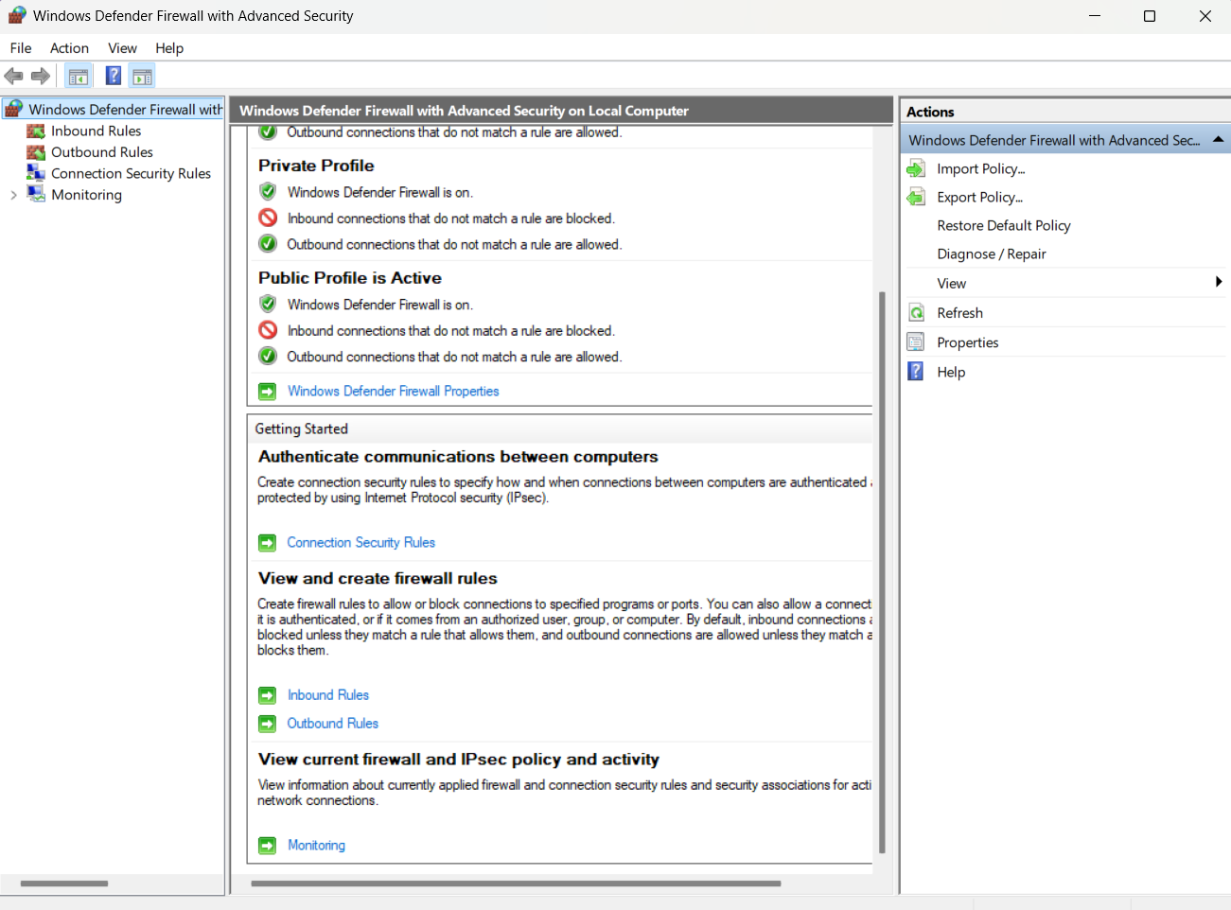Navigated to Inbound Rules to view current configuration.

## 3. Created Rule to Block Port 23 (Telnet)

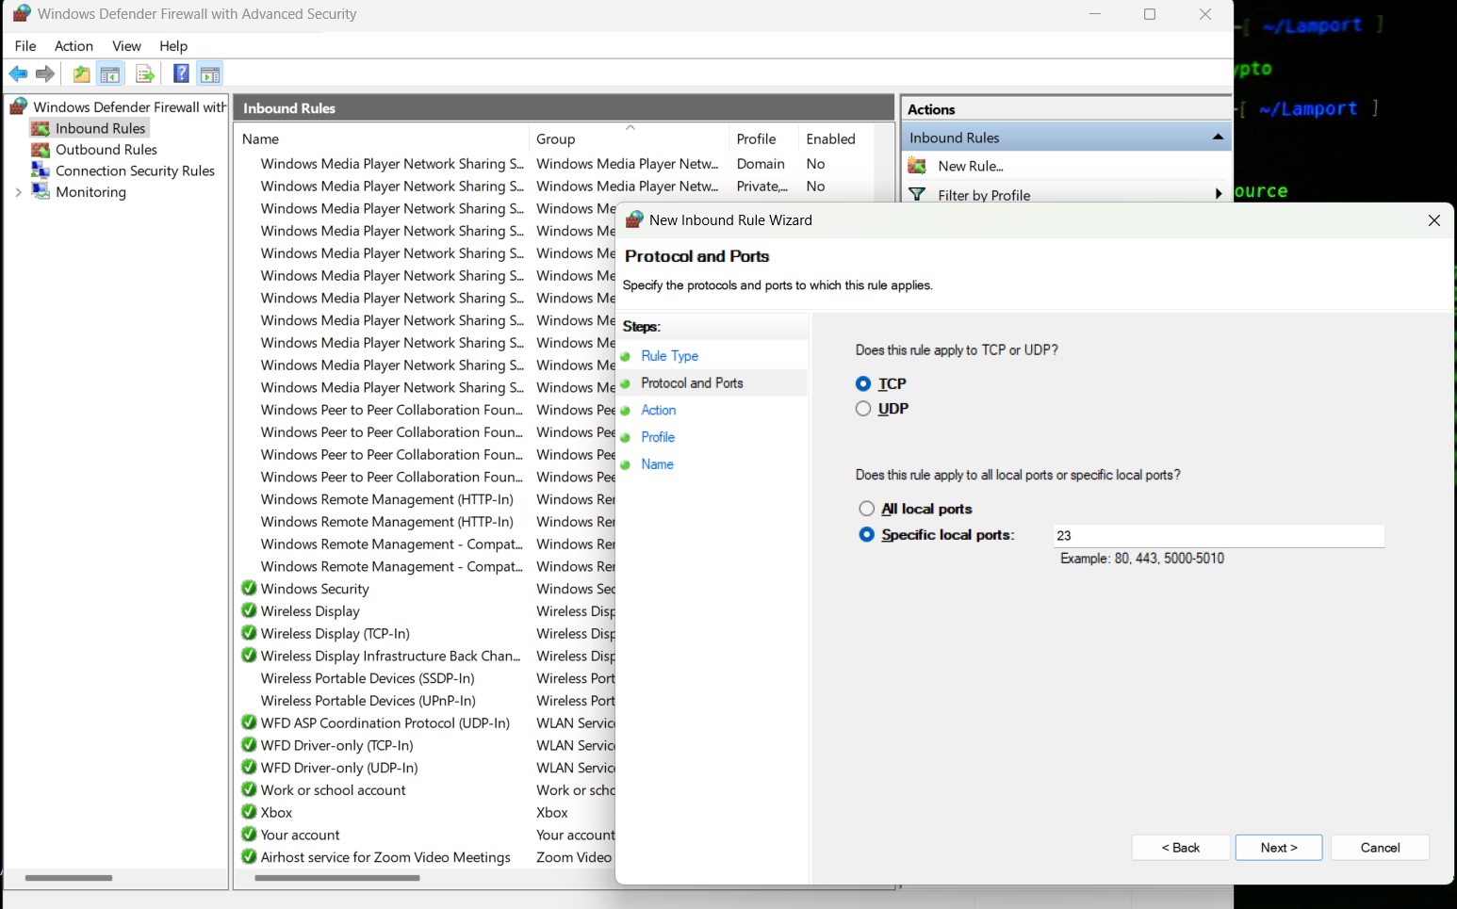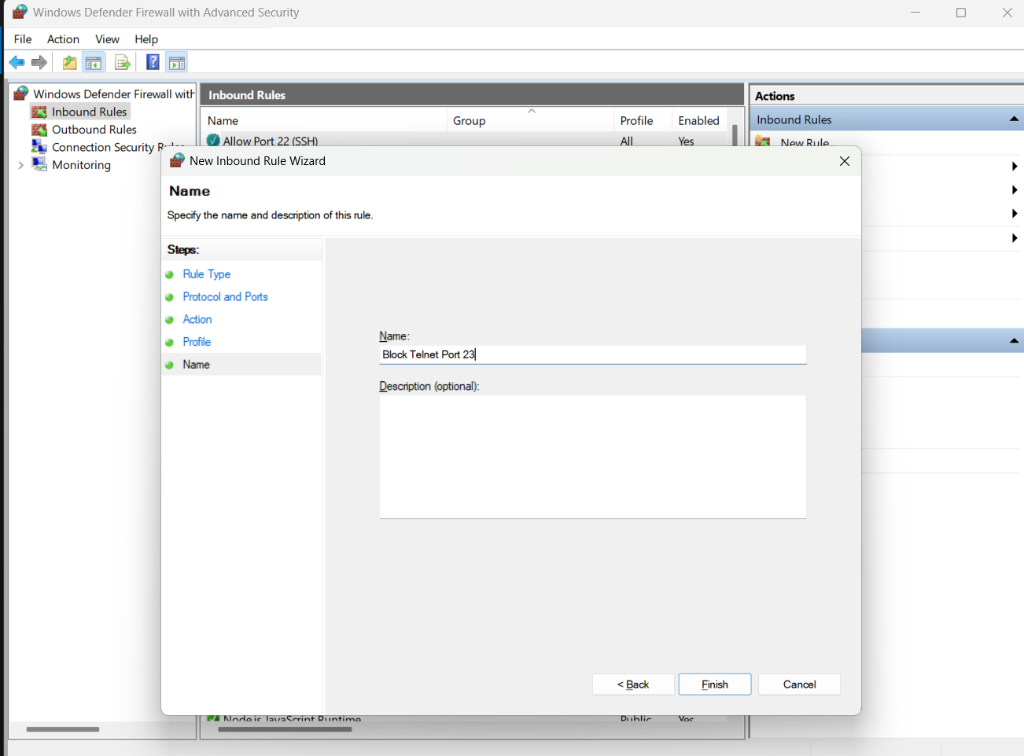New Rule → Type: Port  
Protocol: TCP, Port: 23  
Action: Block the connection  
Applied to: Domain, Private, Public  
Rule name: Block Telnet Port 23

## 4. Installed Telnet Client

Enabled via Command Prompt:  
dism /online /Enable-Feature /FeatureName:TelnetClient

## 5. Tested the Block Rule

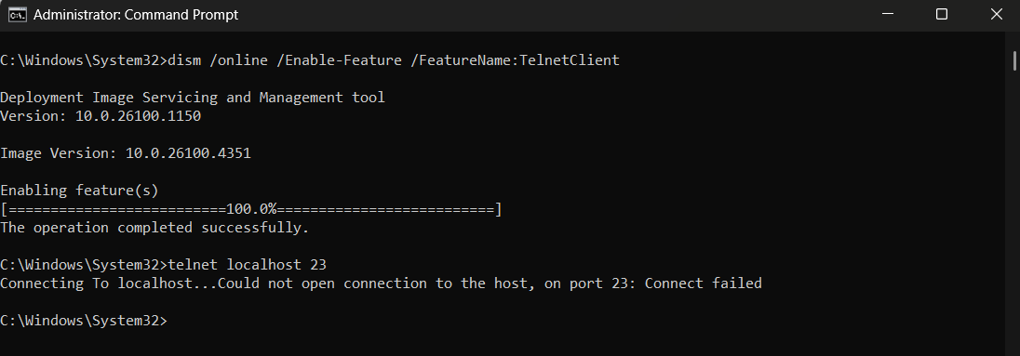Ran command: telnet localhost 23  
Result: 'Could not open connection to the host, on port 23: Connect failed'  
✅ This confirmed that port 23 was successfully blocked by the firewall rule.

## 6. Created Rule to Allow Port 22 (SSH)

Created similar rule to allow TCP traffic on port 22.

## 7. Removed Test Rule

Deleted the Block Telnet Port 23 rule from Inbound Rules to restore original state.

## 6. Created Rule to Allow Port 22 (SSH)

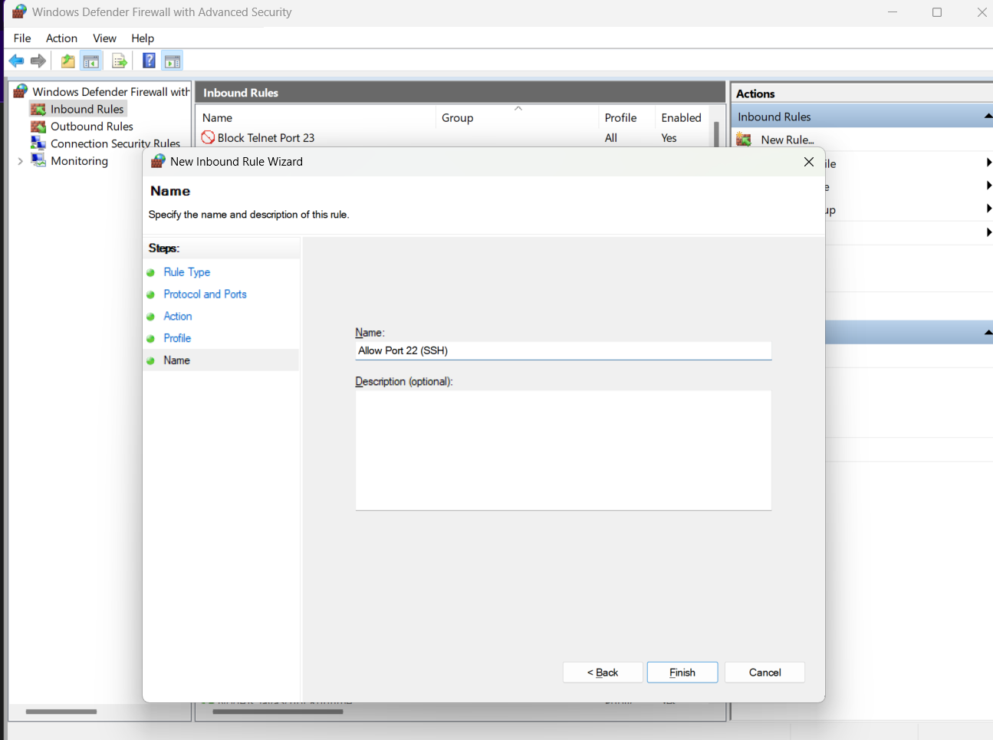Created similar rule to allow TCP traffic on port 22.

## 7. Removed Test Rule

Deleted the Block Telnet Port 23 rule from Inbound Rules to restore original state.

# Summary:

Windows Defender Firewall uses rule-based control to allow or block traffic by port, program, or IP address. In this task, a custom rule was created to **block Telnet traffic (port 23)**, and the rule was verified using the Telnet client. Additionally, a rule was created to **allow SSH traffic (port 22)**, which is commonly used for secure remote access. The firewall successfully blocked unauthorized access and permitted secure connections, demonstrating how it effectively filters and manages network traffic based on defined rules.