Task 5 Report: Network Protocol Analysis – www.instagram.com

Date: 30 June 2025

Captured By: Aryanshu Singh

Target: Local Network Interaction

Tool Used: Wireshark v4.2.5

# Objective

To capture and analyze live local network traffic using Wireshark, focusing on ARP, ICMP, and DNS protocols to understand their roles in communication.

# Traffic Capture Summary

Total Duration: ~1 minute

Total Packets Captured: 103

# Protocols Identified

|  |  |  |
| --- | --- | --- |
| Protocol | Description | Role in Session |
| ARP | Address Resolution Protocol | Maps IP addresses to MAC addresses in the local network |
| ICMP | Internet Control Message Protocol | Used for error messages and diagnostics (e.g., ping) |
| DNS | Domain Name System | Resolves domain names to IP addresses |

# Packet Details

* 🔹 1. ARP

Filter Used: arp

Example Packet:  
Who has 10.0.2.2? Tell 10.0.2.15  
Reply: 10.0.2.2 is at aa:bb:cc:dd:ee:ff

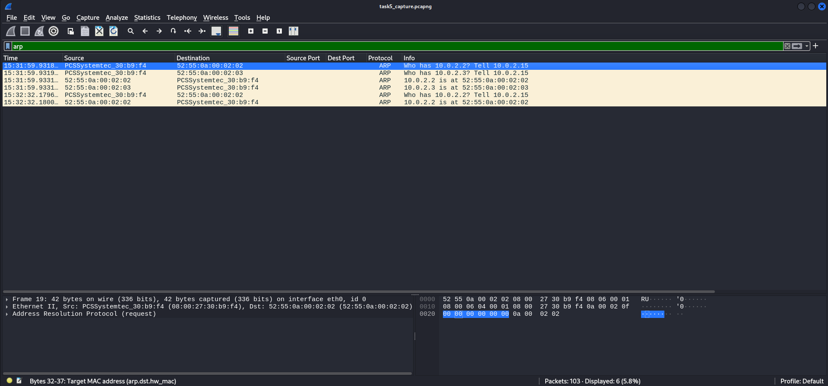

* 🔹 2. ICMP

Filter Used: icmp

Example Packet:  
Echo (ping) request from host A to host B  
Echo reply from host B to host A

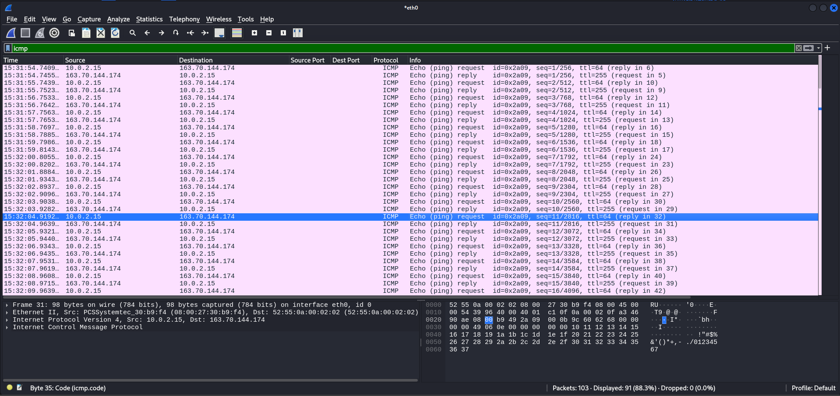

* 🔹 3. DNS

Filter Used: dns

Example Packet:  
Query: Standard query A www.instagram.com  
Response: A record returned with IP address 10.0.2.3

# 

# Conclusion

The network capture confirmed local activity involving ARP for MAC resolution, ICMP for connectivity checks, and DNS for domain resolution. These are fundamental for establishing basic network communications and diagnostics.