ARES: Adaptive Reinforcement-based Endpoint Security — An Offline QR-Code Phishing Detector with Calculus-Based Threshold Analysis
Aryan S Jain  RV University  Bengaluru, Karnataka, India  USN: 1RUA25CSE0087  aryanjainbtech25@ rvu.edu.in | Ashwin Chandrashekar Naik  RV University  Bengaluru, Karnataka, India  USN: 1RUA25CSE0090  ashwinchandrashekarnaik btech25@rvu.edu.in | Ashwin Rajesha Bhat  RV University  Bengaluru, Karnataka, India  USN: 1RUA25CSE0091  ashwinrajeshabhatbtech25@rvu.edu.in | Ashwin Subramaniam  RV University  Bengaluru, Karnataka, India  USN: 1RUA25CSE0092  ashwinsubramaniambtech25@ rvu.edu.in
Final-Year AIML Project Report · CIE-3 | Semester 3 · RV University, Bengaluru, Karnataka, India · Submission date: 1 November 2026 · Artefact trace: baseline.json; calculus_experiment.json; calculus_threshold.py; project source and test artefacts

Abstract—ARES is an offline QR-code phishing detection prototype that extracts URL-level lexical and structural features, applies a calibrated XGBoost classifier, and maps the predicted phishing probability to allow, review, or block actions. This report examines a two-threshold decision policy and a calculus-based procedure intended to analyse its thresholds. A hard operational cost combines false-positive, false-negative, and review rates, while a sigmoid-smoothed surrogate makes the threshold objective differentiable. The implementation first searches a feasible threshold grid and then applies projected gradient steps using central finite-difference gradients. On the recorded test split, the baseline thresholds (0.35, 0.70) produce hard cost 0.3998726. The returned thresholds (0.60, 0.75) produce hard cost 0.387223, a reduction of 3.16% relative to that baseline. This comparison requires an important qualification: the grid winner (0.30, 0.45) has hard cost 0.2829383, and the subsequent gradient-descent path increases the smoothed surrogate from 0.2907 to 0.4399. Therefore, the improvement of the returned point over the baseline is not evidence that gradient descent reduced the cost; it is attributable to the grid-search starting point and the reported path must be interpreted cautiously. The returned point is boundary-clipped, is not stationary, and is not claimed to satisfy KKT conditions. The report also documents data, prevalence, and generalisation limitations.
Index Terms—QR-code security, phishing detection, URL classification, XGBoost, isotonic calibration, sigmoid surrogate, projected gradient descent, finite differences, threshold optimization.

I. Introduction
QR codes are convenient entry points to websites, but a QR code can encode a URL that leads to a phishing destination. A detector that operates without fetching the destination can provide a quick local warning, although URL-only inspection cannot reveal all behaviours that occur after navigation.
ARES is structured as an offline pipeline: a QR image is decoded to obtain a URL; URL-string features are extracted; a trained and calibrated classifier estimates phishing probability; and a two-threshold policy maps the probability to an action. For probability $p$, the policy allows when $p<t_{r}$, sends the URL for review when $t_{r}≤p<t_{b}$, and blocks when $p≥t_{b}$. The thresholds satisfy box bounds and a minimum separation.
The calculus component is an analysis of the decision thresholds, not a claim that the complete application is a reinforcement-learning system. The feedback component is described as a feedback-driven heuristic policy. The threshold experiment uses a smoothed objective, finite-difference derivatives, grid search, and projected updates. The implementation does not establish that the returned point is a stationary or KKT optimum.
Contributions and scope: (1) an offline QR-to-URL detection pipeline; (2) a calibrated URL classifier; (3) a cost-sensitive two-threshold decision rule; (4) a differentiable surrogate and numerical threshold analysis; and (5) an explicit account of limitations and optimisation behaviour. The report evaluates the recorded artefacts and does not claim production deployment or generalisation beyond the constructed evaluation data.
Terminology note: the project name contains “Reinforcement-based”, but the policy evidenced by the implementation is heuristic and does not implement an MDP, Q-learning, or a learned reinforcement-learning policy.

II. Mathematical Formulation

A. Two-threshold decision rule
Let $p_{i}$ be the classifier probability for sample $i$, and let $t_{r}$ and $t_{b}$ denote the review and block thresholds. The decision is:
$\begin{matrix} & \text{allow if }p_{i}<t_{r}; \\ & \text{review if }t_{r}≤p_{i}<t_{b}; \\ & \text{block if }p_{i}≥t_{b}.\end{matrix}$ (1)
The feasible region used by the implementation is
$\begin{matrix} & 0.15≤t_{r}≤0.60, \\ & 0.45≤t_{b}≤0.95, \text{and} \\ & t_{b}−t_{r}≥0.15.\end{matrix}$ (2)
The resulting action regions for the threshold pairs discussed in this report are shown in Fig. 1.
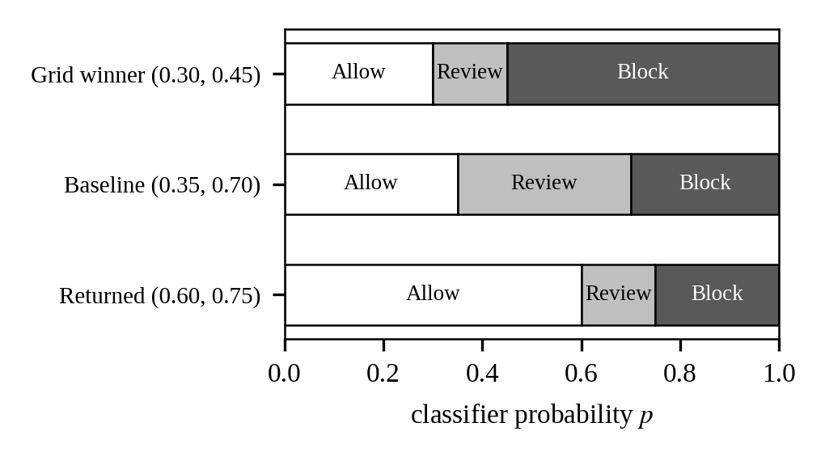
Fig. 1. Allow, review, and block regions on the probability axis for the returned thresholds (0.60, 0.75), the baseline thresholds (0.35, 0.70), and the grid winner (0.30, 0.45).

B. Hard operational cost
The hard rates are
$\begin{matrix}FPR & =\frac{fp_review+fp_block}{N_{benign}}, \\ FNR & =\frac{fn_allow+fn_review}{N_{phish}}, \text{and} \\ ReviewRate & =\frac{N_{review}}{N}.\end{matrix}$ (3)
The cost is
$C=c_{FP}⋅FPR+c_{FN}⋅FNR+c_{review}⋅ReviewRate+R\left(t_{r},t_{b}\right),$ (4)
where $c_{FP}=1$, $c_{FN}=5$, $c_{review}=0.5$, and
$R=0.05\left[{\left(t_{r}−0.35\right)}^{2}+{\left(t_{b}−0.70\right)}^{2}\right].$ (5)
The regulariser pulls thresholds toward the baseline defaults (0.35, 0.70). Consequently, this baseline is also the regulariser target; it is not an externally established universal standard.

C. Sigmoid smoothing
For $τ=0.05$, define
$\begin{matrix}σ\left(z\right) & =1/\left(1+e^{−z}\right), \\ s_{r}\left(p\right) & =σ\left(\left(p−t_{r}\right)/τ\right), \text{and} \\ s_{b}\left(p\right) & =σ\left(\left(p−t_{b}\right)/τ\right).\end{matrix}$ (6)
The surrogate rates are
$\begin{matrix}\tilde{FPR} & =mean\left[s_{r}\left(p_{i}\right) \text{for} y_{i}=0\right], \\ \tilde{FNR} & =1−mean\left[s_{b}\left(p_{i}\right) \text{for} y_{i}=1\right], \text{and} \\ \tilde{ReviewRate} & =mean\left[s_{r}\left(p_{i}\right)\left(1−s_{b}\left(p_{i}\right)\right)\right]\end{matrix}$ (7)
over all samples. The smoothed objective $\tilde{J}$ uses the same weights and regulariser as $C$, replacing the hard rates with their smoothed counterparts.

D. Projected gradient update
The implementation uses a fixed learning rate $η=0.05$. It forms $t_{r}′=t_{r}−ηg_{r}$ and $t_{b}′=t_{b}−ηg_{b}$, clips each coordinate to its box, and enforces the minimum gap. If the gap is too small, it sets $t_{b}′$ to $clip\left(t_{r}′+0.15, 0.45, 0.95\right)$. The code uses a defensive feasibility guard after this operation.

E. First- and second-order conditions
At an unconstrained interior differentiable minimum, a necessary first-order condition is $∇\tilde{J}=0$. For a strict local minimum, a positive-definite Hessian is a sufficient second-order condition when the usual smoothness assumptions hold. At a constrained boundary point, the unconstrained zero-gradient test is not sufficient; constraint qualification and multiplier conditions would be needed for a KKT analysis. The project artefacts do not verify KKT multipliers. Accordingly, the returned point is described as a boundary-clipped feasible point, not as a verified KKT optimum.
The single-threshold Bayes reference in the JSON is $c_{FP}/\left(c_{FP}+c_{FN}\right)=1/6≈0.1667$. It is a reference for a simplified binary decision setting, not the learned two-threshold solution and not a replacement for the review region.

III. A Differentiable Surrogate
The hard decision rule changes discontinuously when a threshold crosses a sample probability. Its empirical cost is therefore piecewise constant in the thresholds and does not provide a useful ordinary gradient for gradient-based optimisation. The sigmoid functions replace hard transitions with smooth transitions of temperature $τ$ (Fig. 2). A smaller $τ$ makes the transition sharper; the experiment records $τ=0.05$.
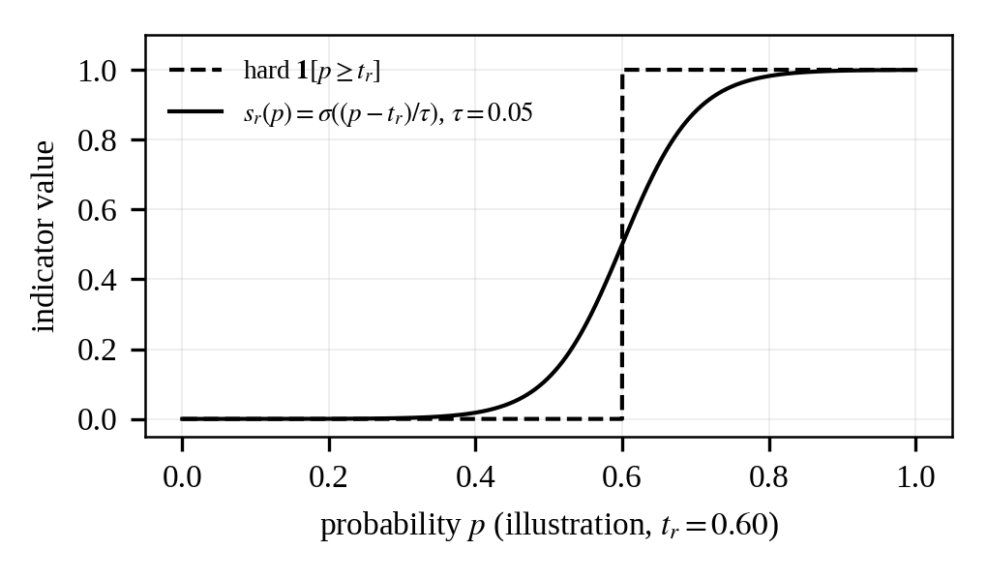
Fig. 2. Illustration of the hard threshold indicator and its sigmoid counterpart $s_{r}\left(p\right)$ for $τ=0.05$ (plotted from the stated definition; no experimental data).
The surrogate is an optimisation aid, not the operational cost itself. The final report therefore distinguishes smoothed cost $\tilde{J}$ from hard cost $C$. This distinction is essential in the experiment: the returned point has smoothed cost 0.439942 and hard cost 0.387223, while the grid winner has a lower hard cost of 0.2829383.

IV. Gradient and Optimization Algorithm

A. Analytic gradient as a reference derivation
The derivative identity for the sigmoid is $σ′\left(z\right)=σ\left(z\right)\left(1−σ\left(z\right)\right)$. With $s_{r}=σ\left(\left(p−t_{r}\right)/τ\right)$ and $s_{b}=σ\left(\left(p−t_{b}\right)/τ\right)$, the chain rule gives $∂s_{r}/∂t_{r}=−s_{r}\left(1−s_{r}\right)/τ$ and $∂s_{b}/∂t_{b}=−s_{b}\left(1−s_{b}\right)/τ$; the cross derivatives are zero.
For the smoothed rates,
∂FPR∂tr=−1Nbenignτyi=0​sr1−sr, and∂FNR∂tb=1Nphishτyi=1​sb1−sb. (8)
The review-rate derivatives are
∂ReviewRate∂tr=−1Nτi​sr1−sr1−sb, and∂ReviewRate∂tb=1Nτi​srsb1−sb. (9)
Thus, with regulariser coefficient $λ=0.05$ and target $\left(t_{r}^{0},t_{b}^{0}\right)=\left(0.35,0.70\right)$:
∂J∂tr=​−cFPNbenignτyi=0​sr1−sr−creviewNτi​sr1−sr1−sb+2λtr−tr0. (10)
∂J∂tb=​cFNNphishτyi=1​sb1−sb+creviewNτi​srsb1−sb+2λtb−tb0. (11)
This analytic expression is included as a mathematical reference derivation. It is not the gradient routine evaluated by the submitted Python implementation.

B. Implemented numerical gradient
The uploaded calculus_threshold.py implements compute_cost_gradient_fd. It evaluates the smoothed cost at positive and negative perturbations and uses central finite differences:
$\begin{matrix}g_{r} & ≈\frac{\tilde{J}\left(t_{r}+ϵ,t_{b}\right)−\tilde{J}\left(t_{r}−ϵ,t_{b}\right)}{2ϵ}, \text{and} \\ g_{b} & ≈\frac{\tilde{J}\left(t_{r},t_{b}+ϵ\right)−\tilde{J}\left(t_{r},t_{b}−ϵ\right)}{2ϵ},\end{matrix}$ (12)
with $ϵ={10}^{−4}$. The implementation also estimates the two diagonal Hessian entries and the mixed derivative by finite differences.

C. Recorded returned-point derivatives
TABLE I
RECORDED RETURNED-POINT DERIVATIVES
Quantity | Recorded value | Source field
∂J̃/∂t_{r} | −0.153059 | optimized.​derivative_​check.​​first_​derivative_​review
∂J̃/∂t_{b} | 1.621676 | optimized.​derivative_​check.​​first_​derivative_​block
Stationary / critical point | False | optimized.​derivative_​check.​​is_​stationary_​point
Gradient tolerance | 0.01 | optimized.​derivative_​check.​​grad_tol
Learning rate | 0.05 | optimized.​derivative_​check.​​learning_rate
Finite-difference ϵ | 0.0001 | calculus_​threshold.​py, compute_​cost_​gradient_​fd default
The derivative values are nonzero and the JSON marks the point as non-stationary. The threshold coordinates are clipped by the review upper bound and the minimum-gap constraint.

D. One worked update
At the returned point, the recorded review derivative is negative and the block derivative is positive. Before projection, the update direction therefore increases $t_{r}$ and decreases $t_{b}$. The review coordinate cannot increase beyond 0.60, and the minimum-gap constraint prevents the block coordinate from falling below $t_{r}+0.15$. The resulting feasible point is (0.60, 0.75), with both the review upper bound and gap constraint active. This illustrates why the final point is boundary-clipped rather than an interior stationary point (Fig. 3).
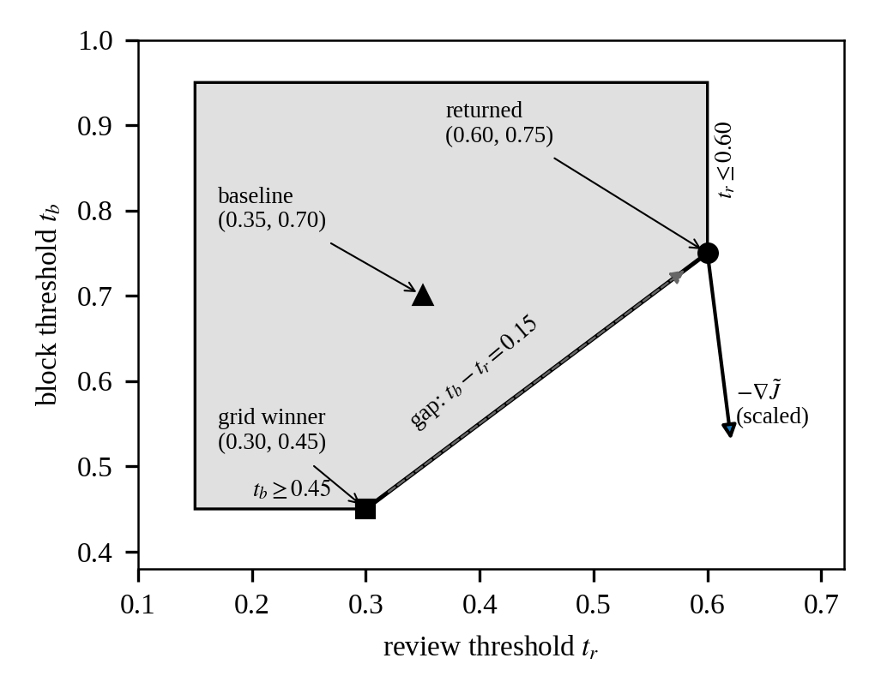
Fig. 3. Feasible region in the $\left(t_{r},t_{b}\right)$ plane with the grid winner, baseline, and returned points. The dashed arrow shows only the net displacement between the endpoints (the per-iteration path is not plotted). The solid arrow is the direction of $−∇\tilde{J}$ at the returned point, using the recorded gradient (−0.153059, 1.621676), drawn at an arbitrary display scale.

V. Optimality Verification

A. First-order assessment
The recorded gradient is (−0.153059, 1.621676), and is_stationary_point is false. Hence the unconstrained first-order stationarity condition is not met. The returned point is not described as a stationary optimum.

B. Boundary and KKT qualification
The active constraints recorded are review_box_0.60 and gap_0.15. The derivative signs indicate that the unconstrained descent direction would move the review threshold above its permitted upper bound and the block threshold downward, while the gap constraint prevents that downward movement. KKT multipliers and complementary-slackness conditions have not been verified. No KKT-optimality claim is made.

C. Second-order diagnostic
The finite-difference Hessian at the returned point is
$H=\left[\begin{matrix}0.405678 & −0.088070 \\ −0.088070 & 17.086192\end{matrix}\right].$ (13)
Its determinant is 6.923728 and trace is 17.491870. Both diagonal entries are positive and the determinant is positive, so this numerically estimated symmetric 2×2 Hessian is positive definite at the evaluated point. This is a local curvature diagnostic for the smoothed objective; it does not override the nonzero gradient or establish constrained optimality.

D. Reference threshold
The recorded single-threshold Bayes reference is 0.1667 for the cost weights 1 and 5. ARES uses two thresholds and a review band, so this value is contextual rather than the selected operating threshold.

VI. ARES System and Adaptive Policies
The prototype pipeline is: QR image input → local QR decoding → URL string → lexical/structural feature extraction → calibrated XGBoost probability → threshold decision → allow, review, or block (Fig. 4). The application is described as offline with respect to URL inspection; it does not fetch page content or inspect redirect chains as part of the detector.
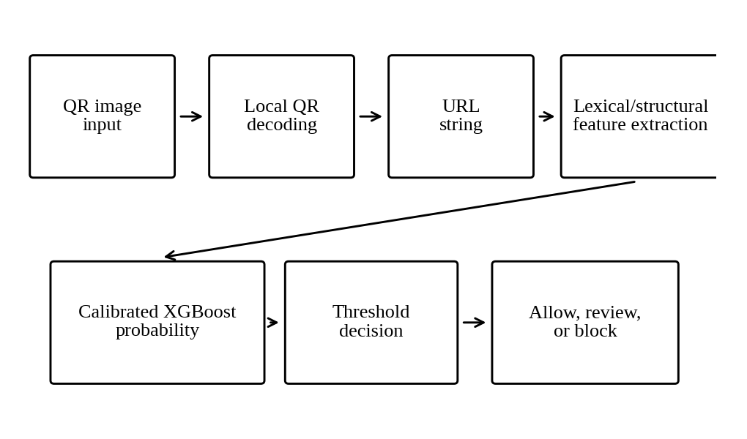
Fig. 4. ARES prototype pipeline.
The feedback-driven heuristic policy adjusts thresholds using a step based on a learning-rate term, a multiplier, and the probability margin. The supplied evidence explicitly does not establish a Markov decision process, Q-learning, or a learned RL policy. The project name should therefore not be used as evidence that reinforcement learning was implemented.
TABLE II
ARES COMPONENTS AND EVIDENCE-BASED DESCRIPTIONS
Component | Role | Evidence-based description
QR decoding | Obtain URL from QR image | Local decoding path; no network inspection
Feature extraction | Represent URL | 24 lexical/structural URL features, as stated in supplied project evidence
Classifier | Estimate phishing probability | XGBoost classifier with isotonic calibration
Threshold policy | Map probability to action | Two thresholds: allow / review / block
Feedback adjustment | Adapt policy values | Feedback-driven heuristic, not reinforcement learning
Calculus experiment | Analyse thresholds | Grid search plus projected updates using finite-difference derivatives

VII. Experimental Setup
The baseline artefact records a GroupShuffleSplit 80/20 split by registrable domain and 5-fold GroupKFold isotonic calibration. The evaluation scope is a held-out domain-grouped evaluation on a semi-synthetic constructed dataset. The test split contains 5,083 URLs from 1,497 domains and has phishing prevalence 0.7478. The baseline JSON reports 17,057 training examples and 5,985 training domains. Random seed is 42.
The classifier is XGBoost (XGBClassifier) with isotonic calibration, migrated from RandomForest. Recorded software versions are scikit-learn 1.9.1, NumPy 2.5.4, and Python 3.14.2. The experiment compares baseline thresholds (0.35, 0.70), a grid winner (0.30, 0.45) documented in the supplied results brief, and the returned thresholds (0.60, 0.75).
Important evaluation qualification: the threshold optimisation uses the same y_true and y_proba test split that is used to report the threshold rates. No separate held-out threshold-tuning check is present in the final artefacts. Therefore, the threshold comparison is in-sample with respect to threshold selection, despite the classifier’s domain-grouped train/test split.

VIII. Results and Analysis

A. Classifier-level metrics
TABLE III
CLASSIFIER-LEVEL METRICS
Metric | Recorded value | Source
ROC AUC | 0.9931 | baseline.​test.​roc_auc
PR AUC | 0.9977 | baseline.​test.​pr_auc
Brier score | 0.0302 | baseline.​test.​brier
Precision field | 0.9833 | baseline.​test.​precision
F1 score | 0.9707 | baseline.​test.​f1_score
TPR | 0.9584 | baseline.​test.​tpr
FPR | 0.0484 | baseline.​test.​fpr
Confusion matrix | [[1220, 62], [158, 3643]] | baseline.​test.​confusion_​matrix
The classifier-level confusion matrix (Fig. 5) is a separate evaluation summary and must not be conflated with the policy-specific outcome counts below. The JSON also records precision_at_prevalence values of 0.952 at 50% prevalence, 0.5105 at 5%, 0.1668 at 1%, and 0.0195 at 0.1% (Fig. 6). The supplied limitations note quoted different prevalence-adjusted values; the JSON values are used here as the canonical artefact values.
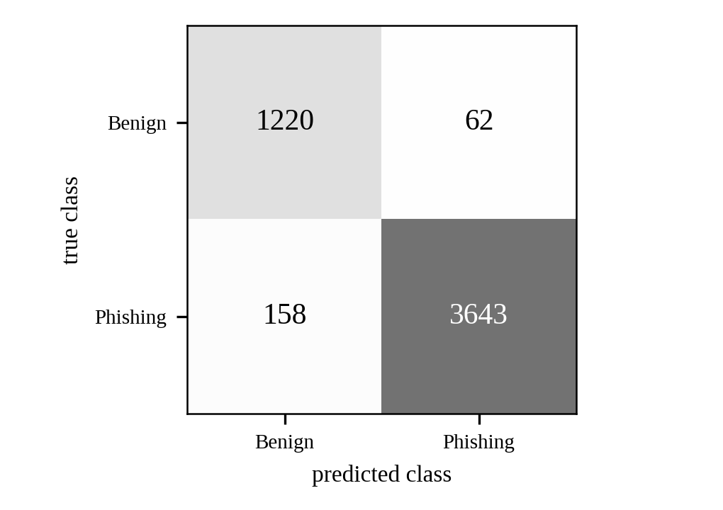
Fig. 5. Classifier-level confusion matrix, [[1220, 62], [158, 3643]] (rows: true class; columns: predicted class).
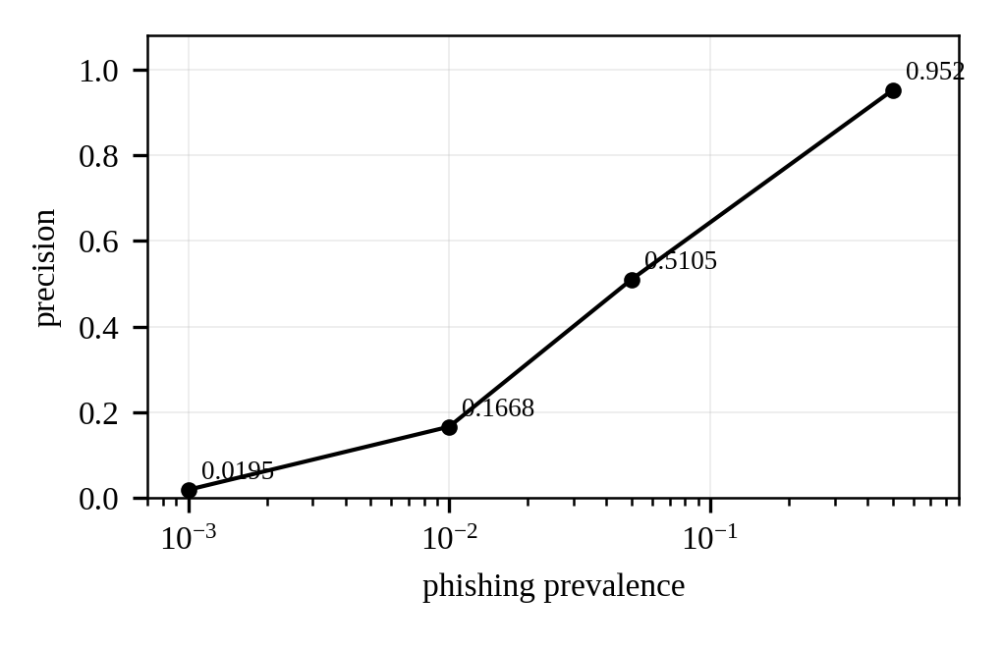
Fig. 6. Recorded precision at phishing prevalence 0.1%, 1%, 5%, and 50%.

B. Threshold rates and hard cost
TABLE IV
THRESHOLD RATES AND HARD COST
Measure | Baseline (0.35, 0.70) | Returned (0.60, 0.75) | Change
FPR | 6.94% | 3.43% | −50.6% relative
FNR | 6.24% | 6.81% | +0.57 pp (+9.22% relative)
Review rate | 3.74% | 1.79% | −52.1% relative
Hard cost | 0.3998726 | 0.387223 | −3.16% relative
The returned thresholds reduce the false-positive rate and review rate, but increase the false-negative rate (Fig. 7). The FNR change is +0.57 percentage points; this is not a +0.57% relative change.
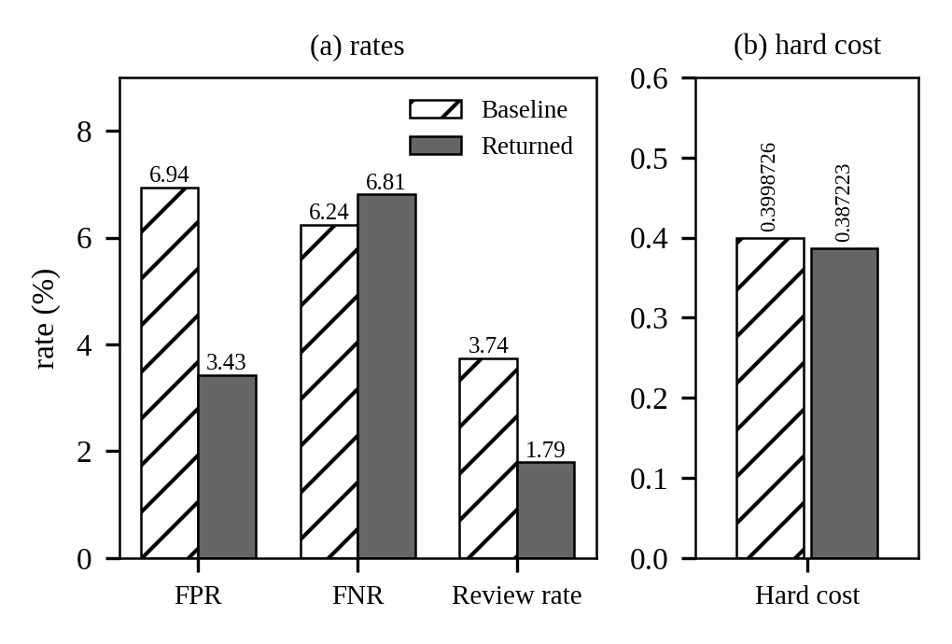
Fig. 7. Baseline (0.35, 0.70) versus returned (0.60, 0.75) thresholds: (a) FPR, FNR, and review rate in percent; (b) hard cost.

C. Policy outcome counts
TABLE V
POLICY OUTCOME COUNTS
Outcome count | Baseline | Returned
fp_review | 62 | 25
fp_block | 27 | 19
tn | 1193 | 1238
fn_allow | 109 | 193
fn_review | 128 | 66
tp | 3564 | 3542
These six outcome categories describe the threshold policy. They differ from the classifier confusion matrix because they separate review and block/allow outcomes (Fig. 8).
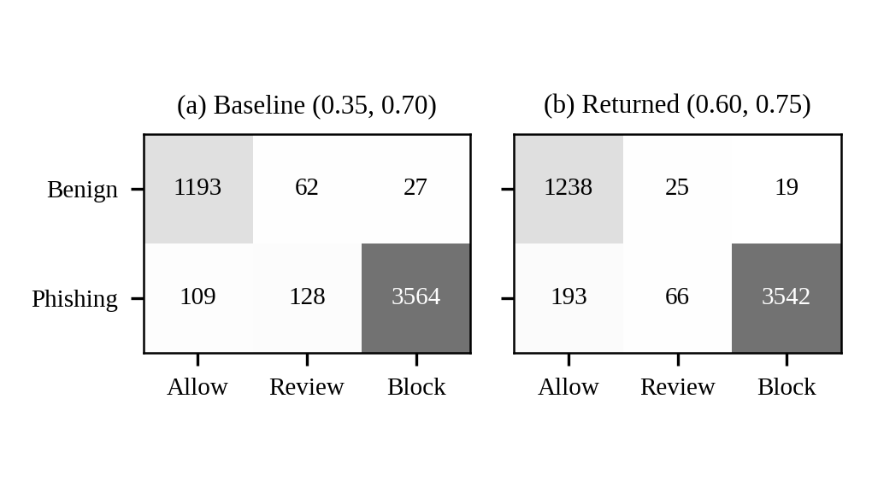
Fig. 8. Policy outcome counts (rows: true class; columns: allow, review, block action) for (a) the baseline and (b) the returned thresholds.

D. Grid search and gradient path
TABLE VI
GRID WINNER, BASELINE, AND RETURNED POINT
Point | Thresholds (t_{r}, t_{b}) | Smoothed cost | Hard cost
Grid winner | (0.30, 0.45) | 0.2907197 | 0.2829383
Baseline | (0.35, 0.70) | Not reported | 0.3998726
Returned point | (0.60, 0.75) | 0.4399421 | 0.3872226
The history contains 30 entries, corresponding to 29 gradient-descent updates. Along the recorded path, the smoothed surrogate increases from 0.2907197 at the grid winner to 0.4399421 at the returned point (Fig. 9). The returned point’s hard cost is also higher than the grid winner’s hard cost. The improvement over the baseline is therefore attributable to the grid-search initial point and the subsequent path/selection behaviour, not to gradient descent reducing the objective. This is the central optimisation limitation of the experiment.
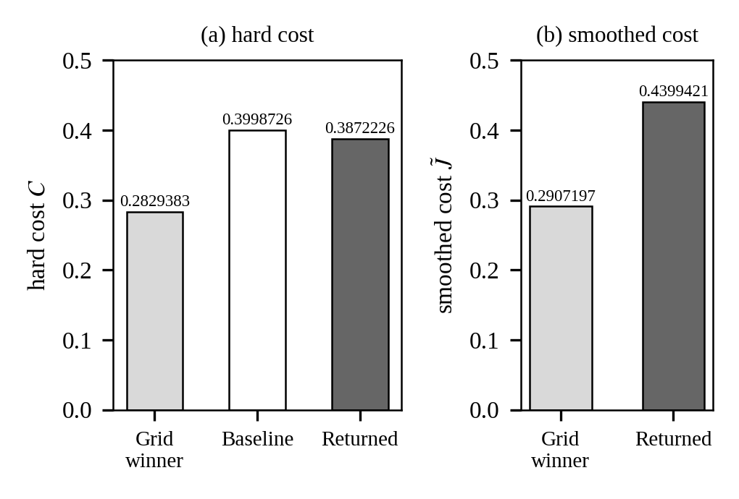
Fig. 9. (a) Hard cost at the grid winner, baseline, and returned point; (b) smoothed cost at the grid winner and returned point (the baseline smoothed cost is not reported).

IX. Discussion and Limitations

A. Synthetic benign data
Benign URLs are generated as path and parameter variants of 820 base domains (train_model.py::benign_variants). This gives limited benign diversity: variants of a base domain share the base domain’s lexical signature, so the model may generalise poorly to real-world benign URLs whose hostnames and paths are not related to the 820 base domains.

B. Lexical features only
Only 24 lexical and structural features are extracted from the URL string. No page content, redirect chain, TLS certificate, or external reputation feed is inspected. The detector therefore cannot catch phishing URLs whose lexical form is benign—for example, a shortened link to a legitimate-looking domain that redirects to a phishing page.

C. Test-set prevalence is not deployment prevalence
The constructed test set has 74.78% phishing prevalence. The baseline JSON records precision_at_prevalence values of 0.952 at 50% prevalence, 0.5105 at 5%, 0.1668 at 1%, and 0.0195 at 0.1%. Real-world QR traffic may have a much lower phishing prevalence, so precision can be substantially lower in deployment.

D. In-sample threshold tuning
The reported threshold rates are computed on the 5,083-URL test split, and the calculus thresholds are tuned on the same y_true and y_proba. No separate held-out threshold-tuning check is present in the final artefacts. A domain-grouped tuning/evaluation split would provide a more independent estimate; the reported threshold improvement is not claimed to generalise.

E. Smoothed surrogate rises during gradient descent
The smoothed surrogate cost rises from 0.2907 to 0.4399 over the recorded 29 gradient-descent updates. The grid winner (0.30, 0.45) has hard cost 0.2829, while the returned point (0.60, 0.75) has hard cost 0.3872. The returned point is therefore worse than the grid winner under hard cost. Projection onto the box and gap constraints does not guarantee a descent step. The baseline-to-returned-point reduction (0.3999 to 0.3872, about 3.16%) must not be attributed to gradient descent; the grid search supplied the lower-cost starting point.

F. Regulariser-tied thresholds
The cost includes the regulariser $0.05\left[{\left(t_{r}−0.35\right)}^{2}+{\left(t_{b}−0.70\right)}^{2}\right]$, which pulls thresholds toward (0.35, 0.70). This makes the baseline thresholds the regulariser target rather than an independently justified universal standard. A different target would change the objective and could change the selected thresholds. The baseline comparison should therefore be interpreted as a comparison against this specific regularised baseline.
Additional interpretation: the returned point is boundary-clipped and non-stationary; KKT multipliers were not verified. The Hessian diagnostic alone does not establish constrained optimality. The threshold experiment is a useful numerical case study, but it does not demonstrate successful descent or out-of-sample threshold generalisation.

X. Conclusion
ARES demonstrates an offline QR-code URL inspection pipeline and a cost-sensitive two-threshold decision policy. The classifier’s recorded ranking and calibration metrics are strong on the constructed, domain-grouped evaluation split, but the split has high phishing prevalence and the data and features impose important limits on deployment claims. The calculus experiment provides a sigmoid-smoothed objective and numerical derivative diagnostics. However, the recorded gradient-descent path increases the surrogate cost, the returned point is not stationary, and its hard cost is higher than the grid winner’s. The reported 3.16% hard-cost reduction relative to the baseline should therefore be described carefully and not credited to gradient descent. Future work should separate threshold tuning from final evaluation, broaden benign URL diversity, evaluate realistic prevalence, and revise the constrained optimisation procedure with a verified descent method and explicit constrained optimality checks.

Acknowledgment
The authors acknowledge the guidance of the faculty and the support of RV University.

References
[1] T. Chen and C. Guestrin, “XGBoost: A Scalable Tree Boosting System,” in Proc. 22nd ACM SIGKDD Int. Conf. Knowledge Discovery and Data Mining, 2016, pp. 785–794.
[2] A. Niculescu-Mizil and R. Caruana, “Predicting Good Probabilities with Supervised Learning,” in Proc. 22nd Int. Conf. Machine Learning (ICML), 2005, pp. 625–632.
[3] J. Nocedal and S. J. Wright, Numerical Optimization, 2nd ed. New York, NY, USA: Springer, 2006.
[4] S. Boyd and L. Vandenberghe, Convex Optimization. Cambridge, U.K.: Cambridge University Press, 2004.

Appendix A. Core Threshold Routines and Analytic Gradient Derivation
The submitted calculus_threshold.py contains the hard two-threshold rates, smoothed rates, hard and smoothed expected-cost functions, central finite-difference gradient, finite-difference Hessian, grid search, projected updates, and final-point diagnostics. The report summarises these routines rather than reproducing an unverified or altered code listing.

A.1 Sigmoid derivative
Let $σ\left(z\right)=1/\left(1+e^{−z}\right)$. Differentiating gives
$σ′\left(z\right)=\frac{e^{−z}}{{\left(1+e^{−z}\right)}^{2}}=σ\left(z\right)\left[1−σ\left(z\right)\right].$ (14)

A.2 Chain rule
For $s_{r}\left(p\right)=σ\left(\left(p−t_{r}\right)/τ\right)$, $∂s_{r}/∂t_{r}=−s_{r}\left(1−s_{r}\right)/τ$. For $s_{b}\left(p\right)=σ\left(\left(p−t_{b}\right)/τ\right)$, $∂s_{b}/∂t_{b}=−s_{b}\left(1−s_{b}\right)/τ$. The cross derivatives are zero because each sigmoid depends on only its own threshold.

A.3 Derivatives of smoothed rates
FPR=1/Nbyi=0​srpi, so
∂FPR∂tr=−1Nbτyi=0​srpi1−srpi. (15)
FNR=1−1/Npyi=1​sbpi, so
∂FNR∂tb=1Npτyi=1​sbpi1−sbpi. (16)
ReviewRate=1/Ni​srpi1−sbpi. By the product rule,
∂ReviewRate∂tr=−1Nτi​srpi1−srpi1−sbpi, and∂ReviewRate∂tb=1Nτi​srpisbpi1−sbpi. (17)

A.4 Full symbolic gradient
With $R=λ\left[{\left(t_{r}−t_{r}^{0}\right)}^{2}+{\left(t_{b}−t_{b}^{0}\right)}^{2}\right]$, the regulariser derivatives are $2λ\left(t_{r}−t_{r}^{0}\right)$ and $2λ\left(t_{b}−t_{b}^{0}\right)$. Therefore:
∂J∂tr=​−cFPNbτyi=0​sr1−sr−creviewNτi​sr1−sr1−sb+2λtr−tr0. (18)
∂J∂tb=​cFNNpτyi=1​sb1−sb+creviewNτi​srsb1−sb+2λtb−tb0. (19)
Implementation distinction: compute_cost_gradient_fd evaluates central finite differences with $ϵ={10}^{−4}$; the analytic expressions above are a reference derivation and are not directly evaluated by that function. The implementation also computes second derivatives by finite differences.

A.5 Core Code Excerpts
The two excerpts below show the central finite-difference gradient and the projected update that are used in the reported experiment; the full source file is calculus_threshold.py in the submitted repository.

def compute_cost_gradient_fd(y_true, y_proba, t_review, t_block,
cost_fp=1.0, cost_fn=5.0,
cost_review=0.5, eps=1e-4, tau=0.05):
def c(r, b):
return expected_cost_smoothed(
y_true, y_proba, r, b,
cost_fp, cost_fn, cost_review, tau)
dC_d_review = (c(t_review + eps, t_block) -
c(t_review - eps, t_block)) / (2 * eps)
dC_d_block = (c(t_review, t_block + eps) -
c(t_review, t_block - eps)) / (2 * eps)
return {"dC_d_review": dC_d_review, "dC_d_block": dC_d_block}
Listing 1. Central finite-difference gradient (compute_cost_gradient_fd).
for k in range(max_iter):
grad = compute_cost_gradient_fd(...)
tr_new = float(np.clip(tr - lr * grad["dC_d_review"], 0.15, 0.60))
tb_new = float(np.clip(tb - lr * grad["dC_d_block"], 0.45, 0.95))
if tb_new - tr_new < 0.15:
tb_new = float(np.clip(tr_new + 0.15, 0.45, 0.95))
Listing 2. Projected gradient descent update.

These excerpts are the two code paths that produced the results reported in Section VIII; the surrounding grid search, cost function, and Hessian diagnostic are summarised in Sections II–V and not reproduced here.

Appendix B. Numerical Traceability Audit
The following table records the numerical values used in the report and their canonical artefact fields. Values quoted to fewer decimal places in prose are rounded displays of the source values.
TABLE VII
NUMERICAL TRACEABILITY AUDIT
Reported quantity | Value | Traceability
Raw rows / benign / phishing | 160064 / 820 / 159244 | baseline.​test.​raw_​dataset_​summary.​​total_rows / benign_rows / phishing_rows
Train size / train domains | 17057 / 5985 | baseline.​test.​n_train / n_​train_​domains
Test size / test domains | 5083 / 1497 | baseline.​test.​n_test / n_​test_​domains
Test phishing prevalence | 0.7478 | baseline.​test.​test_​phishing_​prevalence
Random seed | 42 | baseline.​test.​random_seed
Software versions | sklearn 1.9.1; NumPy 2.5.4; Python 3.14.2 | baseline.​test.​sklearn_​version / numpy_version / python_​version
ROC AUC / PR AUC / Brier | 0.9931 / 0.9977 / 0.0302 | baseline.​test.​roc_auc / pr_auc / brier
Precision / F1 / TPR / FPR | 0.9833 / 0.9707 / 0.9584 / 0.0484 | baseline.​test.​precision / f1_score / tpr / fpr
Classifier confusion matrix | [[1220,62],[158,3643]] | baseline.​test.​confusion_​matrix
Precision at prevalence 0.5 / 0.05 / 0.01 / 0.001 | 0.952 / 0.5105 / 0.1668 / 0.0195 | baseline.​test.​precision_​at_​prevalence
Baseline thresholds | 0.35 / 0.70 | calculus_​experiment.​​baseline.​review / block
Baseline hard cost | 0.39987259019990573 | calculus_​experiment.​​baseline.​cost
Baseline FPR / FNR / review | 0.0694227769 / 0.0623520126 / 0.0373795003 | calculus_​experiment.​​baseline.​rates
Baseline policy counts | 62,27,109,128,1193,3564 | calculus_​experiment.​​baseline.​rates.​fp_review / fp_block / fn_allow / fn_review / tn / tp
Returned thresholds | 0.60 / 0.75 | calculus_​experiment.​​optimized.​review_​threshold / block_​threshold
Returned hard cost | 0.387223 (rounded); 0.38722259534246795 in results brief | calculus_​experiment.​​optimized.​optimal_cost / final_​cost_​hard
Returned smoothed cost | 0.439942 | calculus_​experiment.​​optimized.​optimal_​cost_​smoothed / final_cost
Returned FPR / FNR / review | 0.0343 / 0.0681 / 0.0179 | calculus_​experiment.​​optimized.​rates_​at_​optimum
Returned policy counts | 25,19,193,66,1238,3542 | calculus_​experiment.​​optimized.​rates_​at_​optimum.​​fp_review / fp_block / fn_allow / fn_review / tn / tp
Gradient components | −0.153059 / 1.621676 | optimized.​derivative_​check.​​first_​derivative_​review / first_​derivative_​block
Hessian entries | 0.405678 / 17.086192 / −0.08807 | optimized.​derivative_​check.​​second_​derivative_​review / second_​derivative_​block / cross_​derivative_​review_​block
Hessian determinant / trace | 6.923728 / 17.491870 | optimized.​derivative_​check.​​hessian_det; trace computed as sum of diagonal entries
Active constraints | review_​box_​0.​60; gap_0.15 | optimized.​derivative_​check.​​boundary_hit
Bayes reference threshold | 0.1667 | optimized.​derivative_​check.​​bayes_​optimal_​single_​threshold
Gradient steps / history entries | 29 / 30 | optimized.​derivative_​check.​​gradient_​descent_​iterations; len(optimized.​history)
Learning rate / tau / grad tolerance | 0.05 / 0.05 / 0.01 | optimized.​derivative_​check.​​learning_rate / temperature_​tau / grad_tol
Grid winner thresholds / costs | (0.30,0.45); smoothed 0.2907196813; hard 0.2829383160 | results_​brief.​md grid-winner computation; not a field in calculus_​experiment.​json
Finite difference epsilon | 0.0001 | calculus_​threshold.​py compute_​cost_​gradient_​fd default eps
Regulariser coefficient / target | 0.05 / (0.35,0.70) | calculus_​threshold.​py expected_cost and expected_​cost_​smoothed lines 41,46
Limitations 1, 2 and 6 evidence | 820 base domains; 24 features; default thresholds | User-supplied evidence statements; train_​model.​py / feature_​extractor.​py / adaptive_​agent.​py not attached for independent line verification
Submission date | 1 November 2026 | Project conversation deadline context; confirm if institutional cover date differs
Traceability cautions: (i) The grid-winner hard cost is sourced from the supplied results brief rather than a field in calculus_experiment.json. (ii) The 24-feature count and source-function descriptions are supplied project evidence; the corresponding feature_extractor.py and train_model.py files were not attached in this report-generation batch. (iii) No held-out threshold-tuning experiment or 1,017-URL result is included or claimed.

