
CS2403 COMPUTER NETWORKS
Mini Project Report
Design and Simulation of a Smart College Network Using VLANs
Submitted
By
Aryan Inchal (1RUA25CSE0084)
Bellumkonda Sandilya (1RUA25CSE0108)
Bhuvan Tej U (1RUA25CSE0119)
Aryan S Jain (1RUA25CSE0087)
Under the guidance of:
Prof. Evlin Vidyu Latha P
School of Computer Science and Engineering
RV University, Bangalore
GitHub: https://github.com/asj-cs-cjc-rvu-binary-1000/04-Design-and-Simulation-of-a-Smart-College-Network-Using-VLANs

School of Computer Science and Engineering
CERTIFICATE
Certified that the CS2403 Computer Networks Mini Project work titled Design and Simulation of a Smart College Network Using VLANs is carried out by Aryan Inchal (1RUA25CSE0084), Bellumkonda Sandilya (1RUA25CSE0108), Bhuvan Tej U (1RUA25CSE0119) and Aryan S Jain (1RUA25CSE0087), who are bonafide students of the School of Computer Science and Engineering, RV University, Bengaluru, during the year 2025–26. It is certified that all corrections/ suggestions from all the continuous internal evaluations have been incorporated into the project and in this report.
Prof. Evlin Vidyu Latha P
Faculty Guide Program Director

1. Problem Statement
A flat campus network places students, faculty, administrative staff, guests, the IT lab, the medical centre and the servers in a single broadcast domain, so any user can attempt to reach sensitive resources, broadcasts reach every device, and no access policy can be applied between user groups. This project addresses that problem by designing and simulating a secure, segmented smart college campus network in Cisco Packet Tracer in two stages: a basic star topology (VLANs, 802.1Q trunk, Router-on-a-Stick inter-VLAN routing, static addressing and extended ACLs) and an enterprise topology (a 3560 multilayer core with SVI-based inter-VLAN routing, DHCP with relay, wireless access with WPA2-PSK, DNS and HTTP services, port-specific ACLs, and NAT/PAT access to a simulated internet), with the network behaviour verified through ping tests, Packet Tracer Simulation Mode and Wireshark traffic analysis.

2. Introduction
A college campus serves groups with very different trust levels and needs: students, faculty, administrative staff, visiting guests, the IT lab, the medical centre and the servers that host campus services. Keeping all of them on one flat network exposes the servers and administrative machines to every connected device. This project therefore builds the campus network twice. Topology A is a basic star around one 2960-24TT switch and one ISR4331 router with four VLANs and static addressing (Day 1 to 5). Topology B is the enterprise design built on top of it, with six user VLANs plus a servers VLAN, an edge router, an ISP and a simulated internet.
A Virtual LAN (VLAN) splits one physical switch into isolated broadcast domains, and IEEE 802.1Q trunking carries the tagged frames of many VLANs over one link. Topology B uses VLANs 10 (Students), 20 (Faculty), 30 (Admin), 40 (Guests), 50 (IT Lab), 60 (Medical) and 99 (Servers). Six 2960 access switches connect to a 3560 multilayer-switch core over 802.1Q trunks. Inter-VLAN routing is done by switch virtual interfaces (SVIs) with the gateway address 192.168.x.1 on the core. This differs from Router-on-a-Stick in Topology A, where one router interface is divided into dot1Q subinterfaces and all inter-VLAN traffic must cross a single link to the router.
Addressing and name services are automated in Topology B. A DHCP server (192.168.99.10) holds one pool per user VLAN starting at .100, and each SVI forwards DHCP broadcasts to it with an ip helper-address (DHCP relay). A DNS and HTTP server (192.168.99.20) resolves college.local and smartcollege.local and serves the campus web portal, while internet.local resolves to the simulated internet server at 8.8.8.8. In contrast, Topology A uses manually configured static addresses and no DHCP.
Security is applied at two levels. Wireless access uses WPA2-PSK with AES on the Guest-WiFi and IT-WiFi access points. Extended Access Control Lists (ACLs) filter traffic between VLANs: GUEST_RESTRICT and STUDENT_RESTRICT on the core permit DHCP, DNS and web traffic first and then deny the internal networks, relying on top-to-bottom, first-match evaluation, while Topology A uses STUDENT-ACL and GUEST-ACL on the router subinterfaces with the host permit placed before the network deny.
For internet access, the Edge-Router connects to the core over a 10.0.0.0/30 link and to the ISP-Router over 200.1.1.0/30, and Port Address Translation (NAT overload) translates the campus 192.168.0.0/16 addresses to the single public address 200.1.1.1. The network is built and tested in Cisco Packet Tracer 8.x, with Simulation Mode used to follow ARP, ICMP, DHCP (Discover, Offer, Request, ACK) and TCP three-way handshake packets. Because Wireshark cannot capture Packet Tracer’s internal traffic, Wireshark 4.x was also run on a Linux laptop (interface wlo1, mobile hotspot 172.16.222.0/24) to capture real ARP, ICMP, DNS, TCP and UDP traffic.

3. Network Diagram

3.1 Topology A: Basic Star (Day 1 to 5)
Topology A is a star around the College Core Switch (2960-24TT). The College Core Router (ISR4331) connects to switch port Gig0/1, an 802.1Q trunk, and provides Router-on-a-Stick routing for VLANs 10, 20, 30 and 40. The four PCs and the College Server connect to access ports Fa0/1 to Fa0/5.
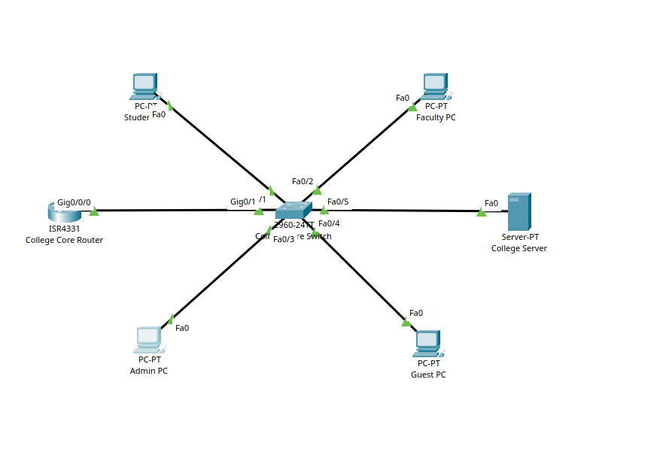
Fig. 1. Topology A: basic star topology in Cisco Packet Tracer (College Core Router, College Core Switch, Student PC, Faculty PC, Admin PC, Guest PC and College Server).
Table 1. Topology A physical connections
Device | Device port | Switch port | VLAN
Student PC | Fa0 | Fa0/1 | 10
Faculty PC | Fa0 | Fa0/2 | 20
Admin PC | Fa0 | Fa0/3 | 30
Guest PC | Fa0 | Fa0/4 | 40
College Server | Fa0 | Fa0/5 | 30
College Core Router | Gig0/0/0 | Gig0/1 | Trunk

Table 2. Topology A VLAN and IP addressing plan (static, no DHCP; mask 255.255.255.0, DNS 8.8.8.8)
VLAN | Name | Network | Gateway (subinterface) | Device and IP address
10 | STUDENTS | 192.168.10.0/24 | 192.168.10.1 (g0/0/0.10) | Student PC, 192.168.10.10
20 | FACULTY | 192.168.20.0/24 | 192.168.20.1 (g0/0/0.20) | Faculty PC, 192.168.20.10
30 | ADMIN | 192.168.30.0/24 | 192.168.30.1 (g0/0/0.30) | Admin PC, 192.168.30.10; College Server, 192.168.30.100
40 | GUESTS | 192.168.40.0/24 | 192.168.40.1 (g0/0/0.40) | Guest PC, 192.168.40.10

3.2 Topology B: Enterprise (Phase 2 to 11)
Topology B is built around the Core-MLS-3560. Six 2960 access switches (SW-Admin, SW-Student, SW-Faculty, SW-Guest-WiFi, SW-IT-Lab and SW-Medical) connect to core ports Fa0/1 to Fa0/6 over 802.1Q trunks. The core connects through Gig0/1 (10.0.0.1/30) to the Edge-Router Gig0/0/0 (10.0.0.2/30). The Edge-Router connects through Gig0/0/1 (200.1.1.1/30) to the ISP-Router (200.1.1.2/30), whose other interface (8.8.8.1/24) connects to Server-Internet (8.8.8.8). Fig. 2 shows the base Layer 2/Layer 3 design (Phase 2.3) and Fig. 3 the final topology with the ISP and internet server (Phase 9).
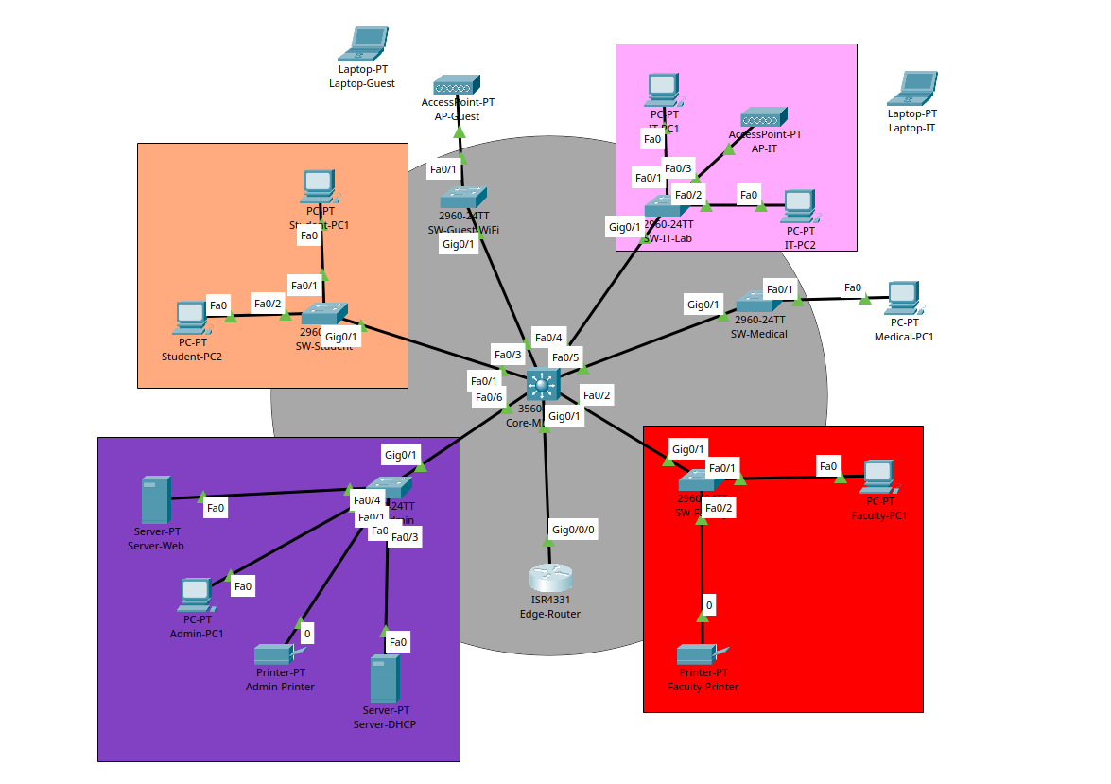
Fig. 2. Topology B, Phase 2.3: enterprise base with Core-MLS-3560, six access switches, Edge-Router, servers and access points.
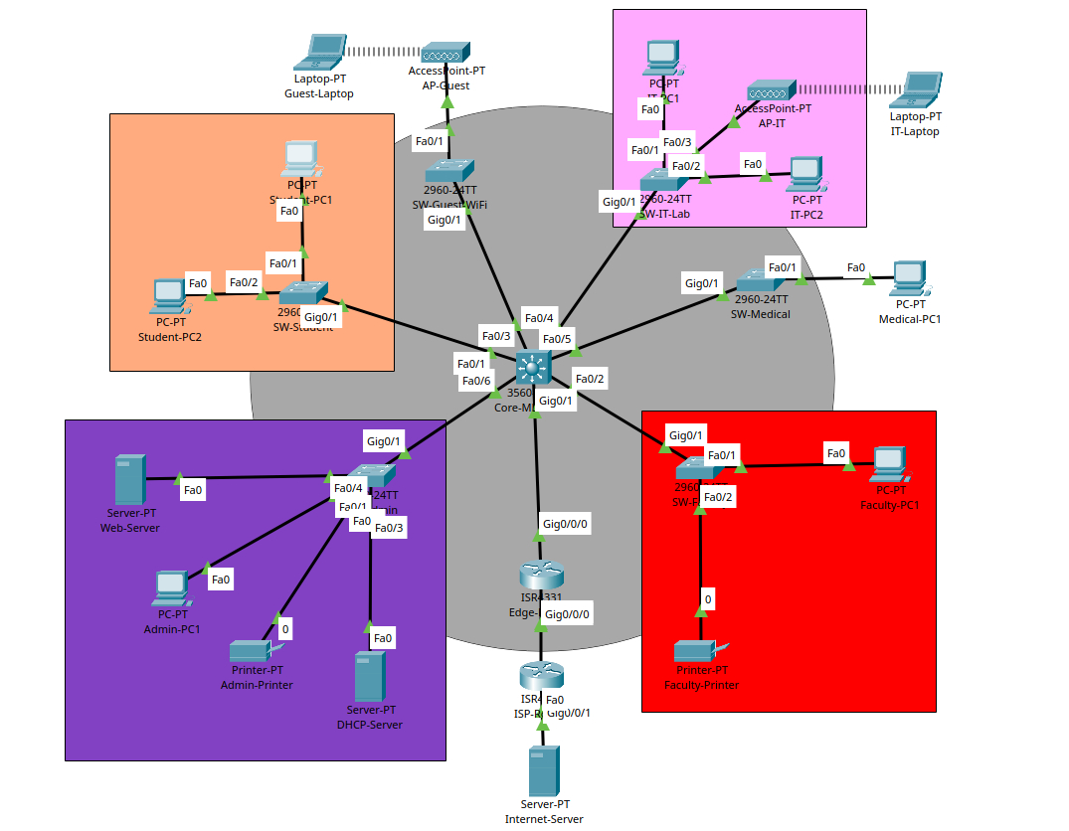
Fig. 3. Topology B, final (Phase 9): Core-MLS-3560, Edge-Router, ISP-Router and Server-Internet (8.8.8.8) added.
IP addressing method. Topology A uses manually configured static addresses with no DHCP. Topology B uses DHCP pools starting at 192.168.x.100/24 (maximum 50 users for Students and Guests, 20 for the other VLANs) with DNS server 192.168.99.20; only the servers Server-DHCP (192.168.99.10) and Server-Web (192.168.99.20) use static addresses. The six pools are listed in Section 4.2.5.
Table 3. Topology B VLAN and IP addressing plan
VLAN | Name | Network | Gateway (SVI) | DHCP pool start / max users | Access switch and ports
10 | STUDENTS | 192.168.10.0/24 | 192.168.10.1 | 192.168.10.100 / 50 | SW-Student Fa0/1-2
20 | FACULTY | 192.168.20.0/24 | 192.168.20.1 | 192.168.20.100 / 20 | SW-Faculty Fa0/1-2
30 | ADMIN | 192.168.30.0/24 | 192.168.30.1 | 192.168.30.100 / 20 | SW-Admin Fa0/1-2
40 | GUESTS | 192.168.40.0/24 | 192.168.40.1 | 192.168.40.100 / 50 | SW-Guest-WiFi Fa0/1 (AP-Guest)
50 | IT_LAB | 192.168.50.0/24 | 192.168.50.1 | 192.168.50.100 / 20 | SW-IT-Lab Fa0/1-3 (AP-IT and PCs)
60 | MEDICAL | 192.168.60.0/24 | 192.168.60.1 | 192.168.60.100 / 20 | SW-Medical Fa0/1
99 | SERVERS | 192.168.99.0/24 | 192.168.99.1 | Static (no pool) | SW-Admin Fa0/3-4 (Server-DHCP 192.168.99.10, Server-Web 192.168.99.20)

Table 4. Topology B routed and server addresses
Device / interface | Address | Connected to
Core-MLS-3560 Gig0/1 | 10.0.0.1/30 | Edge-Router Gig0/0/0
Edge-Router Gig0/0/0 | 10.0.0.2/30 (NAT inside) | Core-MLS-3560 Gig0/1
Edge-Router Gig0/0/1 | 200.1.1.1/30 (NAT outside) | ISP-Router Gig0/0/0
ISP-Router Gig0/0/0 | 200.1.1.2/30 | Edge-Router Gig0/0/1
ISP-Router Gig0/0/1 | 8.8.8.1/24 | Server-Internet Fa0
Server-DHCP | 192.168.99.10 (gateway 192.168.99.1) | SW-Admin
Server-Web (DNS and HTTP) | 192.168.99.20 (gateway 192.168.99.1) | SW-Admin
Server-Internet | 8.8.8.8/24 (gateway 8.8.8.1) | ISP-Router Gig0/0/1

4. Configuration Setup
The configuration of every device in both topologies is given below. Topology A (Section 4.1) is configured with static addresses and no DHCP; Topology B (Section 4.2) is configured as listed in the project README.

4.1 Topology A: Basic Star (Day 1 to 5)

4.1.1 Student PC
IP address | 192.168.10.10
Subnet mask | 255.255.255.0
Default gateway | 192.168.10.1
DNS server | 8.8.8.8
Connected to | College Core Switch Fa0/1 (VLAN 10 STUDENTS)
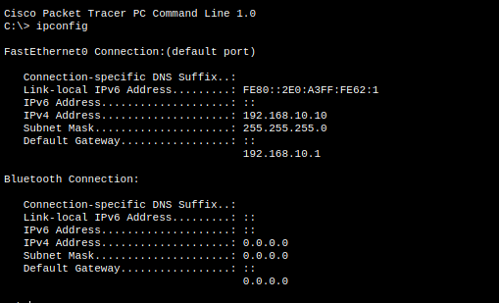
Fig. 4. ipconfig on the Student PC showing the static settings.

4.1.2 Faculty PC
IP address | 192.168.20.10
Subnet mask | 255.255.255.0
Default gateway | 192.168.20.1
DNS server | 8.8.8.8
Connected to | College Core Switch Fa0/2 (VLAN 20 FACULTY)
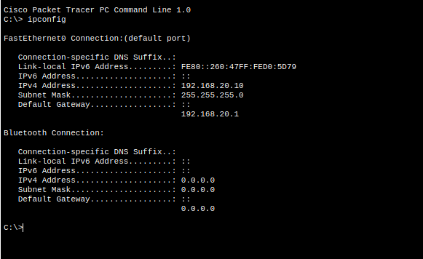
Fig. 5. ipconfig on the Faculty PC showing the static settings.

4.1.3 Admin PC
IP address | 192.168.30.10
Subnet mask | 255.255.255.0
Default gateway | 192.168.30.1
DNS server | 8.8.8.8
Connected to | College Core Switch Fa0/3 (VLAN 30 ADMIN)
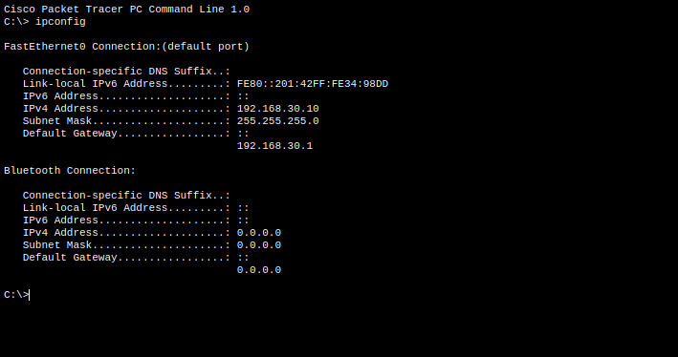
Fig. 6. ipconfig on the Admin PC showing the static settings.

4.1.4 Guest PC
IP address | 192.168.40.10
Subnet mask | 255.255.255.0
Default gateway | 192.168.40.1
DNS server | 8.8.8.8
Connected to | College Core Switch Fa0/4 (VLAN 40 GUESTS)
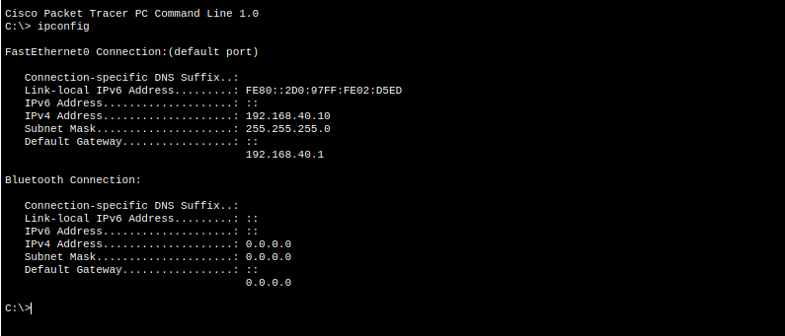
Fig. 7. ipconfig on the Guest PC showing the static settings.

4.1.5 College Server (Server-PT)
IP address | 192.168.30.100
Subnet mask | 255.255.255.0
Default gateway | 192.168.30.1
DNS server | 8.8.8.8
Connected to | College Core Switch Fa0/5 (VLAN 30 ADMIN)
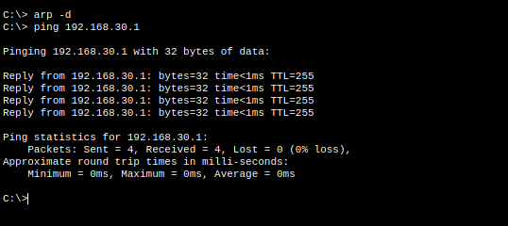
Fig. 8. College Server pinging its gateway 192.168.30.1 (4/4 replies) after static configuration.

4.1.6 College Core Switch (Cisco 2960-24TT)
VLANs 10, 20, 30 and 40 are created and named; each host port is an access port in its VLAN; Gig0/1 is an 802.1Q trunk to the router.
vlan 10
name STUDENTS
vlan 20
name FACULTY
vlan 30
name ADMIN
vlan 40
name GUESTS
!
interface FastEthernet0/1
switchport mode access
switchport access vlan 10
interface FastEthernet0/2
switchport mode access
switchport access vlan 20
interface FastEthernet0/3
switchport mode access
switchport access vlan 30
interface FastEthernet0/4
switchport mode access
switchport access vlan 40
interface FastEthernet0/5
switchport mode access
switchport access vlan 30
!
interface GigabitEthernet0/1
switchport mode trunk
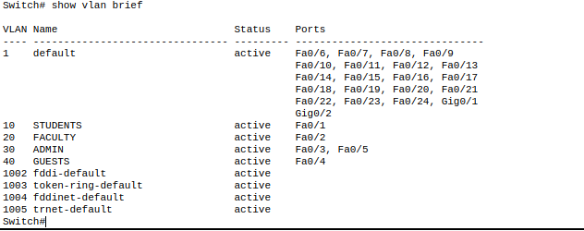
Fig. 9. show vlan brief on the College Core Switch: VLAN 10 (Fa0/1), VLAN 20 (Fa0/2), VLAN 30 (Fa0/3, Fa0/5) and VLAN 40 (Fa0/4).

4.1.7 College Core Router (Cisco ISR4331)
The physical interface g0/0/0 is brought up with no IP address, and one dot1Q subinterface per VLAN carries the gateway address (Router-on-a-Stick). STUDENT-ACL and GUEST-ACL are applied inbound on the Student and Guest subinterfaces.
interface g0/0/0
no shutdown
!
interface g0/0/0.10
encapsulation dot1Q 10
ip address 192.168.10.1 255.255.255.0
ip access-group STUDENT-ACL in
interface g0/0/0.20
encapsulation dot1Q 20
ip address 192.168.20.1 255.255.255.0
interface g0/0/0.30
encapsulation dot1Q 30
ip address 192.168.30.1 255.255.255.0
interface g0/0/0.40
encapsulation dot1Q 40
ip address 192.168.40.1 255.255.255.0
ip access-group GUEST-ACL in
!
ip access-list extended STUDENT-ACL
remark Allow Students to College Server only
permit ip 192.168.10.0 0.0.0.255 host 192.168.30.100
remark Deny Students to rest of Admin network
deny ip 192.168.10.0 0.0.0.255 192.168.30.0 0.0.0.255
permit ip 192.168.10.0 0.0.0.255 any
!
ip access-list extended GUEST-ACL
deny ip 192.168.40.0 0.0.0.255 192.168.10.0 0.0.0.255
deny ip 192.168.40.0 0.0.0.255 192.168.20.0 0.0.0.255
deny ip 192.168.40.0 0.0.0.255 192.168.30.0 0.0.0.255
permit ip 192.168.40.0 0.0.0.255 any

Table 5. Access policy enforced by the basic-topology ACLs
Source | Destination | Policy
Students (VLAN 10) | College Server, 192.168.30.100 | Allow
Students (VLAN 10) | Rest of ADMIN network, 192.168.30.0/24 | Deny
Students (VLAN 10) | All other destinations | Allow
Guests (VLAN 40) | Students, Faculty, Admin (192.168.10.0, 20.0, 30.0 /24) | Deny
Faculty (VLAN 20) | All | Allow (no ACL)

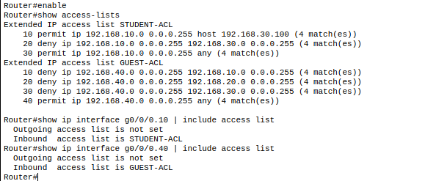
Fig. 10. show access-lists and show ip interface on the router: STUDENT-ACL inbound on g0/0/0.10 and GUEST-ACL inbound on g0/0/0.40.

4.2 Topology B: Enterprise

4.2.1 Core-MLS-3560 (Cisco 3560-24PS)
IP routing is enabled; VLANs are created one at a time (the 3560 does not accept a comma-separated VLAN list); Fa0/1 to Fa0/6 are 802.1Q trunks to the access switches; each SVI is the VLAN gateway and, for VLANs 10 to 60, relays DHCP to Server-DHCP; Gig0/1 is a routed port to the Edge-Router with a default route.
ip routing
!
vlan 10
name STUDENTS
vlan 20
name FACULTY
vlan 30
name ADMIN
vlan 40
name GUESTS
vlan 50
name IT_LAB
vlan 60
name MEDICAL
vlan 99
name SERVERS
!
interface range fa0/1 - 6
switchport trunk encapsulation dot1q
switchport mode trunk
!
interface Vlan10
ip address 192.168.10.1 255.255.255.0
ip helper-address 192.168.99.10
ip access-group STUDENT_RESTRICT in
interface Vlan20
ip address 192.168.20.1 255.255.255.0
ip helper-address 192.168.99.10
interface Vlan30
ip address 192.168.30.1 255.255.255.0
ip helper-address 192.168.99.10
interface Vlan40
ip address 192.168.40.1 255.255.255.0
ip helper-address 192.168.99.10
ip access-group GUEST_RESTRICT in
interface Vlan50
ip address 192.168.50.1 255.255.255.0
ip helper-address 192.168.99.10
interface Vlan60
ip address 192.168.60.1 255.255.255.0
ip helper-address 192.168.99.10
interface Vlan99
ip address 192.168.99.1 255.255.255.0
!
interface GigabitEthernet0/1
no switchport
ip address 10.0.0.1 255.255.255.252
!
ip route 0.0.0.0 0.0.0.0 10.0.0.2

Extended ACLs on the core (DNS, DHCP and web permitted first, then the internal networks denied, then permit all remaining traffic):
ip access-list extended GUEST_RESTRICT
permit udp any any eq 67
permit udp any any eq 68
permit udp any host 192.168.99.20 eq 53
permit udp any host 192.168.99.10 eq 67
permit udp any host 192.168.99.10 eq 68
permit tcp any host 192.168.99.20 eq 80
permit tcp any host 192.168.99.20 eq 443
permit tcp any host 192.168.99.20 eq 53
deny ip 192.168.40.0 0.0.0.255 192.168.10.0 0.0.0.255
deny ip 192.168.40.0 0.0.0.255 192.168.20.0 0.0.0.255
deny ip 192.168.40.0 0.0.0.255 192.168.30.0 0.0.0.255
deny ip 192.168.40.0 0.0.0.255 192.168.50.0 0.0.0.255
deny ip 192.168.40.0 0.0.0.255 192.168.60.0 0.0.0.255
deny ip 192.168.40.0 0.0.0.255 192.168.99.0 0.0.0.255
permit ip any any
!
ip access-list extended STUDENT_RESTRICT
permit udp any host 192.168.99.20 eq 53
permit tcp any host 192.168.99.20 eq 80
permit tcp any host 192.168.99.20 eq 53
permit tcp any host 192.168.99.20 eq 443
permit udp any host 192.168.99.10 eq 67
permit udp any host 192.168.99.10 eq 68
deny ip 192.168.10.0 0.0.0.255 192.168.30.0 0.0.0.255
deny ip 192.168.10.0 0.0.0.255 192.168.99.0 0.0.0.255
permit ip any any

Note: the Packet Tracer 3560 always reports show ip interface VlanX | include access as “not set” even when a list is applied. The lists are verified with show running-config | include access-group, which shows both applied (GUEST_RESTRICT on Vlan40 and STUDENT_RESTRICT on Vlan10).

4.2.2 Edge-Router (Cisco ISR4331)
interface GigabitEthernet0/0/0
ip address 10.0.0.2 255.255.255.252
ip nat inside
!
interface GigabitEthernet0/0/1
ip address 200.1.1.1 255.255.255.252
ip nat outside
no shutdown
!
access-list 1 permit 192.168.0.0 0.0.255.255
access-list 1 permit 10.0.0.0 0.0.0.3
ip nat inside source list 1 interface GigabitEthernet0/0/1 overload
!
ip route 0.0.0.0 0.0.0.0 200.1.1.2
ip route 192.168.0.0 255.255.0.0 10.0.0.1

4.2.3 ISP-Router (Cisco ISR4331)
hostname ISP-Router
!
interface GigabitEthernet0/0/0
description Link to Edge-Router
ip address 200.1.1.2 255.255.255.252
no shutdown
interface GigabitEthernet0/0/1
description Simulated Internet LAN
ip address 8.8.8.1 255.255.255.0
no shutdown
!
ip route 192.168.0.0 255.255.0.0 200.1.1.1
ip route 10.0.0.0 255.255.255.0 200.1.1.1

4.2.4 Access Switches (Cisco 2960)
Each access switch connects to the core through its Gig0/1 uplink, configured as a trunk with switchport mode trunk only (see the note below). Host ports are access ports in the VLANs below.
Note on the trunk command: switchport trunk encapsulation dot1q is valid only on the 3560 core, whose ports support both ISL and 802.1Q and must be told which to use. The 2960 supports only 802.1Q, so the command is rejected there as invalid and was removed; switchport mode trunk alone is enough.
Switch | Ports | VLAN / connected devices
SW-Admin | Fa0/1-2 | VLAN 30 (ADMIN): Admin-PC1 and Admin-Printer
SW-Admin | Fa0/3-4 | VLAN 99 (SERVERS): Server-DHCP and Server-Web
SW-Student | Fa0/1-2 | VLAN 10 (STUDENTS): Student-PC1 and Student-PC2
SW-Faculty | Fa0/1-2 | VLAN 20 (FACULTY): Faculty-PC1 and Faculty-Printer
SW-Guest-WiFi | Fa0/1 | VLAN 40 (GUESTS): AP-Guest
SW-IT-Lab | Fa0/1-3 | VLAN 50 (IT_LAB): AP-IT, IT-PC1 and IT-PC2
SW-Medical | Fa0/1 | VLAN 60 (MEDICAL): Medical-PC1

4.2.5 Server-DHCP (192.168.99.10)
Static address 192.168.99.10, gateway 192.168.99.1, connected to SW-Admin (VLAN 99). Services, DHCP: ON, with the six pools below. The default serverPool was disabled (Start IP 0.0.0.0, maximum users 0) because Packet Tracer would not remove it.
Pool name | Default gateway | Start IP | Mask | Max users
STUDENT_POOL | 192.168.10.1 | 192.168.10.100 | 255.255.255.0 | 50
FACULTY_POOL | 192.168.20.1 | 192.168.20.100 | 255.255.255.0 | 20
ADMIN_POOL | 192.168.30.1 | 192.168.30.100 | 255.255.255.0 | 20
GUEST_POOL | 192.168.40.1 | 192.168.40.100 | 255.255.255.0 | 50
IT_POOL | 192.168.50.1 | 192.168.50.100 | 255.255.255.0 | 20
MEDICAL_POOL | 192.168.60.1 | 192.168.60.100 | 255.255.255.0 | 20
DNS server in every pool: 192.168.99.20.
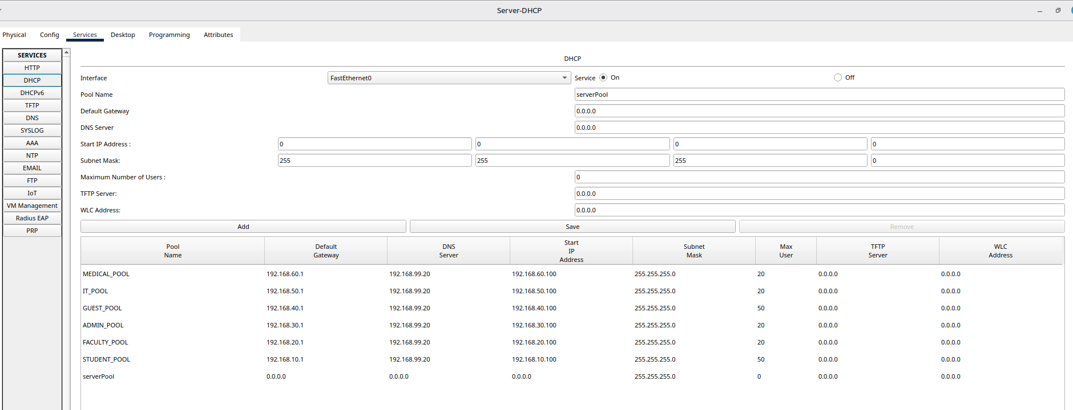
Fig. 11. Server-DHCP, Services, DHCP: six pools with DNS server 192.168.99.20 and the disabled default serverPool.

4.2.6 Server-Web (192.168.99.20)
Static address 192.168.99.20, gateway 192.168.99.1, connected to SW-Admin (VLAN 99). Services, DNS: ON, with the records below. Services, HTTP: ON, with index.html replaced by the Smart College Network portal (header, VLAN status, VLAN 10 to 60 cards and core infrastructure).
Name | Type | Address
college.local | A | 192.168.99.20
smartcollege.local | A | 192.168.99.20
server-dhcp.local | A | 192.168.99.10
internet.local (added in Phase 9) | A | 8.8.8.8

4.2.7 Server-Internet (8.8.8.8)
Static address 8.8.8.8/24 with gateway 8.8.8.1, connected to ISP-Router Gig0/0/1. Services, HTTP: ON, with index.html replaced by the WELCOME TO THE INTERNET portal (black cards with forced white text).

4.2.8 Access Points (AP-Guest and AP-IT)
Access point | SSID | Authentication | PSK passphrase | Encryption / channel
AP-Guest (Port 1) | Guest-WiFi | WPA2-PSK | Nopass@123 | AES / channel 6
AP-IT (Port 1) | IT-WiFi | WPA2-PSK | Cisco123! | AES / channel 6
The laptops join through the PC Wireless Connect tab: click Refresh, select the SSID, enter the pre-shared key and wait for Associated. After a DHCP renew the Guest-Laptop receives 192.168.40.101 on Wireless0 (Section 5.2.1).
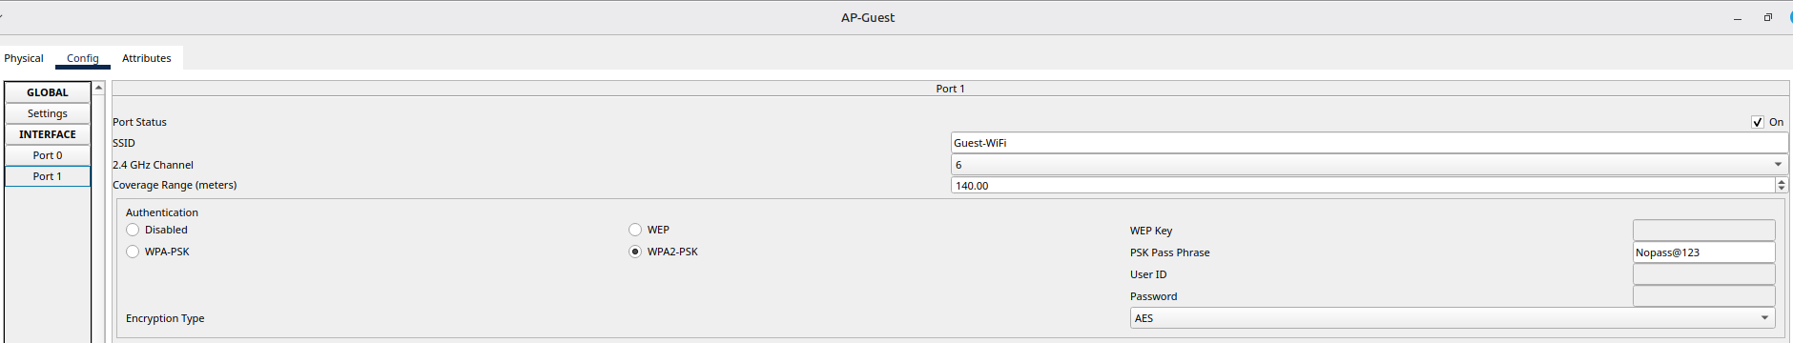
Fig. 12. AP-Guest, Config, Port 1: SSID Guest-WiFi, WPA2-PSK, AES.
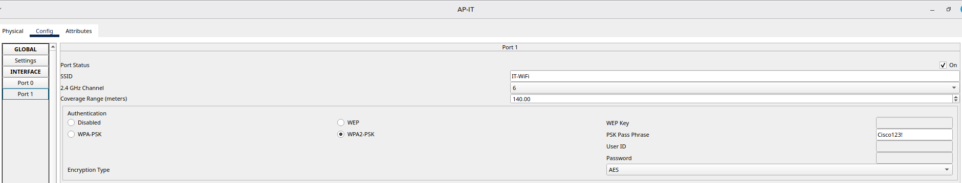
Fig. 13. AP-IT, Config, Port 1: SSID IT-WiFi, WPA2-PSK, AES.

4.2.9 End Devices (DHCP clients)
Every client is set to DHCP and receives its address, gateway and DNS server (192.168.99.20) from Server-DHCP through the relay on its VLAN. The wireless laptops (Guest-Laptop, IT-Laptop) use the Wireless0 interface, connect to their SSID and enter the pre-shared key. Leased addresses can change when a lease is renewed.
Device | VLAN | Interface | Leased address | Gateway
Student-PC1 | 10 | FastEthernet0 | 192.168.10.100 | 192.168.10.1
Faculty-PC1 | 20 | FastEthernet0 | 192.168.20.100 | 192.168.20.1
Admin-PC1 | 30 | FastEthernet0 | 192.168.30.100 | 192.168.30.1
Guest-Laptop | 40 | Wireless0 | 192.168.40.101 | 192.168.40.1
IT-PC1 | 50 | FastEthernet0 | 192.168.50.100 | 192.168.50.1
Medical-PC1 | 60 | FastEthernet0 | 192.168.60.101 | 192.168.60.1

5. Results
The results below are the proofs of communication between devices for both topologies: ping tests, DHCP, DNS, web, ACL and NAT results from Packet Tracer, Simulation Mode packet flow, and Wireshark captures of real traffic.

5.1 Topology A: Basic Star (Day 1 to 5)

5.1.1 Gateway and Inter-VLAN Connectivity (before ACLs)
Every PC and the server reached its own gateway, and after Router-on-a-Stick was configured, pings between VLANs succeeded. The router also pinged the Student and Admin PCs with 100 percent success.
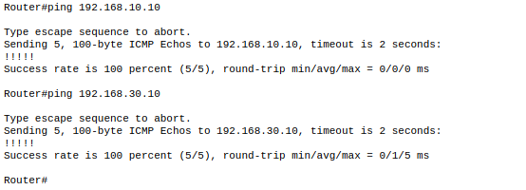
Fig. 14. Ping from the College Core Router to 192.168.10.10 and 192.168.30.10: success rate 100 percent (5/5) each.
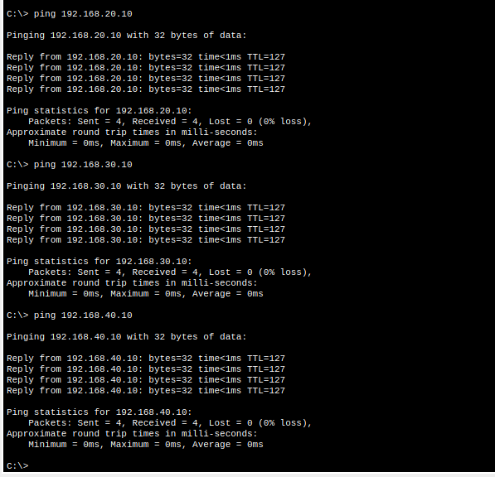
Fig. 15. Inter-VLAN pings from the Student PC (before ACLs) succeed through the router subinterfaces.

5.1.2 ACL Results: Permitted and Blocked Communication
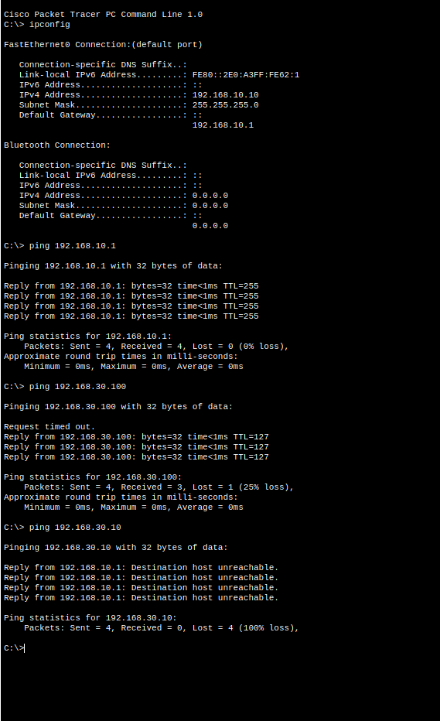
Fig. 16. Student PC: ipconfig, ping to gateway 192.168.10.1 (reply), ping to College Server 192.168.30.100 (permitted; the first echo times out while ARP resolves) and ping to Admin PC 192.168.30.10 (destination host unreachable, blocked by STUDENT-ACL).
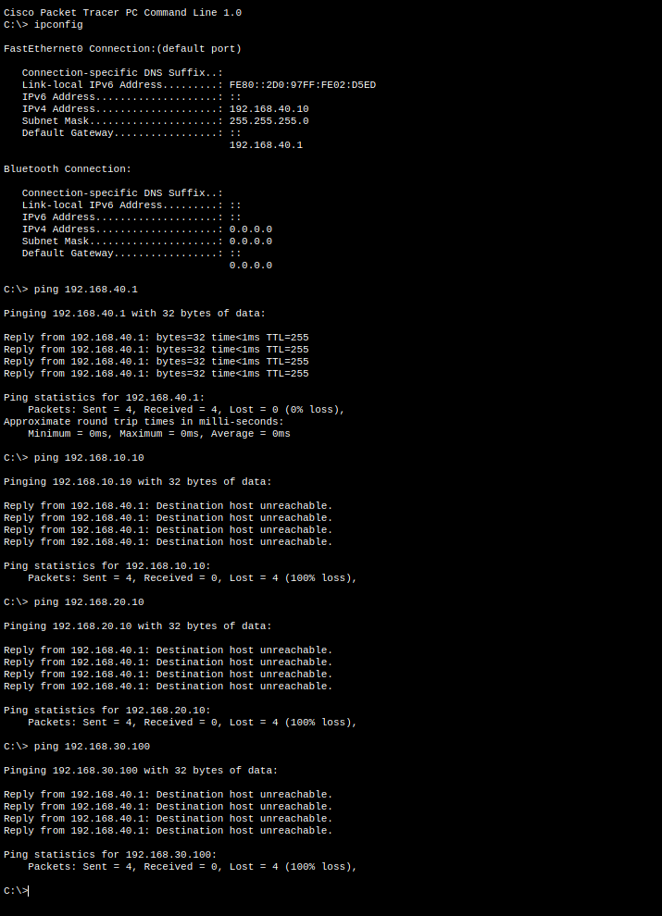
Fig. 17. Guest PC: pings to 192.168.10.10, 192.168.20.10 and 192.168.30.100 all fail (destination host unreachable from 192.168.40.1, blocked by GUEST-ACL), while the Guest’s own gateway 192.168.40.1 replies.
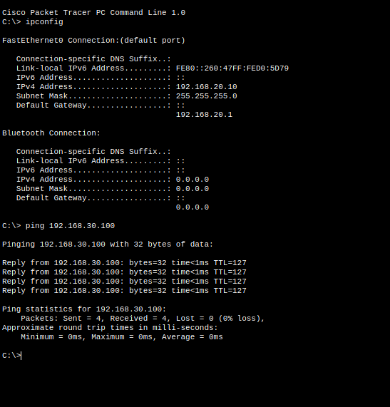
Fig. 18. Faculty PC: ping to College Server 192.168.30.100 gets 4/4 replies (no ACL on g0/0/0.20).
Table 6. Summary of basic-topology test results
Test | Command | Result | Status
Student reaches its gateway | ping 192.168.10.1 | Reply, TTL=255, 4/4 | Pass
Student to College Server | ping 192.168.30.100 | Reply, TTL=127 | Pass
Student to Admin PC | ping 192.168.30.10 | Destination host unreachable | Blocked (expected)
Guest to Student, Faculty, Server | ping 192.168.10.10 / 20.10 / 30.100 | Destination host unreachable | Blocked (expected)
Faculty to College Server | ping 192.168.30.100 | Reply, TTL=127, 4/4 | Pass

5.1.3 Packet Tracer Simulation Mode (ARP and ICMP)
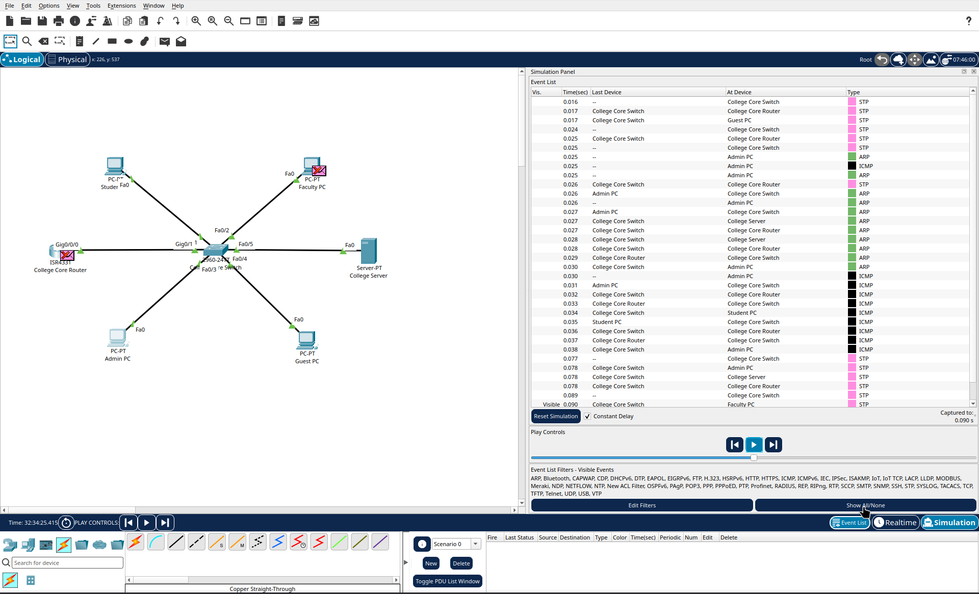
Fig. 19. Simulation Mode event list showing ARP and ICMP events across the PCs, College Core Switch, Router and Server.

5.1.4 Wireshark Capture of Real Traffic (interface wlo1)
Real traffic was captured on a Linux laptop (host 172.16.222.235/24 on a mobile hotspot; capture of 2968 packets) while generating pings, an nslookup and web browsing.
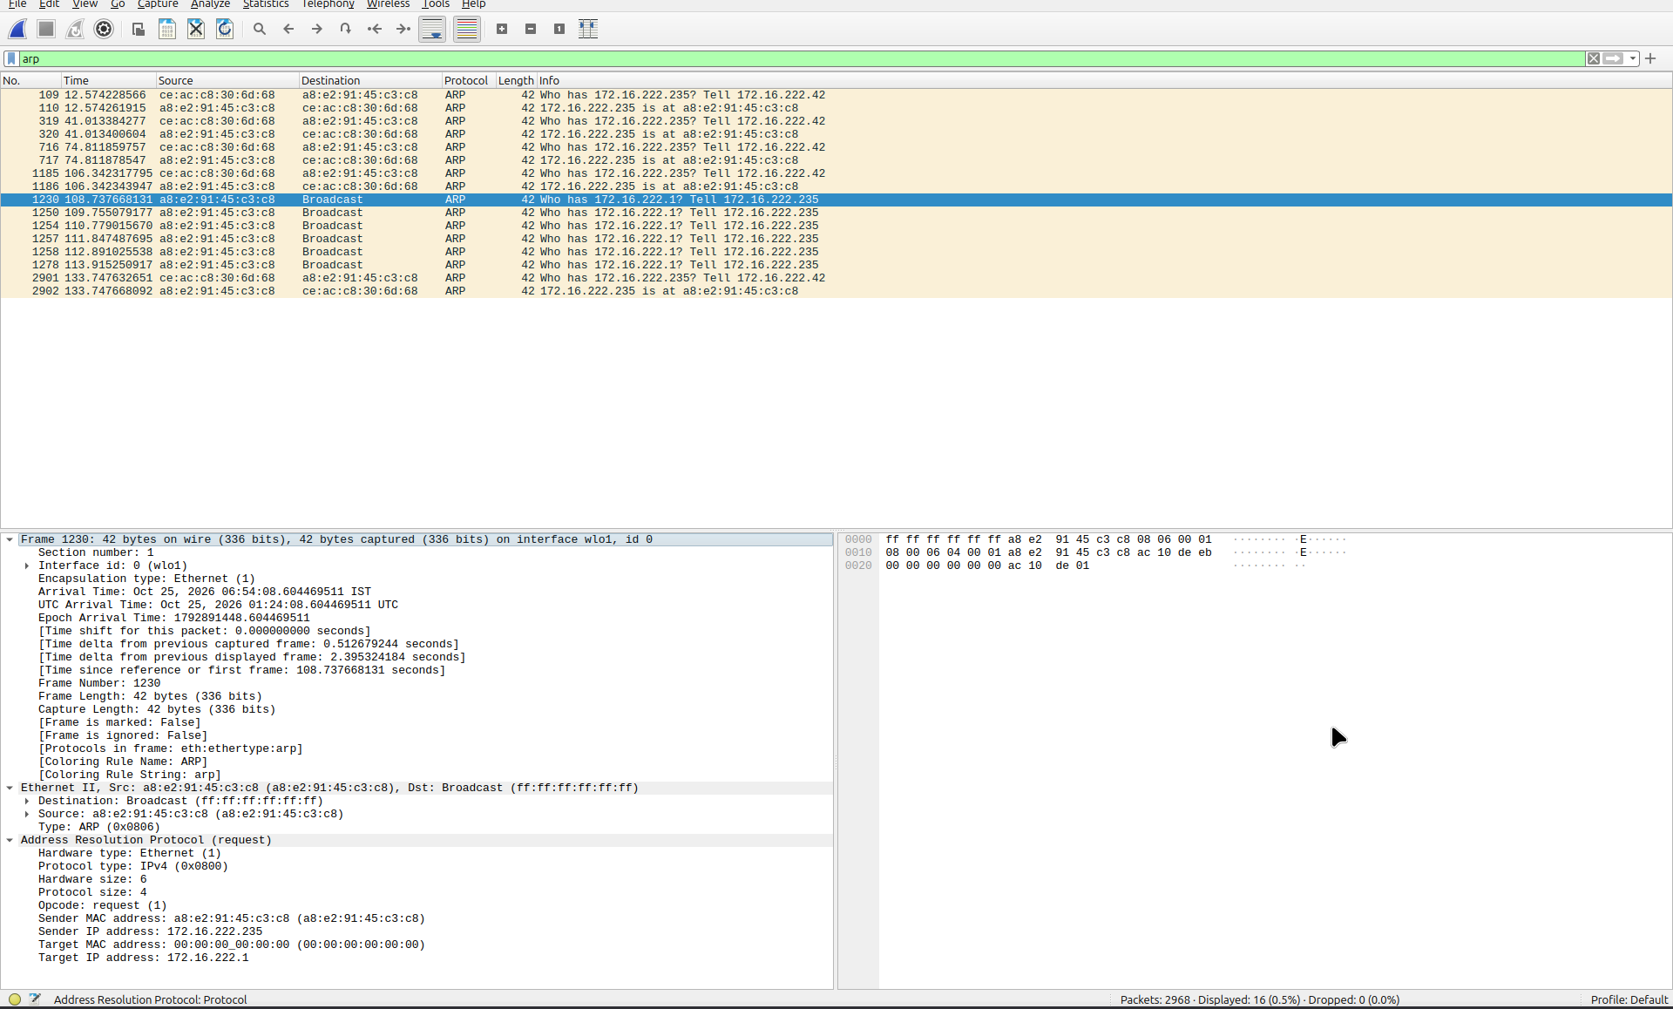
Fig. 20. Wireshark arp filter: broadcast ARP requests (“Who has 172.16.222.…? Tell 172.16.222.235”) and replies, with Ethernet II and ARP layers expanded.
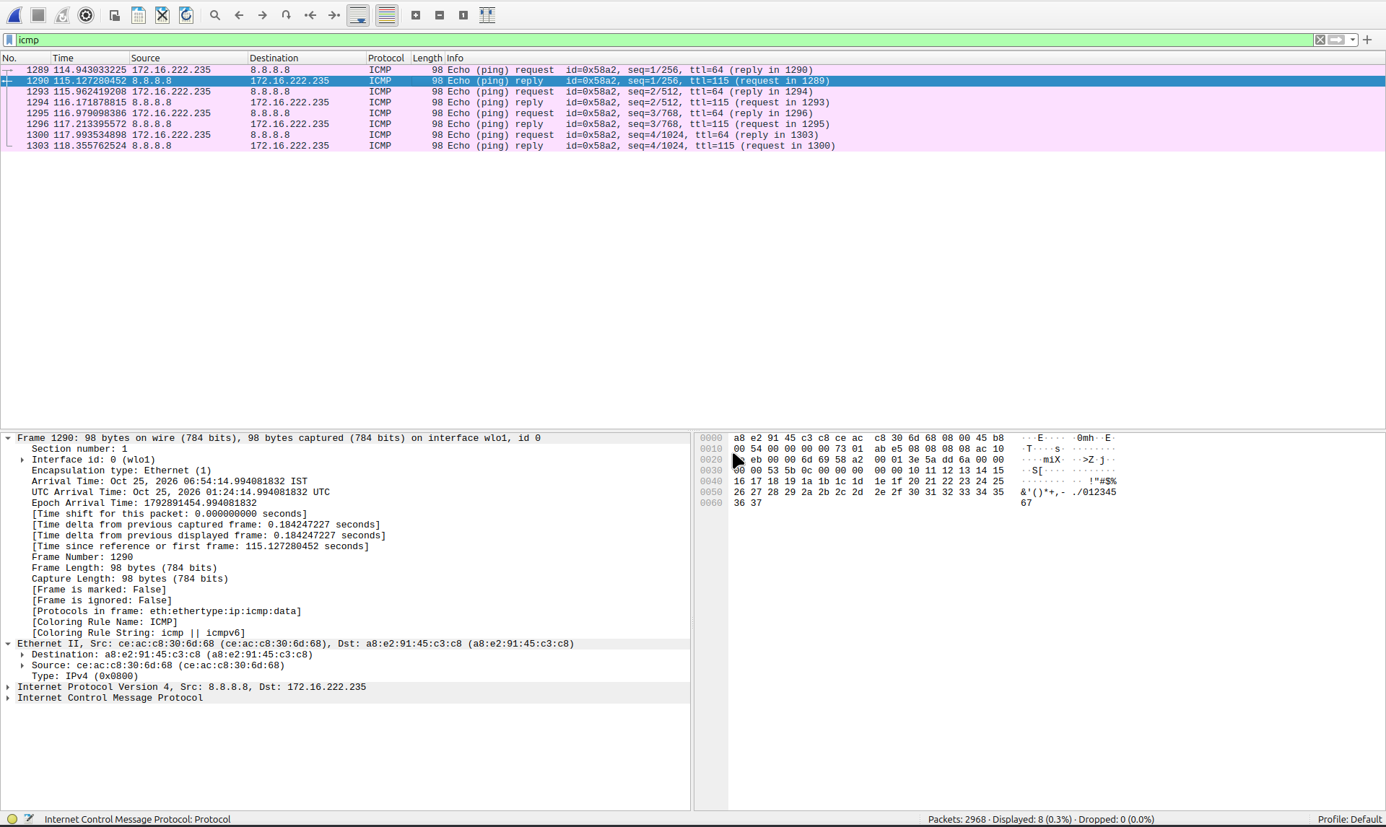
Fig. 21. Wireshark icmp filter: echo request (Type 8) and echo reply (Type 0) between 172.16.222.235 and 8.8.8.8, sequence 1 to 4.
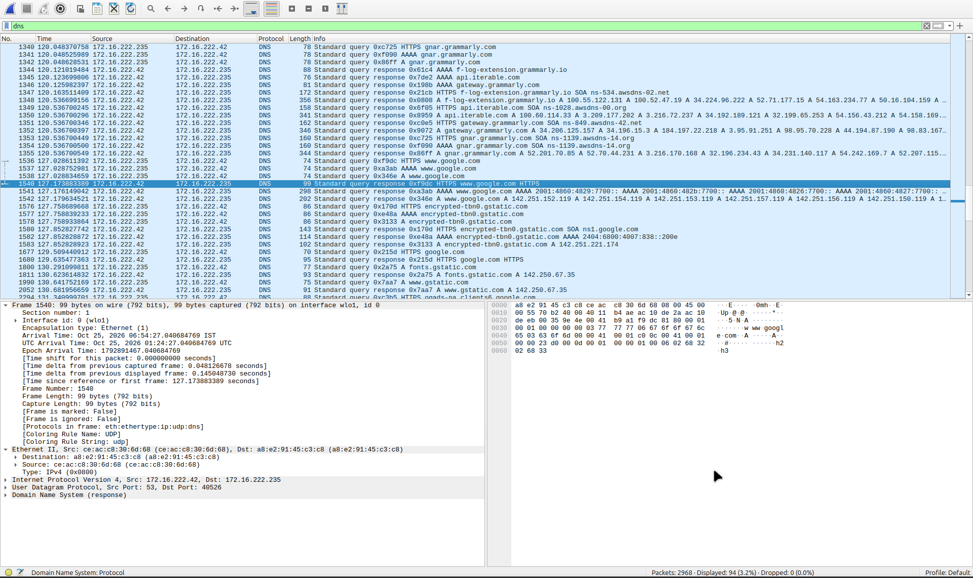
Fig. 22. Wireshark dns filter: standard queries and responses over UDP port 53, with Ethernet II, IP, UDP and DNS layers expanded.
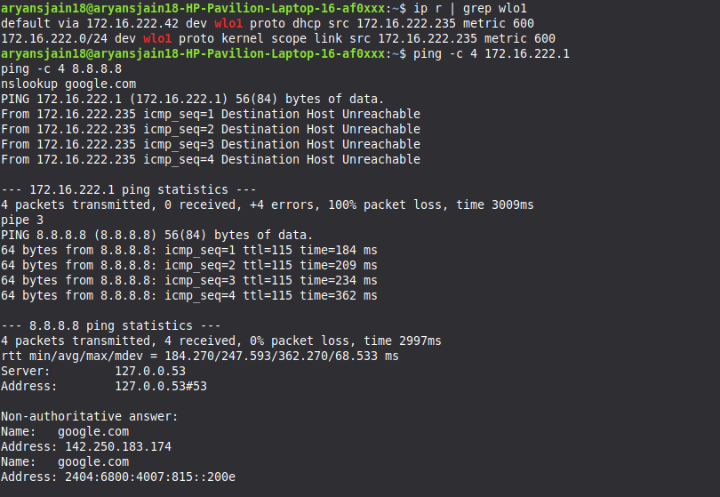
Fig. 23. Linux terminal: ip r | grep wlo1, ping to 8.8.8.8 (4/4 received, 0% loss) and nslookup google.com.

5.2 Topology B: Enterprise

5.2.1 DHCP and DHCP Relay
Clients in every VLAN obtained their address, gateway and DNS server (192.168.99.20) from Server-DHCP (192.168.99.10) through the ip helper-address relay on the core SVIs. Student-PC1 received 192.168.10.100 and the wireless Guest-Laptop received 192.168.40.101 on Wireless0.
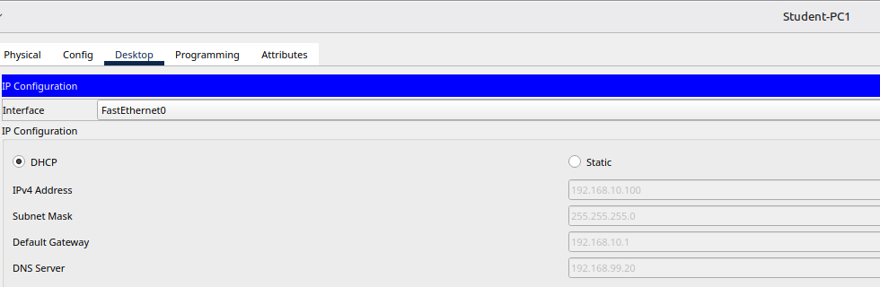
Fig. 24. Student-PC1, IP Configuration (DHCP): 192.168.10.100/24, gateway 192.168.10.1, DNS 192.168.99.20.
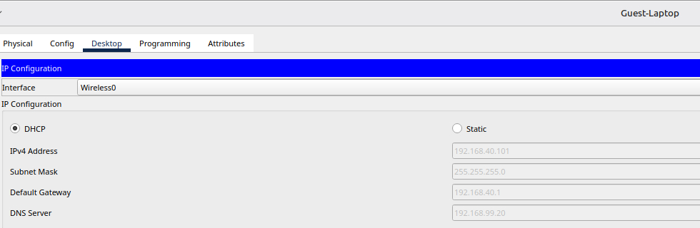
Fig. 25. Guest-Laptop, Wireless0, IP Configuration (DHCP): 192.168.40.101/24, gateway 192.168.40.1, DNS 192.168.99.20.
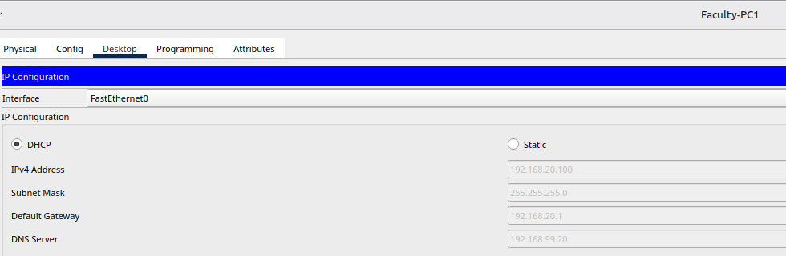
Fig. 26. Faculty-PC1 (DHCP): 192.168.20.100/24, gateway 192.168.20.1.
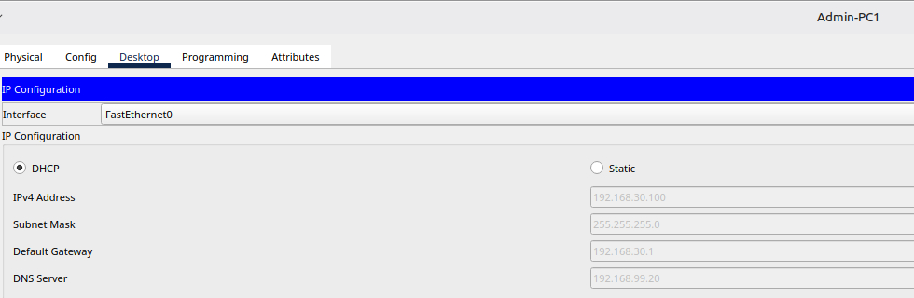
Fig. 27. Admin-PC1 (DHCP): 192.168.30.100/24, gateway 192.168.30.1.
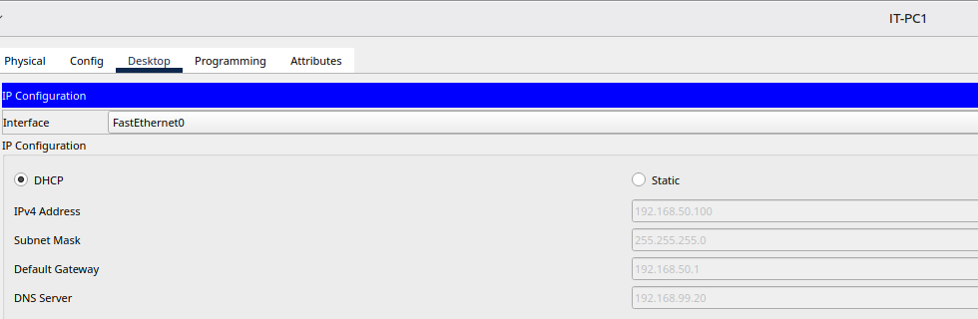
Fig. 28. IT-PC1 (DHCP): 192.168.50.100/24, gateway 192.168.50.1; “DHCP request successful” is shown.
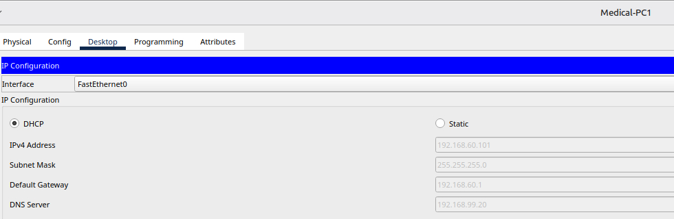
Fig. 29. Medical-PC1 (DHCP): 192.168.60.101/24, gateway 192.168.60.1.

5.2.2 DNS Resolution
Server-Web (192.168.99.20) answered every query: college.local and smartcollege.local resolve to 192.168.99.20, and internet.local resolves to 8.8.8.8.
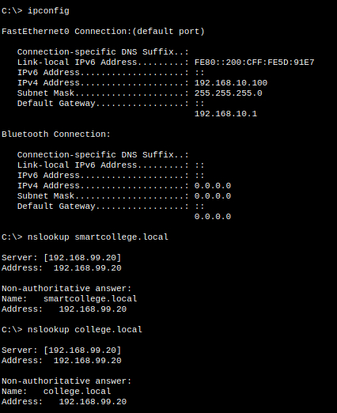
Fig. 30. Student-PC1: nslookup smartcollege.local and nslookup college.local both return 192.168.99.20 (server 192.168.99.20).
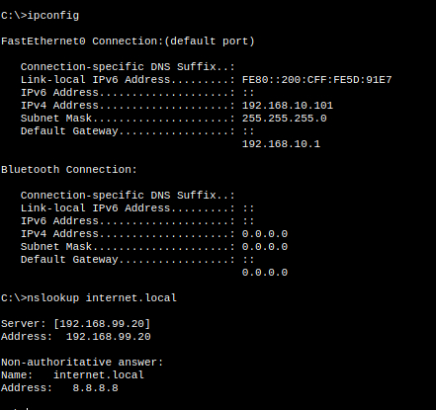
Fig. 31. Student-PC1: nslookup internet.local returns 8.8.8.8 (server 192.168.99.20).

5.2.3 Web Portals (HTTP)
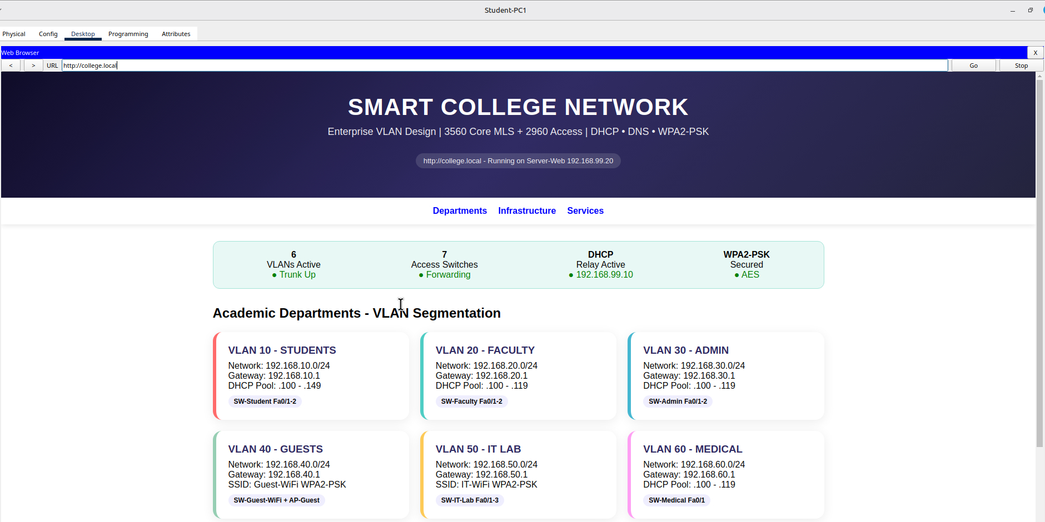
Fig. 32. Student-PC1 browser: http://college.local loads the SMART COLLEGE NETWORK portal.
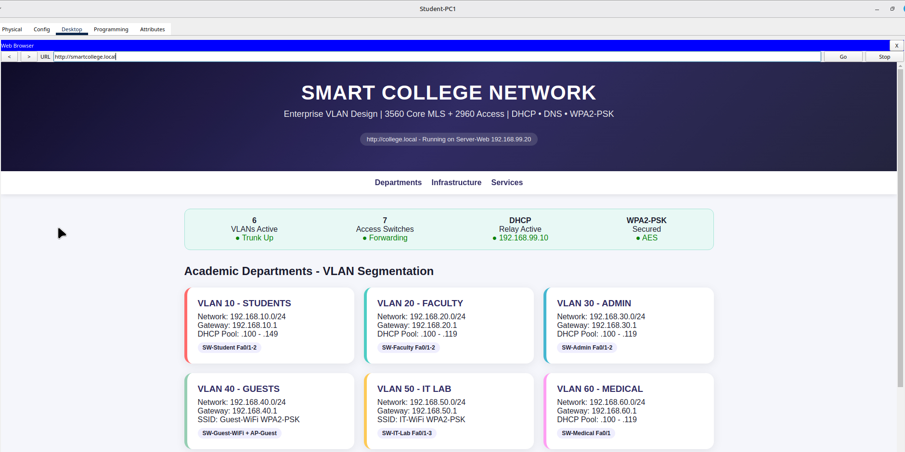
Fig. 33. Student-PC1 browser: http://smartcollege.local loads the same portal.
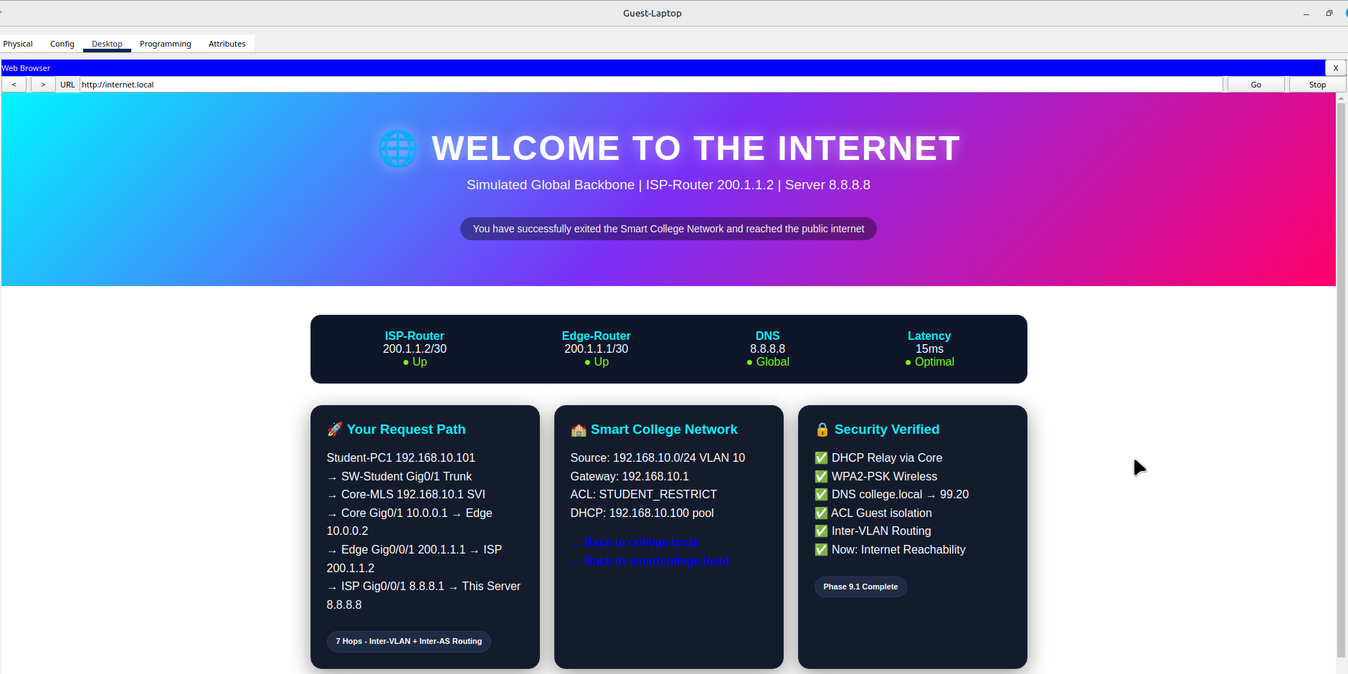
Fig. 34. Guest-Laptop browser: http://internet.local loads the WELCOME TO THE INTERNET portal (white text on black cards) from Server-Internet.

5.2.4 ACL Results (GUEST_RESTRICT and STUDENT_RESTRICT)
Table 7. Enterprise ACL test results
Source | Destination | Expected | Actual / reason
Guest-Laptop (Wireless0) | Student-PC1 192.168.10.100 (ping) | Blocked | Destination host unreachable, 100% loss (deny 40 to 10)
Guest-Laptop | 192.168.99.20 (ping) | ICMP blocked | Destination host unreachable (deny 40 to 99)
Guest-Laptop | 192.168.99.20 (web browser) | Allow | Portal loads (permit tcp to 99.20 eq 80)
Student-PC1 | Admin 192.168.30.100 (ping) | Blocked | Destination host unreachable (deny 10 to 30)
Student-PC1 | Faculty 192.168.20.100 (ping) | Allow | Reply, TTL 127 (permit any)

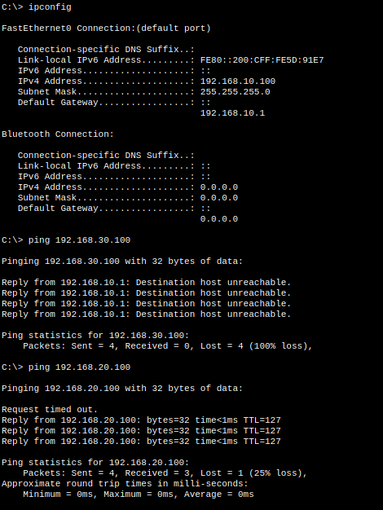
Fig. 35. Student-PC1: ping 192.168.30.100 (Admin) gets destination host unreachable, blocked by STUDENT_RESTRICT, while ping 192.168.20.100 (Faculty) is answered (TTL 127; the first echo times out during ARP).
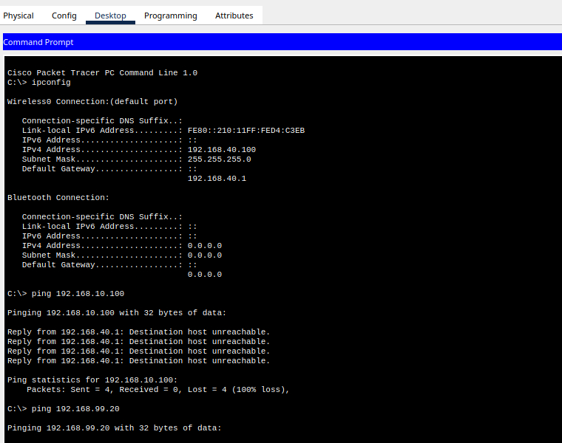
Fig. 36. Guest-Laptop (Wireless0, 192.168.40.100): pings to Student-PC1 (192.168.10.100) and to 192.168.99.20 are blocked by GUEST_RESTRICT.
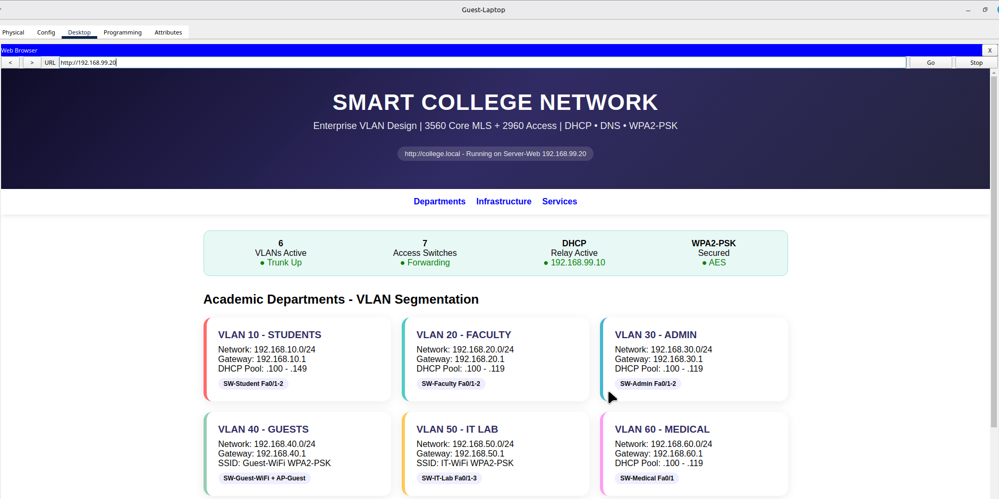
Fig. 37. Guest-Laptop browser: http://192.168.99.20 still loads the portal, because GUEST_RESTRICT permits TCP port 80 even though ICMP is denied.
This shows port-specific security: ICMP from the guest VLAN to the servers is denied while HTTP and DNS are allowed. The Packet Tracer 3560 reports the access list as “not set” under show ip interface for an SVI even when it is applied, so the application of both lists was confirmed with show running-config | include access-group.

5.2.5 ISP Link, NAT/PAT and Internet Reachability
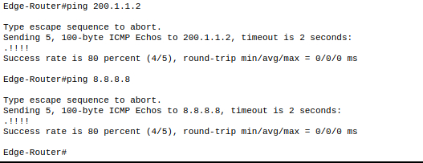
Fig. 38. Edge-Router: ping 200.1.1.2 (ISP link) and ping 8.8.8.8 each succeed 80 percent (4/5); the first echo is lost while ARP resolves.
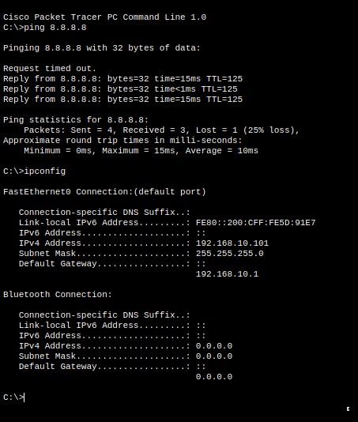
Fig. 39. Student-PC1 (192.168.10.101): ping 8.8.8.8 before NAT overload was configured, 3 of 4 replies, TTL 125.
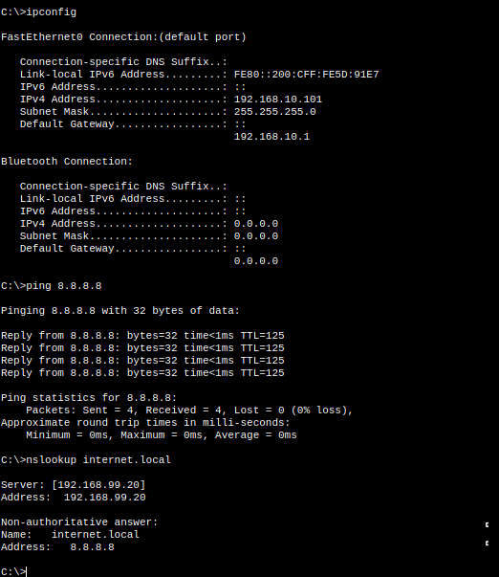
Fig. 40. Student-PC1 after NAT overload: ping 8.8.8.8 receives 4/4 replies (0% loss) and nslookup internet.local returns 8.8.8.8.
The translation table on the Edge-Router (show ip nat translations) maps the student host to the single public address 200.1.1.1 using port numbers, as shown in Fig. 41.
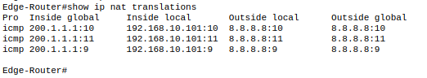
Fig. 41. Edge-Router: show ip nat translations lists three icmp translations that map Student-PC1 (192.168.10.101) to the single public address 200.1.1.1 using ports 9, 10 and 11, for the ping to 8.8.8.8.
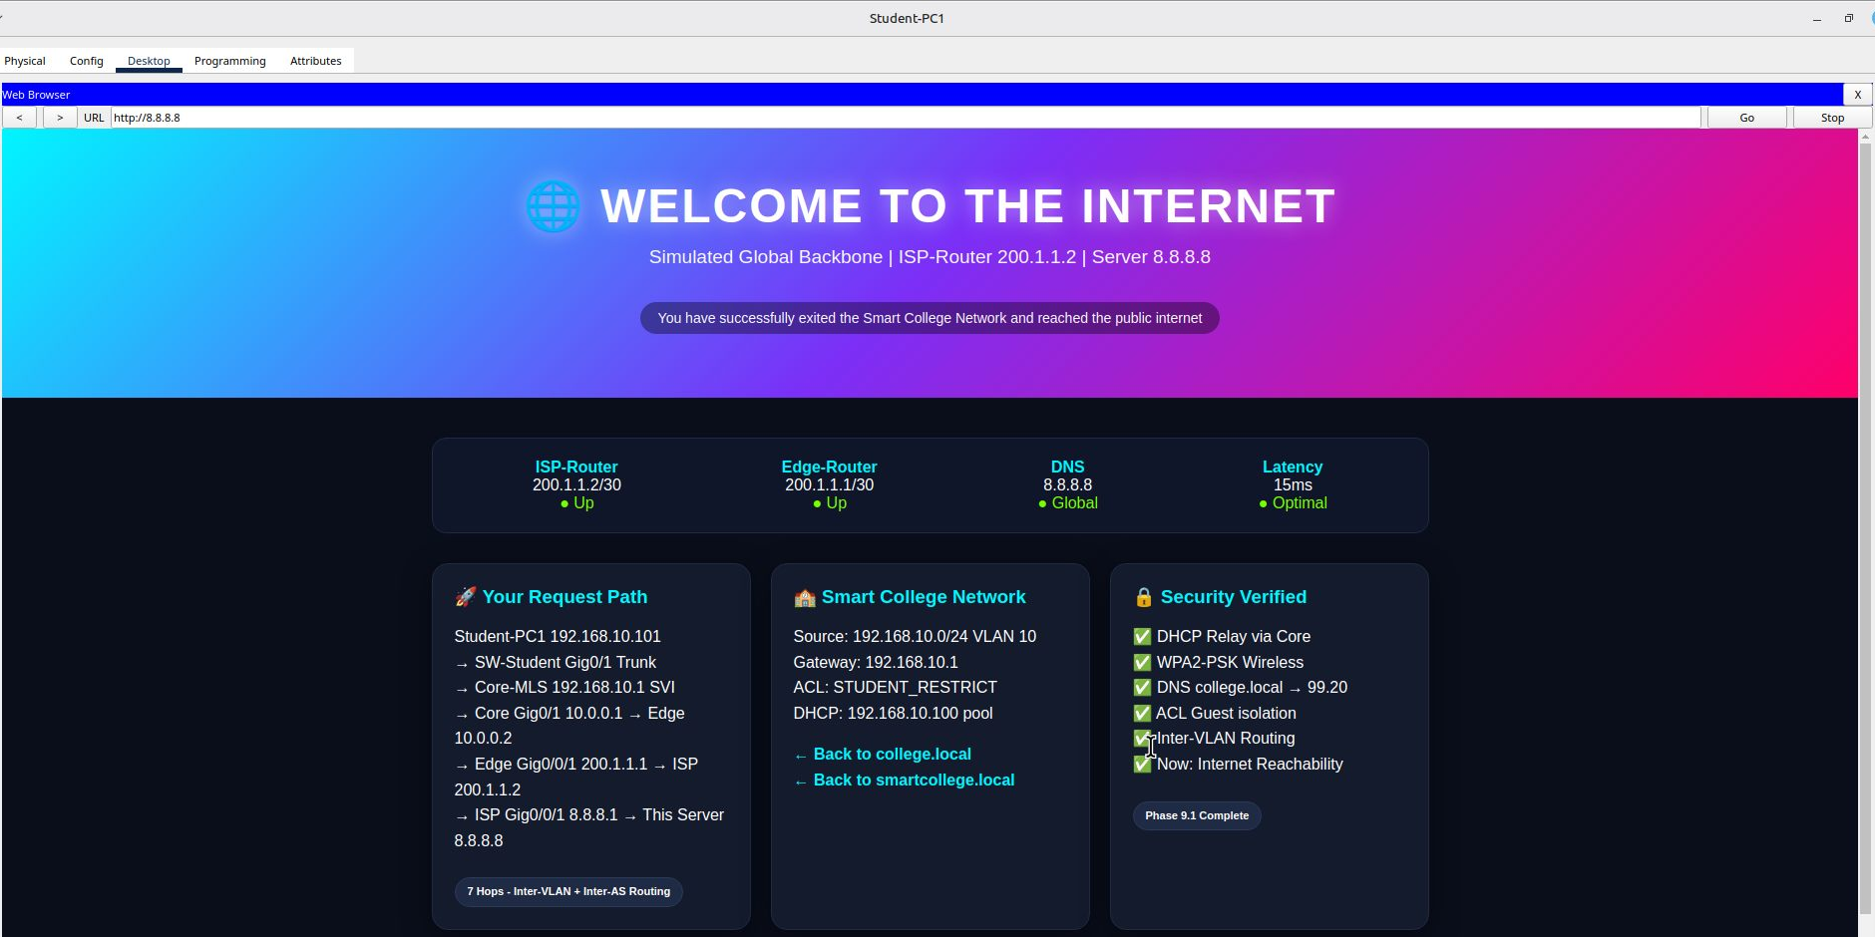
Fig. 42. Student-PC1 browser: http://8.8.8.8 loads the internet portal, showing the request path through the SVI, Edge-Router and ISP-Router.

5.2.6 Packet Tracer Simulation Mode (DHCP, TCP and ARP/ICMP)
Simulation Mode was used with a protocol filter for each test. DHCP: Student-PC1 was set to static 0.0.0.0 and then back to DHCP, and the exchange Discover (0.0.0.0 to 255.255.255.255), Offer (192.168.99.10 to 192.168.10.101), Request and ACK was followed one packet at a time. TCP: Student-PC1 opened http://college.local and the SYN, SYN-ACK and ACK of the three-way handshake were followed to Server-Web. ARP and ICMP: Admin-PC1 cleared its ARP cache with arp -d and pinged its gateway 192.168.30.1, producing an ARP request, an ARP reply and then ICMP echo packets.
Simulation Mode controls: the Realtime tab is normal operation and the Simulation tab is capture mode. Edit Filters, then Show All/None, is used to tick only the protocols needed (DHCP only; TCP and HTTP; ARP and ICMP). Play runs the simulation automatically, Capture/Forward advances one packet at a time (used for DHCP and ARP so each step is visible), and Reset Simulation clears the event list before a new test. Clicking the Realtime tab stops the simulation.
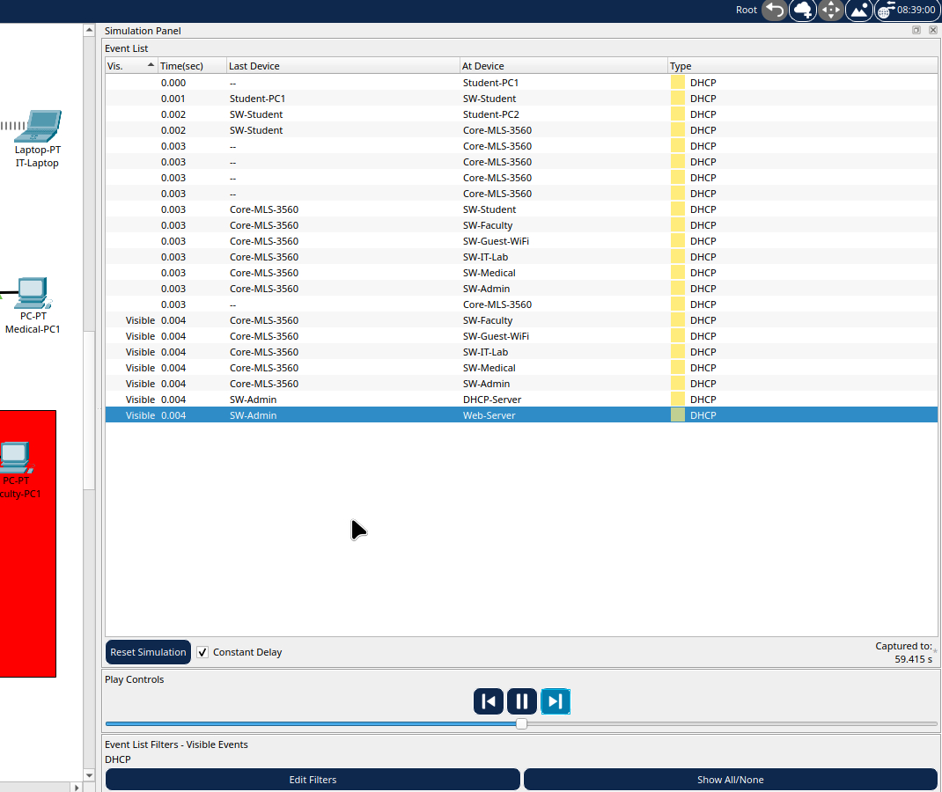
Fig. 43. Simulation Mode, DHCP filter only: DHCP packets travel from Student-PC1 through SW-Student and Core-MLS-3560, which relays them across the access switches to Server-DHCP.
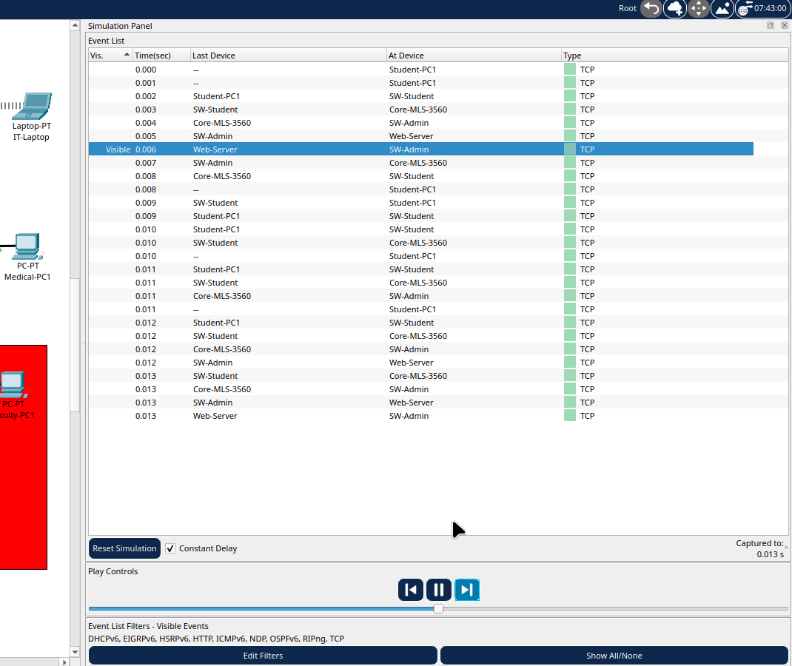
Fig. 44. Simulation Mode, TCP filter: packets between Student-PC1 and Web-Server through SW-Student, Core-MLS-3560 and SW-Admin (three-way handshake followed by the HTTP exchange).
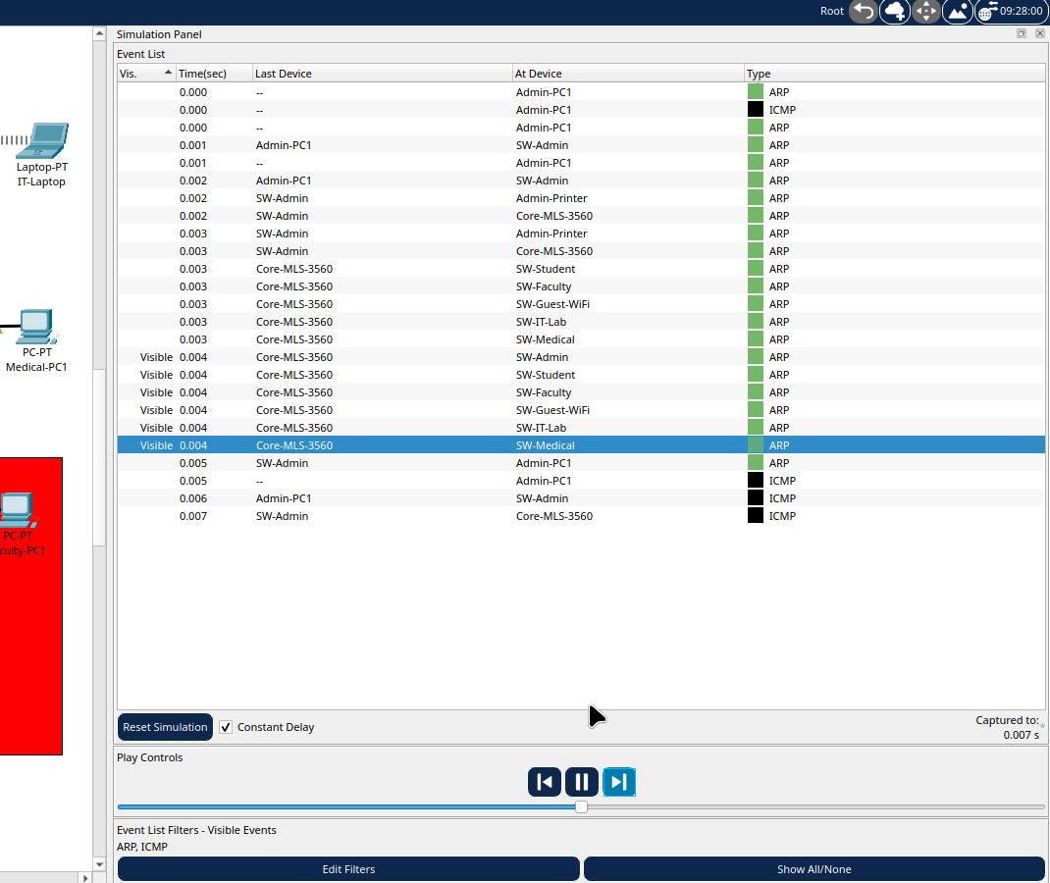
Fig. 45. Simulation Mode, ARP and ICMP filter: ARP request and reply from Admin-PC1 flooded across the switches, followed by ICMP echo packets.

5.2.7 Summary of Enterprise Test Results
Table 8. Enterprise final test results
Test | Expected | Actual | Status
Student receives DHCP | 192.168.10.100/24, GW 10.1, DNS 99.20 | DHCP: 192.168.10.100/24, GW 10.1, DNS 99.20, DHCP server 99.10 | Pass
Guest wireless DHCP | 192.168.40.x/24, GW 40.1 | DHCP: 40.101 on Wireless0, GW 40.1, DNS 99.20 | Pass
Core trunks (show interfaces trunk) | Fa0/1-6 trunking VLANs 1,10,20,30,40,50,60,99 | Active and forwarding | Pass
DHCP relay (show run | include helper) | 6 helper addresses | 6 x ip helper-address 192.168.99.10 | Pass
WPA2-PSK | Guest-WiFi Nopass@123, IT-WiFi Cisco123! | Both SSIDs WPA2-PSK, AES | Pass
DNS college.local | 192.168.99.20 | Server 99.20 returns 99.20 | Pass
HTTP college.local | Portal loads | SMART COLLEGE NETWORK portal loads | Pass
HTTP smartcollege.local | Portal loads | Same portal loads | Pass
Student to Admin (ACL) | Blocked | Destination host unreachable | Blocked (expected)
Student to Faculty (ACL) | Allow | Reply, TTL 127 | Pass
Guest to Student (ACL) | Blocked | Destination host unreachable | Blocked (expected)
Guest to web (ACL) | Allow (TCP 80) | Portal loads although ping is blocked | Pass
ISP link | ping 200.1.1.2 from Edge | 80% (4/5) | Pass
Internet reach | ping 8.8.8.8 from Student | Reply, 0% loss after NAT | Pass
NAT/PAT | 192.168.10.101 translated to 200.1.1.1 | icmp 200.1.1.1:10 192.168.10.101:10 8.8.8.8:10 | Pass
DNS internet.local | 8.8.8.8 | Server 99.20 returns 8.8.8.8 | Pass
HTTP internet.local | Internet portal | WELCOME TO THE INTERNET portal loads | Pass
DHCP simulation | Discover, Offer, Request, ACK | DHCP packets in Event List | Pass
TCP simulation | SYN, SYN-ACK, ACK | TCP packets Student-PC1 to Web-Server | Pass
ARP simulation | ARP request and reply, then ICMP | ARP and ICMP packets in Event List | Pass

5.3 Troubleshooting Log
Table 9. Issues encountered and fixes
Issue | Cause | Fix
Same-VLAN timeout | Cables on Fa0/6, Fa0/8 not Fa0/3, Fa0/5 | Port labels enabled, rewired to match show vlan brief
Router flapping | Gig0/1 not trunk | switchport mode trunk
show interfaces trunk invalid on router | Switch-only command | Used show ip interface brief on the router
Simulation showed only ICMP | ARP cache cached | arp -d + clear arp-cache + filter ARP and ICMP
Simulation showed only ARP | Simple PDU expired after gateway ARP | Used ping inside Simulation Mode, not Simple PDU
Wireshark no Wi-Fi interface | Linux uses wlo1, not Wi-Fi | Used wlo1 interface
Wireshark permission error | Not in wireshark group | usermod -a -G wireshark + re-login, or sudo wireshark
Hotspot IP 172.16.222.x, not 192.168.43.x | Android 12+ hotspot range | Documented as an observation
3560 vlan 10,20,30,40,50,60,99 invalid | 3560 IOS does not support a comma list in the vlan command | Created VLANs one by one: vlan 10, vlan 20 ...
2960 switchport trunk encapsulation dot1q invalid | 2960 does not support the encapsulation command | Removed it; used only switchport mode trunk
DHCP serverPool cannot be removed | Packet Tracer bug (default pool) | Disabled it: Start IP 0.0.0.0, Max 0
show ip interface VlanX shows no access-group | Packet Tracer 3560 display bug | Trusted show run | include access-group; tested with ping
Guest laptop DHCP failed | AP SSID was Default, not Guest-WiFi, plus distance | Set AP SSID Guest-WiFi, moved laptop closer, entered WPA2-PSK key
Laptop module swap | Laptop-PT is already wireless | Used the PC Wireless Connect tab directly
Edge route 8.8.8.0 255.255.0.0 inconsistent | Mask mismatch | Used 0.0.0.0/0 default route instead
Guest ping to 99.20 fails but web loads | ACL blocks ICMP but permits TCP 80 | Correct enterprise behaviour: ping blocked, web allowed
Simulation shows STP and DHCP together | Filter has many protocols | Edit Filters, Show All/None, tick only the needed protocols

6. Conclusion
In this project we designed and simulated a secure, segmented smart college network in Cisco Packet Tracer, first as a basic star topology with four VLANs, Router-on-a-Stick routing and ACLs, and then as an enterprise topology with six user VLANs and a servers VLAN, a 3560 multilayer core with SVIs and DHCP relay, WPA2-PSK wireless access, DNS and HTTP services, and NAT/PAT access to a simulated internet. We built it using a 3560 core, 2960 access switches, ISR4331 routers and extended ACLs, and verified it with ping, DHCP, DNS and web tests, Packet Tracer Simulation Mode (DHCP, TCP, ARP and ICMP) and Wireshark captures of real traffic. The design is useful for campus security because it isolates guests and restricts students from administrative systems, it uses IP addresses efficiently through DHCP pools and a single public NAT address, and it is easy to manage by user group. In future it can be extended with IPv6, RADIUS-based authentication, OSPF dynamic routing and a firewall at the network edge.

