RV UNIVERSITY, BENGALURU
SCHOOL OF COMPUTER SCIENCE AND ENGINEERING
SE2041 Applied Statistics
CIE 3 – STATISTICAL ANALYSIS PROJECT AND PRESENTATION

Statistical Analysis of Per-Capita Cocoa Supply

Submitted by
Aryan S Jain (1RUA25CSE0087)
Under the guidance of
Prof. Varadurga Bhat

Academic Year 2026–2027 | 12 November 2026

CERTIFICATE
Certified that the SE2041 Applied Statistics CIE 3 project titled “Statistical Analysis of Per-Capita Cocoa Supply” is carried out by Aryan S Jain (1RUA25CSE0087), a student of the School of Computer Science and Engineering, RV University, Bengaluru, during the academic year 2026–2027.

Faculty Guide: __________________________ Program Director: __________________________

1. Problem Statement and Research Objectives
This project examines how per-capita cocoa supply varies over time and across countries and regions. The research question is: “Is there an association between year and per-capita cocoa supply across countries?” The analysis uses the annual country/territory observations in the Our World in Data indicator dataset. It describes distributions, compares entities, and examines the pooled association between year and the indicator.

2. Dataset Description and Source
The downloaded dataset contains 13,210 rows and four original variables. The observation is an entity-year record. The years span 1961–2023; the file contains 244 distinct entities. The indicator is measured in kilograms per person per year.
The underlying provider is the Food and Agriculture Organization of the United Nations (FAO), with data processed by Our World in Data (OWID). The indicator represents food supply available at the consumer level, not directly measured intake; consumer waste is not deducted. It combines cocoa beans and specified cocoa products. The report therefore uses the term “per-capita cocoa supply” rather than claiming to measure actual chocolate eaten.
Citation: Food and Agriculture Organization of the United Nations (2025) – processed by Our World in Data. “Yearly per capita supply of cocoa beans” [dataset]. Food and Agriculture Organization of the United Nations, Food Balances. Retrieved 12 November 2026 from https://ourworldindata.org/grapher/chocolate-consumption-per-person

3. Variables and Measurement Scales
Variable | Classification | Scale | Description
Entity | Qualitative | Nominal | Country, territory or region name
Code | Qualitative | Nominal | Geographic identifier; some aggregate rows have no code
Year | Quantitative – discrete | Interval | Calendar year
Cocoa beans - Food available for consumption (kilograms per year per capita) | Quantitative – continuous | Ratio | Annual food supply in kg/person/year
Entity_Type | Qualitative – derived | Nominal | Country/territory or region/aggregate classification based on code format
The cleaned analytical file retains rows with missing Code values because these can represent OWID aggregate or region entities. Records are excluded only if Entity, Year or the numerical indicator is missing. No values are imputed.

4. Data Cleaning and Sampling
The source file has 13,210 observations. After checking required fields and removing rows with missing Entity, Year or indicator values, 13,210 observations remain. Missing Code values are retained and classified as region/aggregate rather than treated as missing observations. The full available dataset is used; no random sample is drawn.

5. Frequency Tables and Visualizations
A frequency table is prepared for entity type. The indicator is continuous, so its values are grouped into numerical intervals for a frequency distribution. The latest-year bar chart compares countries/territories, while the pie chart describes the composition of entity types in the latest year.
Entity type | Frequency
Country/territory | 10176
Region or aggregate | 3034
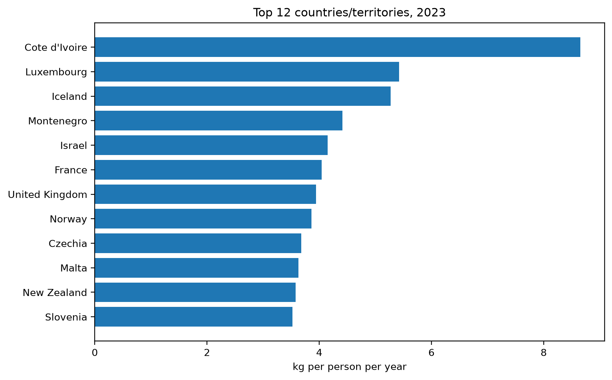
Figure 1. Countries/territories with the highest per-capita cocoa supply in the latest year
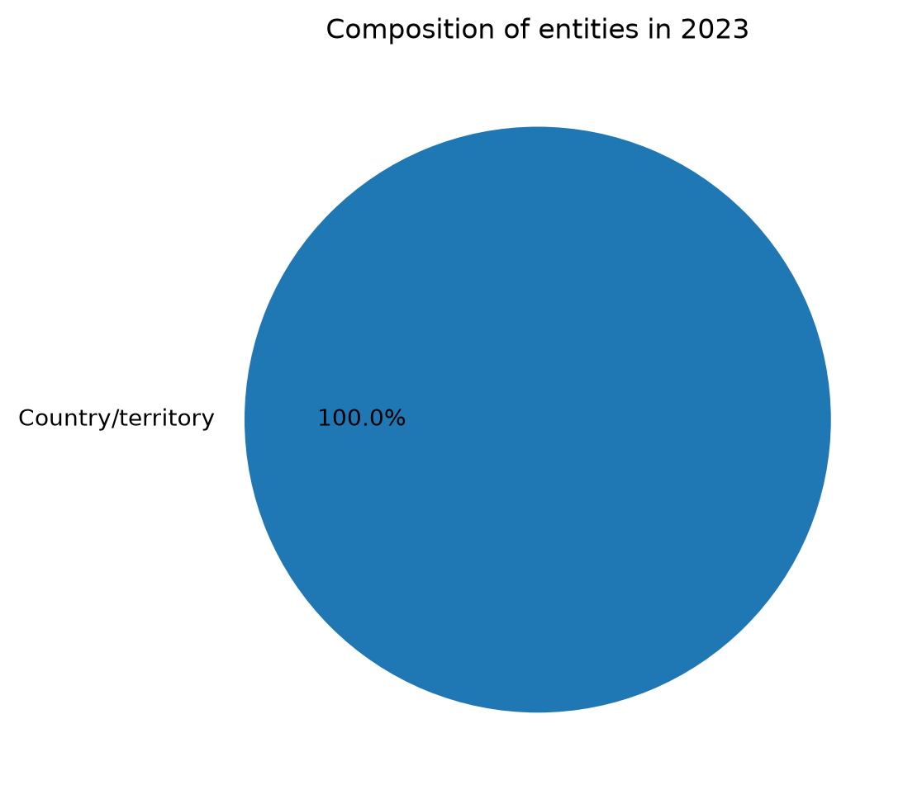
Figure 2. Entity-type composition in the latest year
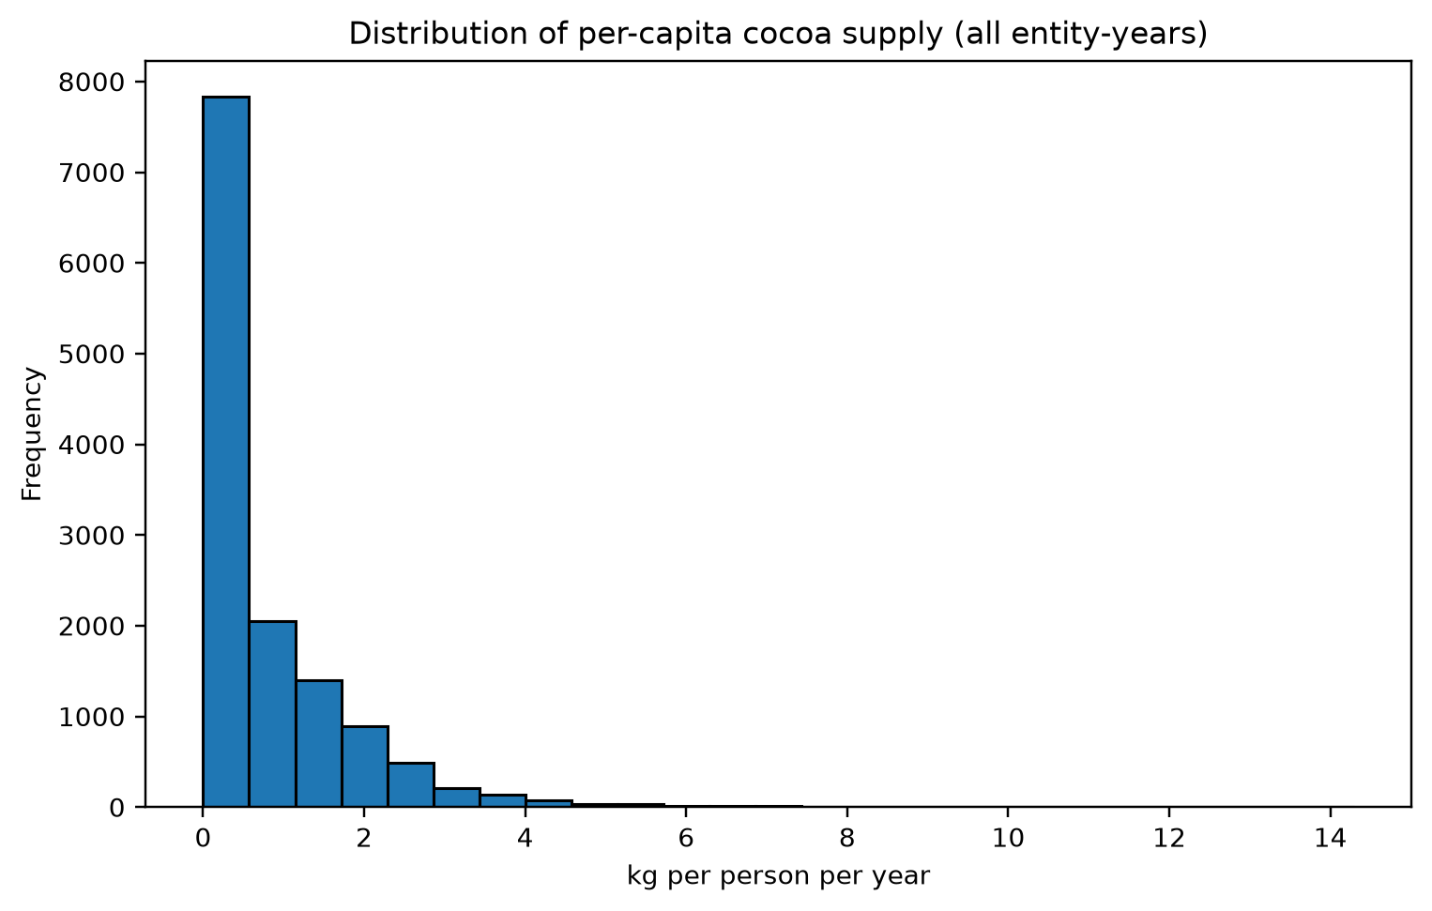
Figure 3. Distribution of per-capita cocoa supply across entity-year observations
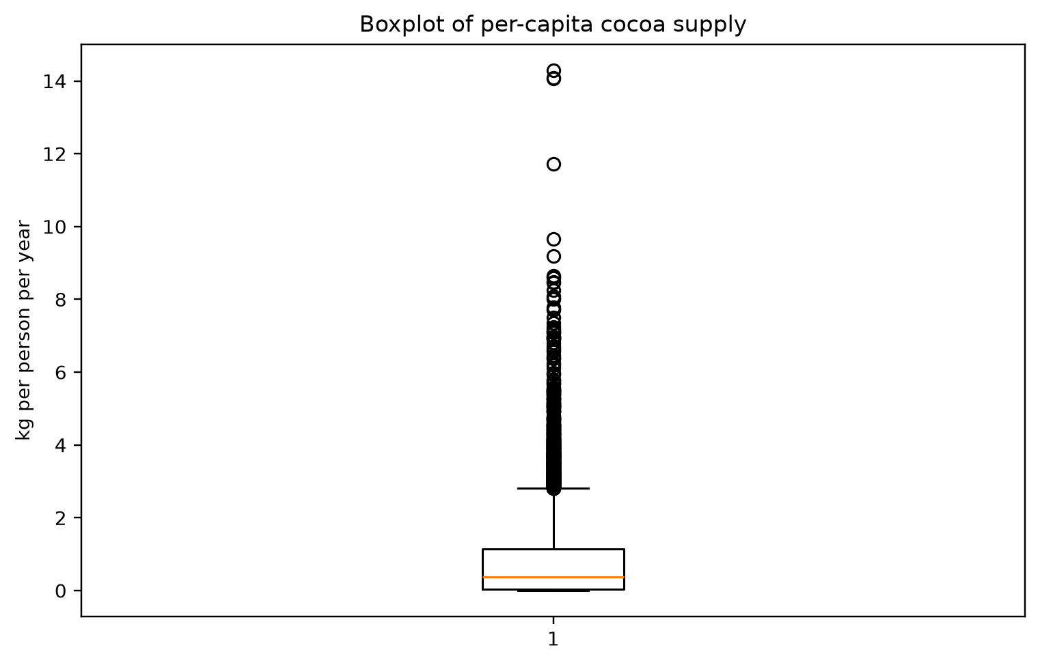
Figure 4. Box-and-whisker plot of per-capita cocoa supply
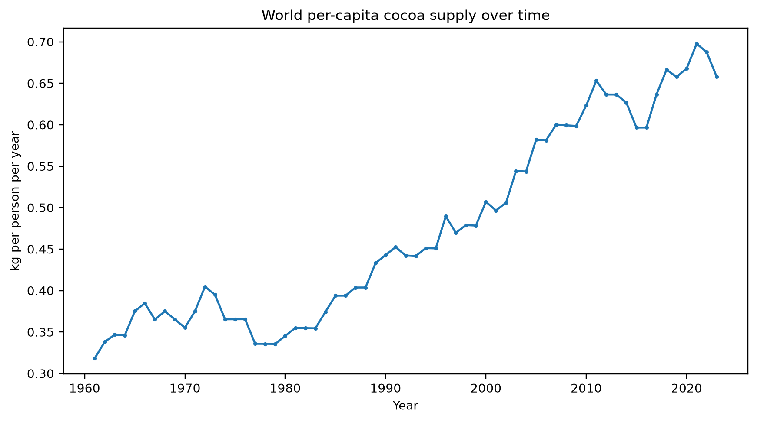
Figure 5. World aggregate per-capita cocoa supply over time

6. Descriptive Statistical Analysis
Measure | Per-capita cocoa supply
Count | 13210
Mean | 0.7649
Median | 0.3717
Mode | 0.0000
Minimum | 0.0000
Maximum | 14.2941
Range | 14.2941
Sample variance | 1.0480
Sample standard deviation | 1.0237
Q1 | 0.0455
Q2 | 0.3717
Q3 | 1.1511
IQR | 1.1056
P10 | 0.0000
P90 | 2.0700
Coefficient of variation (%) | 133.8433
The mean is 0.7649 kg/person/year and the median is 0.3717. The standard deviation is 1.0237, while the coefficient of variation is 133.84%. The mean exceeding the median may indicate right-skewness; the histogram and boxplot should be considered alongside these summaries. These pooled statistics combine different entities and years and should not be interpreted as the experience of a typical individual country.

7. Relationship Between Year and Per-Capita Cocoa Supply
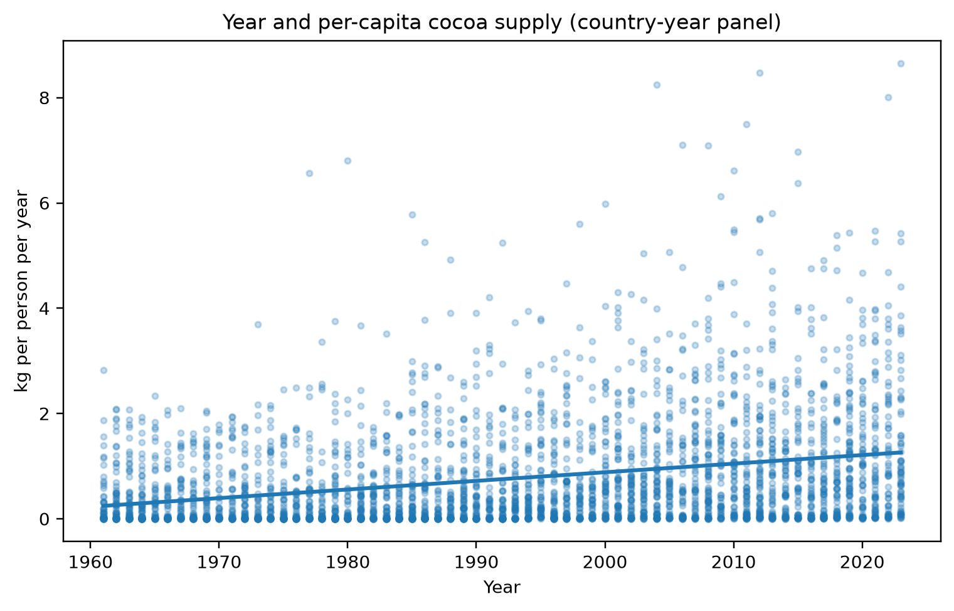
Figure 6. Scatterplot of year and per-capita cocoa supply for country/territory observations (display sample)
For country/territory observations with three-letter codes, the pooled Pearson correlation between Year and the indicator is r = 0.2749 (n = 10,176). The fitted descriptive line is supply = 0.016358 × year + -31.8308, with R² = 0.0756. This pooled panel correlation describes the overall linear association in the combined country-year observations.
Important limitation: observations repeat for the same country/territory across years, and countries differ substantially in their long-run supply levels. The pooled Pearson coefficient therefore does not satisfy the usual independent-observation assumption for conventional significance testing. It can also combine within-country time trends with between-country differences. It is not evidence that calendar year causes a change in supply. A stronger follow-up would estimate country-specific trends or use a panel-data model.

8. Conclusion
The dataset provides 13,210 entity-year observations from 1961 to 2023 and includes qualitative entity identifiers alongside the quantitative year and per-capita supply variables. Descriptive statistics and visualizations show the distribution and variation of the indicator. The pooled country-year correlation is 0.2749; it should be interpreted cautiously because the observations form a repeated-measures panel. The results describe food supply available per person, not actual consumption after waste.

9. Limitations and Future Scope
The indicator is a food-supply measure and not direct survey measurement of individual consumption. The dataset combines country/territory observations and regional aggregates; aggregate rows must not be mixed with countries when making country-level comparisons. Repeated observations over time are not independent. Future work can focus on a single country’s time series, compare a preselected group of countries, or use panel regression with entity effects.

10. References
Food and Agriculture Organization of the United Nations (2025) – processed by Our World in Data. “Yearly per capita supply of cocoa beans” [dataset]. Food and Agriculture Organization of the United Nations, Food Balances. Retrieved 12 November 2026 from https://ourworldindata.org/grapher/chocolate-consumption-per-person
Our World in Data. “Cocoa bean consumption per person.” https://ourworldindata.org/grapher/chocolate-consumption-per-person
Data accessed 12 November 2026. The dataset and OWID-produced materials are made available under CC BY; original FAO data remain subject to the provider’s terms. Credit both FAO and Our World in Data.

