Description

Intended User

Features

User Interface Mocks

Screen 1

Screen 2

Screen 3

Screen 4

Screen 5

Key Considerations

How will your app handle data persistence?

Describe any edge or corner cases in the UX.

Describe any libraries you’ll be using and share your reasoning for including them.

Describe how you will implement Google Play Services or other external services.

Next Steps: Required Tasks

Task 1: Project Setup

Task 2: Implement UI for Each Activity and Fragment

Task 3:Get data from API

Task 4: Make Timer functionality and add Start Stop functionality in it

Task 5: Calculation of BMI

Task 6: User can press favorite fab button on any exercise and that exercise would be stored as favorite, Will be displayed in the favorite fragment

**GitHub Username**: aryansoni1108@gmail.com

HyperFit

# Description

Write a brief summary of what your app does. What problem does your app solve?

This workout app is a mix of in gym and home exercises. You can choose the body part you want to buff up or make it strong it will show you the exercise you need todo. Track your progress start the timer and work out. It has more than 100 exercises in total. Enough for to make your body a masterpiece.

# Intended User

Who is your intended user? (For example, is this an app for dog owners? Families? Students? Travelers?)

# Features

List the main features of your app. For example:

* Shows Chart in Workouts graph
* Share achievements with friends
* Retention of progress when user signs in from another device
* Calculate BMI for weight conscious people
* Start and stop timer for a particular Workout
* Display of steps for how to do a particular exercise

Optional Features:

* Sync with google fit
* Use of google FIT api

# User Interface Mocks

## Screen 1

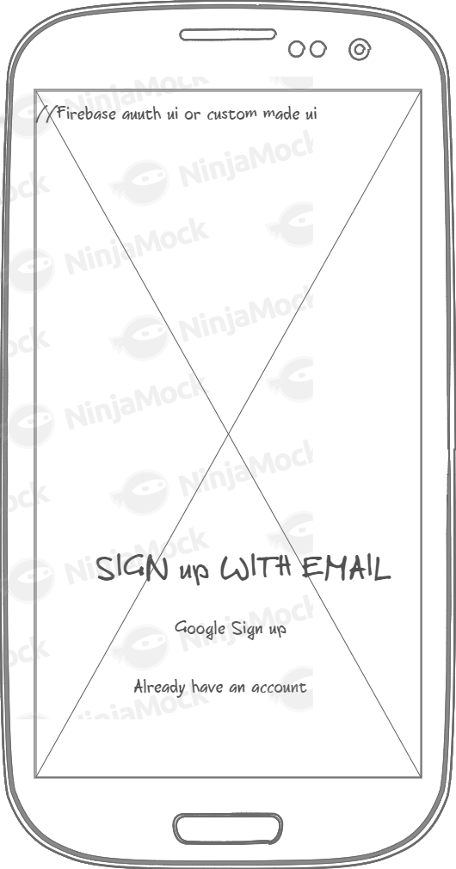

## Screen 2

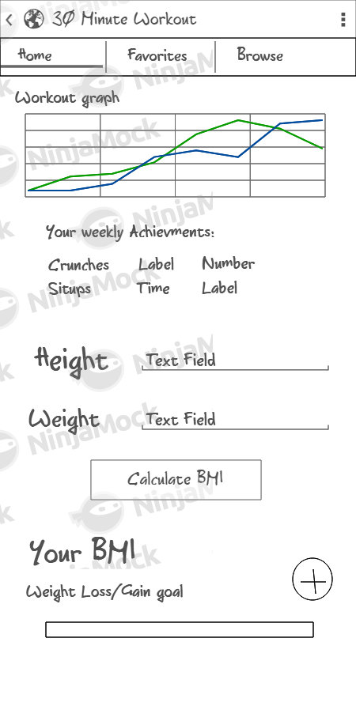

## Screen 3

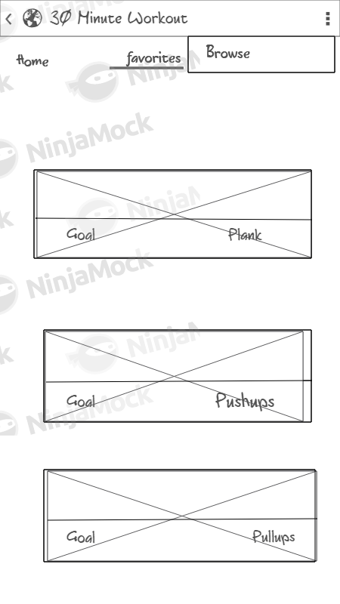

## Screen 4

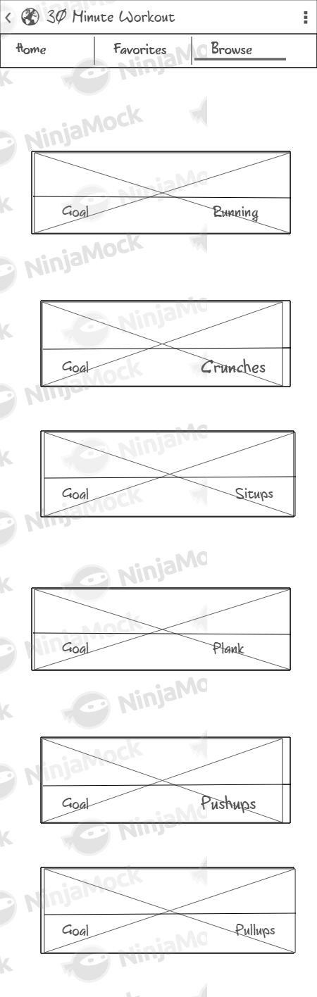

# Screen 5

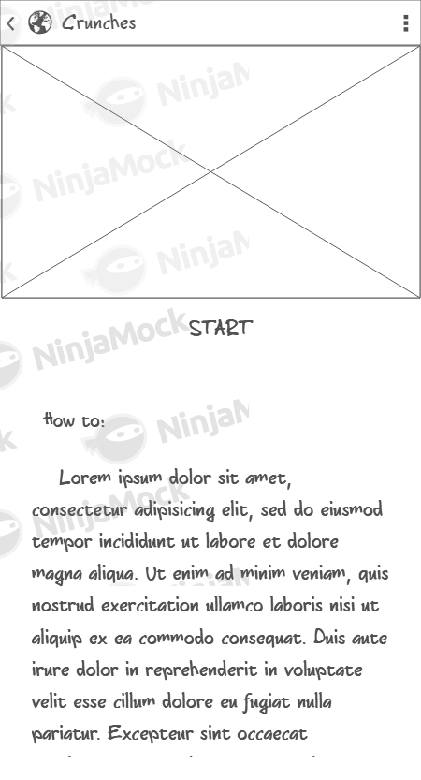

# Key Considerations

### How will your app handle data persistence?

Use of LiveData,Room Persistance Library for firebase data to be stored in database

### Describe any edge or corner cases in the UX.

User will be able to return to mainactivity by back button on toolbar

Also user can change the workout simply by sliding finger left or right in workout activity

.

### Describe any libraries you’ll be using and share your reasoning for including them.

For example, Picasso or Glide to handle the loading and caching of images.

Picasso

Butterknife

Library for chart

GSON

Volley

### Describe how you will implement Google Play Services or other external services.

Use of wger.de API service for workout details.

Optional:

Use of firebase authentication for cross device data persistance(Saving progress)

# Next Steps: Required Tasks

This is the section where you can take the main features of your app (declared above) and break them down into tangible technical tasks that you can complete one at a time until you have a finished app.

## Task 1: Project Setup

Write out the steps you will take to setup and/or configure this project. See previous implementation guides for an example.

You may want to list the subtasks. For example:

* Configure libraries
* Create a new project in Firebase Console and download json file
* Setup Firebase Realtime Database(optional)

If it helps, imagine you are describing these tasks to a friend who wants to follow along and build this app with you.

## Task 2: Implement UI for Each Activity and Fragment

List the subtasks. For example:

* Build UI for MainActivity
* Build UI for Home Fragment
* Build UI for Favorites Fragment
* Build UI for Browse Fragment
* Build UI for login Activity
* Build UI for Exercise fragment

**Task 3: Implement UI for Each Activity and Fragment**

**Subtasks:**

* Make pojo class for getting setting objects
* Populate recyclerview

## Task 4: Make Timer functionality and add Start Stop functionality in it

Describe the next task. For example, “Implement Google Play Services,” or “Handle Error Cases,” or “Create Build Variant.”

Describe the next task. List the subtasks. For example:

* Timer Starts when user presses Timer button
* Timer pauses when user presses Timer button
* Timer stops when user presses stops button and logs the activity to Phone database
* Timer stops automatically and a sound is ringed to notify user of completion of exercise

## Task 5: Calculation of BMI

Describe the next task. List the subtasks. For example:

* User inputs its height and weight and presses calculate BMI to show the person’s BMI
* This BMI is also stored either as a shared preference or in the phone database

## Task 6: User can press favorite fab button on any exercise and that exercise would be stored as favorite, Will be displayed in the favorite fragment

Describe the next task. List the subtasks. For example:

* Add fab button in workouts activity
* Save favorite workouts in device and user would be able to see favorite workouts in favorite fragment

Task 6: User can set new goal by pressing the fab button

A new Activity for goal setting:

* Add weight goal

A progress bar will tell how much goal is achieved by the user