**ASSIGNMENT 2**

USING GAME TREE SEARCH TO BEAT A MYOPIC PLAYER IN CONNECT 4

horizontal line

# 

# Introduction

In the assignment we are given the codebase for a connect 4 game and the code for a myopic player who looks ahead only one move . The aim of the assignment is to create a GameTreePlayer class which uses minimax function to create a game tree of depth 5 and defeat the myopic player in less than 5 moves . The questions in the assignment are

(a) Comparison of different evaluation functions .

(b) Playing the game with the depth of the tree=3.

(c) Implementing move ordering heuristic .

(d) Compare average number of moves and winnings when depth = 5.

In the assignment we are given the code for running the test case which is provided in a separate csv file , we need to import the file and then use it to play with the GameTreePlayer.

# Creating the GameTreePlayer() Class .

The GameTreePlayer() class is created. An evaluation function which maintains a score of the game is also used , the myopic player is denoted by -1 and the game tree player is denoted by +1 .

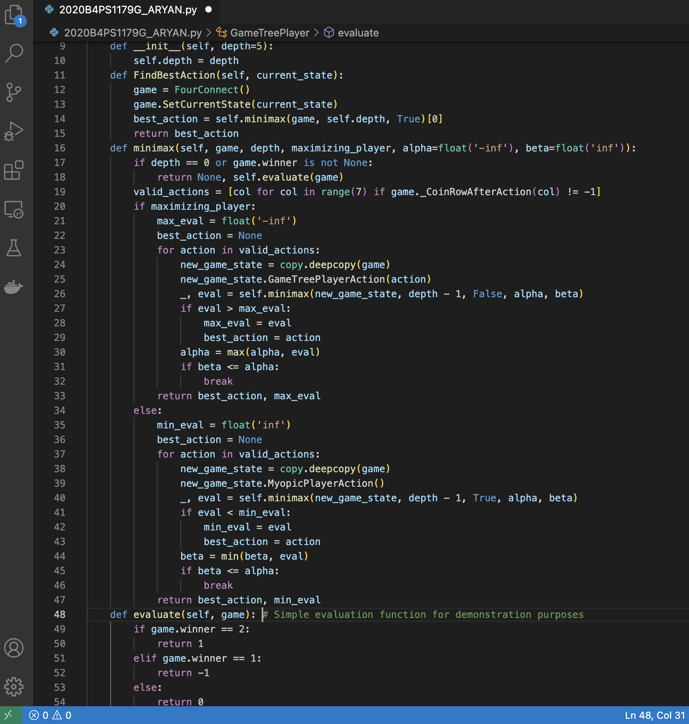

# AVERAGE WINNINGS

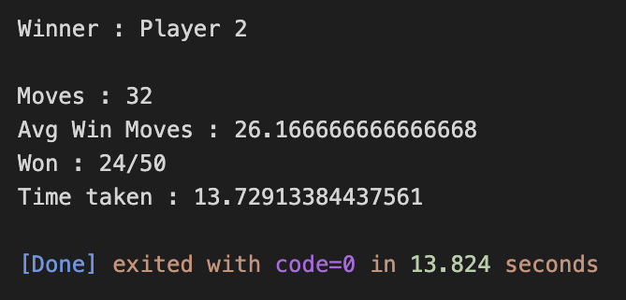

# TESTCASE

After completing the code , it is run with the test cases and it is observed that the testcase has been passed

