# E-commerce project proposal

* The name of the business - ***E-Commerce***
* A brief description of this business, including:
  + the number of employees,
    - *Total 5 employees*

*5 employees including Management, Web Designers and Developers*

* + how long the company has been in business
    - *The company has been in business since August 2019.*
    - *Head office is located in Exchange district, Winnipeg.*
  + the type of product they intend to sell online
    - *Clothing, Computer, Electronics*
  + how they currently sell their products
    - *Through their retail store and want to expand their business through online selling and via app*
* The target demographic for this online store. (In other words, the intended customer.)
  + - *Massive market*

The description of your database must include:

* The name of the tables.
  + - *Products,*
    - *Categories,*
    - *Orders,*
    - *Customer*
* A brief description of why each table is required. One sentences if possible, two max.
  + - *Products – Product table consists of all type of products from various brands*
    - *Categories – This includes different type of product types like electronics, clothing, etc.*
    - *Orders – This consist of the orders placed by customers on the website*
    - *Customer – This stores the data of the users who have created their accounts on the website*
* The column names and data types for each table.

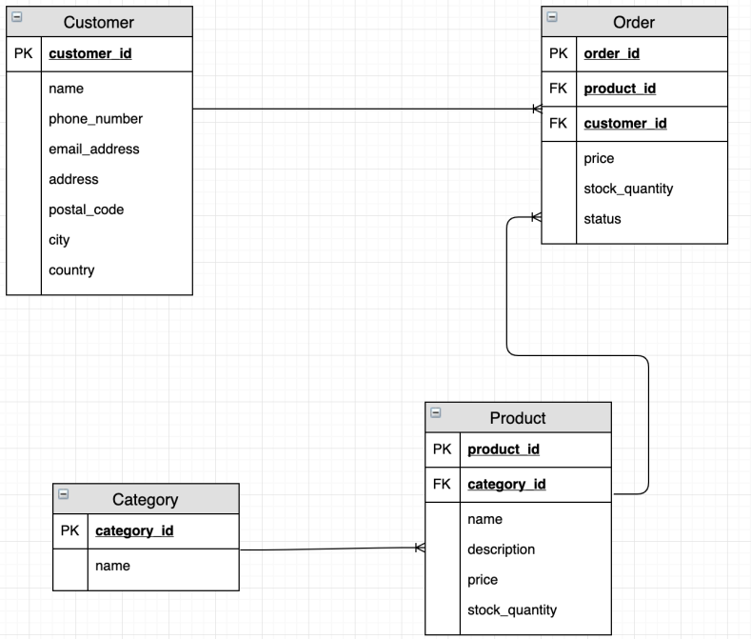

* A description of the associations between the tables.
  + - *Categories have many-to-many relationship with the products.*
    - *Each product has one-to-many relationship with the orders*
    - *Customer has one-to-many relationship with orders.*