Supplemental Material

E1. Baseline characteristics of 3,300,708 offspring born 1973-2008 in Sweden and mortality, psychiatric, academic, and social adversity outcomes by gestational age.
E2. Modeling results for Academic Problems
E3. Results of cousin-comparison analyses of gestational age and offspring outcomes.

Table E1. Baseline characteristics of 3,300,708 offspring born 1973-2008 in Sweden and mortality, psychiatric, academic, and social adversity outcomes by gestational age.
 |  |  |  |  | Gestational Age Group [ wk - wk, days (n) ]
Covariates and Outcomes | Birth Year | N | Statistic |  | 23 - 27, 6 (5,856) |  | 28 - 30, 6 (9,663) |  | 31 - 33, 6 (23,913) |  | 34 - 36, 6 (114,890) |  | 37 - 42, 6 (3,146,386)
Offspring | 1973-2008 | 3,300,708
Female |  |  | (n, %) |  | 2,661 | 45.44 | 4,340 | 44.91 | 10,385 | 43.43 | 51,741 | 45.04 | 1,527,944 | 48.56
Birth Weight (g) |  |  | (M, SD) |  | 928.25 | 465.59 | 1,350.79 | 433.54 | 1,947.08 | 480.99 | 2,703.40 | 493.53 | 3,579.47 | 493.17
Maternal | 1924-1995 | 1,736,735
Age at birth (yrs) |  |  | (M, SD) |  | 28.21 | 5.94 | 28.06 | 5.84 | 27.83 | 5.67 | 27.54 | 5.42 | 27.43 | 5.11
Upper Secondary Education (1-3 yrs) |  |  | (n, %) |  | 1,785 | 50.03 | 2,931 | 49.19 | 7,513 | 50.29 | 34,429 | 49.84 | 786,682 | 47.87
Criminality (any) |  |  | (n, %) |  | 522 | 14.63 | 796 | 13.36 | 1,837 | 12.30 | 8,519 | 12.33 | 179,865 | 10.95
Paternal | 1904-1993 | 1,729,899
Age at birth (yrs) |  |  | (M, SD) |  | 32.60 | 6.88 | 32.08 | 6.68 | 31.81 | 6.61 | 31.65 | 6.40 | 31.73 | 6.03
Upper Secondary Education (1-3 yrs) |  |  | (n, %) |  | 1,512 | 49.48 | 2,814 | 50.99 | 7,248 | 50.43 | 33,861 | 50.26 | 804,703 | 49.08
Criminality (any) |  |  | (n, %) |  | 1,162 | 38.02 | 2,309 | 41.84 | 5,879 | 40.91 | 27,086 | 40.20 | 610,419 | 37.23
Mortality
Infant Mortality | 1973-2008 | 3,300,708 | (n, %) |  | 2,352 | 40.16 | 1,576 | 16.31 | 1,523 | 6.37 | 2,167 | 1.89 | 8,799 | 0.28
Died After 1st Year | 1973-2008 | 3,300,708 | (n, K-M est) |  | 29 | 2.16 | 71 | 1.73 | 198 | 1.65 | 759 | 1.36 | 13,370 | 0.88
Psychiatric Morbidity
Psychotic or Bipolar Disorder | 1973-1997 | 2,308,032 | (n, K-M est) |  | 34 | 5.54 | 83 | 3.02 | 183 | 2.27 | 811 | 1.89 | 18,507 | 1.53
Autism | 1980-2001 | 2,032,803 | (n, K-M est) | ‡ | 84 | 0.80 | 103 | 0.59 | 205 | 0.41 | 754 | 0.32 | 14,977 | 0.29
ADHD Diagnosis | 1980-2001 | 2,032,803 | (n, K-M est) | ‡ | 113 | 1.49 | 181 | 1.11 | 389 | 0.89 | 1,417 | 0.54 | 28,075 | 0.35
Suicide Attempt | 1973-1997 | 2,308,032 | (n, K-M est) |  | 33 | 3.59 | 94 | 3.38 | 246 | 2.70 | 1,207 | 2.62 | 29,328 | 2.24
Substance Use Problem | 1973-1997 | 2,308,032 | (n, K-M est) |  | 34 | 1.45 | 144 | 3.46 | 368 | 3.39 | 1,736 | 3.32 | 43,850 | 3.04
Criminality | 1973-1994 | 2,044,992  1,776,454 | (n, K-M est) |  | 136 | 13.74 | 596 | 18.13 | 1,907 | 18.53 | 10,447 | 19.11 | 271,543 | 17.82
Academic Problems
Failing Grades | 1973-1992 | 1,776,454 | (n, %) |  | 285 | 25.29 | 832 | 21.96 | 2,181 | 18.82 | 10,811 | 17.68 | 252,469 | 14.86
Education under 10 yrs | 1973-1991 | 1,689,102 | (n, %) |  | 479 | 44.43 | 1,316 | 36.35 | 3,626 | 32.58 | 18,211 | 31.10 | 464,578 | 28.77
Higher Education | 1973-1983 | 911,749 | (n, %) |  | 85 | 19.59 | 412 | 23.80 | 1,464 | 26.00 | 8,450 | 27.95 | 279,131 | 31.95
Social Adversity
Parenthood | 1973-1995 | 2,138,861 | (n, K-M est) |  | 176 | 14.48 | 802 | 15.74 | 2,702 | 16.01 | 15,794 | 16.82 | 477,438 | 15.39
Ever Partnered | 1973-1990 | 1,609,646 | (n, K-M est) |  | 77 | 5.31 | 372 | 11.99 | 1,232 | 16.39 | 7,402 | 20.17 | 197,945 | 18.92
Social Welfare Benefits | 1973-1990 | 1,609,646 | (n, K-M est) |  | 299 | 37.44 | 1,021 | 37.01 | 3,014 | 34.15 | 14,921 | 31.47 | 362,204 | 27.89
Note. n = number of cases in the gestational age group; % = percentage of cases in the gestational age group; M = mean; SD = standard deviation; K-M est = Kaplan-Meier product-limit survival estimate; ‡ = K-M estimate for diagnosis by the age of 10 years; all other estimates are for 25 years of age.

E2. Modeling results for Academic Problems

Academic Problems
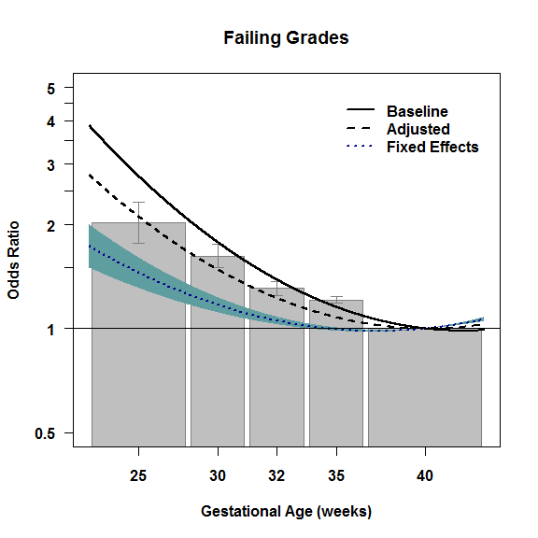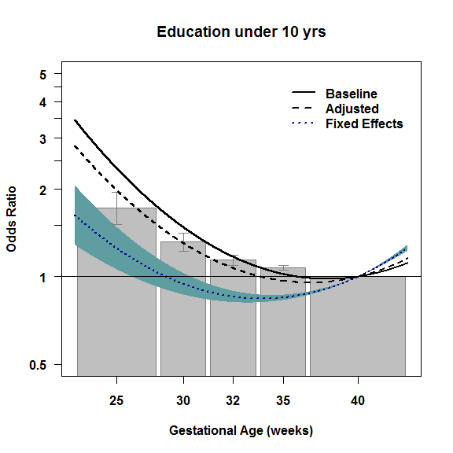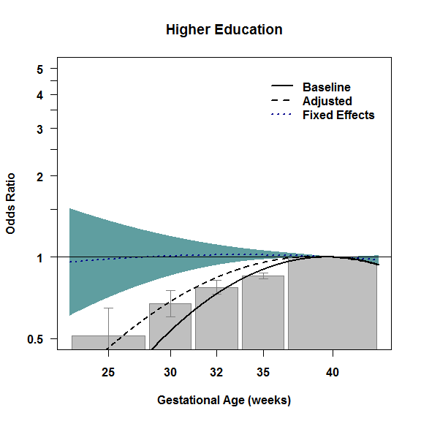

Note. See note in main text for detailed information regarding the interpretation of the figures.
E3. Results of cousin-comparison analyses of gestational age and offspring outcomes.

The cohort in the main analysis consisted of N=3,300,708 individuals born to 1,736,735 unique mothers and 1,729,899 unique fathers. For the cousin comparison analysis, we used the Multigenerational Register to identify the maternal grandmothers of all offspring in the original cohort. Data for 331,972 individuals were excluded from this sensitivity analysis due to missing identifiers for the grandmothers. Thus, the final cohort for the cousin-comparisons consisted of N=2,968,736 offspring born to 1,542,984 unique mothers and 1,553,140 unique fathers with cousins clustered by 1,162,228 unique maternal grandmothers.

We fit two models for each outcome, the baseline and the fixed-effects models. It is important to note that the fixed-effects models in these analyses compared differentially exposed cousins (rather than siblings). The results are presented in Figure E3, where we plotted the baseline risk with the solid blue line. The cousin-comparison results are presented with the dotted blue lines, with the 95% confidence intervals represented by the shaded blue. Overall, the results of the cousin-comparison models are commensurate with the results from the sibling-comparison models. First, the association between GA and many of the outcomes remained robust when comparing differentially exposed cousins. Second and most important, though, the associations between GA and suicide attempts, school grades, educational attainment, and receiving social welfare benefits were all greatly attenuated in the cousin-comparison models, which are consistent with the siblings-comparison results. Carryover effects are arguably less of a concern when comparing cousins than when comparing siblings. Because the associations between GA and these outcomes were attenuated both in sibling- and cousin-comparisons the results strongly suggest that carry-over effects do not account for the attenuated associations with GA.

E3. Figures. Comparison of the baseline and fixed-effects models for the association between continuous gestational age and offspring Mortality, Psychiatric Morbidity, Academic Problems, and Social Adversity.
Mortality
E3.1 E3.2
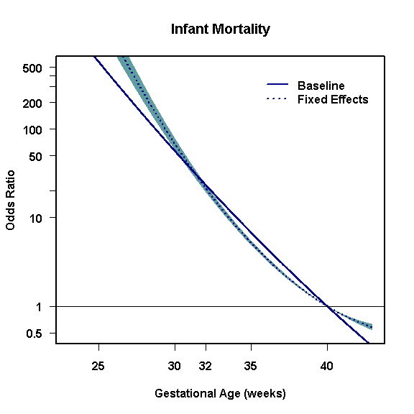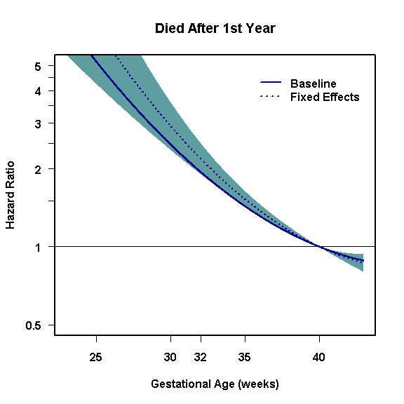
Psychiatric Morbidity
E3.3 E3.4
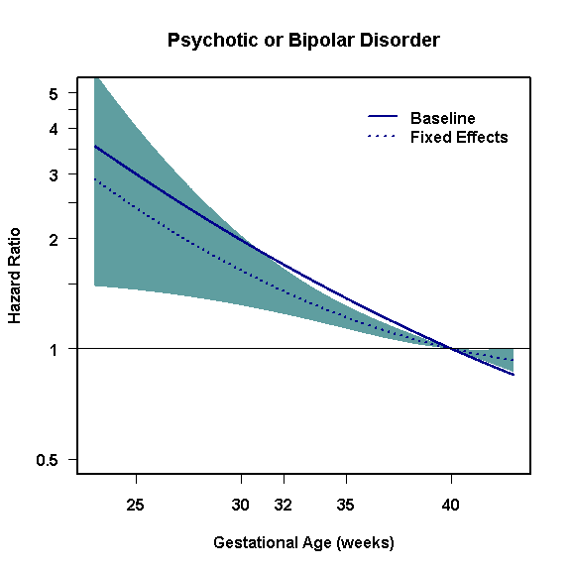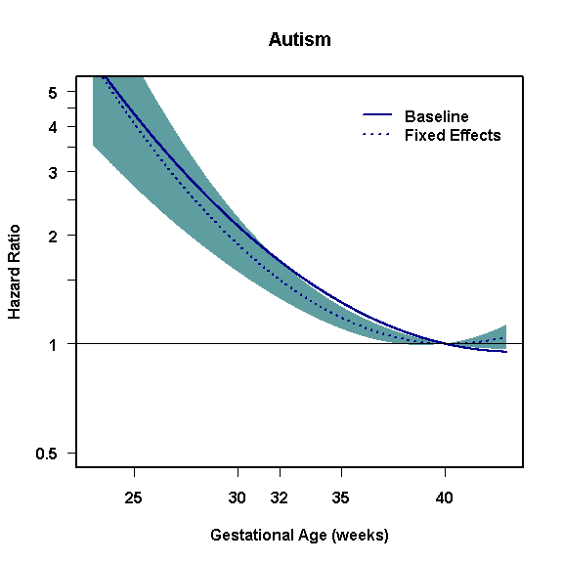

Psychiatric Morbidity (con’t)
E3.5 E3.6
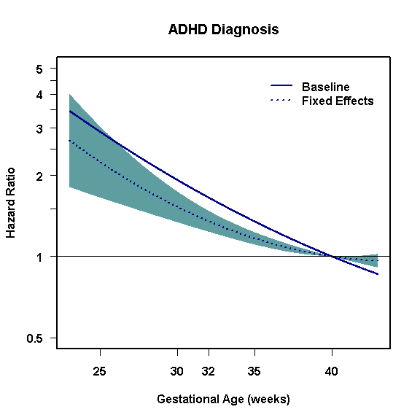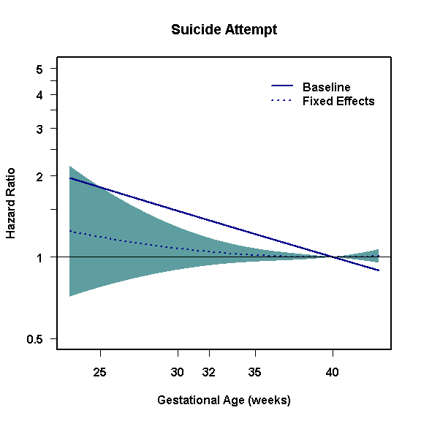
E3.7 E3.8
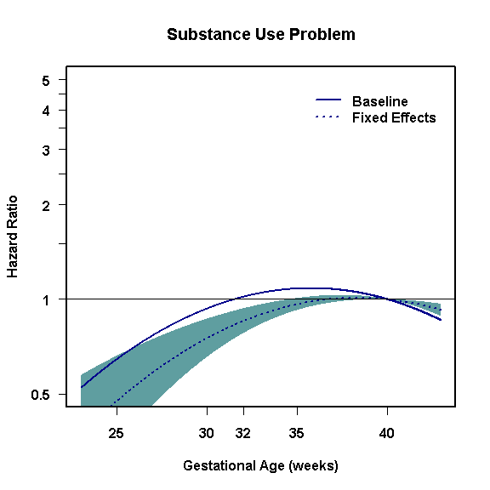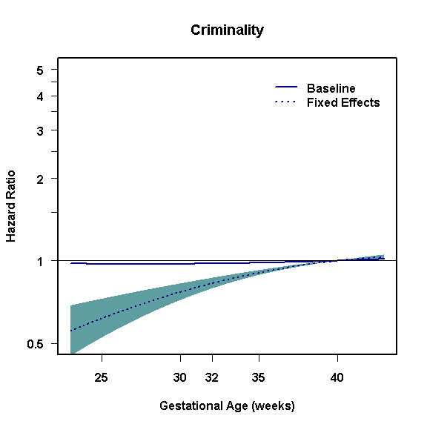

Academic Problems
E3.9 E3.10
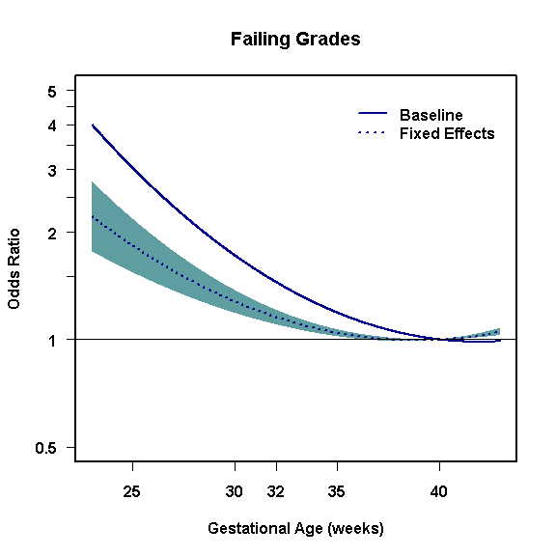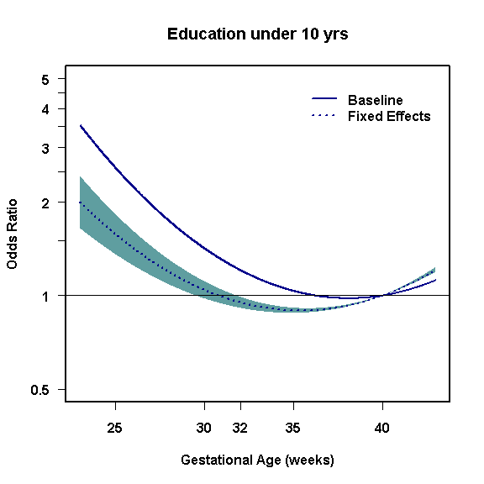
E3.11
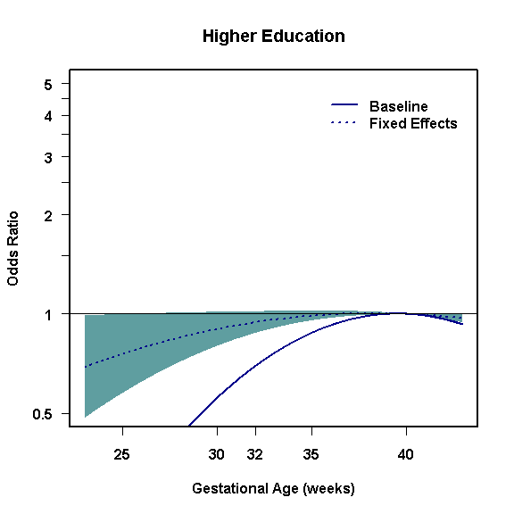

Social Adversity
E3.12 E3.13
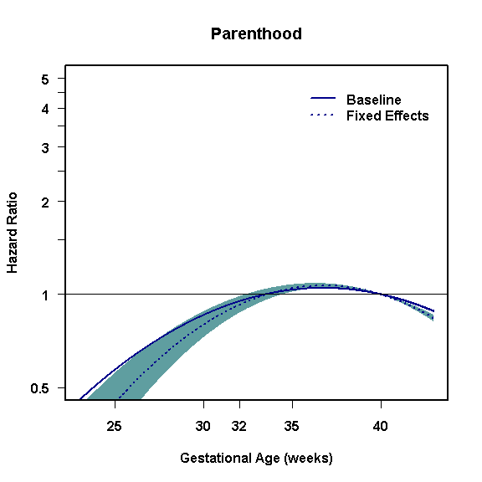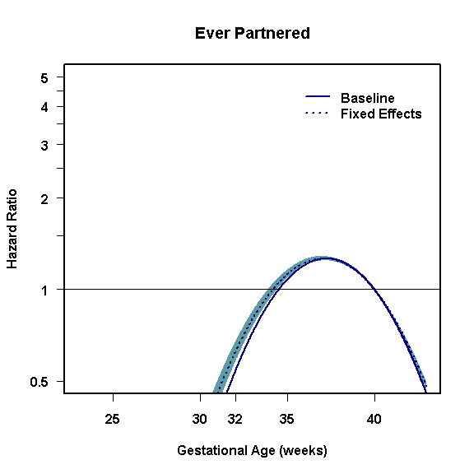
E3.14


