Transfer Learning — Concept Notes
CNN → Transfer Learning track

Phase 1 — Feature Extraction
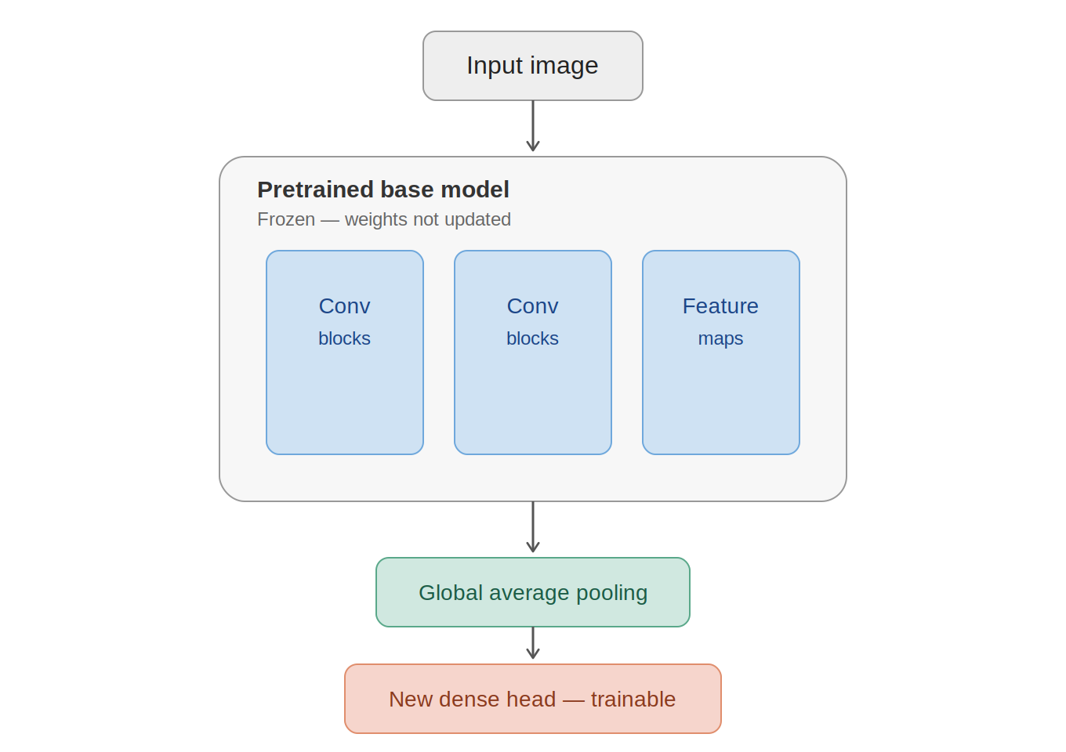
Figure 1: Phase 1 architecture — frozen base model with a new trainable dense head

Core idea
A CNN trained from scratch starts with random weights and must learn everything — edges, textures, shapes — from scratch, which needs huge amounts of data and time.
A model already trained on ImageNet (millions of images), such as MobileNetV2, has convolutional layers that already know how to detect generic visual features: edges, curves, textures, patterns. These generic features are useful for almost any image task.

Why freeze the base model
In Phase 1, the base model's knowledge is treated as already good, so it is frozen — its weights are not updated during backpropagation. Only the newly added head (dense layers) is trained.
- Training is much faster — far fewer parameters are being updated
- Works well even with a small dataset, since feature extraction is already solid
- Lower risk of overfitting on a small dataset

Mapping to the diagram
- Conv blocks (blue) — pretrained knowledge, frozen. Extract generic features from the image (edges → textures → complex patterns).
- Feature maps — output of the conv blocks, a compressed representation of the image.
- Global average pooling — converts feature maps into a flat vector by averaging spatial dimensions, so a dense layer can use it.
- New dense head (coral) — completely new, randomly initialized, and the only part that trains. Learns to map generic features to the specific target classes.

Problem this solves
Without transfer learning, training a deep CNN on a small dataset is close to impossible — the model either overfits or fails to learn properly. Transfer learning bridges this gap by borrowing the "experience" of a model already trained on a much larger dataset.

Phase 2 — Fine-Tuning
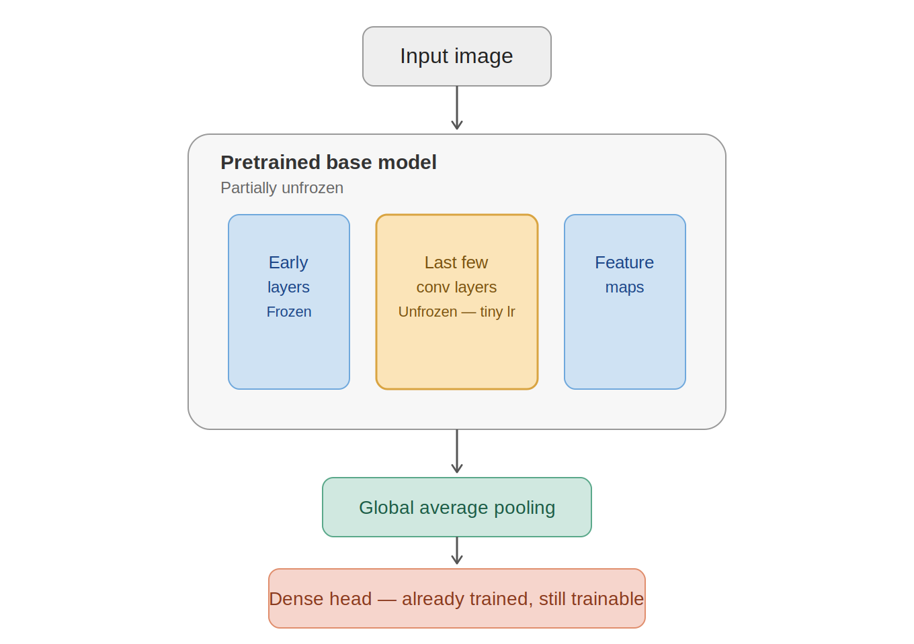
Figure 2: Phase 2 architecture — early layers stay frozen, last few conv layers unfrozen with a tiny learning rate

What changes from Phase 1
Phase 2 builds on the model trained in Phase 1. Instead of keeping the entire base frozen, the last few convolutional layers are unfrozen and trained together with the already-trained dense head, using a much smaller learning rate.
A tiny learning rate is essential here: the pretrained weights are already good, and large updates at this stage would wipe out that learned knowledge — this is called catastrophic forgetting.

Phase 1 vs Phase 2
Aspect | Phase 1 | Phase 2
base_model.trainable | False — entire base frozen | True, but only last N layers actually trainable; rest re-frozen
Learning rate | 0.001 (normal) | 1e-5 (about 100x smaller)
What trains | Only the new dense head | Dense head + last few conv layers

Real-world usage
In practice, both phases are used together — Phase 1 first to stabilize the new head, then Phase 2 to carefully fine-tune. Starting directly with Phase 2 (unfreezing without Phase 1 first) is rare, because the new head is randomly initialized; training it together with an unfrozen base right away sends large gradients through the pretrained network and can damage it quickly.

Callbacks
Callbacks are functions that trigger automatically during training, typically after every epoch, to monitor and control the training process.

EarlyStopping
Stops training automatically once the validation loss stops improving, so epochs are not wasted once the model starts overfitting.

ModelCheckpoint
Continuously saves the best-performing model to disk during training, so the best version is preserved even if training later overfits or crashes.
Callbacks don't change the training loop itself — they simply plug into it, and can be used in both Phase 1 and Phase 2.

Data Augmentation
Transfer learning datasets are often small, which makes overfitting likely (high training accuracy, low validation accuracy). Data augmentation creates artificial variety in the training images — rotation, flipping, zooming, cropping — so the model doesn't see the exact same image repeatedly.
An augmentation layer placed right after the input behaves like BatchNorm in terms of mode-awareness: it applies random transformations during training, but passes images through unchanged during evaluation and prediction.

