EKOS
Enterprise Knowledge Operating System
An IR-First Enterprise Knowledge Discovery and Integrity Platform
Information Retrieval Course Project — Technical Report
Fictional dataset: Aurelia Technologies (~2,000 employees)
September 2026

Abstract
EKOS is a prototype enterprise knowledge platform that goes beyond document retrieval to address knowledge fragmentation and integrity in organizational documentation. Built over a fictional 2,000-employee company (Aurelia Technologies), the system combines a four-system information retrieval pipeline (BM25, dense/LSA retrieval, Reciprocal Rank Fusion hybrid, and reranking), a rule-based knowledge graph (34 entities, 73 relationships extracted from document metadata and cross-references), and a four-detector integrity engine (outdated-version detection, duplicate detection, contradiction detection, and definition-conflict detection). Every component is evaluated against hand-labeled ground truth, and every reported result — including two honest negative findings in the integrity engine — is backed by an investigation into why, not just a pass/fail number. The system is fully functional end to end: a FastAPI backend and a React frontend both run against real data with no mocked responses anywhere in the demonstration path.

1. Problem Statement
Modern organizations do not suffer from a shortage of information; they suffer from fragmentation and integrity decay in the information they already have. The same policy fact is often restated across an employee handbook, a formal policy document, and informal notes. Over time, documents are superseded but not retired, departments define shared terms differently, and outdated guidance continues to be cited as though it were current. Conventional enterprise search retrieves documents that match a query, but does not tell the user which of several matching sources is authoritative, whether two matching sources actually contradict each other, or whether the top result has since been superseded.
EKOS is a prototype designed to answer four questions a search box alone cannot: where is the relevant knowledge, how relevant is it, how is it connected to other knowledge in the organization, and can it be trusted — is it current, and does it conflict with anything else the organization has on record.

2. System Overview
The system pipeline runs from raw markdown documents through chunking, dual lexical/semantic indexing, hybrid retrieval and reranking, into a knowledge graph and a four-detector integrity engine, all backed by a single SQLite database and exposed through a FastAPI backend consumed by a React frontend.
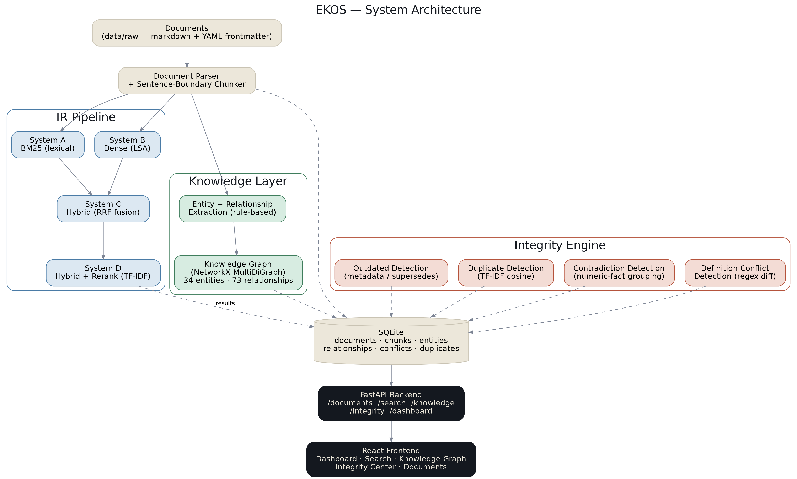
Figure 1. EKOS system architecture.

3. Dataset and Ground Truth
The evaluation corpus is a hand-authored, fictional enterprise knowledge base for “Aurelia Technologies,” spanning HR, IT-Security, Finance, Engineering, and Projects. It comprises 21 documents (24 chunks after sentence-boundary chunking, three documents long enough to split into two chunks each), deliberately engineered to contain known cases rather than being generated at random:
- 2 near-duplicate passage pairs (paraphrased, not verbatim)
- 2 factual contradictions between currently-valid sources
- 2 outdated/superseded document version pairs
- 1 cross-department conflicting-definition case
A separate ground-truth layer (data/ground_truth/) records exactly which chunks belong to each case, plus an 18-query evaluation set with hand-labeled relevant chunks for retrieval evaluation. A resolver script maps these hand-authored references to real chunk IDs after ingestion, and this mapping is verified byte-exact against the actual chunked text by an automated test — catching, during development, several snippet/text mismatches before they could silently invalidate the evaluation.

4. Information Retrieval Pipeline and Evaluation

4.1 Pipeline
Documents are parsed from markdown with YAML frontmatter, cleaned, and split into ~220-token chunks with one-sentence overlap at chunk boundaries. Four retrieval systems are built and evaluated on identical ground truth:
- System A — BM25 (rank_bm25.BM25Okapi) over tokenized chunk text.
- System B — Dense retrieval via Latent Semantic Analysis (TF-IDF + TruncatedSVD), indexed with a FAISS flat inner-product index over L2-normalized vectors.
- System C — Hybrid retrieval: BM25 and dense candidate lists fused with Reciprocal Rank Fusion (RRF), chosen because it operates purely on rank rather than raw score, needing no cross-method score normalization and no tuned weight to overfit an 18-query evaluation set.
- System D — Hybrid + Rerank: the fused candidate pool rescored by a per-query TF-IDF cosine reranker.
Systems B and D use no-network fallback implementations (LSA in place of a sentence-transformer encoder; TF-IDF cosine in place of a trained cross-encoder) because the development environment could not reach the Hugging Face Hub to download pretrained model weights. Both are implemented behind an abstract interface (ir/embeddings/, ir/reranking/) so a real sentence-transformers encoder and cross-encoder reranker can be substituted with a one-line configuration change once running with internet access.

4.2 Evaluation Methodology
All four systems are evaluated on the same 18-query set using Precision@K, Recall@K, MRR, and nDCG@K, computed from a from-scratch metrics implementation that is itself unit-tested against hand-calculated values before being trusted for the real evaluation run.
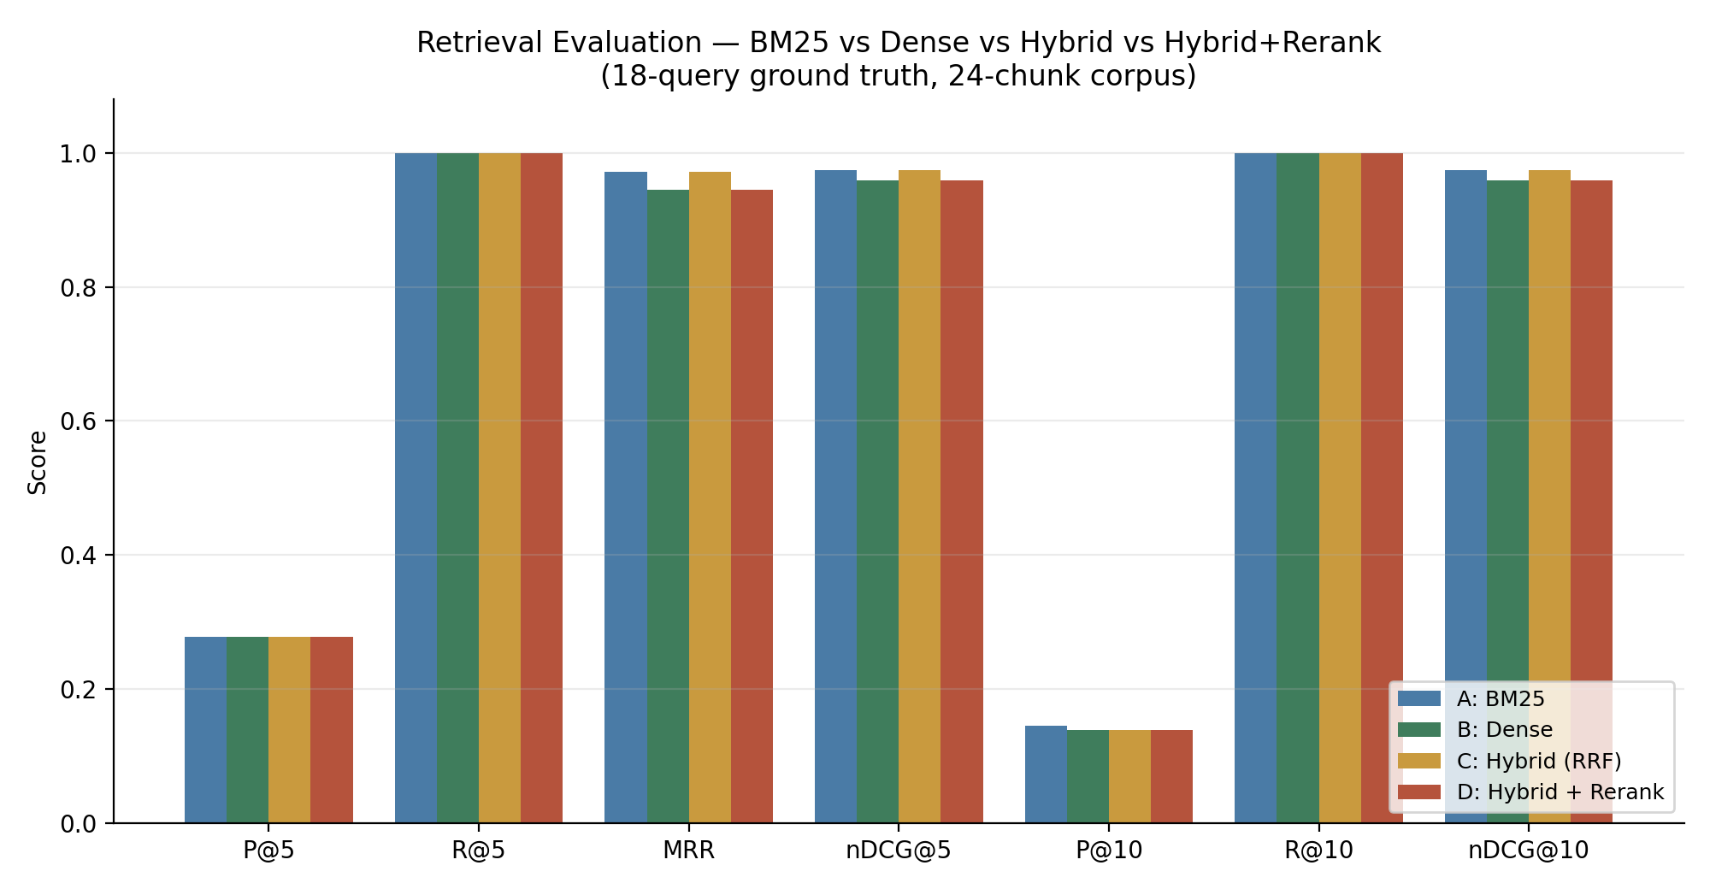
Figure 2. Retrieval evaluation across all four systems.
System | P@5 | R@5 | MRR | nDCG@5 | P@10 | R@10 | nDCG@10
A: BM25 | 0.278 | 1.000 | 0.972 | 0.975 | 0.144 | 1.000 | 0.975
B: Dense (LSA) | 0.278 | 1.000 | 0.944 | 0.959 | 0.139 | 1.000 | 0.959
C: Hybrid (RRF) | 0.278 | 1.000 | 0.972 | 0.975 | 0.139 | 1.000 | 0.975
D: Hybrid + Rerank | 0.278 | 1.000 | 0.944 | 0.959 | 0.139 | 1.000 | 0.959
Table 1. Full retrieval evaluation results.

4.3 Honest Findings
Recall@5/10 = 1.000 across every system is a property of the evaluation set — the 18 queries were authored as close paraphrases of a 24-chunk corpus — rather than evidence that any system is unusually strong. This is stated explicitly rather than presented as a stronger result than it is.
System D scores at or below System C on every metric. This was traced to a specific case rather than dismissed as noise: for the query “What is the company's reimbursement limit for expenses?”, Hybrid RRF ranks the current Expense Policy (v2) fractionally above its superseded predecessor (v1), since their text is nearly identical apart from the dollar figure. The TF-IDF reranker, which has no authority or recency signal, reverses that order. This is not a defect in the reranking mechanism — it is the expected result of reranking on lexical similarity alone when two candidates are near-duplicates differing mainly in a fact that changed between versions. It directly motivates the planned metadata-authority ranking boost and the integrity engine's outdated-detection component (Section 6).

5. Knowledge Graph
Rather than a trained NER pipeline, entities and relationships are extracted from structured metadata already present in each document (department, owner, author, supersession links) plus a rule-based text-reference detector that scans document bodies for other documents' titles. This achieves precision by construction for the metadata-derived relations (owned_by, belongs_to, created_by, supersedes, applies_to, confidence 1.0) and near-precision for text-detected references (confidence 0.9), at the cost of coverage compared to a full LLM-based extractor.
The resulting graph (34 entities: documents, departments, people, and a synthetic “Employees” group; 73 relationships) was validated by manual inspection against the source text rather than trusted on sight. This caught four real defects before they shipped:
- A plain directed graph silently collapses two different relation types between the same node pair into one edge (a department-owned SOP is both owned_by and applies_to the same department) — fixed by switching to a multigraph.
- Two document versions sharing an identical title caused a document's own heading to spuriously “match” its sibling version, producing a nonsensical backward-in-time reference (the older version appearing to reference the newer one).
- A target title that is a literal substring of the source document's own title (“Leave Policy” inside “Parental Leave Policy”) produced the same class of false match.
- Hard line-wraps in the source markdown defeated naive substring matching until body text was whitespace-normalized — this one was a genuine miss, not just a false positive, until fixed.
All four are now covered by regression tests. The API supports a neighborhood query (GET /knowledge/graph?entity_name=...) that reproduces the exact interactive-exploration scenario described in the project brief: searching a policy surfaces its owning department, its applies-to scope, cross-referenced related policies, and any superseded prior version.

6. Integrity Engine
Four rule-based detectors, chosen and scoped around the same network constraint that shaped the retrieval fallbacks (no access to a hosted LLM or embedding model in the development environment). Each detector's output was validated against the hand-labeled ground truth before being trusted.
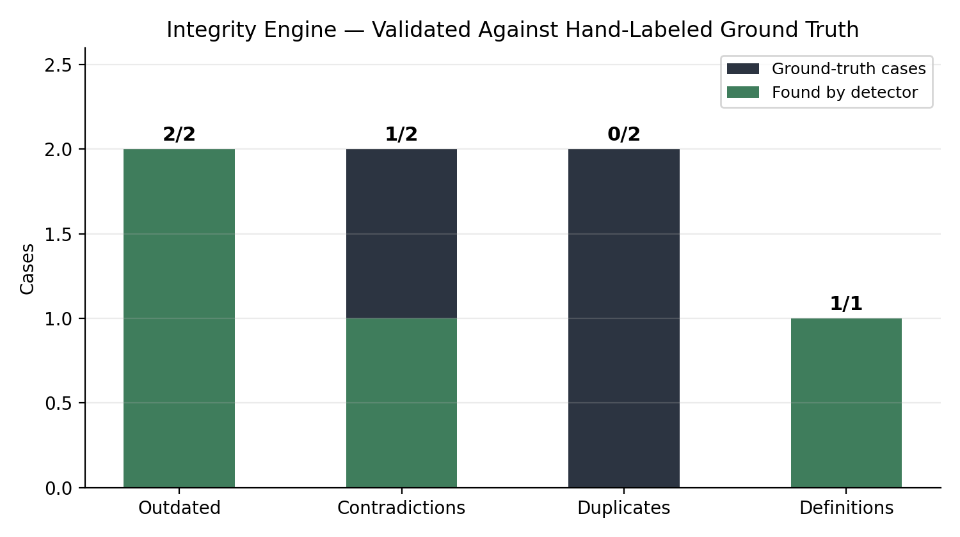
Figure 3. Integrity engine results against ground truth.

6.1 Outdated Detection — 2/2
Purely metadata-driven: walks the supersedes_doc_key chain captured at ingestion. This is not an evaluation of a detection technique so much as a confirmation that the metadata pipeline is wired correctly — included for completeness.

6.2 Contradiction Detection — 1/2
Implemented as numeric-fact extraction (regex for value, unit, and local context, e.g. “changed every 90 days”) grouped by concept across chunks from different, non-superseding documents; a group with two or more distinct values is a candidate contradiction, resolved by document authority level. This cleanly finds the password-expiration contradiction (90 vs. 180 days) with zero false positives across the corpus, and correctly resolves it in favor of the higher-authority source.
It misses the production-database-access contradiction by design: that case is a qualitative disagreement about an approval rule, not a numeric fact, and this fallback detector has no mechanism to compare two policy statements semantically. Before settling on numeric-fact grouping, whole-chunk similarity (both LSA and TF-IDF cosine) was tested as a candidate-pair generator and found unreliable here — the true contradiction pair scores only 0.106 cosine similarity, lower than numerous unrelated pairs, because the source document is multi-topic and the shared concept is diluted across the whole-chunk vector.

6.3 Duplicate Detection — 0/2
The most important honest finding in this project. Both labeled duplicate pairs were checked against every cross-document chunk pair in the corpus: the true duplicates score 0.14–0.18 cosine similarity, lower than several unrelated same-topic pairs in the corpus (0.27–0.31). No threshold value separates the true duplicates from noise with either LSA or plain TF-IDF. This is because the two labeled cases are genuine paraphrases (“submit leave requests at least 48 hours before” vs. “should be submitted two days before”) sharing the underlying fact but little surface vocabulary — exactly the case bag-of-words methods are weakest at, and exactly what a trained sentence-embedding model is designed to solve. The threshold was deliberately not lowered to force a pass on two examples, which would have been overfitting rather than detection; the limitation is documented and left honest instead.

6.4 Definition Conflict Detection — 1/1
Regex extraction of “X is defined as Y” / “X means Y” statements, grouped by term and flagged when two departments define the same term with low word overlap. Correctly finds the Finance-vs-Marketing “Customer” definition conflict with zero false positives, and is deliberately not resolved via authority ranking — unlike a contradiction, two departments legitimately using a term differently for their own reporting purposes is not necessarily an error.

7. Frontend
A React and Vite single-page application with six views — Dashboard, Search, Knowledge Graph, Integrity Center, Documents, and Document Detail — consuming the live backend with no mocked data anywhere. The signature interface element is the “Conflict Card”: a redline-style two-source diff with an authority-based verdict line, used on both the Dashboard and the Integrity Center to make the system's core thesis — knowing which source to trust — visually concrete rather than just returning a ranked list.
The frontend was verified against the running backend with browser automation rather than assumed correct from source review, which caught and fixed two real defects: a rendering bug where full definition-conflict sentences displayed inside a numeric-fact callout designed for short values like “90 days,” and a complete lack of mobile responsiveness in the initial layout (the fixed-width sidebar consumed most of a 390px viewport). Both were fixed and re-verified with the same screenshot-based process.

8. Integration and Robustness
Beyond per-component testing, the system was deliberately stress-tested for integration gaps: a completely fresh install with no build scripts run, the frontend running against a backend that returns errors, and navigation to invalid routes and document IDs. Every case was confirmed to degrade gracefully — honest empty states, clear actionable error messages, and no unhandled exceptions — rather than assumed to work because the individual pieces were tested in isolation.

9. Limitations and Future Work
- The dense encoder and reranker run on no-network fallbacks (LSA, TF-IDF) rather than the sentence-transformers models originally planned, due to a development-environment network constraint. Both are swappable via a one-line configuration change; re-running the full evaluation and integrity engine with real embeddings, once available, is the highest-value next step and may materially change both the retrieval comparison and the duplicate/contradiction detection results.
- Contradiction detection is limited to numeric-value disagreements; qualitative contradictions require semantic/NLI-style reasoning, planned as an LLM-assisted step in the original architecture but not implemented here for the same network-access reason.
- The evaluation corpus (24 chunks, 18 queries) is intentionally small and controlled for a course project; retrieval recall is saturated at 1.000 across all systems, and a larger, harder query set would produce more discriminating results between systems.
- No authentication is implemented on any API endpoint; this is a documented, intentional scope cut for a prototype, with a JWT/role-based-access design sketch left for future work rather than built.
- The frontend has no automated test suite; correctness was established via manual and browser-automation verification rather than a CI-enforced test pipeline.

10. Conclusion
EKOS demonstrates that a hybrid lexical/semantic retrieval pipeline, layered with a rule-based knowledge graph and a validated integrity engine, can surface not just relevant documents but the organizational context — authority, currency, and conflict — that a conventional search system omits. Every component in this report is backed by a real, reproducible evaluation run rather than an assumed result, and every limitation is disclosed with the investigation behind it rather than left implicit. The clearest evidence for the project's own thesis may be its most honest finding: the integrity engine's 0/2 result on paraphrased duplicate detection is not a failure of the system design, but a precise, validated demonstration of exactly where lexical methods stop being sufficient and semantic understanding becomes necessary — which is the same problem EKOS exists to solve for an organization's documentation in the first place.

Repository: see README.md for setup instructions, docs/architecture.md for the full phase-by-phase development log, evaluation/FINDINGS.md and integrity/FINDINGS.md for the complete honest results write-ups referenced throughout this report.

