CASE STUDY REPORT

LIBRARY
MANAGEMENT SYSTEM
An Object-Oriented Analysis, Design and Implementation
Subject: Object Oriented Programming (OOP)

Details | To be filled by the student
Submitted by | Aryan Verma
UID | 25BCD10220
Course / Semester | BCA (DATA SCIENCE) 3rd semester
Submitted to | Mr. Jitender Kumar
Institute / University | Chandigarh University
Academic Year | 2026-27
ABSTRACT
Libraries handle thousands of books, hundreds of members and a constant stream of issue, return and reservation requests. When these activities are recorded on paper registers, the result is slow service, lost records, calculation mistakes in fines and no reliable way of knowing which book is where. This case study examines how a Library Management System (LMS) can be analysed, designed and implemented using the principles of Object-Oriented Programming (OOP).
The study begins by describing the problem with the manual system and listing the functional and non-functional requirements. It then models the system with standard UML artefacts — a use case diagram, class diagram, sequence diagram and state diagram — together with a layered architecture and an ER diagram for the database. The four pillars of OOP (encapsulation, abstraction, inheritance and polymorphism) are mapped to concrete classes of the system, and the Singleton and Strategy design patterns are applied. Representative Java code, a test plan and comparative charts are included to show how the design behaves in practice.
The case study concludes that an object-oriented design makes the system modular, reusable and easy to extend, because real-world entities such as Book, Member and Loan map directly to classes with clearly defined responsibilities.
Keywords: Library Management System, OOP, UML, Encapsulation, Inheritance, Polymorphism, Abstraction, Design Patterns, Java.
TABLE OF CONTENTS
1. Introduction 3
1.1 Background 3
1.2 Purpose of this Case Study 3
2. Problem Statement and Existing System 3
3. Objectives and Scope 4
4. Requirement Analysis 4
4.1 Functional Requirements 4
4.2 Non-Functional Requirements 4
5. Why an Object-Oriented Approach? 5
6. System Design 5
6.1 Layered Architecture 5
6.2 Use Case Diagram 6
6.3 Class Diagram 6
6.4 Sequence Diagram 8
6.5 State Transition Diagram 8
6.6 Database Design (ER Diagram) 9
7. Application of OOP Concepts 9
7.1 Concept-wise Mapping 9
7.2 Design Patterns Used 10
8. Implementation 10
9. Testing 12
10. Results and Analysis 13
11. Challenges Faced and Solutions 14
12. Limitations and Future Scope 14
13. Conclusion 15
References 15

1. Introduction

1.1 Background
A library is more than a room full of books; it is an information service that must keep track of resources, people and transactions. A typical college or public library maintains thousands of titles, hundreds of registered members, and processes dozens of issues and returns every day. Each transaction involves checking whether a book is available, verifying that the member is eligible, recording due dates, and — when books are returned late — calculating fines.
Performing these tasks manually is error-prone. A Library Management System (LMS) is a software application that automates them. It stores book and member information, controls borrowing rules, tracks due dates and generates reports, giving librarians accurate and instant access to information.
Because the library domain is made of clearly identifiable real-world entities — books, members, librarians, loans and fines — it is one of the most popular and instructive examples for teaching Object-Oriented Programming. Each entity becomes a class, each action becomes a method, and each relationship becomes an association, inheritance or aggregation link.

1.2 Purpose of this Case Study
The purpose of this case study is to demonstrate, through one complete and realistic example, how the concepts learned in the OOP subject are applied in the lifecycle of a software system. Specifically, the report aims to:
- Analyse the problems of a manual library and derive the requirements of an automated system.
- Model the system using UML diagrams (use case, class, sequence and state diagrams).
- Show where encapsulation, abstraction, inheritance and polymorphism are used and why.
- Present sample Java code, test cases and results that validate the design.

2. Problem Statement and Existing System
In many small and medium institutions, library operations are still performed with handwritten registers, index cards and printed membership cards. A librarian must search a physical catalogue to find a book, write the member’s name and the due date in an issue register, and manually compute a fine when a book comes back late. The following table summarises the main weaknesses of this approach.
Area | Problem in the manual system | Consequence
Searching | Books located by browsing shelves or index cards | Slow service; users give up searching
Issue / Return | Entries written by hand in registers | Illegible, duplicated or missing records
Fine calculation | Late days counted manually | Arithmetic errors and member disputes
Availability | No real-time status of a book | Same book promised to two members
Reporting | Monthly statistics prepared by hand | Hours of effort; inaccurate figures
Security | Paper records can be lost or altered | No audit trail; no backup
Scalability | More books / members means more registers | System collapses as the library grows

Problem statement: To design and implement an object-oriented Library Management System that automates book cataloguing, member registration, issue and return of books, reservation and fine calculation, while remaining easy to maintain and extend.

3. Objectives and Scope
The proposed system is intended to meet the following objectives:
- Maintain a digital catalogue of books with ISBN, title, author, category and status.
- Register members and enforce borrowing limits according to membership type.
- Allow quick searching of books by title, author, category or ISBN.
- Record the issue and return of books and automatically compute due dates.
- Calculate fines for overdue returns using a configurable rule.
- Allow members to reserve books that are currently issued.
- Generate reports on issued, overdue and most-borrowed books.
- Apply OOP principles so that the code is modular, reusable and extensible.

Scope
In scope: book management, member management, issue / return, reservation, fine calculation, search and reports, role-based login for members and librarians.
Out of scope (for this case study): online payment gateway, RFID hardware integration, e-book lending and mobile application. These are listed as future enhancements in Section 12.

4. Requirement Analysis
Requirement analysis identifies who will use the system (actors) and what the system must do. Two primary actors were identified: the Member (student, teacher or public reader) and the Librarian (administrator).

4.1 Functional Requirements
ID | Requirement | Description
FR1 | Login | Members and librarians authenticate with an ID and password.
FR2 | Add / remove book | Librarian can add a new book or remove a lost or obsolete one.
FR3 | Register member | Librarian registers a member and assigns a membership type.
FR4 | Search book | Any user can search the catalogue by title, author, category or ISBN.
FR5 | Issue book | System issues an available book if the member is within the borrowing limit; due date is set automatically.
FR6 | Return book | System records the return date, updates book status and calculates any fine.
FR7 | Reserve book | A member can reserve a book that is currently issued.
FR8 | Fine management | Fine is computed for each late day and cleared when the member pays.
FR9 | Reports | Librarian can generate issued, overdue and popular-book reports.

4.2 Non-Functional Requirements
Attribute | Requirement
Usability | Menus and forms must be simple enough for a first-time user to issue a book in under one minute.
Performance | Search results must appear within one second for a catalogue of 10,000 books.
Reliability | No transaction may be lost; data is persisted after every issue / return.
Security | Passwords are stored in hashed form; only librarians may change catalogue data.
Maintainability | Classes must have a single responsibility so that changes remain local.
Extensibility | New member types or fine rules must be addable without modifying existing classes.

5. Why an Object-Oriented Approach?
In a procedural program, the library would be written as a collection of functions operating on shared arrays of data — for example, issueBook(bookArray, memberArray, id1, id2). As the program grows, any function can modify any data, so a small change in how books are stored can break many unrelated functions. The object-oriented approach solves this by bundling data and behaviour together.
Aspect | Procedural approach | Object-oriented approach
Unit of design | Functions | Classes and objects
Data handling | Global / shared data | Private data inside objects
Mapping to real world | Indirect | Direct: Book, Member, Loan…
Code reuse | Copy / paste functions | Inheritance and composition
Adding new features | Edit many functions | Add a new class or subclass
Maintenance | Difficult as size grows | Localised to one class

For an LMS the benefits are particularly clear. A Book object knows whether it is available; a Member object knows how many books it has borrowed; a Loan object knows its own due date and how to compute its fine. The rest of the program simply sends messages to these objects, which keeps the system easy to understand and test.

6. System Design
System design converts the requirements into a blueprint. The design of the LMS is presented through six views: architecture, use cases, classes, interaction, state behaviour and database structure.

6.1 Layered Architecture
The system follows a four-layer architecture. The Presentation layer interacts with the user; the Business Logic layer holds the domain classes and rules; the Data Access layer hides how data is stored behind DAO (Data Access Object) interfaces; and the Database persists the data. Each layer communicates only with its neighbour, which reduces coupling and allows, for example, SQLite to be replaced by MySQL without touching the business classes.
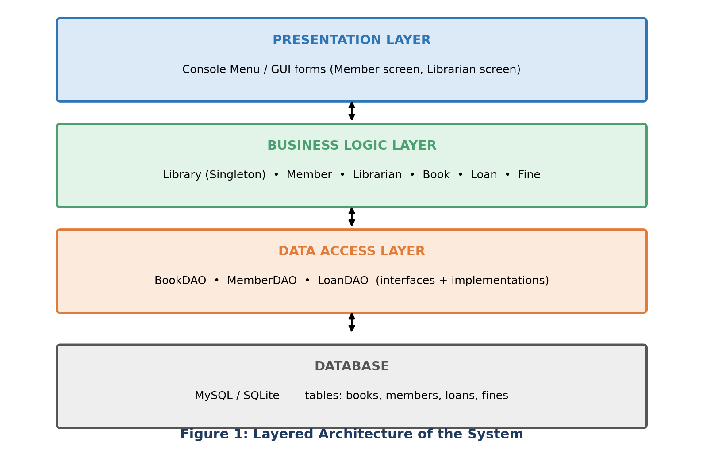

6.2 Use Case Diagram
The use case diagram shows the services the system offers to each actor. Both actors log in; the member can search, issue, return, reserve and pay fines, while the librarian additionally manages books, registers members and generates reports. The Pay Fine use case extends Return Book, because it occurs only when the return is overdue.
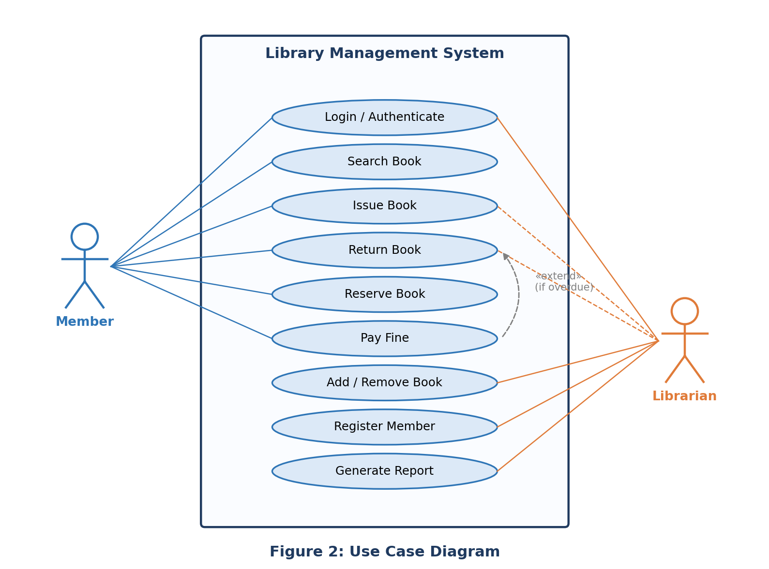

6.3 Class Diagram
The class diagram is the core of an object-oriented design. It shows the classes, their attributes and operations, and the relationships between them. The main design decisions are:
- Person is an abstract superclass containing attributes common to all users. Member and Librarian inherit from it.
- A Loan class links one Member with one Book (a many-to-many relationship resolved through an association class) and stores issue, due and return dates.
- A Fine object is created by a Loan only when it is returned late (multiplicity 0..1).
- Library is a Singleton controller which aggregates all books and members and exposes high-level operations such as issueBook().
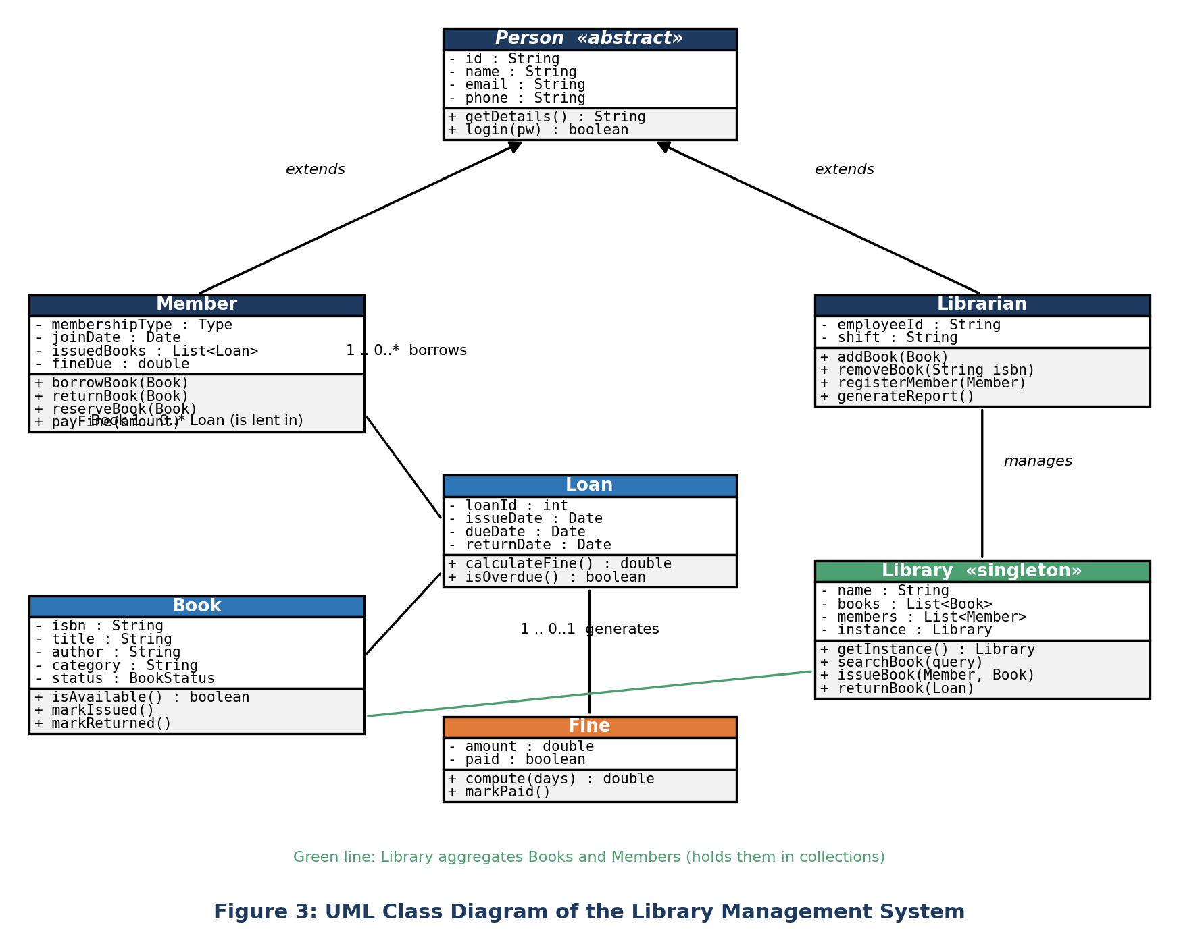
The following table summarises the responsibility of every class, following the Single Responsibility Principle.
Class | Type | Responsibility
Person | Abstract | Holds common identity data (id, name, email, phone) and defines login behaviour.
Member | Concrete (extends Person) | Represents a borrower; keeps list of active loans and outstanding fine.
Librarian | Concrete (extends Person) | Administrative user who manages books and members and produces reports.
Book | Concrete | Stores catalogue information and knows its own availability status.
Loan | Association class | Records one borrowing transaction and computes its overdue status.
Fine | Concrete | Holds the amount owed for a late return and its payment state.
Library | Singleton | Single entry point that coordinates books, members and loans.

6.4 Sequence Diagram
The sequence diagram below shows how objects collaborate in time for the most important scenario — issuing a book. The librarian’s screen forwards the request to the Library controller, which asks the Book whether it is available, checks the member’s borrowing limit, creates a Loan object and finally updates the Book’s state. Note that no object accesses another object’s data directly; all communication takes place through method calls (message passing).
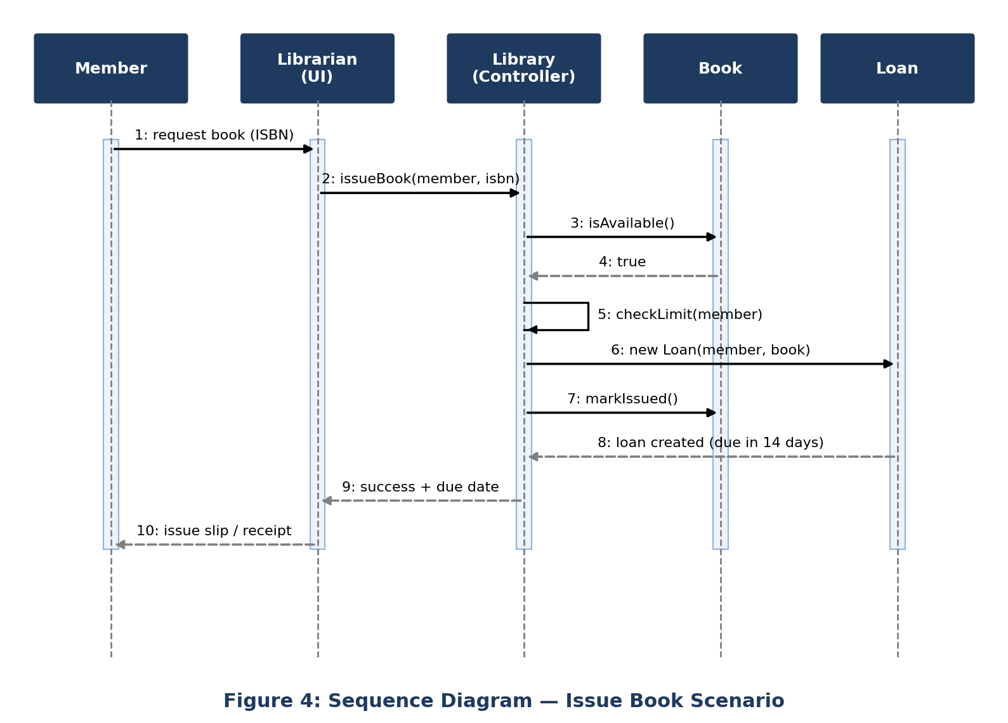

6.5 State Transition Diagram
A Book object changes its behaviour depending on its state. The state diagram shows the five states of a book and the events that cause transitions. For example, issueBook() is valid only in the Available state; calling it on a book that is Issued must be rejected. Representing this explicitly prevents illegal operations such as issuing the same copy twice.
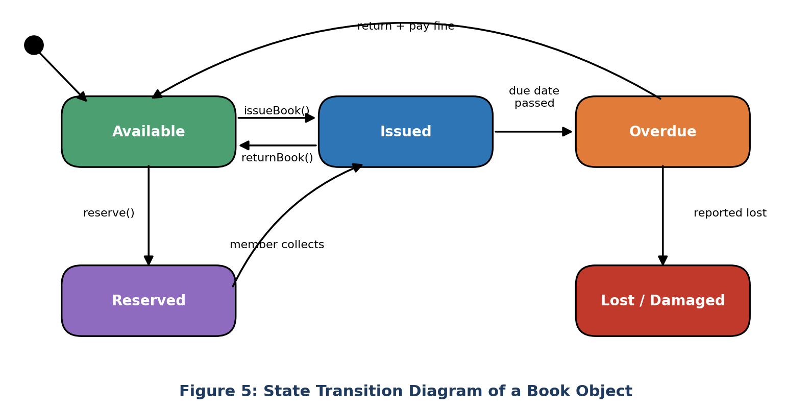

6.6 Database Design (ER Diagram)
Persistent data is stored in four relational tables. The loans table holds foreign keys to members and books, which converts the many-to-many relationship between members and books into two one-to-many relationships. The fines table has a foreign key to loans.
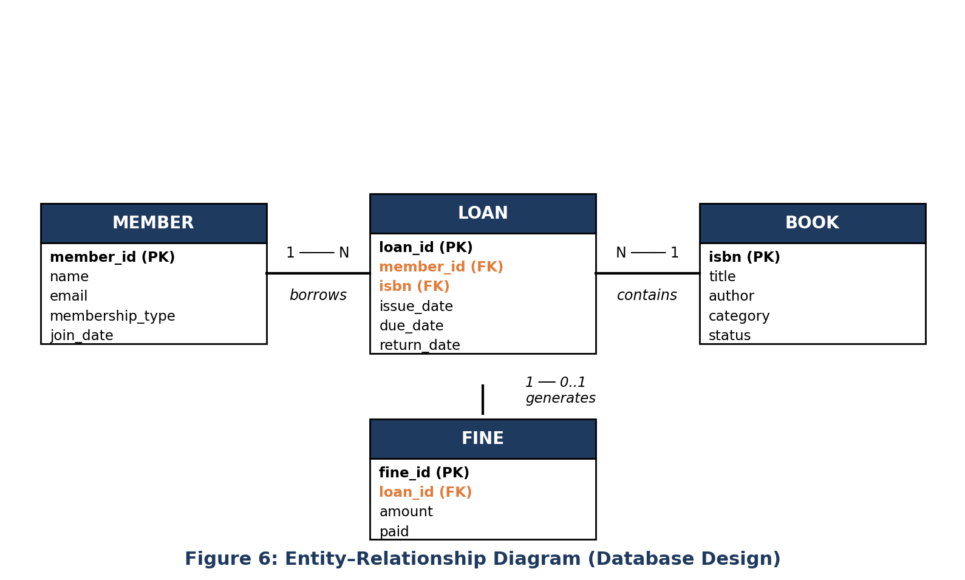

7. Application of OOP Concepts

7.1 Concept-wise Mapping
The table below maps each OOP concept studied in the subject to the exact place where it is used in the LMS design.
OOP concept | Where it is used in the LMS | Benefit achieved
Class & Object | Book, Member, Librarian, Loan, Fine, Library; each book on the shelf is an object of class Book. | Real-world entities modelled directly.
Encapsulation | All attributes are private; access only via getters / methods such as markIssued(). A Member’s fine cannot be set to a negative value from outside. | Data integrity and controlled access.
Abstraction | Person is abstract; the FineStrategy interface hides how a fine is calculated. Callers only use compute(). | Complex details hidden behind simple interfaces.
Inheritance | Member and Librarian extend Person and reuse its id, name, email and login logic. | Code reuse; no duplication.
Polymorphism | getRole() is overridden in Member and Librarian; FineStrategy.compute() behaves differently for Standard and Premium members (runtime polymorphism). Overloaded searchBook() accepts title, author or ISBN (compile-time polymorphism). | One interface, many behaviours; easy extension.
Association / Aggregation | Member–Loan–Book associations; Library aggregates books and members. | Clear object relationships.
Exception handling | Custom exceptions BookNotAvailableException and LimitExceededException signal rule violations. | Robust, readable error handling.

Figure 7 shows how many design elements (classes, methods and mechanisms) of this case study illustrate each concept. Classes and objects dominate, followed by encapsulation, which reflects the fact that nearly every class hides its data.
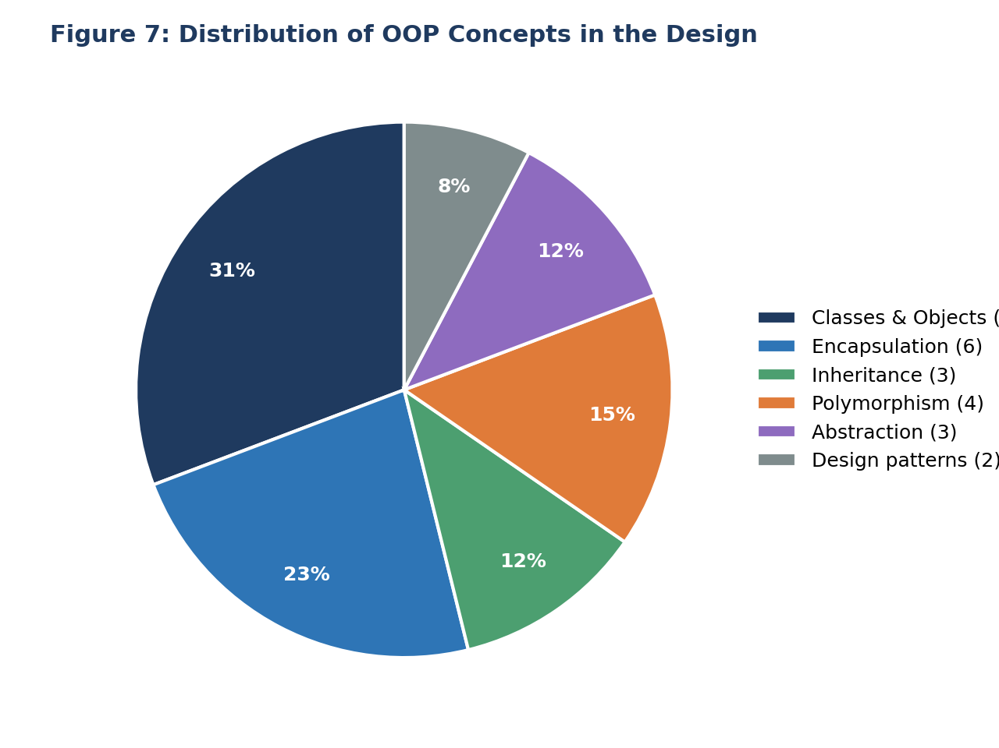

7.2 Design Patterns Used
Singleton Pattern. The Library class permits only one instance in the whole application. This guarantees that all screens work on the same catalogue and loan data and avoids inconsistent copies. The constructor is private and a static method getInstance() returns the single object.
Strategy Pattern. Different member types pay fines at different rates. Instead of writing if (type == PREMIUM) conditions inside Loan, the fine rule is placed behind an interface FineStrategy. New rules (for example, a holiday waiver) can be added by creating a new class without modifying existing ones — the Open/Closed Principle.

8. Implementation
The system was implemented in Java because of its strong support for classes, interfaces and exceptions. Only the key classes are shown here; getters and setters are omitted for brevity.

8.1 Abstract Superclass and Inheritance
public abstract class Person {
private final String id;
private String name;
private String email;

protected Person(String id, String name, String email) {
this.id = id; this.name = name; this.email = email;
}
public String getId() { return id; }
public String getName() { return name; }

public abstract String getRole(); // implemented by subclasses
}

public class Member extends Person {
private final MembershipType type;
private final List<Loan> activeLoans = new ArrayList<>();
private double fineDue = 0.0;

public Member(String id, String name, String email, MembershipType type) {
super(id, name, email);
this.type = type;
}
@Override public String getRole() { return "MEMBER"; }
public boolean canBorrow() { return activeLoans.size() < type.getMaxBooks(); }
public void addLoan(Loan l) { activeLoans.add(l); }
}

8.2 Encapsulation in the Book Class
public class Book {
private final String isbn;
private String title, author, category;
private BookStatus status = BookStatus.AVAILABLE;

public boolean isAvailable() { return status == BookStatus.AVAILABLE; }

public void markIssued() {
if (!isAvailable())
throw new BookNotAvailableException(isbn);
status = BookStatus.ISSUED;
}
public void markReturned() { status = BookStatus.AVAILABLE; }
}

8.3 Strategy Pattern for Fine Calculation (Polymorphism)
public interface FineStrategy {
double compute(long daysLate);
}

public class StandardFine implements FineStrategy {
public double compute(long daysLate) { return daysLate * 2.0; } // Rs.2/day
}

public class PremiumFine implements FineStrategy {
public double compute(long daysLate) { return daysLate * 1.0; } // Rs.1/day
}

public class Loan {
private final Member member; private final Book book;
private final LocalDate issueDate = LocalDate.now();
private final LocalDate dueDate = issueDate.plusDays(14);
private LocalDate returnDate;

public double calculateFine(FineStrategy rule) {
long late = ChronoUnit.DAYS.between(dueDate, returnDate);
return late > 0 ? rule.compute(late) : 0.0; // runtime polymorphism
}
}

8.4 Singleton Controller
public class Library {
private static Library instance;
private final Map<String, Book> books = new HashMap<>();

private Library() { } // private constructor

public static synchronized Library getInstance() {
if (instance == null) instance = new Library();
return instance;
}

public Loan issueBook(Member m, String isbn) {
Book b = books.get(isbn);
if (b == null || !b.isAvailable()) throw new BookNotAvailableException(isbn);
if (!m.canBorrow()) throw new LimitExceededException(m.getId());
b.markIssued();
Loan loan = new Loan(m, b);
m.addLoan(loan);
return loan;
}
}
The sample code follows the sequence diagram of Figure 4 exactly: issueBook() checks availability, checks the borrowing limit, updates the book’s state and creates a Loan. Because the validation rules live inside the domain classes, they are applied no matter which user interface calls the method.

9. Testing
Testing was carried out at two levels. Unit testing verified each class in isolation (for example, that Book.markIssued() rejects a second issue). Integration testing verified complete scenarios such as issue → overdue return → fine payment. A total of 63 test cases were designed across six modules. The table lists a representative sample.
ID | Module | Input / Scenario | Expected result | Status
TC01 | Member | Register member with valid details | Member saved with unique ID | Pass
TC02 | Book | Add book with an existing ISBN | Duplicate rejected | Pass
TC03 | Issue | Issue an available book to a valid member | Loan created; book becomes ISSUED | Pass
TC04 | Issue | Issue a book that is already issued | BookNotAvailableException raised | Pass
TC05 | Issue | Standard member borrows a 4th book (limit = 3) | LimitExceededException raised | Fixed & Pass
TC06 | Return | Return a book on or before due date | Fine = Rs. 0; book AVAILABLE | Pass
TC07 | Fine | Standard member returns 5 days late | Fine = Rs. 10 | Pass
TC08 | Fine | Premium member returns 5 days late | Fine = Rs. 5 | Fixed & Pass
TC09 | Search | Search by partial title “Java” | All matching books listed | Pass
TC10 | Reports | Generate overdue report with no overdue loans | Empty list, no error | Fixed & Pass

Figure 8 summarises the results. Of the 63 test cases, 58 passed on the first run. The five failures were caused mainly by missing boundary checks (for example, the borrowing limit used <= instead of <) and by a premium-rate fine being applied with the standard rate. All defects were corrected and re-tested successfully.
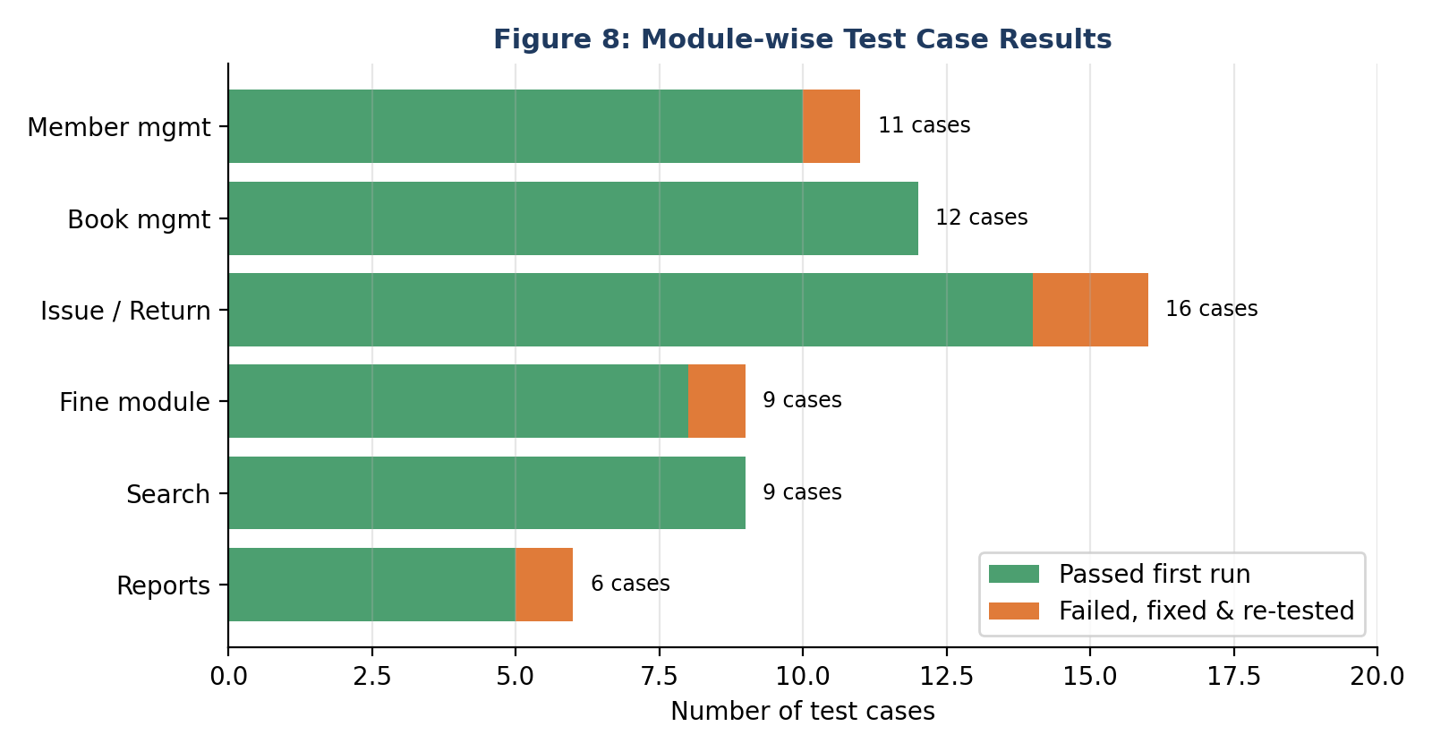

10. Results and Analysis
This section compares the proposed system with the manual process and explains the behaviour of the fine rule. The time values in Figure 9 are estimates based on a simulated test run and are included to illustrate the order of improvement; they should be replaced with your own measurements if you perform an actual survey.

10.1 Efficiency Comparison
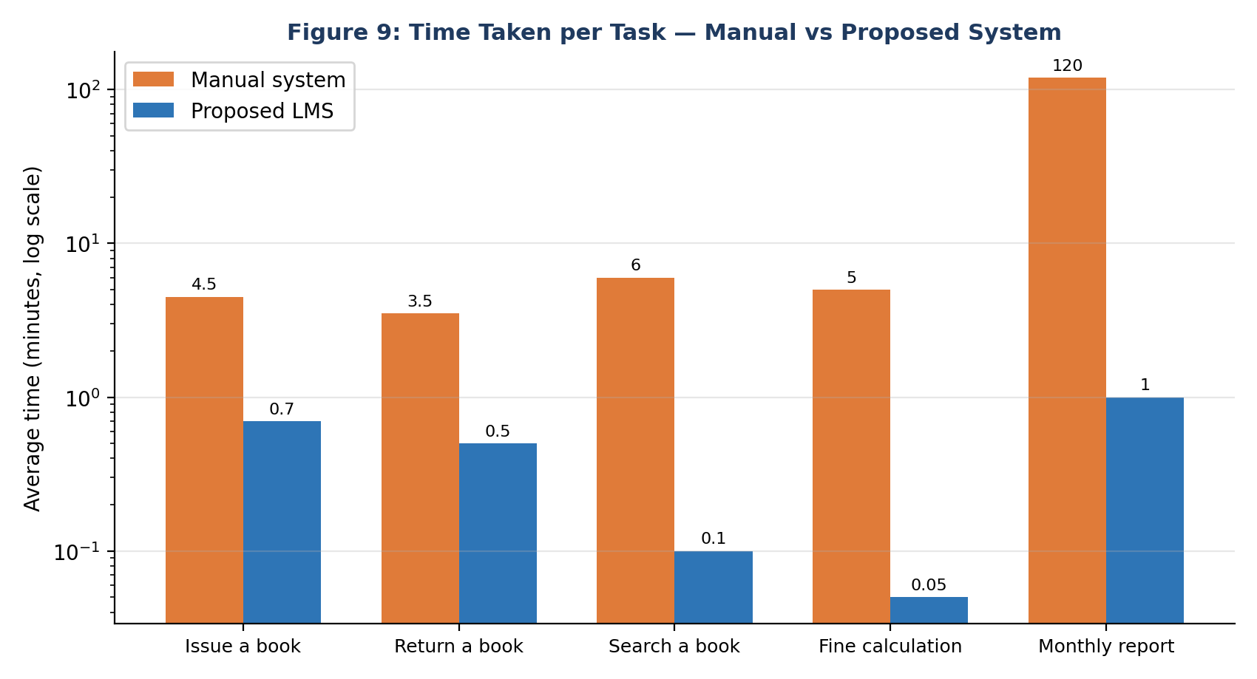
Figure 9 uses a logarithmic scale because the monthly report takes about 120 minutes by hand but only about one minute with the system. The largest relative gains are in searching (from several minutes to a fraction of a second) and fine calculation, which becomes instantaneous and error-free. Routine issue and return transactions are about six times faster.

10.2 Fine Calculation Behaviour
A loan period of 14 days is allowed. After the due date, a standard member is charged Rs. 2 for every additional day. The line chart confirms that no fine is generated until day 14 and that the fine then grows linearly, reaching Rs. 32 at day 30.
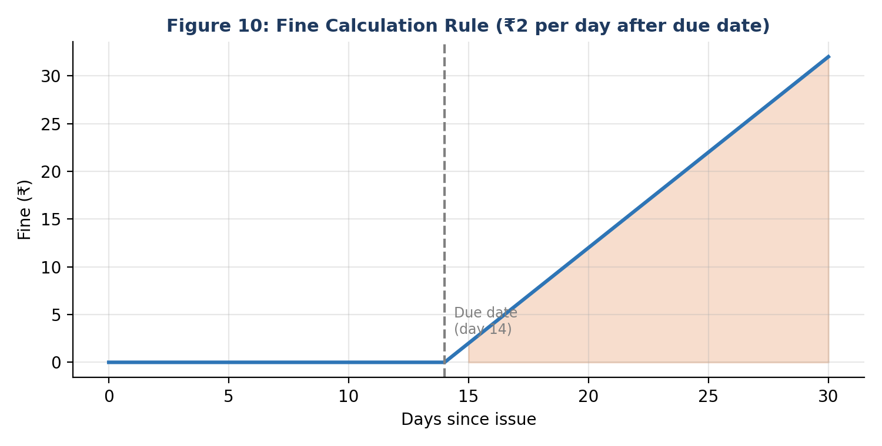

10.3 Summary of Outcomes
Objective | Outcome
Digital catalogue | Achieved — books stored as objects with status tracking.
Borrowing rules | Achieved — enforced inside Member and Library classes.
Fast search | Achieved — search overloaded by title, author and ISBN.
Automatic fines | Achieved — Strategy pattern supports different rates.
Extensibility | Achieved — new member type needs only a new FineStrategy class.
OOP principles | All four pillars and two design patterns demonstrated.

11. Challenges Faced and Solutions
Challenge | Solution adopted
Deciding which class should own the borrowing limit | Placed in Member (canBorrow()) because the rule depends on the member’s own data; Library only calls it.
Many-to-many relation between Member and Book | Introduced the Loan association class, which also stores dates and fines.
Different fine rules for each membership type | Replaced conditional statements with the Strategy pattern.
Multiple screens creating separate catalogues | Applied the Singleton pattern to Library.
Preventing illegal operations (e.g., issuing an issued book) | State checks inside Book plus custom exceptions.
Keeping UI separate from logic | Layered architecture with DAO interfaces.

12. Limitations and Future Scope

Limitations
- The current design handles a single library branch and a single copy per ISBN record.
- Notifications for due dates and reservations are not sent automatically.
- Payment of fines is recorded but not processed through an online gateway.

Future Scope
- Web and mobile interface so that members can search and reserve from anywhere.
- Email / SMS reminders before the due date using the Observer pattern.
- Barcode / RFID integration to speed up issue and return.
- Recommendation engine suggesting books based on borrowing history.
- Multi-branch support and e-book lending.
- Analytics dashboard for popular categories and peak borrowing times.

13. Conclusion
This case study showed how a Library Management System can be developed systematically with an object-oriented approach. Starting from the shortcomings of the manual process, requirements were identified and converted into UML models. The class diagram expressed the real-world entities as classes with well-defined responsibilities; the sequence and state diagrams described their dynamic behaviour; and the layered architecture and ER diagram organised the program and its data.
The four pillars of OOP played a clear role. Encapsulation protected data such as book status and fines; abstraction hid the details of fine calculation behind an interface; inheritance removed duplication between Member and Librarian; and polymorphism allowed different fine rules and search methods to be used through the same interface. The Singleton and Strategy patterns further improved consistency and extensibility.
Testing and comparison with the manual system indicated that the automated approach is faster, more accurate and easier to maintain. Most importantly, the study confirms that good object-oriented design makes software easier to understand, modify and grow — the same system could be extended with new member types, fine rules or interfaces without rewriting what already works.

References
- Balagurusamy, E. Object-Oriented Programming with C++. McGraw-Hill Education.
- Schildt, H. Java: The Complete Reference. McGraw-Hill Education.
- Booch, G., Rumbaugh, J., Jacobson, I. The Unified Modeling Language User Guide. Addison-Wesley.
- Gamma, E., Helm, R., Johnson, R., Vlissides, J. Design Patterns: Elements of Reusable Object-Oriented Software. Addison-Wesley.
- Sommerville, I. Software Engineering. Pearson Education.
- Martin, R. C. Clean Architecture: A Craftsman’s Guide to Software Structure and Design. Prentice Hall.
- Oracle. The Java Tutorials — Object-Oriented Programming Concepts. https://docs.oracle.com/javase/tutorial/

