**Name : Aryan Mundra**

**Roll No : 19102B0053**

**Branch/Div : CMPN/B**

**Subject : Audit Course Level 1 Task.**

**Project Name : Projectwebsite**

|  |  |
| --- | --- |
| Front End Tools | HTML 5, CSS3 |
| Project Leader | Aryan Mundra |
| Project Language | English |
| Country | India |
| Reference sites | www.w3schools.com |
| Github Repository Link | https://github.com/aryanvit53/projectwebsite/tree/master |

**Project Description :** This website is a fully responsive website . It can be operated on any device very convinently. This website is for the gym services. It has pages which states the services provided by the gy,, also it has contact us page.This is a part of an Audit course named “Industry Ready Web Developer” in which I have used basic HTML CSS to create aresponsive website.Below attached are the screenshots of the work done till now.

**Screenshots:** 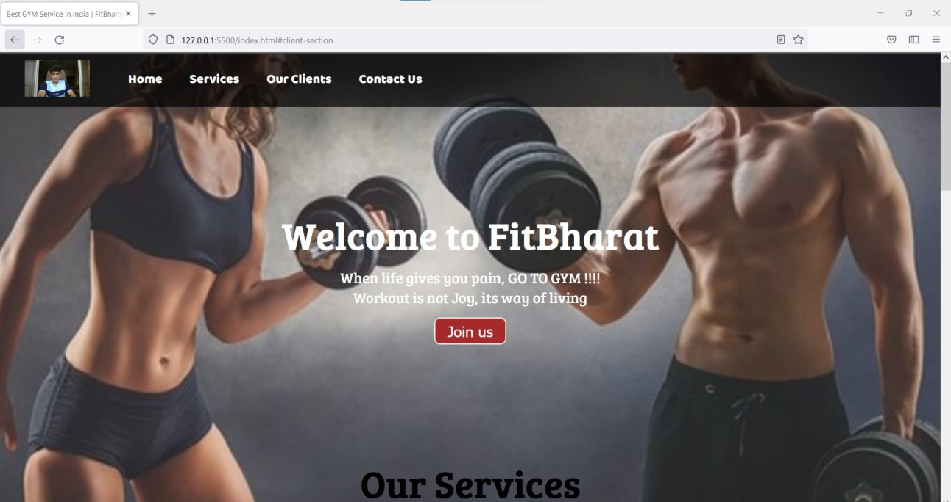

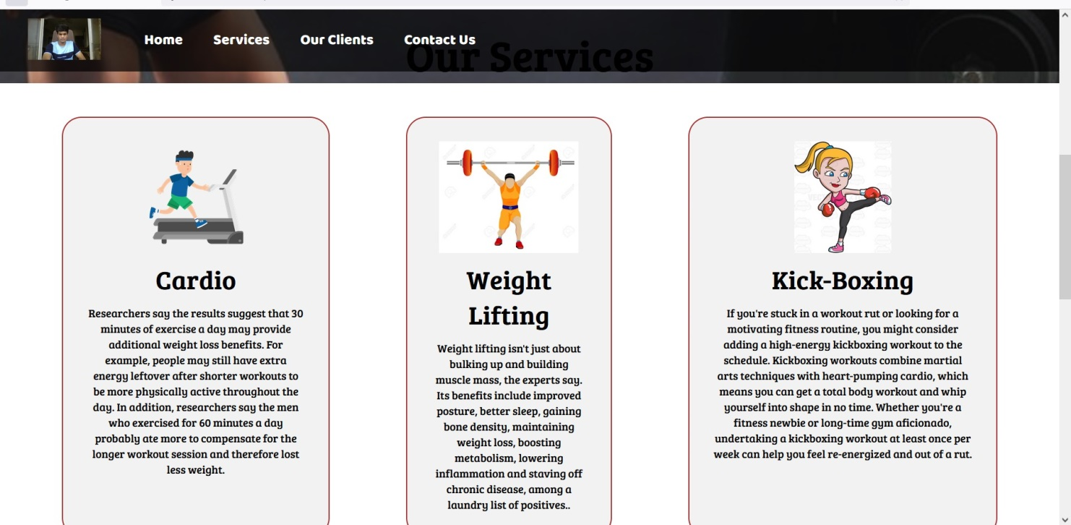

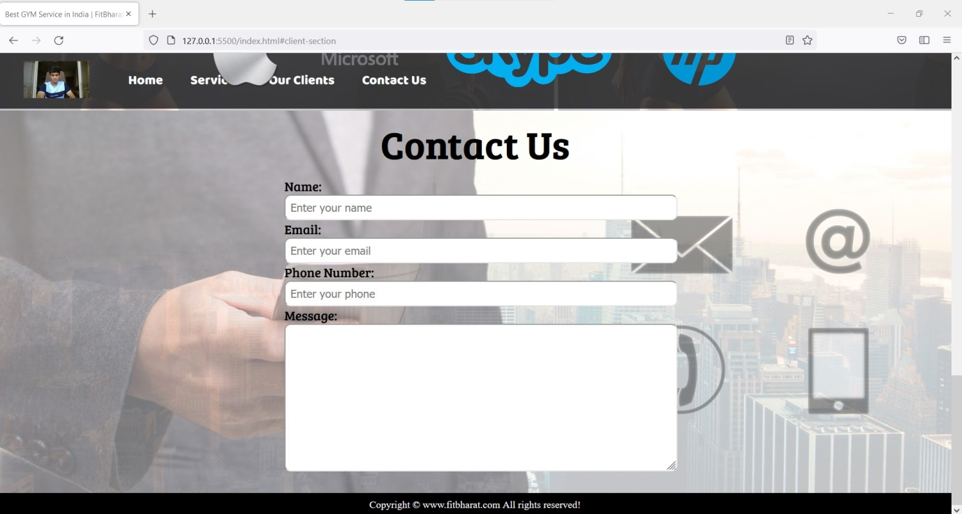

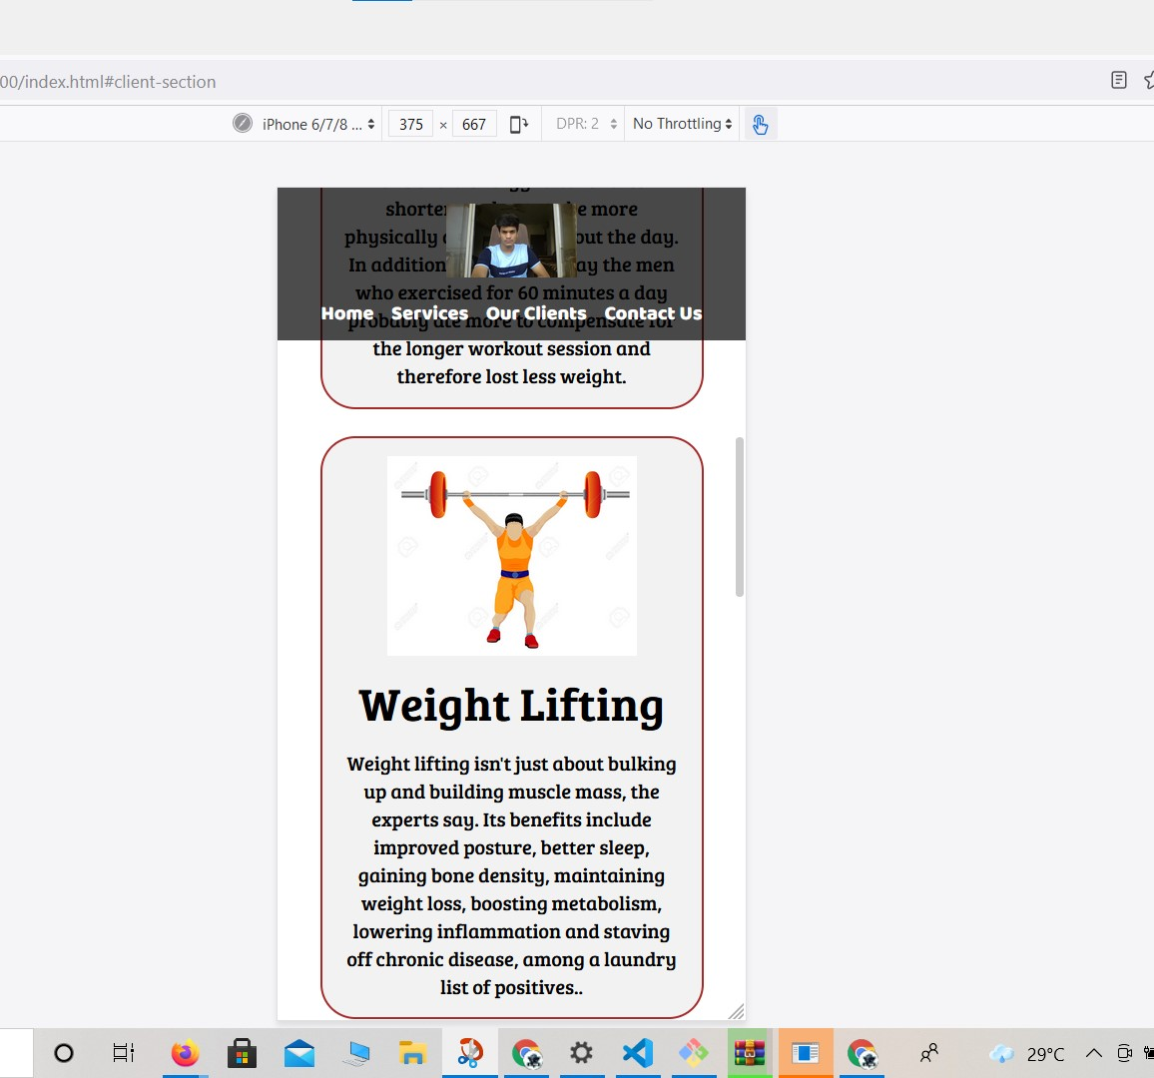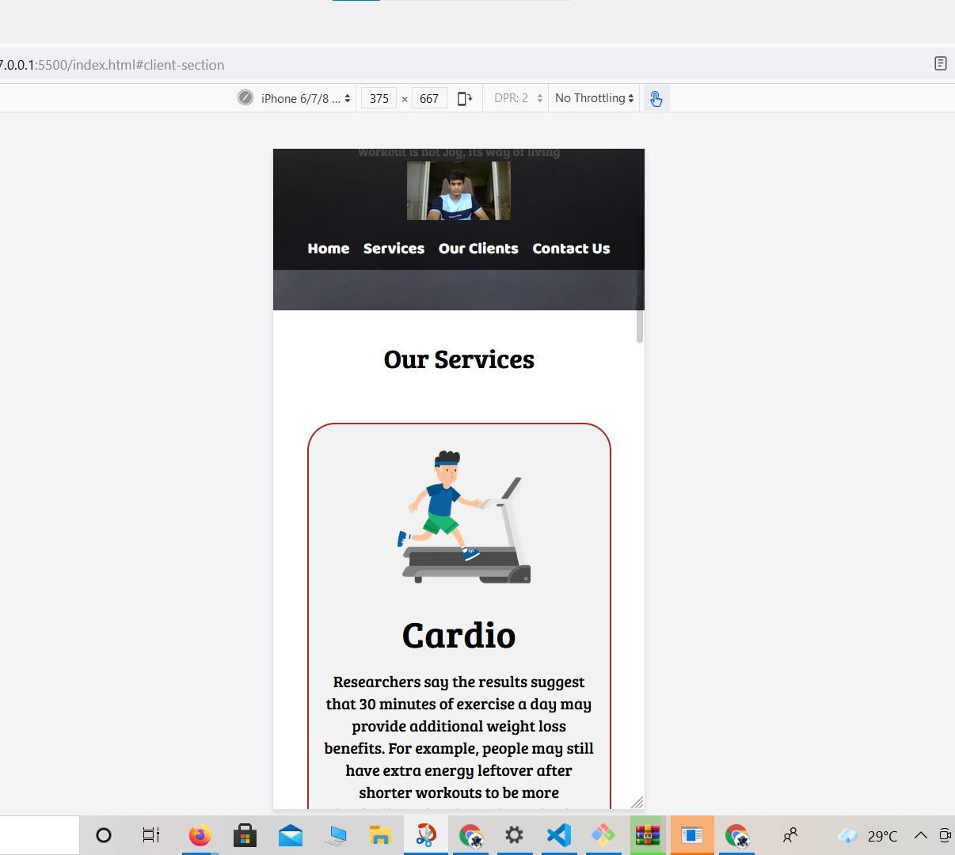

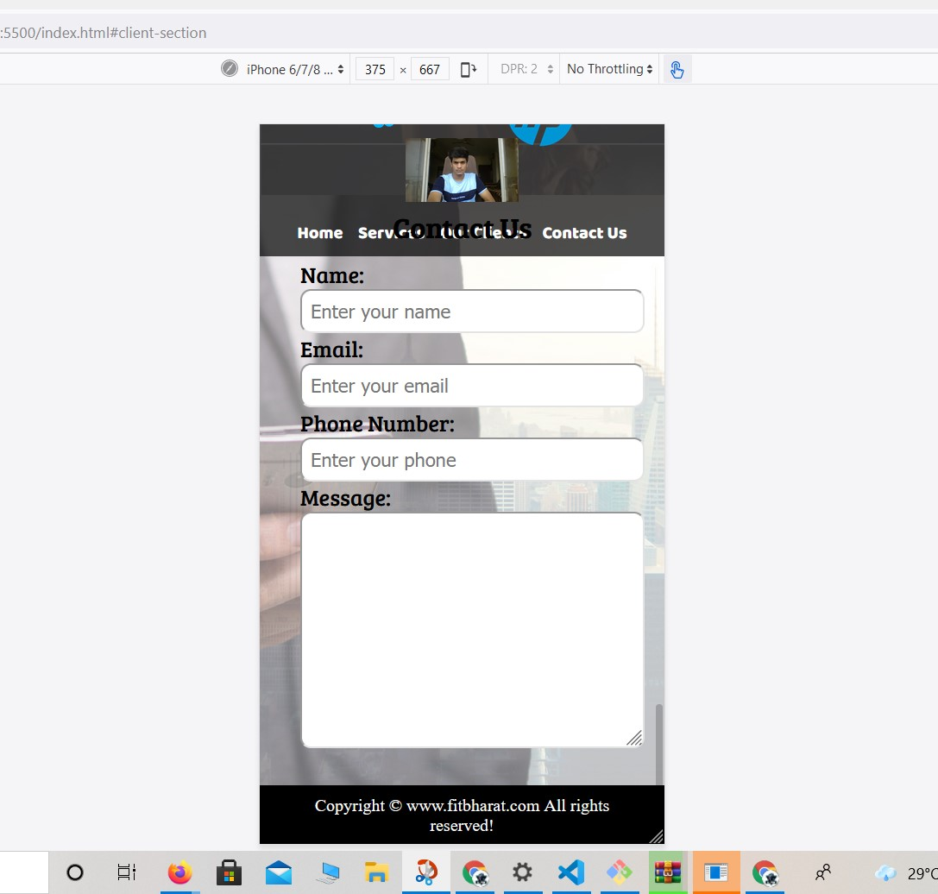

**Repository Link Here : https://github.com/aryanvit53/projectwebsite/tree/master**