TECHNICAL RESEARCH & DESIGN REPORT

PROJECT NOVA: AI-Assisted Data Observability & Auto-Healing Pipeline
Author: Aryan Verma (The Architect) Date: March 2026 Domain: Data Engineering, MLOps, Enterprise Security Status: MVP Architecture Lock

TABLE OF CONTENTS
- Abstract & Executive Summary
- Problem Statement: The Fragility of Modern ETL
- Proposed Architecture Overview
- Phase 1: Ingestion & Deterministic Governance
- Phase 2: Asynchronous Decoupling & Semantic Clustering
- Phase 3: Air-Gapped SLM Remediation (The Engine)
- Phase 4: Enterprise Safety Guardrails & Reversibility
- The "Doomsday" Fallback (Circuit Breaker & DLQ)
- System Flow Diagrams & Workflows
- Conclusion & Business Impact

1. ABSTRACT & EXECUTIVE SUMMARY
In the era of Big Data, the migration of records from legacy databases to modern cloud data warehouses (e.g., Snowflake, BigQuery) is a critical B2B operation. However, traditional ETL (Extract, Transform, Load) pipelines like Fivetran or Airbyte act as "dumb pipes." They transport data but lack the semantic understanding to validate it. When schema drift or high-cardinality data anomalies occur (e.g., incorrect date formats, corrupted strings), the pipeline either crashes or propagates bad data, forcing Data Engineers to write brittle, manual SQL scripts.
Project Nova introduces a paradigm shift: a 100% air-gapped, decoupled, AI-assisted observability layer. Instead of sending sensitive enterprise data to expensive Cloud LLMs (violating GDPR/HIPAA), Nova utilizes local Small Language Models (SLMs) combined with Vector DB semantic clustering. The system intercepts anomalies, automatically generates deterministic execution code to fix them, and safely stages the data with zero-data-loss guarantees.

2. PROBLEM STATEMENT: The Fragility of Modern ETL
The current data engineering landscape faces four critical bottlenecks:
- The "Manual Scripting" Tax: Data Quality relies on hardcoded Regex or SQL rules. Every new anomaly requires a new line of code written by a human.
- The LLM Throughput Bottleneck: Processing 100,000 bad rows individually through an LLM (RAG) is computationally impossible, resulting in massive latency, rate limits, and OOM (Out of Memory) crashes.
- Data Sovereignty & Privacy Risks: Sending Personally Identifiable Information (PII) like Bank Accounts or Medical Records to public APIs (OpenAI/Gemini) is a strict compliance violation for B2B enterprises.
- Silent Data Corruption & False Positives: Automated tools often misclassify data, merging distinct records (False Positives) or dropping rows without triggering alerts (Silent Data Loss).

3. PROPOSED ARCHITECTURE OVERVIEW
To solve these issues, Project Nova implements a Multi-Tier Hybrid Routing Engine. It assumes that 99% of data is clean and should move at lightning speed, while the remaining 1% of anomalous data requires intelligent, asynchronous remediation.
Core Principles:
- Decoupling: Never block the main ingestion pipeline.
- Air-Gapped Security: Zero external internet dependencies for AI inference.
- Auto-Generation over Auto-Fixing: The AI generates the logic (code) to fix the data, not the fixed data itself.
- Auditability: Every transformation must be explainable and reversible.

4. PHASE 1: INGESTION & DETERMINISTIC GOVERNANCE
Before any AI is invoked, the system must enforce strict data contracts.

4.1. The Schema Diff Validator
Prior to data ingestion, the system compares the source schema signature with the target database schema.
- Logic: If Hash(Source_Schema) != Hash(Target_Schema) -> Trigger Critical Alert.
- Purpose: Prevents pipeline destruction caused by upstream developers changing column types (e.g., changing an INT to a VARCHAR) without notifying the data team.

4.2. The Deterministic Bouncer (Layer 1)
Data enters a high-speed Python/Polars validator.
- The Fast Lane: Data passing basic structural checks (Nulls, basic Regex) bypasses AI completely and is streamed directly to the Target Database.
- The Suspect Queue: Rows failing deterministic checks are tagged (Validation_Status = 'NEEDS_AI') and diverted.

5. PHASE 2: ASYNCHRONOUS DECOUPLING & SEMANTIC CLUSTERING
To prevent OOM crashes when dealing with high-cardinality anomalies, we implement decoupling and compression.

5.1. The Message Queue
Anomalous rows are pushed into an asynchronous message queue (Redis/RabbitMQ). The main ingestion pipeline finishes its task and spins down, ensuring 100% uptime.

5.2. Semantic Compression (ChromaDB)
Instead of treating 50,000 string errors as unique tasks, we utilize Vector Embeddings.
- Mechanism: Anomalies are embedded using a local lightweight embedding model. ChromaDB clusters these embeddings based on semantic similarity.
- Result: 50,000 textual errors (e.g., 50k variations of a wrong date format) are mathematically compressed into ~100 actionable Pattern Clusters.

6. PHASE 3: AIR-GAPPED SLM REMEDIATION (The Engine)
This phase represents the core intellectual property of Project Nova.

6.1. Metadata Extraction
The background worker extracts a representative sample (Meta-data, typically 3-5 rows) from a specific ChromaDB cluster.

6.2. Transformation Template Restriction (The Sandbox)
The sample is passed to a local, air-gapped SLM (e.g., Llama-3 8B or Phi-3 via Ollama). The SLM is strictly prompted to output only a sandboxed Pandas lambda function or a deterministic transformation rule.
- Why: We do not trust the AI to modify the data directly (which can lead to hallucinations). We trust the AI to suggest a mathematical function, which our system executes.

6.3. Auto-Execution
The system takes the AI-generated Python code and applies it across the entire cluster (e.g., all 45,000 rows matching that pattern) in milliseconds.

7. PHASE 4: ENTERPRISE SAFETY GUARDRAILS & REVERSIBILITY
An enterprise system must assume the AI will eventually make a mistake. Project Nova implements strict DataOps guardrails.

7.1. Hybrid Fingerprinting (Preventing False Positives)
Vector similarity is fuzzy. "John Doe ID:101" and "Jon Doe ID:102" might have a 99% similarity score.
- Solution: We combine Semantic Similarity with strict SHA-256 Hashes for Primary Keys. If the PK hash differs, the records are forced into separate clusters, eliminating false merging.

7.2. Safe Promotion & Automated Testing
Fixed data is never written directly to the production tables.
- Staging: Data is dumped into an isolated Staging Schema.
- Validation: Automated dbt (Data Build Tool) tests run against the staging data to verify business logic.
- Promotion: Only if all tests PASS is the data promoted to Production. If FAIL, the data is moved to a Human Quarantine Dashboard.

7.3. Explainable AI (XAI) & Audit Logging
The SLM must return a JSON object containing a confidence_score and reasoning. Every modification is logged in an Audit Table: [Row_ID, Old_Value, New_Value, AI_Reason, Confidence_Score, Model_Version, Timestamp]

7.4. Zero-Data-Loss Reconciliation Check
At the end of every batch run, the system executes an immutable mathematical check: Total_Source_Rows == (Snowflake_Success_Rows + Quarantine_Rows) Any mismatch > 0 triggers an immediate webhook alert.

8. THE "DOOMSDAY" FALLBACK (Circuit Breaker)
Scenario: Schema Drift occurs simultaneously with a panic in the deterministic layer, and the local SLM goes offline.
Fallback Execution: The system shifts from Remediation to Absolute Preservation.
- Trip the Circuit Breaker: Ingestion for the failing stream is instantly halted to isolate the blast radius.
- Immutable Raw Vault: The unparseable payload is serialized into raw bytes (JSON/Parquet) and dumped into an immutable Cold Storage Bucket (AWS S3) or Dead Letter Queue (DLQ).
- Sev-1 Escalation: An alert containing the stack trace and the S3 URI is fired to PagerDuty.
- Replayability: Engineers can manually fix the logic and replay the raw S3 payload back into the pipeline, guaranteeing zero data loss even during a total system failure.

9. SYSTEM FLOW DIAGRAMS

9.1. Core Architectural Flow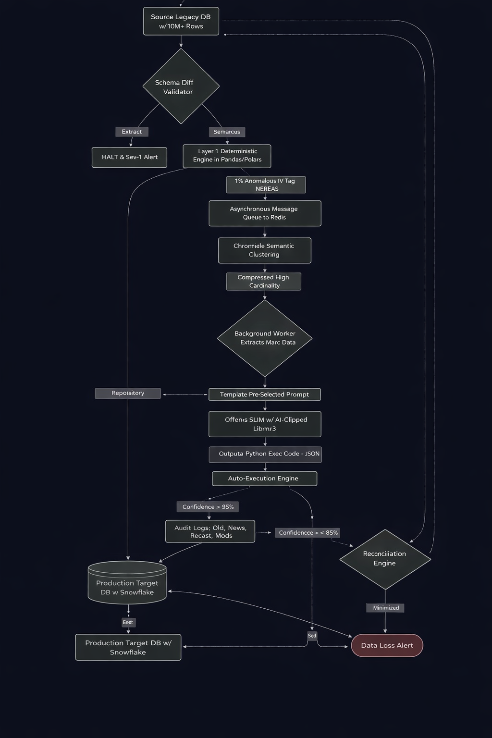

project_nova/
│
├── main.py # Central Orchestrator (No logic, only flow control)
├── config.py # Global configs (model, thresholds, paths)
├── requirements.txt
├── README.md # Clear explanation + flow diagram
│
├── data/
│ ├── raw/ # Immutable input batches
│ ├── clean/ # Deterministic pass output
│ ├── anomalies/ # Needs_AI rows
│ ├── staging/ # Post-AI execution sandbox
│ ├── production/ # Final promoted dataset (DuckDB)
│ └── vault/ # Replay-safe raw storage
│
├── logs/
│ ├── system.log # Runtime logs
│ └── audit_log.json # Transformation tracking
│
├── utils/
│ ├── logger.py # Central logging config
│ ├── schema_validator.py # Schema drift checks
│ ├── queue_manager.py # Async/local queue abstraction
│ ├── embedding_engine.py # Vector creation + clustering
│ ├── audit_logger.py # Audit tracking logic
│ ├── hash_utils.py # Idempotency + hashing
│ └── test_runner.py # Basic validation tests
│
├── phases/
│ ├── phase1_ingestion.py # Load + deterministic split
│ ├── phase2_clustering.py # Cluster anomalies
│ ├── phase3_slm_remediation.py # AI JSON output (restricted)
│ ├── phase4_execution.py # Template-based transformation
│ ├── phase5_guardrails.py # Confidence routing + circuit breaker
│ └── phase6_promotion.py # Staging → production
│
├── prompts/
│ ├── remediation_v1.txt
│ └── system_rules.txt
│
├── tests/
│ ├── test_ingestion.py
│ ├── test_clustering.py
│ └── test_execution.py
│
└── docs/
├── architecture.md
├── flow_diagram.png
└── risk_matrix.md

10. CONCLUSION & BUSINESS IMPACT
Project Nova redefines data observability by bridging the gap between rigid data engineering pipelines and intelligent AI automation. By utilizing a decoupled architecture and Air-Gapped SLMs, it ensures:
- Cost Efficiency: $0 external API costs and minimal compute overhead due to Semantic Clustering.
- Compliance: 100% Data Sovereignty as PII never leaves the local network.
- Resilience: The Circuit Breaker and Immutable Raw Vault guarantee zero data loss and eliminate the risk of production corruption.
- Engineering Velocity: Eliminates 90% of manual SQL script maintenance, freeing Data Engineers to focus on architecture rather than plumbing.
Project Nova is not just a migration tool; it is a self-healing data ecosystem built for enterprise scale.

