Calibrated Escalation for IT Ticket Triage: What the Calibration Distribution Decides
Aryan Manoj Waingankar, Shreyansh Pandey, Parth Bagle, Swapnil Samrat,
Dr. Madhvi Saxena, Dr. Aditi Saxena
Department of Artificial Intelligence and Machine Learning
Symbiosis Institute of Technology, Symbiosis International (Deemed University)
Pune, India
aryan.waingankar.btech2023@sitpune.edu.in, shreyansh.pandey.btech2023@sitpune.edu.in
parth.bagle.btech2023@sitpune.edu.in, swapnil.samrat.btech2023@sitpune.edu.in
madhvi.saxena@sitpune.edu.in, aditi.saxena@sitpune.edu.in

Abstract—Automatic triage of IT support tickets has to do two things: send each ticket to the right team, and recognise when it should not act on its own and should pass the ticket to a person. This paper builds a triage pipeline around the second requirement. Two escalation gates are calibrated separately. A confidence threshold of 0.50 on a fast lexical classifier decides whether its label is trusted or a slower embedding classifier is consulted, and a cosine-similarity threshold of 0.67 on retrieved past tickets decides whether a language model may draft a resolution or the ticket goes to a human. On a 9-ticket adversarial set the retrieval gate makes the correct decision for every ticket, compared with 3 of 9 when it is removed. A zero-shot LLM classifies more accurately than our trained classifier (40/45 against 33/45) but provides no abstention mechanism and no cost control, so we report it as a baseline rather than as the design. Across coverage guarantees, drift monitoring and classification, one pattern repeats: the data a component is trained or calibrated on limits it more than the method chosen. We also report negative results, an error analysis of misrouting, wrong escalations and unsupported drafts, and the configuration needed to reproduce every number. [[FILL-A1: one sentence on results for the independent and real-world test sets]] The main corpus is synthetic and the evaluation sets are small, and all conclusions are scoped accordingly.
Index Terms—IT ticket triage, selective prediction, escalation, calibration, conformal prediction, retrieval-augmented generation
I. Introduction
When employees raise a support ticket, they usually describe a symptom in their own words and do not know which team owns the problem. A triage system that routes such a ticket confidently but wrongly is more expensive than one that asks for help: the ticket waits in the wrong queue, and an automatically suggested fix may target the wrong problem. Accuracy alone therefore does not describe a good triage system. It also matters when the system decides not to answer.
We design a pipeline in which escalation to a human is a first-class output. A ticket is first assigned to one of seven teams by a two-tier classification cascade. Similar resolved tickets are then retrieved, and a language model is allowed to draft a resolution only when the closest past ticket is similar enough. Both decision thresholds were chosen from measured calibration data, and Section V presents the evidence for each value.
A natural alternative is to ask a large language model to classify the ticket directly. On our out-of-template benchmark this works well: a zero-shot model is more accurate than our trained classifier (Section VI-C). However, it gives no calibrated signal for when to abstain and no control over the cost of each ticket. Because the escalation decision, not raw accuracy, determines whether a wrong answer reaches a user, we keep the zero-shot model as a prominent baseline. The contributions of this work are:
- A two-gate escalation pipeline whose two thresholds are calibrated independently and can be recalibrated separately, reported together with the evidence for each value and the calibration attempts we rejected.
- A finding that recurs across experiments: the data distribution used to fit or calibrate a component constrains it more than the method or test applied to it. We observe this for a coverage guarantee, a drift reference and a trained classifier.
- Transparent baselines and error analysis: a controlled ablation showing that the cascade saves latency rather than accuracy, zero-shot LLM baselines from two vendors, an audit of an LLM judge, and a breakdown of misclassifications, wrong escalations and unsupported drafts.
II. Related Work
Ticket triage. LLM-based methods have been applied to routing and escalating IT and customer-support tickets [1]–[3]. These studies mainly report routing accuracy; our focus is the decision to abstain that surrounds the classifier.
Cascades and deferral. Confidence-based cascades pass difficult inputs from an inexpensive model to a more capable one [4]. Conformal variants give distribution-free accuracy guarantees for multi-tier cascades [5], and a cascade can end with a human decision-maker [6]. We compare deferral rules at the coverage at which our live gate actually operates.
Conformal prediction under shift. Split conformal prediction guarantees marginal coverage when calibration and test data are exchangeable [7], [8]. Weighted conformal prediction restores the guarantee under covariate shift when the likelihood ratio is known [9]; later work bounds the loss when exchangeability fails [10] and adapts online [11]. Our coverage measurements are an empirical example of this gap, where the shift is a change in writing style.
Abstention in retrieval-augmented generation. A retrieval-augmented generation (RAG) system [12] can abstain when the retrieved context is insufficient [13], or correct itself when retrieval is poor [14]. We evaluate a context-sufficiency rater as a candidate second gate.
LLM judges. Jung et al. [15] propose judges with guaranteed human agreement that escalate when uncertain, and Jain et al. [16] study an agreeableness bias in LLM judges. The judge we audited shows the failure these works warn about.
Synthetic benchmarks. The value of synthetic data as an evaluation benchmark has itself been studied [17]. We treat what our synthetic corpus can and cannot measure as part of the results.
Positioning. Table I summarises the closest works using only what each abstract reports. Two of the ticket-triage studies evaluate on real tickets, while our main evaluation does not (Section VIII). None of them combines escalation gates calibrated on measured data with generation that is permitted only after retrieval passes such a gate.

TABLE I
Comparison with the closest related work, based on each paper's abstract
Work | Task | Escalation / abstention mechanism | Evaluated on
TickIt [1] | Online ticket escalation | Routes tickets to support teams | Deployment on Volcano Engine
Paket et al. [2] | Service desk ticket classification (LLMs vs BERT) | not stated | Turkish service desk tickets, 172 classes
Carroll et al. [3] | REDCap ticket triage and drafting | not stated | Real REDCap tickets, expert-rated
Jitkrittum et al. [4] | Classifier cascade deferral | Confidence-based and post-hoc deferral | not stated
Conformal Cascade [5] | Multi-tier LLM inference | Defer unless conformal set is a singleton | Multiple-choice benchmarks
Fanconi et al. [6] | Human–AI decision-making | Deferral, then abstention to a human expert | General and medical QA
Sufficient context [13] | RAG error analysis | Sufficient-context guided abstention | Several models and datasets
CRAG [14] | Robust retrieval-augmented generation | Retrieval evaluator triggers corrective actions | Short- and long-form generation tasks
Ours | IT ticket triage | Two calibrated gates (confidence, retrieval) | Synthetic corpus; 45-ticket out-of-template set; [[FILL-T0: new test sets]]
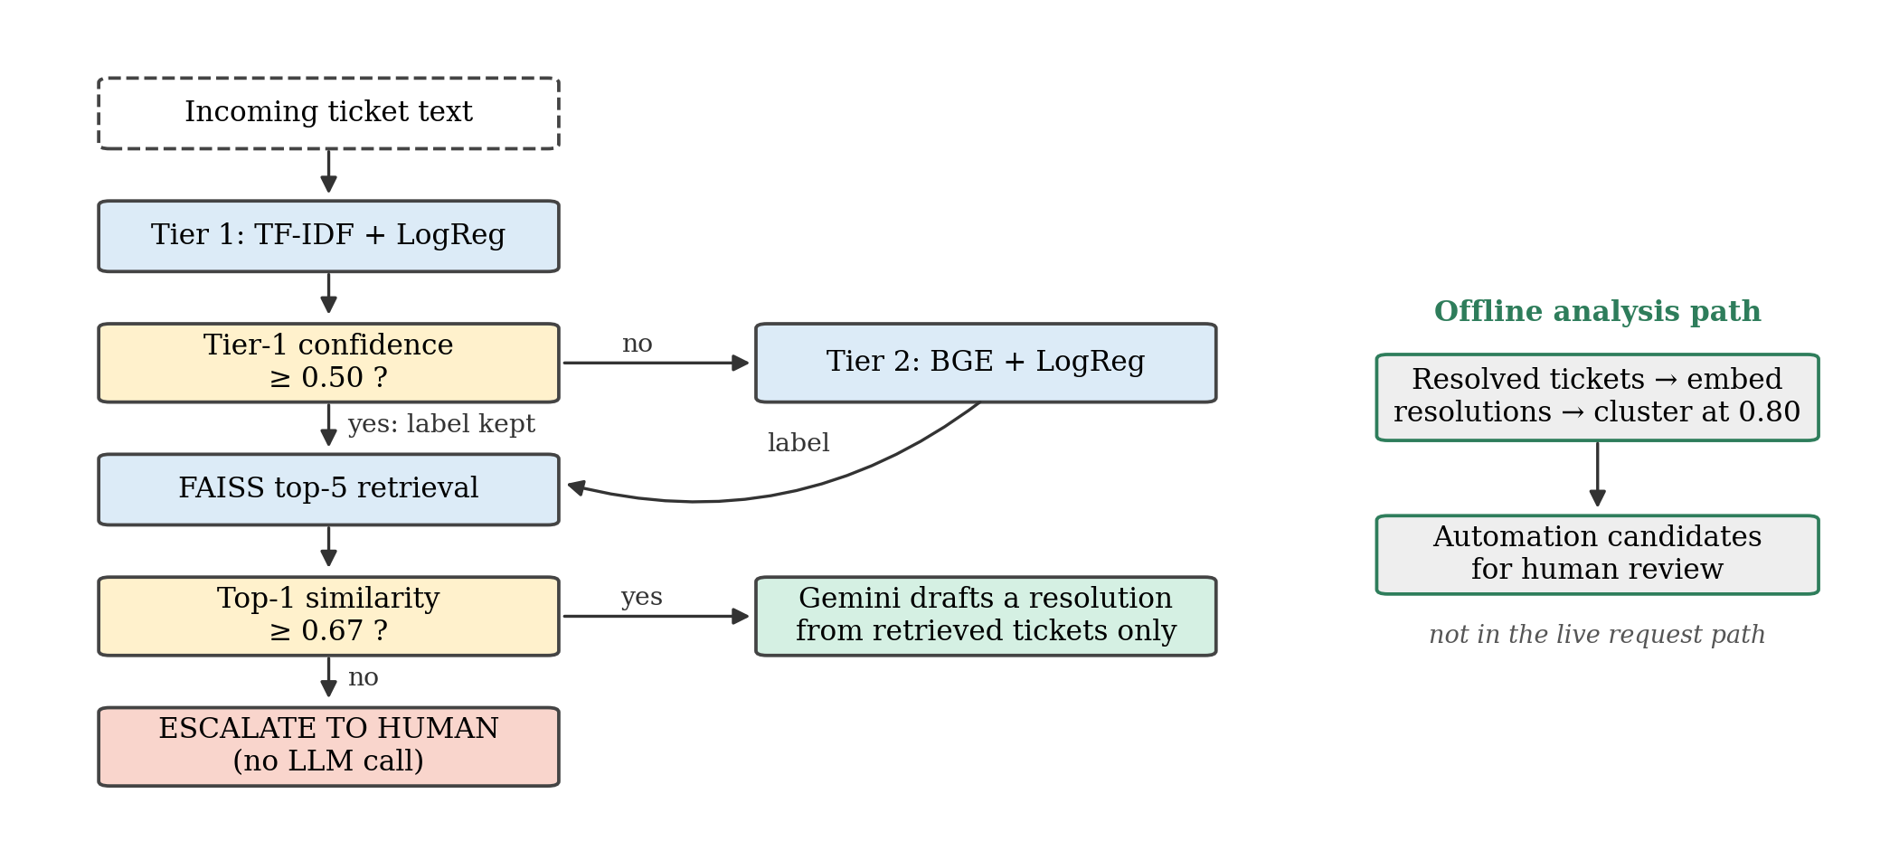
Fig. 1. The pipeline. Two separately calibrated gates decide escalation; the language model drafts only above the retrieval gate and never assigns the category. The offline path clusters resolved tickets into automation candidates.

III. Methodology
A. System overview
Fig. 1 shows the pipeline. It is a sequential pipeline with clear agent boundaries and an HTTP interface, not a distributed or autonomous multi-agent system. Each stage (classify, retrieve, resolve) is an agent that declares the artifacts it needs, checks them when it is created, and makes no routing decision itself. All routing decisions are taken by one orchestrator, which records a trace for every stage, including the stages it skipped; a skipped resolution step is therefore direct evidence that no language model was called. Each stage can be called separately over HTTP, but the triage endpoint runs them in-process, so the measured latency contains no network hops. If a stage fails, the ticket is escalated instead of returning a server error, because a failed ticket needs a person rather than a retry.
B. Classification cascade
Tier 1 is a TF-IDF representation with logistic regression. Its vocabulary is committed to the repository so that the features are identical on every machine. If the highest class probability from Tier 1 is at least 0.50, its label is accepted. Otherwise Tier 2 classifies the ticket using logistic regression over frozen BGE embeddings [18] (bge-base-en-v1.5, 768 dimensions). Section V-A explains how the value 0.50 was selected.
C. Retrieval gate and grounded drafting
The five nearest resolved tickets are retrieved from a FAISS inner-product index [19]. If the cosine similarity of the closest ticket is below 0.67, the ticket is escalated and no language model is called. Otherwise Gemini (gemini-flash-lite) drafts a resolution. The prompt contains the title, description, resolution, category and similarity score of each retrieved ticket. It instructs the model to base every step only on these past resolutions rather than on outside knowledge, and to say so and recommend a human check when the examples do not fit. The language model never assigns the category. Section V-B explains how the value 0.67 was selected.
D. Independence of the two gates
The cascade threshold depends only on the confidence of Tier 1, so replacing the Tier-2 embedding model does not require recalibrating it. The retrieval threshold depends on the embedding model and must be recalibrated whenever that model changes.
E. Conformal measurement
To test whether a finite-sample guarantee could replace the cascade threshold, we calibrate split conformal prediction [7], [8] for each tier. A nonconformity score is computed from the predicted class probabilities on a held-out calibration set; its empirical quantile defines a prediction set whose marginal miscoverage is at most α when calibration and test tickets are exchangeable. This analysis runs offline and gates no production decision. Section VI-A tests whether the guarantee survives the move from calibration data to out-of-template text.
F. Automation candidates
An offline job clusters resolved tickets by the similarity of their resolution text at a threshold of 0.80 and shows recurring clusters to a reviewer as candidates for automation.
G. Verification
A value that is wrong for its context but internally consistent can produce a wrong result without raising any error. The checks in Table II therefore run before any result is accepted. Routing decisions are compared exactly, and floating-point values are compared within tolerances derived from their arithmetic.
TABLE II
Checks that run before a result is accepted. A count is given only where a committed file records it
Check | What it guards | Count
Golden parity | Category, tier, escalation and neighbour count equal the recorded decisions exactly | 54 tickets
Adversarial gate | Each adversarial ticket escalates or proceeds as expected | 9/9
Gate headroom | No golden similarity lies within its tolerance of the gate; closest, as a multiple of the tolerance | 3.18×
Artifact guards | Index and metadata aligned; encoder, index and configured dimension agree; Tier 1 matches its dataset and vocabulary | –
Paper parity | Every quoted number is regenerated from a committed result file, and none is typed by hand | –

IV. Experimental Setup
A. Origin of the dataset
The project follows the nasscom use-case brief on ticket routing and resolution. The brief specified seven categories, routing, resolution suggestion, confidence-based escalation and automation flagging, and recommended a synthetic, LLM-generated dataset with title, description, category, resolution and priority fields. We generated 4,000 tickets following this specification. [[FILL-D1: list the seven category names]] The synthetic corpus is therefore a requirement of the brief rather than a convenience choice, but it limits what can be claimed (Section VIII).
B. Properties of the corpus
Three measurements describe what the corpus can support. First, the generation templates coincide with the resolution classes, so clustering precision cannot be measured on it. Second, memorisation happens at the template level: our calibration set touches 62 of the 66 templates, and removing whole templates would leave only 210 of the 4,000 rows, so the corpus cannot be decontaminated by filtering. Third, additional training rows add little accuracy on text written outside the templates (Section VI-C).
C. Dataset splits and evaluation sets
Accuracy on a held-out split of the generated data is not informative: the TF-IDF baseline scores 100% on it, which we treat as a warning rather than a result. Table III lists every split and its purpose. The classifiers are trained on 3,200 rows. Evaluation uses fixed, read-only sets written outside the templates: a hand-written 14-ticket benchmark, a 45-ticket out-of-template benchmark, and a 9-ticket adversarial set of off-topic, vague and slang tickets, each labelled with its expected escalate-or-proceed outcome. A 175-ticket deployment-distribution set, written in the style of the benchmark rather than the templates, serves as a second calibration and evaluation distribution. The benchmark and the deployment set were generated with Gemini. [[FILL-D2: one sentence describing the new independent and real-world test sets]]
TABLE III
Dataset splits and evaluation sets
Set | Size | Source | Used for
Training | 3,200 | Synthetic (templates) | Fitting all trained classifiers
In-distribution held-out | [[FILL-S1]] | Synthetic (templates) | Sanity check only
Paraphrased calibration | [[FILL-S2]] | Paraphrased tickets | Cascade threshold (0.50)
In-domain calibration | [[FILL-S3]] | Synthetic | Conformal calibration; drift reference
Out-of-domain calibration | [[FILL-S4]] | [[FILL-S5]] | Retrieval threshold (0.67)
Deployment distribution | 175 | Gemini, benchmark style | Second calibration and evaluation set
Hand-written benchmark | 14 | Written by authors | Evaluation
Out-of-template benchmark | 45 | Gemini | Main evaluation
Adversarial | 9 | Off-topic, vague, slang | Gate evaluation
Independent test set (new) | [[FILL-S6]] | Written blind by the authors | Extended evaluation
Real-world tickets (new) | [[FILL-S7]] | [[FILL-S8: public dataset name]] | Extended evaluation

D. Model configurations and hyperparameters
Table IV gives the configuration of every component. Latency is the warm median per ticket at batch size one.
TABLE IV
Model configurations and hyperparameters
Component | Configuration
Tier 1 | TF-IDF, committed vocabulary of 5,000 features, [[FILL-H1: n-gram range]]; logistic regression, [[FILL-H2: C, solver, max_iter]]
Tier 2 | bge-base-en-v1.5 (768-d, frozen) + logistic regression, [[FILL-H3]]
Cascade gate | Accept Tier-1 label if top-class probability ≥ 0.50
Retrieval | FAISS inner-product index over normalised BGE embeddings; top-5 neighbours
Retrieval gate | Draft only if top-1 cosine similarity ≥ 0.67
Drafting LLM | gemini-flash-lite, [[FILL-H4: temperature, max output tokens]]
Zero-shot baselines | gemini-flash-lite and Qwen2.5-3B (local CPU) with byte-identical prompts
Other encoders | MiniLM and E5 with the same logistic head; DistilBERT fine-tuned, [[FILL-H5: epochs, learning rate, batch size]]
Clustering | Resolution embeddings, similarity threshold 0.80, union-find grouping
Conformal | α ∈ {0.01, 0.05, 0.10, 0.20}; noise band = ±2 s.d. over [[FILL-H6: number]] calibration draws
Seeds, hardware | [[FILL-H7: random seeds; CPU/RAM used for latency]]

E. Prompts
Two prompts are used. The drafting prompt is described in Section III-C. The zero-shot classification prompt lists the seven categories and asks for exactly one label; Gemini and Qwen receive byte-identical text. The exact wording of both prompts is given in Appendix A.
F. Statistics
Proportions are reported with Wilson 95% intervals [20], and paired comparisons use the exact McNemar test [21]. A difference smaller than its own noise band is never reported as an ordering.
G. Result generation
Every number in this paper is produced by scripts from committed result files, and an automated parity test fails if any quoted number differs from its source. Appendix B lists the commands that rebuild the index, rerun each experiment and regenerate every table and figure. Code, data and result files are available at https://github.com/aryanwaingankar4/ticket-routing-resolution-agent.
V. Threshold Selection and Calibration Evidence
A. Cascade threshold (0.50)
This threshold decides when the fast Tier-1 label is trusted. We made three calibration attempts and kept one. Calibrating on an in-distribution split failed because every confidence bucket sat at the accuracy ceiling: observed accuracy was 1.0 in every bin, so both tiers appeared under-confident (expected calibration error 0.112 for Tier 1 and 0.099 for Tier 2) and any threshold would have looked safe. A second attempt on a small hand-written set was rejected and never committed. The third attempt used paraphrased tickets, which move Tier 1 away from its template vocabulary. For each candidate threshold we measured the accuracy of the tickets that Tier 1 keeps and chose the lowest threshold that meets the target accuracy. This procedure returned 0.50 at the two looser target accuracies, and 0.50 is the live value. [[FILL-T1: target accuracies used; accuracy and share of tickets kept by Tier 1 at 0.50]] Fig. 4 shows the resulting curve.
[[FILL-F4: insert figure — accuracy of Tier-1-kept tickets and share kept vs. threshold on the paraphrased calibration set]]
Fig. 4. Cascade threshold calibration on paraphrased tickets. The dashed line marks the live threshold of 0.50.
B. Retrieval threshold (0.67)
This threshold decides whether a draft may be generated at all. It was chosen on a combined set of in-domain and out-of-domain tickets by sweeping candidate values and recording, for each value, the share of in-domain tickets that proceed and the share of out-of-domain tickets that wrongly pass (leakage). At 0.67, all 175/175 in-domain tickets proceed and 13.3% of out-of-domain tickets leak through; two grid steps lower, leakage almost triples to 37.8%. The value was then checked on the adversarial set. Any threshold between the highest similarity of a ticket that must escalate (0.6196) and the lowest similarity of a ticket that must proceed (0.6704) separates the two groups, and 0.67 lies inside this range. With the gate, 9/9 adversarial tickets are decided correctly; without it, only 3/9. Table V summarises both gates and Fig. 5 shows the full sweep.
Two cautions apply. First, 0.67 lies close to the upper end of the safe range, so a small change in the embedding model could move a ticket across it; this is why the retrieval gate must be recalibrated with any model change (Section III-D). Second, one similarity threshold is the simplest rule that works on this corpus, not a claim that a single number suffices in general.
[[FILL-F5: insert figure — in-domain proceed rate and out-of-domain leakage vs. similarity threshold, adversarial safe range shaded]]
Fig. 5. Retrieval threshold sweep. The shaded band is the adversarial safe range [0.6196, 0.6704]; the dashed line marks the live threshold of 0.67.
TABLE V
The two gates at their live operating points. Leakage is the share of out-of-domain calibration tickets that clear the retrieval gate
Quantity | Value
Retrieval gate
Threshold on top-1 cosine similarity | 0.67
In-domain tickets that proceed at the gate | 175/175
Out-of-domain leakage at the gate | 13.3%
Out-of-domain leakage two steps below | 37.8%
Adversarial safe range | [0.6196, 0.6704]
Adversarial decided correctly, with gate | 9/9
Adversarial decided correctly, gate removed | 3/9
Cascade gate
Threshold on Tier-1 top-class probability | 0.50
Tier-1 median latency (ms) | 1.04
Tier-2 median latency (ms) | 156.4
Tier-2 cost relative to Tier-1 | 151.0×

VI. Results
A. Coverage transfer and the calibration distribution
We calibrate split conformal prediction for both tiers and measure coverage on the 45-ticket out-of-template benchmark (Fig. 2, Table VI). The results should be read as three linked statements.
- On our corpus, split-conformal coverage transfers for the BGE representation but not for the lexical one. At α = 0.10, the coverage gap is −0.233 for Tier 1 and −0.011 for Tier 2, against a noise band of ±0.045 (two standard deviations over calibration draws).
- External replication is inconclusive. On an independently generated external corpus (not real production data), a version shift left the two tiers indistinguishable (0.0009 against −0.0072, band ±0.0165). A version shift is the wrong kind of shift for a vocabulary-level effect, and that corpus shows almost no representation gap (label accuracy 34.8% against 37.3%). A paraphrase shift, the right kind, was blocked by our own pre-registered degeneracy rule at a domain AUC of 0.9972, so the finding has been shown neither to hold nor to fail outside its original corpus.
- Post-hoc evidence appears in accuracy. Under the paraphrase shift, Tier 1 lost 10.5 accuracy points against 2.4 for Tier 2; the difference-in-differences is −0.08042 (95% CI [−0.136364, −0.020979]). This analysis is post-hoc and does not replace the blocked primary test.
Recalibrating on the deployment-distribution set, with the same method, α and benchmark, moves the Tier-1 gap from −0.233 to −0.144. Only the calibration distribution changed. Matching the distribution helps but is not sufficient, since the residual remains well outside the noise band; for Tier 2 the benefit appears as smaller prediction sets. Reweighting with a density ratio [9] is likewise a partial repair rather than a correction. In practice, the lexical tier's guarantee cannot be quoted on out-of-template text, which is one reason conformal prediction remains a measurement rather than a gate.
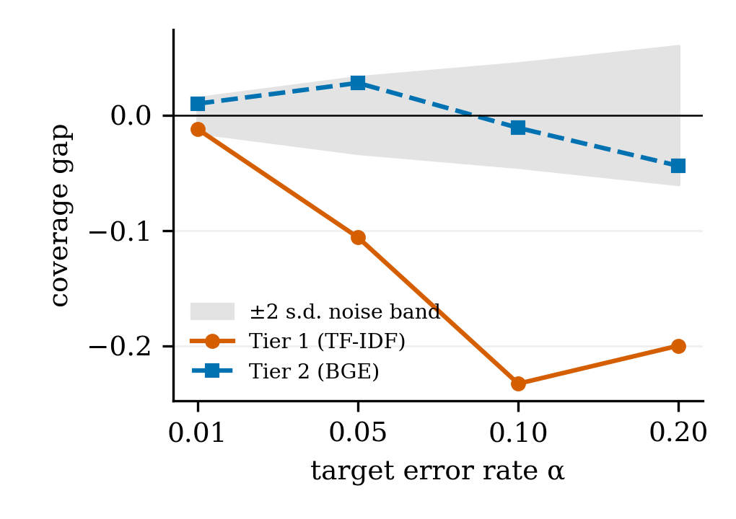
Fig. 2. Coverage gap on the out-of-template benchmark by representation and α, against the two-standard-deviation noise band.
TABLE VI
Split-conformal coverage gap on the 45-ticket benchmark. Only the calibration set changes between the two gap columns
Tier | α | Gap, in-domain cal. | Gap, deployment cal. | ±2 s.d. | Set size
1 | 0.20 | −0.200 | −0.244 | 0.060 | 2.69
1 | 0.10 | −0.233 | −0.144 | 0.045 | 3.40
1 | 0.05 | −0.106 | −0.083 | 0.033 | 5.00
1 | 0.01 | −0.012 | −0.012 | 0.015 | 6.67
2 | 0.20 | −0.044 | 0.000 | 0.060 | 1.11
2 | 0.10 | −0.011 | −0.011 | 0.045 | 1.82
2 | 0.05 | 0.028 | −0.039 | 0.033 | 2.60
2 | 0.01 | 0.010 | −0.012 | 0.015 | 4.80

B. The cascade saves latency, not accuracy
If Tier 1 answered every ticket, accuracy would be 16/45, which is 35.6 points below the full pipeline. That gap reflects the difference between the BGE and TF-IDF representations, not the value of cascading. The fair control is Tier 2 answering every ticket (Table VII). Against it, the cascade is one ticket worse on each set: 32/45 against 33/45 on the benchmark (exact McNemar p = 1.000) and 131/175 against 132/175 on the deployment set (p = 1.000). What the cascade buys is speed. Tier 2 costs 151.0× as much as Tier 1 (156.4 ms against 1.04 ms median), so the cascade reduces median per-ticket latency by 8% on the benchmark and 18% on the deployment set, where more tickets pass the Tier-1 threshold and never reach the encoder.
TABLE VII
Cascade against the control that isolates it (Tier 2 answering everything)
Set | Tier-2 only | Cascade | Tier-2 (ms) | Cascade (ms) | Saving
Benchmark | 33/45 | 32/45 | 156.4 | 143.5 | 8.2%
Deployment | 132/175 | 131/175 | 156.4 | 127.9 | 18.2%

C. Zero-shot LLM baselines
Two zero-shot LLMs received byte-identical prompts: Gemini (gemini-flash-lite) and Qwen2.5-3B, a 3-billion-parameter open-weight model run locally on a laptop CPU [22]. Fig. 3 places them beside every classifier we trained. A 3B model with no training on this corpus is not beaten by a classifier fitted on 3,200 of its rows, and this holds across two vendors. Each comparison is reported separately:
- Gemini scores 40/45 (95% CI [0.765, 0.952]) and is significantly better than Tier 2 at 33/45 (p = 0.039).
- Qwen2.5-3B scores 34/45 (95% CI [0.613, 0.858]) and is statistically indistinguishable from Tier 2 (p = 1.000); indistinguishable does not mean better.
- Qwen2.5-3B against Gemini gives p = 0.070, which is not significant.
Because the benchmark was generated with Gemini, the Qwen result acts as a partial control for authorship, and Gemini's extra margin cannot be attributed to capability alone. The comparison is also not like-for-like: it measures what a template-generated training set is worth on differently phrased tickets, not whether a language model outperforms the pipeline as a system, whose contribution is the calibrated escalation that neither zero-shot model provides. Among trained classifiers, the representation matters more than the model family: the lexical tier scores 16/45, two other frozen sentence encoders with the same logistic head score 32/45 and 27/45, and a fine-tuned DistilBERT scores 18/45 and 21/45 in two runs of one configuration. Those two runs differ, so we draw no ordering between them, and neither approaches the frozen BGE encoder.
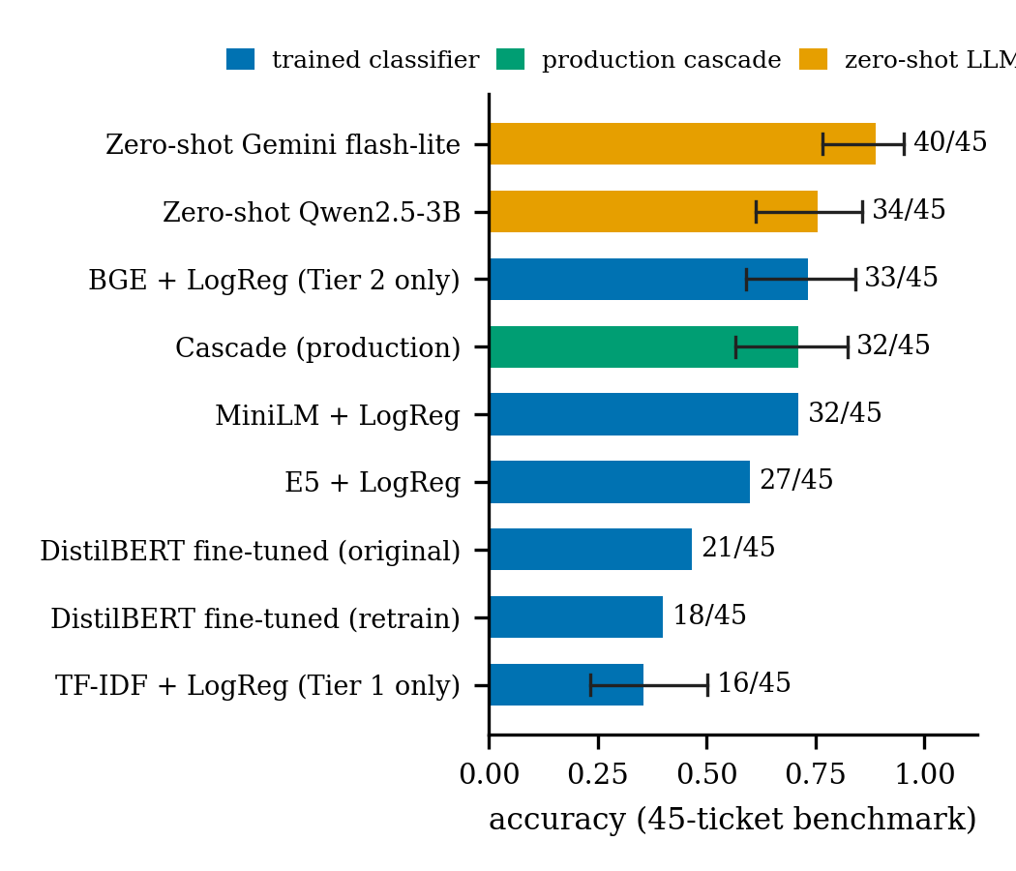
Fig. 3. Accuracy on the 45-ticket out-of-template benchmark. Error bars are Wilson 95% intervals where the result file records one. Zero-shot models have no abstention mechanism, calibrated gate or cost model.
D. Groundedness, an LLM judge, and a sufficiency gate
Every benchmark and adversarial ticket that passed the retrieval gate (33 tickets) received a draft, and a human labelled 31/33 drafts as grounded in the retrieved text (95% CI [0.804, 0.983]). An LLM judge using the same rubric agreed with the human on 30/33 drafts yet reached Cohen's κ = −0.042 [23], because every disagreement was the judge rating appropriateness instead of support. We therefore treat an LLM judge as something to audit, not as an unaudited way to scale labelling. A retrieval-sufficiency rater that never sees the draft caught 2/2 ungrounded drafts but also flagged 26/31 grounded ones, so it cannot be used as a gate.
E. Extended evaluation on independent and real-world tickets
To test whether the results above depend on Gemini-generated evaluation text, we evaluated the unchanged pipeline on two additional sets (Table VIII). [[FILL-X1: describe how the independent set was written (who, how many, blind to templates, labelling and inter-annotator agreement) and which real-world dataset was used, its licence, and how its categories were mapped to our seven]]
TABLE VIII
Results on the independent and real-world test sets (pipeline unchanged)
Set | n | Cascade acc. | Tier-2 acc. | Escalation rate
Out-of-template (ref.) | 45 | 32/45 | 33/45 | [[FILL-X2]]
Independent | [[FILL-X4]] | [[FILL-X5]] | [[FILL-X6]] | [[FILL-X7]]
Real-world | [[FILL-X8]] | [[FILL-X9]] | [[FILL-X10]] | [[FILL-X11]]
[[FILL-X3: two or three sentences interpreting Table VIII — does accuracy drop, does the gate escalate more, do the conclusions change?]]
F. The recurring finding
The data distribution a component is fitted or calibrated on, not the method or test applied to it, is the main constraint. The finding has two scoped instances. For calibration and reference distributions, recalibrating on a deployment-distribution set moved the Tier-1 coverage gap from −0.233 to −0.144 with nothing else changed (Section VI-A), and legitimate deployment-style tickets trigger the in-domain drift reference at rates of 0.217 to 0.646 across four α levels, 3.2 to 38.2 times the per-ticket null, so a monitor built on that reference would alarm continuously regardless of the test, α or window. For the training distribution, training on the corpus does not transfer to out-of-template phrasing better than no training at all (Section VI-C).
Methodological lessons. An area-under-the-risk–coverage metric showed effects that the pre-registered comparison at the live operating coverage could not resolve, so an averaged metric alone is not a reason to adopt a deferral rule. A pre-registered degeneracy rule blocked our paraphrase-shift experiment, and we kept the rule after seeing the results even though a critique of it was reasonable. On nine occasions a value or artifact was wrong for its context yet internally consistent and silently produced a wrong result; each case is documented in the repository.
VII. Error Analysis
Table IX groups the errors of the live pipeline into three types: wrong category, wrong escalation decision, and unsupported resolution.
TABLE IX
Error taxonomy of the live pipeline
Error type | Count | Cases and likely cause
Misclassification (benchmark) | 13/45 | [[FILL-E1: most frequent confusions, e.g. Infrastructure ↔ Network]]
Safe ticket escalated | 1 | N45: context was adequate but top-1 similarity fell below 0.67
Unsafe ticket drafted | 2 | N26, N31: passed the gate, but the draft was labelled ungrounded
Out-of-domain leakage | 13.3% | Out-of-domain calibration tickets above 0.67; [[FILL-E2: examples]]
Adversarial, gate removed | 6/9 | Off-topic and vague tickets drafted instead of escalated

A. Misclassification
The production cascade assigns the wrong team to 13 of the 45 benchmark tickets (Fig. 6). Infrastructure tickets are the hardest category: recall is 50% for the trained classifier and also 50% for both zero-shot LLMs, which suggests that these tickets are ambiguous in their wording rather than that one method is weak. Tier 1 alone misclassifies 29 of 45 tickets, mostly where the user's wording does not share vocabulary with the templates. [[FILL-E3: two or three concrete misclassified examples with true and predicted category]]
[[FILL-F6: insert confusion-matrix figure for the cascade on the 45-ticket benchmark]]
Fig. 6. Confusion matrix of the production cascade on the 45-ticket benchmark.
B. Incorrect escalation decisions
The retrieval gate can fail in two directions. It escalated one ticket that could safely have been drafted (N45), and it allowed two tickets whose drafts turned out to be unsupported (N26, N31). On out-of-domain calibration tickets, 13.3% clear the gate, which is the price of letting every in-domain ticket proceed. The most important interaction is between misrouting and escalation: [[FILL-E4: of the 13 misclassified tickets, how many were escalated (safe outcome) and how many received a draft (unsafe outcome)]].
C. Unsupported resolutions
Two of 33 drafts were labelled ungrounded by the human annotator. [[FILL-E5: for N26 and N31, what in the draft was not supported by the retrieved tickets]] The sufficiency rater caught both but also flagged 26 of 31 grounded drafts, and the LLM judge disagreed with the human in a systematic direction (Section VI-D). Neither can yet replace human review of drafts.
VIII. Limitations
Synthetic data and small evaluation sets. All training data is synthetic and template-generated, and the evaluation sets are small. At 45 tickets, a single ticket visibly changes accuracy: the Wilson interval on Tier 2's 33/45 is [0.590, 0.840], and the conformal noise band at α = 0.10 is ±0.045. Differences smaller than these, which include most comparisons between strong methods, cannot be ordered. The benchmark and deployment set were written by Gemini, the same model family that drafts resolutions and forms one zero-shot baseline, and the external corpus used to test transfer is itself generated. [[FILL-L1: state how far the new independent and real-world sets reduce this limitation, and what remains]]
No live evaluation and few human quality labels. No real ticket stream has passed through the system and no help-desk user has acted on its output, so its effect on resolution time, misrouting cost and user trust is unmeasured, and the drift monitor has no reference built from deployment traffic. Resolution quality rests on human labels for only 33 drafts; it could not be scaled with an LLM judge, whose 30/33 raw agreement concealed a Cohen's κ of −0.042, so the share of grounded drafts is known only within a wide interval ([0.804, 0.983]).
IX. Conclusion and Future Work
A triage pipeline is valuable only if it knows when not to answer. We built a sequential triage pipeline with two separately calibrated escalation gates: a confidence threshold that decides when a lexical classifier may answer alone, and a retrieval threshold that decides when a language model may draft a fix grounded in past tickets. On our evaluation sets the retrieval gate decides 9/9 adversarial tickets correctly against 3/9 without it, while letting 13.3% of out-of-domain tickets through, and the cascade reduces median per-ticket latency by 8% to 18% without improving accuracy. A human judged 31/33 drafts grounded, and an LLM judge could not replace that label. Across coverage guarantees, drift monitoring and classification, the data distribution used for fitting or calibration constrained each component more than the method chosen.
These conclusions are established on a synthetic corpus and small, mostly LLM-generated evaluation sets, and they should not be read as performance claims for a production help desk. [[FILL-C1: one sentence on what the independent and real-world sets showed]] Three directions follow. First, deployment in a live help desk would provide real tickets to recalibrate both gates, a deployment-traffic drift reference, and a direct measure of misrouting cost. Second, a larger human-labelled set of drafts, with labels for context sufficiency as well as support, would narrow the uncertainty on resolution quality and allow any second gate or judge to be audited before use. Third, a larger benchmark of real tickets would test whether the recurring finding holds outside our corpus.
References
- F.-R. Liu et al., “TickIt: Leveraging large language models for automated ticket escalation,” in Proc. 33rd ACM Int. Conf. Foundations of Software Engineering (FSE), 2025.
- E. Paket et al., “IT service desk ticket classification via large language models,” in Proc. 9th Int. Conf. Computer Science and Engineering (UBMK), 2024.
- A. Carroll et al., “Evaluating large language models for automated REDCap support ticket triage and response,” JAMIA Open, 2026.
- W. Jitkrittum et al., “When does confidence-based cascade deferral suffice?” in Advances in Neural Information Processing Systems (NeurIPS), 2023.
- Y.-F. Dou et al., “Conformal cascade: Distribution-free accuracy guarantees for multi-tier LLM inference,” 2026, arXiv:2607.25018.
- C. Fanconi et al., “Cascaded language models for cost-effective human–AI decision-making,” in Advances in Neural Information Processing Systems (NeurIPS), 2025.
- V. Vovk, A. Gammerman, and G. Shafer, Algorithmic Learning in a Random World. New York: Springer, 2005.
- A. N. Angelopoulos and S. Bates, “Conformal prediction: A gentle introduction,” Foundations and Trends in Machine Learning, vol. 16, no. 4, pp. 494–591, 2023.
- R. J. Tibshirani, R. F. Barber, E. J. Candès, and A. Ramdas, “Conformal prediction under covariate shift,” in Advances in Neural Information Processing Systems (NeurIPS), 2019.
- R. F. Barber, E. J. Candès, A. Ramdas, and R. J. Tibshirani, “Conformal prediction beyond exchangeability,” The Annals of Statistics, vol. 51, no. 2, pp. 816–845, 2023.
- I. Gibbs and E. J. Candès, “Adaptive conformal inference under distribution shift,” in Advances in Neural Information Processing Systems (NeurIPS), 2021.
- P. Lewis et al., “Retrieval-augmented generation for knowledge-intensive NLP tasks,” in Advances in Neural Information Processing Systems (NeurIPS), 2020.
- H. Joren et al., “Sufficient context: A new lens on retrieval augmented generation systems,” in Proc. Int. Conf. Learning Representations (ICLR), 2025.
- S.-Q. Yan et al., “Corrective retrieval augmented generation,” 2024, arXiv:2401.15884.
- J. Jung, F. Brahman, and Y. Choi, “Trust or escalate: LLM judges with provable guarantees for human agreement,” in Proc. Int. Conf. Learning Representations (ICLR), 2025.
- S. Jain et al., “Beyond consensus: Mitigating the agreeableness bias in LLM judge evaluations,” 2025, arXiv preprint.
- G. Maheshwari, D. Ivanov, and K. El Haddad, “Efficacy of synthetic data as a benchmark,” 2024, arXiv preprint.
- S. Xiao et al., “C-Pack: Packed resources for general Chinese embeddings,” in Proc. 47th Int. ACM SIGIR Conf. Research and Development in Information Retrieval, 2024.
- J. Johnson, M. Douze, and H. Jégou, “Billion-scale similarity search with GPUs,” IEEE Transactions on Big Data, vol. 7, no. 3, pp. 535–547, 2021.
- E. B. Wilson, “Probable inference, the law of succession, and statistical inference,” Journal of the American Statistical Association, vol. 22, no. 158, pp. 209–212, 1927.
- Q. McNemar, “Note on the sampling error of the difference between correlated proportions or percentages,” Psychometrika, vol. 12, no. 2, pp. 153–157, 1947.
- Qwen Team, “Qwen2.5 technical report,” 2024, arXiv:2412.15115.
- J. Cohen, “A coefficient of agreement for nominal scales,” Educational and Psychological Measurement, vol. 20, no. 1, pp. 37–46, 1960.
Appendix A: Prompts
Drafting prompt. [[FILL-P1: paste the exact drafting prompt text from the repository]]
Zero-shot classification prompt. [[FILL-P2: paste the exact zero-shot prompt text]]
Appendix B: Reproduction Steps
[[FILL-R1: numbered list of commands — environment setup, building the FAISS index, running each experiment, regenerating tables and figures, running the parity tests]]

