Calibrated Escalation for IT Ticket Triage: What the Calibration Distribution Decides
Online Supplement
Online supplement to the paper above, submitted to IConAECC 2026. It holds the appendices of the full version (v4), moved here unchanged to meet the six-page limit, and two figures removed from the paper. Every number is regenerated from the committed result files in the repository, https://github.com/aryanwaingankar4/ticket-routing-resolution-agent.

S-A. Prompts
Drafting prompt. The ‘Past ticket #k’ block is repeated for each of the top-5 retrieved tickets, k = 1…5.
You are an IT-support assistant that drafts suggested resolutions for new support tickets.

IMPORTANT INSTRUCTIONS:
- Base your suggestion ONLY on the RETRIEVED PAST TICKETS below. These are real past fixes from our ticket history.
- Do NOT invent a generic answer from outside knowledge. Ground every step in what the retrieved resolutions actually did.
- If the retrieved examples do not fully match the new ticket, say so explicitly and recommend that a human agent double-check.
- Keep the suggestion concise: a few sentences of clear, actionable steps.

================ NEW TICKET (needs a resolution) ================
Title: <NEW TICKET TITLE>
Description: <NEW TICKET DESCRIPTION>

================ RETRIEVED PAST TICKETS ================

--- Past ticket #1 (similarity <SIMILARITY, 3 d.p.>, category: <PAST CATEGORY>) ---
Title: <PAST TITLE>
Description: <PAST DESCRIPTION>
Resolution: <PAST RESOLUTION>

================ YOUR TASK ================
Write a concise SUGGESTED RESOLUTION for the NEW TICKET, grounded in the retrieved past resolutions above. End with a one-line note stating whether the retrieved examples closely match or whether a human should verify.
Zero-shot classification prompt.
Classify this IT support ticket into exactly one category.

TICKET:
<TICKET TEXT>

CATEGORIES:
- Infrastructure
- Application
- Security
- Database
- Storage
- Network
- Access Management

Answer with STRICT JSON, exactly:
{"category": "<one of the categories above, copied exactly>"}

S-B. Reproduction Steps
1. Environment: python -m venv venv; .\venv\Scripts\Activate.ps1; pip install -r requirements.txt (Python 3.14.3); for the revision analyses also pip install -r requirements-revision.txt. GEMINI_API_KEY in .env is needed only for steps that call Gemini.
2. Data, models and index: python data/generate_dataset.py; python src/classification/train_tier1.py; python src/classification/train_embeddings.py; python src/rag/build_vector_index.py.
3. Threshold calibration: python src/classification/train_cascade.py; python -m src.experiments.calibrate_rag_similarity_threshold; python -m src.experiments.calibrate_conformal.
4. Evaluation: python src/experiments/test_adversarial_escalation.py; python src/experiments/run_ablation_study.py --mode {baseline, tier2-only, no-cascade, no-rag}; python src/experiments/compare_cascade_vs_tier2.py; python src/experiments/measure_inference_latency.py; python src/experiments/run_zeroshot_baselines.py and compare_zeroshot_vs_tier2.py; python src/experiments/score_groundedness_set.py; python src/experiments/score_sufficiency_gate.py.
5. Revision analyses and figures: python scripts/reproduce_cascade_calibration_curve.py; python scripts/reproduce_ood_similarities.py; python scripts/error_analysis_benchmark45.py; python scripts/export_prompts.py; python scripts/make_revision_figures.py; python scripts/make_paper_figures.py.
6. Extended evaluation: python scripts/fetch_zenodo_tickets.py; python scripts/prepare_zenodo_tickets.py; python scripts/run_realworld_routing.py; python scripts/score_realworld.py (and --variant fileservice_storage); python scripts/draft_realworld.py (calls Gemini); python scripts/eval_independent.py.
7. Tables, numbers and checks: python src/experiments/build_paper_artifacts.py --force; pytest.

S-C. Sensitivity of the Real-World Result to the Category Mapping
Table S-I repeats the real-world evaluation of Section VI-E of the paper with the Fileservice category mapped to Storage instead of Access Management; everything else is unchanged. Sources: realworld_summary.csv and realworld_summary_sens_fileservice_storage.csv in data/external_zenodo_7648117/.
TABLE S-I. Real-world results under the primary mapping (file-share access requests → Access Management) and the sensitivity mapping (→ Storage). Distinct texts, n = 583. 95% Wilson intervals in brackets
Quantity | Primary | Sensitivity
Cascade correct | 115/583 (19.7%) [16.7, 23.1] | 294/583 (50.4%) [46.4, 54.5]
Tier 2 alone correct | 114/583 | 292/583
Exact McNemar, cascade vs Tier 2 | p = 1.0 | p = 0.79
Recall, Access Management | 86/319 | 62/82
Recall, Application | 29/264 | 29/264
Recall, Storage | – | 203/237
Tier-1 answers correct | 39/238 | 199/238
Drafted and correctly routed | 83/454 | 262/454
Escalated at 0.67 | 129/583 (22.1%) | 129/583 (22.1%)

S-D. Model Configurations and Hyperparameters
TABLE S-II. Model configurations and hyperparameters
Component | Configuration
Tier 1 | TF-IDF, committed vocabulary of 5,000 features, unigrams and bigrams, English stop words removed; logistic regression, max_iter = 1000; otherwise scikit-learn defaults (L2, C = 1.0, lbfgs)
Tier 2 | bge-base-en-v1.5 (768-d, frozen) + logistic regression, max_iter = 1000, scikit-learn defaults, fitted on the 3,200-row split
Cascade gate | Accept Tier-1 label if top-class probability ≥ 0.50
Retrieval | FAISS inner-product index over normalised BGE embeddings; top-5 neighbours
Retrieval gate | Draft only if top-1 cosine similarity ≥ 0.67
Drafting LLM | gemini-flash-lite, API defaults (no generation config set); zero-shot runs at temperature 0.0
Zero-shot baselines | gemini-flash-lite and Qwen2.5-3B (local CPU) with byte-identical prompts
Other encoders | MiniLM and E5 with the same logistic head; DistilBERT fine-tuned, 4 epochs, learning rate 2 × 10⁻⁵, batch size 16, maximum length 128, weight decay 0.01
Clustering | Resolution embeddings, similarity threshold 0.80, union-find grouping
Conformal | α ∈ {0.01, 0.05, 0.10, 0.20}; noise band = ±2 s.d. of a binomial coverage estimate, n = 175
Seeds, hardware | seed 42 throughout (stratified 80/20 split); latency on an Intel Core i5-1334U (12 logical CPUs), Windows 11, Python 3.14.3, median of 200 runs after 20 warm-up runs

S-E. Verification Checks
TABLE S-III. Checks that run before a result is accepted. A count is given only where a committed file records it
Check | What it guards | Count
Golden parity | Category, tier, escalation and neighbour count equal the recorded decisions exactly | 54 tickets
Adversarial gate | Each adversarial ticket escalates or proceeds as expected | 9/9
Gate headroom | No golden similarity lies within its tolerance of the gate; closest, as a multiple of the tolerance | 3.18×
Artifact guards | Index and metadata aligned; encoder, index and configured dimension agree; Tier 1 matches its dataset and vocabulary | –
Paper parity | Every quoted number is regenerated from a committed result file, and none is typed by hand | –

S-F. Methodological Lessons
Methodological lessons. An area-under-the-risk–coverage metric showed effects that the pre-registered comparison at the live operating coverage could not resolve, so an averaged metric alone is not a reason to adopt a deferral rule. A pre-registered degeneracy rule blocked our paraphrase-shift experiment, and we kept the rule after seeing the results even though a critique of it was reasonable. On nine occasions a value or artifact was wrong for its context yet internally consistent and silently produced a wrong result; each case is documented in the repository.

S-G. Additional Figures
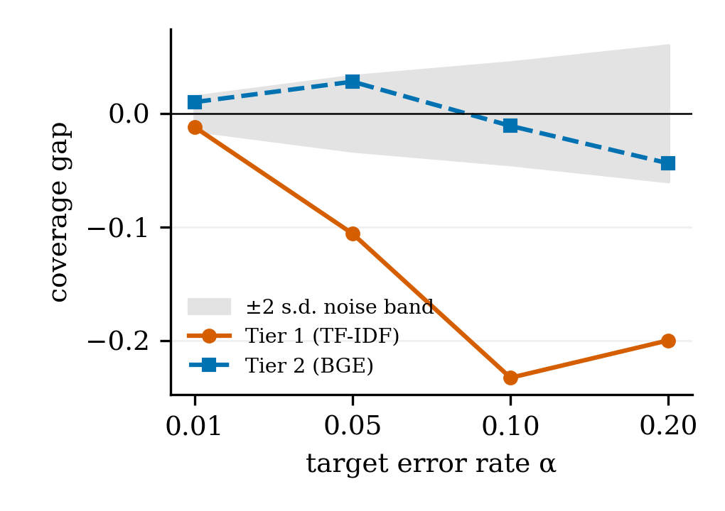
Fig. S1. Coverage gap on the out-of-template benchmark by representation and α, against the two-standard-deviation noise band. The same values are in Table IV of the paper.
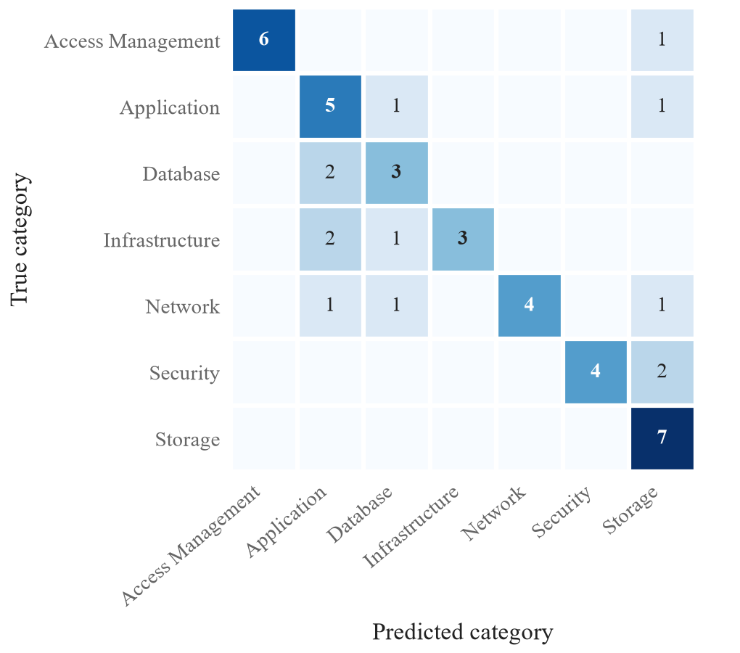
Fig. S2. Confusion matrix of the production cascade on the 45-ticket benchmark.
Examples of misrouted tickets. For example, N31 (Security: ransomware pop-ups demanding payment) was routed to Storage, N39 (Network: the VPN connection to the company portal fails) to Database, and N13 (Infrastructure: company websites down for the whole office) to Database.

