A PROJECT REPORT

ON

“Calibrated Escalation for IT Ticket Triage: A Two-Gate Retrieval-Augmented Pipeline”

A project report submitted in partial fulfillment of the requirements for the degree of Bachelor of Technology in Artificial Intelligence & Machine Learning

BACHELOR OF TECHNOLOGY IN ARTIFICIAL INTELLIGENCE & MACHINE LEARNING

Submitted By
Aryan Manoj Waingankar (PRN: 23070126022)
Shreyansh Pandey (PRN: 23070126120)
Parth Bagle (PRN: 23070126085)
Swapnil Samrat (PRN:27070125010)

UNDER THE GUIDANCE OF

Dr. Madhvi Saxena (Guide)

Assistant Professor, Department of AI & ML
Dr. Aditi Saxena (Co-guide),


Pune – 412115, Maharashtra State, India
https://www.sitpune.edu.in/

DEPARTMENT OF ARTIFICIAL INTELLIGENCE & MACHINE LEARNING
AY 2026-27

Pune – 412115, Maharashtra State, India
https://www.sitpune.edu.in/

DEPARTMENT OF ARTIFICIAL INTELLIGENCE & MACHINE LEARNING

CERTIFICATE
This is to certify that the project work entitled “Calibrated Escalation for IT Ticket Triage: A Two-Gate Retrieval-Augmented Pipeline” is carried out by Aryan Manoj Waingankar, Shreyansh Pandey, Parth Bagle and Swapnil Samrat in partial fulfilment for the award of the degree of Bachelor of Technology in Artificial Intelligence & Machine Learning, Symbiosis International (Deemed University), Pune, during the academic year 2026-2027.

Dr. Madhvi Saxena  Name and Signature of the Guide | Dr. Aditi Saxena  Name and Signature of the Co-Guide | Dr. Sumit Kumar  Head, Department of AI & ML

DECLARATION
We hereby declare that the project titled “Calibrated Escalation for IT Ticket Triage: A Two-Gate Retrieval-Augmented Pipeline” submitted to Symbiosis Institute of Technology, Constituent of Symbiosis International (Deemed University), Pune, for the award of the degree of Bachelor of Technology in Artificial Intelligence & Machine Learning is a result of original research carried out by us. We understand that our report may be made electronically available to the public. It is further declared that the project report or any part thereof has not been previously submitted to any University or Institute for the award of any degree or diploma.
Name(s) of Student(s) : Aryan Manoj Waingankar, Shreyansh Pandey, Parth Bagle, Swapnil Samrat
PRN: 23070126022, 23070126120, 23070126085, 27070125010
Degree: Bachelor of Technology in AI & ML
Department: Artificial Intelligence & Machine Learning
Title of the project : Calibrated Escalation for IT Ticket Triage: A Two-Gate Retrieval-Augmented Pipeline
_________________________________
(Signatures of the Students)
Date: 27/10 /2026

ACKNOWLEDGEMENT
We are sincerely grateful to our project guide, Dr. Madhvi Saxena, Assistant Professor, Department of Artificial Intelligence & Machine Learning, for her steady guidance throughout this work. Her insistence that every claim be backed by a measurement, and that results which did not work be reported as carefully as those that did, shaped both the project and this report.
We thank our co-guide, Dr. Aditi Saxena, for her reviews of our experiments and our paper, and for her suggestions on how to present the evaluation clearly.
We thank the Head of the Department, Dr. Sumit Kumar, for providing the facilities and the encouragement that made this project possible.
The problem we worked on comes from Use Case 1 of the nasscom hackathon brief on IT ticket routing and resolution. We thank the organisers for a well-specified problem statement that gave the project a clear starting point.
As a team, each of us thanks the others, Aryan Manoj Waingankar, Shreyansh Pandey, Parth Bagle and Swapnil Samrat, for their hard work and cooperation at every stage, including the evenings spent writing and cross-labelling test tickets.
We also thank our families and friends for their patience and support, and Symbiosis Institute of Technology, Pune, for giving us the opportunity to carry out this project.

ABSTRACT
When an employee raises an IT support ticket, a triage system must send it to the team that owns the problem and, just as importantly, recognise the tickets it should not handle on its own. This project builds and evaluates such a system for seven support teams, starting from Use Case 1 of the nasscom hackathon brief. The pipeline treats escalation to a human as a normal output. A fast TF-IDF classifier answers when its confidence is at least 0.50; otherwise a classifier over BGE sentence embeddings decides. The five most similar resolved tickets are then retrieved, and Gemini may draft a resolution only if the closest one has a cosine similarity of at least 0.67; below that the ticket goes to a person and no language model is called. Both thresholds were chosen from measured calibration data, and the report records the calibration attempts that were rejected.
On a 9-ticket adversarial set the retrieval gate decides every ticket correctly, against 3 of 9 without it. The cascade is not more accurate than the embedding classifier alone (32/45 against 33/45, p = 1.000), but it cuts median per-ticket latency by 8% to 18%. A zero-shot language model classifies the 45-ticket benchmark better (40/45) but offers no way to abstain. A human judged 31 of 33 drafts grounded in the retrieved tickets, while an LLM judge reached a Cohen's kappa of −0.042 against that human. On 108 tickets written and cross-labelled by two team members (kappa = 0.936) the cascade routes 74 of 98 correctly, but the gate also escalates 32 actionable tickets. On 583 distinct real tickets covering two teams, accuracy falls to 19.7% (50.4% under an alternative category mapping), and 371 of 468 misrouted tickets still pass the gate. The recurring lesson is that the data a component is trained or calibrated on limits it more than the method chosen.
The system is delivered as a FastAPI service, a Streamlit demonstration and a Docker image, with 456 automated tests.
Keywords: IT ticket triage; escalation; selective prediction; classification cascade; retrieval-augmented generation; conformal prediction; calibration; sentence embeddings

TABLE OF CONTENTS
CERTIFICATE i
DECLARATION ii
ACKNOWLEDGEMENT iii
ABSTRACT iv
TABLE OF CONTENTS v
LIST OF TABLES vii
LIST OF FIGURES viii
LIST OF ABBREVIATIONS ix
Chapter 1 Introduction 1
1.1 Introduction 1
1.2 Problem statement 2
1.3 Scope of research 3
1.4 Research hypothesis 4
1.5 Objectives 5
1.6 Organization of the report 5
Chapter 2 Literature Review 6
2.1 Background 6
2.1.1 Ticket triage and IT service management 6
2.1.2 Text classification: from TF-IDF to sentence embeddings 7
2.1.3 Classifier cascades, deferral and selective prediction 7
2.1.4 Conformal prediction and distribution shift 7
2.1.5 Retrieval-augmented generation and abstention 8
2.1.6 Large language models as judges 8
2.1.7 Synthetic data as training and evaluation data 8
2.1.8 Comparative analysis of existing approaches 8
2.2 Summary of literature review and research gap 11
Chapter 3 Software Requirements Specification 14
3.1 Software tools, platforms and frameworks 14
3.2 Hardware tools 15
3.3 Work breakdown structure 15
3.4 Functional requirements 17
3.5 Non-functional requirements 18
3.6 Project cost estimation 18
Chapter 4 Methodology 20
4.1 Dataset and splits 20
4.2 System architecture and workflow 21
4.3 Classification cascade and the 0.50 threshold 24
4.4 Retrieval, the 0.67 gate and grounded drafting 26
4.5 API, demo, Docker and CI 27
4.6 Testing and verification 28
4.7 Evaluation design 29
Chapter 5 Results and Discussion 31
5.1 Benchmark accuracy and classifier comparison 31
5.2 Cascade against Tier 2 alone, and latency 32
5.3 Zero-shot LLM baselines 33
5.4 The gates and the adversarial set 33
5.5 Conformal coverage 34
5.6 Groundedness, the LLM judge and the sufficiency rater 35
5.7 Results on the independent set 36
5.8 Results on real-world tickets 37
5.9 Error analysis 37
5.10 Summary of results and discussion 38
Chapter 6 Conclusion and Future Scope 40
6.1 Conclusion 40
6.2 Future Scope 41
References 42
Appendix A AIC Form 44
Appendix B Similarity Report 45
Appendix C AI Plagiarism Report 46
Appendix D Research Paper 47

LIST OF TABLES
Table 1.1: Elements of the nasscom Use Case 1 brief and the components that address them 3
Table 1.2: Research hypotheses and how each one is tested 4
Table 2.1: Comparative analysis of existing approaches for IT ticket triage 9
Table 2.2: Survey of the literature most relevant to this project 11
Table 2.3: Comparison of the closest related systems with this project 12
Table 3.1: Software tools and frameworks, with the versions pinned in requirements.txt 14
Table 3.2: Hardware used for development and measurement 15
Table 3.3: Project phases with dates from the git history 16
Table 3.4: Functional requirements and where each is implemented 17
Table 3.5: Non-functional requirements with measured values 18
Table 3.6: Actual cost of the project 19
Table 3.7: Estimated monthly cost of a small deployment (assumptions stated; not measured) 19
Table 4.1: Dataset splits and evaluation sets 21
Table 4.2: Attempt 3: Tier-1 confidence buckets on the 175 paraphrased calibration tickets 25
Table 4.3: HTTP endpoints of the FastAPI service 27
Table 4.4: The automated test suite, grouped by area 28
Table 4.5: Mapping of the real-world categories to our teams (English tickets) 30
Table 5.1: Accuracy of every classifier on the out-of-template sets 31
Table 5.2: The cascade against the control that isolates it (Tier 2 answering everything) 32
Table 5.3: Zero-shot language models against the trained Tier 2 (45-ticket benchmark) 33
Table 5.4: The adversarial set at the live gates 34
Table 5.5: Coverage gap on the 45-ticket benchmark; only the calibration set differs between the two gap columns 34
Table 5.6: Draft quality and the two automated raters (33 drafts) 36
Table 5.7: Results on the independent author-written set (pipeline unchanged) 36
Table 5.8: Real-world results, 583 distinct texts, under the primary and the sensitivity mapping 37
Table 5.9: Error taxonomy of the live pipeline 38
Table 5.10: Outcome of each research hypothesis 39

LIST OF FIGURES
Figure 1.1: The life of a support ticket. A confident but wrong routing decision sends the ticket into a reassignment loop, and each transfer adds a queue wait before any work starts. 1
Figure 2.1: The research areas that this project draws on. Each surrounding area contributes a method or a caution; the project combines them in one ticket-triage pipeline. 6
Figure 2.2: Taxonomy of related work, grouped by the job each approach does in a triage system. 9
Figure 3.1: Work breakdown structure of the project. Six streams, each broken into four work packages. 16
Figure 3.2: Project timeline. Each bar runs from the first to the last commit of a phase. 17
Figure 4.1: Profile of the 4,000-ticket synthetic corpus: (a) tickets per category, (b) priority mix within each category. 20
Figure 4.2: Overall system architecture: data, model, agent, service and presentation layers, with the offline automation-flagging path and the DevOps layer. 22
Figure 4.3: End-to-end workflow of one ticket through both gates. 23
Figure 4.4: Sequence diagram of one POST /triage request. 24
Figure 4.5: Project development workflow. 24
Figure 4.6: Cascade threshold calibration on the 175 paraphrased tickets: share kept by Tier 1 and accuracy of the kept tickets. The dashed line marks the live threshold of 0.50. 25
Figure 4.7: Retrieval threshold sweep: in-domain proceed rate and out-of-domain leakage. The shaded band is the adversarial safe range; the dashed line marks 0.67. 26
Figure 4.8: Top-1 similarity of the nine adversarial tickets against the 0.67 gate. Circles must escalate, squares must proceed; the shaded band is the safe range. 26
Figure 4.9: The Streamlit demo on an off-topic ticket that is escalated (left) and on a VPN ticket that receives a grounded draft (right). 28
Figure 4.10: Data and evaluation pipeline: which data fit the models, which calibrate the thresholds, which evaluate the unchanged system, and what is measured. 29
Figure 5.1: Accuracy on the 45-ticket out-of-template benchmark, with Wilson 95% intervals where the result file records one. 32
Figure 5.2: Median per-ticket latency (warm, batch size 1, Intel Core i5-1334U). 33
Figure 5.3: Coverage gap on the out-of-template benchmark by representation and α, against the two-standard-deviation noise band. 35
Figure 5.4: Confusion matrix of the production cascade on the 45-ticket benchmark. 38
Figure 5.5: Cascade routing accuracy with Wilson 95% intervals on every evaluation set. 39

LIST OF ABBREVIATIONS
Abbreviation | Meaning
α | Target error rate (miscoverage level) in conformal prediction
κ | Cohen's kappa, chance-corrected agreement between two annotators
AI | Artificial Intelligence
API | Application Programming Interface
AUC | Area Under the (ROC) Curve
AURC | Area Under the Risk–Coverage curve
BERT | Bidirectional Encoder Representations from Transformers
BGE | BAAI General Embedding (bge-base-en-v1.5 in this project)
CC BY | Creative Commons Attribution licence
CI | Confidence interval (statistics); continuous integration (software)
CPU | Central Processing Unit
CSV | Comma-Separated Values
DiD | Difference-in-differences
ECE | Expected Calibration Error
FAISS | Facebook AI Similarity Search (vector-search library)
FR | Functional Requirement
GPU | Graphics Processing Unit
HTTP | Hypertext Transfer Protocol
ITSM | IT Service Management
JSON | JavaScript Object Notation
KS | Kolmogorov–Smirnov (test)
LLM | Large Language Model
LogReg | Logistic Regression
ML | Machine Learning
NFR | Non-Functional Requirement
NLP | Natural Language Processing
OOD | Out-of-Domain
RAG | Retrieval-Augmented Generation
RAM | Random-Access Memory
SDK | Software Development Kit
SRS | Software Requirements Specification
TF-IDF | Term Frequency–Inverse Document Frequency
UI | User Interface
WBS | Work Breakdown Structure

Chapter 1
Introduction

1.1 Introduction
Every medium or large organisation runs an IT service desk. Employees report problems such as a laptop that will not join the VPN, a slow database query or a shared folder they can no longer open, and each report becomes a ticket with a short title, a free-text description and, once closed, a resolution note. Behind the desk sit specialist teams for networks, databases, security, storage and so on. The desk's first job is triage: deciding which team owns the problem and placing the ticket in that team's queue.
Triage creates much of the delay in IT support. Users describe a symptom ("nothing loads since this morning"), not a cause ("the DNS server is down"), and one symptom can belong to several teams. A ticket in the wrong queue waits until someone there reads it, decides it is not theirs and passes it on, and every transfer adds another queue wait. Figure 1.1 shows this loop: a confident but wrong routing decision costs more than one that admits uncertainty and asks a person, because the error is discovered only after the wait.
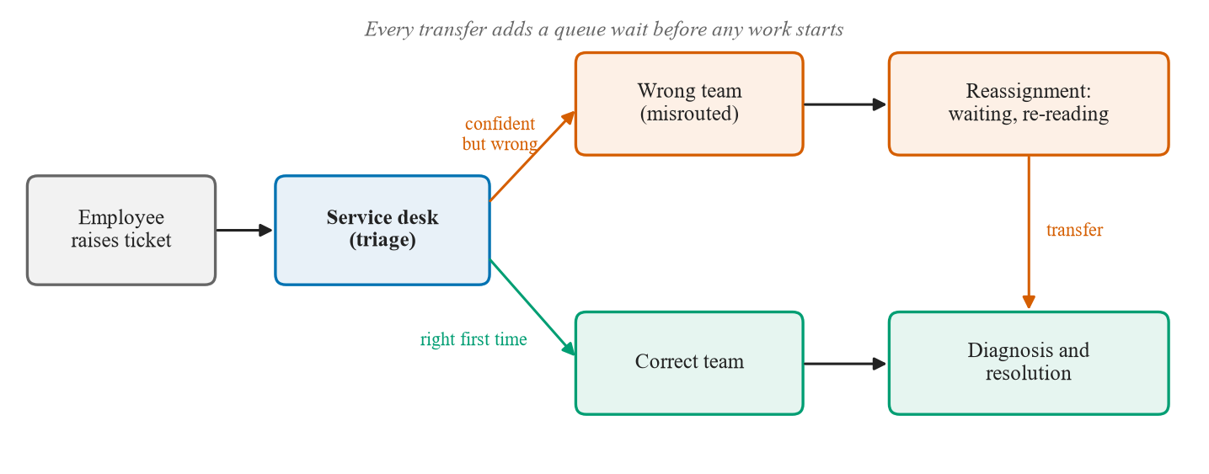
Figure 1.1: The life of a support ticket. A confident but wrong routing decision sends the ticket into a reassignment loop, and each transfer adds a queue wait before any work starts.
Automating triage with machine learning has been studied for many years [1], and modern language models can also draft a suggested fix. Most published work, however, reports only the share of tickets routed correctly. That hides the practical question: what does the system do with the tickets it is likely to get wrong? A classifier that is 75% accurate and silently guesses on the rest recreates the reassignment loop; the same classifier, if it hands a large part of its mistakes to a human, is far more useful. Drafted resolutions raise the same concern more sharply. A large language model (LLM) writes fluent, confident text whether or not it has a basis for it. Retrieval-augmented generation (RAG) [2] grounds the model in similar past cases, but only helps when the retrieved cases are relevant.
This project therefore treats escalation to a human as a first-class output. Our pipeline has two decision points, or gates. The first decides whether a fast classifier is confident enough to assign the team alone or whether a slower, stronger classifier must be consulted. The second decides whether the retrieved past tickets are similar enough for a language model to draft a resolution at all; if not, the ticket goes to a person and no language model is called. Each gate is a single threshold, and the central question is how to choose those thresholds from evidence rather than intuition. The work began as our final-year B.Tech project and grew into a research study written up as an IEEE-style paper; results that did not turn out as expected are reported as carefully as the positive ones.

1.2 Problem statement
The project is based on Use Case 1 of the nasscom hackathon brief, which asks for an AI-assisted agent that routes IT support tickets and suggests resolutions. The brief fixed:
- Seven support categories, treated as seven teams: Access Management, Application, Database, Infrastructure, Network, Security and Storage.
- Routing, resolution suggestion based on similar past tickets, confidence-based escalation to a human, and automation flagging of recurring issues.
- Data: a synthetic dataset generated with a language model, about 1,000 tickets with the fields title, description, category, resolution and priority.
Table 1.1 maps each element of the brief to a component of our system.
Table 1.1: Elements of the nasscom Use Case 1 brief and the components that address them
Element of the brief | Component in this project | Described in
Seven categories | Fixed label set used by every classifier and dataset | Section 4.1
Routing | Two-tier classification cascade (TF-IDF, then BGE) | Section 4.3
Resolution suggestion | FAISS retrieval of five similar tickets and grounded drafting with Gemini | Section 4.4
Confidence-based escalation | Cascade confidence gate (0.50) and retrieval similarity gate (0.67) | Section 4.3, Section 4.4
Automation flagging | Offline clustering of resolution texts at a similarity of 0.80 | Section 4.2
Synthetic dataset | 4,000 template-generated tickets with the five fields | Section 4.1

Stated as one problem: given the text of a new IT ticket, assign it to one of seven teams and, when it is safe, draft a resolution grounded in similar past tickets; whenever either step is likely to be wrong, escalate the ticket to a human instead of guessing. Mature tools exist for each component, so the difficulty lies in deciding when the system should act and showing with data that those decisions are sound. The brief asks for confidence-based escalation without saying how confidence should be measured or where the cut-off belongs, and it recommends synthetic data, which limits what any accuracy measured on it can mean. We therefore treated the corpus itself as an object of study (Sections 4.1 and 5.10).

1.3 Scope of research
The scope was set by the brief, by one academic year, and by our hardware, an ordinary laptop without a graphics card.
In scope
- English tickets (title and description) routed to the seven teams of the brief, through a complete pipeline: classification, retrieval, escalation, grounded drafting and offline automation flagging, exposed as an HTTP service and a demonstration interface.
- Calibration of both thresholds from measured data, including rejected attempts, and evaluation on out-of-template benchmarks, an adversarial escalation set, 108 tickets written by two team members and real user tickets from a public dataset.
- Comparisons that put the design in context (gate ablations, zero-shot LLM baselines, an audited LLM judge, conformal prediction and drift monitoring), and engineering practices that make every number reproducible.
Out of scope
- Live deployment: no real ticket stream has passed through the system and no engineer has acted on its output.
- Languages other than English, attachments and conversation threads; predicting priority or assigning individual engineers; training or fine-tuning large language models; formal user studies.

1.4 Research hypothesis
The project was framed around five testable hypotheses, each tied to one of the gates or to the data used to fit and calibrate them (Table 1.2). Chapter 5 reports the outcomes, and Table 5.10 summarises the verdicts.
Table 1.2: Research hypotheses and how each one is tested
No. | Hypothesis | Measurable prediction | Tested in
H1 | One threshold on the top-1 retrieval similarity, chosen from in-domain and out-of-domain calibration tickets, decides escalation better than no gate | More adversarial tickets decided correctly with the gate than without | Gate ablation; similarity sweep (Section 5.4)
H2 | Letting the fast lexical classifier answer above a calibrated confidence reduces latency without reducing accuracy | Lower median latency; accuracy indistinguishable from Tier 2 alone | Exact McNemar; latency (Section 5.2)
H3 | Coverage calibrated on paraphrased training tickets transfers to out-of-template text for embeddings but not for TF-IDF; the calibration distribution matters more than the method | Gap at α = 0.10 inside the noise band for BGE, outside it for TF-IDF | Split conformal prediction (Section 5.5)
H4 | A classifier trained only on templates keeps its accuracy on human-written and real tickets | Accuracy close to the benchmark | 108 author-written and 583 real tickets (Section 5.7, Section 5.8)
H5 | Drafts above the gate are grounded, and an LLM judge can replace the human check | Most drafts grounded; judge agrees beyond chance | 33 human-labelled drafts; Cohen's kappa (Section 5.6)

The hypotheses were written so that a negative outcome would be informative. H4 was expected to fail in some form; the questions were how badly, and whether the gates would catch the resulting errors.

1.5 Objectives
- Build a synthetic corpus that follows the nasscom brief and measure what it can and cannot support.
- Develop a two-tier cascade (TF-IDF backed by BGE embeddings) with a confidence threshold chosen from calibration data.
- Build retrieval over past tickets with FAISS and a Gemini drafting step allowed only above a calibrated similarity threshold.
- Evaluate both gates on out-of-template benchmarks and an adversarial set, with ablations that isolate each gate.
- Compare the pipeline with zero-shot language models and audit an LLM judge of draft quality.
- Study conformal prediction and drift monitoring as principled alternatives or additions to the fixed thresholds.
- Test the unchanged pipeline on tickets no language model wrote: an independent, cross-labelled set and real user tickets.
- Package the system as a tested HTTP service, a demonstration interface and a container image, with every number reproducible from committed files.

1.6 Organization of the report
Chapter 2 reviews the literature and compares existing approaches, ending with the research gap. Chapter 3 specifies the requirements, tools, work breakdown and cost. Chapter 4 describes the methodology: data, architecture and workflow, both gates, the service and deployment, testing, and the evaluation design. Chapter 5 presents every result, including the negative ones, with an error analysis and a summary. Chapter 6 concludes and outlines future work. References and appendices follow.

Chapter 2
Literature Review

2.1 Background
Our system draws on several research areas (Figure 2.1): ticket triage in IT service management, text classification, classifier cascades and selective prediction, conformal prediction, retrieval-augmented generation with abstention, language models as judges, and synthetic benchmarks. The subsections below review each briefly, and Section 2.1.8 compares the approaches side by side.
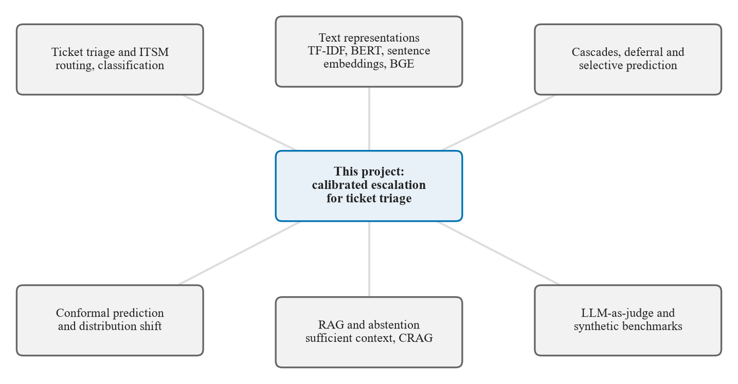
Figure 2.1: The research areas that this project draws on. Each surrounding area contributes a method or a caution; the project combines them in one ticket-triage pipeline.

2.1.1 Ticket triage and IT service management
Early work on automated routing did not read the ticket text. Shao et al. [1] fitted a Markov model to the sequences of groups that historical tickets passed through and showed that the resolving group could often be reached with fewer transfers than human dispatchers needed, which confirms that reassignment is a measurable cost. Diao et al. [3] let experts author classification rules on a shared platform and found, on data from several IT delivery centres, that rules balance accuracy against the cost of labelling when pre-classified tickets are scarce. Recent systems use large language models. TickIt [4], deployed on ByteDance's Volcano Engine platform, keeps ticket state up to date, routes tickets to suitable teams and fine-tunes a model with category guidance; there, "escalation" means moving a ticket between teams. Paket et al. [5] compared language models with BERT on Turkish service-desk tickets in 172 classes. Carroll et al. [6] evaluated GPT-4o, with and without retrieval over documentation, on 90 REDCap support tickets: agreement with experts on complexity was high (kappa around 0.85), 81–89% of tickets were categorised correctly, and the authors still recommended human oversight. These studies report accuracy but rarely say what to do with tickets the system is likely to get wrong.

2.1.2 Text classification: from TF-IDF to sentence embeddings
TF-IDF weighting with a linear classifier is the classic baseline for short text: Salton and Buckley [7] showed that weighting terms by in-document frequency, discounting common terms and normalising length works well across collections, and Joachims [8] showed that support vector machines on such features gave substantial gains for text categorisation. These features match words, not meaning, so "can't get on the internet" shares nothing with "network connectivity outage". Our Tier 1 is a TF-IDF logistic regression built with scikit-learn [9]. Transformers such as BERT [10] capture meaning, with cheaper distilled versions such as DistilBERT [11] and MiniLM [12]; Sentence-BERT [13], E5 [14] and BGE [15] produce sentence vectors that can be compared directly. We use bge-base-en-v1.5 (768 dimensions) for Tier 2 and retrieval. Cosine similarities are not comparable across embedding models, so a threshold such as 0.67 is meaningful only for the model it was calibrated on.

2.1.3 Classifier cascades, deferral and selective prediction
A cascade runs a cheap model first and passes difficult inputs to an expensive one, as in Viola and Jones's face detector [16]. Deciding when to pass on is selective prediction: Chow [17] showed that, with known posteriors, rejecting below a confidence threshold is optimal for a given rejection rate, and Geifman and El-Yaniv [18] chose such thresholds on held-out data to guarantee risk on deep networks. Guo et al. [19] showed that modern networks are often poorly calibrated. Jitkrittum et al. [20] found that confidence-based deferral can fail under specialisation, label noise or distribution shift; Conformal Cascade [21] defers unless a conformal set is a single label; and Fanconi and van der Schaar [22] end the cascade with abstention to a human expert. These are evaluated on question answering, and none gates generation on retrieved evidence.

2.1.4 Conformal prediction and distribution shift
Conformal prediction [23], [24] turns a classifier's output into a label set that contains the true label with probability at least 1 − α, provided calibration and test data are exchangeable. In the split version, an empirical quantile of nonconformity scores on a calibration set becomes the threshold. Tibshirani et al. [25] restore the guarantee under covariate shift by likelihood-ratio weighting, Barber et al. [26] bound the loss when exchangeability fails, and Gibbs and Candès [27] adapt online. Drift detection [28], [29] likewise needs a reference sample of normal traffic.

2.1.5 Retrieval-augmented generation and abstention
RAG [2] gives a generator the passages most relevant to a query and improved open-domain question answering. Nearest-neighbour search at scale uses libraries such as FAISS [30], which indexes our 4,000 past tickets. RAG helps only when the context is relevant: Joren et al. [31] found that large models tend to answer wrongly rather than abstain when context is insufficient, and that a sufficiency signal improves selective answering; Corrective RAG [32] scores retrieved documents and triggers corrective actions. Our gate is a simpler version of this idea (Section 5.6).

2.1.6 Large language models as judges
Zheng et al. [33] found that GPT-4 agreed with human preferences more than 80% of the time but showed position and length biases. Jung et al. [34] escalate to a stronger model or a human when the judge is unsure, and Jain et al. [35] found that judges accepted valid outputs more than 96% of the time but rejected invalid ones less than 25% of the time. Agreement should be reported with Cohen's kappa [36], which corrects for chance; a judge that calls almost everything "good" can reach high raw agreement while carrying no information, as we observed (Section 5.6).

2.1.7 Synthetic data as training and evaluation data
Maheshwari et al. [37] found that LLM-generated benchmarks rank methods well for simple tasks such as intent classification but less well for harder ones, and that a smaller model generating the data is favoured when it also performs the task. This matters for our zero-shot comparison, because our 45-ticket benchmark was written with Gemini (Section 5.3). Public real-ticket data rarely match a given set of teams: the Zenodo dataset of Pereira [38], our real-world test set, has seven different categories and several languages, so we filtered it to English with langid.py [39] (Section 4.7).

2.1.8 Comparative analysis of existing approaches
Figure 2.2 arranges the related work into a taxonomy by the job each approach does in a triage system: routing a ticket, supporting its resolution, deciding when to stop, or evaluating outputs. Table 2.1 compares the main families of approach for IT triage, and the paragraphs below discuss the eight most relevant ones.
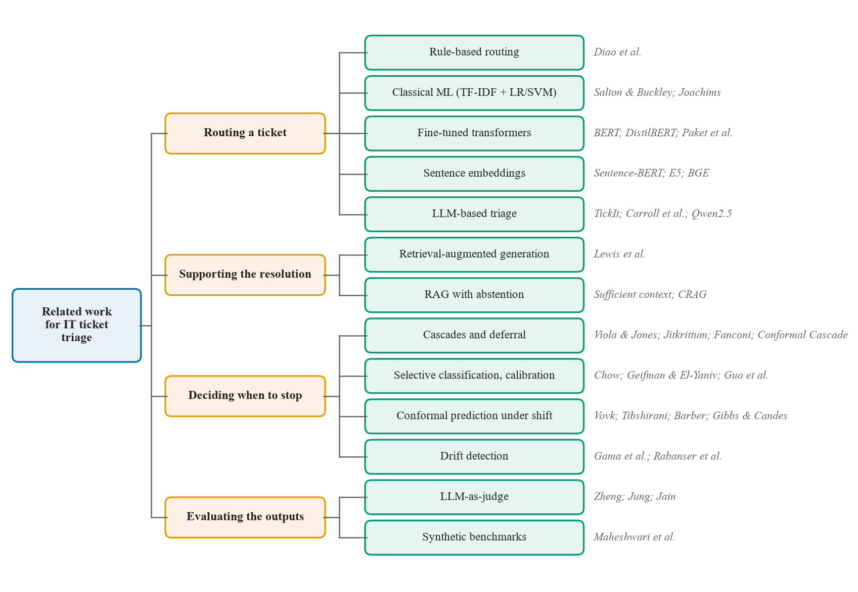
Figure 2.2: Taxonomy of related work, grouped by the job each approach does in a triage system.
Table 2.1: Comparative analysis of existing approaches for IT ticket triage
Approach | Example works | Strengths | Weaknesses for IT triage
Keyword or rule-based routing | Diao et al. [3] | Transparent; needs no labelled data; experts encode known patterns | Brittle to new wording; rules grow and conflict; no confidence measure
Classical ML (TF-IDF + LR or SVM) | [7], [8], [9] | Fast (about 1 ms per ticket here), cheap to train, probabilistic output | Matches words, not meaning; overfits template vocabulary
Fine-tuned transformers | BERT [10], DistilBERT [11], Paket et al. [5] | Capture meaning; strong with enough labelled data | Costly to train; overfit small or narrow corpora
Frozen sentence embeddings + linear head | Sentence-BERT [13], E5 [14], BGE [15] | Robust to paraphrase; no fine-tuning; same vectors serve retrieval | Slower than TF-IDF; similarity scale differs per model
Zero-shot LLM classification | Carroll et al. [6], Qwen2.5 [40] | No training data; handles unseen phrasing well | No calibrated abstention; cost and quota per call; outputs vary
Retrieval-augmented generation | RAG [2], sufficient context [31], CRAG [32] | Grounds drafts in past fixes | Fluent but unsupported answers when retrieval is poor
Cascades and deferral | [16], [20], [22], [21] | Save cost; can end with a human | Confidence can mislead under shift; evaluated mostly on QA benchmarks
Conformal prediction | [23], [24], [25] | Finite-sample coverage guarantee | Guarantee needs exchangeable data; marginal only
LLM-as-judge | [33], [34], [35] | Scales evaluation of free text | Biased toward approval; must be audited against humans

Keyword or rule-based routing. Rules such as "if the text mentions password, route to Access Management" are easy to inspect and need no training data, which is why expert-authored rules remain attractive when labelled tickets are scarce [3]. Their weakness is the user's vocabulary: a rule cannot anticipate every phrasing, and a growing rule base becomes hard to maintain. A rule also gives no measure of confidence, so it cannot drive escalation.
Classical machine learning. A TF-IDF representation with logistic regression or a support vector machine [7], [8] learns the rules from data and outputs class probabilities. It is extremely fast, which makes it attractive as a first stage, but it inherits the vocabulary of its training data; on our template-generated corpus it scores 100% in distribution yet only 16/45 on out-of-template tickets (Section 5.1).
Fine-tuned transformers. Fine-tuning BERT-style models [10], [11] gives representations that understand paraphrase and has been compared with LLMs for service-desk classification [5]. On small, narrow corpora they overfit; our fine-tuned DistilBERT scored 18/45 and 21/45 in two runs, well below a frozen encoder.
Frozen sentence embeddings. Encoders trained for sentence similarity [13]–[15] can be used without fine-tuning, with a linear classifier on top. The same vectors also drive retrieval, which keeps the system simple. Their cost is speed (156.4 ms per ticket on our CPU against 1.04 ms for TF-IDF) and a similarity scale that is specific to each model.
Zero-shot LLM classification. A prompted language model needs no training data and handles unseen phrasing well; Carroll et al. [6] report 81–89% correct categories, and on our benchmark Gemini scored 40/45 (Section 5.3). But it offers no calibrated way to abstain, each call costs time and quota, and its authorship overlap with a Gemini-written benchmark complicates comparison [37].
Retrieval-augmented generation. Grounding drafts in retrieved past fixes [2] is the natural way to suggest resolutions from ticket history. Its risk is the case where retrieval fails: the model still writes something. Sufficiency raters [31] and corrective retrieval [32] address this with additional models; our design uses a single similarity threshold and tests a sufficiency rater against it.
Cascades and deferral. Running a cheap model first and deferring hard cases [16], [20] saves cost, and recent work ends the chain with a human [22] or uses conformal sets to defer [21]. Their guarantees and evaluations assume data like the calibration data, and they have been tested on question answering rather than support tickets.
Conformal prediction. Conformal methods [23], [24] add a finite-sample coverage guarantee to any classifier and can be reweighted for covariate shift [25]. The guarantee is marginal and requires exchangeability, which is exactly what a change in writing style breaks (Section 5.5).
LLM-as-judge. Using a language model to grade drafts [33] scales evaluation, but judges lean toward approval [35] and should escalate when unsure [34]. In our audit, a judge agreed with the human on 30/33 drafts yet reached a kappa below zero (Section 5.6).

2.2 Summary of literature review and research gap
Table 2.2 summarises twenty of the works discussed above, based on each paper's published abstract.
Table 2.2: Survey of the literature most relevant to this project
Work | Year | Method | Data | Key finding | Limitation for our problem
Shao et al. [1] | 2008 | Markov model over ticket-transfer sequences | Historical enterprise ticket-transfer records | Resolver group often reached with fewer transfers than human dispatch | Ignores ticket text; no abstention
TickIt [4] | 2025 | LLM-based online escalation with category-guided fine-tuning | Volcano Engine cloud platform; 20,000+ tickets analysed | Deployed and validated in production | Proprietary data; "escalation" re-routes between teams
Carroll et al. [6] | 2026 | GPT-4o with and without RAG over documentation | 90 REDCap tickets from one medical centre | Kappa about 0.85 on complexity; 81–89% correct category | Single institution, small sample; oversight still needed
BERT [10] | 2019 | Bidirectional transformer pre-training, then fine-tuning | GLUE, SQuAD and other benchmarks | Improved results on eleven NLP tasks | Costly to fine-tune; no direct sentence embedding
Sentence-BERT [13] | 2019 | Siamese fine-tuning for sentence embeddings | NLI data; similarity benchmarks | Similar-pair search over 10,000 sentences in about 5 s instead of 65 h | Quality depends on training domain
DistilBERT [11] | 2019 | Knowledge distillation of BERT | GLUE and other benchmarks | 40% smaller, 60% faster, 97% of BERT's performance | Needs fine-tuning, which can overfit narrow data
BGE / C-Pack [15] | 2024 | Large-scale contrastive training of embeddings | C-MTEB and English counterparts | Among the strongest general embeddings at release | Similarities model-specific; thresholds must be recalibrated
Selective classification [18] | 2017 | Confidence threshold for a guaranteed risk | CIFAR-10/100, ImageNet | 2% top-5 error with 99.9% probability at about 60% coverage | Assumes test data match threshold data
Calibration [19] | 2017 | Measuring calibration; temperature scaling | Image and text classification | Modern networks poorly calibrated; temperature scaling helps | Fixed in distribution only
Jitkrittum et al. [20] | 2023 | Theory of optimal deferral; post-hoc deferral | Classifier cascades | Confidence deferral fails under specialisation, label noise or shift | Deferral between models, not to a human
Conformal Cascade [21] | 2026 | Conformal set size as the deferral rule | 18 multiple-choice benchmarks | Beats the strongest heuristic cascade on most pairs | Multiple-choice only
Fanconi et al. [22] | 2025 | Base model, larger model, then human | ARC, MMLU, MedQA, MedMCQA | More accurate than single models at lower cost | Question answering, not tickets
Split conformal [23], [24] | 2005, 2023 | Calibrated prediction sets | General | Marginal coverage at least 1 − α under exchangeability | Breaks when data change style
Weighted conformal [25] | 2019 | Likelihood-ratio weighting of calibration points | Simulated and real regression data | Restores coverage under covariate shift | Needs a density ratio; ill-posed when domains separate
Dataset-shift detection [29] | 2019 | Dimensionality reduction plus two-sample tests | Image classification benchmarks | Tests on a pre-trained classifier's outputs work best | Needs a reference sample of normal traffic
RAG [2] | 2020 | Seq2seq generator with dense retriever | Open-domain QA, fact checking | Best results on three open-domain QA tasks | No abstention when retrieval fails
Sufficient context [31] | 2025 | Context-sufficiency rater and selective generation | Several LLMs and QA datasets | Large models answer wrongly instead of abstaining | Depends on an LLM rater
CRAG [32] | 2024 | Retrieval evaluator triggers corrective actions | Four generation tasks | Improves RAG methods significantly | Corrects retrieval rather than handing off
LLM-as-judge [33] | 2023 | Strong LLMs judging chatbot answers | MT-Bench, Chatbot Arena | Over 80% agreement with human preferences | Position, length and self-preference biases
Agreeableness bias [35] | 2025 | Minority-veto ensemble; regression on human labels | Feedback on student programs | Judges accept valid outputs (>96%), reject invalid ones rarely (<25%) | One task domain

Three themes emerge: escalation is usually treated as routing, not abstention; methods that decide when to stop carry guarantees that hold only when test data resemble calibration data and were evaluated mainly on question answering or images; and abstention in RAG relies on LLM raters that need checking against people. Table 2.3 compares the closest systems with ours.
Table 2.3: Comparison of the closest related systems with this project
Work | Task | How it escalates or abstains | Evaluated on
TickIt [4] | Online ticket escalation | Routes the ticket to another support team | Production deployment on Volcano Engine
Carroll et al. [6] | Ticket triage and drafting | Not stated in the abstract; human oversight recommended | Real REDCap tickets, rated by experts
Jitkrittum et al. [20] | Classifier cascade | Confidence-based and post-hoc deferral | Classification benchmarks
Conformal Cascade [21] | Multi-tier LLM inference | Defers unless the conformal set is a single label | Multiple-choice benchmarks
Fanconi et al. [22] | Human–AI decision making | Defers to a larger model, then abstains to a human | General and medical QA
Sufficient context [31] | RAG error analysis | Abstains when a rater finds context insufficient | Several models and datasets
CRAG [32] | Robust RAG | Evaluator triggers corrective retrieval | Generation tasks
This project | IT ticket triage into seven teams | Two thresholds calibrated on measured data: a confidence gate and a retrieval gate that blocks drafting | Synthetic corpus; out-of-template and adversarial sets; 108 author-written tickets; 583 real tickets [38]

Research gap
No work we found combines, for ticket triage, (i) a classification cascade whose threshold is chosen from measured calibration data, (ii) a separate retrieval-similarity gate that decides whether a language model may draft at all, and (iii) an evaluation that reports where both gates fail and why. The guarantees of conformal and selective methods have not, to our knowledge, been tested on the shift that matters for tickets, a change in how people write, and whether a cheap similarity threshold suffices compared with an LLM rater has not been studied with human labels in this setting.
How this project addresses the gap
We build the two-gate pipeline and calibrate each threshold separately, recording rejected attempts (Sections 4.3 and 4.4); test the gates with ablations, an adversarial set and conformal alternatives (Sections 5.4 and 5.5); audit the language-model components, namely zero-shot classifiers, an LLM judge and a sufficiency rater (Sections 5.3 and 5.6); and evaluate the unchanged system on tickets that no language model wrote, reporting the negative result openly (Sections 5.7 and 5.8).

Chapter 3
Software Requirements Specification
This chapter specifies the software and hardware used, the work breakdown and schedule, the functional and non-functional requirements, and the cost of the project. Measured values are given with their sources.

3.1 Software tools, platforms and frameworks
The system is written in Python, and every library version is pinned in requirements.txt because a newer release could change a published number silently (Table 3.1).
Table 3.1: Software tools and frameworks, with the versions pinned in requirements.txt
Tool or library | Version | Role in the project
Python | 3.14.3 | Pipeline, experiments and tests
scikit-learn | 1.9.0 | TF-IDF vectoriser and logistic regression for both cascade tiers; metrics
sentence-transformers | 5.6.1 | Loads the BGE encoder (BAAI/bge-base-en-v1.5) and comparison encoders
transformers / torch | 5.14.1 / 2.13.0 | Encoder back end; DistilBERT baseline (CPU build)
faiss-cpu | 1.14.3 | Inner-product index over 4,000 normalised ticket embeddings
numpy, pandas, scipy | 2.5.1, 3.0.5, 1.18.0 | Data handling; statistical tests in the drift module
google-genai | 2.14.0 | Gemini SDK; gemini-flash-lite-latest drafts resolutions and is a zero-shot baseline
Ollama + Qwen2.5-3B | Ollama 0.40.8 at the time of writing; qwen2.5:3b-instruct | Local, free zero-shot baseline and second rater on the laptop CPU
pydantic | 2.13.4 | Frozen typed configuration; schema of every pipeline stage
FastAPI / uvicorn | 0.140.0 / 0.51.0 | HTTP service with per-agent endpoints and /triage
Streamlit, matplotlib | 1.60.0, 3.11.1 | Demonstration interface; all figures
pytest, pytest-cov, httpx | 9.1.1, 7.1.0, 0.28.1 | Offline test suite (456 tests)
langid, huggingface-hub | 1.1.6, 1.24.0 | English filter for real tickets; pinned download of an external corpus
Docker | python:3.14.3-slim, pinned by digest | Container that builds its own artifacts
GitHub Actions | ubuntu-latest | ci.yml on every push; gates.yml on demand
python-docx, Playwright | 1.2.0, 1.64.1 | Building this report and its screenshots (not part of the system)

We use the current unified google-genai SDK, not the deprecated google-generativeai. The Gemini free tier allows 15 requests per minute and 500 per day, so every calling script waits at least four seconds between calls, dry-runs first and caches each raw response on disk. The local Qwen2.5-3B model [40] costs nothing and, since it wrote none of our evaluation sets, partly controls for the fact that our main benchmark was written with Gemini.

3.2 Hardware tools
All development and measurement used one laptop (Table 3.2). CPU, core count, operating system and Python version are recorded by the latency script; the memory size is stated by the team.
Table 3.2: Hardware used for development and measurement
Component | Specification
Processor | 13th Gen Intel Core i5-1334U, 12 logical CPUs
Memory | 16 GB RAM
Graphics | Integrated only; no discrete GPU is used by any part of the pipeline
Operating system | Windows 11
Continuous integration | GitHub-hosted Linux runners (ubuntu-latest)

No GPU is needed: the heaviest live step, encoding a ticket with BGE, takes a median of 156.4 ms on this CPU. Memory was the real constraint: a local language model and BGE running together once got an experiment killed, so a local model is unloaded before embedding work and refuses to start below a free-memory floor.

3.3 Work breakdown structure
The work was organised into six streams (Figure 3.1) and delivered in numbered phases. Each phase opened with a written plan reviewed before coding and closed with a report at a review gate, which made it natural to record results that did not work out.
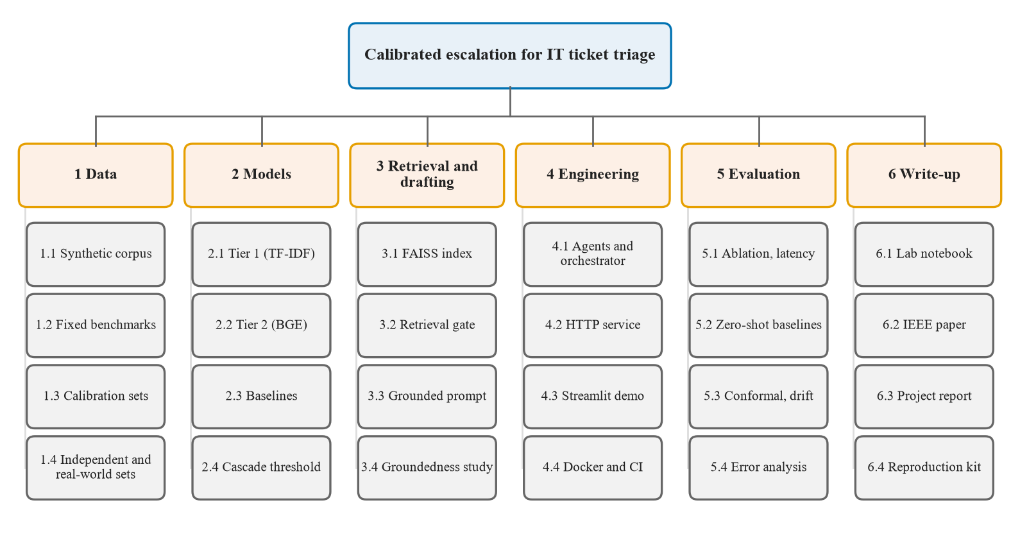
Figure 3.1: Work breakdown structure of the project. Six streams, each broken into four work packages.
Table 3.3 lists the phases with the dates of their first and last commits from the git history, and Figure 3.2 shows them as a timeline.
Table 3.3: Project phases with dates from the git history
Phase | Dates (2026) | Main work and outcome
Prototype | 28 Jul – 15 Aug | Dataset generator (scaled to 4,000 tickets), TF-IDF, MiniLM and DistilBERT classifiers, FAISS retrieval with Gemini drafting, Streamlit demo, cascade calibration, clustering, benchmark and adversarial sets
Embedding migration | 26 Aug – 1 Sep | Encoder moved from MiniLM to BGE; retrieval threshold recalibrated to 0.67
Phase 0 | 13 Sep | Four duplicated pipeline copies consolidated into one package
Phases 1–2 | 14 Sep | Conformal prediction; automation-flag validation; groundedness study and judge audit
Phase 3 | 14–15 Sep | Persisted Tier 1; agents and orchestrator; HTTP service
Phase 4 | 15–20 Sep | Decision log; drift detector and its evaluation (measured, not shipped)
Phase 5 | 20–21 Sep | Template-grouping correction; controlled cascade ablation; zero-shot baselines
Phase 6 | 21–22 Sep | Conformal deferral; weighted conformal; sufficiency rater
Phase 7 | 22 Sep | External-validity experiments
Phase 8 | 22–23 Sep | Paper numbers generated from committed files; Docker and CI
Phase 9 | 23–28 Sep | IEEE paper, audit, release v1.0, guide's revisions
Paper revision | 19–23 Oct | Independent set, real-world tickets, error analysis, paper v4
Project report | 25–28 Oct | This report

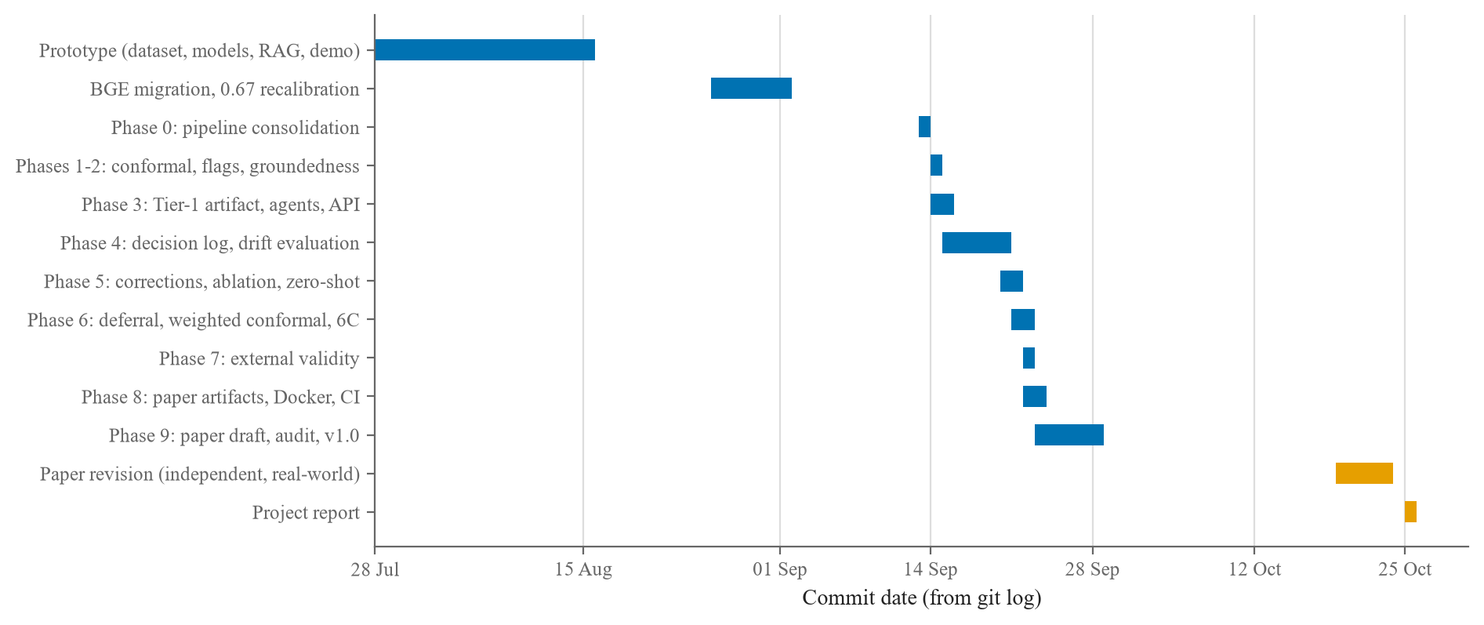
Figure 3.2: Project timeline. Each bar runs from the first to the last commit of a phase.

3.4 Functional requirements
Table 3.4 lists what the system must do and traces each requirement to the endpoint, agent or orchestrator that implements it (architecture in Section 4.2).
Table 3.4: Functional requirements and where each is implemented
ID | Requirement | Implemented by
FR-1 | Accept a ticket (title, description, optional identifier) and validate it against a typed schema | TicketIn; POST /triage, /agents/*
FR-2 | Assign every ticket to exactly one of the seven teams | ClassificationAgent; POST /agents/classify
FR-3 | Accept the Tier-1 label when its top-class probability is at least 0.50, else use Tier 2; report the tier and Tier 1's prediction and confidence | classifier.py
FR-4 | Retrieve the five most similar resolved tickets with category, resolution and similarity | RetrievalAgent; POST /agents/retrieve
FR-5 | Escalate to a human, calling no language model, when the top-1 similarity is below 0.67 | Orchestrator; POST /policy/rag-gate
FR-6 | When the gate passes and drafting is requested, draft a resolution grounded only in the retrieved tickets | ResolutionAgent; POST /agents/resolve
FR-7 | Spend language-model quota only on request: /triage drafts only with generate_resolution=true | /triage query parameter (default false)
FR-8 | Return the decision, its reason, the threshold, the observed value and a trace of every agent, including skipped ones | PipelineResult, StepTrace
FR-9 | Answer a known agent failure with HTTP 200 and an escalation; an unknown error with HTTP 500 | /triage failure boundary
FR-10 | Report configuration fingerprint, model, index size and thresholds | GET /health
FR-11 | Let a user type or pick a ticket and see the classification, neighbours and draft or escalation | Streamlit demo
FR-12 | Offline, cluster resolution texts at 0.80 and list recurring clusters as automation candidates for human review | flag_automation_candidates.py
FR-13 | Optionally log every decision as JSON lines for drift analysis (off by default) | configure_logging(...)

FR-7 protects the daily quota from a looping client; FR-9 sends a failed ticket to a person while never hiding an unknown bug behind an escalation.

3.5 Non-functional requirements
Table 3.5 gives the required qualities, with measured values where they exist.
Table 3.5: Non-functional requirements with measured values
Quality | Requirement | Measured value or mechanism
Latency, Tier 1 | Fast path almost free | Median 1.04 ms, 95th percentile 1.74 ms (warm, batch size 1)
Latency, Tier 2 | Slow path well under a second on a laptop CPU | Median 156.4 ms, 95th percentile 227.0 ms; 151.0 × Tier 1
Latency, cascade | Cheaper than always using Tier 2 | Expected median 143.5 ms (45-ticket benchmark) and 127.9 ms (175-ticket set): savings of 8.2% and 18.2%
Safety | No language model below the retrieval gate | Enforced by the orchestrator; 9/9 adversarial tickets decided correctly
Reproducibility | Every number regenerable from committed files | Seed 42, pinned versions, committed TF-IDF vocabulary, results written to files
Determinism | Identical decisions across machines | Decisions on 54 recorded tickets compared exactly; Tier-1 confidence within 10⁻¹²; similarity within a derived 4.578 × 10⁻⁵
Artifact integrity | Stale models or indexes stop the system | Three load-time guards on index, encoder dimension and Tier-1 manifest
Maintainability | One source of truth for constants | Frozen typed configuration; a test fails if a threshold changes
Testability, portability | Offline checks; runs off the developer's machine | 456 tests with no paid API calls; Docker image builds its own artifacts
Cost, security | Free tiers; no secrets in the repository | Cached Gemini calls; key in a git-ignored .env; container runs as non-root
Usability | Usable by a non-programmer | Streamlit interface; interactive API documentation at /docs

Determinism taught us something. On a GitHub runner, Tier 1's confidence for one adversarial ticket came out as 0.31818032412549274 against 0.3182984770932253 locally, from an unchanged model: 11,834 terms tied for the last 760 of 5,000 vocabulary slots, and CPUs broke the tie differently. Committing the vocabulary fixed it; decisions now match exactly across platforms (Section 4.6).

3.6 Project cost estimation
Actual cost
The project cost nothing in money (Table 3.6); the team's time is not priced.
Table 3.6: Actual cost of the project
Resource | Cost (₹) | Reason
Laptop (i5-1334U, 16 GB) | 0 | Already owned
Python and all libraries; BGE, MiniLM, E5, DistilBERT, Qwen2.5-3B | 0 | Open-source licences and open weights, run locally
Gemini API | 0 | Free tier, every call cached (e.g. 59 zero-shot calls, 33 drafts and 33 judge verdicts, 30 real-ticket drafts of which 27 live)
GitHub, Docker Desktop | 0 | Free plans for public and educational use
Real-world dataset | 0 | Public Zenodo record under CC BY 4.0
Total | 0

Estimated deployment cost
Table 3.7 estimates the monthly cost of a small deployment. These are estimates, not measurements: Gemini list prices were checked on 25 October 2026, and the server price is left to be filled in because we could not verify it.
Table 3.7: Estimated monthly cost of a small deployment (assumptions stated; not measured)
Item | Assumption | Estimated cost per month
Server | One VM with 4 vCPUs and 16 GB RAM, like the measurement laptop; no GPU | [₹ — fill in from a current cloud price list]
Volume and drafts | 10,000 tickets a month (assumed); about two-thirds pass the gate, as 30 of 45 did on the benchmark: about 6,700 drafts | —
Tokens per draft | Up to 1,500 input and 200 output tokens (assumed) | —
Gemini, cheapest Flash-Lite | USD 0.10 / 0.40 per million input / output tokens (2.5 Flash-Lite) | About USD 1.5
Gemini, dearest Flash-Lite | USD 0.30 / 2.50 per million input / output tokens (3.5 Flash-Lite) | About USD 6.4
Storage, classification, retrieval | Megabytes of data; run on the server CPU | Negligible / included

At the cheapest price, about 10 million input tokens cost about USD 1.0 and 1.3 million output tokens about USD 0.5. The dominant real cost would be the server and the engineering needed to connect a ticketing tool and recalibrate both gates on real tickets, which this project shows is necessary (Section 5.8).

Chapter 4
Methodology
This chapter describes how the system was built and evaluated: the data, the architecture and the flow of a ticket through it, the two gates and the evidence behind their thresholds, the service and deployment, the tests that guard every result, and the design of the evaluation.

4.1 Dataset and splits
The synthetic corpus
Following the brief, the training corpus is synthetic, produced by an offline generator (data/generate_dataset.py, seed 42) that makes no network calls. Each of 66 templates links a title pattern, a symptom phrase and the matching resolution, so a ticket can never pair a database title with a password-reset fix; placeholders are resolved once per ticket, priority follows a per-category distribution, and validation gates check balance, empty fields and duplicates. Gemini was used only for the separate calibration and benchmark sets.
Figure 4.1 profiles the 4,000 tickets: 571 or 572 per category, 9 templates per category except Database (12), priorities High 1,684, Medium 1,473 and Low 843, and a median of 32 words per ticket (range 23–44). The 4,000 descriptions share only 962 distinct titles and 1,271 distinct resolutions.
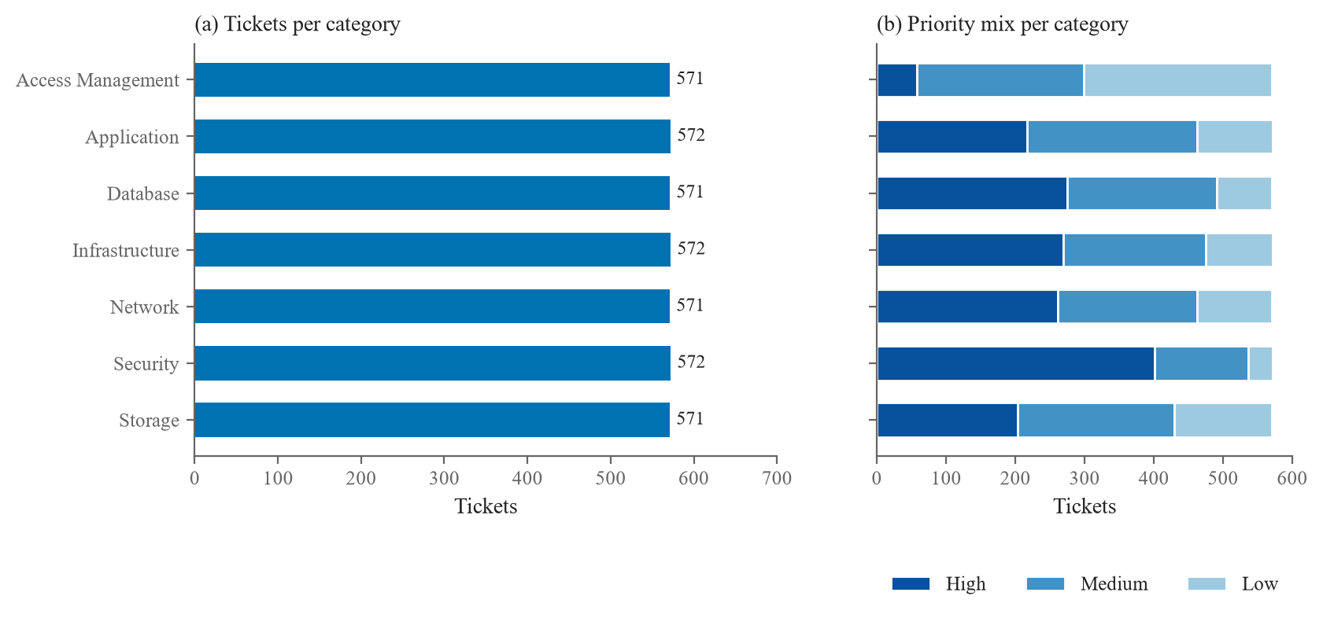
Figure 4.1: Profile of the 4,000-ticket synthetic corpus: (a) tickets per category, (b) priority mix within each category.
Memorisation happens at the template level: the 175 paraphrased calibration tickets touch 62 of the 66 templates, and removing every touched template would leave only 210 rows, so the corpus cannot be decontaminated by filtering. A held-out split is therefore uninformative (TF-IDF scores 100% on it), and every claim rests on sets written outside the templates.
Splits and evaluation sets
Table 4.1 lists every set and its role. Tier 2 and the DistilBERT baseline are trained on a stratified 3,200-row split (seed 42); the production Tier 1 is fitted on all 4,000 rows. The benchmark sets are fixed and read-only.
Table 4.1: Dataset splits and evaluation sets
Set | Size | Source | Used for
Training | 3,200 / 4,000 | Synthetic templates | Tier 2 and DistilBERT (3,200); Tier 1 (4,000)
In-distribution held-out | 800 | Synthetic templates | Sanity check only
Paraphrased calibration | 175 | Gemini paraphrases of training rows | Cascade threshold, conformal calibration, drift reference, in-domain arm of the retrieval sweep
Out-of-domain calibration | 45 | Gemini variants of 15 hand-written off-topic and vague seeds | Retrieval threshold
Deployment-style set | 175 | Gemini, benchmark style | Second calibration and evaluation distribution
Hand-written benchmark | 14 | Written by the team | Evaluation
Out-of-template benchmark | 45 | Gemini | Main evaluation
Adversarial set | 9 | Off-topic, vague, slang | Gate evaluation
Independent set | 108 | Two team members, blind cross-labelled | Extended evaluation
Real-world tickets | 583 distinct (984) | Public Zenodo dataset [38] | Extended evaluation

4.2 System architecture and workflow
Overall architecture
Figure 4.2 shows the system in layers. The data layer holds the corpus, the FAISS index with aligned metadata, the resolved-ticket store and the frozen configuration. The model layer holds both classifiers, the shared BGE encoder and Gemini as an external API. The agent layer wraps each stage as an agent under one orchestrator that applies both gates; the service layer exposes them over FastAPI; and the presentation layer holds the demo, the API documentation and the experiment scripts. An offline path clusters resolved tickets by resolution-text similarity at 0.80 into automation candidates for human review, and a DevOps layer of tests, a container image and CI guards every change.
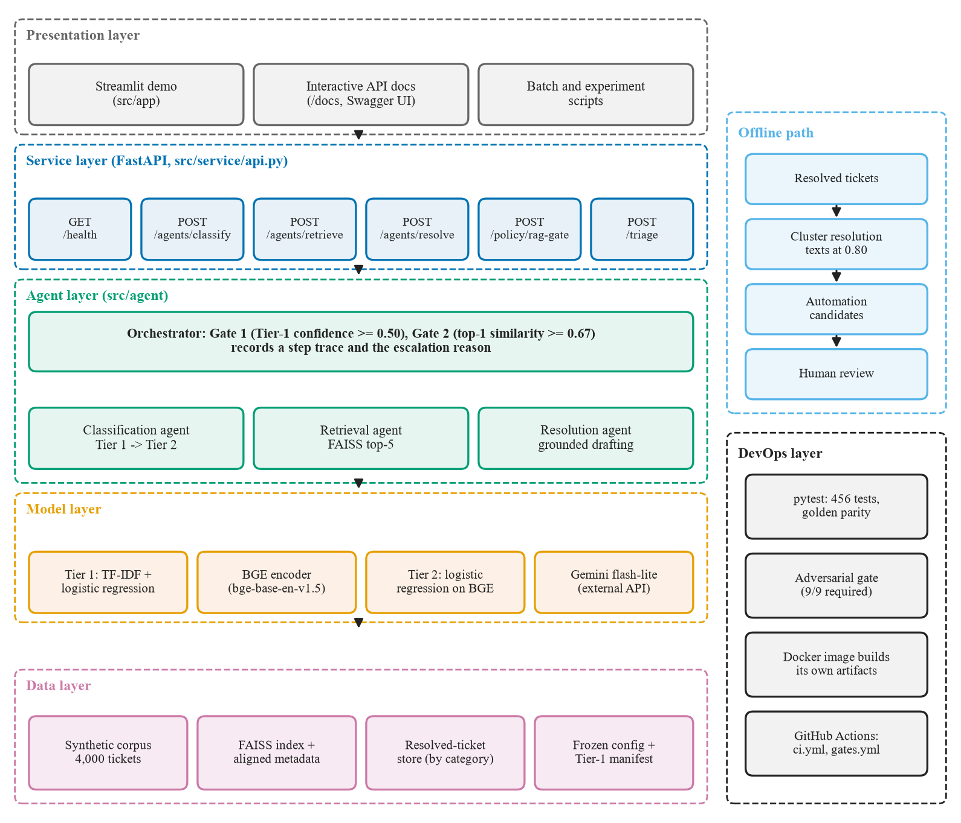
Figure 4.2: Overall system architecture: data, model, agent, service and presentation layers, with the offline automation-flagging path and the DevOps layer.
It is a sequential pipeline with agent boundaries and an HTTP interface, not a distributed multi-agent system: /triage runs the agents in-process, so measured latency has no network hops.
Agents and the orchestrator
Each agent declares the artifacts it needs (classification: vectoriser, both classifiers and the encoder; retrieval: encoder, index and metadata; resolution: a Gemini client), checked when the agent is created. An agent decides nothing: every threshold lives in the orchestrator, which records a trace entry for each agent, including skipped ones, so a skipped resolution step proves that no language model was called. One loader enforces three guards: index and metadata have the same length; encoder, index and configuration agree on 768 dimensions; and Tier 1 matches the dataset and committed vocabulary in its manifest. Each guard exists because a stale artifact once produced plausible but wrong results without any error.
End-to-end workflow of one ticket
Figure 4.3 follows one ticket through both gates. Below a similarity of 0.67 the ticket is escalated with the reason low_retrieval_similarity and Gemini is never called; every response carries the decision, its reason, the threshold, the observed value and the trace, and a known agent failure becomes an escalation rather than an error.
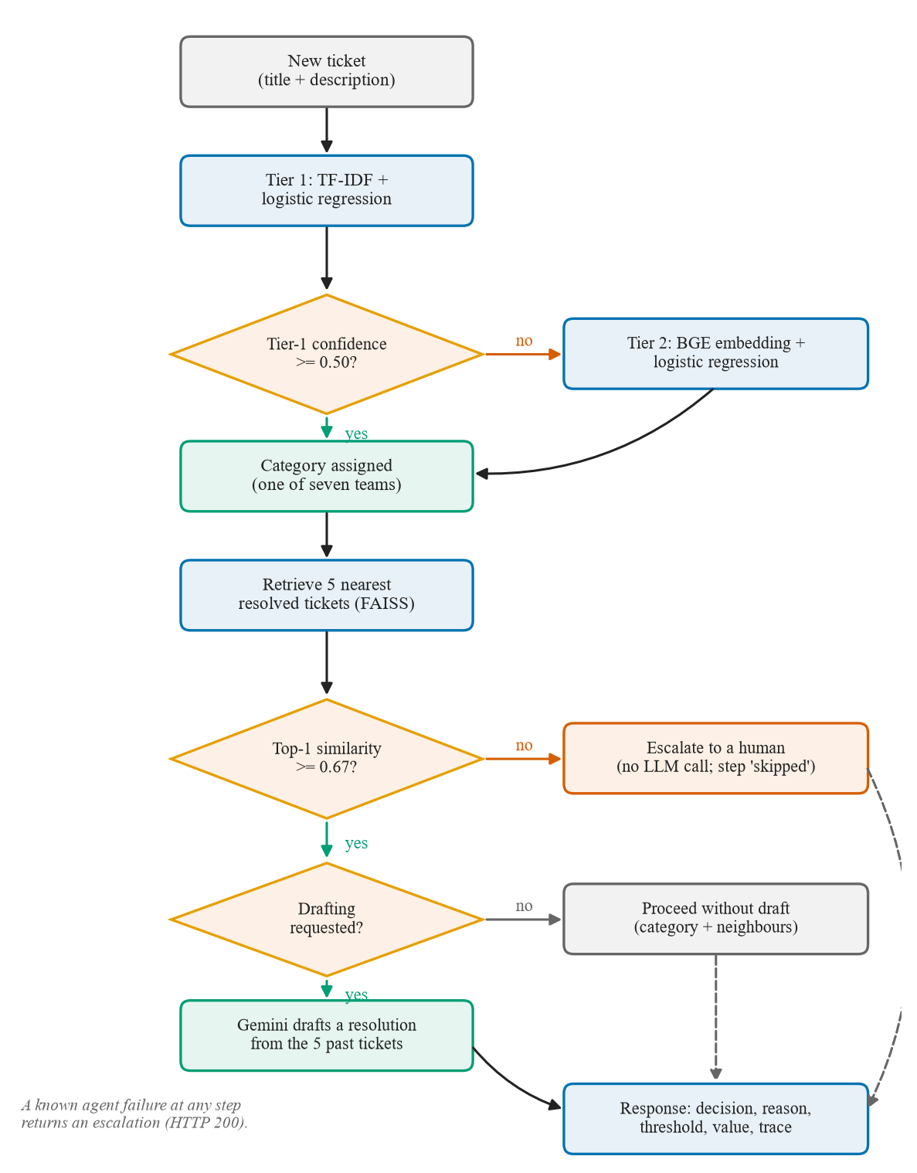
Figure 4.3: End-to-end workflow of one ticket through both gates.
Figure 4.4 shows the messages of one /triage request; Gemini appears only on the branch above the retrieval gate.
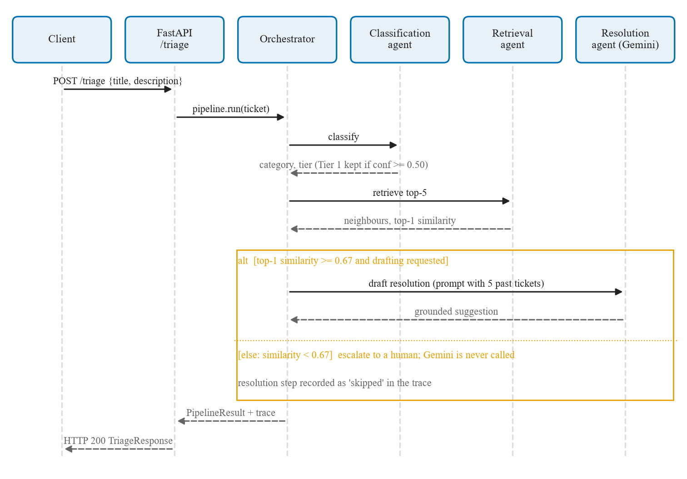
Figure 4.4: Sequence diagram of one POST /triage request.
Development workflow
Figure 4.5 shows the order of development; each step was a phase with a reviewed plan and a reviewed report (Section 3.3).
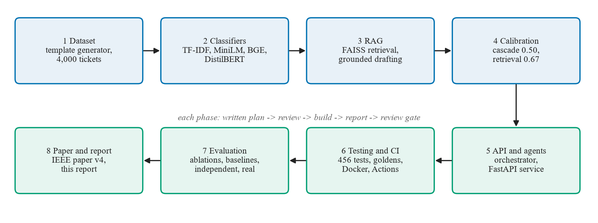
Figure 4.5: Project development workflow.

4.3 Classification cascade and the 0.50 threshold
Tier 1 is a TF-IDF representation (unigrams and bigrams, English stop words removed) over a committed vocabulary of 5,000 features, followed by logistic regression (max_iter = 1000, otherwise scikit-learn defaults). It costs a median of 1.04 ms per ticket. Tier 2 is logistic regression over frozen 768-dimensional BGE embeddings and costs 156.4 ms. The threshold between them decides when the cheap answer can be trusted.
We made three calibration attempts and kept one. Attempt 1, on the 800 held-out tickets, found every populated bucket 100% accurate (5, 515 and 280 tickets in the 70–80%, 80–90% and 90–100% buckets), so any threshold looked safe; the same ceiling makes the in-distribution calibration errors (0.112 for Tier 1, 0.099 for Tier 2) show under-confidence. Attempt 2, a small hand-written set, was too sparse and never committed. Attempt 3 used the 175 paraphrased tickets (Table 4.2).
Table 4.2: Attempt 3: Tier-1 confidence buckets on the 175 paraphrased calibration tickets
Tier-1 confidence | Tickets | Accuracy in bucket | Correct
below 0.50 | 152 | 44.7% | 68
0.50–0.60 | 13 | 100% | 13
0.60–0.70 | 7 | 71.4% | 5
0.70–0.80 | 3 | 33.3% | 1
0.80 and above | 0 | — | —

The rule picks the lowest bucket edge whose cumulative accuracy meets a target. No edge met 0.90; the 0.80 and 0.70 targets both gave 0.50, the live value, at which Tier 1 keeps 23 of 175 tickets (13.1%) and labels 19 correctly (82.6%). Above 0.60 only 10 tickets remain and 6 are correct (Figure 4.6); on a 0.01 grid kept accuracy peaks at 25/30 at 0.46, so 0.50 sits near the peak. The threshold depends only on Tier 1, so changing the Tier-2 encoder does not require recalibrating it.
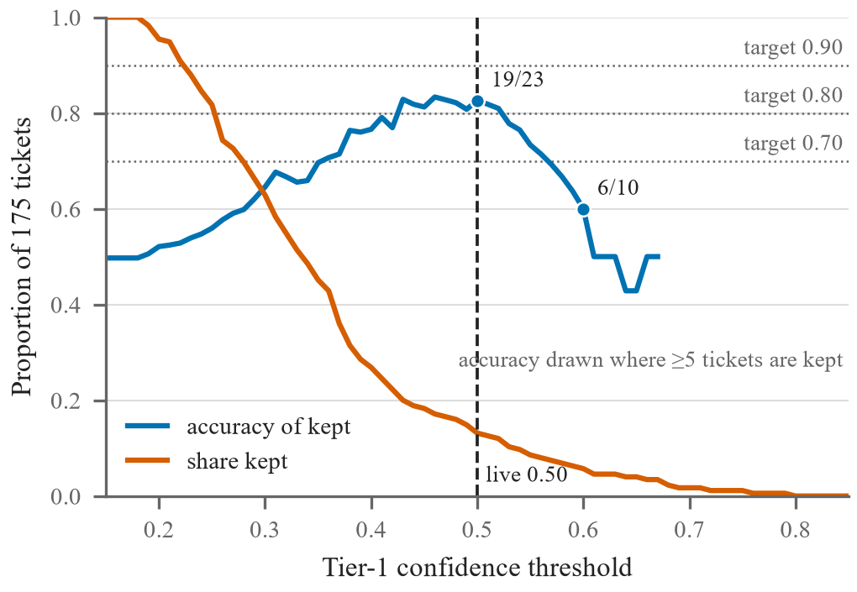
Figure 4.6: Cascade threshold calibration on the 175 paraphrased tickets: share kept by Tier 1 and accuracy of the kept tickets. The dashed line marks the live threshold of 0.50.

4.4 Retrieval, the 0.67 gate and grounded drafting
All 4,000 tickets are embedded with BGE, normalised and stored in a FAISS inner-product index, so the inner product equals cosine similarity [30]. For a new ticket, the five nearest past tickets are retrieved with their title, description, resolution, category and similarity.
The threshold was chosen by sweeping candidate values over 175 paraphrased tickets (which should proceed) and 45 out-of-domain tickets (which should not) (Figure 4.7). At 0.67 all 175 in-domain tickets proceed and 6/45 (13.3%) out-of-domain tickets leak; at 0.65 leakage rises to 17/45 (37.8%). The leaks are all vague "something is broken" messages from 3 of the 15 seeds; no off-topic ticket passes.
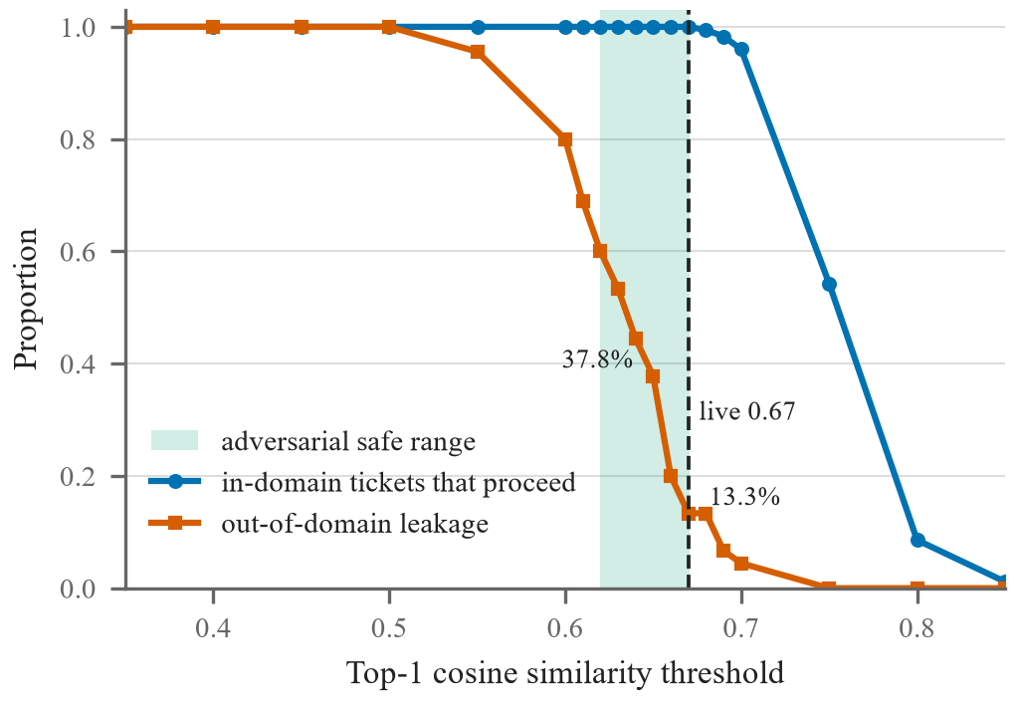
Figure 4.7: Retrieval threshold sweep: in-domain proceed rate and out-of-domain leakage. The shaded band is the adversarial safe range; the dashed line marks 0.67.
On the adversarial set (Figure 4.8), any threshold between the highest similarity of a must-escalate ticket (0.6196) and the lowest of a must-proceed ticket (0.6704) separates the groups; 0.67 lies near the top of this range, so this threshold, unlike the cascade's, is recalibrated whenever the encoder changes (it was 0.35 under MiniLM).
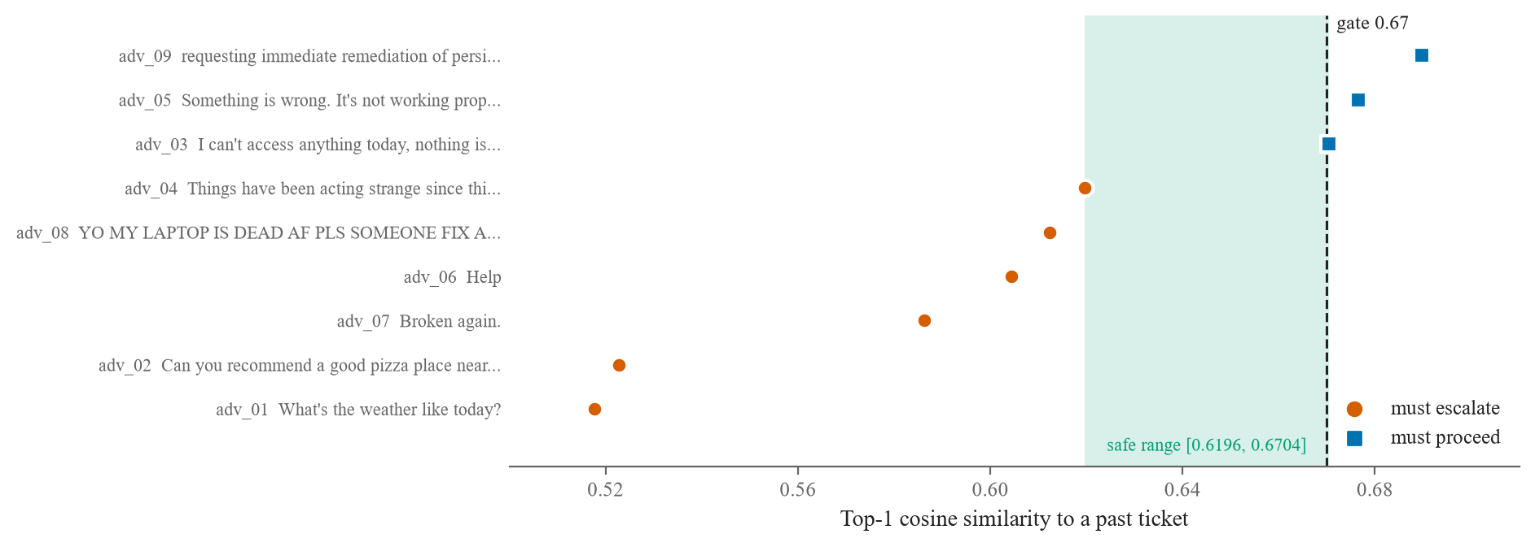
Figure 4.8: Top-1 similarity of the nine adversarial tickets against the 0.67 gate. Circles must escalate, squares must proceed; the shaded band is the safe range.
Above the gate, Gemini (gemini-flash-lite-latest, API defaults) drafts a resolution. The prompt lists the new ticket and the five past tickets with their similarities, and its instructions are:
- Base your suggestion ONLY on the RETRIEVED PAST TICKETS below.
- Do NOT invent a generic answer from outside knowledge. Ground every
step in what the retrieved resolutions actually did.
- If the retrieved examples do not fully match the new ticket, say so
explicitly and recommend that a human agent double-check.
- Keep the suggestion concise: a few sentences of clear, actionable steps.
The language model never assigns the category; classification belongs entirely to the trained models.

4.5 API, demo, Docker and CI
Table 4.3 lists the HTTP endpoints. /triage drafts only when generate_resolution=true, so a looping client cannot exhaust the 500-call daily quota, and /health returns a configuration fingerprint (9c9a5cbcb53f for the published results) that reveals a deployment serving stale artifacts.
Table 4.3: HTTP endpoints of the FastAPI service
Endpoint | Behaviour
GET /health | Fingerprint, embedding model, index size, both thresholds, whether drafting is available
POST /agents/classify | Classification agent alone; HTTP 503 if it fails
POST /agents/retrieve | Retrieval agent alone; HTTP 503 if it fails
POST /agents/resolve | Drafting from a given retrieval; the only endpoint that always spends quota
POST /policy/rag-gate | The escalation decision for a retrieval result, computed by the tested code, so a workflow tool never holds a threshold
POST /triage | Whole pipeline in-process; a known agent failure returns HTTP 200 with an escalation, an unknown error returns HTTP 500

The Streamlit demo (Figure 4.9) shows the classification, the five neighbours and a draft or an escalation. A weather question (left) has a closest similarity of only 57.0% and is escalated without a language-model call; a VPN ticket (right) gets a Tier-1 confidence of 0.30, is routed to Network by Tier 2, and with a similarity of 77.7% receives a grounded draft.
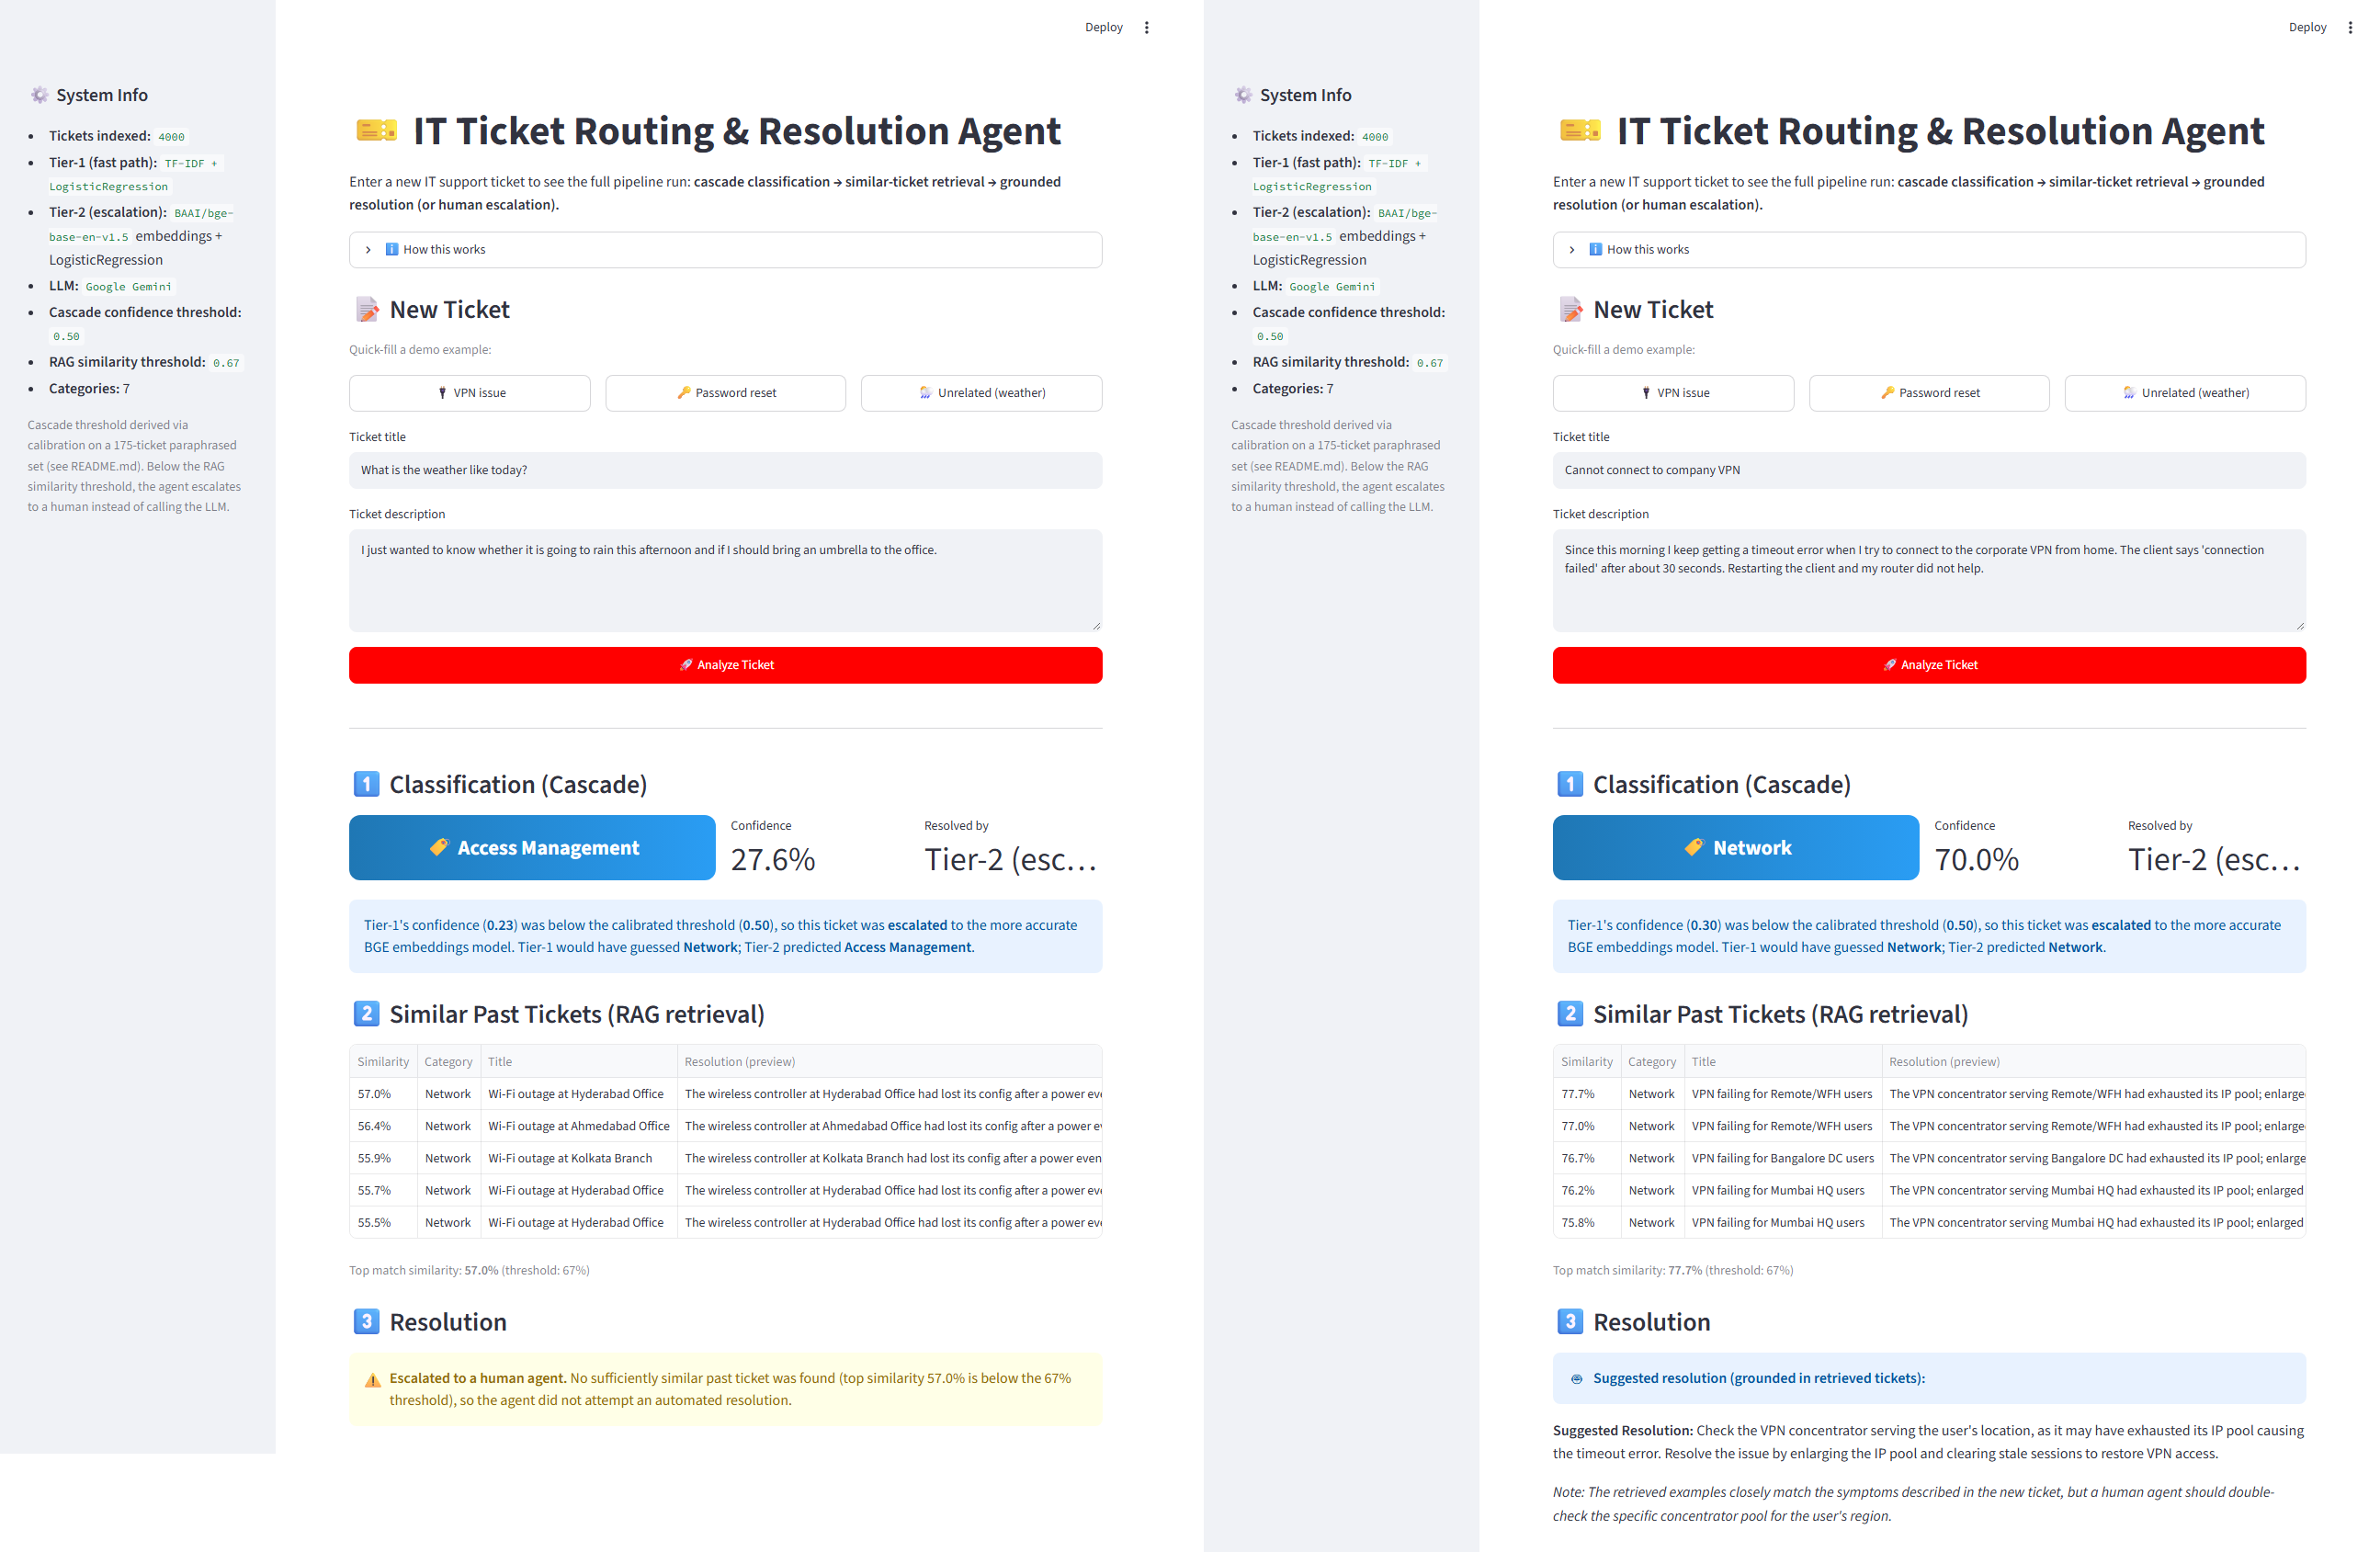
Figure 4.9: The Streamlit demo on an off-topic ticket that is escalated (left) and on a VPN ticket that receives a grounded draft (right).
The Docker image (python:3.14.3-slim, pinned by digest) builds its own artifacts during the build; a guard step fails the build if any pre-built artifact reaches the context, because an early image silently reused a stale embedding cache. The build runs the startup checks, so an image with mismatched artifacts cannot exist, and the container runs as a non-root user without an API key. In CI, ci.yml runs the fast tests and paper-parity checks on every push, and the manual gates.yml runs the full suite, the adversarial gate, the ablation checks and a container build verified over HTTP; neither spends quota.

4.6 Testing and verification
The suite has 456 automated tests, none of which calls a paid API (Table 4.4).
Table 4.4: The automated test suite, grouped by area
Area | Tests | Examples of what is checked
Pipeline, service and configuration | 109 | Orchestrator gates and traces; service failure boundary; frozen thresholds and their provenance; no silent fallback constants; golden parity; adversarial gate
Conformal, deferral and drift | 121 | Quantile and coverage logic; weighted conformal; risk–coverage curves; drift tests and their null rates
Shift experiments | 66 | External dataset profile; version and paraphrase shift analyses
LLM baselines and raters | 110 | Zero-shot parsing, caching and prompt identity; summary statistics; sufficiency rater
Reproducibility and paper | 50 | Every paper number regenerated from its file; gate-CSV comparison; draft wording rules

Three checks protect the results. Golden parity fixes every routing decision for the 45 benchmark and 9 adversarial tickets: decisions are compared exactly, Tier-1 confidence within 10⁻¹², and similarity within a float32 bound for a 768-term inner product (4.578 × 10⁻⁵) [41]; the closest recorded similarity is 3.18 times that tolerance from the gate, so the tolerance cannot hide a flipped decision. The adversarial gate must pass 9/9 before any change to a threshold, encoder or retrieval path, and has caught two real bugs. Paper parity regenerates every quoted number from its result file. These checks exist because the project recorded nine cases where a value was wrong for its context yet internally consistent, and produced a wrong result without any error.

4.7 Evaluation design
Figure 4.10 summarises how data flow into the evaluation: the corpus fits the models, the calibration sets fix the thresholds, and every evaluation set then runs through the unchanged pipeline, with no refitting or recalibration. Proportions carry Wilson 95% intervals [42], paired comparisons use the exact McNemar test [43], and agreement uses Cohen's kappa [36]. A difference smaller than its own noise band is never reported as an ordering.
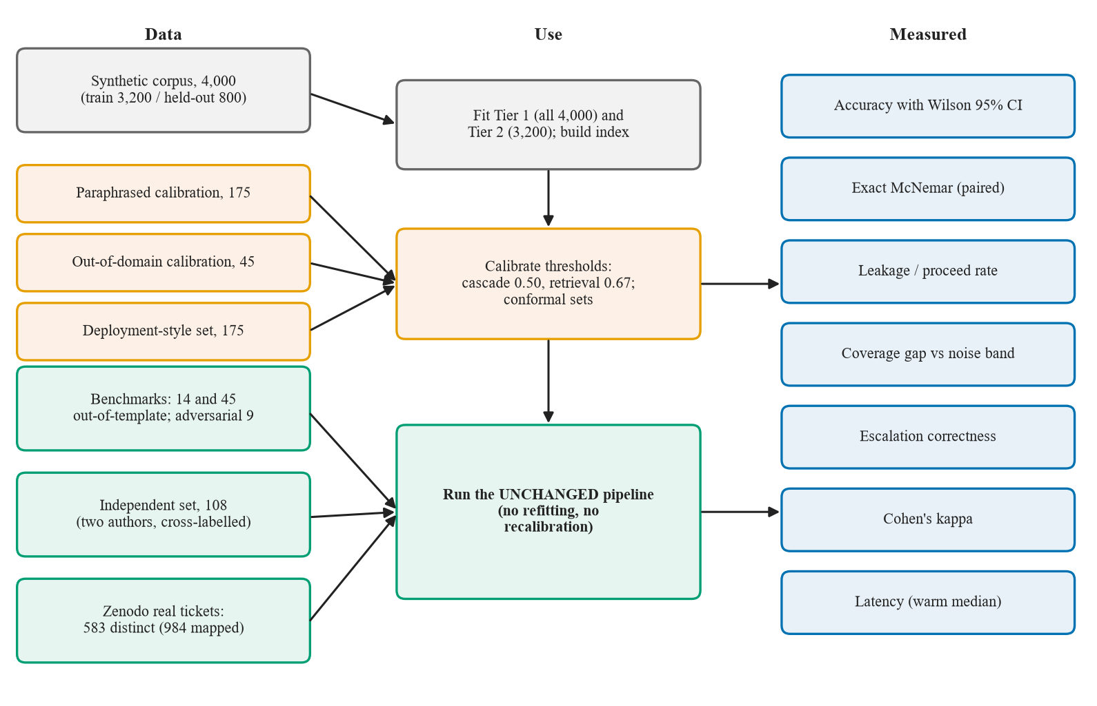
Figure 4.10: Data and evaluation pipeline: which data fit the models, which calibrate the thresholds, which evaluate the unchanged system, and what is measured.
Conformal measurement
Split conformal prediction [23], [24] is calibrated for each tier on the 175 paraphrased tickets, with score one minus the probability of the true label, for α ∈ {0.01, 0.05, 0.10, 0.20}, and coverage is measured on the 45-ticket benchmark. The coverage gap (measured coverage minus 1 − α) is compared with ±2 binomial standard deviations at n = 175 (±0.045 at α = 0.10). It runs offline and gates nothing.
Independent author-written set
Two team members each wrote 54 tickets, seven per team plus five off-topic or vague ones, without consulting the training data, the templates or the benchmarks and without LLM help. Each then labelled the category and the expected outcome (escalate or proceed) of the other's tickets without seeing the writer's labels. Before adjudication, Cohen's kappa was 0.936 for category (bootstrap 95% CI [0.882, 0.979]; 102/108 agreement) and 1.000 for outcome. The six category disagreements were adjudicated, and the writer's label was kept in all six.
Real-world tickets
The real-world set is Pereira's public dataset [38] (CC BY 4.0): 2,229 user-typed tickets labelled into seven categories by three IT professionals, of which langid.py [39] finds 1,734 English. Four source categories map to our teams, fixed before any prediction was examined (Table 4.5). Of the 984 mapped tickets, 401 repeat an earlier text, mostly system-generated subjects, so the headline uses 583 distinct texts; a sensitivity reading maps Fileservice to Storage.
Table 4.5: Mapping of the real-world categories to our teams (English tickets)
Source category | English tickets | Mapped to
Fileservice | 597 | Access Management (sensitivity: Storage)
Active Directory | 85 | Access Management
Software | 158 | Application
O365 | 144 | Application
Support general, EOL, Computer-Services | 601, 103, 46 | Excluded (750)

Chapter 5
Results and Discussion
Every number in this chapter comes from a committed result file; reports/black_book/SOURCES.md names the file behind each one. At 45 tickets a single ticket moves accuracy by 2.2 points, so differences inside a result's own interval are not read as orderings.

5.1 Benchmark accuracy and classifier comparison
Table 5.1 compares every classifier we trained or prompted, and Figure 5.1 plots the 45-ticket results. In distribution every model is near perfect (TF-IDF scores 100% on the 800 held-out rows), so only the out-of-template sets discriminate.
Table 5.1: Accuracy of every classifier on the out-of-template sets
Method | 14-ticket | 45-ticket | 175 deployment-style
TF-IDF + logistic regression (Tier 1 alone) | 6/14 | 16/45 | 91/175
MiniLM embeddings + logistic regression | — | 32/45 | —
E5 embeddings + logistic regression | — | 27/45 | —
DistilBERT, fine-tuned (two runs) | 7/14 | 18/45 and 21/45 | —
BGE embeddings + logistic regression (Tier 2 alone) | 10/14 | 33/45 | 132/175
Production cascade (Tier 1 → Tier 2) | 10/14 | 32/45 | 131/175
Gemini flash-lite, zero-shot | 14/14 | 40/45 | —
Qwen2.5-3B, zero-shot (laptop CPU) | 12/14 | 34/45 | —

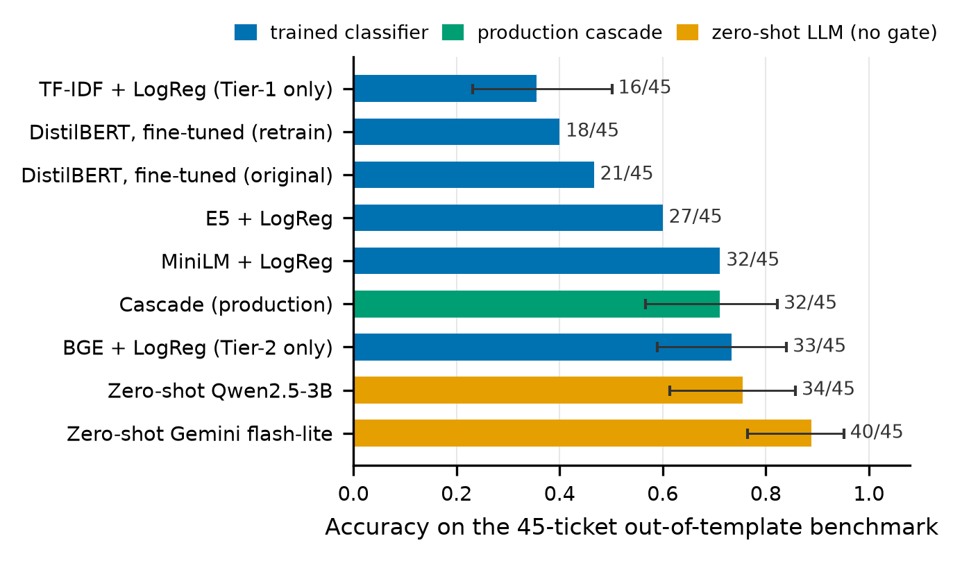
Figure 5.1: Accuracy on the 45-ticket out-of-template benchmark, with Wilson 95% intervals where the result file records one.
The representation matters more than the model family: TF-IDF reaches only 16/45 (95% CI [0.232, 0.502]) because new wording shares little vocabulary with the templates, frozen encoders do far better (BGE 33/45, MiniLM 32/45), and fine-tuned DistilBERT overfits the repetitive rows (its two runs differ by three tickets, so no ordering is drawn).

5.2 Cascade against Tier 2 alone, and latency
Tier 1 alone scores 35.6 points below the pipeline, but that gap measures TF-IDF against BGE, not the value of cascading. The fair control is Tier 2 answering every ticket (Table 5.2).
Table 5.2: The cascade against the control that isolates it (Tier 2 answering everything)
Set | Tier 2 alone | Cascade | Tier 2 (ms) | Cascade (ms) | Saving
Benchmark (45) | 33/45 | 32/45 | 156.4 | 143.5 | 8.2%
Deployment-style (175) | 132/175 | 131/175 | 156.4 | 127.9 | 18.2%

The cascade is one ticket worse on each set, and the exact McNemar test gives p = 1.000 both times, so accuracy is indistinguishable. What it buys is speed (Figure 5.2): Tier 2 costs 151 times as much as Tier 1, and Tier 1 answers 4 of 45 benchmark tickets (8.9%) and 33 of 175 deployment-style tickets (18.9%), which is why the saving is larger on the second set. H2 is supported for latency; the cascade brings no accuracy gain.
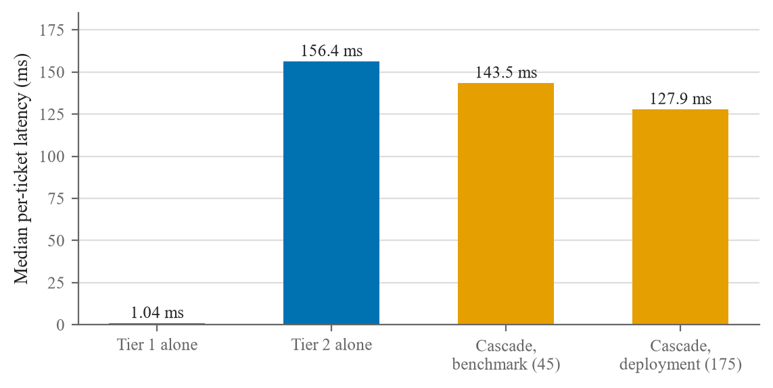
Figure 5.2: Median per-ticket latency (warm, batch size 1, Intel Core i5-1334U).

5.3 Zero-shot LLM baselines
Both language models received byte-identical prompts (verified by hash on all 45 tickets) and returned no unparseable answers (Table 5.3).
Table 5.3: Zero-shot language models against the trained Tier 2 (45-ticket benchmark)
Comparison | Accuracy | 95% CI | Exact McNemar p
Gemini flash-lite vs Tier 2 (33/45) | 40/45 | [0.765, 0.952] | 0.039
Qwen2.5-3B vs Tier 2 (33/45) | 34/45 | [0.613, 0.858] | 1.000
Qwen2.5-3B vs Gemini | 34/45 vs 40/45 | — | 0.070

Gemini is significantly more accurate than Tier 2; Qwen is indistinguishable from it, which is not the same as better; and the six-ticket gap between them is not significant. Because Gemini also wrote the benchmark, Qwen is a partial control for authorship [37]. Infrastructure recall is 50% for Tier 2, Gemini and Qwen alike, which points to ambiguous wording rather than a weak method. This is a zero-shot model against a trained classifier: it shows what a template-generated training set is worth on new phrasing, while neither language model can abstain, which is the purpose of our gates.

5.4 The gates and the adversarial set
The retrieval gate decides all nine adversarial tickets correctly; with the gate removed, only the three that should proceed are right, because the six that should escalate would receive a drafted fix (Table 5.4). H1 is supported.
Table 5.4: The adversarial set at the live gates
ID | Type | Ticket (shortened) | Top-1 sim. | Outcome
adv_01 | Off-topic | What's the weather like today? | 0.518 | Escalated (correct)
adv_02 | Off-topic | Can you recommend a good pizza place…? | 0.523 | Escalated (correct)
adv_03 | Vague | I can't access anything today… | 0.670 | Proceeded (correct)
adv_04 | Vague | Things have been acting strange… | 0.620 | Escalated (correct)
adv_05 | Uninformative | Something is wrong. It's not working… | 0.677 | Proceeded (correct)
adv_06 | Very short | Help | 0.604 | Escalated (correct)
adv_07 | Very short | Broken again. | 0.586 | Escalated (correct)
adv_08 | Slang | YO MY LAPTOP IS DEAD AF PLS… | 0.612 | Escalated (correct)
adv_09 | Over-formal | requesting immediate remediation of persistent authentication failure… | 0.690 | Proceeded (correct)

The gate errs in both directions on harder cases. It lets 13.3% of out-of-domain calibration tickets through, and on the 45-ticket benchmark it escalates 15 tickets (33.3%), including one whose context was adequate (Section 5.9). adv_08 shows a design limit: a real problem written in slang is escalated because it resembles no past ticket, which is safe but not helpful.

5.5 Conformal coverage
Table 5.5 gives the split-conformal coverage gap of each tier on the 45-ticket benchmark, and Figure 5.3 plots it against the noise band. The result has three linked parts that must be read together.
Table 5.5: Coverage gap on the 45-ticket benchmark; only the calibration set differs between the two gap columns
Tier | α | Gap, paraphrased cal. | Gap, deployment cal. | ±2 s.d. | Mean set size
1 | 0.20 | −0.200 | −0.244 | 0.060 | 2.69
1 | 0.10 | −0.233 | −0.144 | 0.045 | 3.40
1 | 0.05 | −0.106 | −0.083 | 0.033 | 5.00
2 | 0.20 | −0.044 | 0.000 | 0.060 | 1.11
2 | 0.10 | −0.011 | −0.011 | 0.045 | 1.82
2 | 0.05 | 0.028 | −0.039 | 0.033 | 2.60

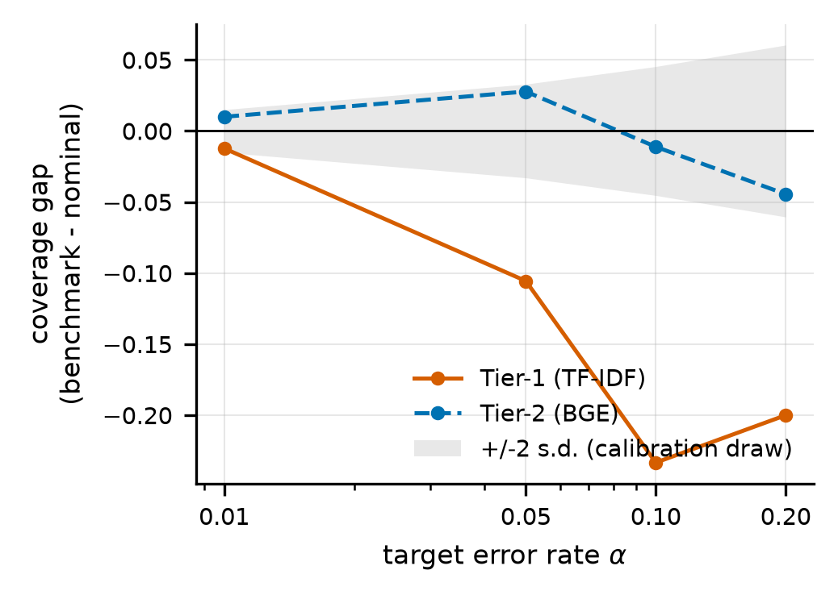
Figure 5.3: Coverage gap on the out-of-template benchmark by representation and α, against the two-standard-deviation noise band.
On our corpus, coverage transfers for BGE but not for TF-IDF: at α = 0.10 the gap is −0.233 for Tier 1 and −0.011 for Tier 2, against a band of ±0.045. External replication is inconclusive: on an independently generated corpus a version shift left the tiers indistinguishable (0.0009 against −0.0072), but that is the wrong kind of shift for a vocabulary effect, and the right kind, a paraphrase shift, was blocked by our own pre-registered degeneracy rule (domain AUC 0.9972). Post-hoc evidence appears in accuracy: under that paraphrase shift Tier 1 lost 10.5 points against 2.4 for Tier 2 (difference-in-differences −0.080, 95% CI [−0.136, −0.021]). Recalibrating on the deployment-style set moved Tier 1's gap from −0.233 to −0.144 with nothing else changed, and density-ratio reweighting [25] moved it to −0.122, still 5.4 standard deviations below nominal: both are partial repairs. Compared directly with the 0.50 gate, conformal deferral showed no signal in any of 12 comparisons at the coverage the gate operates at, so it remains a measurement. H3 is supported on our corpus.
A drift monitor built on the same paraphrased reference behaves similarly: legitimate deployment-style tickets are flagged at rates of 0.217 to 0.646 across four α levels, 3.2 to 38.2 times the per-ticket null rate, so it would alarm continuously whatever the test. The detector was measured but not shipped.

5.6 Groundedness, the LLM judge and the sufficiency rater
Every benchmark and adversarial ticket that passed the gate (33) received a draft, labelled by a human for support by the retrieved tickets (Table 5.6).
Table 5.6: Draft quality and the two automated raters (33 drafts)
Measure | Value | Reading
Drafts grounded (human) | 31/33, 95% CI [0.804, 0.983] | Most drafts stay within the retrieved fixes
Hedge appropriate (human) | 32/33 | Drafts say when the examples do not fit
LLM judge: raw agreement with the human | 30/33 | Looks reliable…
LLM judge: Cohen's kappa | −0.042 | …but agrees no better than chance
Sufficiency rater: ungrounded drafts caught | 2/2 | Catches both failures…
Sufficiency rater: grounded drafts flagged | 26/31 | …but would escalate 28 of 33 eligible tickets

H5 is supported for drafts and rejected for the judge. All three disagreements were the judge rating whether a fix was appropriate rather than supported, so 91% raw agreement concealed a kappa below zero. The sufficiency rater, which never sees the draft, would suppress about 85% of auto-resolution to recover two bad drafts and has no threshold to tune; it also judged one escalated ticket (N45, similarity 0.640) to have adequate context.

5.7 Results on the independent set
On the 108 tickets written by two team members (Table 5.7), routing accuracy is similar to the Gemini-written benchmark, but the retrieval gate escalates many actionable tickets.
Table 5.7: Results on the independent author-written set (pipeline unchanged)
Quantity | Value | 95% CI
Tickets (with a team / off-topic or vague) | 108 (98 / 10) | —
Cascade routing accuracy | 74/98 = 75.5% | [66.1, 83.0]
Tier 2 alone | 75/98 = 76.5% | [67.2, 83.8]
Per-team recall (cascade) | from 8/14 (Security) to 14/14 (Database) | —
Escalated at the 0.67 gate | 40/108 = 37.0% | [28.5, 46.4]
Off-topic or vague tickets escalated | 8/10 | —
Actionable tickets escalated | 32/98 | —
Escalate-or-proceed decision correct | 74/108 = 68.5% | [59.3, 76.5]
Misrouted tickets that reached the drafter | 16 of 24 | —
Tier-1 share | 27/108 = 25.0% | —

Human-written text written to our seven teams is routed about as well as the benchmark (74/98 against 32/45). The cost is on the gate: one actionable ticket in three goes to a person because its wording is unlike any template.

5.8 Results on real-world tickets
On real user tickets the classifier does not transfer (Table 5.8).
Table 5.8: Real-world results, 583 distinct texts, under the primary and the sensitivity mapping
Quantity | Primary (Fileservice → Access Mgmt.) | Sensitivity (→ Storage)
Cascade correct | 115/583 = 19.7% [16.7, 23.1] | 294/583 = 50.4% [46.4, 54.5]
Tier 2 alone correct (McNemar p) | 114/583 (p = 1.0) | 292/583 (p = 0.79)
Recall: Access Mgmt. / Application / Storage | 86/319 / 29/264 / — | 62/82 / 29/264 / 203/237
Tier-1 answers correct | 39/238 | 199/238
Escalated at 0.67 | 129/583 = 22.1% [18.9, 25.7] | same (label-free)
Misrouted: escalated / reached the drafter | 97 / 371 of 468 | —

The cascade routes 19.7% of distinct texts correctly (12.1%, 119/984, over all tickets), the same as Tier 2 alone. Tier 1 answers far more often than on generated text (238/583 against 4/45), but only 39 of those answers are right. The gate escalates 20.7% of misrouted texts and 27.8% of correctly routed ones, so it does not separate misroutes: 371 of 468 misrouted texts reached the drafter. Accuracy hinges on one mapping: most Fileservice tickets are file-share access requests, which our generator files under Storage, where the pipeline sends 203 of the 238 distinct Fileservice texts. Only two teams are covered, and the 30 drafts generated for real tickets were not labelled. H4 holds for human-written text in our taxonomy but not for real tickets.

5.9 Error analysis
Table 5.9 groups the errors of the live pipeline into wrong category, wrong escalation decision and unsupported resolution, and Figure 5.4 shows the benchmark confusion matrix.
Table 5.9: Error taxonomy of the live pipeline
Error type | Count | Cases and likely cause
Misclassification (benchmark) | 13/45 | Database→Application, Infrastructure→Application and Security→Storage (2 each); 10 of 13 errors predict Application or Storage
Safe ticket escalated | 1 | N45: context adequate, similarity 0.640 below the gate
Unsafe ticket drafted | 2 | N26 (0.701), N31 (0.675): passed the gate; drafts labelled ungrounded
Out-of-domain leakage | 13.3% | 6 vague "something is broken" tickets from 3 seeds; no off-topic ticket leaks
Adversarial, gate removed | 6/9 | Off-topic and vague tickets would be drafted instead of escalated

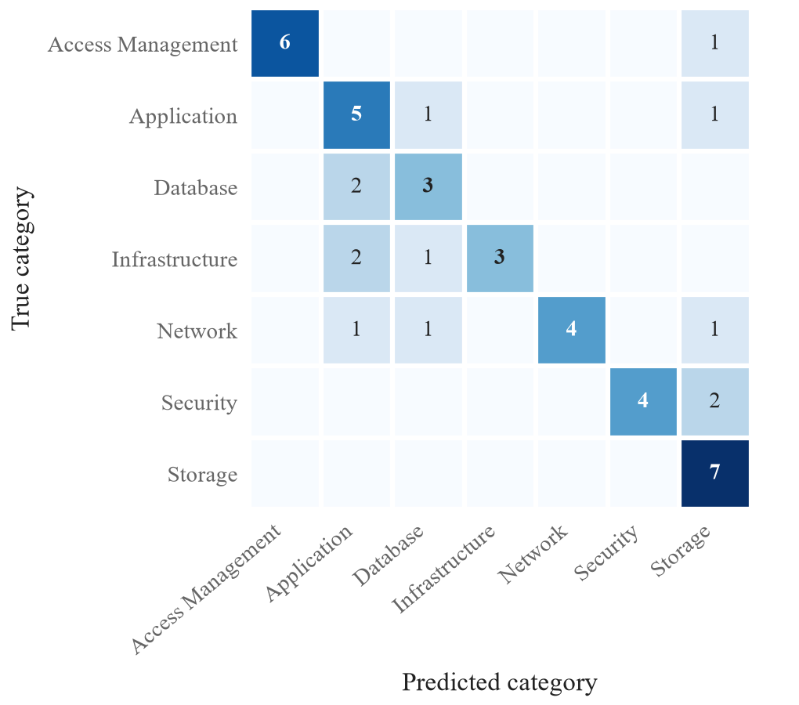
Figure 5.4: Confusion matrix of the production cascade on the 45-ticket benchmark.
Recall ranges from 3/6 (Infrastructure) to 7/7 (Storage). Tier 1 alone misclassifies 29 of 45 tickets, for example N31 (ransomware pop-ups) to Storage and N39 (VPN failure) to Database. Of the 13 misclassified tickets, 5 were escalated (the safe outcome) and 8 received a draft, 7 of them faithful to retrieved tickets from the wrong team: the classification gate does not stop a misrouted ticket from reaching the drafter, which the real-world set confirms at scale. In both ungrounded drafts the model noted that the examples did not match, then added outside-knowledge steps the prompt forbids.

5.10 Summary of results and discussion
Table 5.10 gives the verdict on each hypothesis, and Figure 5.5 compares routing accuracy across all evaluation sets.
Table 5.10: Outcome of each research hypothesis
No. | Verdict | Evidence
H1 | Supported | 9/9 adversarial tickets decided correctly with the gate, 3/9 without; 13.3% out-of-domain leakage
H2 | Supported for latency only | 8–18% lower median latency; accuracy 32/45 vs 33/45 and 131/175 vs 132/175 (p = 1.000)
H3 | Supported on our corpus | Gap −0.233 (TF-IDF) vs −0.011 (BGE), band ±0.045; external replication inconclusive
H4 | Partly; rejected for real tickets | 74/98 on author-written tickets; 19.7% (50.4% under the alternative mapping) on real tickets
H5 | Drafts yes; judge no | 31/33 drafts grounded; LLM judge kappa −0.042

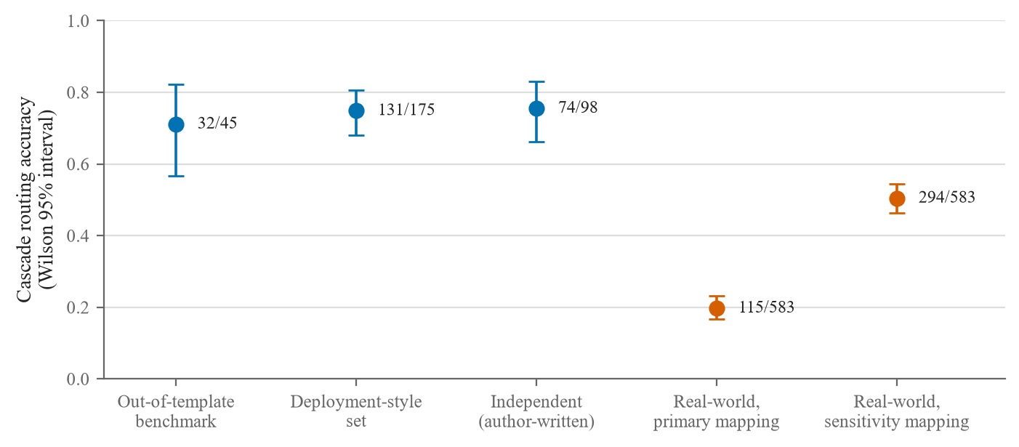
Figure 5.5: Cascade routing accuracy with Wilson 95% intervals on every evaluation set.
What worked. The retrieval gate keeps a language model away from off-topic and vague tickets, the cascade saves latency at no measurable accuracy cost, drafts above the gate are almost always grounded, and every number can be regenerated and checked.
What did not. Neither gate filters misrouted tickets; the gate escalates a third of actionable human-written tickets; an LLM judge and a sufficiency rater both failed as automatic checks; and the classifier does not transfer to real tickets.
The recurring finding. Across coverage guarantees, drift monitoring and classification, the data a component is trained or calibrated on limits it more than the method chosen. Recalibrating on a different distribution moved a coverage gap more than any change of method, a drift monitor's verdict depended on its reference rather than its test, and the real-world result shows a classifier trained only on synthetic templates failing on real text while gates calibrated on the same material do not compensate.

Chapter 6
Conclusion and Future Scope

6.1 Conclusion
A triage system is valuable only if it knows when not to answer. Starting from Use Case 1 of the nasscom brief, we built a pipeline that routes IT tickets to seven teams and treats escalation to a human as a normal output, controlled by two separately calibrated gates. A confidence threshold of 0.50 decides when a fast TF-IDF classifier may answer alone, and a similarity threshold of 0.67 decides when Gemini may draft a resolution grounded in retrieved past tickets. Both values were chosen from measured calibration data, and the rejected attempts are recorded. The system is delivered as a FastAPI service, a Streamlit demonstration and a self-building Docker image, guarded by 456 automated tests.
The retrieval gate decides all nine adversarial tickets correctly, against three of nine without it, at the cost of letting 13.3% of out-of-domain calibration tickets through. The cascade does not improve accuracy over the embedding classifier alone (32/45 against 33/45, p = 1.000) but reduces median latency by 8% to 18%. A zero-shot language model classifies the benchmark more accurately (40/45), but it cannot abstain, which is exactly what our gates provide. A human judged 31 of 33 drafts grounded, while an LLM judge reached a kappa of −0.042 against that human, so automated judging could not replace human review.
The extended evaluation was the most informative part of the project. On 108 tickets written and blind cross-labelled by two team members (kappa 0.936), the cascade routed 74 of 98 correctly, similar to the benchmark, but the gate escalated 32 actionable tickets. On 583 distinct real tickets covering two teams, accuracy fell to 19.7% (50.4% under an alternative mapping), and 371 of 468 misrouted tickets still passed the gate. Across coverage guarantees, drift monitoring and classification, the same lesson recurred: the data a component is trained or calibrated on limits it more than the method chosen. These conclusions rest on a synthetic corpus, small evaluation sets, 108 author-written tickets and real tickets for two teams only, and should not be read as performance claims for a production help desk. We found no public, real, English IT ticket dataset whose categories match our seven teams; the Zenodo corpus was the closest real option, and our hand-written set covers all seven.

6.2 Future Scope
- Deployment and recalibration on real traffic. Running the system in a live help desk would provide real tickets to recalibrate both gates, a deployment-traffic reference for drift monitoring, and a direct measure of misrouting cost and resolution time.
- Training on real or more varied tickets. The real-world result shows that template-generated training data is the binding constraint; real labelled tickets, or synthetic data written in many registers, are the most direct way to improve transfer.
- A gate that sees routing errors. Neither gate stops a misrouted ticket from reaching the drafter. Combining classifier confidence with agreement between the predicted team and the teams of the retrieved tickets is a natural next experiment.
- Larger human-labelled sets. Labelling more drafts, including direct labels for context sufficiency, would narrow the uncertainty on draft quality and allow any automated judge or second gate to be audited before use; labelling the 30 real-ticket drafts is the first step.
- Broader real-world coverage. A real benchmark covering all seven teams, and multilingual tickets, would test whether the recurring finding holds outside our corpus.

References
[1] Q. Shao, Y. Chen, S. Tao, X. Yan, and N. Anerousis, "Efficient ticket routing by resolution sequence mining," in Proc. 14th ACM SIGKDD Int. Conf. Knowledge Discovery and Data Mining, 2008, pp. 605–613.
[2] P. Lewis et al., "Retrieval-augmented generation for knowledge-intensive NLP tasks," in Advances in Neural Information Processing Systems (NeurIPS), 2020.
[3] Y. Diao, H. Jamjoom, and D. Loewenstern, "Rule-based problem classification in IT service management," in Proc. 2009 IEEE Int. Conf. Cloud Computing, 2009, pp. 221–228.
[4] F.-R. Liu et al., "TickIt: Leveraging large language models for automated ticket escalation," in Proc. 33rd ACM Int. Conf. Foundations of Software Engineering (FSE), 2025.
[5] E. Paket et al., "IT service desk ticket classification via large language models," in Proc. 9th Int. Conf. Computer Science and Engineering (UBMK), 2024.
[6] A. Carroll et al., "Evaluating large language models for automated REDCap support ticket triage and response," JAMIA Open, vol. 9, no. 3, 2026.
[7] G. Salton and C. Buckley, "Term-weighting approaches in automatic text retrieval," Information Processing & Management, vol. 24, no. 5, pp. 513–523, 1988.
[8] T. Joachims, "Text categorization with support vector machines: Learning with many relevant features," in Machine Learning: ECML-98, Lecture Notes in Computer Science. Berlin: Springer, 1998, pp. 137–142.
[9] F. Pedregosa et al., "Scikit-learn: Machine learning in Python," Journal of Machine Learning Research, vol. 12, pp. 2825–2830, 2011.
[10] J. Devlin, M.-W. Chang, K. Lee, and K. Toutanova, "BERT: Pre-training of deep bidirectional transformers for language understanding," in Proc. 2019 Conf. North American Chapter of the Association for Computational Linguistics (NAACL-HLT), 2019, pp. 4171–4186.
[11] V. Sanh, L. Debut, J. Chaumond, and T. Wolf, "DistilBERT, a distilled version of BERT: Smaller, faster, cheaper and lighter," presented at the 5th Workshop on Energy Efficient Machine Learning and Cognitive Computing, NeurIPS, 2019, arXiv:1910.01108.
[12] W. Wang, F. Wei, L. Dong, H. Bao, N. Yang, and M. Zhou, "MiniLM: Deep self-attention distillation for task-agnostic compression of pre-trained transformers," in Advances in Neural Information Processing Systems (NeurIPS), vol. 33, 2020.
[13] N. Reimers and I. Gurevych, "Sentence-BERT: Sentence embeddings using Siamese BERT-networks," in Proc. 2019 Conf. Empirical Methods in Natural Language Processing and 9th Int. Joint Conf. Natural Language Processing (EMNLP-IJCNLP), 2019, pp. 3980–3990.
[14] L. Wang et al., "Text embeddings by weakly-supervised contrastive pre-training," 2022, arXiv:2212.03533.
[15] S. Xiao et al., "C-Pack: Packed resources for general Chinese embeddings," in Proc. 47th Int. ACM SIGIR Conf. Research and Development in Information Retrieval, 2024.
[16] P. Viola and M. Jones, "Rapid object detection using a boosted cascade of simple features," in Proc. IEEE Computer Society Conf. Computer Vision and Pattern Recognition (CVPR), 2001, pp. I-511–I-518.
[17] C. K. Chow, "On optimum recognition error and reject tradeoff," IEEE Transactions on Information Theory, vol. 16, no. 1, pp. 41–46, 1970.
[18] Y. Geifman and R. El-Yaniv, "Selective classification for deep neural networks," in Advances in Neural Information Processing Systems (NeurIPS), 2017, pp. 4878–4887.
[19] C. Guo, G. Pleiss, Y. Sun, and K. Q. Weinberger, "On calibration of modern neural networks," in Proc. 34th Int. Conf. Machine Learning (ICML), 2017.
[20] W. Jitkrittum et al., "When does confidence-based cascade deferral suffice?" in Advances in Neural Information Processing Systems (NeurIPS), 2023.
[21] Y.-F. Dou et al., "Conformal cascade: Distribution-free accuracy guarantees for multi-tier LLM inference," 2026, arXiv:2607.25018.
[22] C. Fanconi et al., "Cascaded language models for cost-effective human–AI decision-making," in Advances in Neural Information Processing Systems (NeurIPS), 2025.
[23] V. Vovk, A. Gammerman, and G. Shafer, Algorithmic Learning in a Random World. New York: Springer, 2005.
[24] A. N. Angelopoulos and S. Bates, "Conformal prediction: A gentle introduction," Foundations and Trends in Machine Learning, vol. 16, no. 4, pp. 494–591, 2023.
[25] R. J. Tibshirani, R. F. Barber, E. J. Candès, and A. Ramdas, "Conformal prediction under covariate shift," in Advances in Neural Information Processing Systems (NeurIPS), 2019.
[26] R. F. Barber, E. J. Candès, A. Ramdas, and R. J. Tibshirani, "Conformal prediction beyond exchangeability," The Annals of Statistics, vol. 51, no. 2, pp. 816–845, 2023.
[27] I. Gibbs and E. J. Candès, "Adaptive conformal inference under distribution shift," in Advances in Neural Information Processing Systems (NeurIPS), 2021.
[28] J. Gama, I. Žliobaitė, A. Bifet, M. Pechenizkiy, and A. Bouchachia, "A survey on concept drift adaptation," ACM Computing Surveys, vol. 46, no. 4, pp. 1–37, 2014.
[29] S. Rabanser, S. Günnemann, and Z. C. Lipton, "Failing loudly: An empirical study of methods for detecting dataset shift," in Advances in Neural Information Processing Systems (NeurIPS), 2019.
[30] J. Johnson, M. Douze, and H. Jégou, "Billion-scale similarity search with GPUs," IEEE Transactions on Big Data, vol. 7, no. 3, pp. 535–547, 2021.
[31] H. Joren et al., "Sufficient context: A new lens on retrieval augmented generation systems," in Proc. Int. Conf. Learning Representations (ICLR), 2025.
[32] S.-Q. Yan et al., "Corrective retrieval augmented generation," 2024, arXiv:2401.15884.
[33] L. Zheng et al., "Judging LLM-as-a-judge with MT-Bench and Chatbot Arena," in Advances in Neural Information Processing Systems (NeurIPS), Datasets and Benchmarks Track, 2023.
[34] J. Jung, F. Brahman, and Y. Choi, "Trust or escalate: LLM judges with provable guarantees for human agreement," in Proc. Int. Conf. Learning Representations (ICLR), 2025.
[35] S. Jain et al., "Beyond consensus: Mitigating the agreeableness bias in LLM judge evaluations," 2025, arXiv:2510.11822.
[36] J. Cohen, "A coefficient of agreement for nominal scales," Educational and Psychological Measurement, vol. 20, no. 1, pp. 37–46, 1960.
[37] G. Maheshwari, D. Ivanov, and K. El Haddad, "Efficacy of synthetic data as a benchmark," 2024, arXiv:2409.11968.
[38] L. S. B. Pereira, "Classification of IT support tickets," Zenodo, Dec. 2022, doi: 10.5281/zenodo.7648117. Dataset, CC BY 4.0.
[39] M. Lui and T. Baldwin, "langid.py: An off-the-shelf language identification tool," in Proc. ACL 2012 System Demonstrations, Jeju Island, Korea, 2012, pp. 25–30.
[40] Qwen Team, "Qwen2.5 technical report," 2024, arXiv:2412.15115.
[41] N. J. Higham, Accuracy and Stability of Numerical Algorithms, 2nd ed. Philadelphia: SIAM, 2002.
[42] E. B. Wilson, "Probable inference, the law of succession, and statistical inference," Journal of the American Statistical Association, vol. 22, no. 158, pp. 209–212, 1927.
[43] Q. McNemar, "Note on the sampling error of the difference between correlated proportions or percentages," Psychometrika, vol. 12, no. 2, pp. 153–157, 1947.

Appendix A
AIC Form
[Insert the completed AIC Form here (mandatory)]

Appendix B
Similarity Report
[Insert the Similarity Report here (mandatory)]

Appendix C
AI Plagiarism Report
[Insert the AI Plag Report here (mandatory)]

Appendix D
Research Paper
[Attach approved paper v4]

