**8. Post-Experiments Exercise**

**A. Extended Theory:**

a. Check current git version supported by IDE(attach SS here)

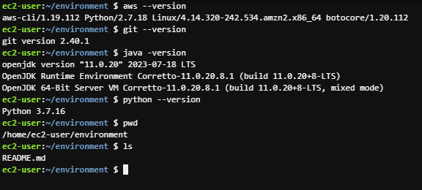

b. Give command to create empty python file using IDE terminal(attach SS here)



**B. Questions:**

2. Which programming languages are supported by cloud9? (Soft copy)

AWS Cloud9 supports over 40 programming languages, including:

1. JavaScript
2. Python
3. Ruby
4. Java
5. PHP
6. C++
7. C#
8. Go
9. D
10. TypeScript
11. HTML
12. CSS
13. Swift
14. Kotlin
15. Rust
16. Scala
17. Perl
18. Shell scripting (Bash)
19. R
20. Haskell
21. Matlab
22. Erlang

