2. Give user console access , Provide user with custom password.

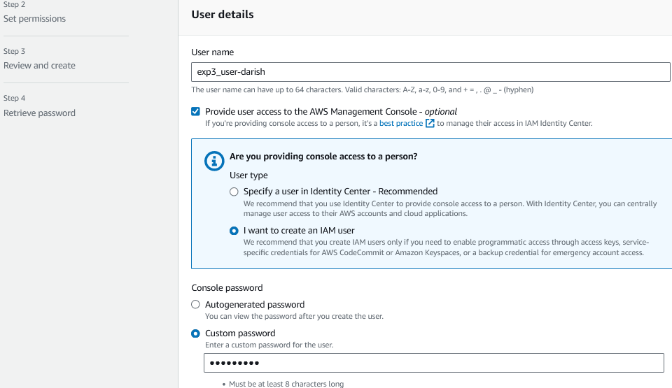

6. click on your group name which you have created and nevigate to permission tab

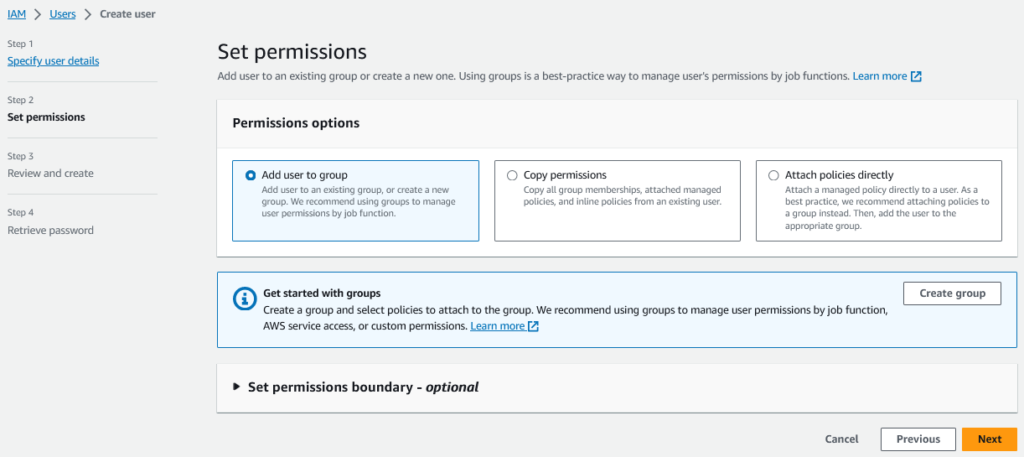

7. Add permission and select Attach Policy after that search for Cloud9 related policy and select Awscloud9EnviornmentMember policy and add it.

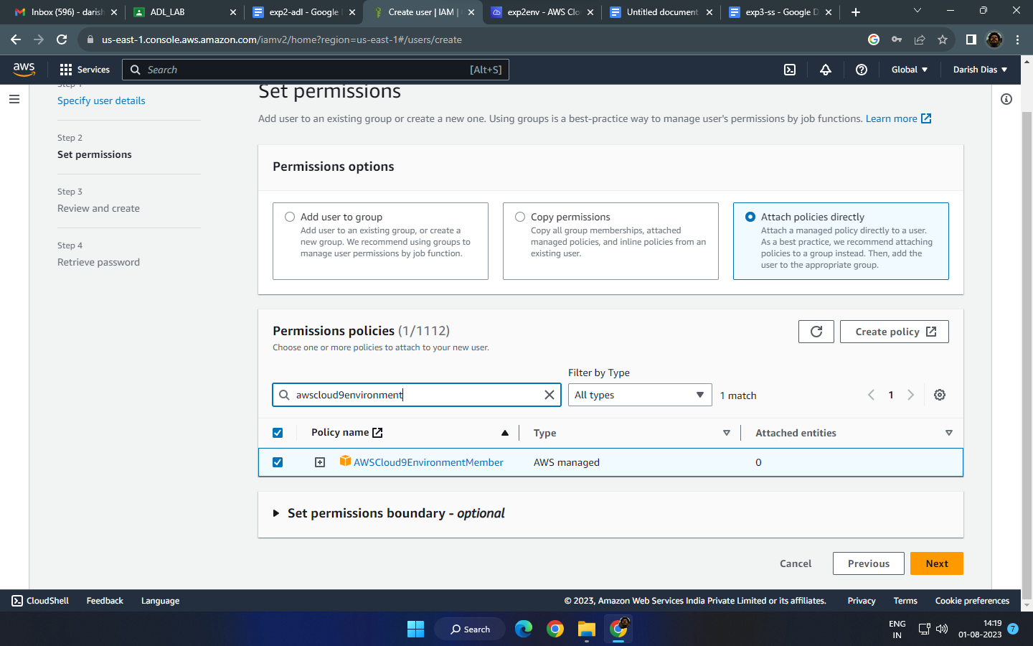

IAM Dashboard

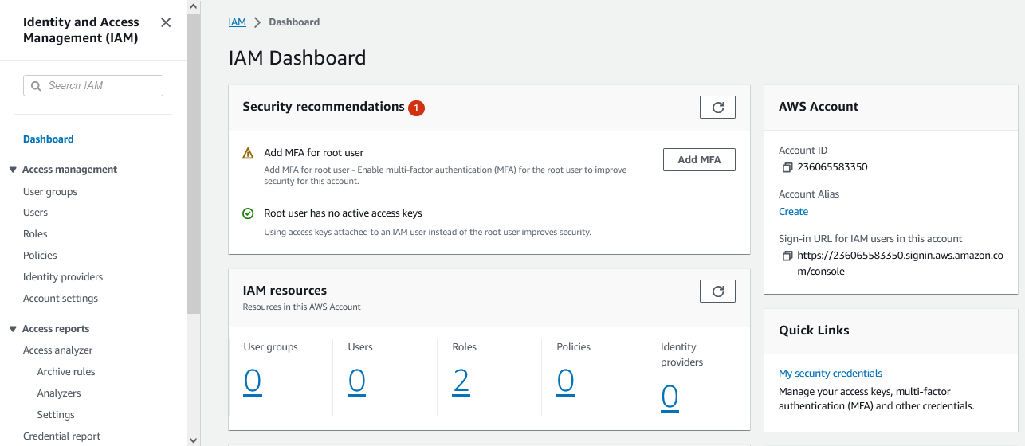

Creation of IAM User

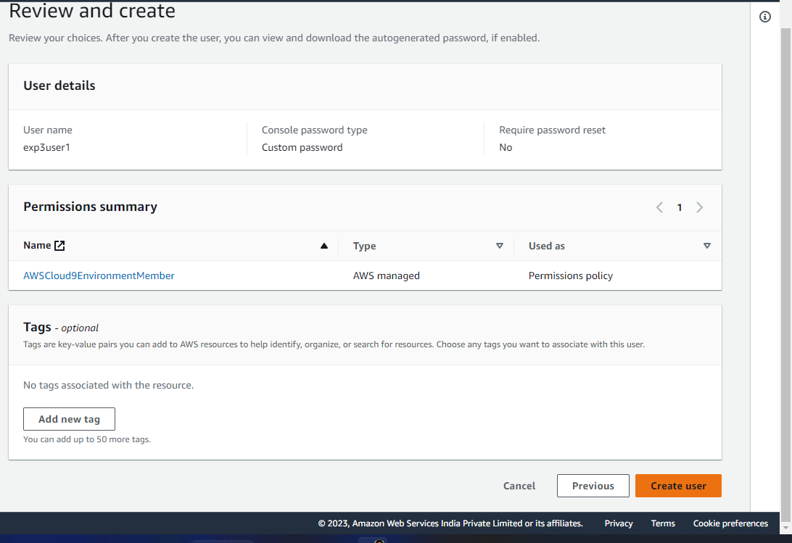

IAM user name and password

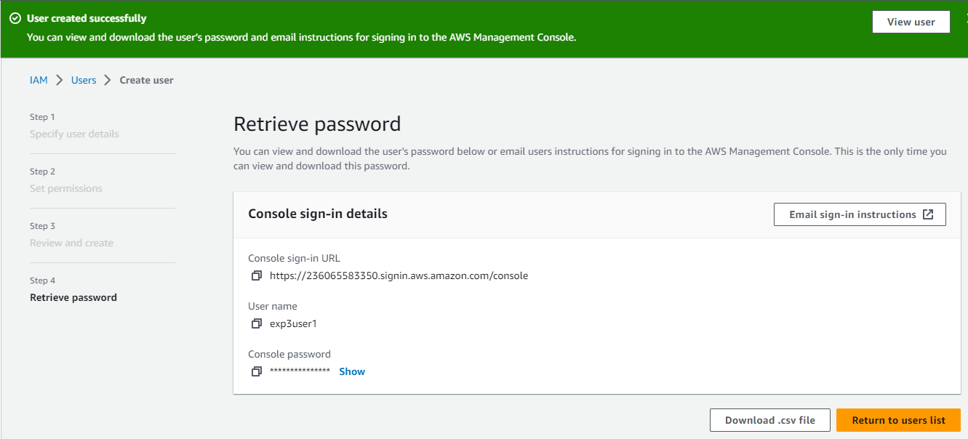

User Credentials and password excel sheet (and IAM login link which is to be logged in using Incognito browser window)



Security Warning message (Confirmation to add user for collaboration)

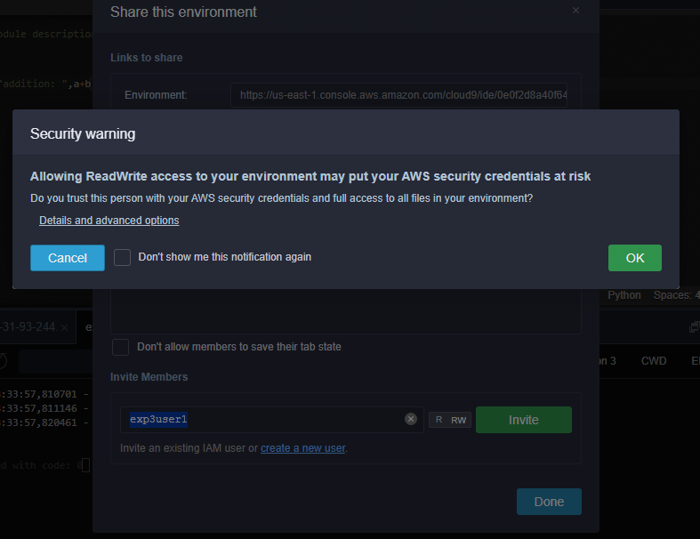

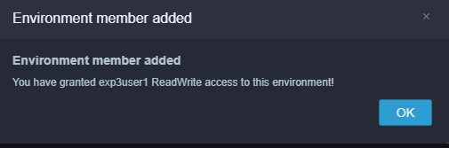

Collaboration (IAM user logged in from Incognito tab)

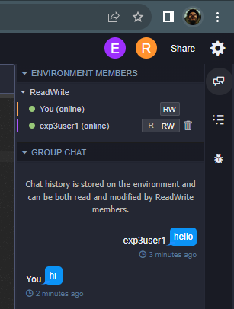 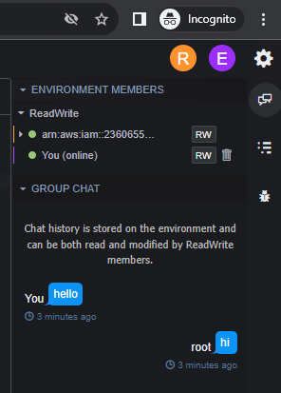

Cloud9 IDE AWS ecplorer tab

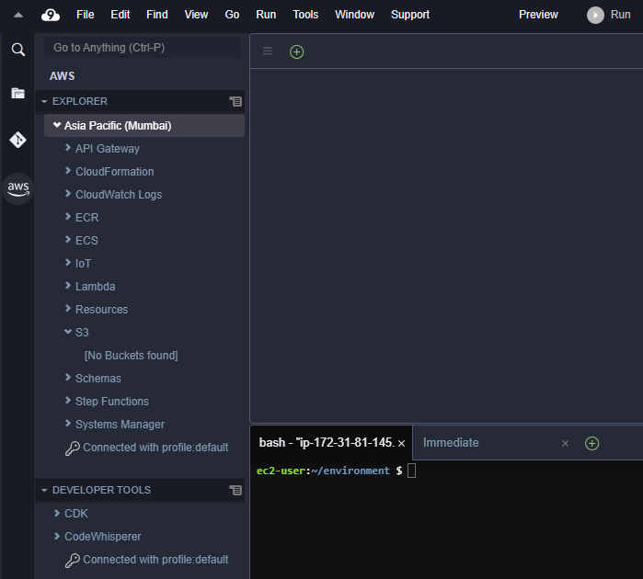

Steps to Deploy SAM Application

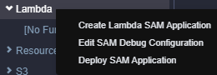

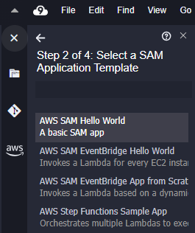 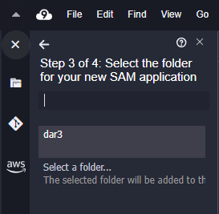 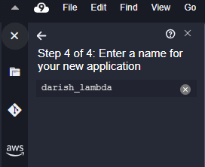

successful creation of SAM application

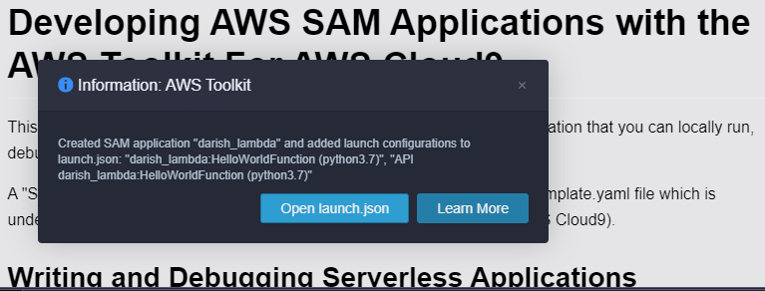

launch.json file containing details of HelloWorld Function.

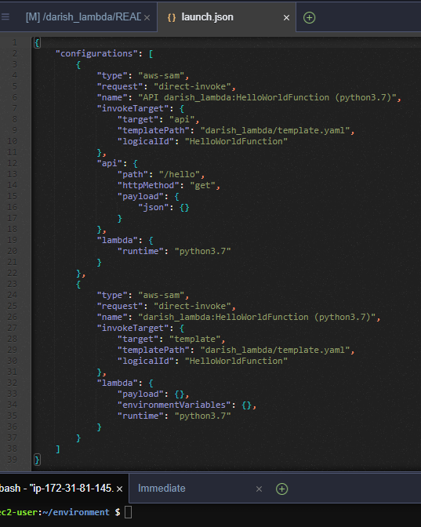

Deployment of SAM application after editing the launch.json file

