St. Francis Institute of Technology, Mumbai-400 103

**Department Of Information Technology**

A.Y. 2023-2024

Class: TE-ITA/B, Semester: V

Subject: **Advanced DevOps Lab**

**Experiment –5: To understand Kubernetes cluster architecture, install and spin up a Kubernetes cluster on a linux machine or cloud platform.**

**1. Aim:** To understand Kubernetes Cluster Architecture and its installation.

**2. Objectives:** Aim of this experiment is that, the students will learn:

**●** Kubernetes concepts

**●** Installation of Kubernetes architecture.

**●** Creating instances of client server architecture on EC2

**●** Use kubectl to deploy resources into an EKS cluster

**●** Work with and configure commonly used Kuberenetes resources

**3. Lab objective mapped : ITL504.2:** To deploy single and multiple container applications and manage application deployments with rollouts in Kubernetes

**4. Prerequisite:**

● Basic Linux command line administration

● Basic Kubernetes and Container-based concepts

**5. Requirements:** AWS account, browser, Personal Computer, Windows operating system, Internet Connection, AWS CLI, kubectl, Required IAM permissions,

**6. Pre-Experiment Exercise:**

**Brief Theory:**

**Amazon EKS** Amazon Elastic Kubernetes Service (Amazon EKS) is a managed service that you can use to run Kubernetes on AWS without needing to install, operate, and maintain your own Kubernetes control plane or nodes. Kubernetes is an open-source system for automating the deployment, scaling, and management of containerized applications. Amazon EKS:

Runs and scales the Kubernetes control plane across multiple AWS Availability Zones to ensure high availability.

Automatically scales control plane instances based on load, detects and replaces unhealthy control plane instances, and it provides automated version updates and patching for them.

Is integrated with many AWS services to provide scalability and security for your applications, including the following capabilities:

Amazon ECR for container images

Elastic Load Balancing for load distribution

IAM for authentication

Amazon VPC for isolation

**How does Amazon EKS work?**

Create an Amazon EKS cluster in the AWS Management Console or with the AWS CLI or one of the AWS SDKs.

Launch managed or self-managed Amazon EC2 nodes, or deploy your workloads to AWS Fargate.

When your cluster is ready, you can configure your favorite Kubernetes tools, such as kubectl, to communicate with your cluster.

Deploy and manage workloads on your Amazon EKS cluster the same way that you would with any other Kubernetes environment. You can also view information about your workloads using the AWS Management Console.

**Amazon EKS pricing** You pay $0.10 per hour for each Amazon EKS cluster that you create. You can use a single EKS cluster to run multiple applications by taking advantage of Kubernetes namespaces and IAM security policies. You can run EKS on AWS using either Amazon Elastic Compute Cloud (Amazon EC2) or AWS Fargate, and on-premises using AWS Outposts.

**1 Clusters x 0.10 USD per hour x 730 hours per month = 73.00 USD**

**EKS Total Cost (monthly): 73.00 USD**

**Kubectl** is a command line tool that you use to communicate with the Kubernetes API server. The kubectl binary is available in many operating system package managers.

CLI – A command line tool for working with AWS services, including Amazon EKS.

**Features:**

1. Auto-scaling. Automatically scale containerized applications and their resources up or down based on usage.

2. Lifecycle management. Automate deployments and updates with the ability to Rollback to previous versions and Pause and continue a deployment.

3. Declarative model. Declare the desired state, and K8s work in the background to maintain that state and recover from any failures.

4. Resilience and self-healing. Auto placement, auto restart, auto replication

and auto-scaling provide application self-healing.

5. Persistent storage. Ability to mount and add storage dynamically.

6. Load balancing. Kubernetes supports various internal and external load balancing options to address diverse needs.

7. DevSecOps support. DevSecOps is an advanced approach to security that simplifies and automates container operations across clouds, integrates security throughout the container lifecycle, and enables teams to deliver secure, high-quality software more quickly. Combining DevSecOps practices and Kubernetes improves developer productivity.

Kubernetes works with Amazon EC2, Azure Container Service, Rack space, GCE, IBM Software, and other clouds. And it works with bare-metal (using CoreOS), Docker, and vSphere.

Kubernetes is used by Google, Spotify, The New York Times, Pinterest, Adidas, Tinder, Capital One, etc.

**7. Laboratory Exercise :**

**Steps to install and spin up a Kubernetes cluster on Linux machine/cloud platforms.** (attach SS) AWS

1. Launch two instances of Linux machine

2. Rename one of the instances as worker and keep the name of the other one as master. 3. Connect both instances using EC2 Instance Connect.

4. Switch to sudo user and get update

Commands:Both Master and Worker

1. sudo su

2. apt-get update

5. Install docker and get its version and status.

Commands:Both Master and Worker

1. apt-get install docker -y

2. docker –version

3. systemcl enable docker

4. systemctl status docker

6. Add repository.

Commands:Both Master and Worker

1. curl -s https://packages.cloud.google.com/apt/doc/apt-key.gpg | sudo apt-key add 2. sudo apt-add-repository &quot;deb http://apt.kubernetes.io/ kubernetes-xenial main&quot;

7. Install Kuber admin, set the hold on it and check its version

Commands:Both Master and Worker

1. sudo apt-get install kubeadm kubelet kubectl

2. sudo apt-mark hold kubeadm kubelet kubectl

3. kubeadm version

**8. Post-Experiments Exercise**

**A. Extended Theory:**

Nil

**B. Questions:**

Nil

**C. Conclusion:**(write in hand)

● 1. Write what was performed in the experiment

● 2. Mention few applications of what was studied.

● 3. Write the significance of the studied topic

**C. References:**

A. https://kubernetes.io/case-studies/

B. https://cloudacademy.com/lab/eks-voteapp/

**—--------------------—---------------**

Steps & Screenshots:

**Step1:** Create a new Instance

* 1. Goto EC2 console and click on Launch Instance

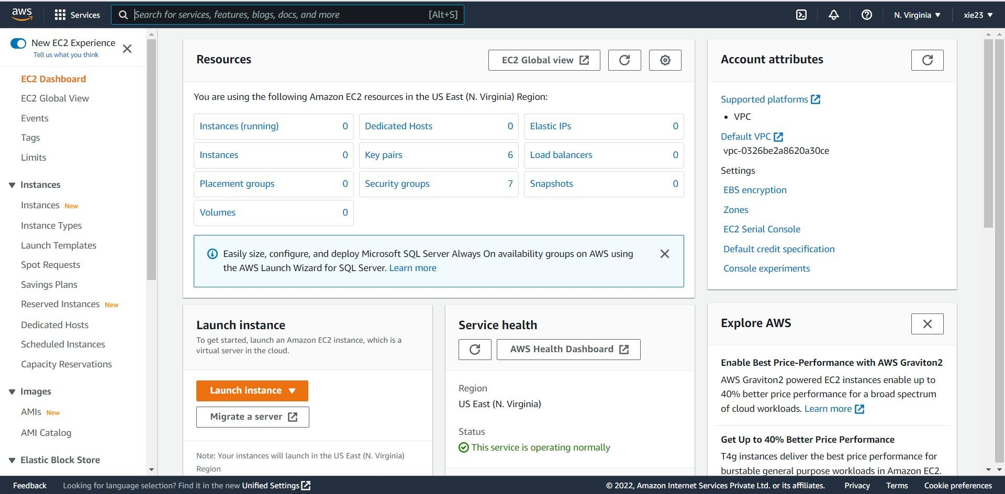

* 1. Give the name to your instance
  2. Choose Ubuntu OS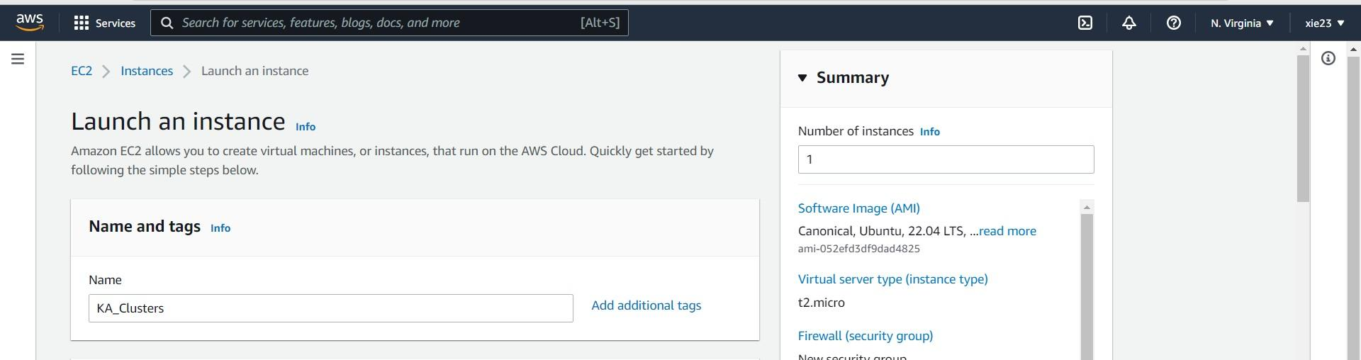

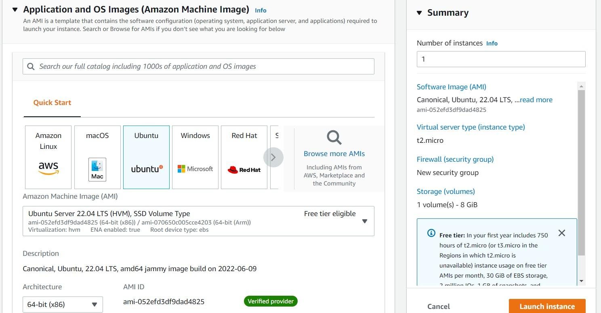

* 1. Click on Create new key pair
  2. Give the Key pair name and select .ppk file format and then click on Create key pair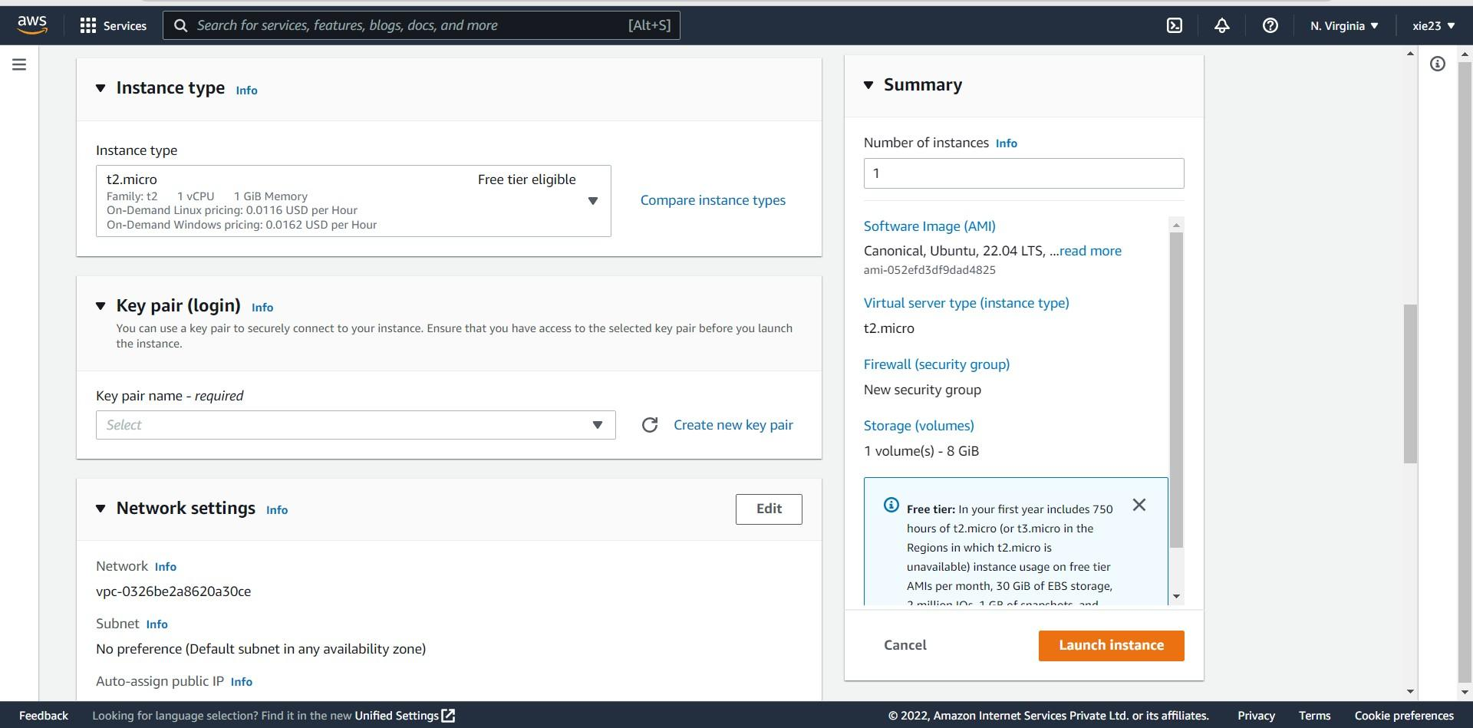

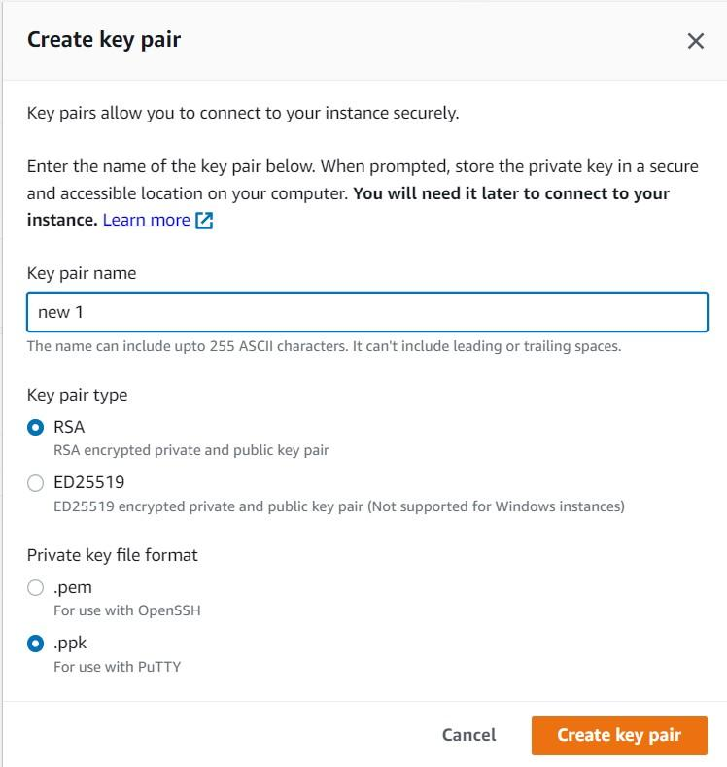

* 1. Click on Launch Instance

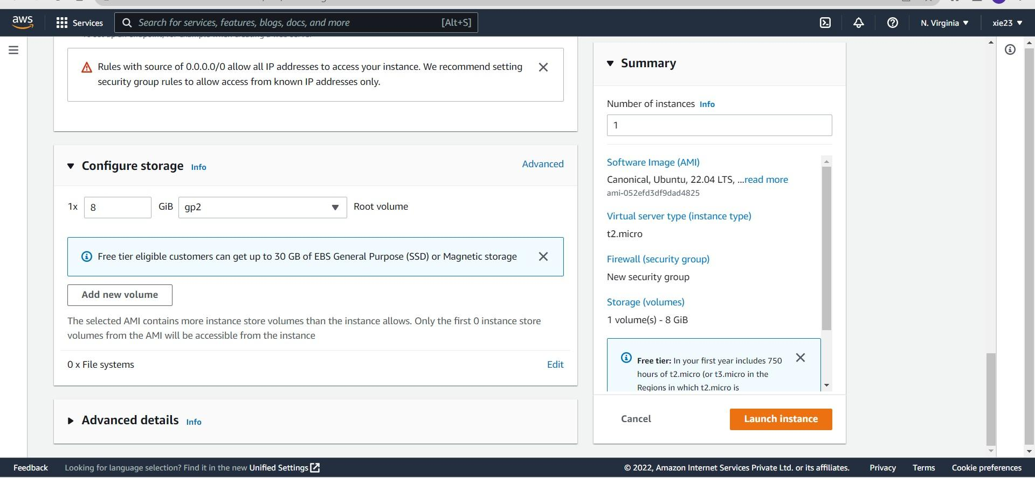

* 1. Successfully instance is launch

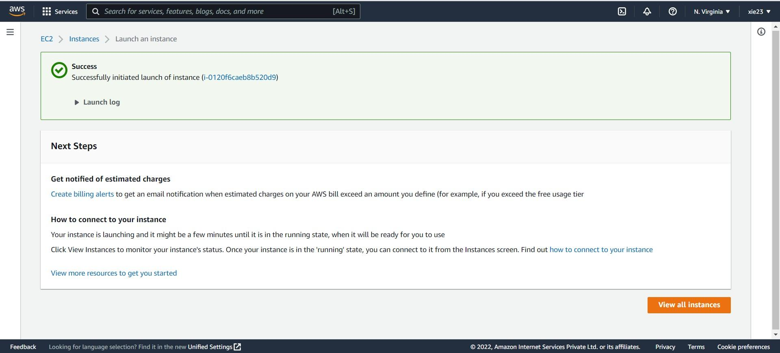

**Step 2:** Connection

1. Goto Instances and select the newly created instance and then click on connect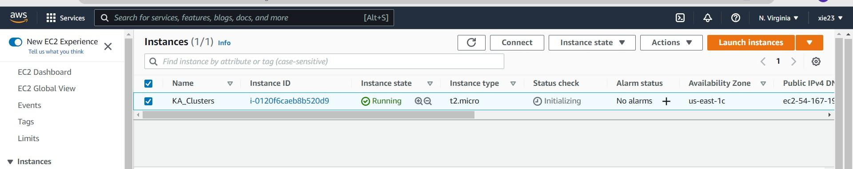
2. Click on Connect
3. Establishing Connection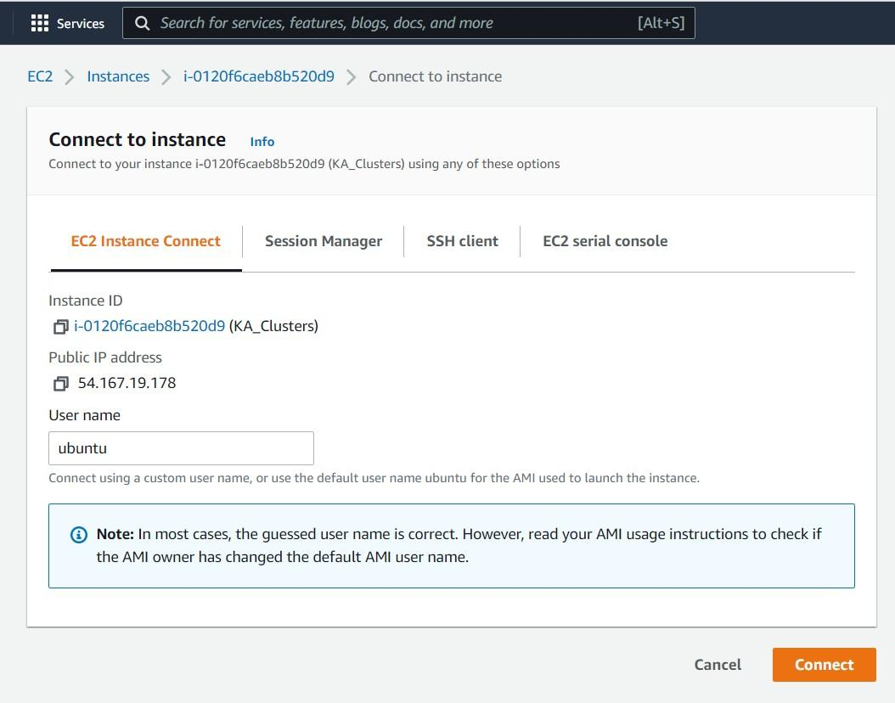

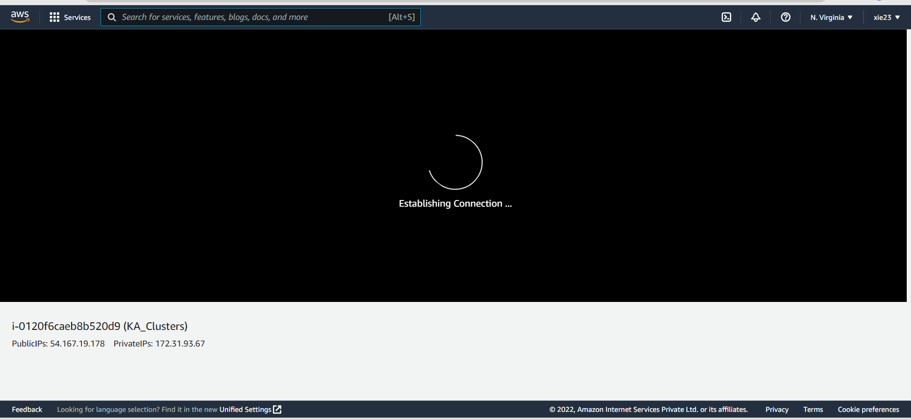

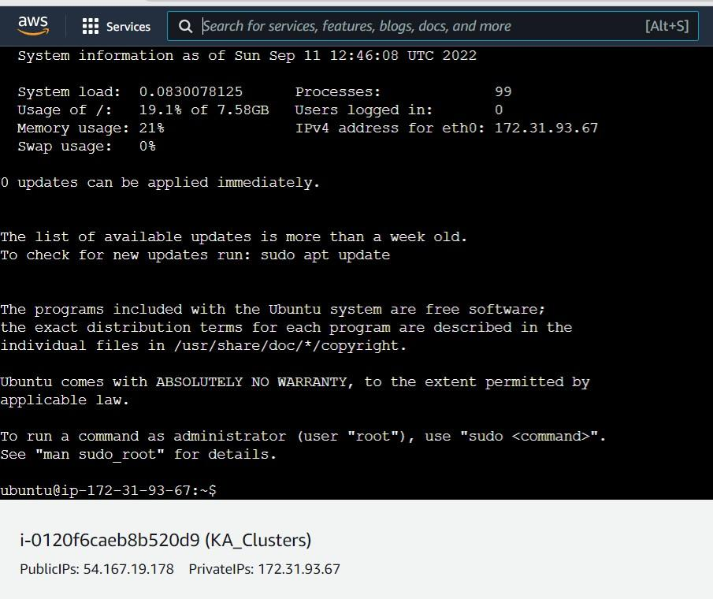

**Step 3:** Run the command “ sudo su -” to goto root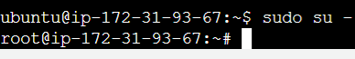

**Step 4:** Install all the updates

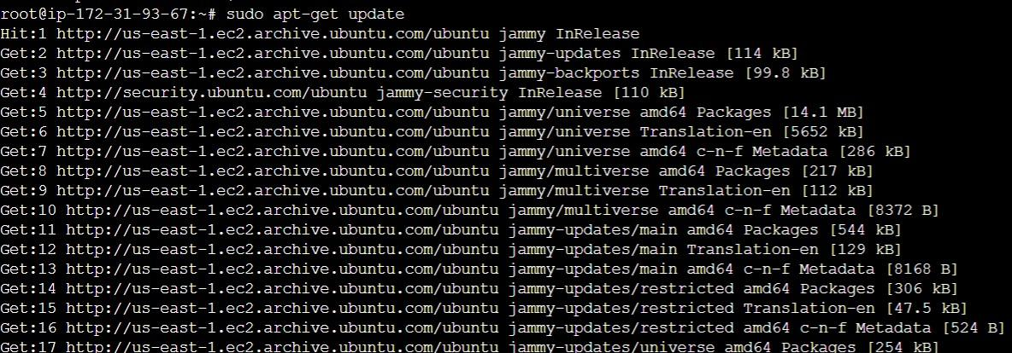

**Step 5:** Install Docker and check its version

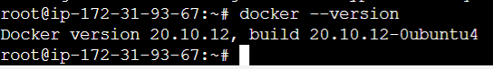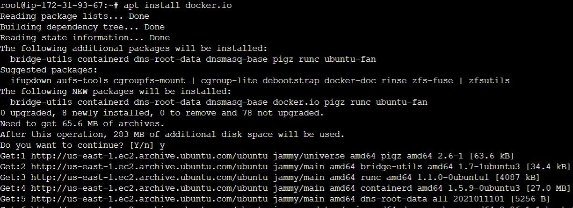

**Step 6:** Enable Docker and then check docker status

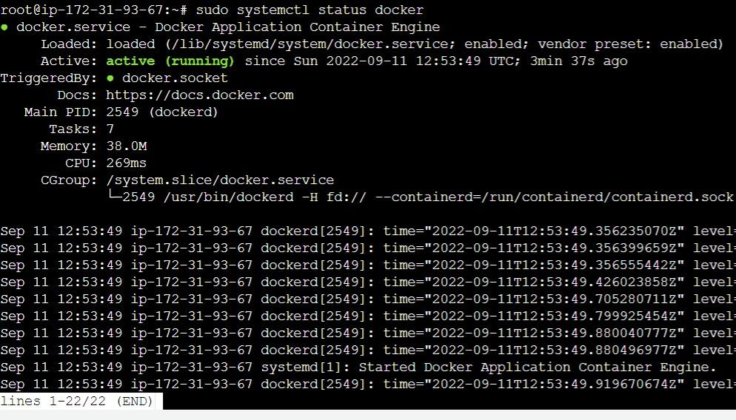

**Step 7 :** Curl



**Step 8:** Add repository

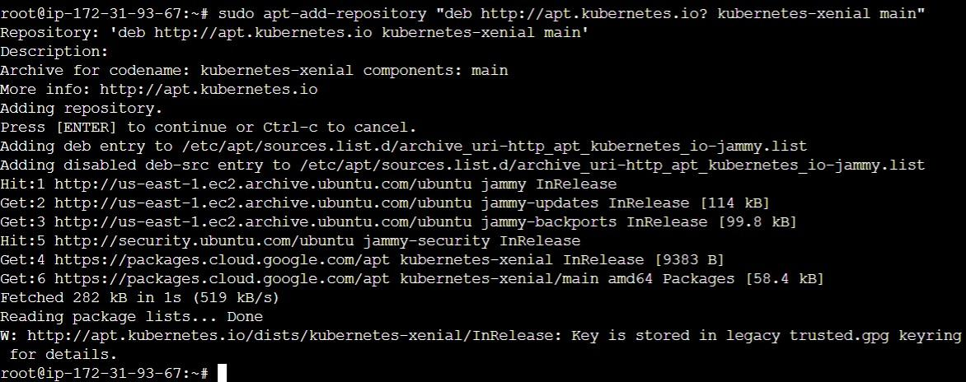

**Step 9:** Install Kubeadm

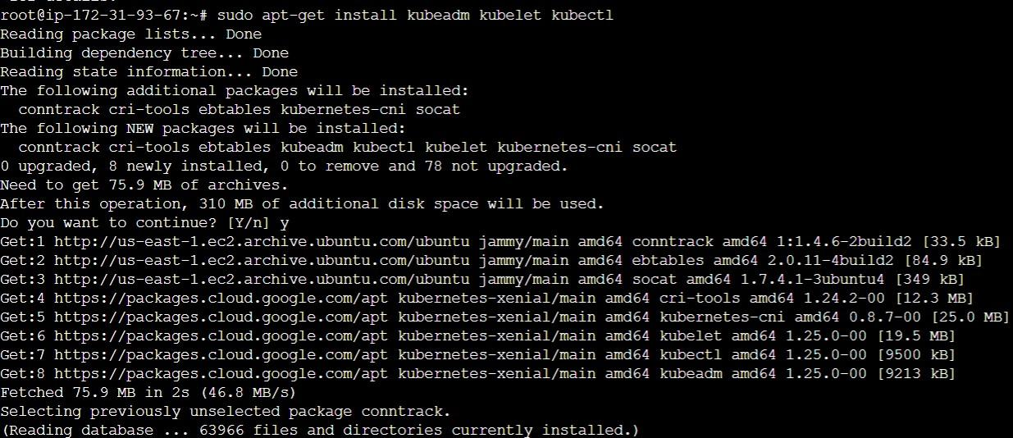

**Step 10:** Set on hold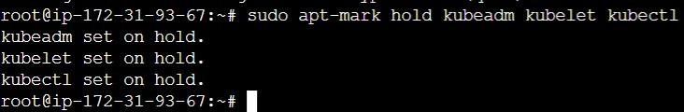

**Step 11:** Check kubeadm version