SFIT, Department of Information Technology **2023**

St. Francis Institute of Technology, Mumbai-400 103

**Department Of Information Technology**

A.Y. 2023-2024

Class: TE-ITA/B, Semester: V

Subject: **Advanced DevOps Lab**

**Experiment –6: To install Kubectl and execute Kubectl commands to manage cluster and deploy your first Kubernetes application.**

**1. Aim:** To understand Kubernetes Cluster Architecture and its installation. **2. Objectives:** Aim of this experiment is that, the students will learn:

**●** Kubernetes concepts

**●** Installation of Kubernetes architecture.

**●** Creating instances of client server architecture on EC2

**●** Use kubectl to deploy resources into an EKS cluster

**●** Work with and configure commonly used Kuberenetes resources

**3. Lab objective mapped : ITL504.2:** To deploy single and multiple container applications and manage application deployments with rollouts in Kubernetes

**4. Prerequisite:**

● Basic Linux command line administration

● Basic Kubernetes and Container-based concepts

**5. Requirements:** AWS account, browser, Personal Computer, Windows operating system, Internet Connection, AWS CLI, kubectl, Required IAM permissions,

**6. Pre-Experiment Exercise:**

**Brief Theory :**

Kubernetes - Cluster Architecture:

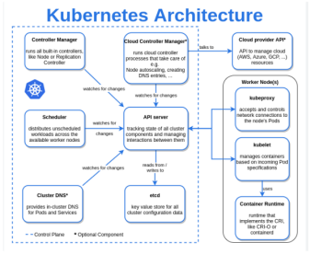

1 **|** ITC ADL LABS

SFIT, Department of Information Technology **2023**

Kubernetes Components:

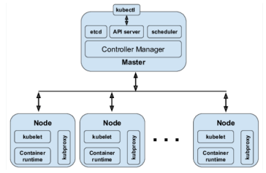Kubernetes - Master Machine Components:

Following are the components of the Kubernetes Master Machine.

➢ etcd

It stores the configuration information which can be used by each of the nodes in the cluster. It is a high-availability key-value store that can be distributed among multiple nodes. It is accessible only by the Kubernetes API server as it may have some sensitive information. It is a distributed key-value Store that is accessible to all.

➢ API Server

Kubernetes is an API server that provides all the operations on the cluster using the API. API server implements an interface, which means different tools and libraries can readily communicate with it. kubeconfig is a package along with the server-side tools that can be used for communication. It exposes Kubernetes API.

Controller Manager

This component is responsible for most of the collectors that regulate the state of the cluster and perform a task. In general, it can be considered a daemon that runs in a nonterminating loop and is responsible for collecting and sending information to the API server. It works toward getting the shared state of the cluster and then make changes to bring the current status of the server to the desired state. The key controllers are the replication controller, endpoint controller, namespace controller, and service account, controller. The controller manager runs different kinds of controllers to handle nodes, endpoints, etc.

➢ Scheduler

This is one of the key components of Kubernetes master. It is a service in the master responsible for distributing the workload. It is responsible for tracking the utilization of the working load on cluster nodes and then placing the workload on which resources are available and accepting the workload. In other words, this is the mechanism responsible for allocating pods to available nodes. The scheduler is responsible for workload utilization and allocating the pod to the new nodes.

Kubernetes - Node Components

2 **|** ITC ADL LABS

SFIT, Department of Information Technology **2023**

Following are the key components of the Node server which are necessary to communicate with

the Kubernetes master.

➢ Docker

The first requirement of each node is Docker which helps in running the encapsulated application containers in a relatively isolated but lightweight operating environment. ➢ Kubelet Service

This is a small service in each node responsible for relaying information to and from the control plane service. It interacts with the etcd store to read configuration details and the right values. This communicates with the master component to receive commands and Controller Manager

This component is responsible for most of the collectors that regulate the state of the cluster and perform a task. In general, it can be considered a daemon that runs in a nonterminating loop and is responsible for collecting and sending information to the API server. It works toward getting the shared state of the cluster and then make changes to bring the current status of the server to the desired state. The key controllers are the replication controller, endpoint controller, namespace controller, and service account, controller. The controller manager runs different kinds of controllers to handle nodes, endpoints, etc.

➢ Scheduler

This is one of the key components of Kubernetes master. It is a service in the master responsible for distributing the workload. It is responsible for tracking the utilization of the working load on cluster nodes and then placing the workload on which resources are available and accepting the workload. In other words, this is the mechanism responsible for allocating pods to available nodes. The scheduler is responsible for workload utilization and allocating the pod to the new nodes.

Kubernetes - Node Components

Following are the key components of the Node server which are necessary to communicate with the Kubernetes master.

➢ Docker

The first requirement of each node is Docker which helps in running the encapsulated application containers in a relatively isolated but lightweight operating environment. ➢ Kubelet Service

This is a small service in each node responsible for relaying information to and from the control plane service. It interacts with the etcd store to read configuration details and the right values. This communicates with the master component to receive commands and

**7. Laboratory Exercise :**

**Steps to install and spin up a Kubernetes cluster on Linux machine/cloud platforms.** (attach SS) **Step 1: Launch 2 instances**

1. Select the Number of instances as 2, and Give the name

3 **|** ITC ADL LABS

SFIT, Department of Information Technology **2023**

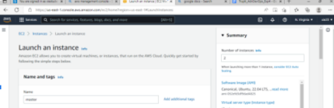2. Now select Ubuntu in Quick Start

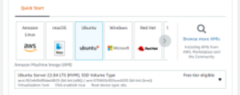

3. Create a new key pair

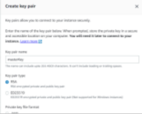

4. Click on the launch Instance



5. Now click on view all instances and rename the instances as Master and Slave. 4 **|** ITC ADL LABS

SFIT, Department of Information Technology **2023**

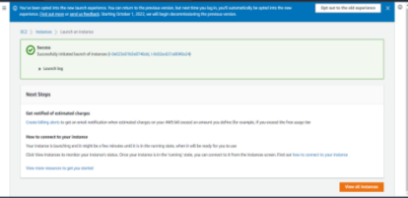

**Step 2:** run the following commands in Master as well as in Slave

**Master Node:**

**Worker Node:**

**Step 3:** Now run the following commands only in Master Node:

kubeadm init –ignore-preflight-errors=all

5 **|** ITC ADL LABS

SFIT, Department of Information Technology **2023**

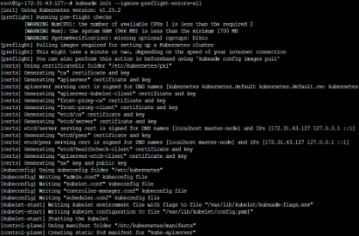

**Step 4:** Save this kubeadm join command which will be used to connect with Slave 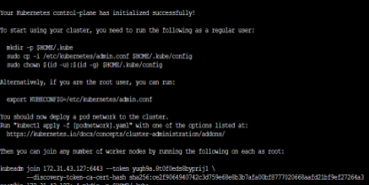**Step 5:** Run the following commands in Master Node

**Step 6:** Run this command in Master Node

6 **|** ITC ADL LABS

SFIT, Department of Information Technology **2023**

**Step 7:** Now switch to the Slave Node and paste the kubeadm join command which we save in Step 4

**Step 8:** Now switch to the Master Node and run the command to see the nodes which are present in our cluster

**Step 9:** To create a deployment run the following command in Master node **Step 10:** Run this command in the Master node

7 **|** ITC ADL LABS

SFIT, Department of Information Technology **2023**



**Step 11:** To see the all the services run this command in Master node

**Step 12:** Run this command in the Master node



**Step 13:** To see the all pods run the following command

**Step 14:** To get the description of deployment run the following command in Master Node

8 **|** ITC ADL LABS

SFIT, Department of Information Technology **2023**



**Step 15:** To delete the service run the following command in Master Node **Step 16:** To delete the deployment run the following command in Master Node **Step 17:** To delete the worker node run the following command in Master Node

9 **|** ITC ADL LABS

SFIT, Department of Information Technology **2023**

**Step 18:** Now check the nodes in Master node you will be getting only Master node 

**8. Post-Experiments Exercise**

**A. Extended Theory:**

Nil

**B. Questions:**

Nil

**C. Conclusion:**(write in hand)

● 1. Write what was performed in the experiment

● 2. Mention few applications of what was studied.

● 3. Write the significance of the studied topic

**C. References:**

A. https://kubernetes.io/case-studies/

B. https://cloudacademy.com/lab/eks-voteapp/

**—--------------------—---------------**

10 **|** ITC ADL LABS