St. Francis Institute of Technology, Mumbai-400103

**Department of Information Technology**

A.Y. 2023-2024

Class: TE-ITA/B, Semester: V

Subject: **Advanced DevOps Lab**

**Experiment – 8: To build, apply and destroy AWS Resources using Terraform.**

**1. Aim:** To build, apply and destroy AWS using Terraform.

**2. Objectives:** After study of this experiment, the student will be able to

**●** Understand basic Terraform commands and concept of creating instance on EC2 using terraform.

**3. Lab objective mapped :** ITL504.3: To be familiarized with infrastructure as code for provisioning, compliance, and management of any cloud infrastructure and d service.

**4. Prerequisite:** Fundamentals of cloud computing and AWS account.

**5. Requirements:** PC and Internet

**6. Pre-Experiment Exercise:**

**Brief Theory:**

**7. Laboratory Exercise**

**Step 1: First we will check that no instance is running on EC2.**

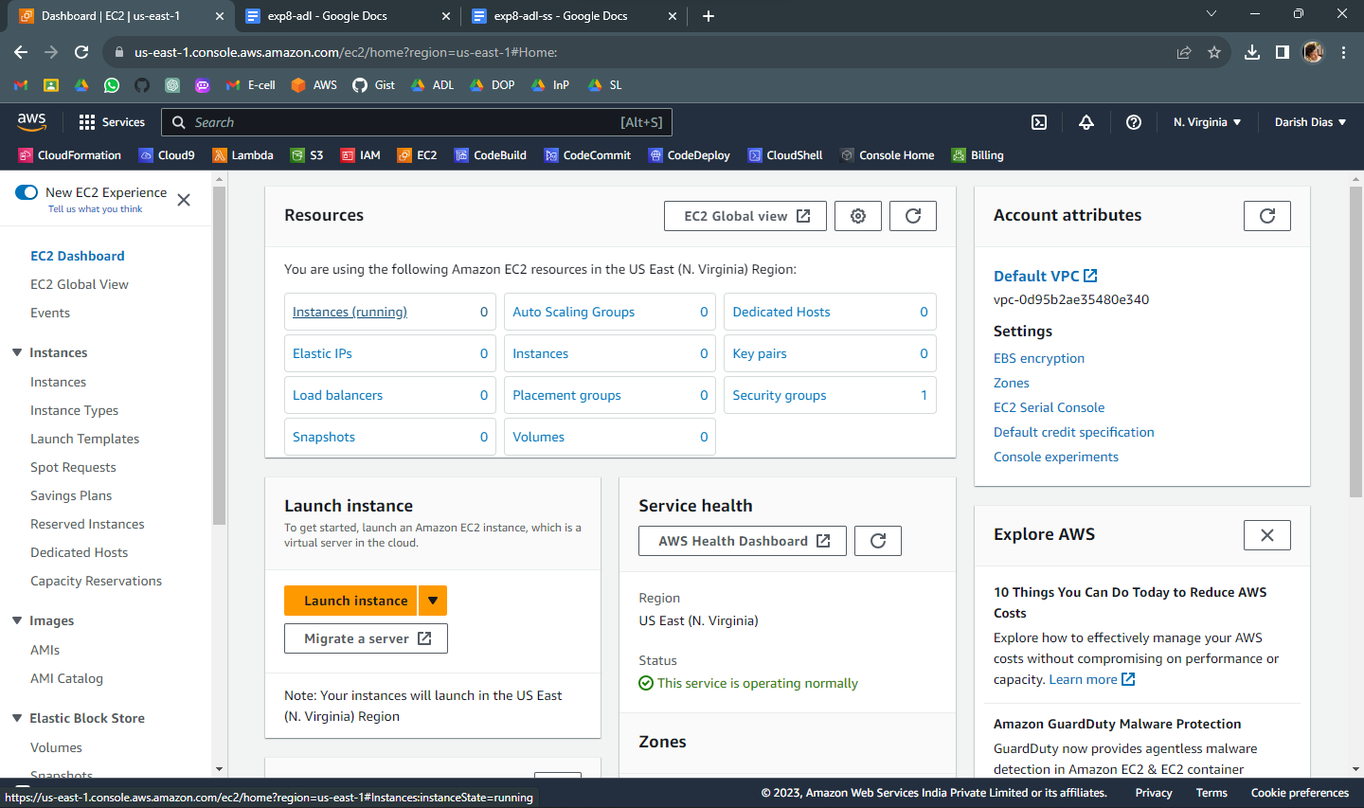

**Step 2: Create an IAM user with Programmatic Password, Administrator access and download access key and secret key from download.csv**

IAM:

USERS:

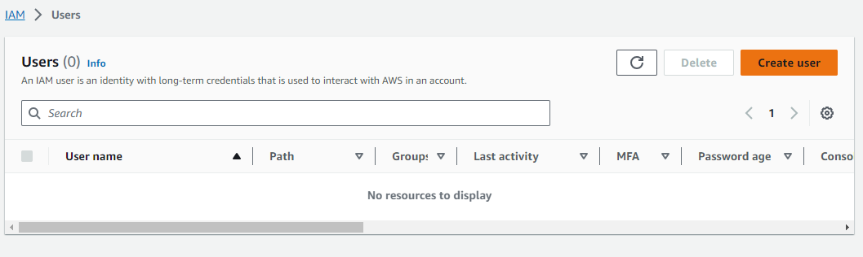

ADD USER:

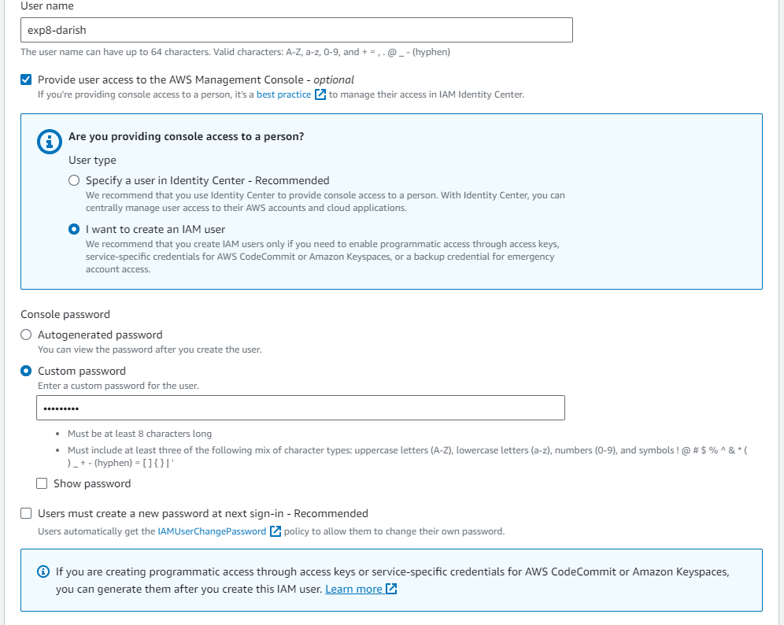

Give console access



I want to create user



custom pwd



Attach policy directly : Administrator Access

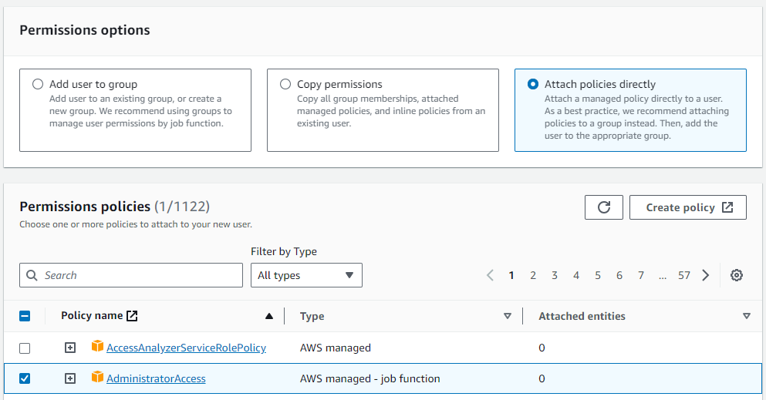

Review:

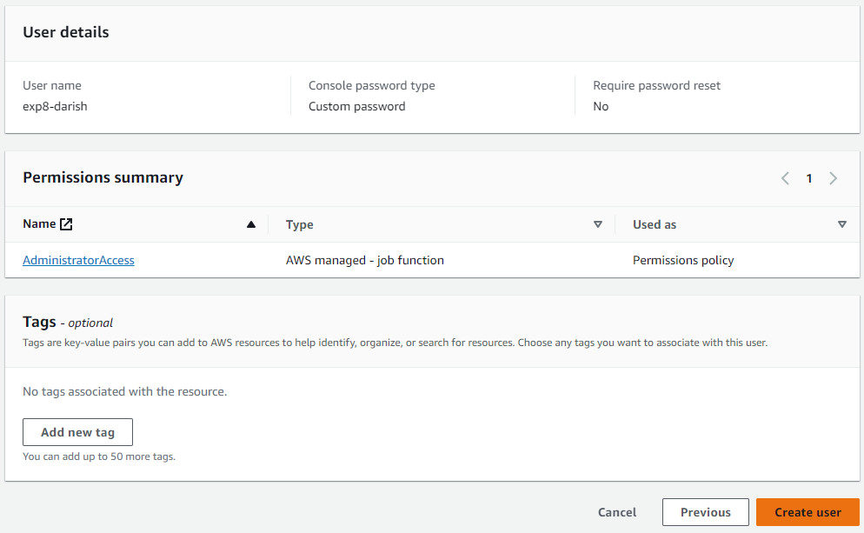

Create user



Clk on user name

Create access key

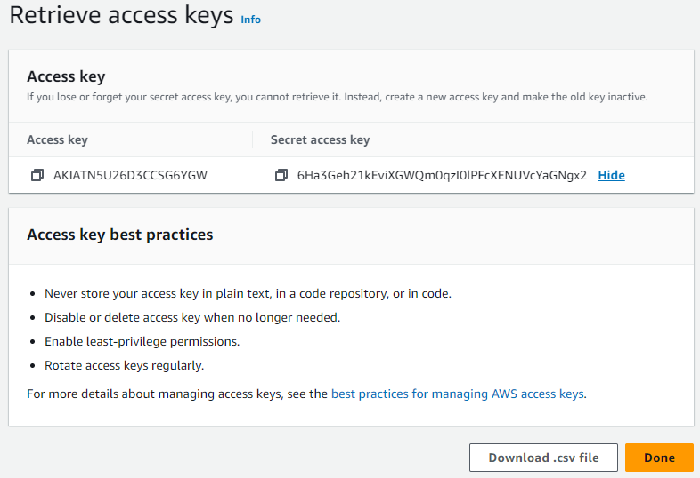

Command line interface

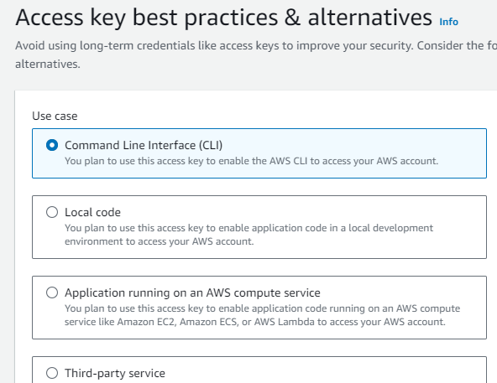

Create access key

**Step 3: Now write a Terraform program in vs code, create new file with .tf extension**

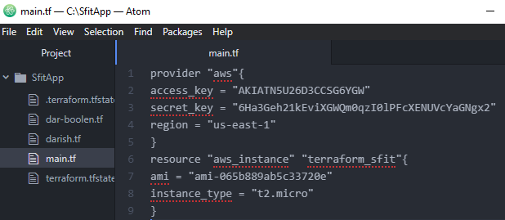

In Launch instance, you will get ami : amazon machine image

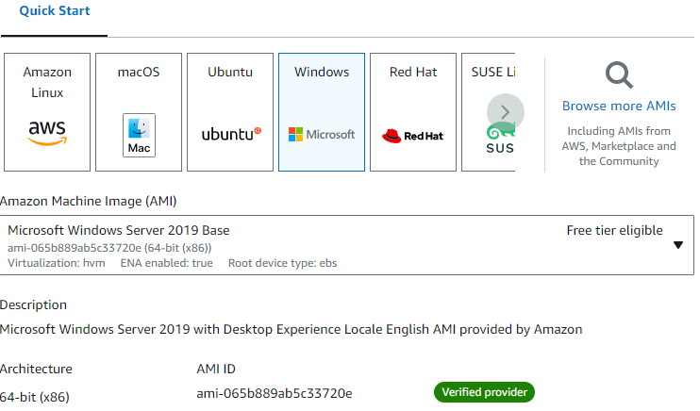

For Instance type : t2.micro is freely available

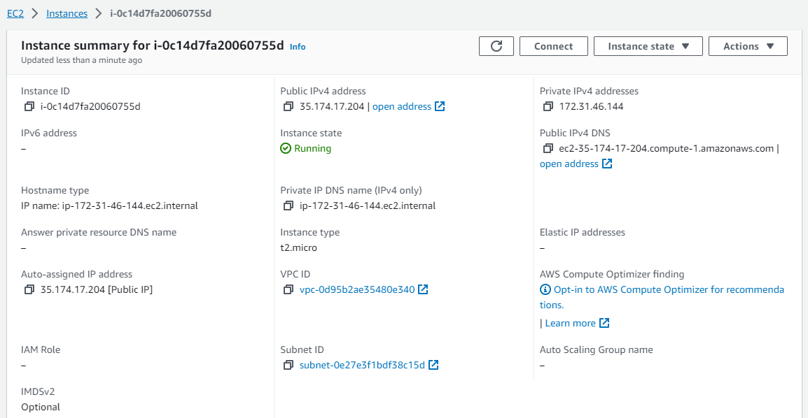

**Step 4: Now initialize the terraform …type c:\SfitApp> terraform init**

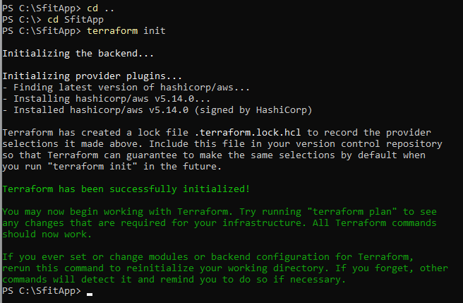

Terraform has been initialized successfully.

**Step 5: c:\sfitApp>terraform plan**

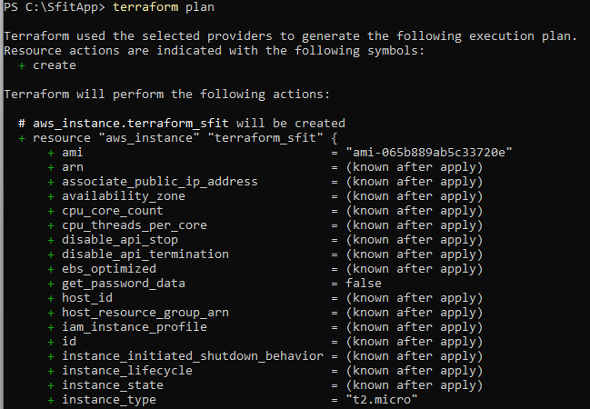

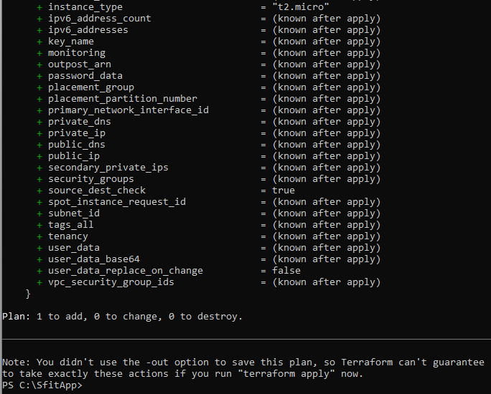

**Step 6: Check the instance on Ec2 before terraform apply**

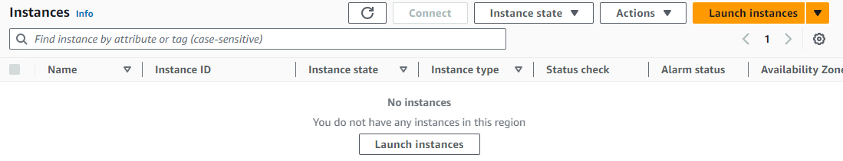

Instance is not yet created.

**Step 7: Terraform apply**

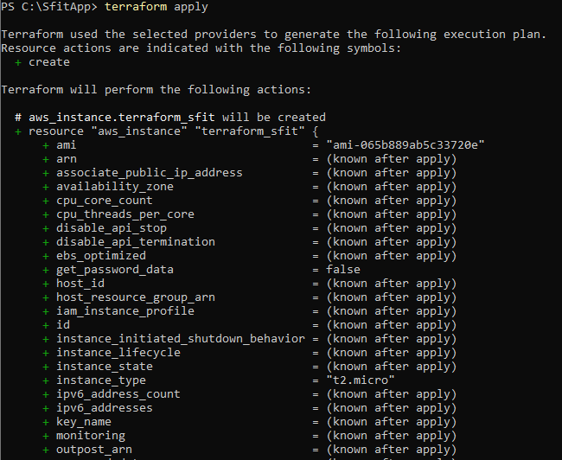

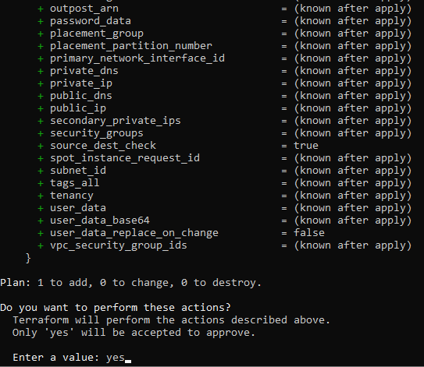

**Step 8: Check terraform created instance on EC2…we have created 3 instances.**

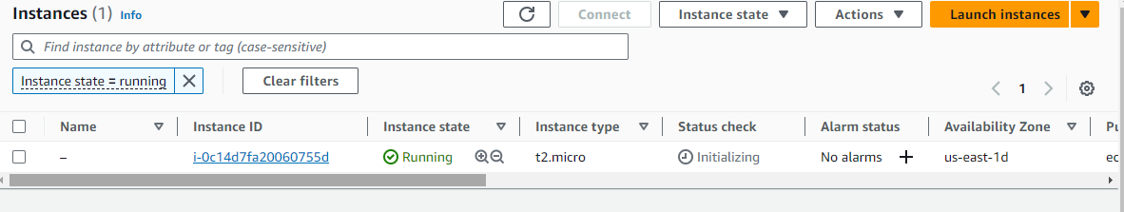

**Step 9: Now destroy the instance from command prompt….c:\SfitApp> terraform destroy**

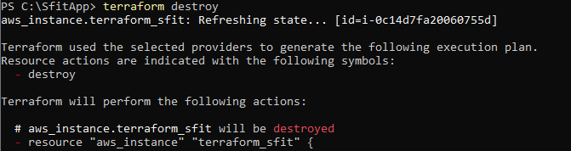

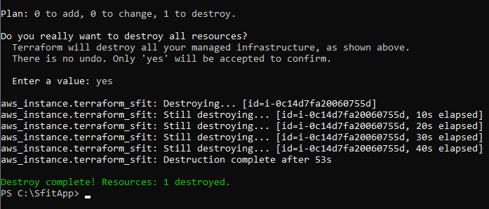

**8. Post-Experiments Exercise**

**A. Extended Theory:** (write in hand)

How to create AWS S3 Bucket using Terraform? (Only write Terraform Code)

**B. Questions:(soft copy)**

**1.** Name some major competitors of Terraform.

2. Why is Terraform preferred as one of the DevOps tools?

**C. Conclusion:**

1. Write what was performed in the experiment

2. Mention few applications of what was studied.

3. Write the significance of the studied topic

**D. References:**

1. https://www.bacancytechnology.com/blog/aws-s3-bucket-using-terraform 2. https://developer.hashicorp.com/terraform/tutorials?product_intent=terrafor m

---------------------------------