Lab 2: README // LAB 3 is fully operational
Lab is fully operational. A picture of the main modules is provided below.
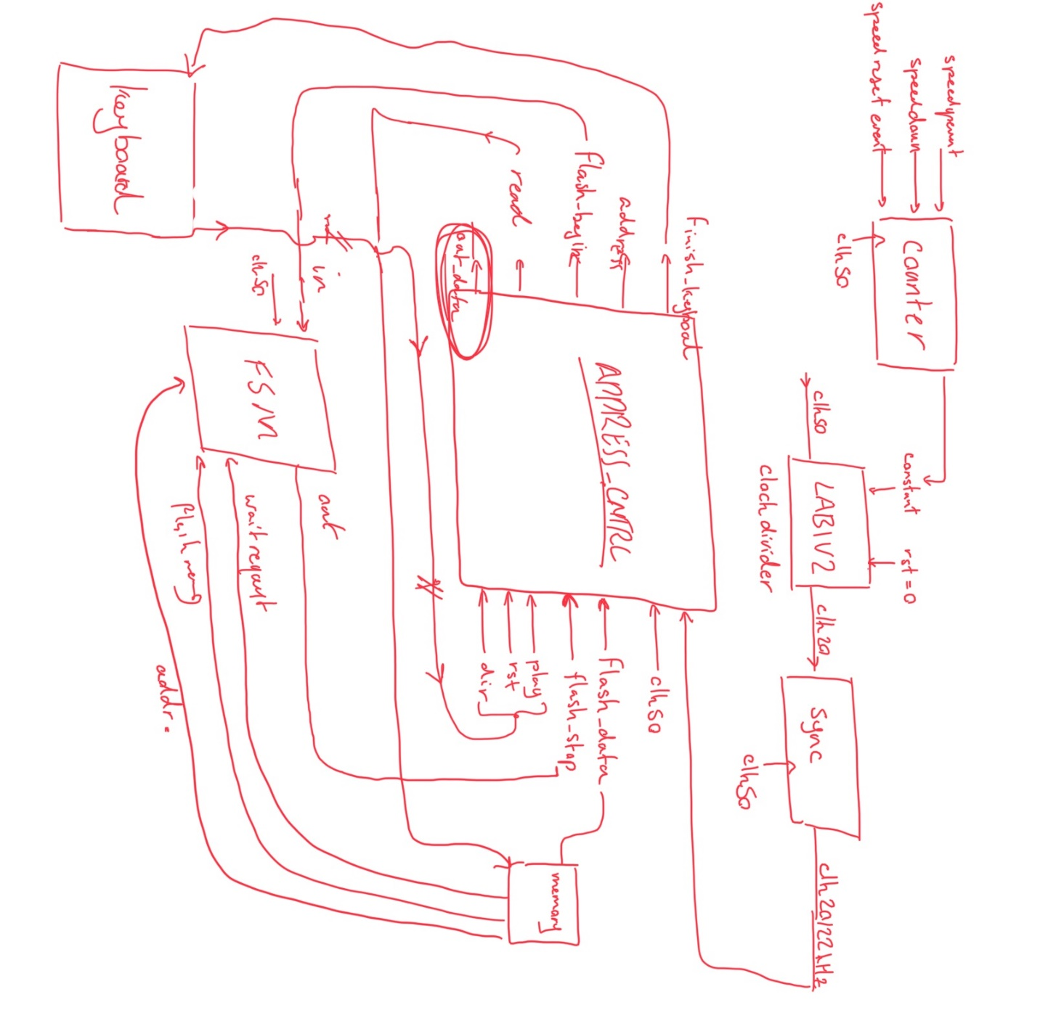

Code contains 6 modules as follows :

COUNTER SPEED_CONTROL (.clk(), .up(), .down(), .rst(),.count());
//increment, decrement or reset a certain value
LAB1V2 CLOCK_DIVIDER (.rst(), .clk(), .constant(), .clk_div());
//divides clocks based on the given value
async_trap_and_reset_gen_1_pulse CLK_22_synchronizer(.async_sig(), .outclk(), .out_sync_sig(), .auto_reset(), .reset());
//synchronizes the 22KHz clock signal
FSM_MEM memory_talk1(.clk(), .read(),.waitrequest(),.data_valid(),.in(),.out());
ADDRESS_CNTRL addr_and_data_manager(.clk(), .frequency_clk(),
.play(), .dir(), .rst(),.flash_stop(), .flash_data(), .flash_begin(),.address(), .read(), .finish_keyboard(),.out_data());
//handles the audio part
KEYBOARD keyboard_cntrl (.clk(), .key(), .finish_read(), .ready(), .play(),
.dir(), .rst());

- COUNTER is a simple counter with up and down enable.
- Lab1V2 is my clock divider code from LAB1 – CPEN 311.
- Async_trap_and_reset_gen_1_pulse was provided in the template to be used for synchronization
- FSM_MEM tells us when a value was read from memory
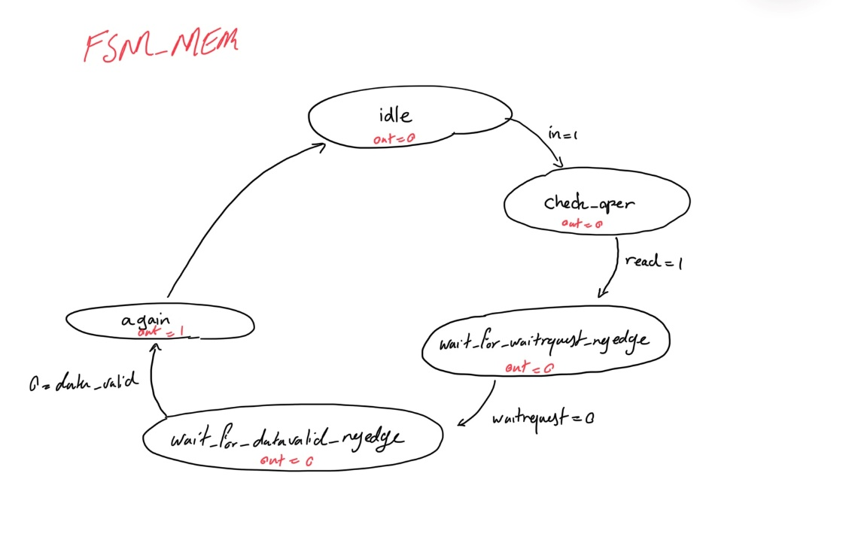

- ADDRESS_CNTRL manages address and what to do with the flash memory data.
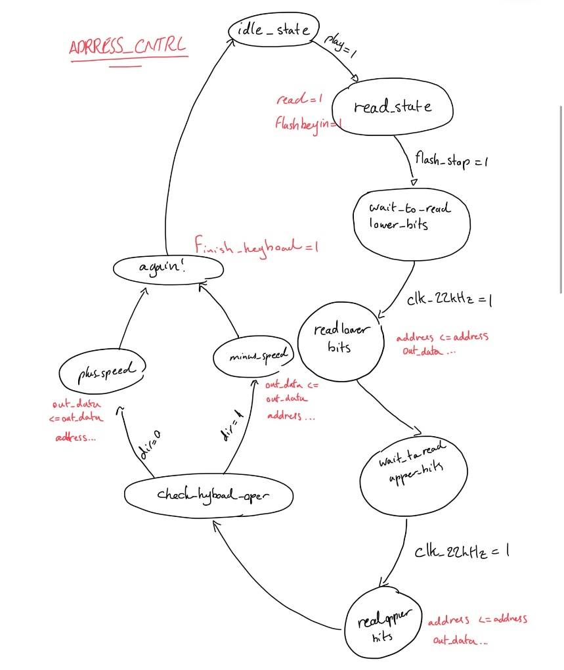
- KEYBOARD is for keyboard interference.
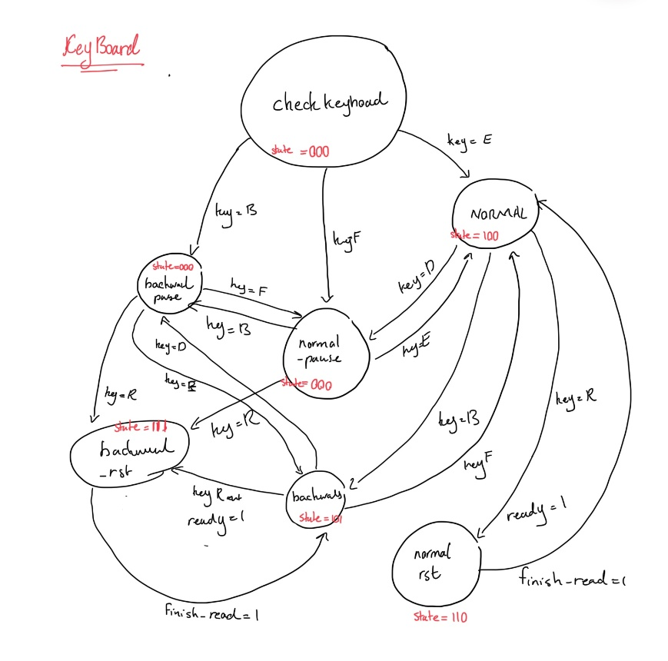

SIMULATIONS:
1.COUNTER
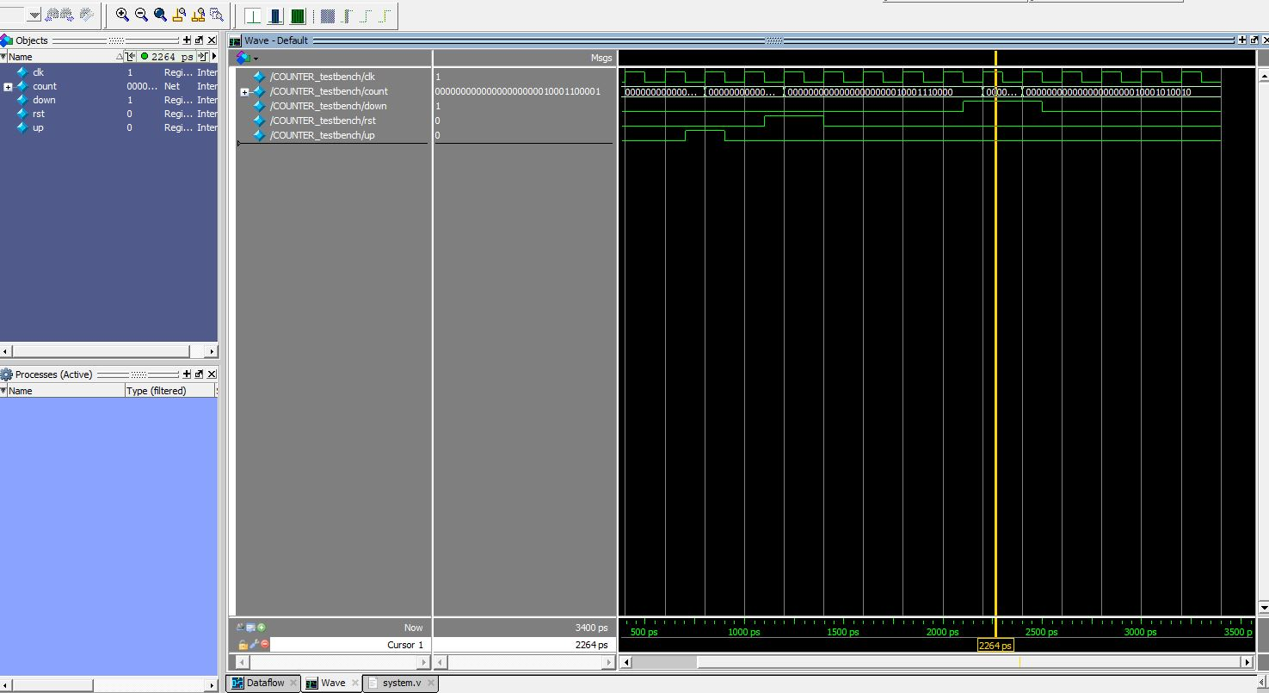
2. FSM
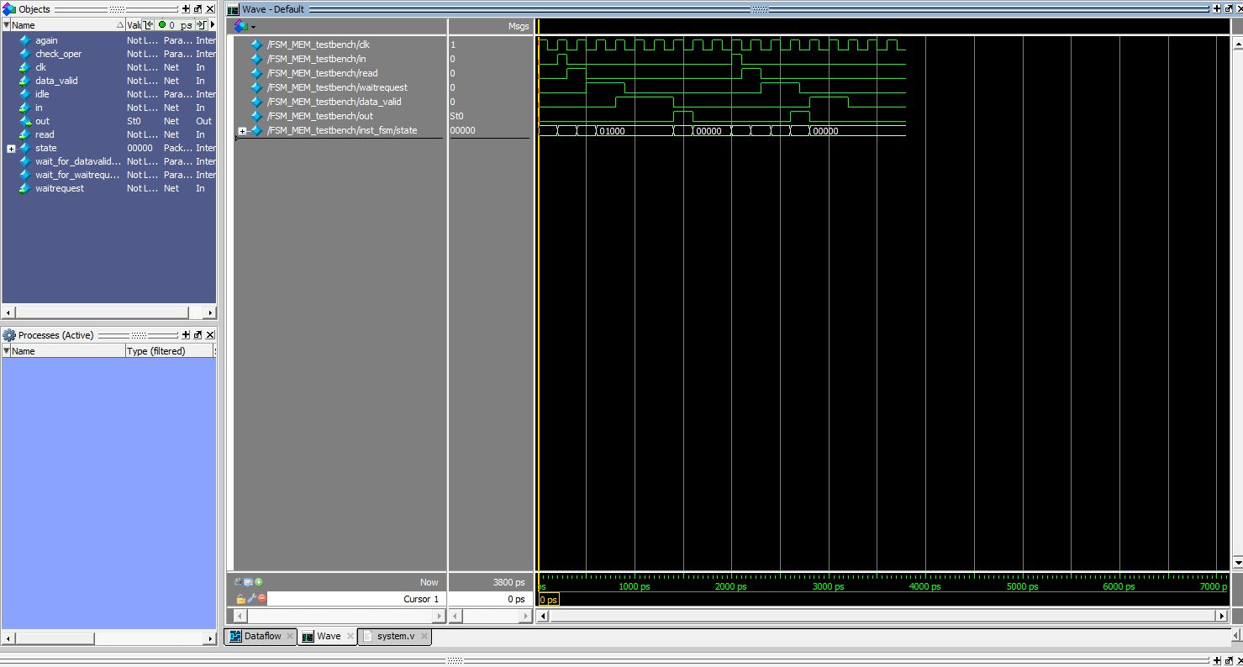

3.ADDRESS_CNTRL
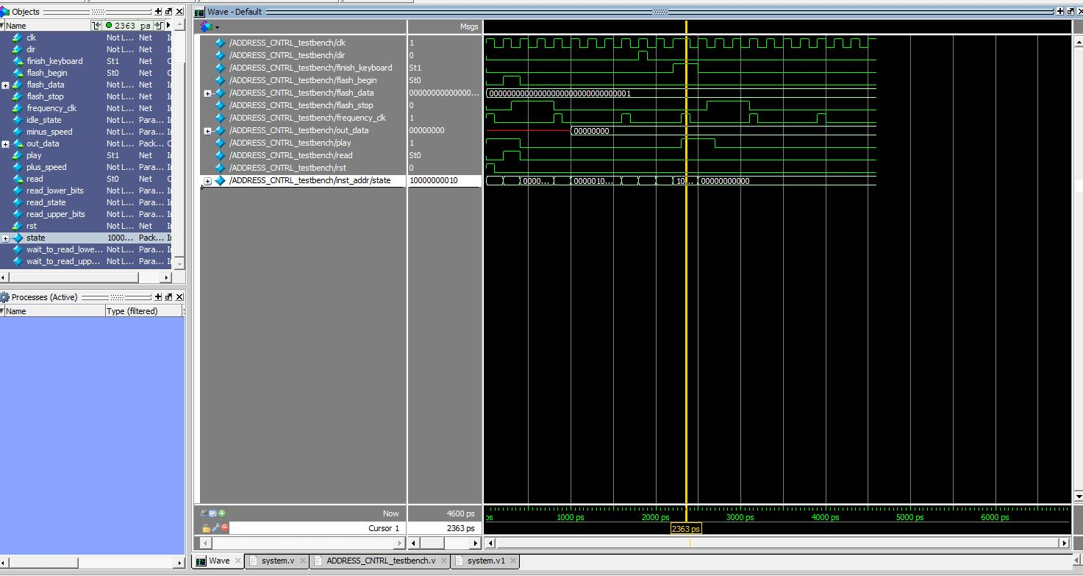
4. KEYBOARD
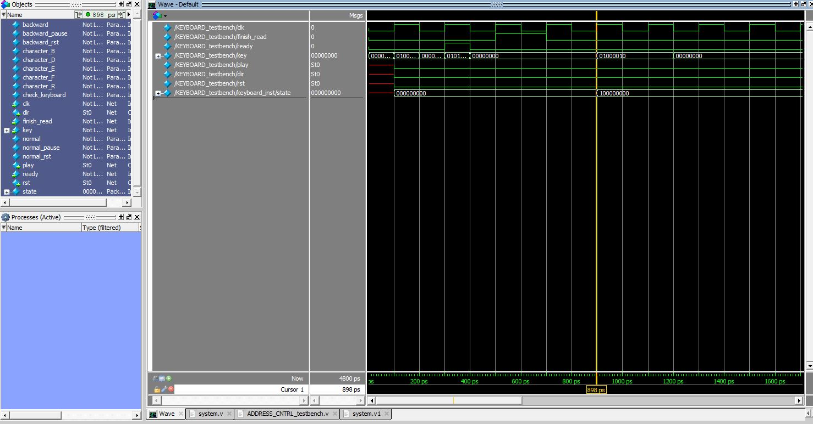
To run the simulations in Modelsim, please open the LAB2V1 folder and open the .mpf file.
To compile the code in Quartus, please open the template folder in the same folder as LAB2V1 and run the

