Session 2025-2026

Vision: To help businesses uncover crucial  insights | Mission: To be a good data scientist

Program Educational Objectives of the program (PEO): (broad statements that describe the professional and career accomplishments)
PEO1 | Preparation | P: Preparation | Pep-CL abbreviation  pronounce as Pep-si-lL easy to recall
PEO2 | Core Competence | E: Environment (Learning Environment)
PEO3 | Breadth | P: Professionalism
PEO4 | Professionalism | C: Core Competence
PEO5 | Learning Environment | L: Breadth (Learning in diverse areas)

Program Outcomes (PO): 1. Understand and Apply Parallel Programming Concepts
2. Analyse and Improve Program Performance.
3. Demonstrate Practical Skills in HPC Tools and Environments.
Keywords of POs:
Engineering knowledge, Problem analysis, Design/development of solutions, Conduct Investigations of Complex Problems, Engineering Tool Usage, The Engineer and The World, Ethics, Individual and Collaborative Team work, Communication, Project Management and Finance, Life-Long Learning

PSO Keywords: Cutting edge technologies, Research

“I am an engineer, and I know how to apply engineering knowledge to investigate, analyse and design solutions to complex problems using tools for entire world following all ethics in a collaborative way with proper management skills throughout my life.” to contribute to the development of cutting-edge technologies and Research.

Integrity: I will adhere to the Laboratory Code of Conduct and ethics in its entirety.

Name and Signature of Student and Date
Aryan Sukhdewe
24/10/2025

Session | 2025-26 (ODD) |  | Course Name | HPC Lab
Semester | 7 |  | Course Code | 22ADS706
Roll No | 40 |  | Name of Student | Aryan Sukhdewe
Practical Number |  | 7
Course Outcome |  | - Understand and Apply Parallel Programming Concepts  - Analyse and Improve Program Performance
Aim |  | Hybrid Programming with MPI + OpenMP Practical
Problem Definition |  | Hybrid Programming with MPI + OpenMP Practical
Theory  (100 words) |  | Requirements  - Software:  - Linux OS (Ubuntu/RedHat recommended)  - MPI library (OpenMPI / MPICH)  - GCC compiler with OpenMP support  - Hardware:  - Multi-core processor  - Optional: Cluster with multiple nodes for full MPI execution  - MPI (Message Passing Interface)  - Used for communication between processes in a distributed memory system.  - Each process has its own address space.  - OpenMP (Open Multi-Processing)  - Used for parallelism within a shared memory node.  - Allows multi-threading using #pragma omp parallel.  - Hybrid Programming  - Combines MPI across nodes and OpenMP within nodes.  - Reduces communication overhead and improves parallel efficiency.  Algorithm  - Initialize MPI and get rank and size.  - Distribute rows of the matrix A among MPI processes.  - Each process computes its local result using OpenMP threads.  - MPI_Reduce is used to gather results to the master process.  - Master process prints the final result.  Steps for execution  Step 1 - Compile: mpicc -fopenmp hybrid_mpi_openmp.c -o hybrid_mpi_openmp  Step 2 - Execute (using 2 MPI processes, adjust threads with OMP_NUM_THREADS): export OMP_NUM_THREADS=4 # Set number of OpenMP threads per process  mpirun -np 2 ./hybrid_mpi_openmp
Code: |  | #include <stdio.h>  #include <stdlib.h>  #include <mpi.h>  #include <omp.h>  #define N 8 // Size of matrix and vector  int main(int argc, char* argv[]) {  int rank, size;  MPI_Init(&argc, &argv);  MPI_Comm_rank(MPI_COMM_WORLD, &rank);  MPI_Comm_size(MPI_COMM_WORLD, &size);  int rows_per_proc = N / size;  double A[rows_per_proc][N];  double x[N];  double y_local[rows_per_proc];  double y[N];  // Initialize vector x and matrix A  if(rank == 0) {  for(int i = 0; i < N; i++)  x[i] = i + 1; // Example vector: 1,2,3...  }  MPI_Bcast(x, N, MPI_DOUBLE, 0, MPI_COMM_WORLD); // Broadcast vector to all processes  // Initialize local part of matrix A  for(int i = 0; i < rows_per_proc; i++) {  for(int j = 0; j < N; j++) {  A[i][j] = (rank * rows_per_proc + i + 1) * (j + 1);  }  }  // Parallel computation using OpenMP  #pragma omp parallel for  for(int i = 0; i < rows_per_proc; i++) {  y_local[i] = 0.0;  for(int j = 0; j < N; j++) {  y_local[i] += A[i][j] * x[j];  }  }  // Gather results to root process  MPI_Gather(y_local, rows_per_proc, MPI_DOUBLE, y, rows_per_proc, MPI_DOUBLE, 0, MPI_COMM_WORLD);  // Print result in master process  if(rank == 0) {  printf("Result vector y:\n");  for(int i = 0; i < N; i++) {  printf("%lf ", y[i]);  }  printf("\n");  }  MPI_Finalize();  return 0;  }
Output |  | 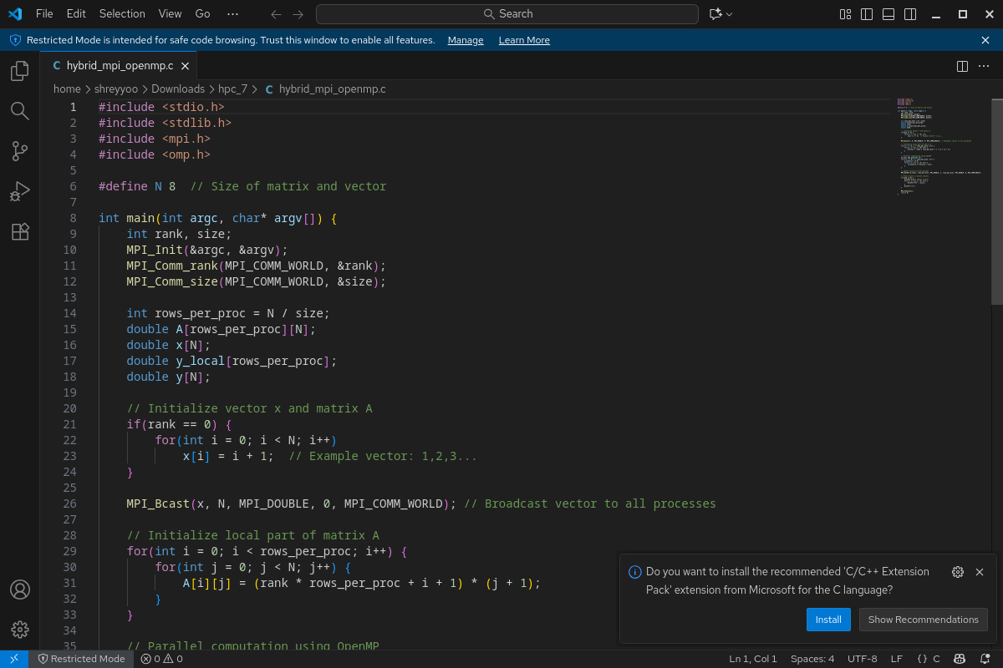  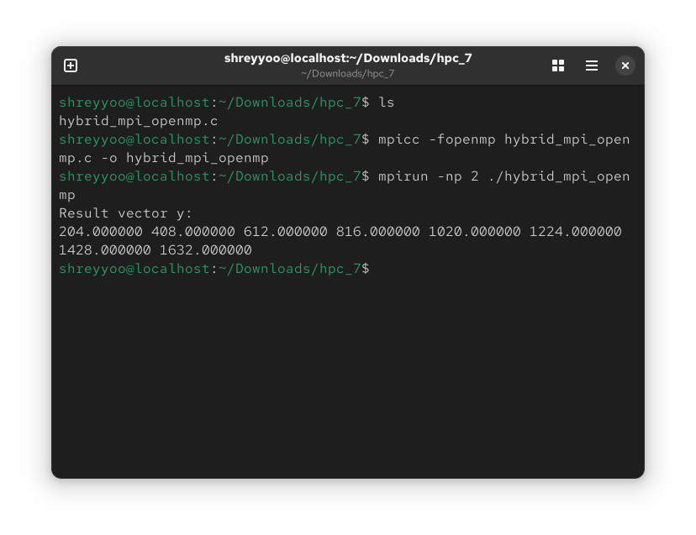
Output Analysis |  | The program executes successfully and gives us the resultant vector y as an output.
Link of student Github profile where lab assignment has been uploaded |  | https://github.com/aryanycce/HPC-Practicals
Conclusion |  | The experiment successfully compiled and ran a hybrid MPI/OpenMP parallel program using 2 MPI processes. The program executed correctly, as confirmed by the output of the 8-element result vector y demonstrating that the system and the parallel code are properly configured for hybrid high-performance computing.
Plag Report (Similarity index < 12%) |  | 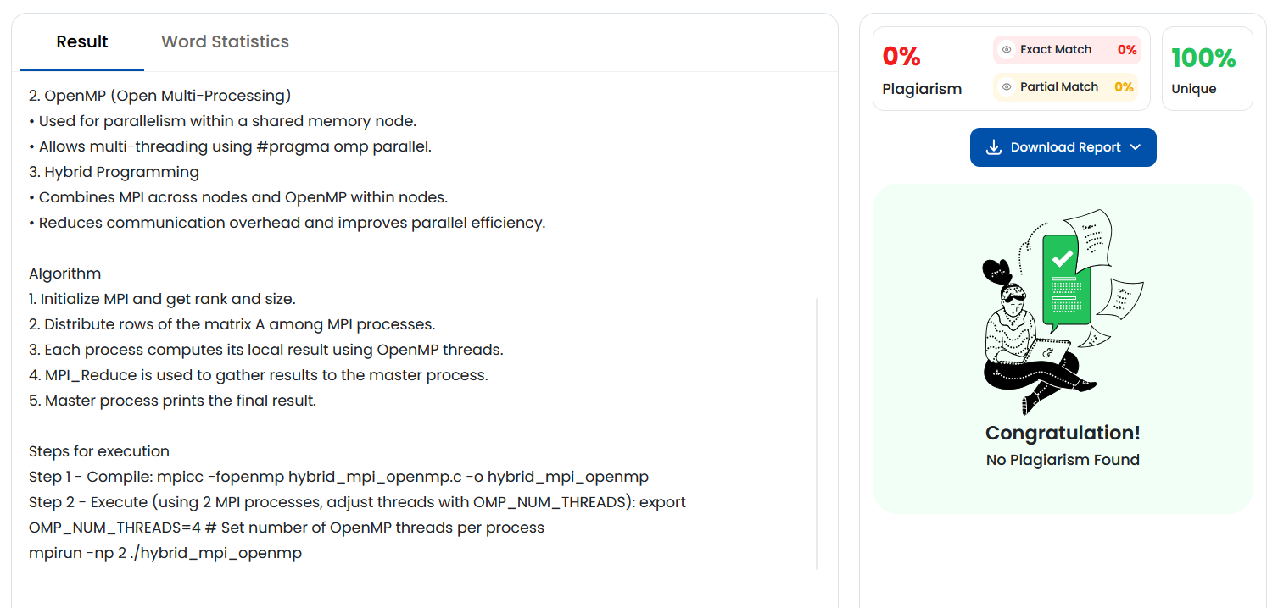
Date |  | 24/10/2025

