Session 2025-2026

Vision: To help businesses uncover crucial  insights | Mission: To be a good data scientist

Program Educational Objectives of the program (PEO): (broad statements that describe the professional and career accomplishments)
PEO1 | Preparation | P: Preparation | Pep-CL abbreviation  pronounce as Pep-si-lL easy to recall
PEO2 | Core Competence | E: Environment (Learning Environment)
PEO3 | Breadth | P: Professionalism
PEO4 | Professionalism | C: Core Competence
PEO5 | Learning Environment | L: Breadth (Learning in diverse areas)

Program Outcomes (PO): 1. Understand and Apply Parallel Programming Concepts
2. Analyse and Improve Program Performance.
3. Demonstrate Practical Skills in HPC Tools and Environments.
Keywords of POs:
Engineering knowledge, Problem analysis, Design/development of solutions, Conduct Investigations of Complex Problems, Engineering Tool Usage, The Engineer and The World, Ethics, Individual and Collaborative Team work, Communication, Project Management and Finance, Life-Long Learning

PSO Keywords: Cutting edge technologies, Research

“I am an engineer, and I know how to apply engineering knowledge to investigate, analyse and design solutions to complex problems using tools for entire world following all ethics in a collaborative way with proper management skills throughout my life.” to contribute to the development of cutting-edge technologies and Research.

Integrity: I will adhere to the Laboratory Code of Conduct and ethics in its entirety.

Name and Signature of Student and Date
Aryan Sukhdewe
24/10/2025

Session | 2025-26 (ODD) |  | Course Name | HPC Lab
Semester | 7 |  | Course Code | 22ADS706
Roll No | 40 |  | Name of Student | Aryan Sukhdewe
Practical Number |  | 6
Course Outcome |  | - Understand and Apply Parallel Programming Concepts  - Analyse and Improve Program Performance
Aim |  | Parallel Pi Calculation using MPI
Problem Definition |  | Parallel Pi Calculation using MPI
Theory  (100 words) |  | The value of π can be approximated using the Monte Carlo method or numerical integration.  One common numerical method is based on the integration of the area under a curve:  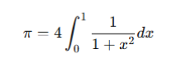  This integral can be approximated by dividing the interval [0,1] into N subintervals and summing the area of rectangles:  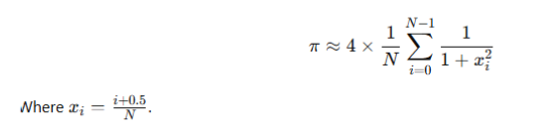  Using MPI, the work of summing these rectangles can be distributed among multiple  processes. Each process computes a partial sum, and the master process (rank 0) collects the  results to compute the final value of π.  Software/Hardware Requirements:  Hardware: Multi-core CPU or cluster with multiple nodes  Software:  o Linux/Unix OS  o MPICH or OpenMPI  o GCC Compiler  Algorithm:  1. Initialize MPI environment using MPI_Init.  2. Get the rank (ID) of each process and total number of processes using  MPI_Comm_rank and MPI_Comm_size.  3. Divide the range [0,1] among processes. Each process computes a partial sum of π  for its assigned range.  4. Use MPI_Reduce to collect and sum all partial results at the root process.  5. The root process prints the final value of π.  6. Finalize MPI using MPI_Finalize.
Code: |  | #include &lt;stdio.h&gt;  #include &lt;mpi.h&gt;  int main(int argc, char* argv[]) {  int rank, size, n = 1000000, i;  double h, sum = 0.0, x, local_sum = 0.0, pi;  MPI_Init(&amp;argc, &amp;argv);  MPI_Comm_rank(MPI_COMM_WORLD, &amp;rank);  MPI_Comm_size(MPI_COMM_WORLD, &amp;size);  h = 1.0 / (double) n;  // Each process computes its portion  for (i = rank; i &lt; n; i += size) {  x = h * (i + 0.5);  local_sum += 4.0 / (1.0 + x * x);  }  local_sum *= h;  // Reduce all local sums to get the final result  MPI_Reduce(&amp;local_sum, &amp;pi, 1, MPI_DOUBLE, MPI_SUM, 0,  MPI_COMM_WORLD);  if (rank == 0) {  printf(&quot;Calculated value of Pi = %.16f\n&quot;, pi);  }  MPI_Finalize();  return 0;  }
Output |  | 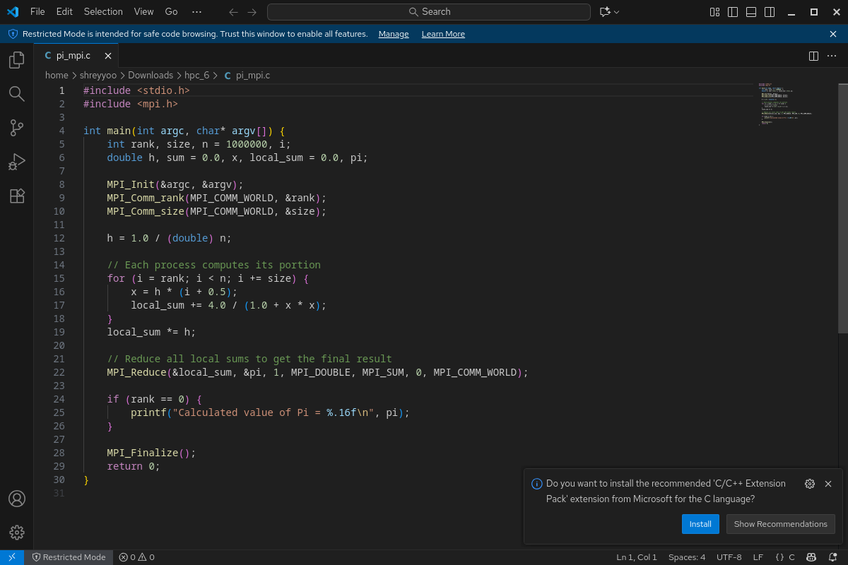  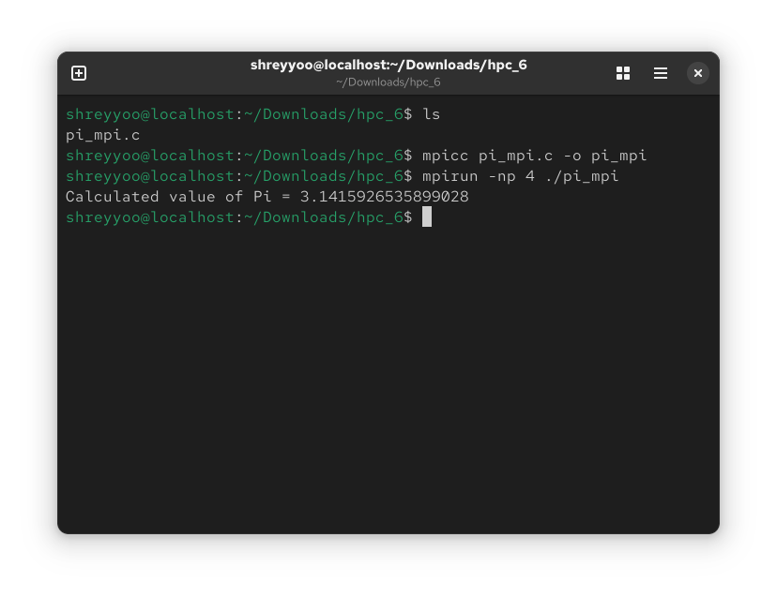
Output Analysis |  | OpenMPI executes the program successfully and gives us the calculated value of Pi.
Link of student Github profile where lab assignment has been uploaded |  | https://github.com/aryanycce/HPC-Practicals
Conclusion |  | The Parallel Pi Calculation using MPI experiment successfully demonstrated that utilizing the Message Passing Interface significantly reduces the computation time compared to a sequential approach by distributing the numerical integration workload among multiple processes.
Plag Report (Similarity index < 12%) |  | 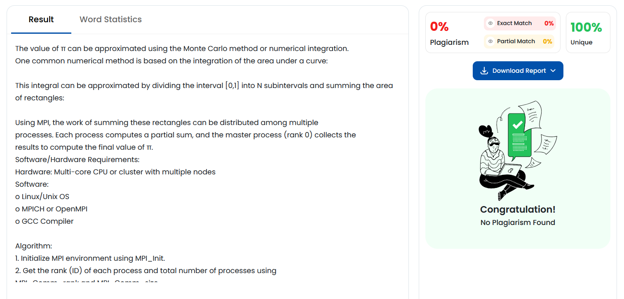
Date |  | 24/10/2025

