Session 2025-2026

Vision: To help businesses uncover crucial  insights | Mission: To be a good data scientist

Program Educational Objectives of the program (PEO): (broad statements that describe the professional and career accomplishments)
PEO1 | Preparation | P: Preparation | Pep-CL abbreviation  pronounce as Pep-si-lL easy to recall
PEO2 | Core Competence | E: Environment (Learning Environment)
PEO3 | Breadth | P: Professionalism
PEO4 | Professionalism | C: Core Competence
PEO5 | Learning Environment | L: Breadth (Learning in diverse areas)

Program Outcomes (PO): 1. Understand and Apply Parallel Programming Concepts
2. Analyse and Improve Program Performance.
3. Demonstrate Practical Skills in HPC Tools and Environments.
Keywords of POs:
Engineering knowledge, Problem analysis, Design/development of solutions, Conduct Investigations of Complex Problems, Engineering Tool Usage, The Engineer and The World, Ethics, Individual and Collaborative Team work, Communication, Project Management and Finance, Life-Long Learning

PSO Keywords: Cutting edge technologies, Research

“I am an engineer, and I know how to apply engineering knowledge to investigate, analyse and design solutions to complex problems using tools for entire world following all ethics in a collaborative way with proper management skills throughout my life.” to contribute to the development of cutting-edge technologies and Research.

Integrity: I will adhere to the Laboratory Code of Conduct and ethics in its entirety.

Name and Signature of Student and Date
Aryan Sukhdewe
24/10/2025

Session | 2025-26 (ODD) |  | Course Name | HPC Lab
Semester | 7 |  | Course Code | 22ADS706
Roll No | 40 |  | Name of Student | Aryan Sukhdewe
Practical Number |  | 8
Course Outcome |  | - Understand and Apply Parallel Programming Concepts  - Analyse and Improve Program Performance
Aim |  | Introduction to GPU Computing
Problem Definition |  | Introduction to GPU Computing
Theory  (100 words) |  | CUDA (Compute Unified Device Architecture) is a parallel computing platform and programming model developed by NVIDIA. It provides a set of extensions to standard programming languages like C/C++ (called CUDA C/C++) that allow developers to harness the parallel power of NVIDIA GPUs.  The Heterogeneous Programming Model  The CUDA model is heterogeneous, meaning an application uses both the CPU and the GPU:  - Host Code: The sequential parts of the application run on the CPU (Host).  - Device Code: The parallel, compute-intensive parts are written as special functions called kernels that run on the GPU (Device).  Typical CUDA Program Flow  A standard CUDA program involves the following steps:  - Allocation: Allocate memory on both the Host (CPU RAM) and the Device (GPU VRAM).  - Transfer: Copy input data from Host memory to Device memory (via the PCIe bus).  - Function: cudaMemcpy(..., cudaMemcpyHostToDevice)  - Kernel Launch: The Host launches the kernel function on the Device. The kernel runs in parallel across thousands of threads.  - Syntax: kernel_name<<<GridDim, BlockDim>>>(arguments);  - Transfer Back: Copy the results from Device memory back to Host memory.  - Function: cudaMemcpy(..., cudaMemcpyDeviceToHost)  - Synchronization: The CPU code waits for the GPU kernel execution to complete (often implicit in the copy-back step).  - Cleanup: Free memory on both the Host and the Device.  Steps for execution  Step 1: Check Prerequisites  nvcc --version  Step 2: Create a CUDA File  Step 3: Compile the Program  nvcc vector_add.c -0 vector_add  Step 4: Run the Program  ./vector_add  Step 5: Verify GPU Availability  Nvidia-smi
Code: |  | #include <stdio.h>  __global__ void add(int *a, int *b, int *c, int n) {  int index = threadIdx.x;  if (index < n)  c[index] = a[index] + b[index];  }  int main(void) {  int n = 5;  int a[5] = {1, 2, 3, 4, 5};  int b[5] = {10, 20, 30, 40, 50};  int c[5] = {0};  int *d_a, *d_b, *d_c;  int size = n * sizeof(int);  cudaMalloc((void **)&d_a, size);  cudaMalloc((void **)&d_b, size);  cudaMalloc((void **)&d_c, size);  cudaMemcpy(d_a, a, size, cudaMemcpyHostToDevice);  cudaMemcpy(d_b, b, size, cudaMemcpyHostToDevice);  add<<<1, n>>>(d_a, d_b, d_c, n);  cudaMemcpy(c, d_c, size, cudaMemcpyDeviceToHost);  printf("Result of vector addition:\n");  for (int i = 0; i < n; i++)  printf("%d + %d = %d\n", a[i], b[i], c[i]);  cudaFree(d_a);  cudaFree(d_b);  cudaFree(d_c);  return 0;  }
Output |  | 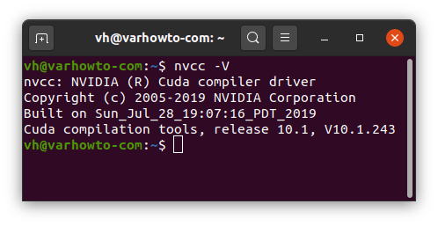  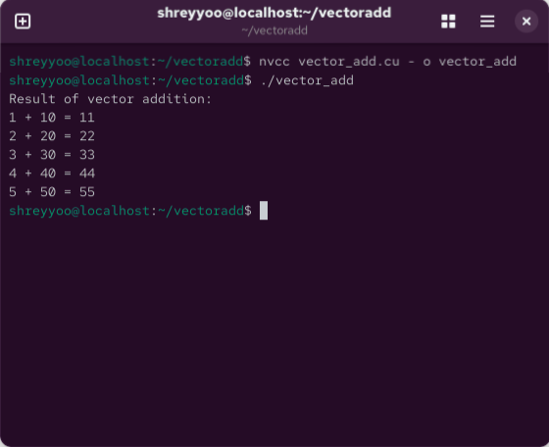  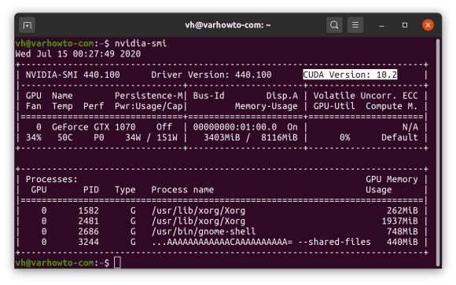
Output Analysis |  | The program executes successfully using CUDA and gives us the output.
Link of student Github profile where lab assignment has been uploaded |  | https://github.com/aryanycce/HPC-Practicals
Conclusion |  | The experiment successfully validated the principles of heterogeneous parallel computing by implementing a performance-critical task using NVIDIA CUDA on a CentOS platform.
Plag Report (Similarity index < 12%) |  | 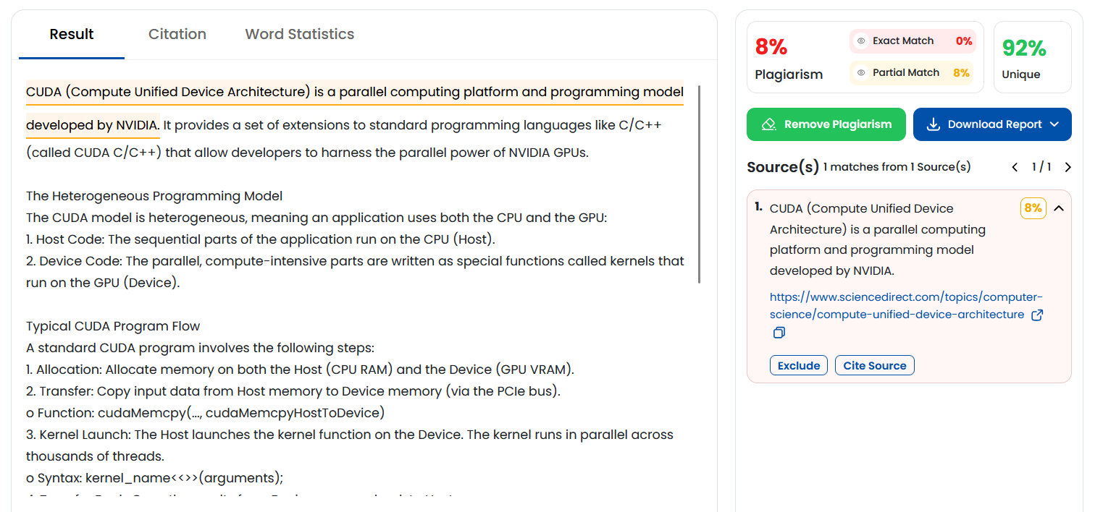
Date |  | 24/10/2025

