Session 2025-2026

Vision: To help businesses uncover crucial  insights | Mission: To be a good data scientist

Program Educational Objectives of the program (PEO): (broad statements that describe the professional and career accomplishments)
PEO1 | Preparation | P: Preparation | Pep-CL abbreviation  pronounce as Pep-si-lL easy to recall
PEO2 | Core Competence | E: Environment (Learning Environment)
PEO3 | Breadth | P: Professionalism
PEO4 | Professionalism | C: Core Competence
PEO5 | Learning Environment | L: Breadth (Learning in diverse areas)

Program Outcomes (PO): 1. Understand and Apply Parallel Programming Concepts
2. Analyse and Improve Program Performance.
3. Demonstrate Practical Skills in HPC Tools and Environments.
Keywords of POs:
Engineering knowledge, Problem analysis, Design/development of solutions, Conduct Investigations of Complex Problems, Engineering Tool Usage, The Engineer and The World, Ethics, Individual and Collaborative Team work, Communication, Project Management and Finance, Life-Long Learning

PSO Keywords: Cutting edge technologies, Research

“I am an engineer, and I know how to apply engineering knowledge to investigate, analyse and design solutions to complex problems using tools for entire world following all ethics in a collaborative way with proper management skills throughout my life.” to contribute to the development of cutting-edge technologies and Research.

Integrity: I will adhere to the Laboratory Code of Conduct and ethics in its entirety.

Name and Signature of Student and Date
Aryan Sukhdewe
24/10/2025

Session | 2025-26 (ODD) |  | Course Name | HPC Lab
Semester | 7 |  | Course Code | 22ADS706
Roll No | 40 |  | Name of Student | Aryan Sukhdewe
Practical Number |  | 5
Course Outcome |  | - Understand and Apply Parallel Programming Concepts  - Analyse and Improve Program Performance
Aim |  | Basics of MPI Programming
Problem Definition |  | Basics of MPI Programming
Theory  (100 words) |  | Message Passing Interface (MPI) is a standard for parallel programming, specifically designed for high-performance computing and distributed memory systems. It allows processes to communicate with each other by passing messages, which is crucial for working in systems with multiple processors or nodes.  Basics of MPI Programming  In MPI programming, processes are distributed across multiple nodes or machines, and they communicate via message-passing mechanisms.  Key Concepts in MPI:  Processes: Each process is a separate running program with its own memory space.  Rank: The unique identifier for each process within a communicator.  Communicators: Defines which group of processes can communicate with each other.  Point-to-Point Communication: Involves direct communication between two processes.  Collective Communication: Involves communication between multiple processes (broadcast, reduce, etc.).  Types of MPI Communication  Point-to-Point:  MPI_Send / MPI_Recv for sending and receiving messages between two processes.  Collective Operations:  MPI_Bcast, MPI_Reduce, MPI_Gather, etc., to perform communication over groups of processes.  Steps to Perform MPI Programming Practically  - Install MPI: sudo yum install openmpi openmpi-devel; export PATH=$PATH:/usr/lib64/openmpi/bin/  - Write a Basic MPI Program (Example: Hello World)  - Compile the MPI Program: mpicc hello.c -o hello  - Run the program: mpirun -np 4 ./hello
Code: |  | hello.c  #include <stdio.h>  #include <mpi.h>  int main(int argc, char* argv[]) {  int rank, size;  // Initialize MPI  MPI_Init(&argc, &argv);  // Get the rank and size of the communicator  MPI_Comm_rank(MPI_COMM_WORLD, &rank); // Get rank of the process  MPI_Comm_size(MPI_COMM_WORLD, &size); // Get total number of processes  // Print "Hello World" from each process  printf("Hello from process %d of %d\n", rank, size);  // Finalize MPI  MPI_Finalize();  return 0;  }
Output |  | 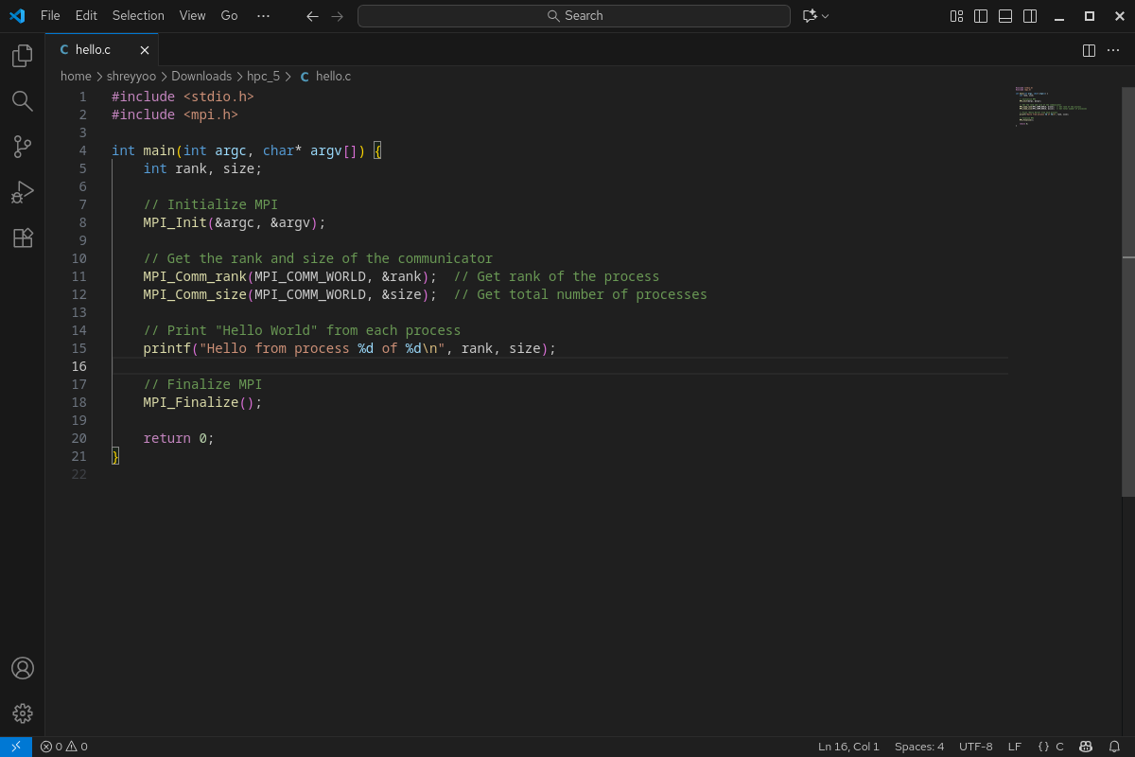  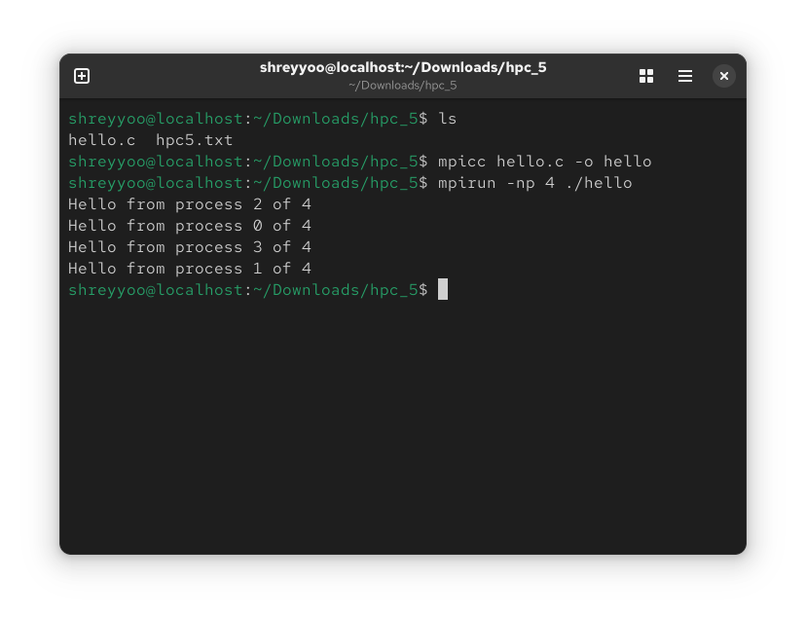
Output Analysis |  | Openmpi executes the hello program using with 4 number of processes.
Link of student Github profile where lab assignment has been uploaded |  | https://github.com/aryanycce/HPC-Practicals
Conclusion |  | The message-passing paradigm (MPI) is a viable and effective method for developing distributed-memory parallel programs. The practical gives us a theoretical understanding of how independent processes communicate and synchronize to solve a common problem, laying the groundwork for tackling more complex parallel computations and exploring performance optimization in future work.
Plag Report (Similarity index < 12%) |  | 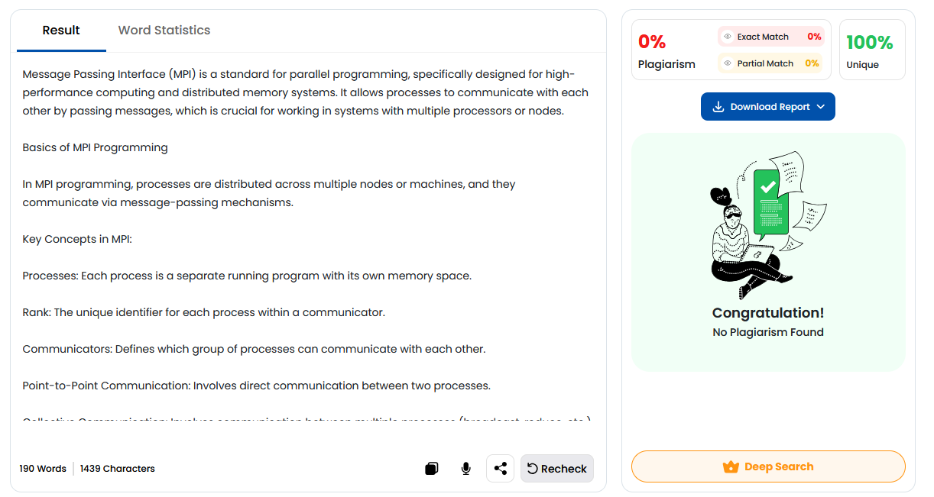
Date |  | 24/10/2025

